FEDERAL COMMUNICATIONS COMMISSION
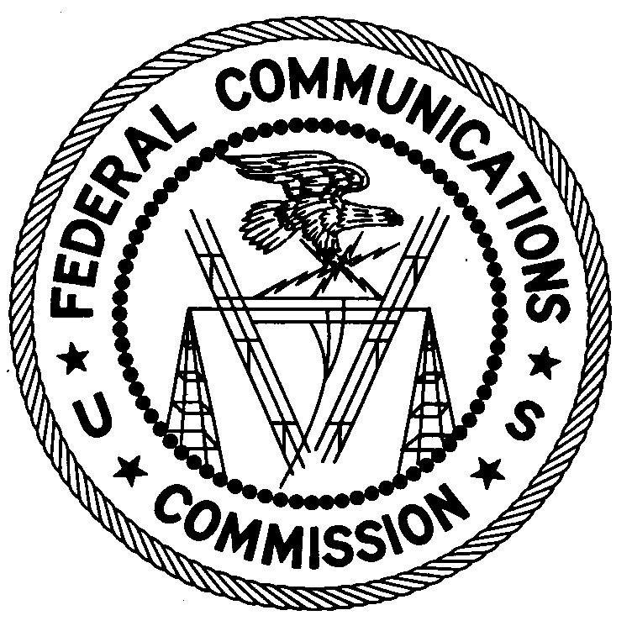
ENFORCEMENT BUREAU
South Central Region

Miami Office
P.O. Box 520617

Miami, FL 33152-0617

March 23, 2009

Cumm Partners, Inc.
Pompano Beach, FL

NOTICE OF UNLICENSED OPERATION

Case Numbers: EB-09-MA-0050

EB-09-MA-0051

Document Number: W200932600044

The Miami Office received information that unlicensed broadcast radio stations on 90.1 MHz and 101.1 MHz were allegedly operating in the Pompano Beach area. On March 18, 2009, agents from this office confirmed by direction finding techniques that radio signals on frequencies 90.1 MHz and 101.1 MHz were emanating from 779 SW 13th Ct., Pompano Beach, FL, 33060, a property owned or managed by Cumm Partners, Inc. The Commission’s records show that no license was issued for operation of broadcast stations on 90.1 MHz and 101.1 MHz at this location in Pompano Beach, FL.

Radio stations must be licensed by the FCC pursuant to 47 U.S.C. § 301. The only exception to this licensing requirement is for certain transmitters using or operating at a power level or mode of operation that complies with the standards established in Part 15 of the Commission’s rules, 47 C.F.R. §§ 15.1 et seq. The field strengths of the signals on frequencies 90.1 MHz and 101.1 MHz were measured at 44,047 microvolts per meter (µV/m) and 307,507 µV/m, respectively, at 111 meters, both which exceeded the maximum permitted level of 250 µV/m at 3 meters for non-licensed devices. Thus, the stations are operating in violation of 47 U.S.C. § 301.

A spurious radio signal associated with the operation of these stations was detected on the frequency of 112.1 MHz. This frequency is within the radio frequency band assigned for communications between aircraft and/or aircraft and aviation ground facilities and therefore a spurious signal on this frequency could present an air safety hazard. This spurious radio signal ceased when operations on 90.1 MHz and 101.1 MHz were discontinued.

You are hereby warned that operation of radio transmitting equipment without a valid radio station authorization or providing services and facilities incidental to the operation of an unlicensed radio transmitter constitutes a violation of the Federal laws cited above and could subject the operator to severe penalties, including, but not limited to, substantial monetary fines, in rem arrest action against the offending radio equipment, and criminal sanctions including imprisonment. (see 47 U.S.C. §§ 401, 501, 503 and 510).

UNLICENSED OPERATION OF THIS RADIO STATION MUST NOT RESUME.

You have ten (10) days from the date of this notice to respond with any evidence that you have authority to operate granted by the FCC. Your response should be sent to the address in the letterhead and reference the listed case and document number. Under the Privacy Act of 1974, 5 U.S.C. § 552a(e)(3), we are informing you that the Commission’s staff will use all relevant material information before it to determine what, if any, enforcement action is required to ensure your compliance with FCC Rules. This will include any information that you disclose in your reply.

You may contact this office if you have any questions.

Steven DeSena
Resident Agent
Miami Office

Attachments:
Excerpts from the Communications Act of 1934, As Amended
Enforcement Bureau, "Inspection Fact Sheet," March 2005

cc: Phillip B. Cummings and Christopher M. Cummings

