FEDERAL COMMUNICATIONS COMMISSION
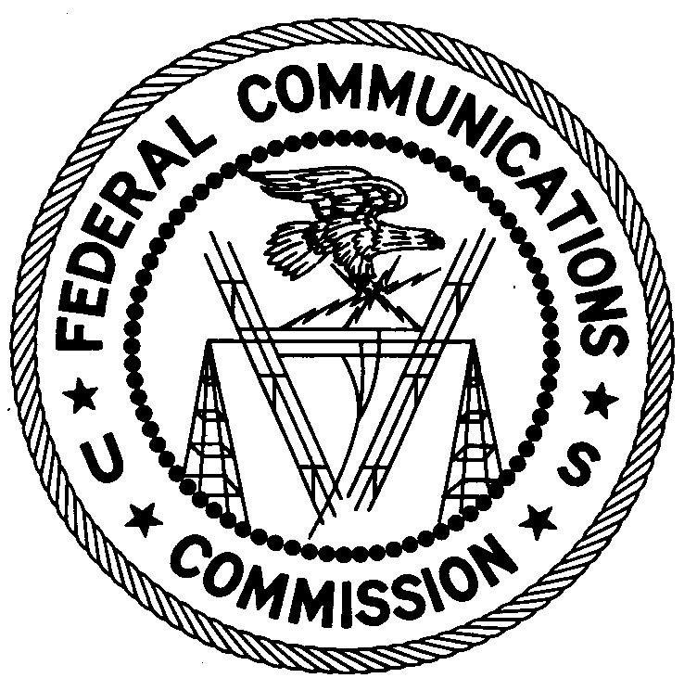
ENFORCEMENT BUREAU
SOUTH CENTRAL REGION

Atlanta Office
3575 Koger Blvd; Ste 320

Duluth, GA 30096

March 23, 2009

Darryl Davis
Talladega, AL 35160

NOTICE OF UNLICENSED OPERATION

Case Number: EB-09-AT-0010

Document Number: W200932480002

The Atlanta Office received information that an unlicensed broadcast radio station on 90.9 MHz was allegedly operating in Talladega, AL. On March 19 2009, agents from this office confirmed by direction finding techniques that radio signals on frequency 90.9 MHz were emanating from a single family residence in Talladega, AL. According to Alabama records, you are the owner of this property. The Commission’s records show that no license was issued for operation of a broadcast station on 90.9 MHz at this location in Talladega, AL

Radio stations must be licensed by the FCC pursuant to 47 U.S.C. § 301. The only exception to this licensing requirement is for certain transmitters using or operating at a power level or mode of operation that complies with the standards established in Part 15 of the Commission’s rules, 47 C.F.R. §§ 15.1 et seq. The field strength of the signal on frequency 90.9 MHz was measured at 4,068,096 microvolts per meter (µV/m) at 228.6 meters, which exceeded the maximum permitted level of 250 µV/m at 3 meters for non-licensed devices. Thus, this station is operating in violation of 47 U.S.C. § 301.

You are hereby warned that operation of radio transmitting equipment without a valid radio station authorization constitutes a violation of the Federal laws cited above and could subject the operator to severe penalties, including, but not limited to, substantial monetary fines, in rem arrest action against the offending radio equipment, and criminal sanctions including imprisonment. (see 47 U.S.C. §§ 401, 501, 503 and 510).

UNLICENSED OPERATION OF THIS RADIO STATION MUST BE DISCONTINUED IMMEDIATELY.

You have ten (10) days from the date of this notice to respond with any evidence that you have authority to operate granted by the FCC. Your response should be sent to the address in the letterhead and reference the listed case and document number. Under the Privacy Act of 1974, 5 U.S.C. § 552a(e)(3), we are informing you that the Commission’s staff will use all relevant material information before it to determine what, if any, enforcement action is required to ensure your compliance with FCC Rules. This will include any information that you disclose in your reply.

You may contact this office if you have any questions.

Douglas Miller
District Director
Atlanta Office

Attachments:
Excerpts from the Communications Act of 1934, As Amended
Enforcement Bureau, "Inspection Fact Sheet", March 2005

