FEDERAL COMMUNICATIONS COMMISSION
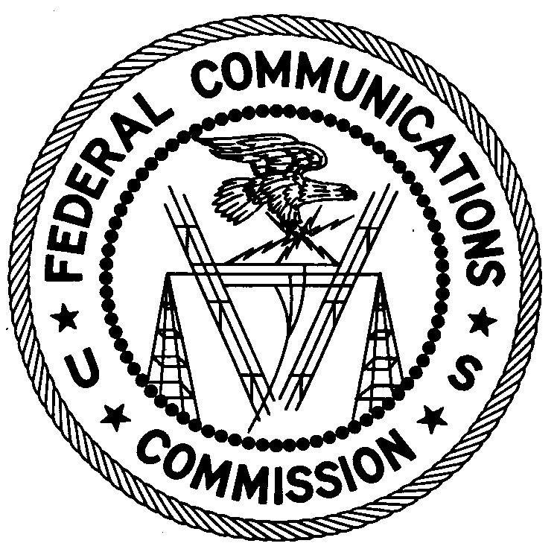
ENFORCEMENT BUREAU
NORTHEAST REGION

Boston Office

1 Batterymarch Park

Quincy, MA 02169

March 24, 2009

(Sent via Certified Return Receipt Requested and First Class U.S. Mail)

Distrigas of Massachusetts LLC
One Liberty Square, 10th Floor
Boston, MA 02109

NOTICE OF UNLICENSED OPERATION

Case Number: EB-09-BS-0007

Document Number: W200932260003

On March 5, 2009, in response to a complaint of interference on the frequency 465.075 MHz from the Boston Police Department, agents from the Boston Office conducted an investigation and determined, using direction finding techniques, that radio signals on that frequency were emanating from a building located at a facility operated by Distrigas of Massachusetts LLC (Distrigas) on the Mystic River in Everett, Massachusetts. During an inspection conducted inside the building, agents determined that Distrigas was operating a telemetry base station on 465.075 MHz. The Commission’s records show that no license was issued for your operation on the frequency 465.075MHz at this location in Everett, MA.

Radio stations must be licensed by the FCC pursuant to 47 U.S.C. § 301. You are hereby warned that operation of radio transmitting equipment without a valid radio station authorization constitutes a violation of 47 U.S.C. § 301 and could subject the operator to severe penalties, including, but not limited to, substantial monetary fines, in rem arrest action against the offending radio equipment, and criminal sanctions including imprisonment. (see 47 U.S.C. §§ 401, 501, 503 and 510).

UNLICENSED OPERATION OF THIS RADIO STATION MUST BE DISCONTINUED IMMEDIATELY.

Pursuant to Section 403 of the Communications Act of 1934, as amended, and Sections 1.17 the FCC’s Rules, Distrigas is directed to provide the following information and any relevant documents:

- Any evidence that you have authority granted by the FCC to operate a telemetry base station on 465.075 MHz in Everett, MA.

- During the inspection of your radio system, agents observed that the transmitter was not identified with an assigned FCC ID number, as required by 47 C.F.R § 2.925. Describe the process by which this equipment was selected for use and provide any contact information available for the vendor and/or installer.

- Provide the make and model number for the transmitter used in the operation of the telemetry base station on 465.075 MHz.

- Provide the date the radio system was installed and the date that operations commenced on 465.075 MHz.

- Describe any coordination efforts that were taken in selecting the frequency of operation, as required by 47 C.F.R. § 90.175.

- Provide any information you have regarding similar systems installed at other locations in the United States.

- Provide any other information that may be relevant to this inquiry.

Your response to this inquiry should reference the listed case and document number and must be supported by a sworn statement, signed by you, attesting to the truth and accuracy of the response. You should submit the sworn response so that it is received at the following address no later than 20 days from the date of this letter:

Federal Communications Commission
Boston Office
1 Batterymarch Park
Quincy, MA 02169

To knowingly and willfully make any false statement or conceal any material fact in reply to this inquiry is punishable by fine or imprisonment. See 18 U.S.C. § 1801; see also 47 C.F.R. § 1.17. Failure to respond appropriately to a Bureau Letter of Inquiry constitutes a violation of the Communications Act and our rules. See SBC Communications, Inc., Order of Forfeiture, 17 FCC Rcd 7589 (2002); Globcom, Inc., Notice of Apparent Liability for Forfeiture and Order, 18 FCC Rcd 19893, n. 36 (2003).

Under the Privacy Act of 1974, 5 U.S.C. § 552a(e)(3), we are informing you that the Commission’s staff will use all relevant material information before it to determine what, if any, enforcement action is required to ensure its compliance with FCC Rules. This will include any information that you discloses in your reply.

You may contact this office if you have any questions.

Dennis V. Loria
District Director
Boston Office

Attachments:
Excerpts from the Communications Act of 1934, As Amended
Enforcement Bureau, "Inspection Fact Sheet", March 2005

47 U.S.C. § 403.
47 C.F.R. §§ 1.17.

