
U.S. Department of Education
Office of Inspector General

________________________________

AGREED UPON PROCEDURES ATTESTATION ENGAGEMENT GUIDE
________________________________

Ensuring Continued Access to
Student Loans Act of 2008
(ECASLA)

Loan Participation Program
and
Loan Purchase Commitment Program
for the
2008-2009 Academic Year

Second Edition
December 9, 2008
UNITED STATES DEPARTMENT OF EDUCATION
OFFICE OF INSPECTOR GENERAL
Washington, DC

December 9, 2008

Dear Colleague:

This letter transmits the second edition of the U.S. Department of Education’s Agreed Upon Procedures (AUP) Attestation Engagement Guide for the Ensuring Continued Access to Student Loans Act of 2008 (ECASLA) Loan Participation Program and Loan Purchase Commitment Program for the 2008-2009 Academic Year – Second Edition. This edition supersedes the first edition, which was issued on October 17, 2008.

Under the ECASLA, for FFEL Program loans made under sections 428 (subsidized Stafford loans), 428B (PLUS loans), and 428H (unsubsidized Stafford loans) of the Higher Education Act (HEA), the U.S. Department of Education has the authority to purchase or enter into forward commitments to purchase FFEL Program loans. AUP attestation engagements are required under Section 8 of the Master Participation Agreement for the FFEL Participation Program and Section 5 of the Master Loan Sales Agreement for the FFEL Purchase Commitment Program. This Guide describes required coverage and procedures, reporting requirements, report submission deadlines, and guidance for initial and subsequent required AUP engagements.

The significant change in this edition, from the first edition, is the inclusion of the requirements for AUP engagements for lenders participating in the Federal Family Education Loan (FFEL) Purchase Commitment Program. This edition also incorporates some revisions to the AUP requirements for the FFEL Participation Program covered in the first edition of the Guide. These revisions are highlighted in the Preface, immediately following this letter. For AUP engagements already underway for the FFEL Participation Program, the first edition may continue to be used. For new AUP engagements of either the FFEL Participation Program or the FFEL Purchase Commitment Program, this second edition shall be used.

Any questions regarding the application of this Guide should be sent to Hugh M. Monaghan, Director, Non-Federal Audits, by email to hugh.monaghan@ed.gov or by fax at 215-656-6397.

Sincerely,

/s/

Keith West
Assistant Inspector General for Audit

PREFACE

This is the Second Edition of this Agreed Upon Procedures (AUP) Engagement Guide.

The First Edition, issued October 17, 2008, covered the Loan Participation Program. This Second Edition also covers the Loan Purchase Commitment Program. With respect to the Loan Participation Program, this Second Edition incorporates the changes detailed below:
- Minor change to the procedure at Chapter 3 §3.3(A) and (A)(5), with conforming change at Attachment 2;
- Clarifying change to the procedure at Chapter 3 §3.3(A)(7);
- Clarifying change to the procedure at Chapter 3 §3.4(B)(2);
- Change to the procedures at Chapter 3 §3.4(G)(3)(b) to specify two ranges, rather than one, for interest rates on PLUS loans;
- Clarifying change to the procedure at Chapter 3 §3.5(A), (D), (G), (H), (Q), (S), (T), and (U), with conforming changes at Attachment 2;
- Change to the procedures at Chapter 3 §3.5(E) to exclude from Loan Documents the name and location of the entity in possession of an original promissory note signed in hardcopy, with conforming change at Attachment 2;
- Change to the procedures at Chapter 3 §3.5(Q)(3) to include determining if a loan’s First Disbursement Date is on or before July 1, 2009, with conforming change at Attachment 2;
- Change to the procedures at Chapter 3 §3.5(S) and (T) to include inspecting credit history documentation pertaining to a PLUS loan endorser, in addition to that of the borrower;
- Clarifying change to the submission process at Chapter 5 §5.2;
- Note that ED will require sponsors and sellers to submit corrective action plans at Chapter 5 §5.2; and
- Minor change in Attachment 1 to reference the title of this Guide.
- Change in Attachment 2 requiring the results of procedures that identified noncompliance reference the applicable finding on the Schedule of Findings.

For AUP engagements already underway for the Loan Participation Program, the First Edition may continue to be used. For new AUP engagements of either the Loan Participation Program or the Loan Purchase Commitment Program, this Second Edition should be used.
Table of Contents
Chapter 1 – General Requirements 1
1.1 Purpose and Background 1
1.2 Engagement Objectives 3
1.3 Engagement Scope 3
1.4 Professional Standards 8
1.5 Fraud or Other Illegal Acts 8
1.6 Confidential Commercial Information 9
1.7 Quality Control Reviews 9
1.8 References and Resources 10
1.9 Technical Assistance 10
1.10 Subsequent Editions of Guide 10
Chapter 2 – Planning the Engagement 11
2.1 Management Assertions 11
2.2 Engagement Letter 11
2.3 Engagement Methodology 12
2.4 Use of a Third Party Servicer 13
Chapter 3 – Agreed Upon Procedures for the Loan Participation Program (Master Participation Agreement) 14
3.1 Agreed Upon Procedures 14
3.2 Reserved 14
3.3 Comparison of Loan Schedule and Purchase Request 14
3.4 Eligibility – Loan Schedules 16
3.5 Eligibility – Loan Level 18
Chapter 4 – Agreed Upon Procedures for the Loan Purchase Commitment Program (Master Loan Sales Agreement) 26
4.1 Agreed Upon Procedures 26
4.2 Comparison of Loan Schedule and Bill of Sale 26
4.3 Eligibility – Loan Schedule 32
4.4 Eligibility – Loan Level 37
Chapter 5 – Reporting 52
5.1 Engagement Report Package Requirements 52
5.2 Reporting Package Submission 53
Attachments 54
Attachment 1 - Illustrative Agreed Upon Procedures Report for the Loan Participation Program (Master Participation Agreement) 54
Attachment 2 - Illustrative Agreed Upon Procedures and Results Section for Agreed Upon Procedures for the Loan Participation Program (Master Participation Agreement) 56
Attachment 3 – Loan Participation Program (Master Participation Agreement) Summary of Loan Population and Sample Characteristics 65
Attachment 4 - Loan Participation Program (Master Participation Agreement) Participation Purchase Request Schedule 66
Attachment 5 - Loan Participation Program (Master Participation Agreement) Schedule of Findings 67
Attachment 6 – Illustrative Agreed Upon Procedures Report for the Loan Purchase Commitment Program (Master Loan Sales Agreement) 68
Attachment 7 - Illustrative Agreed Upon Procedures and Results Section for Agreed Upon Procedures for the Loan Purchase Commitment Program (Master Loan Sales Agreement) 70
Attachment 8 - Loan Purchase Commitment Program (Master Loan Sales Agreement) Summary of Loan Population and Sample Characteristics 88
Attachment 9 - Loan Purchase Commitment Program (Master Loan Sales Agreement) Bill of Sale Schedule 89
Attachment 10 - Loan Purchase Commitment Program (Master Loan Sales Agreement) Schedule of Findings 90
Attachment 11 – Sponsor/Seller and Practitioner Information Sheet 91
Attachment 12- Loan Level Testing Results for the Loan Participation Program (Master Participation Agreement) 92
Attachment 13 - Loan Level Testing Results for the Loan Purchase Commitment Program (Master Loan Sales Agreement) 93
Attachment 14 - Illustrative Examples of Subsequent Engagement Scope for the Loan Participation Program (Master Participation Agreement) 94
Attachment 15 - Examples of Bill of Sale Package Documents for the Loan Purchase Commitment Program (Master Loan Sales Agreement) 97

___________________________________________
Acronyms
___________________________________________

Acronym Definition

AUP Agreed Upon Procedures

BOS Bill Of Sale

ECASLA Ensuring Continued Access to Student
Loans Act of 2008

ED U.S. Department of Education

ELT Eligible Lender Trustee

FFELP Federal Family Education Loan Program

GAGAS Generally Accepted Government Auditing
Standards

HEA Higher Education Act of 1965,
as amended

IRB Interest Receivable from Borrower

MPA Master Participation Agreement

MLSA Master Loan Sales Agreement

NOI Notice of Intent to Participate

OIG Office of Inspector General

PPR Participation Purchase Request
___________________________________________

Chapter 1 – General Requirements
___________________________________________

  - Purpose and Background
This Agreed Upon Procedures Attestation Engagement Guide (the Guide) provides the requirements for agreed upon procedures (AUP) engagements for a lender participating in the Federal Family Education Loan (FFEL) Participation and/or Purchase Commitment Programs authorized under section 459A of the Higher Education Act (HEA) of 1965, as amended by the Ensuring Continued Access to Student Loans Act (ECASLA) of 2008 (Pub. L. 110-227).

Ensuring Continued Access to Student Loans
Under the ECASLA, for FFEL Program loans made under sections 428 (subsidized Stafford loans), 428B (PLUS loans), and 428H (unsubsidized Stafford loans) of the HEA, the U.S. Department of Education (ED) has the authority to purchase or enter into forward commitments to purchase FFEL Program loans. These programs are intended to encourage eligible FFEL Program lenders to provide students and parents access to Stafford and PLUS loans for the 2008-2009 academic year.

Under the ECASLA Loan Participation Program, ED will only purchase participation interests from sponsors that commit to including, over the period of the program, not less than $50,000,000 of FFEL Program loans.

Loan Participation Program
The Loan Participation Program allows ED to purchase participation interests in eligible loans made for the 2008-2009 academic year that are held by an eligible lender approved as a sponsor under a Master Participation Agreement (MPA). Each sponsor (lender or eligible lender trustee) must file a Notice of Intent (NOI) to Participate with ED and enter into a Master Participation Agreement with ED and a third-party custodian acceptable to ED. The filing date on which ED receives the sponsor’s NOI generally determines the eligibility of loans for which the lender may sell participation interests. With the filing of the NOI, the sponsor is vested with the option to sell participation interests in and “put” eligible loans to the Department for purchase (i.e., sell the loans to ED under the Loan Purchase Commitment Program).

ED holds the participation interest until no later than September 30, 2009. The sponsor may redeem the participation interest on or before September 30, 2009, at a price that provides ED a yield on its participation interest equal to the commercial paper rate plus 50 basis points. To redeem the interest, the sponsor may use funds obtained from private sources, or it may sell the loan to ED under the Loan Purchase Commitment Program described below.

The entities involved in the Loan Participation Program include:

- Sponsor – The sponsor is an eligible FFEL Program lender or holder of eligible FFEL Program loans. The sponsor may be a secondary market or beneficial holder under an eligible lender trustee agreement. Under the Loan Participation Program, the sponsor sells participation interests in loans to ED through a custodian.

- Eligible lender trustee (ELT) - Lenders that do not meet the definition of an eligible lender under Section 435(d) of the HEA participate in the FFEL Program through an eligible lender serving as trustee. The eligible lender trustee holds legal title to the loans on behalf of the beneficial holder.

- Custodian – An eligible lender that is a national or state chartered bank that is not affiliated with the sponsor or eligible lender trustee will serve as the custodian. Under the Loan Participation Program, the custodian is granted the legal title to the loans for which a participation interest is sold to ED.

- Originating lender – In some instances, a sponsor may acquire and sell participation interests in loans that were originated by another lender. In these instances, both the sponsor and originating lender must submit a NOI to ED.

Loan Purchase Commitment Program
Under the Loan Purchase Commitment Program, ED purchases from sellers (i.e., lenders or beneficial holders) eligible loans made for the 2008-2009 academic year. In order to participate in this program, each seller must file a NOI to participate and enter into a Master Loan Sales Agreement (MLSA) with ED. The filing date on which ED receives the lender’s NOI generally determines the eligibility of loans that the lender may sell to ED.

Under the provisions of the MLSA, ED will purchase a loan at a price that is the sum of the outstanding principal balance of the loan, plus the total accrued but unpaid interest owed on the loan by the borrower, a reimbursement of the one percent lender fee, and $75 per loan. Sellers wishing to sell eligible fully-disbursed loans to ED may do so at any time until September 30, 2009. The seller must provide a 45-day notice to ED of its intent to sell loans under this program (no later than August 14, 2009) and must complete the sale on or before September 30, 2009.

ED purchases the loans from a seller that is an eligible FFEL Program lender or beneficial holder participating in the FFELP Program through the use of an ELT.

  - Engagement Objectives
This guide provides guidance for the following AUP engagements:

Loan Participation Program AUP Engagement
The objective is: for loans for which participation interests are sold to ED by sponsors, to perform procedures and report results and findings in order to assist ED in evaluating the loans’ compliance with the provisions of the MPA and the Loan Participation Program.

Loan Purchase Commitment Program AUP Engagement
The objective is: for loans which are sold to ED by sellers, to perform procedures and report results and findings in order to assist ED in evaluating the loans’ compliance with the provisions of the MLSA and the Loan Purchase Commitment Program.

These AUP engagements are authorized under Section 8 of the MPA for the Loan Participation Program and Section 5 of the MLSA for the Loan Purchase Commitment Program. These AUP engagements are to be conducted in accordance with the professional standards described below at Chapter 1, Section 4 (§1.4).

  - Engagement Scope

Loan Participation Program AUP Engagements
These AUP engagements must be conducted for sponsors that have executed a MPA with ED and have sold participation interests in eligible loans to ED.

Initial AUP Engagement:

The initial AUP engagement period is the month in which the sponsor’s first Participation Purchase Request (PPR) was consummated. This initial engagement must cover the initial PPR and, if any other PPRs were consummated during that month, it must also cover those PPRs. The initial AUP engagement report must be submitted to ED no later than two months following the end of the month that comprises the initial engagement period.

Exception: When the initial PPR is consummated during August 2008, the initial AUP Report must cover the initial PPR and, if any, all other PPRs consummated during August and September 2008. Such report must be submitted to ED by November 30, 2008.

Determination of Subsequent AUP Engagements

The engagement period for subsequent AUP engagement reports depends on two factors:

- Whether the Sample Characteristic Error Rate reported in the immediately preceding AUP engagement report, as stated in the Loan Participation Program Schedule of Findings required by Attachment 5 of the Guide, was greater than 5%; and

- Whether for the immediate three prior calendar months (or a fewer number of months if indicated here), the sponsor’s total dollar amount of PPRs consummated exceeded the following indicated “high dollar volume” thresholds –

- $1.5 billion for the immediate prior three calendar months, if those three months were covered by one or more prior AUP engagement(s), or as part of one immediate prior AUP engagement covering the prior six months;

- $500 million for the immediate prior calendar month, if that month was covered by the initial AUP engagement for which the audit period consisted solely of that one immediate prior month;

- $1 billion for the immediate prior two calendar months, if those two months were covered by an initial two-month AUP engagement or two one-month AUP engagements, one of which is an initial engagement.

The AUP engagement period for each subsequent engagement is based upon these two factors. Thus, timeframes and frequency of submission may vary as either or both of those factors change from submission to submission.

Each AUP engagement after the initial AUP engagement must cover all PPRs consummated from the end of the prior AUP engagement period through the immediate subsequent number of consecutive calendar months, determined as follows:

Engagement Periods for AUPs after Initial AUP
Dollar Level from Prior Engagement | Sample Characteristic Error Rate
Dollar Level from Prior Engagement | If Error Rate from the immediate prior AUP engagement was 5% or less, the next AUP engagement period is — | If Error Rate from the immediate prior AUP engagement was greater than 5%, the next AUP engagement period is —
Less than the applicable high dollar volume threshold [$1.5 Billion (or alternate amount)]. | The next six months from the end of the prior period. | The next three months from the end of the prior period.
Equal to or greater than the applicable high dollar volume threshold [$1.5 Billion or more (or alternate amount)]. | The next three months from the end of the prior period. | The next one month from the end of the prior period.

Attachment 14 contains illustrative examples of how the requirements described above would apply under various scenarios. Subsequent AUP engagement reports must be submitted to ED no later than two months following the end of the last month in the engagement period.

Loan Purchase Commitment Program AUP Engagements
These AUP engagements must be conducted for sellers that have executed a MLSA with ED and have sold eligible loans to ED.

Initial AUP Engagement:
Standard Rule:
The initial AUP engagement period is the month in which the seller’s first Bill of Sale (BOS) was consummated. For purposes of this Guide, a BOS is consummated when the seller receives payment from ED for the purchase of eligible loans. This initial engagement must cover the initial BOS and any other BOS that were consummated during that month. The initial AUP engagement report must be submitted to ED no later than two months following the end of the month that comprises the initial engagement period.

Exceptions:
There are three exceptions to the initial AUP engagement period described above:

- If the initial BOS was consummated in September, October, or November 2008, the initial AUP report must cover the initial BOS and any other BOS consummated during September, October, and November 2008. The report must be submitted to ED by January 31, 2009.

- If the initial BOS was consummated on or before March 31, 2009, and the total cumulative dollar amount of all BOS consummated is $5 million or less, the initial AUP engagement period shall cover the initial BOS and any other BOS consummated through the earlier of (1) March 31, 2009, or (2) the month in which the total cumulative dollar amount of consummated BOS exceeds $5 million. The initial AUP engagement report must be submitted to ED no later than two months following the end of the last month in the engagement period.

- If the initial BOS was consummated on or after April 1, 2009, and the total cumulative dollar amount of all BOS consummated is $5 million or less, the initial AUP engagement period shall cover the initial BOS and any other BOS consummated through the earlier of (1) September 30, 2009, or (2) the month in which the total cumulative dollar amount of consummated BOS exceeds $5 million. The initial AUP engagement report must be submitted to ED no later than two months following the end of the last month in the engagement period.

Subsequent AUP Engagements:
Standard Rule:
The engagement period for subsequent AUP engagements begins with the next month during which one or more BOS are consummated, and includes the two calendar months immediately following that month. However, if the total cumulative dollar amount of consummated BOS, not yet included in an AUP engagement, exceeds $100 million, the engagement period ends with the month in which that dollar threshold was met and must include all previous BOS not included in an earlier engagement period. In addition, if the Loan Purchase Commitment Program terminates and a three-calendar month period during which one or more BOS are consummated does not lapse, the final AUP engagement shall cover all BOS consummated since the previous AUP engagement. Subsequent AUP engagement reports must be submitted to ED no later than two months following the end of the last month in the engagement period. [See exception described immediately following the table below.]

The table below contains illustrative examples of how the requirements described above would apply under various scenarios.

Illustrative Examples of Subsequent Engagement Scope
for the Loan Purchase Commitment Program
AUP Period # | BOS Volume | Period Covered | Due Date
1 | Not Applicable | Initial Period:  Sep, Oct and/or Nov | Jan 31
2 | $101M | Dec | Feb 28
3 | $25M (Jan)  $76M (Feb)  $101M cumulative | Jan  Feb | Apr 30
4 | $101M | Mar | May 31
5 | $25M (Apr)  $25M (May)  $76M (Jun)  $126M cumulative | Apr  May  Jun | Aug 31
Not Applicable  (N/A) | $0M (Jul)  $0M (Aug) | N/A | N/A
6 | $25M (Sep)  $0M (Oct)  $50M (Nov)  $75M cumulative | Sep  Oct  Nov | Jan 31
7 | $10M (Dec)  $20M (Jan)  $10M (Feb)  $40M cumulative | Dec  Jan  Feb | Apr 30
8 | $25M (Mar)  $0M (Apr)  $0M (May)  $25M cumulative | Mar  Apr  May | Jul 31
Note: These illustrative examples exclude the exception described below.

Exception:
If the total cumulative dollar amount of consummated BOS not yet included in an AUP engagement is $5 million or less at the end of the three month subsequent AUP engagement period (as determined under the standard rule), the end date of the subsequent engagement period may be extended to the earlier of (1) September 30, 2009, or (2) the last day of the month in which the total cumulative dollar amount of BOS consummated since the previous AUP engagement period exceeds $5 million. The subsequent AUP engagement must include all BOS not included in an earlier engagement period. The subsequent AUP engagement report must be submitted to ED no later than two months following the end of the last month in the engagement period.

1.4 Professional Standards
These AUP engagements must be conducted in accordance with Government Auditing Standards (commonly referred to as generally accepted government auditing standards [GAGAS]), July 2007, issued by the Comptroller General of the United States and the Attestation Standards of the American Institute of Certified Public Accountants (AICPA).

GAGAS must be used in conjunction with the AICPA Attestation Standards. GAGAS ¶6.05 identifies additional GAGAS standards for attestation engagements that go beyond the requirements in the AICPA Attestation Standards. Practitioners must comply with these additional GAGAS standards.

Practitioners must comply with applicable provisions of the public accountancy law and the rules of the jurisdiction in which the practitioner is licensed and where the engagement is conducted.

  - Fraud or Other Illegal Acts
With respect to fraud or other illegal acts, the practitioner must be guided by GAGAS provisions covering fraud or other illegal acts, including GAGAS ¶6.13.

A practitioner must exercise reasonable care when pursuing any indication of fraud or other illegal acts and abuse, so that potential future investigations or legal proceedings are not compromised.

If any fraud or any other illegal act is suspected, the practitioner must report it immediately to the ED Office of Inspector General, Investigation Services (OIG/IS), by phone or fax at the numbers shown below, before further extending engagement steps and procedures:
Assistant Inspector General for Investigations
U. S. Department of Education
400 Maryland Avenue, SW
Washington, D.C. 20202-1510
Phone: (202) 245-6966
Fax: (202) 245-6990

The practitioner must promptly prepare a separate written report as instructed by ED-OIG/IS, and must submit the report to the address provided above, either within 30 days after the fraud or illegal act was discovered or within a time frame agreed to by ED-OIG/IS and the practitioner.

  - Confidential Commercial Information
The Freedom of Information Act (FOIA), 5 U.S.C. § 522, gives any person the right to request access to records or information. All agencies of the U.S. Government are required to disclose records upon receiving a written request for them, unless one of the exemptions to the FOIA applies. One of the FOIA exemptions applies to confidential commercial information, which, as defined by the FOIA, means trade secrets and commercial or financial information that is privileged or confidential, because disclosure could reasonably be expected to cause substantial competitive harm.

If you or your client believes that your AUP engagement documentation contains confidential commercial information, you must take appropriate steps to identify that information in your working papers, to protect its confidentiality. If you are asked to submit your AUP engagement documentation to us, and we subsequently receive a request under FOIA for information that you have designated as confidential commercial information, we will make an independent determination of whether that information meets the criteria for exemption from release.

We do not inform you or your client about FOIA requests we receive. However, if we receive a FOIA request for documentation you have identified as confidential commercial information, and we conclude that it should be released under FOIA, to the extent permitted by law; we will make a good faith effort to notify you and provide you, or your client, an opportunity to object, prior to releasing any documentation.

  - Quality Control Reviews
It is ED-OIG policy and practice to evaluate the quality of the AUP engagements. As part of such evaluations, the practitioner must make all AUP engagement documentation available to us or our representatives upon request. If we determine that an AUP engagement is substandard, we may:
- Refer the issue to the State Board of Accountancy where the AUP engagement was performed and/or the practitioner is licensed, and the American Institute of Certified Public Accountants (AICPA), or State Society of Certified Public Accountants, if the practitioner is a member; and/or
- Initiate action to suspend or debar the practitioner from conducting additional U.S. Federal audits or attestation engagements.

Also, ED program officials may require the sponsor or seller to obtain and submit another AUP engagement to replace the substandard one, and suspend the sale of additional participation interests or loans to ED until the matter of the substandard AUP engagement is resolved.

  - References and Resources
Guidance and criteria for ECASLA Loan Participation Purchase and Loan Purchase Commitment Programs are provided on the Federal Student Aid Website at http://federalstudentaid.ed.gov/ffelp/.

1.9 Technical Assistance
Technical questions about applying the procedures in this Guide may be directed to Hugh M. Monaghan, Director, Non-Federal Audits, by email to hugh.monaghan@ed.gov or by fax at 215-656-6397.

1.10 Subsequent Editions of Guide
Subsequent editions of, and /or amendments to, this Guide may be issued to reflect revisions to the AUP and guidance issued by ED. The practitioner shall use the most recent edition of this Guide when conducting the AUP engagement. Practitioners should visit the OIG’s Non-Federal Audits webpage to determine if a subsequent edition of, and /or amendments to, this Guide have been issued. The OIG’s Non-Federal Audits webpage is: http://www.ed.gov/about/offices/list/oig/nonfed/sfa.html

___________________________________________

Chapter 2 – Planning the Engagement
___________________________________________

The provisions of this chapter are applicable to AUP engagements of both the Loan Participation Program and Loan Purchase Commitment Program.

  - Management Assertions
These are AUP engagements as defined in GAGAS ¶1.23. The sponsor under the Loan Participation Program or seller under the Loan Purchase Commitment Program must provide the practitioner with the management assertions detailed below for each program. The practitioner will perform the procedures in Chapter 3 and/or Chapter 4, prepare the respective reporting package described in Chapter 5, and submit the respective reporting package to management of the sponsor or seller.

Management Assertion For Loan Participation Program AUP Engagements:
For all Participation Purchase Requests consummated during the period [MM/DD/YYY] through [MM/DD/YYYY], the loans for which participation interests were sold to ED by [the sponsor] complied with the provisions of the MPA and the Loan Participation Program.

Management Assertion For Loan Purchase Commitment Program AUP Engagements:
For all Bills of Sale consummated during the period [MM/DD/YYY] through [MM/DD/YYYY], the loans which were sold to ED by [the seller] complied with the provisions of the MLSA and the Loan Purchase Commitment Program.

  - Engagement Letter
An engagement letter between the lender (i.e., sponsor under the Loan Participation Program or seller under the Loan Purchase Commitment Program) and the practitioner must be executed and must include the following:
- A statement that the engagement is to be performed in accordance with GAGAS, AICPA Attestation Standards, and this Guide;
- A description of the scope of the engagement and the related reporting that will meet the requirements of this Guide;
- A statement that both parties understand that ED will use the practitioner's report to evaluate the propriety of sales of loans or interests in loans under the Loan Participation Program and/or the Loan Purchase Commitment Program;
- A statement that the lender must provide the practitioner all required representations and assertions;
- A statement that the lender shall provide, or shall cause its servicer to provide to the practitioner access to all agreements, documents, and electronic files pertinent to the scope of the engagement;
- A provision that the practitioner is required to provide the Secretary of Education, the ED Office of Inspector General, and their representatives, access to and photocopies of AUP engagement documentation, upon request; and
- A provision that the practitioner shall retain AUP engagement documentation and reports for a minimum of seven years after the date of issuance of the practitioner’s report(s) to the entity, unless a pertinent law or regulation provides for a longer retention period, or the practitioner is notified in writing by ED to extend the retention period.
One engagement letter may be executed to cover multiple AUP engagements for the programs identified in this Guide.

  - Engagement Methodology
This engagement requires attribute sampling for the AUP described in Chapter 3 §3.5 and Chapter 4 §4.4. The AUP described in Chapter 3 §3.4 and Chapter 4 §4.3 require a review of data records in the loan schedules via queries using database software.

Loan Schedule Testing Procedures:
The queries that are to be run for the Loan Participation Program are described in Chapter 3 §3.3 and §3.4. The queries that are to be run for the Loan Purchase Commitment Program are described in Chapter 4 §4.3.

Loan Level Testing Procedures:
The loan level testing (Chapter 3 §3.5 or Chapter 4 §4.4, as applicable) requires that a random sample (using a random number generator) of loans be selected from the Loan Schedule(s) for PPRs or BOS consummated during the AUP engagement period (defined in Chapter 1 §1.3). The practitioner must select loans using the following guidelines:
- An attribute sample must be used to estimate the frequency of occurrence of noncompliance with the specified eligibility requirements.
- The sampling unit is each individual loan.
- The sample size must be 150 loans. [Exception: If the population is less than 150, all loans shall be selected.]
- The practitioner will apply the procedures, specified in Chapter 3 §3.5 for the Loan Participation Purchase Program or Chapter 4 §4.4 for the Loan Purchase Commitment Program, as applicable, to the sampled loans.
- The results of applying the procedures indicate whether each loan is in compliance with the specified eligibility requirements. A loan is considered to be noncompliant if it fails to meet one or more of the specified eligibility requirements. The count of noncompliant loans should match the number of loans, failing to meet one or more of the eligibility requirements, as detailed in the schedule of Loan Level Testing Results (Attachment 12) for the Loan Participation Purchase Program or (Attachment 13) for the Loan Purchase Commitment Program.
- The practitioner must summarize the population and sample characteristics (e.g., number of errors and error rate) using the Summary of Loan Population and Sample Characteristics (Attachment 3) for the Loan Participation Program or (Attachment 8) for the Loan Purchase Commitment Program.
- As required by certain AUP set forth in Chapters 3 and 4, the practitioner must report findings when exceptions are noted. These findings should be presented as illustrated in the Schedule of Findings (Attachment 5) for the Loan Participation Program or (Attachment 10) for the Loan Purchase Commitment Program.

  - Use of a Third Party Servicer
Sponsors, lenders or custodians may contract with third-party servicers to perform functions and/or maintain records for which they are responsible. Consequently, auditors may need to have access to third-party servicers in order to perform the procedures required by this Guide. In performing engagements under this Guide, practitioners shall consider such third-party servicer records or functions as if they were the lender’s or sponsor’s.
___________________________________________

Chapter 3 – Agreed Upon Procedures for the Loan Participation Program (Master Participation Agreement)
___________________________________________

3.1 Agreed Upon Procedures
The AUP set forth in the sections of this Chapter must be performed on the sponsor’s Loan Schedules and PPRs consummated during the AUP engagement period (defined in Chapter 1 §1.3).

Sections 3.2 through 3.5 below provide the AUP to be performed for sponsors participating in the Loan Participation Program. The procedures detailed below in Chapter 3 §3.3(A)(4) assist in preparing multiple Loan Schedule files for the application of procedures in §3.4 and §3.5.

3.2 Reserved

3.3 Comparison of Loan Schedule and Purchase Request

Compliance Requirements:
Each PPR must be accompanied by a Loan Schedule that details the loans for which a participation interest is being sold to ED. The Loan Schedule’s file layout is specified in ED’s Electronic Announcement #16, dated August 15, 2008. (Available at: http://federalstudentaid.ed.gov/ffelp/)

Required Procedures:
3.3(A). Obtain from the sponsor electronic copies of the Loan Schedule(s) supporting the PPR(s) for which the AUP is being performed and:
1) Read each Loan Schedule to determine that the Loan Schedule contains all the fields specified in ED’s Electronic Announcement #16, dated August 15, 2008. Report any omissions as a finding in the Schedule of Findings (Attachment 5).
2) Compare the total Purchase Price amount specified in each PPR to the PC Funding Request (Header Record Layout Field 4) amount contained in the accompanying Loan Schedule’s header information. [The PC Funding Request amount represents the Participation Certificate funding request for new or reissued disbursements.] Report any discrepancies as a finding in the Schedule of Findings (Attachment 5).
3) Add all of the individual Disbursement Amounts (Loan Level Layout Field 18) on the Loan Schedule and compare the calculated amount to the total PC Funding Request amount (Header Record Layout Field 4). Report any discrepancies as a finding in the Schedule of Findings (Attachment 5).
4) If the Loan Schedule contains records with a Data Flag (Loan Level Layout Field 2) of “I” (i.e., no changes to the loan), inspect all records on the Loan Schedule with a Data Flag of “I” to confirm that all such records have a Disbursement Amount (Loan Level Layout Field 18) of zero. Report any discrepancies as a finding in the Schedule of Findings (Attachment 5).
5) If the AUP engagement covers multiple PPRs, merge the Loan Schedules for each separate PPR covered in the AUP engagement into a single file. Before applying additional procedures, compare the total record count of the merged Loan Schedule to the total of the record counts of the individual Loan Schedules that were merged and be sure that they agree.
6) If applicable, remove from the individual or merged Loan Schedule those records with a Data Flag (Loan Level Layout Field 2) of “I” to ensure that only Loan Schedule records with a Data Flag of “N” (i.e., new loan) or “U” (i.e., new or additional information or disbursement) are subject to the procedures set forth in Chapter 3 §3.4 and §3.5.
7) Following the application of the procedures at §3.3(A)(1) through (6), save the resulting individual or merged Loan Schedule file. The procedures specified in §3.4 and §3.5, are to be applied to this Loan Schedule file. This file will be a single Loan Schedule if the AUP engagement covers a single PPR, or a merged Loan Schedule if the AUP engagement covers multiple PPRs.
The Loan Schedule will contain records with Data Flags (Loan Level Layout Field 2) “N” and “U”, representing new and updated information, respectively. In applying the procedures specified in §3.4 and §3.5 to the Loan Schedule, the practitioner must consider the cumulative effect of records with Data Flags of “N” and “U” associated with a loan. Records with a Data Flag of “U” may indicate an additional Disbursement Amount, a change to a date field, or a change to another field. Some of these updates or changes may impact the eligibility of a loan for the Loan Participation Program.

3.3(B). List the total number of loans and the total disbursement amounts from the Loan Schedule (i.e., from §3.3(A)(7)) on the Loan Participation Program Summary of Loan Population and Sample Characteristics (Attachment 3).

3.4 Eligibility – Loan Schedules

Compliance Requirements:
The lender can sell participation interests in loans that meet the criteria in MPA Section 1 “Terms” and Section 3 “Definitions” (for Eligible Loan).

Required Procedures:
3.4(A). Using database or audit software, query the Loan Schedule (i.e., from §3.3(A)(7)) to determine that the Loan Type (Loan Level Layout Field 20) contains only the following codes: SF (subsidized Stafford), SU (unsubsidized Stafford), PL (PLUS for parent), or GB (PLUS for graduate/professional student). Report as a finding in the Schedule of Findings (Attachment 5) all instances of loans type codes other than SF, SU, PL, or GB included on the Loan Schedule.
3.4(B). Obtain the following documents from the sponsor:
1) The sponsor’s and, if applicable, the original lender’s NOI and the email from ED confirming the receipt of the sponsor’s and, if applicable, the original lender’s NOI. Inspect the NOI noting that the sponsor and, if applicable, the original lender indicated on the NOI its choice to participate in the Loan Participation Program. Report as a finding in the Schedule of Findings (Attachment 5) any of the NOIs that were not obtained or did not indicate the choice to participate in the Loan Participation Program.
2) The MPA’s Adoption Agreement that was signed and dated by the sponsor, ED, the custodian, and, if applicable, the ELT. Report as a finding in the Schedule of Findings (Attachment 5) any Adoption Agreement that was not signed and dated by all applicable parties (i.e., the sponsor, ED, the custodian, and, if applicable, the ELT).
3.4(C). Using database or audit software, query the Loan Schedule (i.e., from §3.3(A)(7)) noting that the Original Lender ID (Loan Level Layout Field 21) and Sponsor ID (Loan Level Field 22) contain only those Lender IDs (LID) specified in the sponsor’s and/or original lender’s NOI and the sponsor’s MPA Adoption Agreement. Report as a finding in the Schedule of Findings (Attachment 5) any instances of LIDs other than those specified in the sponsor’s and/or original lender’s NOI and Adoption Agreement.
3.4(D). Sort the loan records contained in the Loan Schedule (i.e., from §3.3(A)(7)), into two categories as follows:
1) Loan records where the sponsor is the originating lender (i.e., the Sponsor ID (Loan Level Field 22) is the same as the Original Lender ID (Loan Level Layout Field 21)); and
2) Loan records where the sponsor is not the originating lender (i.e., the Sponsor ID (Loan Level Field 22) is different than the Original Lender ID (Loan Level Layout Field 21)).
3.4(E). For loan records where the sponsor is the originating lender (i.e., records identified in step (D)(1), above) –
1) If the sponsor’s NOI date is on or before July 31, 2008, determine that the First Disbursement Date (Loan Level Layout Field 15) has no records with a date on or before April 30, 2008. [The First Disbursement Date represents the date of the first transfer of loan proceeds by a lender to a borrower or school by issuance of a check or electronic funds transfer.] Report as a finding in the Schedule of Findings (Attachment 5) any records indicating a First Disbursement Date on or before April 30, 2008.
2) If the sponsor’s NOI date is on or after August 1, 2008, determine that the First Disbursement Date (Loan Level Layout Field 15) has no records before the NOI date. Report as a finding in the Schedule of Findings (Attachment 5) any records indicating a First Disbursement Date before the NOI date.
3.4(F). For loan records where the sponsor is not the originating lender (i.e., records identified in step (D)(2), above) –
1) If the sponsor’s and originating lenders’ NOI dates are both on or before July 31, 2008, determine that the First Disbursement Date (Loan Level Layout Field 15) has no records with a date on or before April 30, 2008. Report as a finding in the Schedule of Findings (Attachment 5) any records indicating a First Disbursement Date on or before April 30, 2008.
2) If either the sponsor’s or originating lenders’ NOI date is on or after August 1, 2008, determine that the First Disbursement Date (Loan Level Layout Field 15) has no records with a date before the later of the sponsor’s or originating lenders’ NOI date. Report as a finding in the Schedule of Findings (Attachment 5) any records before the applicable NOI date.
3.4(G). Using database or audit software, query the Loan Schedule (i.e., from §3.3(A)(7)) to determine that the:
1) First Disbursement Date (Loan Level Layout Field 15) has no records with a date on or after July 2, 2009. Report as a finding in the Schedule of Findings (Attachment 5) any records with a First Disbursement Date on or after July 2, 2009.
2) Most Recent Disbursement Date (Loan Level Layout Field 16) and Anticipated Final Disbursement Date (Loan Level Layout Field 19) contain no dates on or after October 1, 2009. Report as a finding in the Schedule of Findings (Attachment 5) any such records containing dates on or after October 1, 2009.
3) Actual Interest Rate (Loan Level Layout Field 27) is:
a) Greater than or equal to 5.35% and less than or equal to 6.8% for Stafford subsidized and unsubsidized loans, or
b) For PLUS parent and graduate/professional loans:
i) Greater than or equal to 5.75% and less than or equal to 6%; or
ii) Greater than or equal to 8.25% and less than or equal to 8.5%.
Report as a finding in the Schedule of Findings (Attachment 5) any records containing interest rates outside of these ranges.

3.4(H). For the initial AUP engagement only, determine that the sponsor’s PPRs were consummated on or after the date that the MPA’s Adoption Agreement was signed and dated by the sponsor, ED, the custodian, and, if applicable, the ELT. Report as a finding in the Schedule of Findings (Attachment 5) any PPRs consummated before the Adoption Agreement was signed and dated by all applicable parties.

  - Eligibility – Loan Level

Compliance Requirements:
The lender can sell participation interests in loans that meet the criteria in MPA Section 1 “Terms” and Section 3 “Definitions” (for Eligible Loan). The sponsor must transfer Loan Documents to the custodian, or its designee, pursuant to the MPA’s Section 4(b) and Section 9(b)(iii). Eligible loans must be made with due diligence and reasonable care and in compliance with the HEA and applicable regulations. Pursuant to the definition of an Eligible Loan in Section 3 of the MPA, if the loan is a subsidized or unsubsidized Stafford loan, the sponsor must sell to ED participation interests in all of the borrower’s other subsidized or unsubsidized Stafford loans that are Eligible Loans held by or on behalf of the sponsor.

Required Procedures:
3.5(A). Request from the sponsor’s management a listing of the location(s) of documents, records, and servicing systems for the loans listed on the Loan Schedule. This information is maintained by the sponsor, servicer, custodian, or its designee.

3.5(B). Randomly select (using a random number generator) a sample of 150 loans from one of the following populations:
1) For an AUP engagement covering a single PPR, include all loans in the individual Loan Schedule from §3.3(A)(7); or
2) For an AUP engagement covering multiple PPRs, include all loans in the merged Loan Schedule from §3.3(A)(7).

3.5(C). Add total loan disbursements from the sample population and report the amount on the Summary of Loan Population and Sample Characteristics (Attachment 3).

3.5(D). List the Loan Number (Loan Level Layout Field 1) and the Disbursement Amount (Loan Level Layout Field 18) for each of the loans in the sample on the schedule of Loan Level Testing Results (Attachment 12).

3.5(E). For loans in the sample, obtain Loan Documents from the sponsor’s custodian or its designee. Loan Documents may be hardcopy or electronic records. Inspect the Loan Documents to determine that they include:
1) A copy of the signed promissory note;
2) A repayment schedule, if the loan has entered repayment;
3) A record of each disbursement (e.g., a report from the loan servicing system detailing the date and amount of the disbursement);
4) Disclosure statements (disclosures described in 34 C.F.R. § 682.205 include loan amounts, actual interest rates, fees, etc.), or evidence that a disclosure statement was provided to the borrower; and
5) If the promissory note was electronically signed by the borrower:
a) A statement identifying the name and location of the entity in possession of the original electronic promissory note, and
b) If different from step E(5)(a), contact information of the person who is able to provide the affidavit or certification regarding the creation and maintenance of electronic records as described in 34 C.F.R. § 682.414(a)(6)(i).

3.5(F). Based upon results from §3.5(E), mark an “X” in the “Loan Documents” column on the schedule of Loan Level Testing Results (Attachment 12) if any of the Loan Documents for a loan are missing. In addition, report the specific details of noncompliance as a finding in the Schedule of Findings (Attachment 5).

3.5(G). For loans in the sample, obtain from the sponsor’s custodian or its designee the loan certifications from the student’s school. Compare the following information contained in, or referenced by, the loan certification to the Loan Schedule:
1) Loan Type (Loan Level Layout Field 20),
2) Original Loan Amount (Loan Level Layout Field 25), and
3) Loan Period Begin Date (Loan Level Layout Field 30).

3.5(H). Based upon results from §3.5(G), mark an “X” in the “Loan Certification” column on the schedule of Loan Level Testing Results (Attachment 12) if any of the information for the loan contained in, or referenced by, the loan certification detailed in (G) above does not agree to the Loan Schedule. In addition, report the specific details of noncompliance as a finding in the Schedule of Findings (Attachment 5).

3.5(I). For loans in the sample, compare the following information contained in the Loan Documents to the Loan Schedule:
1) Loan Number (Loan Level Layout Field 1), if recorded in the Loan Documents,
2) SSN (Loan Level Layout Field 3),
3) Last Name (Loan Level Layout Field 5),
4) First Name (Loan Level Layout Field 6),
5) First Disbursement Date (Loan Level Layout Field 15),
6) Guaranty Date (Loan Level Layout Field 13),
7) Disbursement Amount (Loan Level Layout Field 18),
8) Loan Type (Loan Level Layout Field 20),
9) Original Lender ID (Loan Level Layout Field 21), and
10) Actual Interest Rate (Loan Level Layout Field 27).

3.5(J). Based upon results from §3.5(I), mark an “X” in the “Agreement With Loan Schedule” column on the schedule of Loan Level Testing Results (Attachment 12) if any of the information for the loan in the Loan Documents detailed in (I) above does not agree to the Loan Schedule. In addition, report the specific details of noncompliance as a finding in the Schedule of Findings (Attachment 5).

3.5(K). For loans in the sample, inspect the Loan Schedule to determine that the loan’s First Disbursement Date (Loan Level Layout Field 15) is on or before the applicable PPR submission date.

3.5(L). Based upon results from §3.5(K), mark an “X” in the “1st Disbursement Date” column on the schedule of Loan Level Testing Results (Attachment 12) if the loan first disbursement date is not on or before the applicable PPR submission date. In addition, report the specific details of noncompliance as a finding in the Schedule of Findings (Attachment 5).

3.5(M). For loans in the sample, inspect the Loan Documents to determine that the Loan Period includes, or begins on or after, July 1, 2008.

3.5(N). Based upon results from §3.5(M), mark an “X” in the “Loan Period” column on the schedule of Loan Level Testing Results (Attachment 12) if the Loan Period does not include or begin on or after July 1, 2008. In addition, report the specific details of noncompliance as a finding in the Schedule of Findings (Attachment 5).

3.5(O). For loans in the sample, match the loan’s Actual Interest Rate (Loan Level Layout Field 27) shown in the Loan Schedule to the Loan Documents and the applicable statutory interest rate (see table below) net of the following permissible reduction and/or limitation, if applicable:
1) A reduction in interest rates of not more than 0.25% that are contingent on the use of an automatic payment process by the borrower for any payments due;
and/or
2) A 6% limitation in interest rates for eligible borrowers under the Servicemembers Civil Relief Act (50 U.S.C. Appendix § 527).

Statutory Interest Rates
Loan Type | Grade Level | First Disbursement Date
Loan Type | Grade Level | July 1, 2006 Through  June 30, 2008 | July 1, 2008 Through  June 30, 2009 | On or After July 1, 2009
Subsidized Stafford Loans (SF) | Undergraduate | 6.8% | 6.0% | 5.6%
Subsidized Stafford Loans (SF) | Graduate | 6.8% | 6.8% | 6.8%
Unsubsidized Stafford Loans (SU) | Undergraduate | 6.8% | 6.8% | 6.8%
Unsubsidized Stafford Loans (SU) | Graduate | 6.8% | 6.8% | 6.8%
PLUS Loans  (PL or GB) | All | 8.5% | 8.5% | 8.5%
Note: The Actual Interest Rate reported on the Loan Schedule should be the actual interest rate on the loan as charged to the borrower. The Actual Interest Rates are based on the statutory rates and are net of permissible Eligible Borrower Benefits under the MPA’s Section 3 and/or interest rate limitation under the Servicemembers Civil Relief Act, if applicable.

3.5(P). Based upon results from §3.5(O), mark an “X” in the “Interest Rate” column on the schedule of Loan Level Testing Results (Attachment 12) if the loan’s Actual Interest Rate does not agree with the rate in the Loan Documents and to the applicable statutory interest rate net of permissible Eligible Borrower Benefits and/or limitations under the Servicemembers Civil Relief Act. In addition, report the specific details of noncompliance as a finding in the Schedule of Findings (Attachment 5).

3.5(Q). For subsidized or unsubsidized Stafford loans in the sample, determine that the sponsor has sold to ED participation interests in all of the borrower’s other eligible subsidized or unsubsidized Stafford loans as follows:
1) Using the borrower’s SSN (Loan Level Layout Field 3) query the Loan Schedule file to determine if it includes other subsidized or unsubsidized Stafford loans for the borrower.
2) If step (1) identifies no other subsidized or unsubsidized Stafford loans for the borrower, using the borrower’s SSN, query the applicable loan servicing system(s) for other subsidized or unsubsidized Stafford loans for the borrower, as follows:
a) For loan records where the sponsor is the originating lender (i.e., the Sponsor ID (Loan Level Field 22) is the same as the Original Lender ID (Loan Level Layout Field 21)) —
i) If the sponsor’s NOI date is on or before July 31, 2008, query the servicing system for other subsidized or unsubsidized Stafford loans for the borrower with a First Disbursement Date on or after May 1, 2008.
ii) If the sponsor’s NOI date is on or after August 1, 2008, query the servicing system for other subsidized or unsubsidized Stafford loans for the borrower with a First Disbursement Date on or after the sponsor’s NOI date.
b) For loan records where the sponsor is not the originating lender (i.e., the Sponsor ID (Loan Level Field 22) is not the same as the Original Lender ID (Loan Level Layout Field 21)) —
i) If the sponsor’s and originating lenders’ NOI dates are both on or before July 31, 2008, query the servicing system for other subsidized or unsubsidized Stafford loans for the borrower with a First Disbursement Date on or after May 1, 2008.
ii) If either the sponsor’s or originating lenders’ NOI date is on or after August 1, 2008, query the servicing system for other subsidized or unsubsidized Stafford loans for the borrower with a First Disbursement Date on or after the later of the sponsor’s or originating lenders’ NOI date.
3) If the above queries identify other subsidized or unsubsidized Stafford loans for the borrower, for each loan identified, inspect the loan information contained in the applicable loan servicing system and answer the following questions:
a) Is the First Disbursement Date on or before the applicable PPR date?
b) Is the First Disbursement Date on or before July 1, 2009?
c) Does the Loan Period include, or begin on or after, July 1, 2008?
d) Is the Anticipated Final Disbursement Date on or before September 30, 2009?
[Step 3 (above) applies a test (a through d) to see if there are indications that the borrower’s other subsidized or unsubsidized Stafford loans are Eligible Loans that should have been sold to ED. If, for a loan, the answer to each of the four questions (a through d) is yes; this indicates that participation interests in the loan should have been sold to ED.]

3.5(R). Based upon results from §3.5(Q), mark an “X” in the “Inclusion Of All Borrower’s Loans” column on the schedule of Loan Level Testing Results (Attachment 12) if there are indications that the sponsor has not sold to ED participation interests in all of the borrower’s other eligible subsidized or unsubsidized Stafford loans. In addition, report the specific details as a finding in the Schedule of Findings (Attachment 5).

3.5(S). For any PLUS loans in the sample:
1) Obtain from the sponsor’s custodian or its designee the Loan Documentation regarding the borrower’s and, if applicable, the endorser’s credit history.
2) Inspect the Loan Documentation to see that it contains a credit report secured on each borrower and, if applicable, endorser.
3) If a credit report is included in the Loan Documentation, inspect the credit report to see whether it contains the following indications of an adverse credit history:
a) The credit report indicates the borrower or endorser, if applicable, is 90 or more days delinquent on the repayment of a debt, or
b) The credit report indicates that the borrower or endorser, if applicable, has been subject to a default determination, bankruptcy discharge, foreclosure, repossession, tax lien, wage garnishment, or write-off of a Title IV debt, during the five years preceding the date of the credit report.
4) If the credit report contains either of the items described in 3(a) or (b) that indicate an adverse credit history, inspect the Loan Documentation to see if it contains a record of the lender’s basis for determining that extenuating circumstances existed.

3.5(T). Based upon results from §3.5(S), mark an “X” in the “PLUS Documentation” column on the schedule of Loan Level Testing Results (Attachment 12) if the PLUS Loan Documentation does not contain (i) a credit report for each borrower and endorser, if applicable, or (ii), for borrowers with the indications of an adverse credit history described in §3.5(S)(3), a record of the lender’s basis for determining that extenuating circumstances existed (see §3.5(S)(4)). In addition, report the specific details of noncompliance as a finding in the Schedule of Findings (Attachment 5).

3.5(U). If the procedures specified in §3.5 (above), indicate noncompliance, the practitioner must report in the Summary of Loan Population and Sample Characteristics (Attachment 3) the loan level testing results and project such results, at the upper limit only, for the population of loans at a 90 percent confidence level. An upper-only limit yields an estimation that the actual error rate for the population is less than the upper limit. An example of the practitioner’s statement on loan level testing results may be:

As part of the Agreed Upon Procedures, we randomly selected 150 loans with Disbursement Amounts totaling [$375,000] from the population of [130,000] loans with Disbursement Amounts totaling [$325,000,000]. We performed the specified procedures on these loans. Based upon the results of the specified procedures, [two] of the loans, or [1.33] percent, of the loans sampled failed to meet one or more of the specified eligibility requirements. Based upon statistical sampling procedures for attribute samples, at the 90 percent confidence level, it is estimated that no more than [3.5] percent of the loans in the population failed to meet one or more of the specified eligibility requirements.

___________________________________________

Chapter 4 – Agreed Upon Procedures for the Loan Purchase Commitment Program (Master Loan Sales Agreement)
___________________________________________

4.1 Agreed Upon Procedures
The AUP set forth in the sections of this Chapter must be performed on the seller’s BOS and related Loan Schedules consummated during the AUP engagement period (defined in Chapter 1 §1.3).

Sections 4.2 through 4.4 below provide the AUP to be performed for sellers participating in the Loan Purchase Commitment Program. The procedures detailed below in Chapter 4 §4.2 assist in preparing multiple Loan Schedule files for the application of procedures in §4.3 and §4.4.

4.2 Comparison of Loan Schedule and Bill of Sale

Compliance Requirements:
For each BOS consummated, a BOS package is created. Each BOS package must include the following documents, examples of which are contained in Attachment 15:
1) A BOS that provides the terms of the sale of loans. There are two distinct forms of the BOS:
a) A BOS for loans sold directly by the lender to ED.
b) A BOS for loans sold to ED out of a participation facility under the Loan Participation Program. This BOS includes a custodian as a party to the sale.
2) A Loan Schedule (i.e., Loan Purchase Detail Loan Schedule, herein referred to as the Loan Schedule) that details the eligible loans that are to be sold to ED. This schedule is prepared by the ED Servicer from data files provided by the seller or the seller’s servicer. The Loan Schedule is provided to the seller in an Adobe Acrobat (i.e., pdf) file format. The seller reviews and approves the Loan Schedule. The Loan Schedule contains the following fields.

Loan Purchase Commitment Program
Loan Schedule – Header Fields
Field | Definition
Deal ID | The loan sale identification number.
# of Loans* | The number of loans included in the Loan Schedule.
OLA* | The total original loan amount (OLA) for the loans included in the Loan Schedule.
SUB PBO* | The total principal balance outstanding (PBO) for subsidized Stafford loans included in the Loan Schedule, as of the Loan Schedule’s report date.
UNSUB PBO* | The total principal balance outstanding for unsubsidized Stafford and PLUS loans included in the Loan Schedule, as of the Loan Schedule’s report date.
Estimated IRB as of Sale Date* | The total estimated interest receivable from the borrower (IRB) as of the sale date for loans included in the Loan Schedule.
1% Fee* | The total reimbursement of the 1% lender fee. This amount equals 1% of the total OLA.
Loan Fee* | The total $75 purchase fee per loan, based upon the number of loans.
Total Purchase Price* | The sum of, for all loans included in the Loan Schedule, (1) the total PBO, (2) the total estimated IRB, (3) the total 1% lender fee rebate, and (4) the total $75 purchase fee per loan. The applicable Bill of Sale contains this amount.
* The Loan Schedule – Header Fields also include fields providing summary information by Loan Type (i.e., subsidzed Stafford, unsubsidized Stafford, and PLUS).
Loan Schedule – Loan Level Fields
Field | Definition
SOC NBR | The borrower’s Social Security Number.
Name | The borrower’s last and first name.
Status | The loan status (e.g., in school, in repayment).
OLA | The original loan amount.
SUB PBO | The principal balance outstanding for a subsidized Stafford loan, as of the Loan Schedule’s report date.
UNSUB PBO | The principal balance outstanding for an unsubsidized Stafford or PLUS loan, as of the Loan Schedule’s report date.

Estimated IRB as of Sale Date | The estimated interest receivable from the borrower as of the sale date.
LOAN PER BEG DT | The loan period begin date.
LOAN PERIOD END DT | The loan period end date.
INT RATE | The actual interest rate for the loan as charged to the borrower. The actual interest rates are based on the statutory rates and are net of permissible Eligible Borrower Benefits under the MLSA’s Section 3(F) and/or interest rate limitation under the Servicemembers Civil Relief Act, if applicable.
Loan Type | Specifies the type of loan. Eligible loan types are: SF (subsidized Stafford), SU (unsubsidized Stafford), PL (PLUS for parent), or GB (PLUS for graduate/professional student).
1% Fee | The reimbursement of the 1% lender fee, based upon OLA.
Loan Fee | The $75 purchase fee per loan.
Total | The total purchase price for the loan. It is the sum of (1) the PBO, (2) the total estimated IRB, (3) the 1% lender fee rebate, and (4) the $75 purchase fee.
Seller | The seller’s lender ID (LID). If the original lender is the seller, then this LID will be the same as the Original Lender’s LID.
Original Lender | The LID for the lender who made the initial disbursement of the loan to the borrower.
First Disbursement Date | The date of the first disbursement of the loan.
Last Disbursement Date | The date of the final disbursement of the loan.

3) A Final Loan Schedule Summary (i.e., BOS Attachment and Final Loan Schedule Summary of Loans Sold, herein referred to as the Loan Schedule Summary) that summarizes the loans that are to be sold to ED.
4) A Security Release Certification for loans to be sold that are subject to any security interest, pledge or hypothecation for the benefit of any financing institution or third party. Attached to the Security Release Certification must be a Schedule of Loans to which the Security Release applies. The Security Release Certification only applies for sales of loans with a security interest.
5) A Notice of Assignment and Designation of Payee for instances where the seller has assigned to the party holding the security interest the right to receive direct payment from ED. The Notice of Assignment and Designation of Payee is submitted at the option of the seller.
Complete details about the BOS Package are specified in ED’s Electronic Announcements #23 and #26, dated August 22, 2008, and September 9, 2008, respectively. (Available at: http://federalstudentaid.ed.gov/ffelp/)

Required Procedures:
4.2(A). Obtain each BOS package covered by the AUP engagement from the ED Servicer. Contact information for the ED Servicer is as follows:
ED Servicer Contact Information
Name | Susan Manlove
Phone | (310) 847-4198
Email Address | Susan.Manlove@ACS-Inc.com
Note: In order to obtain the BOS Package and other loan information from the ED Servicer, the practitioner may be required to execute an agreement regarding the use and safeguarding of the information provided. ED intends to issue an Electronic Announcement with details on the security agreement and other instructions for obtaining information from the ED Servicer. (The Electronic Announcement may be available at: http://federalstudentaid.ed.gov/ffelp/)
Inspect each BOS package, which will include electronic copies of the Loan Schedules supporting the BOS, and perform the following procedures:
- Compare the number/amounts described for the fields specified in the table below (that are contained in each BOS, accompanying Loan Schedule, and accompanying Final Loan Schedule Summary; examples of each document are provided in Attachment 15) and see that the number/amounts all agree. Report any discrepancies as a finding in the Schedule of Findings (Attachment 10).
Item | Loan Schedule  (Header Fields) | Final Loan Schedule Summary | BOS
A | TOTAL PURCHASE PRICE | Total Final Purchase Price | Purchase Price
B | # of Loans | Total Number of Loans at Purchase Date | Not Applicable
C | OLA | Total Original Amount Disbursed | Not Applicable
D | SUB PBO (see Loan Type Summary_ | Total Outstanding Principal Balance at Purchase Date for FFEL Stafford Subsidized | Not Applicable
E | UNSUB PBO for unsubsidized Stafford (see Loan Type Summary) | Total Outstanding Principal Balance at Purchase Date for FFEL Stafford Unsubsidized | Not Applicable
F | UNSUB PBO for PLUS (see Loan Type Summary) | Total Outstanding Principal Balance at Purchase Date for FFEL PLUS | Not Applicable
G | ESTIMATED IRB AS OF SALE DATE | Total Borrower’s Accrued/Unpaid Interest at Purchase Date | Not Applicable
H | 1% FEE | Reimbursement of One-Percent Lender Fee | Not Applicable
I | LOAN FEE | $75.00 Purchase Fee per Loan | Not Applicable
2) Calculate the number of the Loan Level records (i.e., the number of loans) contained in each Loan Schedule.
3) Calculate the total of all the individual amounts for the Loan Level records contained in each Loan Schedule for the following fields:
a) OLA
b) SUB PBO for Loan Types of “SF” (i.e., subsidized Stafford)
c) UNSUB PBO for Loan Type of “SU” (i.e., unsubsidized Stafford)
d) UNSUB PBO for Loan Type of “GB” and “PL” (i.e., PLUS loans)
e) Estimated IRB as of Sale Date
f) 1% Fee
g) Loan Fee
h) Total [Purchase Price]
- Compare the calculated totals from §4.2(A)(2) and (3), above, with the fields described in the table below and see that all agree. Report any discrepancies as a finding in the Schedule of Findings (Attachment 10).
Item | Loan Schedule  (Loan Level)  From §4.2(A)(2) and (3) | Loan Schedule  (Header) | Final Loan Schedule Summary
A | Total [Purchase Price] | TOTAL PURCHASE PRICE | Total Final Purchase Price
B | Number of Records | # of Loans | Total Number of Loans at Purchase Date
C | OLA | OLA | Total Original Amount Disbursed
D | SUB PBO | SUB PBO | Total Outstanding Principal Balance at Purchase Date for FFEL Stafford Subsidized
E | UNSUB PBO for Loan Type “SU” | UNSUB PBO for Loan Type “SU” | Total Outstanding Principal Balance at Purchase Date for FFEL Stafford Unsubsidized
F | UNSUB PBO for Loan Types “PL” and “GB” | UNSUB PBO for Loan Types “PL” and “GB” | Total Outstanding Principal Balance at Purchase Date for FFEL PLUS
G | Estimated IRB as of Sale Date | Estimated IRB as of Sale Date | Total Borrower’s Accrued/Unpaid Interest at Purchase Date
H | [1% Fee | 1% FEE | Reimbursement of One-Percent Lender Fee
I | Loan Fee | LOAN FEE | $75.00 Purchase Fee per Loan

5) If the AUP engagement covers multiple BOS, merge the Loan Schedules for each separate BOS covered in the AUP engagement into a single file and then:
a) Before applying additional procedures, compare the total record count of the merged Loan Schedule to the total of the record counts of the individual Loan Schedules that were merged and be sure that they agree.
b) Before applying additional procedures, compare the Total [Purchase Price] (Loan Level record) of the merged Loan Schedule to the total of the Total [Purchase Price] (Loan Level record) of the individual Loan Schedules that were merged and be sure that they agree.
6) After performing the procedures at §4.2(A)(1) through (5), save the resulting individual or merged Loan Schedule file. The procedures specified in §4.3 and §4.4, are to be applied to this Loan Schedule file. This file will be a single Loan Schedule if the AUP engagement covers a single BOS, or a merged Loan Schedule if the AUP engagement covers multiple BOS.

4.2(B). List the total number of loans and the total purchase price amounts from the individual or merged Loan Schedule (i.e., §4.2(A)(6)) on the Loan Purchase Commitment Program Summary of Loan Population and Sample Characteristics (Attachment 8).

4.3 Eligibility – Loan Schedule

Compliance Requirements:
The lender can sell loans that meet the criteria in MLSA Section 1 “Terms” and Section 3 “Definitions” (for Eligible Loan). In addition, pursuant to MLSA Section 5 “Conditions Precedent to Purchase,” if any of the loans have been subject to any security interest, pledge, or hypothecation, such an interest must be relinquished by the secured party upon the purchase of the loans by ED.

Required Procedures:
4.3(A). Using database or audit software, query the Loan Schedule (i.e., from §4.2(A)(6)) to see that the Loan Type (Loan Level) codes contains only the following codes: SF (subsidized Stafford), SU (unsubsidized Stafford), PL (PLUS for parent), or GB (PLUS for graduate/professional student). Report as a finding in the Schedule of Findings (Attachment 10) all instances of loan type codes other than SF, SU, PL, or GB included on the Loan Schedule.

4.3(B). Obtain the following from the seller:
1) The seller’s and, if applicable, the original lender’s NOI and the email from ED confirming the receipt of the seller’s and, if applicable, the original lender’s NOI. Inspect the NOI noting that the seller and, if applicable, the original lender indicated on the NOI its choice to participate in the Loan Purchase Commitment Program. Report as a finding in the Schedule of Findings (Attachment 10) any of the NOIs that were not obtained or did not indicate the choice to participate in the Loan Purchase Commitment Program.
2) The MLSA’s Adoption Agreement that was signed and dated by the seller, ED, and, if applicable, the ELT. Report as a finding in the Schedule of Findings (Attachment 10) any Adoption Agreement that was not signed and dated by all applicable parties (i.e., the seller, ED, and, if applicable, the ELT).

4.3(C). Using database or audit software, query the Loan Schedule (i.e., from §4.2(A)(6)) to see that the Original Lender (Loan Level) and Seller (Loan Level) contain only those LIDs specified in the seller’s and/or original lender’s NOI and the seller’s MLSA Adoption Agreement. Report as a finding in the Schedule of Findings (Attachment 10) any instances of LIDs other than those specified in the seller’s and/or original lender’s NOI and Adoption Agreement.

4.3(D). Sort the loan records contained in the Loan Schedule (i.e., from §4.2(A)(6)), into two categories as follows:
1) Loan records where the seller is the originating lender (i.e., the Seller (Loan Level) is the same as the Original Lender (Loan Level); and
2) Loan records where the seller is not the originating lender (i.e., the Seller (Loan Level) is different than the Original Lender (Loan Level).

4.3(E). For loan records where the seller is the originating lender (i.e., records identified in step (D)(1), above) –
1) If the seller’s NOI date is on or before July 31, 2008, query the Loan Schedule (i.e., from §4.2(A)(6)) to see that the First Disbursement Date (Loan Level) has no records with a date on or before April 30, 2008. [The First Disbursement Date represents the date of the first transfer of loan proceeds by a lender to a borrower or school by issuance of a check or electronic funds transfer.] Report as a finding in the Schedule of Findings (Attachment 10) any records indicating a First Disbursement Date on or before April 30, 2008.
2) If the seller’s NOI date is on or after August 1, 2008, query the Loan Schedule (i.e., from §4.2(A)(6)) to see that the First Disbursement Date (Loan Level) has no records before the NOI date. Report as a finding in the Schedule of Findings (Attachment 10) any records indicating a First Disbursement Date before the NOI date.

4.3(F). For loan records where the seller is not the originating lender (i.e., records identified in step (D)(2), above) –
1) If the seller’s and originating lenders’ NOI dates are both on or before July 31, 2008, query the Loan Schedule (i.e., from §4.2(A)(6)) to see that the First Disbursement Date (Loan Level) has no records with a date on or before April 30, 2008. Report as a finding in the Schedule of Findings (Attachment 10) any records indicating a First Disbursement Date on or before April 30, 2008.
2) If the either the seller’s or originating lenders’ NOI date is on or after August 1, 2008, query the Loan Schedule (i.e., from §4.2(A)(6)) to see that the First Disbursement Date (Loan Level) has no records with a date before the later of the seller’s or originating lenders’ NOI date. Report as a finding in the Schedule of Findings (Attachment 10) any records before the applicable NOI date.

4.3(G). Using database or audit software, query the Loan Schedule (i.e., from §4.2(A)(6)) to see that the :
1) First Disbursement Date (Loan Level) has no records with a date on or after July 2, 2009. Report as a finding in the Schedule of Findings (Attachment 10) any records with a First Disbursement Date on or after July 2, 2009.
2) First Disbursement Date (Loan Level) has no records with a date after the applicable Bill of Sale date. Report as a finding in the Schedule of Findings (Attachment 10) any records with a First Disbursement Date after the applicable Bill of Sale date.
3) Final Disbursement Date (Loan Level) contain no dates on or after October 1, 2009. Report as a finding in the Schedule of Findings (Attachment 10) any records with a Final Disbursement Date on or after October 1, 2009.
4) Final Disbursement Date (Loan Level) contain no dates on or after the applicable Bill of Sale date. Report as a finding in the Schedule of Findings (Attachment 10) any records with a Final Disbursement Date after the applicable Bill of Sale date.

5) The Loan Period meets one of the following conditions:
a) The period from LOAN PER BEG DT (Loan Level) through the LOAN PERIOD END DT (Loan Level) includes July 1, 2008; or
b) The LOAN PER BEG DT (Loan Level) is greater than or equal to July 1, 2008.
Report as a finding in the Schedule of Findings (Attachment 10) any records with a loan period that does not meet the conditions at §4.3(G)(5)(a) or (b).
6) INT RATE (Loan Level) is:
a) Greater than or equal to 5.35% and less than or equal to 6.8% for Stafford subsidized and unsubsidized loans, or
b) For PLUS parent and graduate/professional loans:
i) Greater than or equal to 5.75% and less than or equal to 6%; or
ii) Greater than or equal to 8.25% and less than or equal to 8.5%.
Report as a finding in the Schedule of Findings (Attachment 10) any records containing interest rates outside of these ranges.

4.3(H). For the initial AUP engagement only, inspect the BOS and MLSA’s Adoption Agreement to see that the seller’s BOS was/were consummated on or after the date that the MLSA’s Adoption Agreement was signed and dated by the seller, ED, and, if applicable, the ELT. Report as a finding in the Schedule of Findings (Attachment 10) any BOS consummated before the Adoption Agreement was signed and dated by all applicable parties.

4.3(I). For each BOS that lists loans without a custodian and which indicate security interests have been granted to a secured lender, look for evidence that the secured lender has relinquished right, title, and interest it may have in the loans purchased by ED, as follows:
1) Obtain from the seller the following documents:
a) A copy of the Security Release Certification signed and dated by seller and the secured lender.
b) A copy of the Schedule of Loans attached to the Security Release Certification.
c) A copy of the Notice of Assignment and Designation of Payee signed and dated by the seller and creditor, if applicable.
d) Records indicating payment to the secured lender, such as:
i) An email from ED confirming payment to the secured lender, and/or
ii) Bank transaction records from the seller detailing payments made to the secured lender.
e) A copy of the stamped and dated acknowledgement from a Secretary of State (or applicable state government entity) of the filing of a Uniform Commercial Code (UCC) Financing Statement Amendment (Form UCC3).
2) Inspect the documents obtained in step (I)(1), above, and:
a) Look for evidence that a payment was made to the secured lender by ED and/or the seller by comparing the amount due the secured lender specified on the Security Release Certification to the records indicating payment to the secured lender obtained at §4.3(I)(1)(d).
b) Look for evidence that the secured lender has relinquished right, title, and interest it may have in the loans purchased by ED by inspecting the UCC Financing Statement Amendment (Form UCC3) to see that it includes:
i) The name and addresses of the secured lender (i.e., item 9 on Form UCC3) and seller (i.e., item 6 on Form UCC3) from the Security Release Certification;
ii) A filing date on or after the date of payment to the secured lender;
iii) A termination with respect to a security interest (i.e., checked box 2 on Form UCC3) or partial release of collateral (i.e., item 8 includes a checked “deleted” box on Form UCC3); and
- A description of collateral (i.e., item 8 on Form UCC3) that includes the release of 2008-2009 student loans sold to ED and/or loans contained in the Schedule of Loans attached to the Security Release Certification.
Report as a finding in the Schedule of Findings (Attachment 10) if any documents concerning the release of the security interest (specified at §4.3(I)(1)) were not obtained; if no payment was made to the secured lender; or if the UCC Financing Statement Amendment (Form UCC3) does not include the information specified at §4.3(I)(2)(b).

  - Eligibility – Loan Level
Compliance Requirements:
The lender can sell loans that meet the criteria in MLSA Section 1 “Terms” and Section 3 “Definitions” (for Eligible Loan). The seller must transfer Loan Documents to the custodian (i.e., the ED Servicer) pursuant to the MLSA’s Section 4(B) and Section 5(B). Eligible loans must be made with due diligence and reasonable care and in compliance with the HEA and applicable regulations. Pursuant to the definition of an Eligible Loan in Section 3 of the MLSA, if the loan is a subsidized or unsubsidized Stafford loan, the seller must sell to ED all of the borrower’s other subsidized or unsubsidized Stafford loans that are Eligible Loans held by or on behalf of the seller. In addition, pursuant to MLSA Section 5, if any of the loans have been subject to any security interest, pledge, or hypothecation, such an interest must be relinquished by the secured party upon the purchase of the loans by ED.

Required Procedures:
4.4(A). Request from the seller’s management a listing of the location(s) of documents, records, and servicing systems for the loans listed on the Loan Schedule. The seller or the seller’s servicer maintains this information.

4.4(B). Randomly select (using a random number generator) a sample of 150 loans from one of the following populations:
1) For an AUP engagement covering a single BOS, include all loans in the individual Loan Schedule from §4.2(A)(6); or
2) For an AUP engagement covering multiple BOS, include all loans in the merged Loan Schedule from §4.2(A)(6).

4.4(C). Add the Total [purchase price] amount (Loan Level) from the sample population and report the amount on the Summary of Loan Population and Sample Characteristics (Attachment 8).

4.4(D). List the SOC NBR (Loan Level) and Total [purchase price] amount (Loan Level) for each of the loans in the sample on the schedule of Loan Level Testing Results (Attachment 13).

4.4(E). For loans in the sample, obtain Loan Documents from the ED Servicer. Loan Documents may be hardcopy or electronic records. Inspect the Loan Documents to see that they include:
1) A copy of the signed promissory note;
2) A repayment schedule, if the loan has entered repayment;
3) A record of each disbursement (e.g., a report from the loan servicing system detailing the date and amount of the disbursement);
4) If the promissory note was electronically signed by the borrower:
a) A statement identifying the name and location of the entity in possession of the original electronic promissory note, and
b) If different from step E(4)(a), contact information of the person who is able to provide the affidavit or certification regarding the creation and maintenance of electronic records as described in 34 C.F.R. § 682.414(a)(6)(i).

4.4(F). Based upon results from §4.4(E), mark an “X” in the “Loan Documents” column on the schedule of Loan Level Testing Results (Attachment 13) if any of the Loan Documents for a loan are missing. In addition, report the specific details of noncompliance as a finding in the Schedule of Findings (Attachment 10).

4.4(G). For loans in the sample, obtain from the seller or the seller’s servicer the loan certifications from the student’s school for loans in the sample. Compare the following information contained in, or referenced by, the loan certification to the Loan Schedule (i.e., from §4.2(A)(6)):
1) Loan Type (Loan Level),
2) Original Loan Amount (Loan Level),
3) Loan Period Begin Date (Loan Level), and
4) Loan Period End Date (Loan Level).

4.4(H). Based upon results from §4.4(G), mark an “X” in the “Loan Certification” column on the schedule of Loan Level Testing Results (Attachment 13) if any of the information for the loan contained in, or referenced by, the loan certification detailed in §4.4(G) does not agree to the Loan Schedule. In addition, report the specific details of noncompliance as a finding in the Schedule of Findings (Attachment 10).

4.4(I). For loans in the sample, compare the following information contained in the Loan Documentation to the Loan Schedule (i.e., from §4.2(A)(6)):
1) SOC NBR (Loan Level),
2) Name (Loan Level),
3) Status (Loan Level),
4) OLA (Loan Level),
5) SUB, UNSUB, or PLS PBO (Loan Level),
6) First Disbursement Date (Loan Level),
7) Final Disbursement Date (Loan Level),
8) Loan Period Begin Date (Loan Level),
9) Loan Period End Date (Loan Level),
10) Loan Type (Loan Level),
11) Original Lender [LID] (Loan Level), and
12) Interest Rate (Loan Level).

4.4(J). Based upon results from §4.4(I), mark an “X” in the “Agreement With Loan Schedule” column on the schedule of Loan Level Testing Results (Attachment 13) if any of the information for the loan in the Loan Documentation detailed in §4.4 (I) above does not agree to the Loan Schedule. In addition, report the specific details of noncompliance as a finding in the Schedule of Findings (Attachment 10).

4.4(K). For loans in the sample, inspect both the Loan Documentation and Loan Schedule (i.e., from §4.2(A)(6)) to see that:
1) The loan’s First Disbursement Date (Loan Level) is on or before the applicable BOS date and on or before July 1, 2009.
2) The loan’s Final Disbursement Date (Loan Level) is on or before the applicable BOS date and on or before September 30, 2009.
3) All scheduled disbursements for the loan have been made on or before the applicable BOS date, unless the Loan Documentation indicates that the borrower or school cancelled subsequent disbursements.

4.4(L). Based upon results from §4.4(K), mark an “X” in the “Disbursement Date” column on the schedule of Loan Level Testing Results (Attachment 13) if the loan’s disbursement dates are not on or before the dates specified in §4.4(K)(1) through (3). In addition, report the specific details of noncompliance as a finding in the Schedule of Findings (Attachment 10).

4.4(M). For loans in the sample, inspect the Loan Documentation to see that the Loan Period includes, or begins on or after, July 1, 2008.

4.4(N). Based upon results from §4.4(M), mark an “X” in the “Loan Period” column on the schedule of Loan Level Testing Results (Attachment 13) if the Loan Period does not include or begin on or after July 1, 2008. In addition, report the specific details of noncompliance as a finding in the Schedule of Findings (Attachment 10).

4.4(O). For loans in the sample, match the loan’s Interest Rate (Loan Level) shown in the Loan Schedule (i.e., from §4.2(A)(6)) to the Loan Documentation and the applicable statutory interest rate (see table below) net of the following permissible reduction and/or limitation, if applicable:
1) A reduction in interest rates of not more than 0.25% that are contingent on the use of an automatic payment process by the borrower for any payments due;
and/or
2) A 6% limitation in interest rates for eligible borrowers under the Servicemembers Civil Relief Act (50 U.S.C. Appendix § 527).

Statutory Interest Rates
Loan Type | Grade Level | First Disbursement Date
Loan Type | Grade Level | July 1, 2006 Through  June 30, 2008 | July 1, 2008 Through  June 30, 2009 | On or After July 1, 2009
Subsidized Stafford Loans (SF) | Undergraduate | 6.8% | 6.0% | 5.6%
Subsidized Stafford Loans (SF) | Graduate | 6.8% | 6.8% | 6.8%
Unsubsidized Stafford Loans (SU) | Undergraduate | 6.8% | 6.8% | 6.8%
Unsubsidized Stafford Loans (SU) | Graduate | 6.8% | 6.8% | 6.8%
PLUS Loans  (PL or GB) | All | 8.5% | 8.5% | 8.5%
Note: The Actual Interest Rate reported on the Loan Schedule should be the actual interest rate on the loan as charged to the borrower. The Actual Interest Rates are based on the statutory rates and are net of permissible Eligible Borrower Benefits under the MLSA’s Section 3 and/or interest rate limitation under the Servicemembers Civil Relief Act, if applicable.

4.4(P). Based upon results from §4.4(O), mark an “X” in the “Interest Rate” column on the schedule of Loan Level Testing Results (Attachment 13) if the loan’s Interest Rate does not agree with the rate in the Loan Documentation and to the applicable statutory interest rate net of permissible Eligible Borrower Benefits and/or limitations under the Servicemembers Civil Relief Act. In addition, report the specific details of noncompliance as a finding in the Schedule of Findings (Attachment 10).

4.4(Q). For subsidized or unsubsidized Stafford loans in the sample, look for indications that the seller has sold to ED all of the borrower’s other eligible subsidized or unsubsidized Stafford loans as follows:
1) Using the borrower’s SOC NBR (Loan Level) query the Loan Schedule file (i.e., from §4.2(A)(6)) to see if it includes other subsidized or unsubsidized Stafford loans for the borrower.
2) If step (1) identifies no other subsidized or unsubsidized Stafford loans for the borrower, using the borrower’s Social Security Number, query the applicable loan servicing system for other subsidized or unsubsidized Stafford loans for the borrower, as follows:
a) For loan records where the seller is the originating lender (i.e., the Seller [LID] (Loan Level) is the same as the Original Lender [LID] (Loan Level) —
i) If the seller’s NOI date is on or before July 31, 2008, query the servicing system for other subsidized or unsubsidized Stafford loans for the borrower with a First Disbursement Date on or after May 1, 2008.
ii) If the seller’s NOI date is on or after August 1, 2008, query the servicing system for other subsidized or unsubsidized Stafford loans for the borrower with a First Disbursement Date on or after the seller’s NOI date.
b) For loan records where the seller is not the originating lender (i.e., the Seller [LID] (Loan Level) is not the same as the Original Lender [LID] (Loan Level Layout)) —
i) If the seller’s and originating lenders’ NOI dates are both on or before July 31, 2008, query the servicing system for other subsidized or unsubsidized Stafford loans for the borrower with a First Disbursement Date on or after May 1, 2008.
ii) If either the seller’s or originating lenders’ NOI date is on or after August 1, 2008, query the servicing system for other subsidized or unsubsidized Stafford loans for the borrower with a First Disbursement Date on or after the later of the seller’s or originating lenders’ NOI date.

3) If the above queries identify other subsidized or unsubsidized Stafford loans for the borrower, for each loan identified, inspect the loan information contained in the applicable servicing system and answer the following questions:
a) Is the First Disbursement Date on or before the applicable BOS date?
b) Is the First Disbursement Date on or before July 1, 2009?
c) Does the Loan Period include, or begin on or after, July 1, 2008?
d) Is the Final Disbursement Date on or before the applicable BOS date?
e) Is the Final Disbursement Date on or before September 30, 2009?
[Step 3 (above) applies a test (a through e) to see if there are indications that the borrower’s other subsidized or unsubsidized Stafford loans are Eligible Loans that should have been sold to ED. If, for a loan, the answer to each of the five questions (a through e) is yes; this indicates that the loan should have been sold to ED.]

4.4(R). Based upon results from §4.4(Q), mark an “X” in the “Inclusion Of All Borrower’s Loans” column on the schedule of Loan Level Testing Results (Attachment 13) if there are indications that the seller has not sold to ED all of the borrower’s other eligible subsidized or unsubsidized Stafford loans. In addition, report the specific details as a finding in the Schedule of Findings (Attachment 10).

4.4(S). For any PLUS loans in the sample:
1) Obtain from the seller or the seller’s servicer the Loan Documentation regarding the borrower’s and, if applicable, the endorser’s credit history.
2) Inspect the Loan Documentation to see that it contains a credit report secured on each borrower and, if applicable, endorser.
3) If a credit report is included in the Loan Documentation, inspect the credit report to see whether it contains the following indications of an adverse credit history:
a) The credit report indicates the borrower or endorser, if applicable, is 90 or more days delinquent on the repayment of a debt, or
b) The credit report indicates that the borrower or endorser, if applicable, has been subject to a default determination, bankruptcy discharge, foreclosure, repossession, tax lien, wage garnishment, or write-off of a Title IV debt, during the five years preceding the date of the credit report.
4) If the credit report contains either of the items described in 3(a) or (b) that indicate an adverse credit history, inspect the Loan Documentation to see if it contains a record of the lender’s basis for determining that extenuating circumstances existed.

4.4(T). Based upon results from §4.4(S), mark an “X” in the “PLUS Documentation” column on the schedule of Loan Level Testing Results (Attachment 13) if the PLUS Loan Documentation does not contain (i) a credit report for each borrower and endorser, if applicable, or (ii), for borrowers with the indications of an adverse credit history described at §4.4(S)(3), a record of the lender’s basis for determining that extenuating circumstances existed (see §4.4(S)(4)). In addition, report the specific details of noncompliance as a finding in the Schedule of Findings (Attachment 10).

4.4(U). Ask seller officials if the seller provides borrower benefits. If the seller says it does not provide borrower benefits, proceed to §4.4(V). If the seller says it provides borrower benefits, proceed to step (U)(1), below.
1) Ask seller or servicer officials if their servicing system identifies borrower benefits. If the servicing system does not identify borrower benefits, proceed to §4.4(V). If the servicing system identifies borrower benefits:
a) Obtain from the seller or its servicer a listing and description of the borrower benefit fields and/or codes used in the servicing system. Such listing shall indicate if such fields or codes are:
i) Unconditional upfront fee reductions which are accrued and paid or made prior to the consummation of the BOS,
ii) Reductions in interest rates of not more than 0.25 percent that are contingent on the use of an automatic payment process by the borrower for any payments due, or
iii) Neither (i) or (ii), above.
b) For the loans in the sample, inspect the servicing system to see that the borrower benefits fields and/or codes are limited to:
i) Unconditional upfront fee reductions which are accrued and paid or made prior to the consummation of the BOS, or
ii) Reductions in interest rates of not more than 0.25 percent that are contingent on the use of an automatic payment process by the borrower for any payments due.

4.4(V). Based upon results from §4.4(U), mark a “NA” (i.e., not applicable) in the “Borrower Benefits” column on the schedule of Loan Level Testing Results (Attachment 13) if (1) the seller says it does not offer borrower benefits, (2) the servicing system does not identify borrower benefits, or (3) seller or its servicer did not provide the listing and description of the borrower benefit fields and/or codes used in the servicing system called for in §4.4(U)(1)(a).
If (1) the seller says it offers borrower benefits and (2) the servicing system identifies borrower benefits, based upon the results from §4.4(U), mark an “X” in the “Borrower Benefits” column on the schedule of Loan Level Testing Results (Attachment 13) if the indicated borrower benefits are other than those described in §4.4(U)(2)(b). In addition, report the specific details of noncompliance as a finding in the Schedule of Findings (Attachment 10).
If (1) the seller says it offers borrower benefits and (2) the seller or its servicer says the servicing system identifies borrower benefits, but the seller or its servicer did not provide the listing and description of the borrower benefit fields and/or codes used in the servicing system called for in §4.4(U)(1)(a), report the specific details as a finding in the Schedule of Findings (Attachment 10).

4.4(W) Ask seller or servicer officials to specify which fields and codes in their servicing system (or other system) identify claims filed with a guaranty agency and the date of such filings. Examples of claims that lenders can file with guaranty agencies include, but are not limited to, bankruptcy claims, default claims, death claims, and disability claims. Obtain from the seller or its servicer a listing and description of these fields and claim codes used in the servicing system (or other system). For the loans in the sample, inspect the applicable fields and/or codes in the servicing system (or other system) to look for indications of claims filed with a guaranty agency prior to the consummation of the sale to ED.

4.4(X). Based upon results from §4.4(W), mark an “X” in the “Claims Filed” column on the schedule of Loan Level Testing Results (Attachment 13) if there is an indication that the seller has filed a claim with a guaranty agency on the loan. In addition, report the specific details of noncompliance as a finding in the Schedule of Findings (Attachment 10).

4.4(Y). Ask seller or servicer officials to specify which fields and codes in their servicing system (or other system) track the receipt of notices of bankruptcy filings by the borrower. For the loans in the sample, inspect the applicable fields and/or codes in the servicing system (or other system) to look for indications that the seller or servicer has received a notice of bankruptcy filing by the borrower prior to the consummation of the sale to ED.

4.4(Z). Based upon results from §4.4(Y), mark an “X” in the “Bankruptcy Notice” column on the schedule of Loan Level Testing Results (Attachment 13) if there are indications that the seller or servicer has received a notice of bankruptcy filing by the borrower prior to the consummation of the sale to ED. In addition, report the specific details of noncompliance as a finding in the Schedule of Findings (Attachment 10).

4.4(AA). For the loans in the sample, look for evidence that the seller or its servicer remitted to ED payment(s) received after the Loan Schedule’s report date, as follows:
1) Identify the applicable Loan Schedule report date (contained in the Loan Schedule report’s header) for each loan in the sample.
2) For each loan in the sample, inspect the servicing system to see if it indicates that the seller or servicer received a payment after the Loan Schedule’s report date. If the servicing system indicates that a payment was received, record the date and amount.
3) Obtain from the seller or its servicer the listing(s), submitted to ED, detailing the dates and amounts of payment(s) received on each loan. In addition, obtain a confirmation (e.g., bank record or email from ED) that the seller or servicer submitted the payment(s) and listing(s) to ED.
4) Compare the listing compiled by the practitioner (i.e., from §4.4(AA)(2)) to the listing(s) submitted to ED by the seller or its servicer (i.e., from §4.4(AA)(3)) to see if all payments identified at §4.4(AA)(2) are reflected in the listing(s) submitted to ED (i.e., from §4.4(AA)(3)). In addition, look for evidence that the seller or its servicer remitted the payments and listings to ED when or after they were required to do so. [The seller or its servicer is required to remit to ED all payments received, along with a listing identifying the loans for which such payments were received, within two business days following the date of receipt.]

4.4(BB). Based upon results from §4.4(AA), mark an “X” in the “Remit Payment” column on the schedule of Loan Level Testing Results (Attachment 13) if there are indications that seller or servicer has failed to remit the payments and listings to ED when or after they were required to do so. In addition, report the specific details of noncompliance as a finding in the Schedule of Findings (Attachment 10).

4.4(CC). For loans in the sample where the applicable BOS does not indicate security interests have been granted to a secured lender, look for indications that the loans were subject to a security interest, pledge, or hypothecation as of the date that the applicable BOS was consummated, as follows:
- Ask seller or servicer officials how their servicing system (or other system) indicates loans are subject to a security interest, pledge, or hypothecation. In addition, obtain from the seller or its servicer a listing and description of the fields and/or codes used in the servicing system (or other system) to indicate a security interest, pledge, or hypothecation.
- For loans in the sample where the applicable BOS (from §4.2(A)) does not indicate security interests have been granted to a secured lender, inspect the applicable fields and/or codes in the servicing system (or other system) for indications that the loan were subject to a security interest, pledge, or hypothecation.

4.4(DD). Based upon results from §4.4(CC)(1), report as a finding in the Schedule of Findings (Attachment 10) if the servicing system (or other system) does not contain fields and/or codes that indicate if loans are subject to a security interest, pledge, or hypothecation.
Based upon results from §4.4(CC)(2), mark an “X” in the “Security Interest” column on the schedule of Loan Level Testing Results (Attachment 13) if there are indications the loans were subject to a security interest, pledge, or hypothecation as of the date that the applicable BOS was consummated. In addition, report the specific details of noncompliance as a finding in the Schedule of Findings (Attachment 10).

4.4(EE). For loans in the sample where the promissory note was electronically signed by the borrower (see §4.4(E)(1) and (6)) ask officials at the seller if the required exemplary affidavit(s) and supporting material(s) have been submitted to the ED Servicer. If the exemplary affidavit(s) and supporting material(s) have not been submitted to the ED Servicer, proceed to §4.4(FF). If the exemplary affidavit(s) and supporting material(s) have been submitted to the ED Servicer, proceed to steps (EE)(1) through (4) below:
1) Obtain from the seller a document identifying the applicable exemplary affidavit and supporting materials applicable to each loan in the sample where the promissory note was electronically signed by the borrower. [The applicable exemplary affidavit and supporting materials are submitted to the ED Servicer by the loan’s originating lender or its servicer, which may be different from the seller.]
2) Obtain from the ED Servicer copies of the exemplary affidavits and supporting materials specified in the document obtained from the seller (from §4.4(EE)(1)).
3) Inspect each exemplary affidavit and supporting materials for the following:
a) The name and location of the entity in possession of any original electronic promissory notes.
b) A description of the steps followed by a borrower to execute the promissory note (such as a flow chart).
  - A copy of each screen as it would have appeared to the borrower when the borrower signed the note electronically.
  - A description of the field edits and other security measures used to ensure integrity of the data submitted to the originator electronically.
  - A description of how the executed promissory note has been preserved to ensure that it cannot be altered after it was executed.
  - Documentation supporting the lender's authentication and electronic signature process.
  - Included in the supporting materials must be information specified in §4.4(EE)(3)(a) through (f) for at least one loan that was actually sold to ED.
4) For loans in the sample where the promissory note was electronically signed after the submission date of the applicable exemplary affidavit, ask officials at the entity that originated the loan (e.g., the seller, the originating lender, or its servicer) if the procedures for creating and maintaining electronically signed promissory notes that were sold to ED have changed from those described in the applicable exemplary affidavit and supporting materials. If the procedures have changed, ask officials if and when they have submitted to the ED Servicer an exemplary affidavit and supporting materials that reflect the changed procedures.

4.4(FF). Based upon results from §4.4(EE), mark an “X” in the “Exemplary Affidavit” column on the schedule of Loan Level Testing Results (Attachment 13) if (i) the applicable exemplary affidavit and supporting materials were not submitted to the ED Servicer and were required to be submitted, (ii) the exemplary affidavit and supporting materials do not contain the information described in §4.4(EE)(3), or (iii) an exemplary affidavit and supporting materials reflecting revised procedures were not submitted, by November 30, 2009, to the ED Servicer for loans that were originated under the revised procedures and sold to ED. In addition, report the specific details of noncompliance as a finding in the Schedule of Findings (Attachment 10).
For loans in the sample where (i) the promissory note was not electronically signed by the borrower, or (ii) the applicable exemplary affidavit and supporting material have not yet been submitted to the ED Servicer and were not yet required to be submitted, mark an “NA” (i.e., not applicable) in the “Exemplary Affidavit” column on the schedule of Loan Level Testing Results (Attachment 13).

4.4(GG). If the applicable exemplary affidavit and supporting material (i.e., from §4.4(EE)) have been submitted to the ED Servicer, proceed to §4.4(HH).
If the applicable exemplary affidavit and supporting material (i.e., from §4.4(EE)) have not been submitted to the ED Servicer, the practitioner shall perform the following:
For loans in the sample for which the promissory note was electronically signed by the borrower (see §4.4(E)(1) and (6)), look for indications that the seller or its servicer has a record evidencing the borrower’s electronic signatures, as follows:
- From the loans in the sample (i.e., from §4.4(B)), select a sub-sample of loans consisting of the first 25 loans in the sample for which the promissory note was electronically signed by the borrower. If the sample (i.e., from §4.4(B)) contains fewer than 25 loans for which the promissory note was electronically signed by the borrower, then the sub-sample shall consist of all loans for which the promissory note was electronically signed by the borrower.
- Obtain from seller or servicer officials a description of the essential steps completed by borrowers for the electronic signature transaction process(es) used by the seller or its servicer for the promissory notes associated with the sub-sample of 25 loans.
- Obtain from the seller or its servicer the session data for the borrower’s electronic signature of the promissory note associated with each loan in the sub-sample of 25 loans. The session data is data from the system that records the electronic signature transaction that indicates the date and time the borrower completed the essential steps (i.e., from §4.4(GG)(2)) for the electronic signature transaction.
- Compare the date of the borrower’s electronic signature contained in the session data for the promissory note associated with each loan (i.e., from §4.4(GG)(3)) to the date on the promissory note obtained from the ED Servicer (see §4.4(E)(1)).
4.4(HH). Based upon results from §4.4(GG), mark an “X” in the “E-Sign Session Data” column on the schedule of Loan Level Testing Results (Attachment 13) if (i) the seller or its servicer did not provide the electronic session data for the borrower’s electronic signature of the promissory note associated with the loan, or (ii) the date of the borrower’s electronic signature indicated in the session data is not the same as the date on the promissory note obtained from the ED Servicer. In addition, report the specific details of noncompliance as a finding in the Schedule of Findings (Attachment 10).
Mark an “NA” (i.e., not applicable) in the “E-Sign Session Data” column on the schedule of Loan Level Testing Results (Attachment 13) for loans that procedures at §4.4(GG) were not applied, because the loan is associated with an electronically signed promissory note that was not included in the sub-sample of 25 loans.
Mark an “EA” (i.e., exemplary affidavit) in the “E-Sign Session Data” column on the schedule of Loan Level Testing Results (Attachment 13) in cases where the applicable exemplary affidavit and supporting material (i.e., from §4.4(EE)) have been submitted to the ED Servicer by the seller.
Mark an “HC” (i.e., hard copy signature) in the “E-Sign Session Data” column on the schedule of Loan Level Testing Results (Attachment 13) for loans that procedures at §4.4(GG) were not applied, because the loan is associated with a promissory note that was signed in hard copy by the borrower, and therefore not included in the sub-sample of 25 loans.

4.4(II). If the procedures specified in §4.4 (above), indicate noncompliance, the practitioner must report in the Summary of Loan Population and Sample Characteristics (Attachment 8) the loan level testing results and project such results, at the upper limit only, for the population of loans at a 90 percent confidence level. An upper-only limit yields an estimation that the actual error rate for the population is less than the upper limit. An example of the practitioner’s statement on loan level testing results may be:

As part of the Agreed Upon Procedures, we randomly selected 150 loans with Purchase Amounts totaling [$375,000] from the population of [130,000] loans with Purchase Amounts totaling [$325,000,000]. We performed the specified procedures on these loans. Based upon the results of the specified procedures, [two] of the loans, or [1.33] percent, of the loans sampled failed to meet one or more of the specified eligibility requirements. Based upon statistical sampling procedures for attribute samples, at the 90 percent confidence level, it is estimated that no more than [3.5] percent of the loans in the population failed to meet one or more of the specified eligibility requirements.

___________________________________________

Chapter 5 – Reporting
___________________________________________

5.1 Engagement Report Package Requirements

The report package for AUP engagements for the Loan Participation Program must include:

- Agreed Upon Procedures Report and Results (Attachments 1 and 2);
- Summary of Loan Population and Sample Characteristics (Attachment 3);
- PPR AUP Schedule prepared by Sponsor’s Management (Attachment 4);
- Schedule of Findings (Attachment 5);
- Sponsor/Seller and Practitioner Information Sheet (Attachment 11);
- Loan Level Testing Results (Attachment 12);
- Any separate report on illegal acts submitted under the procedures described in Chapter 1 §1.5; and
- Any management letters issued to the lender concerning this engagement.

Note: In Electronic Announcement #33, dated October 22, 2008, ED announced that in order to meet the requirements for the submission of the Sponsor and Servicer Statement of Compliance, required under Section 8(a)(5) of the MPA, sponsors must include the certification along with the report package for AUP engagements for the Loan Participation Program. (The Electronic Announcement is available at: http://federalstudentaid.ed.gov/ffelp/)

Note: The report packages for the Loan Participation Program submitted to ED should not contain any personally identifiable information. Personally identifiable information includes, but is not limited to, names of borrowers, SSNs, and borrowers’ addresses.

The report package for AUP engagements for the Loan Purchase Commitment Program must include:

- Agreed Upon Procedures Report and Results (Attachments 6 and 7);
- Summary of Loan Population and Sample Characteristics (Attachment 8);
- Bill of Sale Schedule prepared by Seller’s Management (Attachment 9);
- Schedule of Findings (Attachment 10);
- Sponsor/Seller and Practitioner Information Sheet (Attachment 11);
- Loan Level Testing Results (Attachment 13);
- Any separate report on illegal acts submitted under the procedures described in Chapter 1 §1.5; and
- Any management letters issued to the lender concerning this engagement.

Note: The Attachment 10 and 13 of the report packages for the Loan Purchase Commitment Program submitted to ED contain personally identifiable information (i.e., SSNs) and therefore are subject to the Privacy Act of 1974, as amended. The dissemination, distribution or providing these attachments to entities other than the practitioner, servicer, seller and ED is strictly prohibited.

5.2 Reporting Package Submission
The reporting package must be transmitted by the submission deadlines described in Chapter 1 §1.3. The sponsor or seller must submit the reporting package electronically, in a PDF format, as follows:

AUP Engagement | Send to | Enter as Email’s Subject
Loan Participation Program | Aupaudits@ed.gov | Participation AUP Audit
Loan Purchase Commitment Program | Aupaudits@ed.gov | Sales AUP Audit

Note: In Electronic Announcement #35, dated November 18, 2008, ED announced that sponsors and sellers will be required to submit a corrective action plan in response to the finding(s) identified through the AUP engagement and reported in the Schedule of Findings (Attachment 5 for the Loan Participation Program and Attachment 10 for the Loan Purchase Commitment Program). Sponsors and sellers will be required to include the corrective action plan along with the report package, described in §5.1, for the AUP engagement. (The Electronic Announcement is available at: http://federalstudentaid.ed.gov/ffelp/)

Questions about the reporting package submission process may be directed to Patricia Trubia, Acting Director, Financial Partner Eligibility & Oversight, by email to patricia.trubia@ed.gov.

Attachments
___________________________________________

Attachment 1 - Illustrative Agreed Upon Procedures Report for the Loan Participation Program (Master Participation Agreement)
___________________________________________

Independent Accountant’s Report

To: [Lender]

We have performed the procedures enumerated below, which were agreed to by the [Sponsor] and the U.S. Department of Education, as set forth in the Agreed Upon Procedures Attestation Engagement Guide for Ensuring Continued Access to Student Loans Act (ECASLA) Loan Participation Program and Loan Purchase Commitment Program for the 2008-2009 Academic Year – Second Edition, which is required to be used per the Program’s Master Participation Agreement (MPA). We performed the procedures solely to assist the specified parties in evaluating the Lender’s compliance with certain U.S. Department of Education requirements regarding the loans for which participation interests were sold to the U.S. Department of Education under the ECASLA Loan Participation Program for the period [beginning date] through [ending date].

Management of the [Sponsor] is responsible for [Sponsor’s] compliance with those requirements. This agreed upon procedures engagement was conducted in accordance with the attestation standards established by the American Institute of Certified Public Accountants and applicable standards contained in Government Auditing Standards, issued by the Comptroller General of the United States. The sufficiency of the procedures is solely the responsibility of the U.S. Department of Education and the management of [Sponsor]. Consequently, we make no representation regarding the sufficiency of the procedures described below either for the purpose for which this report has been requested or for any other purpose.

[See Attachment 2 for an illustrative reporting format of the agreed-upon procedures performed and the results of those procedures.]

We were not engaged to and did not conduct an examination, the objective of which would be the expression of an opinion on [Sponsor’s] compliance with the MPA and Loan Participation Program authorized under section 459A of the HEA of 1965, as amended by the ECASLA of 2008 (Pub. L. 110-227). Accordingly, we do not express such an opinion. Had we performed additional procedures, other matters may have come to our attention that would have been included in this report. Our procedures do not provide a legal determination of the [Sponsor’s] compliance with the specified requirements.

This report is intended solely for the information and use of the U.S. Department of Education and the management of [Sponsor] and is not intended to be and should not be used by anyone other than these specified parties.

[CPA Firm Signature]
[Date]
___________________________________________

Attachment 2 - Illustrative Agreed Upon Procedures and Results Section for Agreed Upon Procedures for the Loan Participation Program (Master Participation Agreement)
___________________________________________

Agreed Upon Procedures | Results
3.3 Comparison Of Loan Schedule and Purchase Request

3.3(A). Obtain from the sponsor electronic copies of the Loan Schedule(s) supporting the PPR(s) for which the AUP is being performed and:  - Read each Loan Schedule to determine that the Loan Schedule contains all the fields specified in ED’s Electronic Announcement #16, dated August 15, 2008. | All required fields included in Loan Schedule.  Or  Required [list] fields missing from Loan Schedule. For specific details, see Schedule of Findings (Attachment 5), Finding No. [specify].
- Compare the total Purchase Price amount specified in each PPR to the PC Funding Request (Header Record Layout Field 4) amount contained in the accompanying Loan Schedule’s header information. | Amounts agree.  Or  Amounts do not agree. The amount specified in the PPR [dated] is [specify]; whereas the amount per the accompanying Loan Schedule’s PC Funding Request is [specify]. For specific details, see Schedule of Findings (Attachment 5), Finding No. [specify].
- Add all of the individual Disbursement Amounts (Loan Level Layout Field 18) on the Loan Schedule and compare the calculated amount to the total PC Funding Request amount (Header Record Layout Field 4). | Amounts agree.  Or  Amounts do not agree. The amount per the Loan Schedule’s PC Funding Request is [specify]; whereas the amount per the Loan Schedule’s individual Disbursement Amounts is [specify]. For specific details, see Schedule of Findings (Attachment 5), Finding No. [specify].
- If the Loan Schedule contains records with a Data Flag (Loan Level Layout Field 2) of “I” (i.e., no changes to the loan), inspect all records on the Loan Schedule with a Data Flag of “I” to confirm that all such records have a Disbursement Amount (Loan Level Layout Field 18) of zero. | Sum of “I” records equals zero.  Or  Sum of “I” records equals [specify]. [Specify count] “I” records have a value other than zero. For specific details, see Schedule of Findings (Attachment 5), Finding No. [specify].
- Not applicable for this schedule.
- Not applicable for this schedule.
- Not applicable for this schedule.
3.3(B). Not applicable for this schedule.
3.4 Eligibility – Loan Schedules

3.4(A). Using database or audit software, query the Loan Schedule (i.e., from §3.3(A)(7)) to determine that the Loan Type (Loan Level Layout Field 20) contains only the following codes: SF (subsidized Stafford), SU (unsubsidized Stafford), PL (PLUS for parent), or GB (PLUS for graduate/professional student). | Loan types include codes SF, SU, PL, or GB only.  Or  Loan types include unallowable code(s) of [specify]. [Specify count] of records have unallowable codes. For specific details, see Schedule of Findings (Attachment 5), Finding No. [specify].
3.4(B). Obtain the following documents from the sponsor:  1) The sponsor’s and, if applicable, the original lender’s NOI and the email from ED confirming the receipt of the sponsor’s and, if applicable, the original lender’s NOI. Inspect the NOI noting that the sponsor and, if applicable, the original lender indicated on the NOI its choice to participate in the Loan Participation Program. | The sponsor and, if applicable, the original lender indicated on the NOI its choice to participate in the Loan Participation Program.  Or  The sponsor and, if applicable, the original lender [specify name], did not indicate on the NOI its choice to participate in the Loan Participation Program. For specific details, see Schedule of Findings (Attachment 5), Finding No. [specify].
2) The MPA’s Adoption Agreement that was signed and dated by the sponsor, ED, the custodian, and, if applicable, the ELT. | The MPA’s Adoption Agreement was signed and dated by all applicable parties.  Or  The MPA’s Adoption Agreement was not signed and dated by all parties [specify]. For specific details, see Schedule of Findings (Attachment 5), Finding No. [specify].
3.4(C). Using database or audit software, query the Loan Schedule (i.e., from §3.3(A)(7)) noting that the Original Lender ID (Loan Level Layout Field 21) and Sponsor ID (Loan Level Field 22) contain only those Lender IDs (LID) specified in the sponsor’s and/or original lender’s NOI and the sponsor’s MPA Adoption Agreement.. | The Loan Schedule’s Original Lender ID and Sponsor ID contain only those LIDs specified in the sponsor’s and/or original lender’s NOI and the sponsor’s MPA Adoption Agreement.  Or  The Original Lender ID and Sponsor ID contained LIDs not specified in the sponsor’s and/or original lender’s NOI and the sponsor’s MPA Adoption Agreement. The LIDs not specified on the sponsor’s and/or original lender’s NOI include [specify]. For specific details, see Schedule of Findings (Attachment 5), Finding No. [specify].
3.4(D). Not applicable for this schedule.
3.4(E). For loan records where the sponsor is the originating lender (i.e., records identified in step (D)(1))–  1) If the sponsor’s NOI date is on or before July 31, 2008, determine that the First Disbursement Date (Loan Level Layout Field 15) has no records with a date on or before April 30, 2008.  2) If the sponsor’s NOI date is on or after August 1, 2008, determine that the First Disbursement Date (Loan Level Layout Field 15) has no records before the NOI date. | First Disbursement Dates were on or after (1) May 1, 2008, if the sponsor’s NOI date is on or before July 31, 2008, or (2) the NOI date, if the sponsor’s NOI date is on or after August 1, 2008.  Or  [Specify number of] records had First Disbursement Dates on or before (1) April 30, 2008, if the sponsor’s NOI date is on or before July 31, 2008, or (2) the NOI date, if the sponsor’s NOI date is on or after August 1, 2008. For specific details, see Schedule of Findings (Attachment 5), Finding No. [specify].
3.4(F). For loan records where the sponsor is not the originating lender(i.e., records identified in step (D)(2))–  1) If the sponsor’s and originating lenders’ NOI dates are both on or before July 31, 2008, determine that the First Disbursement Date (Loan Level Layout Field 15) has no records with a date on or before April 30, 2008.  2) If the either the sponsor’s or originating lenders’ NOI date is on or after August 1, 2008, determine that the First Disbursement Date (Loan Level Layout Field 15) has no records with a date before the later of the sponsor’s or originating lenders’ NOI date. | First Disbursement Dates were on or after (1) May 1, 2008, if the sponsor’s and originating lenders’ NOI dates are both on or before July 31, 2008, or (2) the applicable NOI date, if the either the sponsor’s or originating lenders’ NOI date is on or after August 1, 2008.  Or  [Specify number of] records had First Disbursement Dates on or before (1) April 30, 2008, if the sponsor’s and originating lenders’ NOI dates are both on or before July 31, 2008, or (2) the applicable NOI date, if the either the sponsor’s or originating lenders’ NOI date is on or after August 1, 2008. For specific details, see Schedule of Findings (Attachment 5), Finding No. [specify].
3.4(G). Using database or audit software, query the Loan Schedules (i.e., from §3.3(A)(7)) to determine that the:  1) First Disbursement Date (Loan Level Layout Field 15) has no records with a date on or after July 2, 2009. | First Disbursement Dates were on or before July 1, 2009.  Or  [Specify number of] records had First Disbursement Dates on or after July 2, 2009. For specific details, see Schedule of Findings (Attachment 5), Finding No. [specify].

2) Most Recent Disbursement Date (Loan Level Layout Field 16) and Anticipated Final Disbursement Date (Loan Level Layout Field 19) contain no dates on or after October 1, 2009. | Disbursement Dates are on or before September 30, 2009.  Or  [Specify number of] records had Disbursement Dates on or after October 1, 2009. For specific details, see Schedule of Findings (Attachment 5), Finding No. [specify].
3) Actual Interest Rate (Loan Level Layout Field 27) is:  a) Greater than or equal to 5.35% and less than or equal to 6.8% for Stafford subsidized and unsubsidized loans, or  b) For PLUS parent and graduate/professional loans:  i) Greater than or equal to 5.75% and less than or equal to 6%; or  ii) Greater than or equal to 8.25% and less than or equal to 8.5%. | Actual Interest Rates are within the range of applicable interest rates.  Or  [Specify number of] loans had Actual Interest Rates outside of the range of applicable interest rates. For specific details, see Schedule of Findings (Attachment 5), Finding No. [specify].
3.4(H). [Applicable to the initial AUP engagement only.] Determine that the sponsor’s PPRs were consummated on or after the date that the MPA’s Adoption Agreement was signed and dated by the sponsor, ED, the custodian, and, if applicable, the ELT. | PPRs were consummated after the Adoption Agreement was signed and dated by all applicable parties.  Or  PPRs [dated] were consummated before the Adoption Agreement was signed and dated by all applicable parties. For specific details, see Schedule of Findings (Attachment 5), Finding No. [specify].  Or  Not applicable – This was not the initial AUP engagement.

3.5 Eligibility – Loan Level

3.5(A). Not applicable for this schedule.
3.5(B). Not applicable for this schedule.
3.5(C). Not applicable for this schedule.
3.5(D). Not applicable for this schedule.

3.5(E). For loans in the sample, obtain Loan Documents from the sponsor’s custodian or its designee. Loan Documents may be hardcopy or electronic records. Inspect the Loan Documents to determine that they include:  1) A copy of the signed promissory note;  2) A repayment schedule, if the loan has entered repayment;  3) A record of each disbursement (e.g., a report from the loan servicing system detailing the date and amount of the disbursement);  4) Disclosure statements (disclosures described in 34 C.F.R. § 682.205 include loan amounts, actual interest rates, fees, etc.), or evidence that a disclosure statement was provided to the borrower; and  5) If the promissory note was electronically signed by the borrower:  a) A statement identifying the name and location of the entity in possession of the original electronic promissory note, and  b) If different from step E(5)(a), contact information of the person who is able to provide the affidavit or certification regarding the creation and maintenance of electronic records as described in 34 C.F.R. § 682.414(a)(6)(i). | The practitioner obtained the required Loan Documents from the sponsor’s custodian or its designee.  Or  For [specify number of] loans, the sponsor’s custodian or its designee did not provide the required Loan Documents. Loan Documents not provided include [list specific required documents] for [number] loans in the sample. For specific details, see Schedule of Findings (Attachment 5), Finding No. [specify].
3.5(F). Not applicable for this schedule.
3.5(G). For loans in the sample, obtain from the sponsor’s custodian or its designee the loan certifications from the student’s school. Compare the following information contained in, or referenced by, the loan certification to the Loan Schedule:  1) Loan Type (Loan Level Layout Field 20),  2) Original Loan Amount (Loan Level Layout Field 25), and  3) Loan Period Begin Date (Loan Level Layout Field 30), | The information in the loan certifications agreed to the information in the Loan Schedule.  Or  [Specify number of] loans contained information in the loan certifications that did not agree to the Loan Schedule. For specific details, see Schedule of Findings (Attachment 5), Finding No. [specify].
3.5(H). Not applicable for this schedule.
3.5(I). For loans in the sample, compare the following information contained in the Loan Documents to the Loan Schedule:  1) Loan Number (Loan Level Layout Field 1), if recorded in loan documents,  2) SSN (Loan Level Layout Field 3),  3) Last Name (Loan Level Layout Field 5),  4) First Name (Loan Level Layout Field 6),  5) First Disbursement Date (Loan Level Layout Field 15),  6) Guaranty Date (Loan Level Layout Field 13),  7) Disbursement Amount (Loan Level Layout Field 18),  8) Loan Type (Loan Level Layout Field 20),  9) Original Lender ID (Loan Level Layout Field 21), and  10) Actual Interest Rate (Loan Level Layout Field 27). | The Loan Documents support (i.e., agree to) the data contained in the Loan Schedule.  Or  [Specify number of] loans did not have Loan Documents that support (i.e., agree to) the data contained in the Loan Schedule. For specific details, see Schedule of Findings (Attachment 5), Finding No. [specify].
3.5(J). Not applicable for this schedule.
3.5(K). For loans in the sample, inspect the Loan Schedule to determine that the loan’s First Disbursement Date (Loan Level Layout Field 15) is on or before the applicable PPR submission date. | The First Disbursement Dates were on or before the applicable PPR submission date(s).  Or  [Specify number of] loans did not have a First Disbursement Date on or before the applicable PPR submission date(s). For specific details, see Schedule of Findings (Attachment 5), Finding No. [specify].
3.5(L). Not applicable for this schedule.
3.5(M). For loans in the sample, inspect the Loan Documents to determine that the Loan Period includes, or begins on or after, July 1, 2008. | The Loan Periods include, or begin on or after, July 1, 2008.  Or  [Specify number] loans did not have a Loan Period that includes, or begins on or after, July 1, 2008. For specific details, see Schedule of Findings (Attachment 5), Finding No. [specify].
3.5(N). Not applicable for this schedule.

3.5(O). For loans in the sample, match the loan’s Actual Interest Rate (Loan Level Layout Field 27) shown in the Loan Schedule to the Loan Documents and the applicable statutory interest rate net of a permissible reduction contingent on the use of an automatic payment process (no more than 0.25% reduction) and/or a 6% interest rate limitation for eligible borrowers under the Servicemembers Civil Relief Act if applicable. | The loans’ Actual Interest Rates matched the Loan Documents and the applicable statutory interest rate net of permissible reductions and/or rate limitations.  Or  [Specify number] loans’ Actual Interest Rates did not match the Loan Documents and the applicable statutory interest rate net of permissible reductions and/or rate limitations. For specific details, see Schedule of Findings (Attachment 5), Finding No. [specify].
3.5(P). Not applicable for this schedule.
3.5(Q). For subsidized or unsubsidized Stafford loans in the sample, determine that the sponsor has sold to ED participation interests in all of the borrower’s other eligible subsidized or unsubsidized Stafford loans as follows:  1) Using the borrower’s SSN (Loan Level Layout Field 3) query the Loan Schedule file to determine if it includes other subsidized or unsubsidized Stafford loans for the borrower.  2) If step (1) identifies no other subsidized or unsubsidized Stafford loans for the borrower, using the borrower’s SSN, query the applicable loan servicing system(s) for other subsidized or unsubsidized Stafford loans for the borrower, as follows:  a) For loan records where the sponsor is the originating lender (i.e., the Sponsor ID (Loan Level Field 22) is the same as the Original Lender ID (Loan Level Layout Field 21)) —  i) If the sponsor’s NOI date is on or before July 31, 2008, query the servicing system for other subsidized or unsubsidized Stafford loans for the borrower with a First Disbursement Date on or after May 1, 2008.  ii) If the sponsor’s NOI date is on or after August 1, 2008, query the servicing system for other subsidized or unsubsidized Stafford loans for the borrower with a First Disbursement Date on or after the sponsor’s NOI date.  b) For loan records where the sponsor is not the originating lender (i.e., the Sponsor ID (Loan Level Field 22) is not the same as the Original Lender ID (Loan Level Layout Field 21)) —  i) If the sponsor’s and originating lenders’ NOI dates are both on or before July 31, 2008, query the servicing system for other subsidized or unsubsidized Stafford loans for the borrower with a First Disbursement Date on or after May 1, 2008.  ii) If either the sponsor’s or originating lenders’ NOI date is on or after August 1, 2008, query the servicing system for subsidized or unsubsidized Stafford loans for the borrower with a First Disbursement Date on or after the later of the sponsor’s or originating lenders’ NOI date.  3) If the above queries identify other subsidized or unsubsidized Stafford loans for the borrower, for each loan identified, inspect the loan information contained in the applicable loan servicing system and answer the following questions:  a) Is the First Disbursement Date on or before the applicable PPR date?  b) Is the First Disbursement Date on or before July 1, 2009?  c) Does the Loan Period include, or begin on or after, July 1, 2008?  d) Is the Anticipated Final Disbursement Date on or before September 30, 2009?  [Step 3 (above) applies a test (a through d) to see if there are indications that the borrower’s other subsidized or unsubsidized Stafford loans are Eligible Loans that should have been sold to ED. If, for a loan, the answer to each of the four questions (a through d) is yes; this indicates that participation interests in the loan should have been sold to ED.] | The results of applying the procedures did not indicate any other eligible subsidized or unsubsidized Stafford loans in which a participation interest was not sold to ED that should have been sold to ED.  Or  The results of applying the procedures indicate [specify number] eligible subsidized or unsubsidized Stafford loans in which a participation interest was not sold to ED that should have been sold to ED. For specific details, see Schedule of Findings (Attachment 5), Finding No. [specify].
3.5(R). Not applicable for this schedule.
3.5(S). For any PLUS loans in the sample:  1) Obtain from the sponsor’s custodian or its designee the Loan Documentation regarding the borrower’s and, if applicable, the endorser’s credit history.  2) Inspect the Loan Documentation to see that it contains a credit report secured on each borrower and, if applicable, the endorser.  3) If a credit report is included in the Loan Documentation, inspect the credit report to see whether it contains the following indications of an adverse credit history:  a) The credit report indicates the borrower or endorser, if applicable, is 90 or more days delinquent on the repayment of a debt, or  b) The credit report indicates that the borrower or endorser, if applicable, has been subject to a default determination, bankruptcy discharge, foreclosure, repossession, tax lien, wage garnishment, or write-off of a Title IV debt, during the five years preceding the date of the credit report.  4) If the credit report contains either of the items described in 3(a) or (b) that indicate an adverse credit history, inspect the Loan Documentation to see if it contains a record of the lender’s basis for determining that extenuating circumstances existed. | For PLUS loans, the Loan Documentation contains a credit report for each borrower and, for borrowers with indications of an adverse credit history, a record of the lender’s basis for determining that extenuating circumstances existed.  Or  For [specify number] PLUS loans, the Loan Documentation did not contain a credit report for each borrower or, for borrowers with indications of an adverse credit history, a record of the lender’s basis for determining that extenuating circumstances existed. [Specify number] PLUS loans were included in the sample. For specific details, see Schedule of Findings (Attachment 5), Finding No. [specify].
3.5(T). Not applicable for this schedule.
3.5(U). Not applicable for this schedule.

___________________________________________

Attachment 3 – Loan Participation Program (Master Participation Agreement) Summary of Loan Population and Sample Characteristics
___________________________________________

Summary Of Loan Population and Sample Characteristics

 | Number of Loans | Total Disbursement Amount | Number of Loans With Errors | Error Rate | Upper Limit Error Rate
Population
Characteristics
Sample  Characteristics | 150
Note: For purpose of this Guide, an “error” is a loan considered to be noncompliant with one or more of the specified eligibility requirements. The sample’s “error rate” is the number of errors divided by the sample size (i.e., 150).

Note: This schedule must also include the reporting required by Chapter 3, §3.5(U), if applicable.

___________________________________________

Attachment 4 - Loan Participation Program (Master Participation Agreement) Participation Purchase Request Schedule
___________________________________________
Participation Purchase Requests (PPR)
For Which Agreed Upon Procedures Were Applied

PPR Date | Number of New or Updated Loans | Total Purchase Price
___________________________________________

Attachment 5 - Loan Participation Program (Master Participation Agreement) Schedule of Findings
___________________________________________

Certain AUP in this Guide require the reporting of findings in a Schedule of Findings when exceptions are noted. For such instances, the practitioner is to develop and report the condition of the finding as required by GAGAS ¶ 6.17. Where the finding (condition) pertains to individual loans, the condition must be described as it pertains to each individual loan.

For example:

Finding No. 1 – For 2 of 150 sampled loans, Disbursement Amounts per the Loan Documents differed from the amounts per the Loan Schedule

Condition: In applying AUP §3.5(I), the information in the Loan Documents did not agree with the information in the Loan Schedule for 2 of the 150 sampled loans selected. Specifically:

- Disbursement Amounts differed from the Loan Schedule for the following loans:

Loan #42
Disbursement Amount per Loan Documents: $3,900
Disbursement Amount per Loan Schedule: $3,600
Difference: $300

Loan #84
Disbursement Amount per Loan Documents: $3,600
Disbursement Amount per Loan Schedule: $4,000
Difference: $400

Note: For these engagements, the auditor is not required to develop and present other elements of a finding included in GAGAS ¶6.16 (criteria), ¶6.18 (cause), and ¶6.19 (effect or potential effect), however, such elements may be included.

___________________________________________

Attachment 6 – Illustrative Agreed Upon Procedures Report for the Loan Purchase Commitment Program (Master Loan Sales Agreement)
___________________________________________

To: [Lender]

We have performed the procedures enumerated below, which were agreed to by the [Seller] and the U.S. Department of Education, as set forth in the Agreed Upon Procedures Attestation Engagement Guide for Ensuring Continued Access to Student Loans Act (ECASLA) Loan Participation Program and Loan Purchase Commitment Program for the 2008-2009 Academic Year – Second Edition, which is required to be used per the Program’s Master Loan Sales Agreement (MLSA). We performed the procedures solely to assist the specified parties in evaluating the Lender’s compliance with certain U.S. Department of Education requirements regarding the loans that were sold to the U.S. Department of Education under the ECASLA Loan Purchase Commitment Program for the period [beginning date] through [ending date].

Management of the [Seller] is responsible for [Seller’s] compliance with those requirements. This agreed upon procedures engagement was conducted in accordance with the attestation standards established by the American Institute of Certified Public Accountants and applicable standards contained in Government Auditing Standards, issued by the Comptroller General of the United States. The sufficiency of the procedures is solely the responsibility of the U.S. Department of Education and the management of [Seller]. Consequently, we make no representation regarding the sufficiency of the procedures described below either for the purpose for which this report has been requested or for any other purpose.

[See Attachment 7 for an illustrative reporting format of the agreed-upon procedures performed and the results of those procedures.]

We were not engaged to and did not conduct an examination, the objective of which would be the expression of an opinion on [Seller’s] compliance with the MLSA and Loan Purchase Commitment Program authorized under section 459A of the HEA of 1965, as amended by the ECASLA of 2008 (Pub. L. 110-227). Accordingly, we do not express such an opinion. Had we performed additional procedures, other matters may have come to our attention that would have been included in this report. Our procedures do not provide a legal determination of the [Seller’s] compliance with the specified requirements.

This report is intended solely for the information and use of the U.S. Department of Education and the management of [Seller] and is not intended to be and should not be used by anyone other than these specified parties.

[CPA Firm Signature]
[Date]
___________________________________________

Attachment 7 - Illustrative Agreed Upon Procedures and Results Section for Agreed Upon Procedures for the Loan Purchase Commitment Program (Master Loan Sales Agreement)
___________________________________________

Agreed Upon Procedures | Results
4.2 Comparison of Loan Schedule and Bill of Sale

4.2(A). Obtain each BOS package covered by the AUP engagement from the ED Servicer. Inspect each BOS package and perform the following procedures:  1) Compare the number/amounts described for the fields specified in the table in §4.2(A) (that are contained in each BOS, accompanying Loan Schedule, and accompanying Final Loan Schedule Summary) and see that the number/amounts all agree. | Numbers/amounts all agree.  Or  Numbers/amounts do not all agree. The number/amount for [specify item] specified in the BOS [dated] is [specify]; whereas the amount per the accompanying Loan Schedule is [specify] and the amount per the Final Loan Schedule is [specify]. For specific details, see Schedule of Findings (Attachment 10), Finding No. [specify].
2) Calculate the number of the Loan Level records (i.e., the number of loans) contained in each Loan Schedule.  3) Calculate the total of all the individual amounts for the Loan Level records contained in each Loan Schedule for the following fields:  a) OLA  b) SUB PBO for Loan Types of “SF”  c) UNSUB PBO for Loan Types of “SU”  d) UNSUB PBO for Loan Types of “GB” and “PL”  e) Estimated IRB as of Sale Date  f) 1% Fee  g) Loan Fee  h) Total [Purchase Price]  4) Compare the calculated totals from §4.2(A)(2) and (3), above, with the fields described in the table in §4.2(A)(4) and see that all agree. | All amounts agree.  Or  Amounts do not all agree. The total of field [specify] is [specify], whereas the amount per the table is [specify]. For specific details, see Schedule of Findings (Attachment 10), Finding No. [specify].
5) Not applicable to this schedule.
6) Not applicable for this schedule.
4.2(B). Not applicable to this schedule.
4.3 Eligibility – Loan Schedule

4.3(A). Using database or audit software, query the Loan Schedule (i.e., from §4.2(A)(6)) to see that the Loan Type (Loan Level) contains only the following codes: SF (subsidized Stafford), SU (unsubsidized Stafford), PL (PLUS for parent), or GB (PLUS for graduate/professional student). | Loan types include codes SF, SU, PL, or GB only.  Or  Loan types include unallowable codes(s) of [specify]. [Specify count] records have unallowable codes. For specific details, see Schedule of Findings (Attachment 10), Finding No. [specify].
4.3(B). Obtain the following from the seller:  1) The seller’s and, if applicable, the original lender’s NOI and the email from ED confirming the receipt of the seller’s and, if applicable, the original lender’s NOI. Inspect the NOI noting that the seller and, if applicable, the original lender indicated on the NOI its choice to participate in the Loan Purchase Commitment Program. | The seller and, if applicable, the original lender indicated on the NOI its choice to participate in the Loan Participation Program.  Or  The seller and, if applicable, the original lender [specify name], did not indicate on the NOI its choice to participate in the Loan Participation Program. For specific details, see Schedule of Findings (Attachment 10), Finding No. [specify].
2) The MLSA’s Adoption Agreement that was signed and dated by the seller, ED, and, if applicable, the ELT. | The MLSA’s Adoption Agreement was signed and dated by all applicable parties.  Or  The MLSA’s Adoption Agreement was not signed and dated by all applicable parties [specify]. For specific details, see Schedule of Findings (Attachment 10), Finding No. [specify].
4.3(C). Using database or audit software, query the Loan Schedule (i.e., from §4.2(A)(6)) to see that the Original Lender (Loan Level) and Seller (Loan Level) contain only those Lender IDs (LID) specified in the seller’s and/or original lender’s NOI and the seller’s MLSA Adoption Agreement. | The Loan Schedule’s Original Lender and Seller loan level fields contain only those LIDs specified in the seller’s and/or original lender’s NOI and the seller’s MLSA Adoption Agreement.  Or  The Original Lender and Seller fields contained LIDs not specified in the seller’s and/or original lender’s NOI and MLSA Adoption Agreement. For specific details, see Schedule of Findings (Attachment 10), Finding No. [specify].
4.3(D). Not applicable for this schedule.

4.3(E). For loan records where the seller is the originating lender–  1) If the seller’s NOI date is on or before July 31, 2008, query the Loan Schedule (i.e., from §4.2(A)(6)) to see that the First Disbursement Date (Loan Level) has no records with a date on or before April 30, 2008.  2) If the seller’s NOI date is on or after August 1, 2008, query the Loan Schedule (i.e., from §4.2(A)(6)) to see that the First Disbursement Date (Loan Level) has no records before the NOI date. | First Disbursement Dates were on or after (1) May 1, 2008, if the seller’s NOI date is on or before July 31, 2008, or (2) the NOI date, if the seller’s NOI date is on or after August 1, 2008.  Or  [Specify number of] records had First Disbursement Dates on or before (1) April 30, 2008, if the seller’s NOI date is on or before July 31, 2008, or (2) the NOI date, if the seller’s NOI date is on or after August 1, 2008. For specific details, see Schedule of Findings (Attachment 10), Finding No. [specify].
4.3(F). For loan records where the seller is not the originating lender –  1) If the seller’s and originating lenders’ NOI dates are both on or before July 31, 2008, query the Loan Schedule (i.e., from §4.2(A)(6)) to see that the First Disbursement Date (Loan Level) has no records with a date on or before April 30, 2008  2) If either the seller’s or originating lenders’ NOI date is on or after August 1, 2008, query the Loan Schedule (i.e., from §4.2(A)(6)) to see that the First Disbursement Date (Loan Level) has no records with a date before the later of the seller’s or originating lenders’ NOI date. | First Disbursement Dates were on or after (1) May 1, 2008, if the seller’s and originating lenders’ NOI dates are both on or before July 31, 2008, or (2) the applicable NOI date, if the seller’s or originating lenders’ NOI date is on or after August 1, 2008.  Or  [Specify number of] records had First Disbursement Dates on or before (2) April 30, 2008, if the seller’s and originating lenders’ NOI dates are both on or before July 31, 2008, or (2) the applicable NOI date, if the seller’s or originating lenders’ NOI date is on or after August 1, 2008. For specific details, see Schedule of Findings (Attachment 10), Finding No. [specify].
4.3(G). Using database or audit software, query the Loan Schedule to see that the :  1) First Disbursement Date (Loan Level) has no records with a date on or after July 2, 2009. | First Disbursement Dates were on or before July 1, 2009.  Or  [Specify number of] records had First Disbursement Dates on or after July 2, 2009. For specific details, see Schedule of Findings (Attachment 10), Finding No. [specify].
2) First Disbursement Date (Loan Level) has no records with a date after the applicable BOS date. | First Disbursement Dates were not after the applicable BOS date.  Or  [Specify number of] records had First Disbursement Dates after the applicable BOS date. For specific details, see Schedule of Findings (Attachment 10), Finding No. [specify].
3) Final Disbursement Date (Loan Level) contain no dates on or after October 1, 2009. | Final Disbursement Dates were on or before September 30, 2009.  Or  [Specify number of] records had Final Disbursement Dates on or after October 1, 2009. For specific details, see Schedule of Findings (Attachment 10), Finding No. [specify].
4) Final Disbursement Date (Loan Level) contain no dates on or after the applicable BOS date. | Final Disbursement Dates were on or before the applicable BOS date.  Or  [Specify number of] records had Final Disbursement Dates after the applicable BOS date. For specific details, see Schedule of Findings (Attachment 10), Finding No. [specify].
5) The Loan Period meets one of the following conditions:  a) The period from LOAN PER BEG DT (Loan Level) through the LOAN PERIOD END DT (Loan Level) includes July 1, 2008; or  b) The LOAN PER BEG DT (Loan Level) is greater than or equal to July 1, 2008. | The loan periods for all loans: (1) includes July 1, 2008; or (2) the loan periods begin on or after July 1, 2008.  Or  For [specify number] loans, the loan periods: (1) do not include July 1, 2008, or (2) do not include July 1, 2008, and begin before July 1, 2008. For specific details, see Schedule of Findings (Attachment 10), Finding No. [specify].
6) INT RATE (Loan Level) is:  a) Greater than or equal to 5.35% and less than or equal to 6.8% for Stafford subsidized and unsubsidized loans, or  b) For PLUS parent and graduate/professional loans:  i) Greater than or equal to 5.75% and less than or equal to 6%; or  ii) Greater than or equal to 8.25% and less than or equal to 8.5%. | The loans’ Interest Rate (INT RATE) are within the range of applicable interest rates.  Or  [Specify number] loans’ Interest Rate (INT RATE) are not within the range of applicable interest rates. For specific details, see Schedule of Findings (Attachment 10), Finding No. [specify].
4.3(H). For the initial AUP engagement only, inspect the BOS and MLSA’s Adoption Agreement to see that the seller’s BOS was/were consummated on or after the date that the MLSA’s Adoption Agreement was signed and dated by the seller, ED, and, if applicable, the ELT. | The seller’s BOS was/were consummated on or after the date that the MLSA’s Adoption Agreement was signed and dated by the applicable parties.  Or  The seller’s BOS [identify] was not consummated on or after the date that the MLSA’s Adoption Agreement was signed and dated by the applicable parties. For specific details, see Schedule of Findings (Attachment 10), Finding No. [specify].  Or  Not applicable – This was not the initial AUP engagement.
4.3(I). For each BOS that lists loans without a custodian and which indicate security interests have been granted to a secured lender, look for evidence that the secured lender has relinquished right, title, and interest it may have in the loans purchased by ED, as follows:  1) Obtain from the seller the following documents:  a) A copy of the Security Release Certification signed and dated by seller and the secured lender.  b) A copy of the Schedule of Loans attached to the Security Release Certification.  c) A copy of the Notice of Assignment and Designation of Payee signed and dated by the seller and creditor, if applicable.  d) Records indicating payment to the secured lender, such as:  i) An email from ED confirming payment to the secured lender, and/or  ii) Bank transaction records from the seller confirming payments made to the secured lender.  e) A copy of the stamped and dated acknowledgement from a Secretary of State (or applicable state government entity) of the filing of a Uniform Commercial Code (UCC) Financing Statement Amendment (Form UCC3). | All required documents were obtained by the seller indicating that the secured lender has relinquished right, title, and interest in the loans purchased by ED.  Or  For BOS [identify], the seller did not obtain the required documents indicating that the secured lender has relinquished right, title, and interest in the loans purchased by ED. For specific details, see Schedule of Findings (Attachment 10), Finding No. [specify].  Or  Not applicable – The BOS indicated there were no loans without a custodian and for which security interests had been granted to a secured lender.
2) Inspect the documents obtained in step (I)(1), above, and:  a) Look for evidence that a payment was made to the secured lender by ED and/or the seller by comparing the amount due the secured lender specified on the Security Release Certification to the records indicating payment amount to the secured lender obtained at §4.3(I)(1)(d). | Documents indicate that payment was made and amounts agree.  Or  For BOS [identify] , documents indicate that payment was not made and/or amounts do not agree. For specific details, see Schedule of Findings (Attachment 10), Finding No. [specify].  Or  Not applicable – The BOS indicated there were no loans without a custodian and for which security interests had been granted to a secured lender.
b) Look for evidence that the secured lender has relinquished right, title, and interest it may have in the loans purchased by ED by inspecting the UCC Financing Statement Amendment (Form UCC3) to see that it includes:  i) The name and addresses of the secured lender (i.e., item 9 on Form UCC3) and seller (i.e., item 6 on Form UCC3) from the Security Release Certification;  ii) A filing date on or after the date of payment to the secured lender;  iii) A termination with respect to a security interest (i.e., checked box 2 on Form UCC3) or partial release of collateral (i.e., item 8 includes a checked “deleted” box on Form UCC3); and  iv) A description of collateral (i.e., item 8 on Form UCC3) that includes the release of 2008-2009 student loans sold to ED and/or loans contained in the Schedule of Loans attached to the Security Release Certification. | The applicable UCC Financing Statement Amendment contains the required elements.  Or  For BOS [identify] , the applicable UCC Financing Statement Amendment did not contain the required elements. For specific details, see Schedule of Findings (Attachment 10), Finding No. [specify].  Or  Not applicable – The BOS indicated there were no loans without a custodian and for which security interests had been granted to a secured lender.
4.4 Eligibility – Loan Level

4.4(A). Not applicable for this schedule.
4.4(B). Not applicable for this schedule.
4.4(C). Not applicable for this schedule.
4.4(D). Not applicable for this schedule.
4.4(E). For loans in the sample, obtain Loan Documents from the ED Servicer. Inspect the Loan Documents to see that they include:  1) A copy of the signed promissory note;  2) A repayment schedule, if the loan has entered repayment;  3) A record of each disbursement (e.g., a report from the loan servicing system detailing the date and amount of the disbursement);  4) If the promissory note was electronically signed by the borrower:  a) A statement identifying the name and location of the entity in possession of the original electronic promissory note, and  b) If different from step E(5)(a), contact information of the person who is able to provide the affidavit or certification regarding the creation and maintenance of electronic records as described in 34 C.F.R. § 682.414(a)(6)(i). | The practitioner obtained all of the required Loan Documents from the ED Servicer.  Or  For [specify number of] loans, the ED Servicer did not provide all of the required Loan Documents. For specific details, see Schedule of Findings (Attachment 10), Finding No. [specify].
4.4(F). Not applicable for this schedule.
4.4(G). For loans in the sample, obtain from the seller or the seller’s servicer the loan certifications from the student’s school for loans in the sample. Compare the following information contained in, or referenced by, the loan certification to the Loan Schedule:  1) Loan Type (Loan Level),  2) Original Loan Amount (Loan Level),  3) Loan Period Begin Date (Loan Level), and  4) Loan Period End Date (Loan Level). | The loan certifications support (i.e., agree to) the data contained in the Loan Schedule.  Or  [Specify number of] loans did not have loan certifications that support (i.e., agree to) the data contained in the Loan Schedule. For specific details, see Schedule of Findings (Attachment 10), Finding No. [specify].
4.4(H). Not applicable for this schedule.
4.4(I). For loans in the sample, compare the following information contained in the Loan Documentation to the Loan Schedule:  1) SOC NBR (Loan Level),  2) Name (Loan Level),  3) Status (Loan Level),  4) OLA (Loan Level),  5) SUB, UNSUB, or PLS PBO (Loan Level),  6) First Disbursement Date (Loan Level),  7) Final Disbursement Date (Loan Level),  8) Loan Period Begin Date (Loan Level),  9) Loan Period End Date (Loan Level),  10) Loan Type (Loan Level),  11) Original Lender [LID] (Loan Level), and  12) Interest Rate (Loan Level). | The Loan Documentation supports (i.e., agrees to) the data contained in the Loan Schedule.  Or  [Specify number of] loans did not have Loan Documentation that supports (i.e., agrees to) the data contained in the Loan Schedule. For specific details, see Schedule of Findings (Attachment 10), Finding No. [specify].
4.4(J). Not applicable for this schedule.
4.4(K). For loans in the sample, inspect both the Loan Documentation and Loan Schedule to see that:  1) The loan’s First Disbursement Date (Loan Level) is on or before the applicable BOS date and on or before July 1, 2009. | First Disbursement Dates were on or before the applicable BOS date and were before July 2, 2009.  Or  [Specify number of] records had First Disbursement Dates after the applicable BOS date or after July 1, 2009. For specific details, see Schedule of Findings (Attachment 10), Finding No. [specify].
2) The loan’s Final Disbursement Date (Loan Level) is on or before the applicable BOS date and on or before September 30, 2009. | Final Disbursement Dates were on or before the applicable BOS date and on or before September 30, 2009.  Or  [Specify number] records had Final Disbursement Dates after the applicable BOS date and/or after September 30, 2009. For specific details, see Schedule of Findings (Attachment 10), Finding No. [specify].

3) All scheduled disbursements for the loan have been made on or before the applicable BOS date, unless the Loan Documentation indicates that the borrower or school cancelled subsequent disbursements. | All scheduled loan disbursements, that were not cancelled, were made on or before the applicable BOS date.  Or  [Specify number] loan disbursements were made after the applicable BOS date. For specific details, see Schedule of Findings (Attachment 10), Finding No. [specify].
4.4(L). Not applicable for this schedule.
4.4(M). For loans in the sample, inspect the Loan Documentation to see that the Loan Period includes, or begins on or after, July 1, 2008. | The Loan Periods include, or begin on or after July 1, 2008.  Or  [Specify number] loans did not have a Loan Period that includes, or begins on or after July 1, 2008. For specific details, see Schedule of Findings (Attachment 10), Finding No. [specify].
4.4(N). Not applicable to this schedule.
4.4(O). For loans in the sample, match the loan’s Interest Rate (Loan Level) shown in the Loan Schedule to the Loan Documentation and the applicable statutory interest rate net of the following permissible reduction and/or limitation, if applicable:  1) A reduction in interest rates of not more than 0.25% that are contingent on the use of an automatic payment process by the borrower for any payments due;  and/or  2) A 6% limitation in interest rates for eligible borrowers under the Servicemembers Civil Relief Act. | The loans’ Interest Rates as shown in the Loan Schedule matched the rates shown in the Loan Documents and the applicable statutory interest rate net of permissible reductions and/or rate limitations.  Or  For [specify number] loans, the Interest Rates as shown in the Loan Schedule did not match the rates shown in the Loan Documents and the applicable statutory interest rate, net of permissible reductions and/or rate limitations. For specific details, see Schedule of Findings (Attachment 10), Finding No. [specify].
4.4(P). Not applicable for this schedule.
4.4(Q). For subsidized or unsubsidized Stafford loans in the sample, look for indications that the seller has sold to ED all of the borrower’s other eligible subsidized or unsubsidized Stafford loans as follows:  1) Using the borrower’s SOC NBR (Loan Level) query the Loan Schedule file (i.e., from §4.2(A)(6)) to see if it includes other subsidized or unsubsidized Stafford loans for the borrower.  2) If step (1) identifies no other subsidized or unsubsidized Stafford loans for the borrower, using the borrower’s Social Security Number, query the applicable loan servicing system for other subsidized or unsubsidized Stafford loans for the borrower, as follows:  a) For loan records where the seller is the originating lender (i.e., the Seller [LID] (Loan Level) is the same as the Original Lender [LID] (Loan Level) —  i) If the seller’s NOI date is on or before July 31, 2008, query the servicing system for other subsidized or unsubsidized Stafford loans for the borrower with a First Disbursement Date on or after May 1, 2008.  ii) If the seller’s NOI date is on or after August 1, 2008, query the servicing system for other subsidized or unsubsidized Stafford loans for the borrower with a First Disbursement Date on or after the seller’s NOI date.  b) For loan records where the seller is not the originating lender (i.e., the Seller [LID] (Loan Level) is not the same as the Original Lender [LID] (Loan Level Layout)) —  i) If the seller’s and originating lenders’ NOI dates are both on or before July 31, 2008, query the servicing system for other subsidized or unsubsidized Stafford loans for the borrower with a First Disbursement Date on or after May 1, 2008.  ii) If either the seller’s or originating lenders’ NOI date is on or after August 1, 2008, query the servicing system for other subsidized or unsubsidized Stafford loans for the borrower with a First Disbursement Date on or after the later of the seller’s or originating lenders’ NOI date.  3) If the above queries identify other subsidized or unsubsidized Stafford loans for the borrower, for each loan identified, inspect the loan information contained in the applicable servicing system and answer the following questions:  a) Is the First Disbursement Date on or before the applicable BOS date?  b) Is the First Disbursement Date on or before July 1, 2009?  c) Does the Loan Period include, or begin on or after, July 1, 2008?  d) Is the Final Disbursement Date on or before the applicable BOS date?  e) Is the Final Disbursement Date on or before September 30, 2009?  [Step 3 (above) applies a test (a through e) to see if there are indications that the borrower’s other subsidized or unsubsidized Stafford loans are Eligible Loans that should have been sold to ED. If, for a loan, the answer to each of the five questions (a through e) is yes; this indicates that the loan should have been sold to ED.] | The results of applying the procedures did not indicate any other eligible subsidized or unsubsidized Stafford loans not sold to ED that should have been sold to ED.  Or  The results of applying the procedures indicate [specify number] eligible subsidized or unsubsidized Stafford loans not sold to ED that should have been sold to ED. For specific details, see Schedule of Findings (Attachment 10), Finding No. [specify].
4.4(R). Not applicable for this schedule.
4.4(S). For any PLUS loans in the sample:  1) Obtain from the seller or the seller’s servicer the Loan Documentation regarding the borrower’s and, if applicable, the endorser’s credit history.  2) Inspect the Loan Documentation to see that it contains a credit report secured on each borrower and, if applicable, endorser.  3) If a credit report is included in the Loan Documentation, inspect the credit report to see whether it contains the following indications of an adverse credit history:  a) The credit report indicates the borrower or endorser, if applicable, is 90 or more days delinquent on the repayment of a debt, or  b) The credit report indicates that the borrower or endorser, if applicable, has been subject to a default determination, bankruptcy discharge, foreclosure, repossession, tax lien, wage garnishment, or write-off of a Title IV debt, during the five years preceding the date of the credit report.  4) If the credit report contains either of the items described in 3(a) or (b) that indicate an adverse credit history, inspect the Loan Documentation to see if it contains a record of the lender’s basis for determining that extenuating circumstances existed. | For PLUS loans, the Loan Documentation contains a credit report for each borrower and, for borrowers with indications of an adverse credit history, a record of the lender’s basis for determining that extenuating circumstances existed.  Or  For [specify number] PLUS loans, the Loan Documentation did not contain a credit report for each borrower or, for borrowers with indications of an adverse credit history, a record of the lender’s basis for determining that extenuating circumstances existed. For specific details, see Schedule of Findings (Attachment 10), Finding No. [specify].
4.4(T). Not applicable for this schedule.
4.4(U). Ask seller officials if the seller provides borrower benefits. If the seller says it does not provide borrower benefits, proceed to §4.4(V). If the seller says it provides borrower benefits, proceed to step (U)(1), below. | The seller said it provides borrower benefits.  Or  The seller said it does not provide borrower benefits.
1) Ask seller or servicer officials if their servicing system identifies borrower benefits. If the servicing system does not identify borrower benefits, proceed to §4.4(V). If the servicing system identifies borrower benefits: | The seller or its servicer said the servicing system identifies borrower benefits.  Or  The seller or its servicer said the servicing system does not identify borrower benefits.  Or  Not applicable – The seller said it does not provide borrower benefits.
a) Obtain from the seller or its servicer a listing and description of the borrower benefit fields and/or codes used in the servicing system. Such listing shall indicate if such fields or codes are:  i) Unconditional upfront fee reductions which are accrued and paid or made prior to the consummation of the BOS,  ii) Reductions in interest rates of not more than 0.25 percent that are contingent on the use of an automatic payment process by the borrower for any payments due, or  iii) Neither (i) or (ii), above. | The seller or its servicer provided the kind of listing called for in the procedure.  Or  The seller or its servicer did not provide the kind of listing called for in the procedure. For specific details, see Schedule of Findings (Attachment 10), Finding No. [specify].  Or  Not applicable – The seller said it does not provide borrower benefits.  Or  Not applicable - The seller or its servicer said the servicing system does not identify borrower benefits.
b) For the loans in the sample, inspect the servicing system to see that the borrower benefits fields and/or codes are limited to:  i) Unconditional upfront fee reductions which are accrued and paid or made prior to the consummation of the BOS, or  ii) Reductions in interest rates of not more than 0.25 percent that are contingent on the use of an automatic payment process by the borrower for any payments due. | The results of applying the procedures indicate that, per the servicing system, loans for which borrower benefits were offered were limited to the borrower benefits specified at §4.4(U)(1)(b).  Or  The results of applying the procedures indicate [specify number] loans for which borrower benefits, per the servicing system, were other than the borrower benefits specified at §4.4(U)(1)(b). For specific details, see Schedule of Findings (Attachment 10), Finding No. [specify].  Or  Not applicable – The seller said it does not provide borrower benefits.  Or  Not applicable - The seller or its servicer said the servicing system does not identify borrower benefits.
4.4(V). Not applicable to this schedule.
4.4(W). Ask seller or servicer officials to specify which fields and codes in their servicing system (or other system) identify claims filed with a guaranty agency and the date of such filings. Obtain from the seller or its servicer a listing and description of these fields and claim codes used in the servicing system (or other system). For the loans in the sample, inspect the applicable fields and/or codes in the servicing system (or other system) to look for indications of claims filed with a guaranty agency prior to the consummation of the sale to ED. | The results of applying the procedures disclosed no indications of claims filed with a guaranty agency prior to the consummation of the sale to ED.  Or  The results of applying the procedures disclosed [specify number] loans for which there were indications that claims were filed with a guaranty agency prior to the consummation of the sale to ED. For specific details, see Schedule of Findings (Attachment 10), Finding No. [specify].
4.4(X). Not applicable to this schedule.
4.4(Y). Ask seller or servicer officials to specify which fields and codes in their servicing system (or other system) track the receipt of notices of bankruptcy filings by the borrower. For the loans in the sample, inspect the applicable fields and/or codes in the servicing system (or other system) to look for indications that the seller or servicer has received a notice of bankruptcy filing by the borrower prior to the consummation of the sale to ED. | The results of applying the procedures disclosed no indications that the loans’ seller or servicer had received a notice of bankruptcy filing by the borrower prior to the consummation of the sale to ED.  Or  The results of applying the procedures disclosed that for [specify number] loans, there were indications that the seller or servicer had received a notice of bankruptcy filing by the borrower prior to the consummation of the sale to ED. For specific details, see Schedule of Findings (Attachment 10), Finding No. [specify].  Or  Unable to perform this procedure – Seller or servicer officials said that there were not fields or codes in the servicing system (or other system) that reflect notices of bankruptcy filings.
4.4(Z). Not applicable to this schedule.
4.4(AA). For the loans in the sample, look for evidence that the seller or its servicer remitted to ED payment(s) received after the Loan Schedule’s report date, as follows:  1) Identify the applicable Loan Schedule report date (contained in the Loan Schedule report’s header) for each loan in the sample.  2) For each loan in the sample, inspect the servicing system to see if it indicates that the seller or servicer received a payment after the Loan Schedule’s report date. If the servicing system indicates that a payment was received, record the date and amount.  3) Obtain from the seller or its servicer the listing(s), submitted to ED, detailing the dates and amounts of payment(s) received on each loan. In addition, obtain a confirmation (e.g., bank record or email from ED) that the seller or servicer submitted the payment(s) and listing(s) to ED.  4) Compare the listing compiled by the practitioner (i.e., from §4.4(AA)(2)) to the listing(s) submitted to ED by the seller or its servicer (i.e., from §4.4(AA)(3)) to see if all payments identified at §4.4(AA)(2) are reflected in the listing(s) submitted to ED (i.e., from §4.4(AA)(3)). In addition, look for evidence that the seller or its servicer remitted the payments and listings to ED when or after they were required to do so. [The seller or its servicer is required to remit to ED all payments received, along with a listing identifying the loans for which such payments were received, within two business days following the date of receipt.] | The results of applying the procedures indicate that payments received after the Loan Schedule’s report date were remitted to ED in the manner specified in the procedure.  Or  The results of applying the procedures indicate that [specify number] loans had payments received after the Loan Schedule’s report date that were not remitted to ED in the manner specified in the procedure. For specific details, see Schedule of Findings (Attachment 10), Finding No. [specify].
4.4(BB). Not applicable to this schedule.
4.4(CC). For loans in the sample where the applicable BOS does not indicate security interests have been granted to a secured lender, look for indications that the loans were subject to a security interest, pledge, or hypothecation as of the date that the applicable BOS was consummated, as follows:  1) Ask seller or servicer officials how their servicing system (or other system) indicates loans are subject to a security interest, pledge, or hypothecation. In addition, obtain from the seller or its servicer a listing and description of the codes used in the servicing system (or other system) to indicate a security interest, pledge, or hypothecation.  2) For loans in the sample where the applicable BOS (from §4.2(A)) does not indicate security interests have been granted to a secured lender, inspect the applicable fields and/or codes in the servicing system (or other system) for indications that the loans were subject to a security interest, pledge, or hypothecation. | The results of applying the procedures disclosed no indications that loans were subject to a security interest, pledge, or hypothecation as of the date that the applicable BOS was consummated.  Or  The results of applying the procedures disclosed indications that [specify number] loans were subject to a security interest, pledge, or hypothecation as of the date that the applicable BOS was consummated. For specific details, see Schedule of Findings (Attachment 10), Finding No. [specify].  Or  Unable to perform this procedure – [Explain why.] For specific details, see Schedule of Findings (Attachment 10), Finding No. [specify].
4.4(DD). Not applicable to this schedule.
4.4(EE). For loans in the sample where the promissory note was electronically signed by the borrower, ask officials at the seller if the required exemplary affidavit(s) and supporting material(s) have been submitted to the ED Servicer. If the exemplary affidavit(s) and supporting material(s) have not been submitted to the ED Servicer, proceed to §4.4(FF). If the exemplary affidavit(s) and supporting material(s) have been submitted to the ED Servicer, proceed to steps (EE)(1) through (4) below:  1) Obtain from the seller a document identifying the applicable exemplary affidavit and supporting materials applicable to each loan in the sample where the promissory note was electronically signed by the borrower.  2) Obtain from the ED Servicer copies of the exemplary affidavits and supporting materials specified in the document obtained from the seller. | The required exemplary affidavit(s) and supporting material(s) were submitted to the ED Servicer.  Or  [Specify number] loans with an electronically signed promissory note did not have the required exemplary affidavit(s) and supporting material(s) submitted to the ED Servicer. For specific details, see Schedule of Findings (Attachment 10), Finding No. [specify].  Or  Not applicable – The November 30, 2009, deadline for submitting exemplary affidavits had not yet occurred, and no exemplary affidavits had yet been filed.  Or  Not applicable – The sample contained no loans for which the promissory note was electronically signed by the borrower.
3) Inspect each exemplary affidavit and supporting materials for the following:  a) The name and location of the entity in possession of any original electronic promissory notes.  b) A description of the steps followed by a borrower to execute the promissory note (such as a flow chart).  c) A copy of each screen as it would have appeared to the borrower when the borrower signed the note electronically.  d) A description of the field edits and other security measures used to ensure integrity of the data submitted to the originator electronically.  e) A description of how the executed promissory note has been preserved to ensure that it cannot be altered after it was executed.  f) Documentation supporting the lender's authentication and electronic signature process.  g) Included in the supporting materials must be information specified in §4.4(EE)(3)(a) through (f) for at least one loan that was actually sold to ED. | The exemplary affidavit and supporting materials contain the required information.  Or  For [specify number] of loans, the exemplary affidavit and supporting materials did not contain the required information. For specific details, see Schedule of Findings (Attachment 10), Finding No. [specify].  Or  Not applicable – The November 30, 2009, deadline for submitting exemplary affidavits had not yet occurred, and no exemplary affidavits had yet been filed.  Or  Not applicable – The sample contained no loans for which the promissory note was electronically signed by the borrower.
4) For loans in the sample where the promissory note was electronically signed after the submission date of the applicable exemplary affidavit, ask officials at the entity that originated the loan (e.g., the seller, the originating lender, or its servicer) if the procedures for creating and maintaining electronically signed promissory notes that were sold to ED have changed from those described in the applicable exemplary affidavit and supporting materials. If the procedures have changed, ask officials if and when they have submitted to the ED Servicer an exemplary affidavit and supporting materials that reflect the changed procedures. | Exemplary affidavit and supporting materials reflecting changed procedures were submitted to the ED Servicer in accordance with the requirements.  Or  Officials said that procedures for creating and maintaining electronically signed promissory notes had not changed from those described in the exemplary affidavit(s).  Or  For [specify number] loans, exemplary affidavit and supporting materials reflecting changed procedures were not submitted to the ED Servicer in accordance with the requirements. For specific details, see Schedule of Findings (Attachment 10), Finding No. [specify].  Or  Not applicable – The November 30, 2009, deadline for submitting exemplary affidavits had not yet occurred, and no exemplary affidavits had yet been filed.  Or  Not applicable – The sample contained no loans for which the promissory note was electronically signed by the borrower.  Or  Not applicable – The sample contained no loans for which the promissory note was electronically signed after the submission of the applicable exemplary affidavit.
4.4(FF). Not applicable to this schedule.
4.4(GG). If the applicable exemplary affidavit and supporting material (i.e., from §4.4(EE)) have been submitted to the ED Servicer, proceed to §4.4(HH).  If the applicable exemplary affidavit and supporting material (i.e., from §4.4(EE)) have not been submitted to the ED Servicer, the practitioner shall perform the following:  For loans in the sample for which the promissory note was electronically signed by the borrower (see §4.4(E)(1) and (6)), determine that the seller or its servicer has a record evidencing the borrower’s electronic signatures, as follows:  1) From the loans in the sample (i.e., from §4.4(B)), select a sub-sample of loans consisting of the first 25 loans in the sample for which the promissory note was electronically signed by the borrower.  2) Obtain from seller or servicer officials a description of the essential steps completed by borrowers for the electronic signature transaction process(es) used by the seller or its servicer for the promissory notes associated with the sub-sample of 25 loans.  3) Obtain from the seller or its servicer the session data for the borrower’s electronic signature of the promissory note associated with each loan in the sub-sample of 25 loans. The session data is data from the system that records the electronic signature transaction that indicates the date and time the borrower completed the essential steps (i.e., from §4.4(GG)(2)) for the electronic signature transaction. | For loans in the sub-sample, the seller or its servicer provided the electronic session data for the borrower’s electronic signature of the promissory note associated with the loan.  Or  For [specify number] loans in the sub-sample of [specify number] loans, the seller or its servicer did not provide the electronic session data for the borrower's electronic signature of the promissory note associated with the loan. The sub-sample consisted of [specify number] of loans. For specific details, see Schedule of Findings (Attachment 10), Finding No. [specify].  Or  Not applicable - The applicable exemplary affidavit and supporting material have been submitted to the ED Servicer  Or  Not applicable – The sample contained no loans for which the promissory note was electronically signed by the borrower.

4) Compare the date of the borrower’s electronic signature contained in the session data for the promissory note associated with each loan (i.e., from §4.4(GG)(3)) to the date on the promissory note obtained from the ED Servicer (see §4.4(E)(1)). | For the loans in the sub-sample, the date of the borrower’s electronic signature indicated in the session data is the same as the date on the promissory note obtained from the ED Servicer.  Or  For [specify number] loans in the sub-sample of [specify number] loans, the date of the borrower’s electronic signature indicated in the session data is not the same as the date on the promissory note obtained from the ED Servicer. The sub-sample consisted of [specify number] of loans. For specific details, see Schedule of Findings (Attachment 10), Finding No. [specify].  Or  Not applicable - The applicable exemplary affidavit and supporting material have been submitted to the ED Servicer.  Or  Not applicable – The sample contained no loans for which the promissory note was electronically signed by the borrower.
4.4(HH). Not applicable to this schedule.
4.4(II). Not applicable to this schedule.

___________________________________________

Attachment 8 - Loan Purchase Commitment Program (Master Loan Sales Agreement) Summary of Loan Population and Sample Characteristics
__________________________________________

Summary Of Loan Population and Sample Characteristics

 | Number of Loans | Total Purchase Amount | Number of Loans With Errors | Error Rate | Upper Limit Error Rate
Population
Characteristics
Sample
Characteristics
Note: For purpose of this Guide, an “error” is a loan considered to be noncompliant with one or more of the specified eligibility requirements. The sample’s “error rate” is the number of errors divided by the sample size (i.e., 150).

Note: This schedule must also include the reporting required by Chapter 4, §4.4(II), if applicable.

___________________________________________

Attachment 9 - Loan Purchase Commitment Program (Master Loan Sales Agreement) Bill of Sale Schedule
___________________________________________

Bills of Sale
For Which Agreed Upon Procedures Were Applied

Bill of Sale Date | Number of Loans | Total Sales Price

___________________________________________

Attachment 10 - Loan Purchase Commitment Program (Master Loan Sales Agreement) Schedule of Findings
___________________________________________

Note: The information contained in this Attachment is subject to the Privacy Act of 1974, as amended. The disseminating, distributing or providing this Attachment to entities other than the practitioner, servicer, seller and ED is strictly prohibited.

Certain AUP in this Guide require the reporting of findings in a Schedule of Findings when exceptions are noted. For such instances, the practitioner is to develop and report the condition of the finding as required by GAGAS ¶ 6.17. Where the finding (condition) pertains to individual loans, the condition must be described as it pertains to each individual loan.

For example:

Finding No. 1 – For 2 of 150 sampled loans, Original Loan Amounts per the Loan Documents differed from the amounts per the Loan Schedule.

Condition: In applying AUP §4.4(I) the information in the Loan Documents did not agree with the information in the Bill of Sale for 2 of the 150 sampled loans selected. Specifically:

- Original Loan Amounts (OLA) differed from the Loan Schedule for the following loans:

Loan #12
OLA per Loan Documents: $3,900
OLA per Bill of Sale: $3,600
Difference: $ 300

Loan #106
OLA per Loan Documents: $3,600
OLA per Bill of Sale: $4,000
Difference: $ 400

Note: For these engagements, the auditor is not required to develop and present other elements of a finding included in GAGAS ¶6.16 (criteria), ¶6.18 (cause), and ¶6.19 (effect or potential effect), however, such elements may be included.
___________________________________________

Attachment 11 – Sponsor/Seller and Practitioner Information Sheet
___________________________________________
Sponsor/Seller Information

Lender ID Number(s):
AUP Engagement Period:
Telephone Number:
Fax Number:
President:
Contact Person & Title:
Audit Firm Information

Partner In Charge:
Email Address:
License Number: (Home State):
(Out of State):
Firm’s Name:
Street:
City, State, Zip:
Telephone Number:
Fax Number:
___________________________________________

Attachment 12- Loan Level Testing Results for the Loan Participation Program (Master Participation Agreement)
___________________________________________

LOAN LEVEL SAMPLING RESULTS SUMMARY

Loan Eligibility Requirements
That Were Not Met
(AUP From Section 3.5)

Loan Sample  (See AUP §3.5(D)) |  |  | Loan  Documents | Loan Certification | Agreement With  Loan Schedule | 1st Disbursement Date | Loan Period | Interest Rate | Inclusion Of All Borrower’s Eligible Loans | PLUS Loan Documentation
Sample  # | Loan  No. | Disbursement  Amount | AUP  §3.5  (F) | AUP  §3.5  (H) | AUP  §3.5  (J) | AUP  §3.5  (L) | AUP  §3.5  (N) | AUP  §3.5  (P) | AUP  §3.5  (R) | AUP  §3.5  (T)
1

2

3 . . .

150

______________________________________________________________

Attachment 13 - Loan Level Testing Results for the Loan Purchase Commitment Program (Master Loan Sales Agreement)
______________________________________________________________

Note: The information contained in this Attachment is subject to the Privacy Act of 1974, as amended. The dissemination, distribution or providing this Attachment to entities other than the practitioner, servicer, seller and ED is strictly prohibited.

LOAN LEVEL SAMPLING RESULTS SUMMARY
Loan Eligibility Requirements
That Were Not Met
(AUP From Section 4.4)
Loan Sample  (See AUP §4.4(D)) |  |  | Loan Documents | Loan Certification | Agreement With Loan Schedule | Disbursement Date | Loan Period | Interest Rate | Inclusion of All Borrower’s Loans | PLUS Documentation | Borrower Benefits | Claims Filed | Bankruptcy Notice | Remit Payment | Security Interest | Exemplary Affidavit | E-Sign Session Data
Sample  # | SOC NBR | Total  Purchase  Price | AUP  §4.4  (F) | AUP  §4.4  (H) | AUP  §4.4  (J) | AUP  §4.4  (L) | AUP  §4.4  (N) | AUP  §4.4  (P) | AUP  §4.4  (R) | AUP  §4.4  (T) | AUP  §4.4  (V) | AUP  §4.4  (X) | AUP  §4.4  (Z) | AUP  §4.4  (BB) | AUP  §4.4  (DD) | AUP  §4.4  (FF) | AUP  §4.4  (HH)
1 . . .

150

___________________________________________

Attachment 14 - Illustrative Examples of Subsequent Engagement Scope for the Loan Participation Program (Master Participation Agreement)
___________________________________________

The following charts show examples of how the requirements described in Chapter 1 §1.3 Engagement Scope would apply under various scenarios. The first set of charts apply to sponsor’s whose first PPR consummation occurred in August 2008. The second set illustrates scenarios for a sponsor whose first PPR was consummated in a subsequent month; September 2008 is used in this set of examples. As noted in Chapter 1 §1.3, while a change in either the error rate or volume will impact the time period of a subsequent engagement, the examples below do not reflect such changes. Subsequent AUP engagement reports must be submitted to ED no later than two months following the end of the last month in the engagement period.

First Participation Interest Consummated in August 2008

Low Volume – Low Error Rate (6 Month Period)

AUP Period # | Volume from Prior AUP | Prior Error Rate | Next Period Covered | Due Date
1 | N/A | N/A | Initial Period :  Aug and Sep | Nov 30
2 | <$1B (Aug, Sept) | < or =5% | Oct through Mar | May 31
3 | <$1.5B (Jan, Feb, Mar) | < or =5% | Apr through Sep | Nov 30
4 | <$1.5B (Jul, Aug, Sep) | < or =5% | Oct through Mar | May 31

High Volume – Low Error Rate (3 Month Period)

AUP Period # | Prior Volume | Prior Error Rate | Next Period Covered | Due Date
1 | N/A | N/A | Initial Period :  Aug and Sep | Nov 30
2 | > or =$1B (Aug, Sept) | < or =5% | Oct through Dec | Feb 28
3 | > or =$1.5B (Oct, Nov, Dec) | < or =5% | Jan through Mar | May 31
4 | > or =$1.5B (Jan, Feb, Mar) | < or =5% | Apr through Jun | Aug 31

Low Volume – High Error Rate (3 Month Period)

AUP Period # | Prior Volume | Prior Error Rate | Next Period Covered | Due Date
1 | N/A | N/A | Initial Period:  Aug and Sep | Nov 30
2 | <$1B (Aug, Sep) | >5% | Oct through Dec | Feb 28
3 | <$1.5B (Oct, Nov, Dec) | >5% | Jan through Mar | May 31
4 | <$1.5B (Jan, Feb, Mar) | >5% | Apr through June | Aug 31

High Volume – High Error Rate (1 Month Period)

AUP Period # | Prior Volume | Prior Error Rate | Next Period Covered | Due Date
1 | N/A | N/A | Initial Period:  Aug and Sep | Nov 30
2 | > or =$1B (Aug, Sept) | >5% | Oct | Dec 31
3 | > or =$1.5B (Aug, Sep, Oct) | >5% | Nov | Jan 31
4 | >or =$1.5B (Sep, Oct, Nov) | >5% | Dec | Feb 28

High Volume – Mixed Error Rates

AUP Period # | Prior Volume | Prior Error Rate | Next Period Covered | Due Date
1 | N/A | N/A | Initial Period:  Aug and Sep | Nov 30
2 | > or =$1B (Aug, Sept) | >5% | Oct | Dec 31
3 | > or =$1.5B (Aug, Sep, Oct) | < or = 5% | Nov through Jan | Mar 31
4 | >or =$1.5B (Nov, Dec, Jan) | >5% | Feb | Apr 30
5 | >or =$1.5B (Dec, Jan, Feb) | <=5% | Mar through May | July 31

First Participation Interest Not Consummated in August
(Example - First PPR in September 2008)

Low Volume – Low Error Rate (6 Month Period)

AUP Period # | Prior Volume | Prior Error Rate | Next Period Covered | Due Date
1 | N/A | N/A | Initial Period: Sep | Nov 30
2 | <$500M (Sept) | < or =5% | Oct through Mar | May 31
3 | <$1.5B (Jan, Feb, Mar) | < or =5% | Apr through Sep | Nov 30
4 | <$1.5B (Jul, Aug, Sep) | < or =5% | Oct through Mar | May 31

High Volume – Low Error Rate (3 Month Period)

AUP Period # | Prior Volume | Prior Error Rate | Next Period Covered | Due Date
1 | N/A | N/A | Initial Period: Sep | Nov 30
2 | > or =$500M (Sept) | < or =5% | Oct through Dec | Feb 28
3 | > or =$1.5B (Oct, Nov, Dec) | < or =5% | Jan through Mar | May 31
4 | >or =$1.5B (Jan, Feb, Mar) | < or =5% | Apr through Jun | Aug 31

Low Volume – High Error Rate (3 Month Period)

AUP Period # | Prior Volume | Prior Error Rate | Next Period Covered | Due Date
1 | N/A | N/A | Initial Period: Sep | Nov 30
2 | <$500M (Sept) | >5% | Oct through Dec | Feb 28
3 | <$1.5B (Oct, Nov, Dec) | >5% | Jan through Mar | May 31
4 | <$1.5B (Jan, Feb, Mar) | >5% | Apr through Jun | Aug 31

High Volume – High Error Rate (1 Month Period)

AUP Period # | Prior Volume | Prior Error Rate | Next Period Covered | Due Date
1 | N/A | N/A | Initial Period: Sep | Nov 30
2 | > or =$500M (Sept) | >5% | Oct | Dec 31
3 | > or =$1B (Sept, Oct) | >5% | Nov | Jan 31
4 | > or =$1.5B (Sep, Oct, Nov) | >5% | Dec | Feb 28
5 | > or =$1.5B (Oct, Nov, Dec) | >5% | Jan | Mar 31

High Volume – Mixed Error Rates

AUP Period # | Prior Volume | Prior Error Rate | Next Period Covered | Due Date
1 | N/A | N/A | Initial Period: Sep | Nov 30
2 | > or = $500M (Sept) | >5% | Oct | Dec 31
3 | > or =$1B (Sept, Oct) | >5% | Nov | Jan 31
4 | > or = $1.5B (Sep, Oct, Nov) | < or = 5% | Dec through Feb | Apr 30
5 | > or =$1.5B (Dec, Jan, Feb) | >5% | Mar | May 31

___________________________________________

Attachment 15 - Examples of Bill of Sale Package Documents for the Loan Purchase Commitment Program (Master Loan Sales Agreement)
___________________________________________

Examples:
- BOS for Loans With No Custodian
- BOS for Loans With a Custodian
- Loan Purchase Detail Loan Schedule (Loan Schedule)
- BOS Attachment and Final Loan Schedule Summary of Loans Sold (Final Loan Schedule Summary)
- Security Release Certification
- Notice of Assignment and Designation of Payee

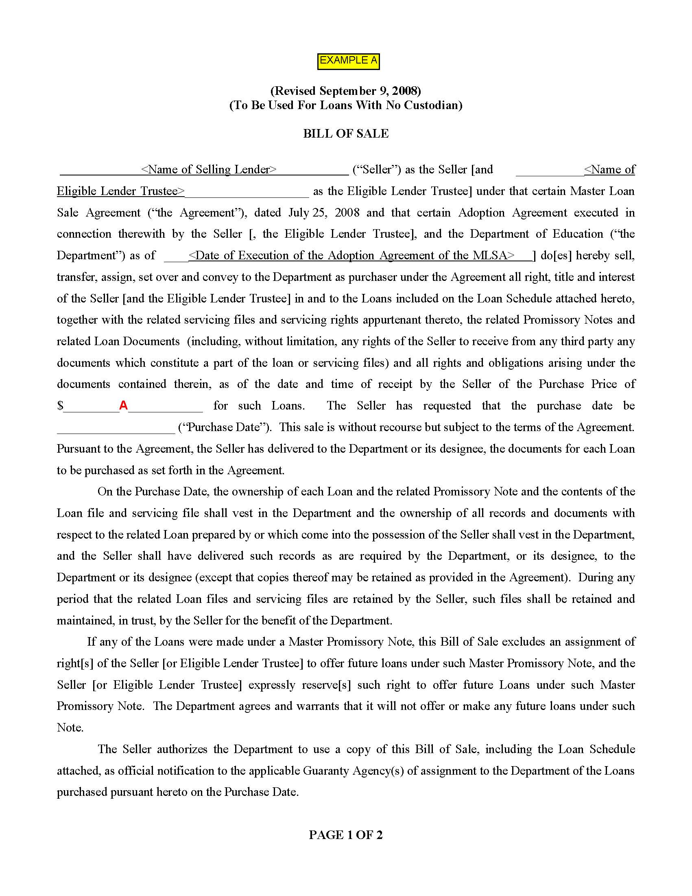
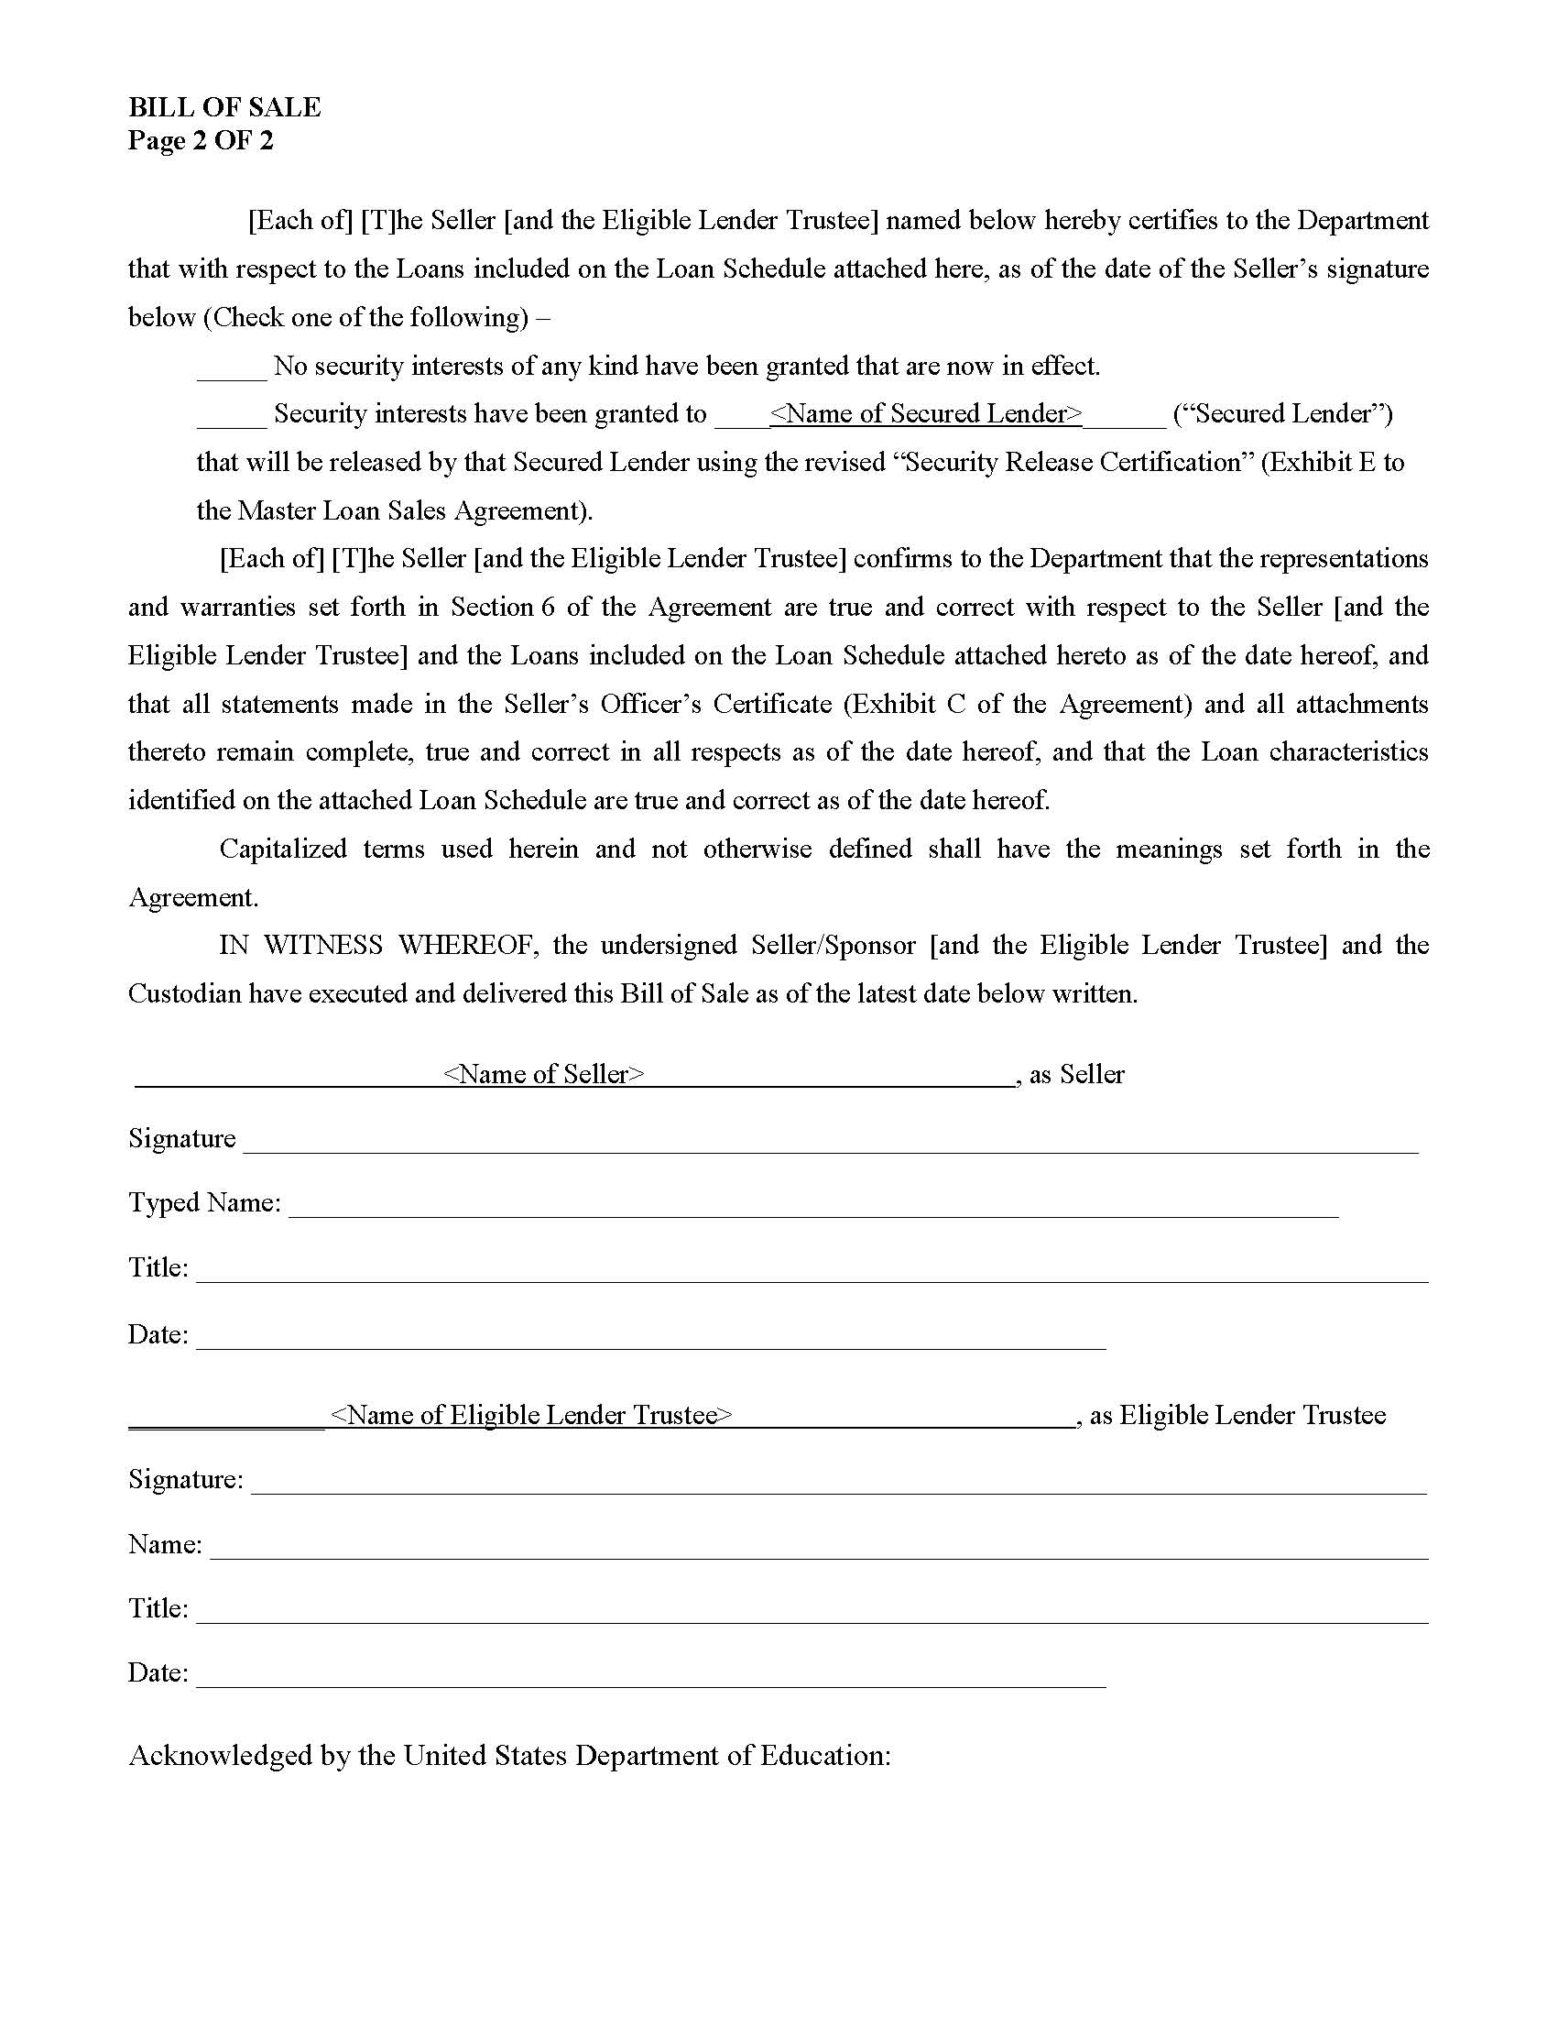
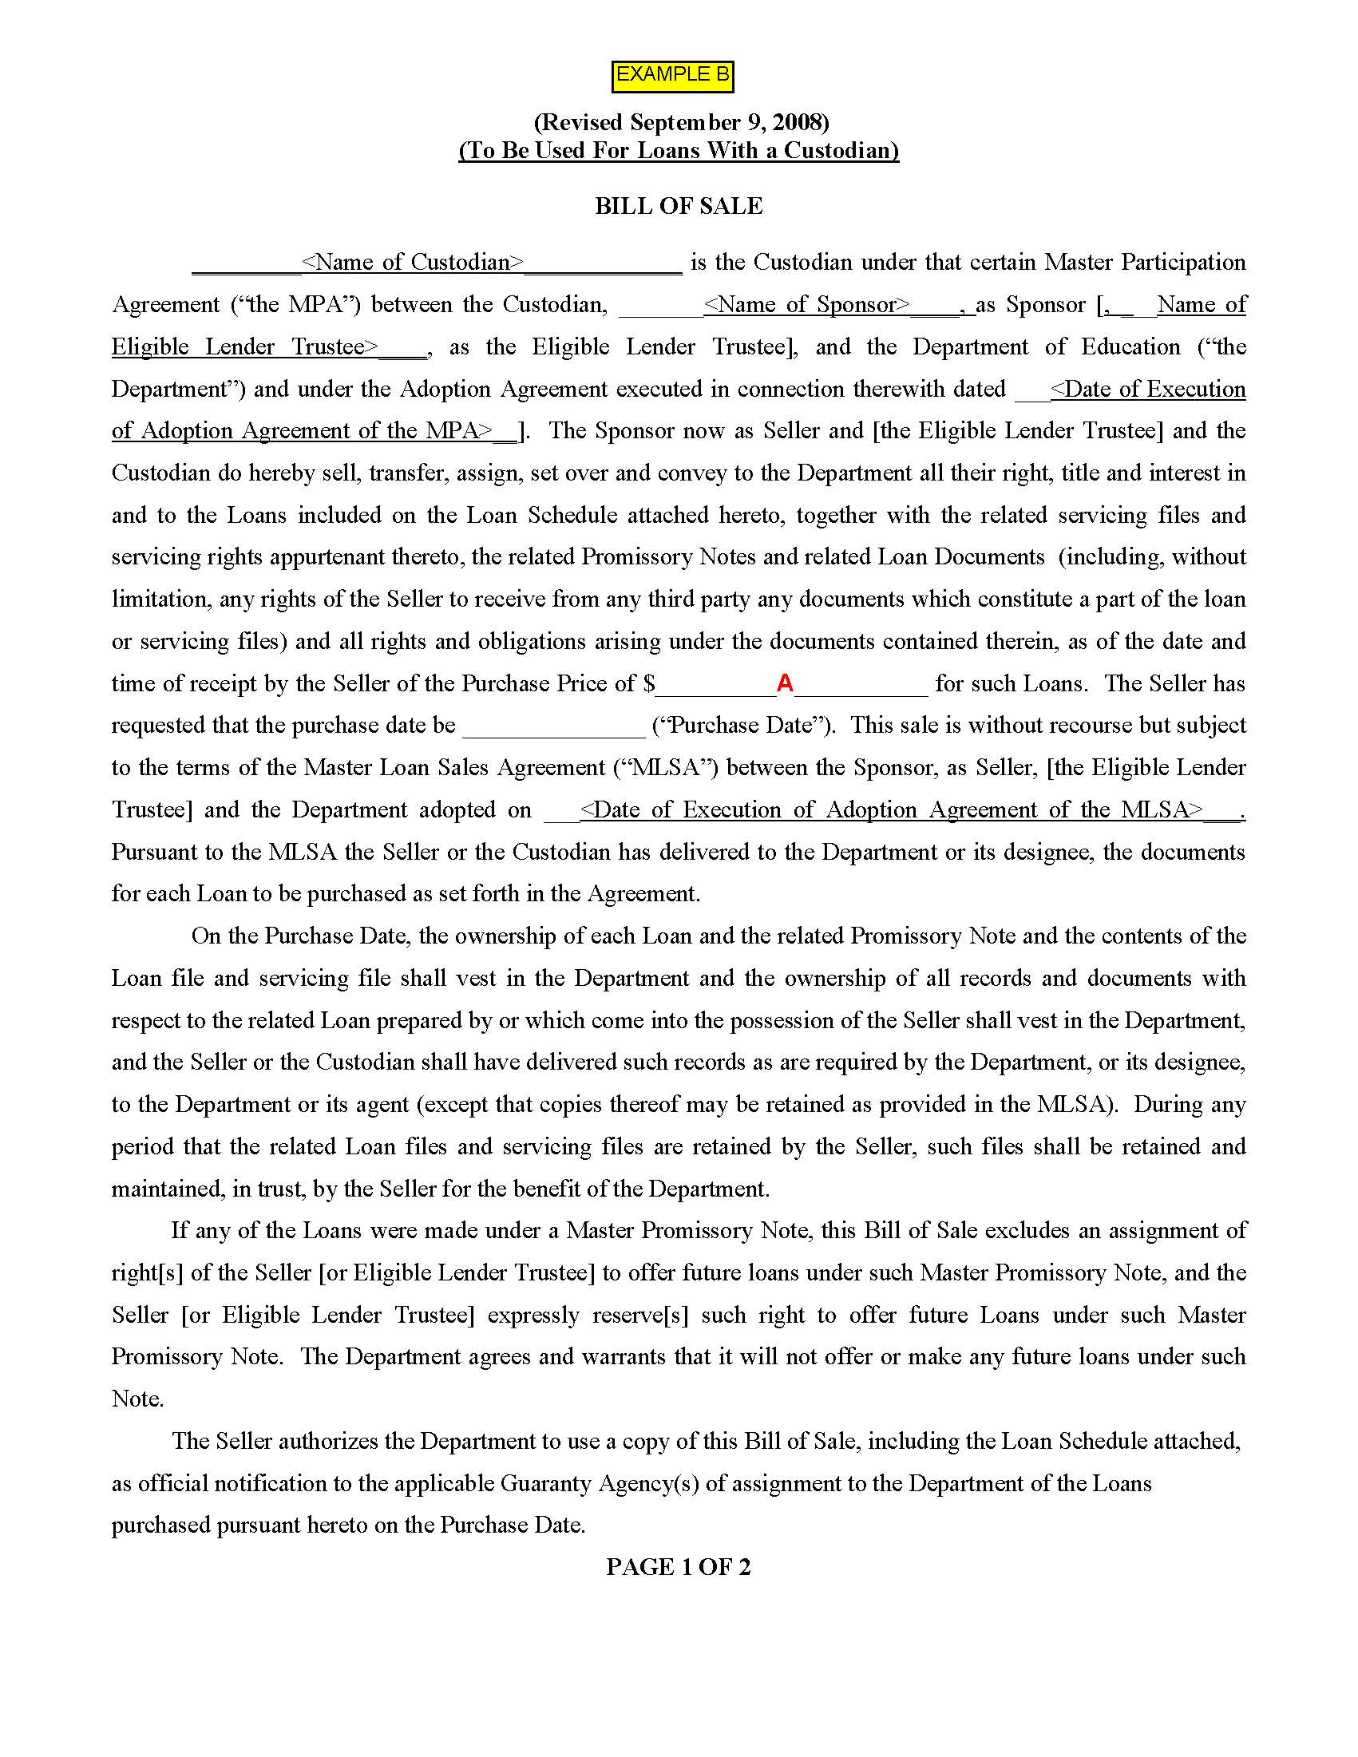
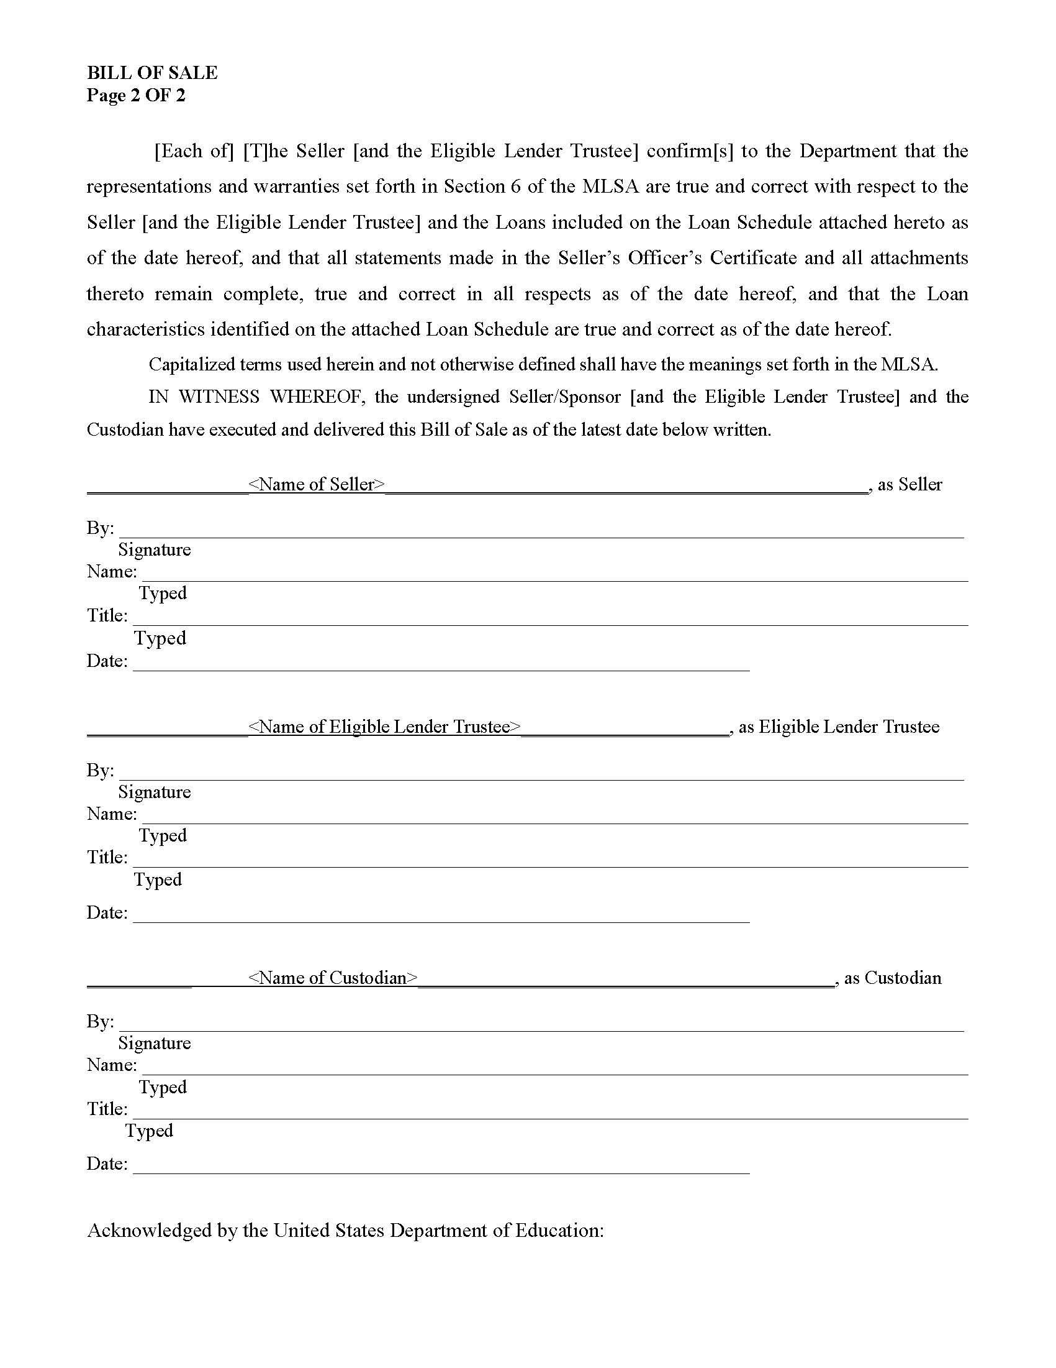
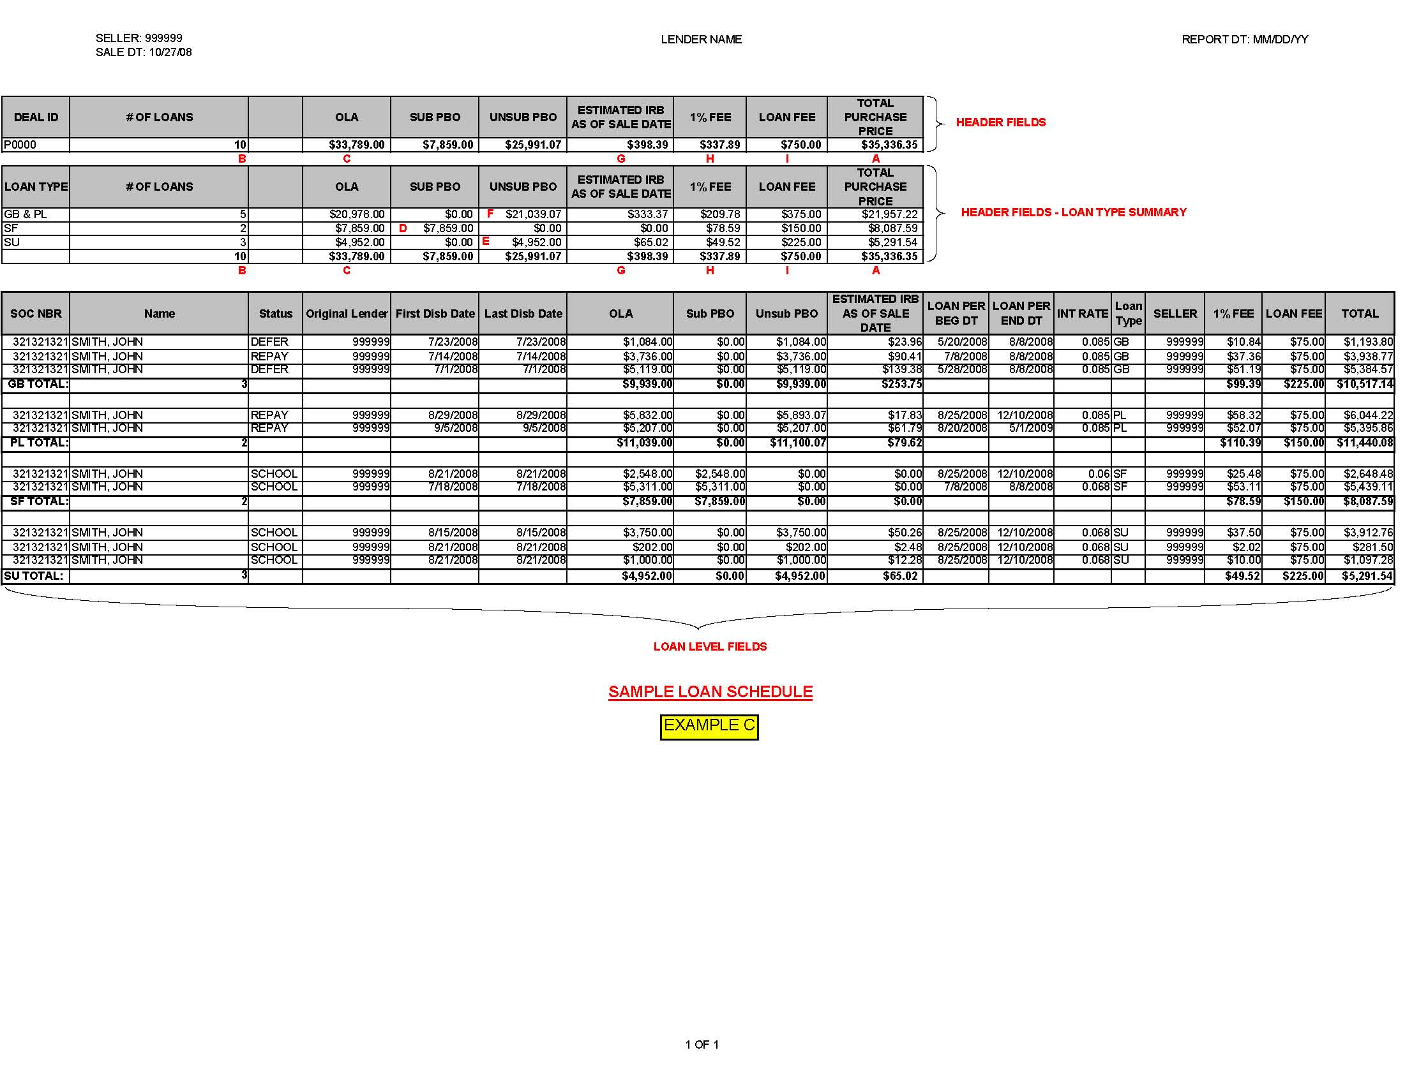
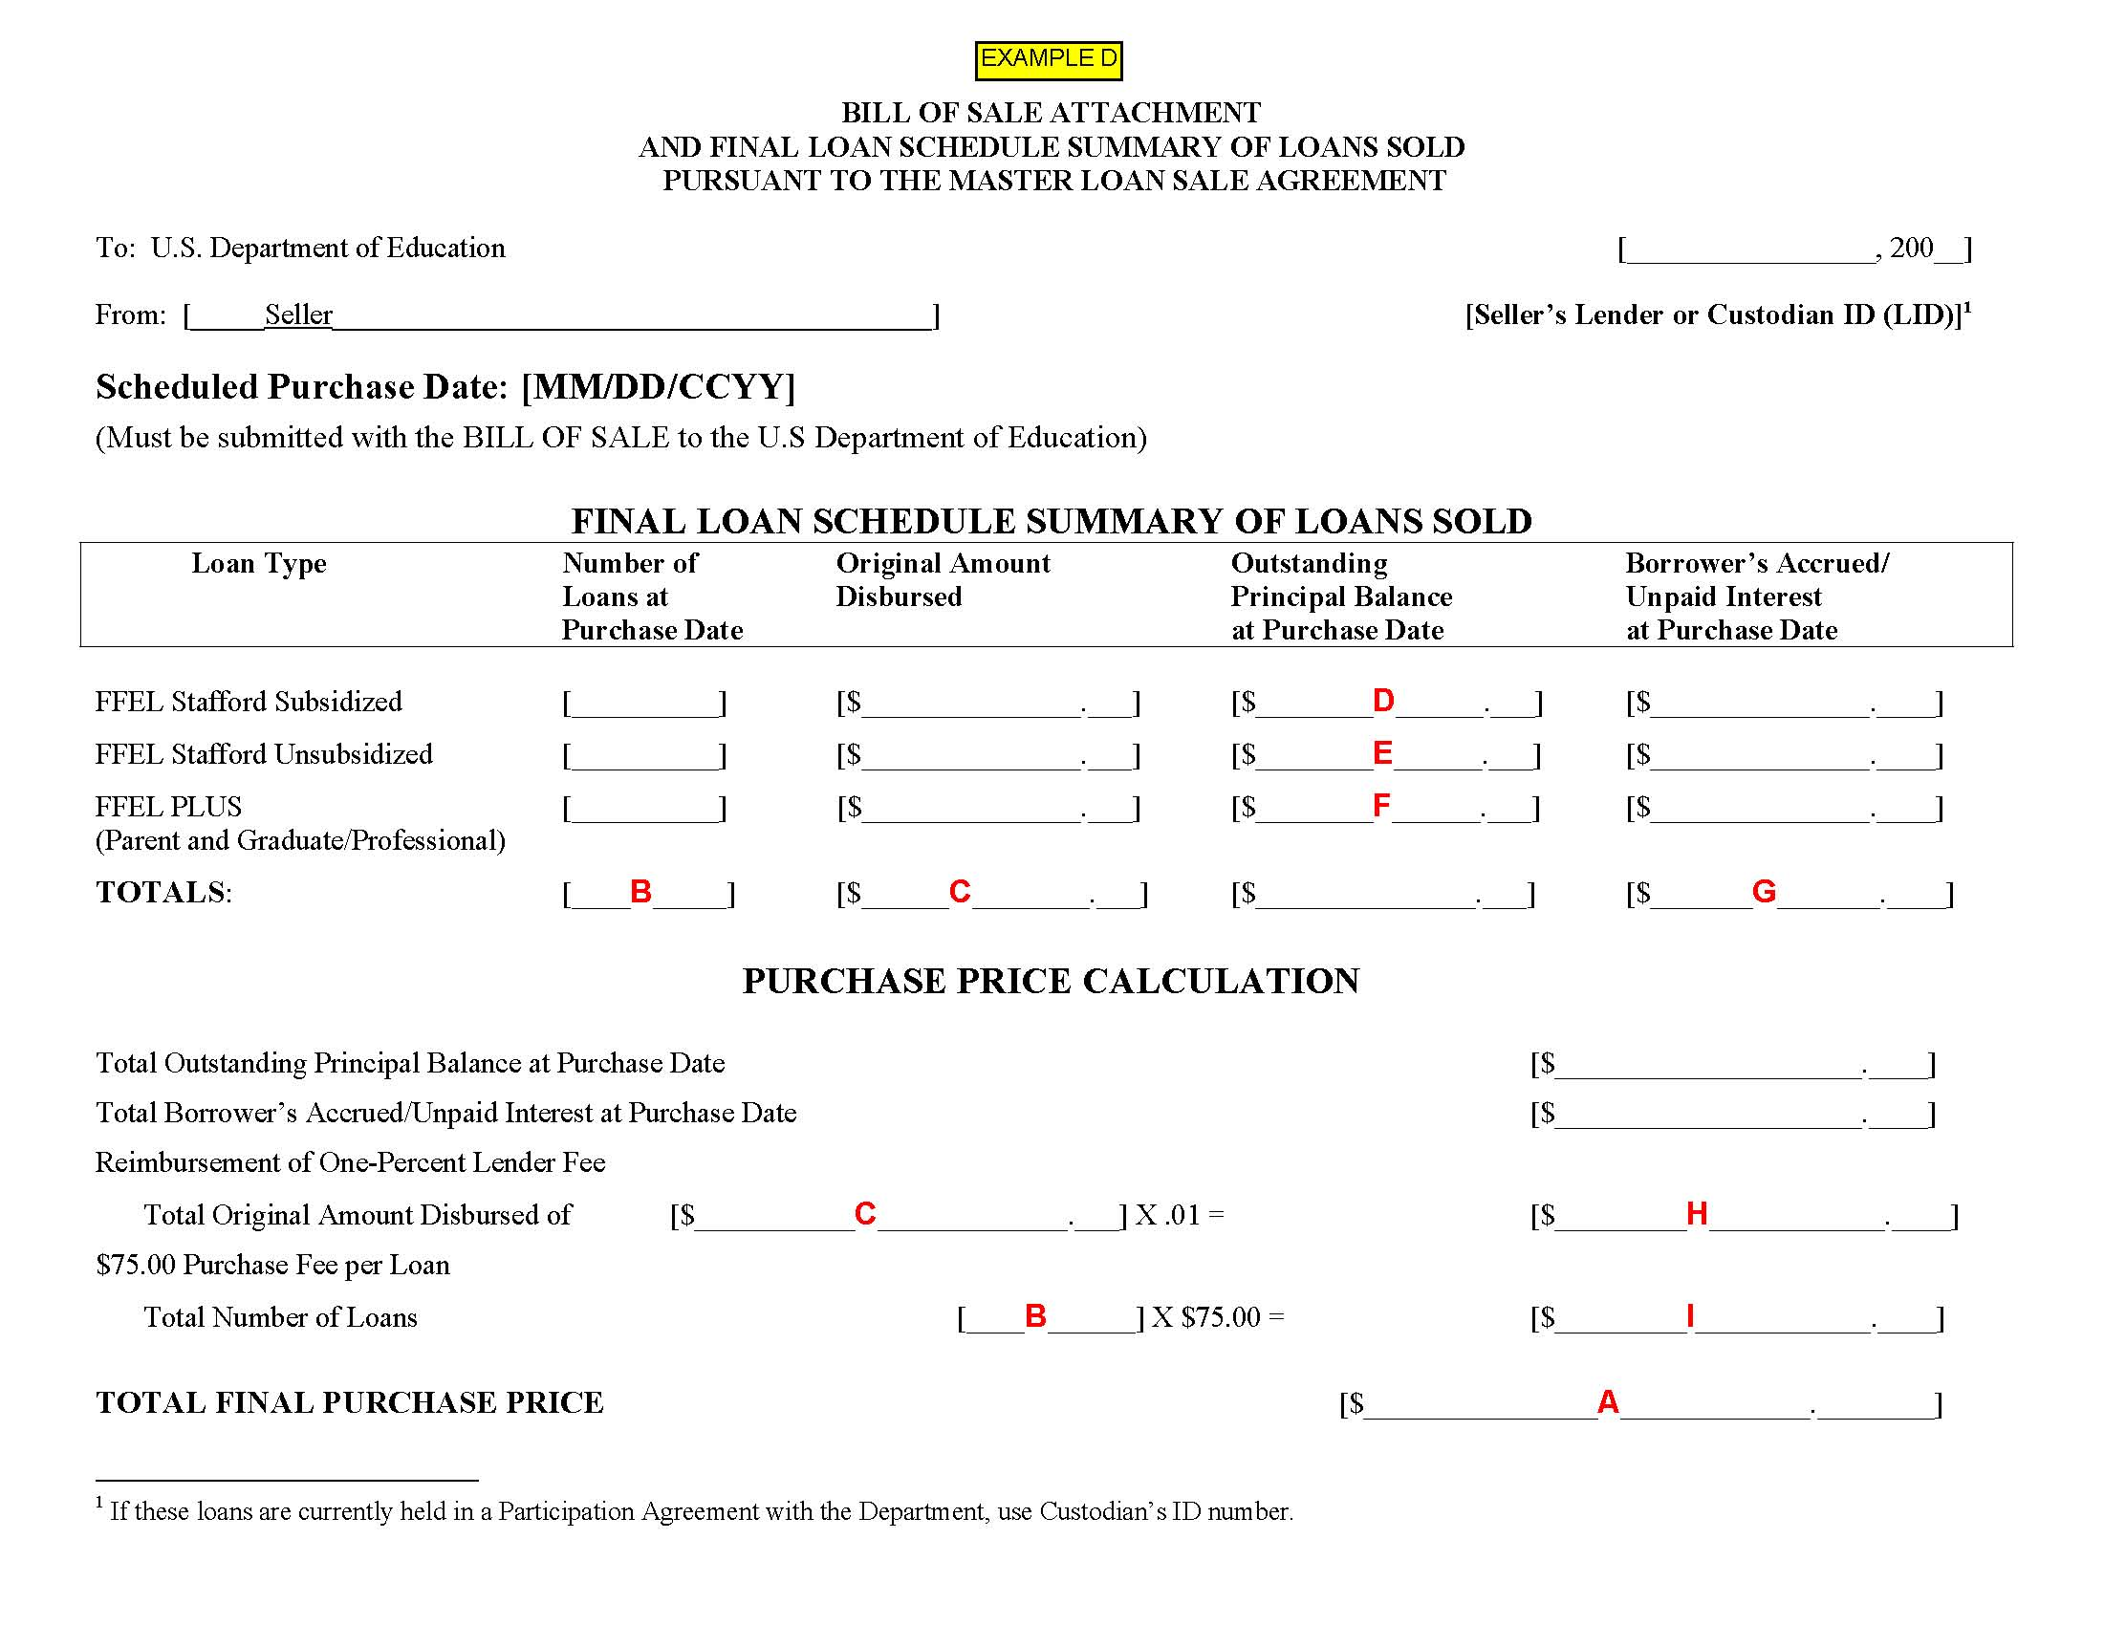

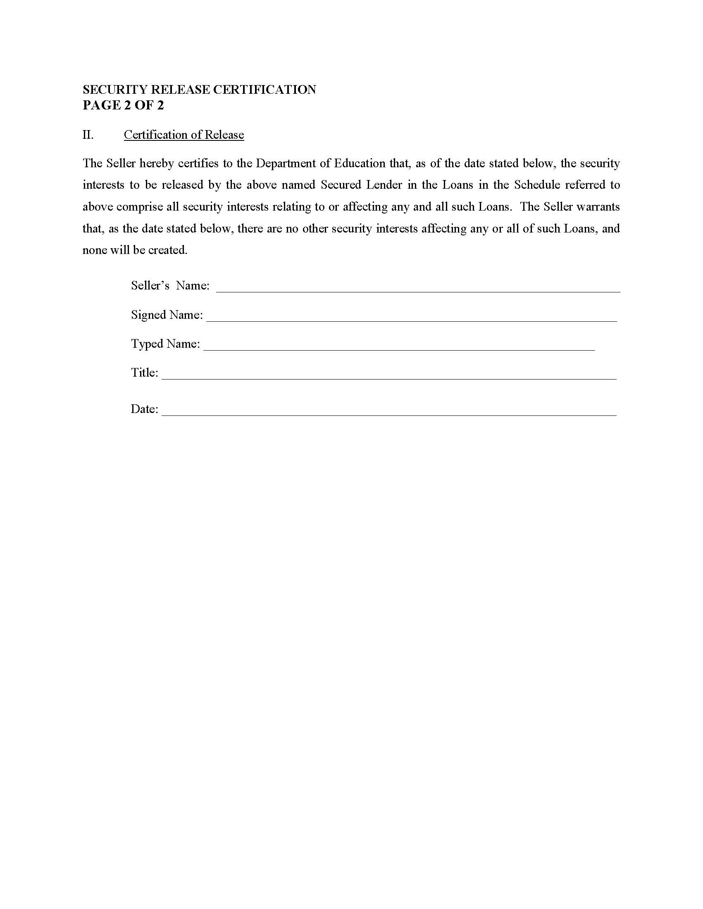

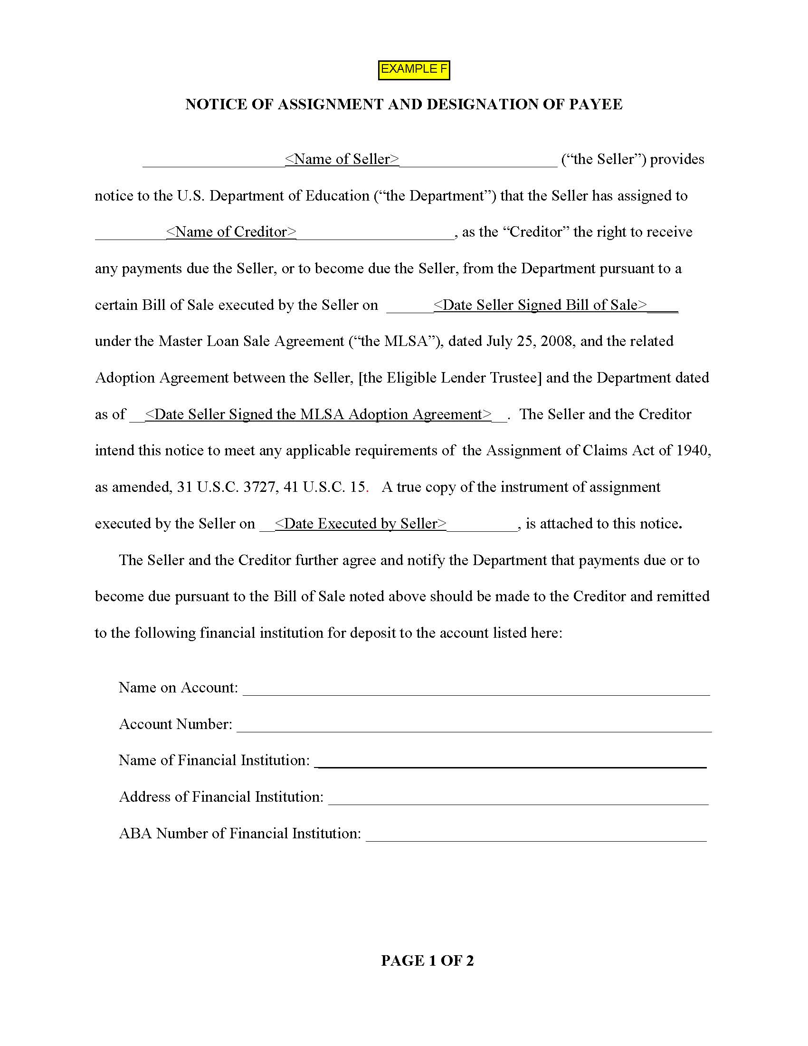

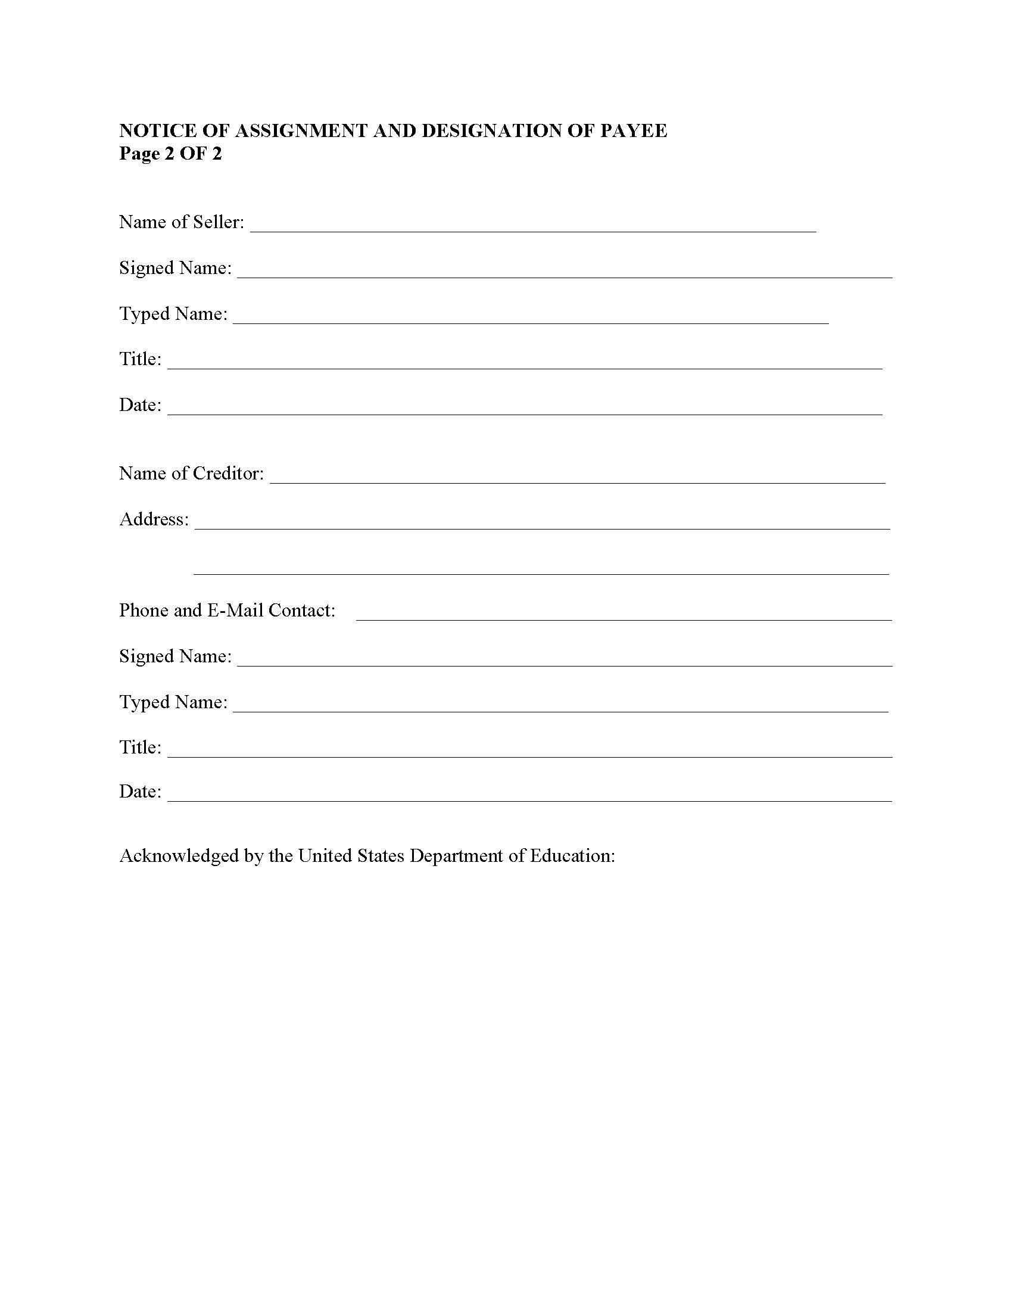

For purposes of this Guide, a PPR is consummated when the sponsor receives payment from ED for the purchase of the participation interests.
ED reserves the right to require more frequent AUP engagements as determined on a case-by-case basis, and will inform the sponsor if such right is exercised. In such cases the indicated frequencies and decision chart will not apply.
Months that immediately follow the previous AUP engagement period and in which no BOS are consummated are excluded from the determination of the three-month AUP engagement period.
ED reserves the right to require more frequent AUP engagements as determined on a case-by-case basis, and will inform the seller if such right is exercised. In such cases the indicated frequencies will not apply.
For purpose of this Guide, an “error” is a loan considered to be noncompliant with one or more of the specified eligibility requirements. The sample’s “error rate” is the number of errors divided by the sample size (i.e., 150).
For example: A record with a Data Flag of “N” contains a First Disbursement Date of September 1, 2008; this is a permissible First Disbursement Date for loans under the terms of the Loan Participation Program. The Sponsor then submits a record with a Data Flag of “U” for the same loan. The record with a Data Flag of “U” changes the loan’s First Disbursement Date to April 1, 2008. April 1, 2008 is not a permissible First Disbursement Date for an Eligible Loan under the terms of the Loan Participation Program.
The confirmation email from ED will note the date the NOI was received by ED. That date will establish the timeline for determining the eligibility of an otherwise eligible loan to be included in the Loan Participation Program. The Guide refers to this date as the sponsor’s and/or originating lender’s NOI date(s).
The Loan Documents or loan servicing system will indicate a loan’s status. Loan statuses include, but are not limited to, in repayment or in school.
A school must certify information that it provides in connection with a loan. 34 C.F.R. § 682.603(a) The school’s certification may be contained in the promissory note or in a separate document and may be a hardcopy or electronic record.
The Loan Period is the student’s enrollment period for which the loan is intended. 34 C.F.R. § 682.200
The Servicemembers Civil Relief Act establishes a maximum interest rate of 6% on debts incurred by a servicemember, or the servicemember and the servicemember’s spouse jointly, before the servicemember enters military service. In order for a debt of the servicemember to be subject to the 6% interest rate limitation, the servicemember shall provide to the lender a written notice and a copy of the military orders calling the servicemember to military service and any orders further extending military service. The effective date of the interest rate limitation is the date on which the servicemember is called to military service.
The information on the borrower’s loan will be contained in a loan servicing system maintained by the sponsor, servicer, custodian, or its designee.
Id.
Lenders are required to review the credit history of PLUS loan borrowers. Borrowers with an adverse credit history may obtain a PLUS Loan with an endorser who has been determined to not have an adverse credit history. 34 C.F.R. § 682.201(c)(1)(vii)
The loan eligibility requirements that are tested under the AUP engagement are specified in Chapter 3 §3.5 for the Loan Participation Program.
The ED Servicer is a contractor that processes the loan sale on behalf of ED and assumes the servicing of loans sold to ED.
Hypothecation is the pledging of property to secure a loan. The title of the property does not transfer, but the right to sell the property in case of default is transferred to the financing party.
In addition to the BOS package(s), after the sample of loans is selected, the practitioner is required to obtain from the ED Servicer copies of loan level documentation. The required loan level documentation is specified in §4.4(E) and (EE). The practitioner shall rely upon the information obtained from the ED Servicer and is not expected to perform on-site procedures at the ED Servicer.
Attachment 15 contains examples of a Loan Schedule, Final Loan Schedule Summary, and BOS. These examples indicate the location of Items A through I (from the table, above).
Id.
The confirmation email from ED will note the date the NOI was received by ED. That date will establish the timeline for determining the eligibility of an otherwise eligible loan to be included in the Loan Purchase Commitment Program. The Guide refers to this date as the sponsor’s and/or originating lender’s NOI date(s).
That is, for the sale of loans in which a participation interest has not been purchased by ED under the Loan Participation Program. (See Attachment 15, Exhibit A.)
Indicated on page 2 of the BOS.
Pursuant to the Security Release Certification (see Attachment 15, Example E), a secured lender is to release any right, title, and interest in a loan upon its receipt of payment. The secured lender may receive payment either (1) from the seller or (2) from ED if the seller submits a Notice of Assignment and Designation of Payee (see Attachment 15, Example F) as part of the BOS package.
Under the MLSA, the custodian is an entity specified by ED to whom the Promissory Notes and other Loan Documents are to be delivered in connection with all loan purchases.
Contact information for the ED Servicer is detailed in §4.2(A).
A school must certify information that it provides in connection with a loan. 34 C.F.R. § 682.603(a) The school’s certification may be contained in the promissory note or in a separate document and may be a hardcopy or electronic record.
As used in Chapter 4, Loan Documentation consists of the (i) Loan Documents obtained from the ED Servicer and (ii) hardcopy or electronic records obtained from the seller or the seller’s servicer.
If, in response to query specified at §4.4(U), the seller states that they do not provide borrower benefits, the loans in the sample should not be subject to the reduction in interest rates of not more than 0.25% (contingent on the use of an automatic payment process).
The Servicemembers Civil Relief Act establishes a maximum interest rate of 6% on debts incurred by a servicemember, or the servicemember and the servicemember’s spouse jointly, before the servicemember enters military service. In order for a debt of the servicemember to be subject to the 6% interest rate limitation, the servicemember shall provide to the lender a written notice and a copy of the military orders calling the servicemember to military service and any orders further extending military service. The effective date of the interest rate limitation is the date on which the servicemember is called to military service.
The information on the borrower’s loan will be contained in a loan servicing system maintained by the seller or the seller’s servicer.
Id.
Id.
Id.
Id.
Id.
Lenders are required to review the credit history of each PLUS loan borrower and, if applicable, endorser. Borrowers with an adverse credit history may obtain a PLUS Loan with an endorser who has been determined to not have an adverse credit history. 34 C.F.R. § 682.201(c)(1)(vii)
In general, borrower benefits include, but are not limited to, fee reductions, interest rate reductions, repayment options, or other benefits provided to borrowers by the lender. The MLSA’s Section 3(F) specifies the eligible borrower benefits for loans sold to ED under the Loan Purchase Commitment Program. In general, an “unconditional upfront fee reduction” is a borrower benefit that is neither received nor retained based on the borrower’s behavior in repayment.
This evidence must be included in the attestation documentation for the engagement.
Id.
Id.
Pursuant to MLSA Section 8(A), within two business days following the receipt of a payment, the seller shall remit to ED any such payment along with a listing identifying the loans, the payment amount, and the date each payment was received.
This is indicated by a BOS Package that (1) includes a BOS for loans without a custodian and (2) does not include a Security Release Certification. (See Attachment 15, Examples A and E.)
This evidence must be included in the attestation documentation for the engagement.
Complete details about exemplary affidavits and supporting materials pertaining to electronically signed promissory notes are specified in ED’s Electronic Announcement #34, dated October 31, 2008. The exemplary affidavit and supporting materials may cover multiple loan sales if the process described in the affidavit and supporting materials are reliably associated with specific cohorts of loans that were sold to ED. The exemplary affidavit and supporting materials must be submitted to the ED Servicer no later than November 30, 2009.
This evidence must be included in the attestation documentation for the engagement.
Contact information for the ED Servicer is detailed in §4.2(A).
This evidence must be included in the attest documentation for the engagement.
The loan eligibility requirements that are tested under the AUP engagement are specified in Chapter 4 §4.4 for the Loan Purchase Commitment Program.
Identify noncompliance with loan eligibility requirements for each loan by placing an “X” in the applicable column.
Identify noncompliance with loan eligibility requirements for each loan by placing an “X” in the applicable column.

