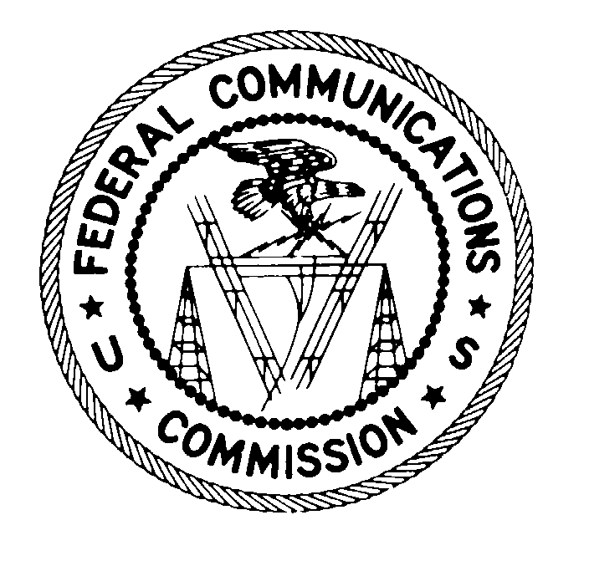 February 26, 2009
FEDERAL COMMUNICATIONS COMMISSION
WASHINGTON, D.C. 20554

VIA CERTIFIED MAIL - RETURN RECEIPT REQUESTED

Mr. Thomas Allen Webb, CEO
TAW Global, LLC
8135 Cox’s Drive, Suite 211
Portage, MI 49002
Re: File No. EB-08-SE-533

Dear Mr. Webb:

This is an official CITATION, issued pursuant to Section 503(b)(5) of the Communications Act of 1934, as amended (“Act”), for marketing a non-compliant and unlabeled radio frequency device in the United States in violation of Section 302(b) of the Act, and Sections 2.803(a), 2.925(a) and 15.239(b) of the Commission’s Rules (“Rules”). As explained below, future violations of the Commission’s rules in this regard may subject TAW Global, LLC (“TAW”) to monetary forfeitures.

By letter of inquiry (“LOI”) dated September 29, 2008, the Spectrum Enforcement Division of the Commission’s Enforcement Bureau initiated an investigation into whether TAW has been marketing an unauthorized and non-compliant radio frequency device in the United States, namely the Whole House (WH) FM Transmitter. In its response to the LOI, TAW stated that it began importing the WH FM Transmitter in May 2004. TAW further stated that it has imported a total of 18,371 units, and that it has distributed and sold in the United States a total of 11,689 units through its website. TAW also stated that the WH FM Transmitter is manufactured by Richfield Electronics Limited (“Richfield”), based in China, and that it is certified. According to TAW, it exercised “due diligence” by receiving verbal assurances and documentation from Richfield “verifying that the FM Transmitter does indeed meet FCC equipment authorization standards and has a proper ID.” TAW acknowledged that the WH FM Transmitter was not properly labeled with the FCC ID, as required by Section 2.925 of the Rules.

Section 302(b) of the Act provides that “[n]o person shall manufacture, import, sell, offer for sale, or ship devices or home electronic equipment and systems, or use devices, which fail to comply with regulations promulgated pursuant to this section.”
Section 2.803(a)(1) of the Commission’s implementing regulations provides that:
[N]o person shall sell or lease, or offer for sale or lease (including advertising for sale or lease), or import, ship, or distribute for the purpose of selling or leasing or offering for sale or lease, any radio frequency device unless … [i]n the case of a device subject to certification, such device has been authorized by the Commission in accordance with the rules in this chapter and is properly identified and labeled as required by § 2.925 and other relevant sections in this chapter.

Under Section 15.201(b) of the Rules, intentional radiators, such as the WH FM Transmitter, must be authorized in accordance with the Commission’s certification procedures before marketing is initiated in the Unites States. Commission records reflect that Richfield obtained an equipment certification for a FM Transmitter on November 5, 2002. Under Section 15.239(a) of the Rules, emissions from intentional radiators that operate within the 88-108 MHz band must be “confined within a band 200 kHz wide … and lie wholly within the frequency range of 88-108 MHz.” Further, under Section 15.239(b) of the Rules, the field strength of any such emission shall not exceed 250 microvolts per meter at 3 meters. According to tests conducted by the Commission’s Office of Engineering and Technology Laboratory (“OET”), the emissions of the WH FM Transmitter exceeded the authorized level under Section 15.239(b) of the Rules. Finally, Section 2.925(a) of the Rules requires that intentional radiators be properly labeled.

It thus appears that TAW has violated Section 302(b) of the Act and Sections 2.803, 2.925(a) and 15.239(b) of the Rules by marketing a non-compliant and unlabeled radio frequency device in the United States.
If, after receipt of this citation, TAW violates the Communications Act or the Commission’s rules in any manner described herein, the Commission may impose monetary forfeitures not to exceed $16,000 for each such violation or each day of a continuing violation.

TAW may respond to this citation within 30 days from the date of this letter either through (1) a personal interview at the Commission’s Field Office nearest to your place of business, or (2) a written statement. TAW’s response should specify the actions that it is taking to ensure that it does not violate the Commission’s rules governing the marketing of radio frequency equipment in the future.

The nearest Commission field office appears to be the Chicago District Office, in Chicago, Illinois. Please call Ava Holly Berland at 202-418-2075 if TAW wishes to schedule a personal interview. TAW should schedule any interview to take place within 30 days of the date of this letter. TAW should send any written statement within 30 days of the date of this letter to:

Ava Holly Berland
Spectrum Enforcement Division
Enforcement Bureau
Re: EB-08-SE-533
Federal Communications Commission
445 12th Street, S.W., Rm. 3-A432
Washington, D.C. 20554

Under the Privacy Act of 1974, 5 U.S.C. § 552(a)(e)(3), we are informing TAW that the Commission’s staff will use all relevant material information before it, including information that TAW discloses in its interview or written statement, to determine what, if any, enforcement action is required to ensure TAW’s compliance with the Communications Act and the Commission’s rules.

The knowing and willful making of any false statement, or the concealment of any material fact, in reply to this citation is punishable by fine or imprisonment under 18 U.S.C. § 1001.

We thank TAW in advance for its anticipated cooperation.

Sincerely,

Kathryn Berthot
Chief, Spectrum Enforcement Division
Enforcement Bureau
Federal Communications Commission

47 U.S.C. § 503(b)(5).
47 C.F.R. §§ 2.803(a), 2.925(a) and 15.239(b).
See Letter from Kathryn S. Berthot, Chief, Spectrum Enforcement Division, Enforcement Bureau, Federal Communications Commission, to Thomas A. Webb, TAW Global, Inc. (September 29, 2008).
See Letter from Thomas Allen Webb, TAW Global, LLC to Kathryn S. Berthot, Chief, Spectrum Enforcement Division, Enforcement Bureau, Federal Communications Commission (October 29, 2008). (“LOI Response”).
See LOI Response at 1.
See id.
See id. at 2; see also FCC ID QKQRF-2001.
Id. at 1-2.
47 C.F.R. § 15.201(b)
Section 15.3(o) of the Rules defines an “intentional radiator” as a “device that intentionally generates and emits radio frequency energy by radiation or induction.” 47 C.F.R. § 15.3(o).
Section 2.803(e)(4) of the Rules defines “marketing” as the “sale or lease, or offering to sale or lease, including advertising for sale or lease, or importation, shipment or distribution for the purpose of selling or leasing or offering for sale or lease.” 47 C.F.R. § 2.803(e)(4).
47 C.F.R. § 15.239(a).
47 C.F.R. § 15.239(b).
See 47 C.F.R. § 1.80(b)(3).

