FEDERAL COMMUNICATIONS COMMISSION
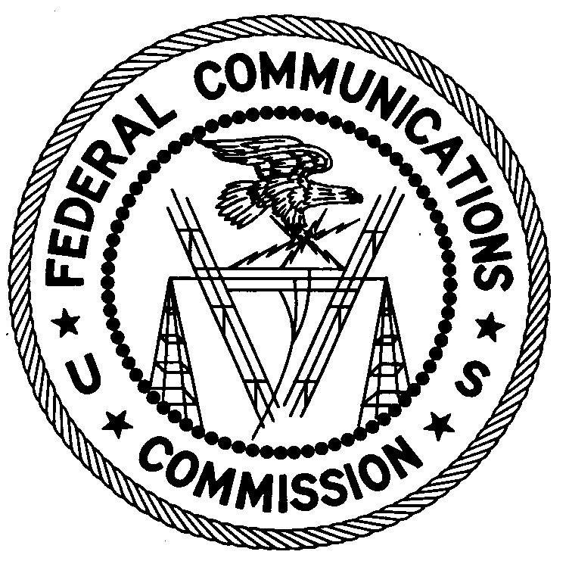
ENFORCEMENT BUREAU
SOUTH CENTRAL REGION

Miami Office
P.O. Box 5206517

Miami, FL 33152

March 2, 2009

Aaron Streeter
Miami, FL

NOTICE OF UNLICENSED OPERATION

Case Number: EB-09-MA-0036

Document Number: W200932600037

On February 26, 2009, the Miami Office received a complaint from the Miami-Dade Fire and Rescue Department that it was receiving interference from an unlicensed radio station on 92.1 MHz in Miami, FL. On February 26, 2009, in response to a complaint of interference to the Miami-Dad Fire and Rescue Department, agents from the Miami Office confirmed by direction finding techniques that radio signals on 92.1 MHz were emanating from an antenna mounted to a residence located on N.W. 95th St., Miami, FL. You admitted to the agents that you were operating an unlicensed radio station on 92.1 MHz from this location. The Commission’s records show that no license was issued for operation of a broadcast station on 92.1 MHz at this location in Miami, FL.

Radio stations must be licensed by the FCC pursuant to 47 U.S.C. § 301. The only exception to this licensing requirement is for certain transmitters using or operating at a power level or mode of operation that complies with the standards established in Part 15 of the Commission’s rules, 47 C.F.R. §§ 15.1 et seq. The field strength of the signal on frequency 92.1 MHz was measured at 204,391 microvolts per meter (µV/m) at 116 meters, which exceeded the maximum permitted level of 250 µV/m at 3 meters for non-licensed devices. Thus, this station is operating in violation of 47 U.S.C. § 301.

You are hereby warned that operation of radio transmitting equipment without a valid radio station authorization constitutes a violation of the Federal laws cited above and could subject the operator to severe penalties, including, but not limited to, substantial monetary fines, in rem arrest action against the offending radio equipment, and criminal sanctions including imprisonment. (see 47 U.S.C. §§ 401, 501, 503 and 510).

UNLICENSED OPERATION OF THIS RADIO STATION MUST BE DISCONTINUED IMMEDIATELY.

You have ten (10) days from the date of this notice to respond with any evidence that you have authority to operate granted by the FCC. Your response should be sent to the address in the letterhead and reference the listed case and document number. Under the Privacy Act of 1974, 5 U.S.C. § 552a(e)(3), we are informing you that the Commission’s staff will use all relevant material information before it to determine what, if any, enforcement action is required to ensure your compliance with FCC Rules. This will include any information that you disclose in your reply.

You may contact this office if you have any questions.

Michael Mattern
Resident Agent
Miami Office

Attachments:
Excerpts from the Communications Act of 1934, As Amended
Enforcement Bureau, "Inspection Fact Sheet", March 2005

