
FAFSA Free Application for Federal Student Aid

Section 1: Student Demographics
Q1. Student’s Full Name
Q2. Student’s Permanent Address
Q3. Student’s Telephone Number | Q4. Student’s State of Legal Residence  
Q5. Student’s Email Address
Q6. Student’s Social Security Number |  |  | Q7. Student’s Date of Birth  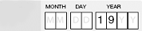

Section 2: Student Eligibility
Q8a. Student’s Citizenship Status  - I am a U.S. Citizen (US natural)  - I am an eligible non-citizen  - I am not a U.S citizen or an eligible non-citizen |  | Q8b. Student’s Alien Registration Number  
Q9. Are you male or female? Most male students must be registered with Selective Service to get federal aid. If you Male ___ Female ___ are male, age 18-25 and not registered, check the box and we will register you.
Register Me ________

Q10. Have you ever been convicted for the possession or sale of illegal drugs for an offense that occurred while you were receiving federal student aid?
Q11. Student’s High School Completion Status |  |  | Q12. Student’s Enrollment Status

Section 3: Student Dependency Status
Q13.Were you born before January 1, 1986?
Q14 As of today, are you married? (Answer “Yes” if you are separated but not divorced.)
Q15 At the beginning of the 2009–2010 school year, will you be working on a master’s or doctorate program (such as an MA, MBA, MD, JD, PhD, EdD, or graduate certificate, etc.)?
Q16 Are you a veteran of the United States Armed Forces or are you currently serving on active duty in the U.S. Armed Forces for purposes other than training?
Q17 Do you have children or other dependents (other than your spouse) who live with you and who receive more than half of their support from you, now and through June 30, 2010?
If you (the student) answered “No” to every question in this section, go to Section 4.
If you answered “Yes” to any question in this section, skip Section 4 and go to Section 5.

Section 4: Parent Demographics - Complete if you (the student) answered “No” to every question in Section 2.
Q18 Mother’s Full Name
Q19 Mother’s Social Security Number | Q20 Mother’s Date of Birth
Q21 Father’s Full Name
Q22 Father’s Social Security Number | Q23 Father’s Date of Birth
Section 5: Income Information – From 2008 IRS Tax Return
If you (the student) answered “No” to EVERY question in Section 2, questions refer to your parent(s).
If you (the student) answered “Yes” to ANY question in Section 2, questions refer to you (and your spouse).
Q24 IRS tax filing status?
(Tax filing status from IRS Form 1040, 1040A, 1040EZ — Boxes 1 through 5)
Q25 Adjusted Gross Income for 2008?
(Adjusted Gross Income on IRS Form 1040—line 37; 1040A—line 21; or 1040EZ—line 4)
Q26 Number of IRS Exemptions.
(Exemptions on IRS Form 1040 Line 6d or on Form 1040A—Line 6d)
Q27 Total amount of excludable income?
(Excludable income is need based student work, federal work study, grants and scholarships)

Section 6: Colleges to Receive the Results of Your FAFSA Application
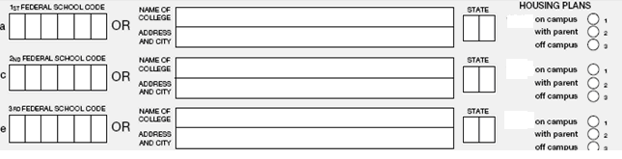

Section 7: Student and Parent Signature Statement
