^{Chapter} 9 Special Considerations:
Policies Regarding Sex Offenses and Offenders

What are the Clery Act requirements regarding policies and procedures for sex offenses? As mentioned in Chapter 8, the Clery Act requires you to provide policy statements regarding sex offenses and obtaining access to information regarding registered sex offenders in the campus community.

Sex Offenses

The FBI’s National Incident-Based Reporting System (NIBRS) edition of the UCR defines a sex offense in general as any sexual act directed against another person, forcibly and/or against that person’s will; or not forcibly or against the person’s will where the victim is incapable of giving consent. (See Chapter 3 for definitions of forcible and non-forcible sex offenses.)

The Clery Act requires you to include a statement about your institution’s sex offense policy, procedures and programs in your annual security report. [Sex offense policy statement cite 34 CFR 668.46(b)(11)] Specifically, the regulation requires a statement of policy regarding the institution’s campus sexual assault programs to prevent sex offenses, and procedures to follow when a sex offense occurs. The statement must include:

- A description of educational programs to promote the awareness of rape, acquaintance rape and other forcible and non-forcible sex offenses. [34 CFR 668.46(b)(11)(i)]
These programs are required by Section 485(f) of the Higher Education Act. We encourage your institution to contract with experts in the area of sex offense education to provide training to students and staff. Such experts include rape crisis intervention specialists, local law enforcement officials and social services personnel.

- Procedures students should follow if a sex offense occurs, including: [34 CFR 668.46(b)(11)(ii)]
- Procedures concerning who should be contacted;
- The importance of preserving evidence for the proof of a criminal offense; and
- To whom the alleged offense should be reported.
Note that the Clery Act does not mandate whom to contact or to whom the offense should be reported. It requires only that your institution include this information in the procedures. Be specific with regard to this information. For example, if students are directed to a rape crisis counselor for support and the campus police department for reporting purposes, provide contact information. We encourage institutions to consult law enforcement about what constitutes “preserving evidence.”
- Information on a student’s option to notify appropriate law enforcement authorities, including: [34 CFR 668.46(b)(11)(iii)]
- On-campus and local police; and
- A statement that institutional personnel will assist the student in notifying these authorities, if the student requests the assistance of these personnel.
Provide information so that students know what notifying law enforcement authorities entails. Be specific about both campus and local police, as applicable. The statement that your institution will comply with a student’s request for assistance in notifying authorities is mandatory.
- Notification to students of existing on- and off-campus counseling, mental health or other student services for victims of sex offenses. [34 CFR 668.46(b)(11)(iv)]
Your statement should provide specific information identifying the appropriate available services for victims. Be sure to include both on- and off-campus services, as applicable. If there are no on-campus services or no off-campus services, state this.
- Notification to students that the institution will change a victim’s academic and living situations after an alleged sex offense, and the options for those changes if those changes are requested by the victim and are reasonably available. [34 CFR 668.46(b)(11)(v)]
An institution is obligated to comply with a student’s request for a living and/or academic situation change following an alleged sex offense. The options should be identified.
These requirements allow an institution flexibility. For example, an institution could permit a victim to break a housing contract with the institution so that the student may seek off campus housing. But, it would not be reasonable to expect the institution to pay for the rental of a private apartment for the student.
- Procedures for campus disciplinary action in cases of an alleged sex offense, including a clear statement that: [34 CFR 668.46 (b)(11)(vi)(A)&(B)]
i. The accuser and the accused are entitled to the same opportunities to have others present during a disciplinary proceeding; and
ii. Both the accuser and the accused must be informed of the outcome of any institutional disciplinary proceeding that is brought alleging a sex offense. Compliance with this paragraph does not constitute a violation of the Family Educational Rights and Privacy Act (FERPA). For the purpose of this paragraph, the outcome of a disciplinary proceeding means only the institution’s final determination with respect to the alleged sex offense and any sanction that is imposed against the accused.
Your statement regarding procedures for campus disciplinary action for alleged sex offenses must include both (i) and (ii). Add any other procedures as appropriate for your institution. The right to have others present and to be informed of the outcome apply to the institutional disciplinary proceedings, regardless of where the alleged sex offense occurred. Disclosure concerning the outcome of proceedings must be unconditional; a victim cannot be required to sign a nondisclosure agreement or to otherwise agree to a prohibition from discussing the case.
- Sanctions the institution may impose following a final determination of an institutional disciplinary proceeding regarding rape, acquaintance rape or other forcible or non-forcible sex offenses. [34 CFR 668.46(b)(11)(viii)]
Note that this does not require you simply to state that sanctions may be imposed. You are required to list the sanctions.
It is very important that you understand that:

- Simply stating the topic of a policy does not meet the requirements. All of the required components of a policy must be included in the policy statement.
- For the most part, institutions have discretion in the wording of these statements and how the policies and procedures are put into practice.
- It is imperative that an institution’s policy statements accurately reflect what the institution does currently to prevent sex offenses, and the procedures that are followed when a sex offense occurs.

Sample Policy Statement Addressing Sex Offenses

Sexual Assault Prevention and Response
The University educates the student community about sexual assaults and date rape through mandatory freshman orientations each fall. The Police Department offers sexual assault education and information programs to University students and employees upon request. Literature on date rape education, risk reduction, and University response is available through the Office of Housing and Residential Education.
If you are a victim of a sexual assault at this institution, your first priority should be to get to a place of safety. You should then obtain necessary medical treatment. The University Police Department strongly advocates that a victim of sexual assault report the incident in a timely manner. Time is a critical factor for evidence collection and preservation. An assault should be reported directly to a University officer and/or to a Housing and Residential Education representative. Filing a police report with a University officer will not obligate the victim to prosecute, nor will it subject the victim to scrutiny or judgmental opinions from officers. Filing a police report will
› ensure that a victim of sexual assault receives the necessary medical treatment and tests, at no expense to the victim
› provide the opportunity for collection of evidence helpful in prosecution, which cannot be obtained later (ideally a victim of sexual assault should not wash, douche, use the toilet, or change clothing prior to a medical/legal exam)
› assure the victim has access to free confidential counseling from counselors specifically trained in the area of sexual assault crisis intervention.
When a sexual assault victim contacts the Police Department, the Metro Police Sex Crimes Unit will be notified as well. A representative from the Office of Housing and Residential Education will also be notified. The victim of a sexual assault may choose for the investigation to be pursued through the criminal justice system and the University Conduct Council, or only the latter. A University representative from the Police Department or the Office of Housing and Residential Education will guide the victim through the available options and support the victim in his or her decision. Various counseling options are available from the University through the Student Health Center, the Women’s Center, University Ministries, Employee Assistance, and the Psychological and Counseling Center. Counseling and support services outside the University system can be obtained through the Rape and Sexual Abuse Center and the Victim Intervention Program of the Metro Police Department.
University disciplinary proceedings, as well as special guidelines for cases involving sexual misconduct, are detailed in the Student Handbook. The Handbook provides, in part, that the accused and the victim will each be allowed to choose one person who has had no formal legal training to accompany them throughout the hearing. Both the victim and accused will be informed of the outcome of the hearing. A student found guilty of violating the University sexual misconduct policy could be criminally prosecuted in the state courts and may be suspended or expelled from the University for the first offense. Student victims have the option to change their academic and/or on-campus living situations after an alleged sexual assault, if such changes are reasonably available.

Advising the Campus Community
About Sex Offenders

Upon release from prison, individuals convicted of sex crimes may be required to register with law enforcement agencies (under laws referred to as “Megan’s Laws”). If registered sex offenders are enrolled at, or employed at a postsecondary institution, the offenders must also provide this information to the state. The information is then provided by the state to campus police departments or to other law enforcement authorities in the jurisdiction where the institution is located.

Your institution must provide a statement advising the campus community where law enforcement agency information provided by a state concerning registered sex offenders may be obtained, such as the law enforcement office of the institution, a local law enforcement agency with jurisdiction for the campus, or a computer network address. [Sex offender registration information cite 34 CFR 668.46(b)(12)]

You should know that:

- Institutions are not required to request this information from the state; rather, the state must provide this information to the campus police department or other law enforcement authorities in the school’s jurisdiction.
- Institutions are required to provide the campus community with information that would enable them to obtain this public information about registered sex offenders on campus. The intention of this requirement is to afford a campus community the same availability of information about registered sex offenders as they would have in their home communities under Megan’s Law.
- While institutions are required to inform the campus community where sex offender information can be accessed, the institution is not required to disseminate sex offender information throughout the community.

How FERPA Affects This Policy

Nothing in FERPA prohibits an educational institution from disclosing information about registered sex offenders. This includes the disclosure of personally identifiable, nondirectory information without prior written consent or other consent from the individual. Institutions also have authority to disclose information about registered sex offenders that may otherwise become available to educational institutions through the operation of state sex offender registration and community notification programs. However, state laws could limit disclosure of such information. Institutions are advised to contact their state authorities for guidance on this issue. [FERPA guidance cite 1232g(b)(7)]

If the state in which your institution is located does not currently register sex offenders, or does not provide campus police or your local law enforcement agencies with this information, a statement in your annual security report should disclose this. However, you would be required to advise the campus community about obtaining registered sex offender information should the state provide it at a future date.

Sample Policy Statement Addressing Sex Offender Registration
(For Institutions Maintaining a List of Registered Sex Offenders On-Site)
Sexual Offender Registration
The Campus Sex Crimes Prevention Act (CSCPA) of 2000 is a federal law that provides for the tracking of convicted sex offenders enrolled at, or employed by, institutions of higher education. The CSCPA is an amendment to the Jacob Wetterling Crimes Against Children and Sexually Violent Offender Act. The federal law requires state law enforcement agencies (in Kansas, it is the Kansas Bureau of Investigation) to provide Dodge City Community College with a list of registered sex offenders who have indicated that they are either enrolled, employed or carrying on a vocation at Dodge City Community College.
Dodge City Community College is required to inform the campus community that a KBI registration list of sex offenders will be maintained and available at two campus locations: the Office of Campus Safety and Security in Shelden Hall and the Office of the Associate Dean of Students, located room 103 of the Student Union.
In addition, a list of all registered sex offenders in Kansas is available from the Kansas Bureau of Investigation at http://www.accesskansas.org/kbi/ro.htm. Dodge City is located in Ford County and the zip code is 67801.
The CSCPA further amends the Family Educational Rights and Privacy Act of 1974 (FERPA) to clarify that nothing in the Act can prohibit an educational institution from disclosing information provided to the institution concerning registered sex offenders.
This statement is provided in compliance with the Campus Sex Crimes Prevention Act of 2000 and the Kansas Offender Registration Act (KORA) of 2003, KSA 22-4902.

Sample Policy Statement Addressing Sex Offender Registration
(For Institutions Providing an Electronic Link to Registered Sex Offender Information Maintained by an Outside Law Enforcement Agency)
In accordance to the "Campus Sex Crimes Prevention Act" of 2000, which amends the Jacob Wetterling Crimes Against Children and Sexually Violent Offender Registration Act, the Jeanne Clery Act and the Family Educational Rights and Privacy Act of 1974, the Virginia Tech Police Department is providing a link to the Virginia State Police Sex Offender Registry. This act requires institutions of higher education to issue a statement advising the campus community where law enforcement information provided by a State concerning registered sex offenders may be obtained. It also requires sex offenders already required to register in a State to provide notice of each institution of higher education in that State at which the person is employed, carries a vocation, or is a student. In the Commonwealth of Virginia, convicted sex offenders must register with the Sex Offender and Crimes Against Minors Registry maintained by the Department of State Police.
The Sex Offender and Crimes Against Minors Registry (SOR) for VIOLENT SEX OFFENDERS is available via Internet pursuant to Section 19.2-390.1 , (D), of the Code of Virginia. Registry information provided under this section shall be used for the purposes of the administration of criminal justice, screening of current or prospective employees, volunteers or otherwise for the protection of the public in general and children in particular. Unlawful use of the information for purposes of intimidating or harassing another is prohibited and willful violation shall be punishable as a Class 1 misdemeanor.
The Virginia State Police is responsible for maintaining this registry. Follow the link below to access the Virginia State Police website.
http://sex-offender.vsp.state.va.us/cool-ICE

^{Chapter} 10 Getting the Word Out:
Distributing the
Annual Security Report

You have a lot of information and may be wondering, “Now what do I do with this?” This chapter will walk you through the steps necessary to help you comply with Clery Act regulations concerning the publication and distribution of your annual security report.

Specifically, you must:

- Meet the deadline;
- Publish the annual security report;
- Determine who gets the annual security report;
- Distribute the report; and
- Retain the records.
When is the deadline? The annual security report must be published and distributed by Oct. 1 each year. This is a firm deadline. There is no grace period. [Distribution cite 34 CFR 668.41 (e)]

What should the publication look like? Whether the report is produced as a separate publication or as part of another publication, it must be contained within a single document. It cannot be published in sections or multiple volumes. For example, the report may be published in a campus directory that is given to all students and employees, provided the report appears in its entirety within that publication. It is not necessary that the report be provided to both students and employees in the same publication. If the report is posted on the institution’s Web site, it must be clearly identified in a single, separate part of the site.

Remember that Clery Act requirements must be met individually for each separate campus. An institution may publish a single document covering all campuses as long as information and crime statistics that vary by campus are clearly presented.

Who gets the annual security report? The report must be distributed to all currently enrolled students (including those attending less than full time and those not enrolled in Title IV programs or courses) and all employees by Oct. 1 each year. The report must also be provided to any prospective student or prospective employee upon request. A prospective student is defined as an individual who has contacted an eligible institution requesting information about admission to that institution. A prospective employee is defined as an individual who has contacted an eligible institution requesting information concerning employment with that institution.
34 CFR 668.41(a)
How should the report be distributed? The report must be distributed to all current students and employees in one of two ways:

- Directly by publications and mailings. This may be accomplished by giving a copy directly to each individual or by direct mailing to each individual through:
- the United States Postal Service;
- Campus mail;
- E-mail; or
- A combination of these methods.
- Posting the annual security report on an Internet or intranet Web site that is reasonably accessible to currently enrolled students and to employees. This method may be used only if an individual notice about the annual security report is distributed by Oct. 1 to each student and employee. This notice should not be buried in another document where a student or employee may be unlikely to read it. The notice should include:
- A statement of the report’s availability.
- A list and brief description of the information contained in the report.
- The exact address (URL) of the Internet or intranet Web site at which the report is posted. This means that the institution must provide a direct link to the annual security report. It is not acceptable to give the URL for the institution’s Web site.
This does not mean that all of your Clery Act-related items must be located at this URL. You may provide links from this URL to such items as your crime log, additional annual security reports for your separate campuses, etc.
- A statement that the school will provide a paper copy of the annual security report upon request. This request does not have to be made in writing. An institution may not charge fees to individuals for copies of the annual security report. Therefore, the annual security report may not be included in any publication for which a fee is charged.
This sample notice may be used to inform students and employees of the availability of the annual security report.

Sample Notice of Availability of Annual Security Report

A copy of [name of institution’s] Annual Security Report. This report includes statistics for the previous three years concerning reported crimes that occurred on-campus; in certain off-campus buildings or property owned or controlled by [name of institution]; and on public property within, or immediately adjacent to and accessible from, the campus. The report also includes institutional policies concerning campus security, such as policies concerning sexual assault, and other matters. You can obtain a copy of this report by contacting [name of office] or by accessing the following web site [address of web site].

The report must also be made available to prospective students and employees. Prospective students and prospective employees are to be provided with a notice containing a statement of the report’s availability, a description of its contents and the opportunity to request a copy. This notice may be provided to prospective students and prospective employees along with other information the institution provides to them.

If your institution solicits applications for a faculty or an adminstrative position through an advertisement, the institution is required to provide a notice of the availability of the annual security report to those individuals it interviews. However, the institution is not required to include notification in the job advertisement, nor is it required to notify an individual to whom it simply sent a rejection letter based on his or her unsolicited employment application.

If the institution chooses to provide its annual security report to prospective students and prospective employees by posting the report on an Internet site, the notice provided to each individual must include:

- The exact URL where the report is posted;
- A brief description of the report; and
- A statement that the institution will provide a paper copy of the report upon request.
Note that an intranet site may not be used to make disclosures to prospective students and employees.

Be sure to retain the annual security report and all supporting records used in compiling the report for three years from the latest publication of the report to which they apply. For example, the 2004 annual security report contains statistics for 2001, 2002 and 2003. The 2001 statistics and supporting records must be kept until Oct. 1, 2007—in effect, seven years.

Records to be kept include, but are not limited to, copies of crime reports; the daily crime logs; records for arrests and referrals for disciplinary action; timely warning reports; documentation, such as letters to and from local police having to do with Clery Act compliance; letters to and from campus security authorities; correspondence with ED regarding Clery Act compliance; and copies of notices to students and employees about the availability of the annual security report. Make sure all documentation is dated and is easily retrievable.

The annual security report is not sent to ED. However, your institution is required to submit to ED the crime statistics that make up the report via a Web-based data collection. (See Chapter 11 of this handbook for detailed information.)

Chapter 11 Submitting Crime Statistics to the
U.S. Department of
Education: Web-Based Data Collection

The Campus Crime and Security at Postsecondary Education Institutions Survey is conducted annually by the U.S. Department of Education’s Office of Postsecondary Education (OPE). This Web-based survey is used to collect data on alleged criminal incidents reported by over 6,700 colleges, universities and institutions of higher education in the United States. This information is posted on a public Web site for use by higher education consumers.

Each year in the late summer, a letter and a certificate from the U.S. Department of Education are sent to the institution’s president or chief executive officer. The letter explains this important Clery Act requirement. The certificate contains the following information necessary to access the Web site and enter data.

- Institution’s User ID—Typically, this ID consists of an uppercase letter plus an 8-digit number. For example: C21370001.
- Institution’s Password—This consists of six uppercase letters. For example: ABCDEF.
- Web address—To access this survey, visit http:/surveys.ope.ed.gov/security.
- Campus Crime Help Desk telephone number—
(800) 435–5985
- Campus Crime e-mail address— http://CampusSecurityHelp@Westat.com.
- Data collection dates—Aug. __ to Oct. __ 200_.
A new ID and password are issued each year.

How Do You Access the Web Site?

Login

Enter the URL http://surveys.ope.ed.gov/security into your browser. The application works best with Internet Explorer but can be accessed using other browsers as well. The screen shown below is the first screen you will see. Click on Click here for login to continue.

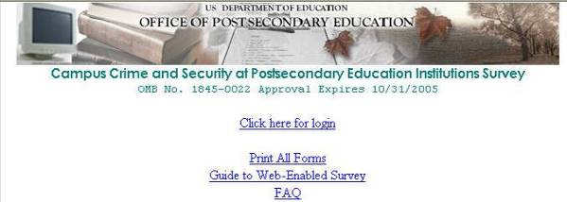

At this screen, enter your User ID and Password from the certificate mailed to the chief administrator of your institution. Both must be entered in uppercase. When you are finished, click “Login.”



Registration

The institution registration screen appears next.

- Enter the name of the individual completing this survey. This is the person who will be contacted if any follow up is required.
- Complete all fields.
- Verify that the e-mail address is correct. It is the most efficient method of recontacting schools when necessary. Do not put a Web address in this field.
- Click “Update.”
- You will see a message on your screen that reads “Your update was successful.”
- Click “Continue.”
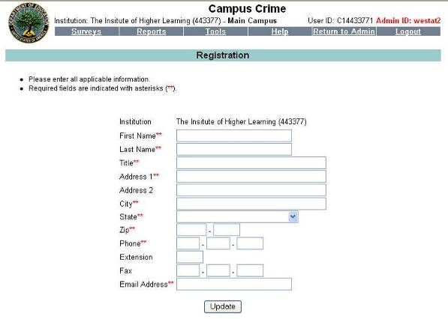

Institution Identification

- Complete this entire screen.
- Correct any inaccurate information that can be changed. Only the institution name field will be “read only” and cannot be changed.
- Click “Update.”
- You will see a message on your screen that reads “Your update was successful.”
- Click “Continue.”
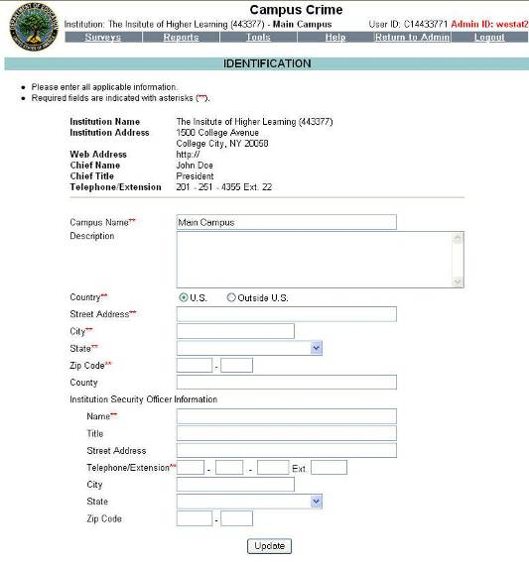

This page intentionally left blank.

Screening Questions

The screening questions appear next.

Institutions are required to make a good-faith effort to obtain statistics from local law enforcement agencies. Only statistics from Clery Act geographic locations provided by the local jurisdiction should be reported. If you have combined these statistics with your institution’s statistics, answer “Yes” to the second screening question. If statistics are not available from local law enforcement, select the “Not Available” option. If you answer “No” to the second screening question, the local screens will appear for you to enter the statistics. (At any time throughout the survey, click on the word “Instructions” for more information.)

- Click “Campus Crime.”
- Answer all three screening questions.
- Upon completion, click “Next Screen.”

DO NOT INCLUDE DATA FOR AREAS OTHER THAN
ON CAMPUS, NON-CAMPUS AND PUBLIC PROPERTY.
have any Non-campus buildings or properties?
Information Not Available from local authorities

Reporting Offenses

You are now ready to enter the criminal offenses for the required geographic areas for your institution. Separate screens will appear for on campus (on-campus residence halls), noncampus, and public property.

- Enter the number of alleged criminal incidents that were reported during the preceding calendar year for each category. (Data for the two prior years will be preloaded for you.)
- Refer to Chapter 3 for the definitions of the various crimes.
- Click on the crime (e.g., Burglary) if you would like the definition to appear on your screen.
- If there are no offenses for a reporting category, enter zero (0) for that category. Do not leave the category blank.
- The caveat is an optional field that allows you to provide additional information about the data that are reported. Because these data will be made available on the OPE Web site and will provide much needed consumer information, institutions are urged to provide text describing special conditions and other information needed to fully explain the meaning of the reported data. For example, an increase in the number of crimes can be explained in part by an even greater increase in the number of students. Institutions can also report reductions in the rate of crime in the caveat.
- At any time, you can click on the word “Instructions” located in the upper right hand corner of the screen for more information.

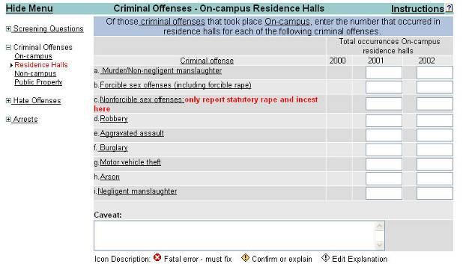

Residence Hall statistics are a subset of on-campus statistics; therefore, the numbers must be equal to or less than the numbers for on campus.
Hate Crimes

Your institution is required to disclose data in your annual security report on hate crimes by category of prejudice. For purposes of this data collection, only the total number of hate crimes is required.

Arrests

Enter statistics for arrests for liquor and drug law violations and illegal weapons possession by geographic area. A separate screen is provided for each area.

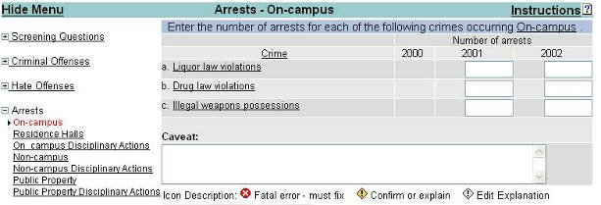

Referrals for Disciplinary Action

Enter statistics for referrals for liquor and drug law violations and illegal weapons possession. If the disciplinary action or judicial referral is the result of an arrest, please do not double count the offense. Count the violation as one arrest.

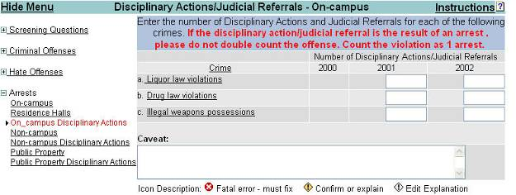

Local Screens

Contacting the local police to request crime statistics is required. The local police may:

- Offer statistics that may be added to your own statistics for on campus, noncampus and public property. (If this is the case, you will have answered “Yes” to the second screening question, and the “Local” screens will not appear.)
- Respond that they are not able to supply statistics for the particular geographic areas requested. (If this is the case, you will have answered “Not Available” to the second screening question, and the “Local” screens will never appear.)
- Respond that they have statistics for the areas requested, but they are unable to pinpoint the exact location. (If this is the case, you will have answered “No” to the second screening question, and the “Local” screens will appear for you to enter these statistics.)
The local screens do not require a geographic breakdown and do not take the place of your own public property screens.

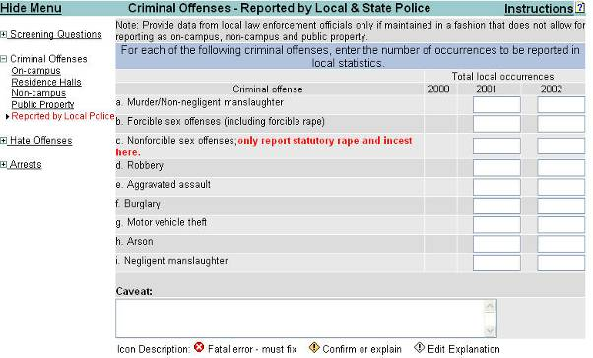

Finishing the Survey

The following steps need to be taken to complete your survey.

Editing Reports

Once you have entered all of your data, you are ready to run the edits.

- Click on “Perform Edits.”
- If there are no errors, the “Lock” link will appear and it will be underlined so that you may proceed with locking your survey.
- If there are errors identified, you must correct the errors before you can proceed. The icons below describe the errors and how to correct them.

Icon Description

Fatal error—must fix. This icon will appear next to an unacceptable entry or non-entry. It must be fixed to allow you to continue and complete the survey.
Confirm or explain. If there is an entry identified as a mistake or a typo, this yellow icon will appear. Click on the icon and a box will appear in the upper left-hand corner of your screen. Enter your explanation in this box.
Edit explanation. This is the symbol that appears after you have clicked on the yellow icon above and had your explanation accepted.
None of these icons appear anywhere other than on the screen you see to help you make the necessary corrections or to provide the necessary explanations. Neither the icon nor your explanation will appear on the public Web site. (See the example of an explanation box on the next page.)

Error Description

For further assistance, please contact the Campus Crime and Security Survey HELP Desk at 1-800-435-5985.
Error Description
The number entered, 23, is not within the expected range.
Please explain or fix.

Explanation:

Verified:

Close

This is the type of box that appears in the upper left-hand corner of your screen when you click on the yellow icons. Write your explanations here—not in the caveat boxes. When you are done, click on “Refresh” to save your explanation.

Surveys
- Listed in the table below are the surveys for this institution, the status of each survey, and any currently available options
- The institution identification must be completed before all applicable surveys will show in the table.
Campus :
Top of Form

Survey | Status | Options
Institution Identification | -- | --
Campus Crime | Has Data (0/1 locks) | Perform Edits Edit Report Print  Bottom of Form

Lock Your File

After the edits have been completed and there are no errors, you are ready to lock your file. This information will be transmitted to us.

- Click “Lock,” which is now underlined.
- Click “Continue with locking.”
- Click “Continue.” This screen tells you the survey has been successfully locked.
Once locked, survey data can no longer be edited or changed. You must contact the Help Desk if you need to make changes. If an institution has multiple campuses, each campus must be locked individually.

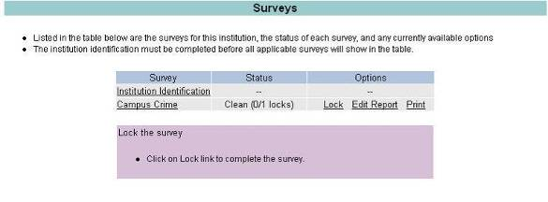

Print Your File

This is the screen you will see when your survey is locked. It will read “Complete 1/1.”

Using the “Print” link, make a copy for your files.

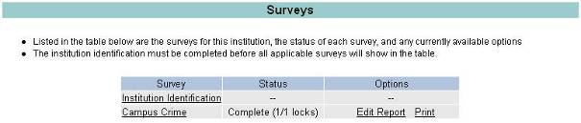

Tools

Using the “Campus Maintenance” function, you can add additional campuses. An additional campus must meet the definition of a separate campus. (See Chapter 2 for the definition of a separate campus.)

You also may request up to six additional users and passwords. Click on “Additional Users/Passwords” to make a request.

If changes need to be made on the “Registration” screen, use the “Registration” link included here.

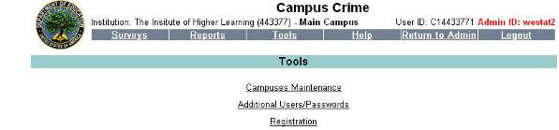

Campuses cannot be deleted by users. This is an administrative function, and you must call the Help Desk for assistance.

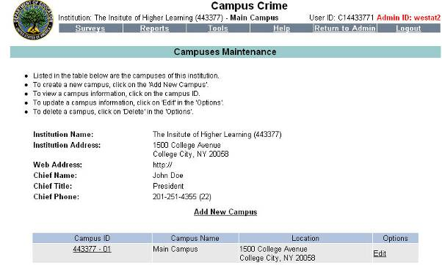

By going to “Help,” you can access all of the links available to assist you in finding the answers to any questions you may have.

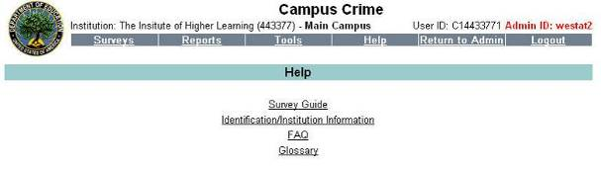

Under “Reports” you can print out blank forms to assist you in completing the survey.

You can also use “Print All Forms” on the “Login” screen to print blank screens.

When you have completed your data entry and have locked your survey, you can print the completed survey by selecting “Survey Forms (data)” from the “Reports” menu. You can also select the “Print” link on the Survey Screen.

