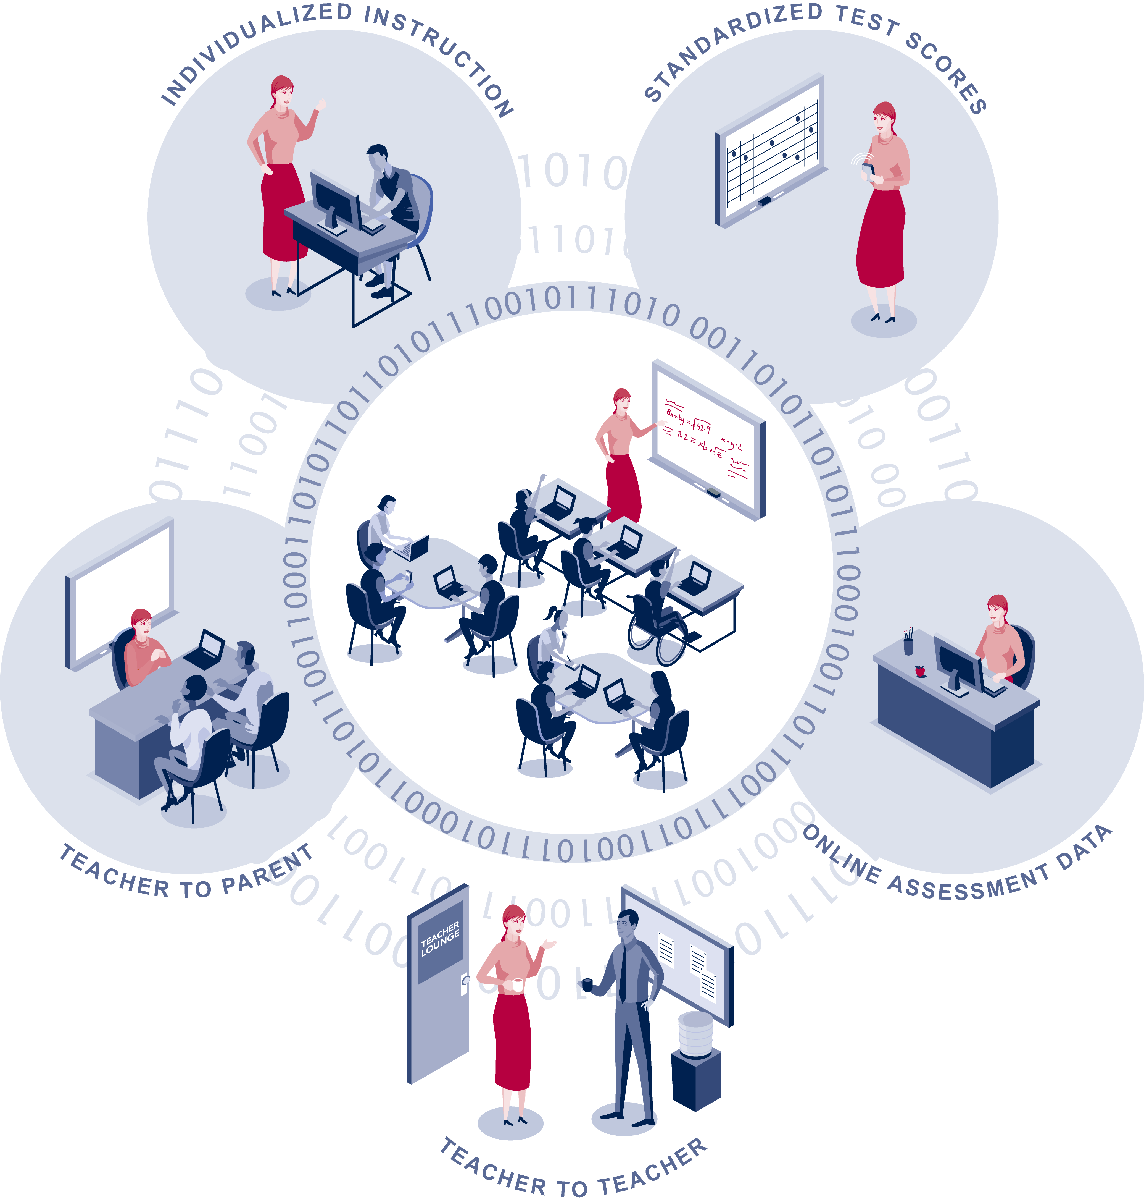

Teachers’ Use of Student Data Systems to Improve Instruction

U.S. Department of Education
Office of Planning, Evaluation and Policy Development

Prepared by:

Barbara Means
Lawrence Gallagher
Christine Padilla

SRI International

2007
This report was prepared for the U.S. Department of Education under Contract Number ED-04-CO-0040/0002 with SRI International. Bernadette Adams Yates served as the project manager. The views expressed herein do not necessarily represent the positions or policies of the Department of Education. No official endorsement by the U.S. Department of Education is intended or should be inferred.
U.S. Department of Education
Margaret Spellings
Secretary
Office of Planning, Evaluation and Policy Development
Doug Mesecar
Acting Assistant Secretary
Policy and Program Studies Service Office of Educational Technology
Alan Ginsburg Timothy J. Magner
Director Director
Program and Analytic Studies Division
David Goodwin
Director
September 2007
This report is in the public domain, except for the graphic on the front cover, which is used with permission and copyright, 2007, xPlane. Authorization to reproduce this report in whole or in part is granted. While permission to reprint this publication is not necessary, the suggested citation is: U.S. Department of Education, Office of Planning, Evaluation and Policy Development, Teachers’ Use of Student Data Management Systems to Improve Instruction, Washington, D.C., 2007.
To order copies of this report, write:
ED Pubs
Education Publications Center
U.S. Department of Education
P.O. Box 1398
Jessup, MD 20794-1398
To order via fax, dial (301) 470-1244. You may also call toll-free: 1-877-433-7827 (1-877-4-ED-PUBS). If 877 service is not yet available in your area, call 1-800-872-5327 (1-800-USA-LEARN). Those who use a telecommunications device for the deaf (TDD) or a teletypewriter (TTY) should call 1-800-437-0833.
To order online, point your Internet browser to: www.edpubs.ed.gov.
This report is also available on the Department’s Web site at www.ed.gov/about/offices/list/opepd/ppss/reports.html.
On request, this publication is available in alternate formats, such as Braille, large print, or computer diskette. For more information, please contact the Department’s Alternate Format Center at
(202) 260-0852 or (202) 260-0818.

Contents

List of Exhibits v
Introduction 1
Purpose of the Brief 1
Data Sources 1
Findings 2
Access to a Student Data System 2
How Teachers and Districts Use Student Data Systems 8
Support for Using Student Data Systems 14
Summary 17
References 19

Exhibits

Exhibit 1 Percentage of Teachers Reporting Access to a Student Data System 3
Exhibit 2 Types of Data That Districts Store Electronically 5
Exhibit 3 Teacher Reported Categories of Data and Support Available to Them 7
Exhibit 4 Percentage of Teachers Who Reported Using a Student Data System
at Least a Few Times a Year for a Specific Function 8
Exhibit 5 Percent of Districts Using a Data System at Least a Few Times a Year
for a Specific Function 10
Exhibit 6 Percentage of Teachers Who Reported Using a Student Data System
at Least a Few Times a Year for a Specific Function, by Teaching Area 12
Exhibit 7 Teachers Who Reported Using a Data Management System at Least
a Few Times a Year for a Specific Function, by Poverty Level of School 13
Exhibit 8 Teachers Who Reported Using a Data System at Least a Few Times
a Year to Make Instructional Decisions, by Social Context of Use 15
Exhibit 9 Teachers Indicating Support for Using Student Data to Guide
Instruction, by Source of Support 17

Introduction
During the past four years, the data collection and reporting requirements of No Child Left Behind (NCLB) have stimulated the development or adoption of new education data systems by many states and districts. This work has been necessary, but it is not sufficient for data-driven decision making to make a mark on education at the local level. Data-driven educational decision making is more than a data system. It is a set of expectations and practices around the ongoing examination of student data to ascertain the effectiveness of educational activities and subsequently to refine programs and practices to improve outcomes for students. In this rapidly changing field, little is known about the prevalence of data-driven decision-making activities nationally or about the supports and barriers for putting these practices into place.

Purpose of the Brief
Using data from national surveys of teachers and school districts, this brief provides the first national estimates of the prevalence of K–12 teachers’ access to and use of electronic student data management systems. Specifically, the brief addresses three research questions: |  | What is data-driven educational decision making?  In an education context, data-driven decision making is the analysis and use of student data and information concerning educational resources and processes to inform planning,
• How broadly are student data systems being implemented in districts and schools?  • Within these systems, how prevalent are tools for generating and acting on data?  • How are school staff using student data systems? |  | resource allocation, student placement, and curriculum and instruction. The practice entails regular data collection and ongoing implementation of a continuous improvement process.

Data Sources
This brief reports on analyses of two data sets from the U.S. Department of Education’s National Educational Technology Trends Study (NETTS). The primary data set used in this brief consists of responses of a nationally representative sample of K–12 teachers to a survey administered in fall and winter 2005. The teachers were clustered in schools sampled from districts participating in a NETTS district survey. The secondary data set consists of respondents to the NETTS district survey—a nationally representative sample of districts surveyed in spring 2005. Both district and teacher respondents were asked to report on activities during the 2004–05 school year.

Teachers were sampled from 975 schools within districts selected for the NETTS district survey. High-poverty schools were oversampled to obtain more precise data about their technology use. The final teacher sample consisted of 6,017 teachers; 82 percent of them responded to the survey. The teacher survey collected information on teacher background characteristics; general
technology access, supports, and barriers; technology-related professional development; technology use by teachers and students; and items on the topic of this evaluation brief—the use of technology-supported student data management systems. Sampling weights were applied to obtain nationally representative estimates based on teacher responses.

Districts were sampled from among the 12,483 districts that received federal Enhancing Education Through Technology (EETT) funds in 2003, as well as an additional 2,239 districts that had not received EETT funds. The district survey was mailed to 1,039 district information technology professionals; 99 percent of them responded to the survey. The survey covered a variety of topics regarding the federal EETT program, including the availability of a technology-supported student data management system and its accessibility to teachers.

Findings

Access to a Student Data System
Roughly half of all teachers (48 percent) reported having access to an electronic data system that provides them with student data.

The first requisite for using an electronic student data system to support data-driven decision making is data access. Only about half of all K–12 teachers reported having access to an electronic student data system during the 2004–05 school year (Exhibit 1).

Teachers in schools that were above average in the proportion of students eligible for free or reduced-price lunches were just as likely as those in lower-poverty schools to report having access to such a data system. A somewhat lower proportion of elementary school teachers (45 percent, compared with 54 percent of both middle and secondary school teachers) reported having access to a student data system.

Of the teachers who said they had access to a student data system, the great majority (75 percent) reported that it was provided by their district. Some teachers (15 percent) reported having access to a student data system made available by their school; relatively few teachers (4 percent) reported having a system provided by their state; 6 percent did not know the source of the system to which they had access. |  | What is an electronic student data system?  The collection of wide-scale information on the availability and use of electronic student data systems is hampered by the lack of a generally accepted definitions for a “student data system.” Generally speaking, an electronic data system is a collection of programs supporting the digital storage, manipulation, and extraction of information from a database. In addition to housing current and historical data on students, some data systems include programs
 |  | capable of capturing transactions such as attendance, managing curriculum resources, and analyzing student data.

Exhibit 1
Percentage of Teachers Reporting Access to a Student Data System
48%
49%
47%
45%
54%
54%
0%
20%
40%
60%
80%
100%
Overall
Higher poverty
Lower poverty
Elementary*
Middle
High
School
poverty
Grade
taught
Teacher grouping
Percent of teachers
Exhibit reads: Overall, 48 percent of teachers said that they had access to a student data system in school year 2004–05.
Note: * indicates significant difference between teachers in elementary schools and those in middle or high schools.
Source: NETTS teacher survey, 2005.
More than 60 percent of districts reported having made electronically stored student data available to their teachers in 2004–05.

Among the districts responding to the NETTS survey of local education agencies, 62 percent said that they had electronic data that teachers could access. But many teachers in these districts were unaware that there was a system they could access. Among those districts in which teachers were sampled for the NETTS teacher survey, just 53 percent of teachers in districts that reported providing electronic data that teachers could use reported having access to an electronic student data system. It is quite possible that teachers were unaware of the data access provided by their district or that teachers lacked the hardware, network connection, or know-how to access a system theoretically available to them. Another possibility is that many teachers regard a student data system as something more than access to district-stored student data. This problem could have been exacerbated by the fact that the NETTS district and teacher surveys used somewhat different terminology.
There were also 393 teachers who said they had access to a district-provided student data management system, although their districts reported that they did not have student data stored electronically in a system that teachers could access. Because the extent to which this discrepancy reflects teacher misconceptions concerning the source of a system, differences in question interpretation, or misreporting by the district or the teacher is unknown, the teacher survey data were analyzed both with and without these 393 cases. The trends and patterns reported in this brief do not appear to be strongly influenced by responses of this set of teachers. When the analyses reported in this brief were rerun without these 393 cases, only a single statistic changed significantly (and that change was just 2 percentage points).

As of 2004–05, over two-thirds of all school districts maintained electronic records of students’ standardized test scores.

Based on all districts responding to the NETTS district survey, the most frequent types of electronic data maintained by districts were attendance (99 percent), demographics (94 percent), course enrollment histories (93 percent), special education information (92 percent), and grades (89 percent). (See Exhibit 2.) Standardized test scores were maintained in electronic form by 69 percent of districts. Fewer districts stored electronic data on teacher qualifications (49 percent) and on participation of students in particular educational programs, such as those using an innovative classroom curriculum (37 percent).

Exhibit 2
Types of Data That Districts Store Electronically
99%
94%
93%
92%
89%
69%
49%
43%
37%
0%
20%
40%
60%
80%
100%
Attendance
Demographics
Course enrollment histories
Special education information
Grades
Standardized test scores
Teacher qualifications
Teacher professional development
Program participation
Percent of districts
Exhibit reads: Almost all districts (99 percent) stored attendance data in electronic form; 69 percent stored student standardized test scores electronically.
Source: NETTS district survey, 2005.

Even though nearly half of all teachers (48 percent) reported having access to student data systems, they did not necessarily have the information or tools they needed to make use of the student data available to them.
There is typically a lag between standardized test administration (usually done in the spring) and availability of student data. Researchers have noted teachers’ frustration with data systems that do not include achievement measures for the group of students with whom they are currently working (Thorn, 2002). Less than 40 percent of teachers with access to a student data system reported having access to standardized test scores from the current year for their students
(2004–05 data in Exhibit 3). Given that only 48 percent of teachers reported having access to a student data system, this means that just 19 percent of responding teachers said that they had access to current-year test scores for their students. Even fewer teachers (less than 20 percent of the 48 percent with data access) reported having access to software that they could use to analyze and interpret test scores. Around a fifth of teachers (22 percent) with access to a student data system reported that it included course enrollment histories for their students.
Only a small proportion of the teachers with access to a student data system reported that the system incorporated online assessments (17 percent) or online instruction that students could use (13 percent). Just 6 percent of teachers with access to a student data system said that it provided information on students’ participation in supplementary education programs such as tutoring.
The only two types of data that a majority of teachers with access to a student data system reported being able to access were class attendance and course grades (74 percent and 66 percent, respectively).
Exhibit 3
Teacher Reported Categories of Data and Support
Available to Them
74%
66%
47%
45%
39%
38%
32%
30%
22%
18%
17%
17%
15%
13%
11%
6%
0%
20%
40%
60%
80%
100%
Attendance
Course grades
Grade-level scores 2003-04
Grade-level scores 2004-05
Student scores 2004-05
Student scores 2003-04
Grade-level scores < 2003-04
Student scores <2003-04
Course histories
Estimates of AYP
Software to analyze data
Online assessments for students
Prior school(s) attended
Online instruction for students
Links scores with instructional resources
Supplementary education program participation
Percent of teachers with access to student data system
Exhibit reads: Of the 48 percent of teachers who reported having access to a student data system, 74 percent indicated that they had access to attendance data, and 39 percent indicated access to the current year’s (2004–05) students’ standardized test scores.
Note: <2003–04 indicates access to standardized test scores from years prior to 2003–04.
Source: NETTS teacher survey, 2005.

How Teachers and Districts Use Student Data Systems
Teachers are using student data systems to provide information to parents, to monitor their students’ status with respect to accountability requirements, and to plan and refine their instruction.
A large majority (89 percent) of teachers with access to a student data system said that they used the system at least a few times during 2004–05. Given the fact that only 48 percent of teachers reported having access to a student data system in 2004–05, this means that just 43 percent of teachers were using a data system in that school year. When system use for particular purposes is examined, the most commonly reported use of data systems was to inform parents about their students’ progress. Seventy percent of the teachers who had acess to student data systems had used them for this purpose (Exhibit 4). Similarly, 65 percent of the teachers who had access to student data systems had used them to track individual students’ test scores. About 44 percent of the teachers with system access had used the systems to examine test scores for a class of students.
Exhibit 4
Percentage of Teachers Who Reported Using a Student Data System at Least a Few Times a Year for a Specific Function
70%
65%
60%
55%
50%
49%
44%
42%
41%
37%
36%
0%
20%
40%
60%
80%
100%
Inform parents
Track individual test scores
Track other measures
Identify skill gaps
Inform curriculum changes
Pacing
Track test scores by grade
Student placement
Identify promising practices
Track AYP
Assess test-taking needs
Percent of teachers with access to student data system
Exhibit reads: Of the 48 percent of teachers who reported having access to a data system, 70 percent said that they had used system data to inform parents of student progress; 55 percent said that they had used system data to identify individual students’ skill gaps.
Source: NETTS teacher survey, 2005.
Use of student data systems to plan and individualize instruction appears less common than use of the systems to inform parents or keep track of accountability measures.
Just over half (55 percent) of the teachers with access to student data systems reported having used system data to identify individual students’ skill gaps, 50 percent had used data from the systems in planning changes to the curriculum, and 41 percent had used data to evaluate promising classroom practices. The ways in which teachers use the data systems may be influenced by the types of data and data query functions in the systems available to teachers (Wayman et al., 2004).
Tracking accountability measures is also the primary use that districts make of their student data systems.
The NETTS district survey asked district staff to report the purposes for which they used their student data systems. Like teachers, district staff report using the system to track test scores and other measures of student progress, for student placement, and to inform parents of student progress (Exhibit 5). Similar proportions of district and teacher respondents reported using a student data system to help inform curriculum changes (61 percent and 50 percent, respectively). Forty-one percent of districts with student information systems used student data from their systems in evaluating promising practices, and 28 percent used data systems in evaluating teacher performance.

Exhibit 5
Percent of Districts Using a Data System at Least a Few Times a Year for a Specific Function
70%
65%
60%
55%
50%
49%
44%
42%
41%
28%
5%
0%
20%
40%
60%
80%
100%
Track other student progress
Track class test scores
Student placement
Inform parents
Inform curriculum changes
Track school graduation rates
Inform professional development offerings
Inform resource allocation
Evaluate promising practices
Evaluate teacher performance
Other
Percent of districts
Exhibit reads: Among districts storing data electronically, 80 percent reported using the system to track other measures of student progress; 61 percent reported using data systems to inform curriculum changes.
Note: Other student progress measures are measures other than test scores and graduation rates.
Source: NETTS district survey, 2005.

There were few differences by grade level and subject area in how teachers reported using student data systems.
Using five teacher grade or subject categories (elementary generalist, middle and high school English, middle and high school mathematics, middle and high school science, and middle and high school social studies), statistically significant differences were found in the prevalence of just three of the 11 data system uses examined in the survey. As shown in Exhibit 6, differences were found in the following uses:
- Identifying skill gaps. Teacher groups varied in their propensity to use data systems to identify their students’ skill gaps. The difference between elementary teachers (61 percent), who were the group most likely to do so, and middle and high school mathematics teachers (43 percent), who were the group least likely to do so, was statistically significant.
- Tracking other measures. Different teacher groups varied in their use of data systems to track measures of student progress other than standardized test scores. Reported use of this practice varied from a high of 68 percent for middle and high school history and social studies teachers with access to student data systems to a low of 46 percent for mathematics teachers.
- Pacing. Among teachers with access to a data system, there were differences across teacher groups in the proportion using student data to help determine how to pace instruction. Elementary teachers (54 percent) appeared to be most likely to report using a data management system to help in pacing instruction; middle and high school mathematics teachers and history and social studies teachers appeared least and likely (40 percent) to report doing so, but the difference did not attain statistical significance.
Exhibit 6
Percentage of Teachers Who Reported Using a Student Data System at Least a Few Times a Year for a Specific Function, by Teaching Area
System Use | Elementary  School | Middle/High School
System Use | Elementary  School | English | Math | Science | History or Social Studies
Inform parents | 66 | 74 | 69 | 68 | 78
Track individual test scores | 65 | 62 | 69 | 56 | 65
Track other measures* | 63 | 58 | 46 | 51 | 68
Identify skill gaps* | 61^ | 47 | 43^ | 46 | 49
Inform curriculum | 51 | 52 | 42 | 51 | 55
Pacing* | 54 | 52 | 40 | 41 | 40
Track test scores by grade | 44 | 43 | 38 | 44 | 48
Student placement | 40 | 39 | 54 | 33 | 46
Identify promising practices | 42 | 43 | 33 | 44 | 43
Track AYP | 39 | 35 | 39 | 33 | 30
Assess test-taking needs | 35 | 48 | 28 | 37 | 40
* Use varies significantly across the five teacher categories.
^ Percentage using system to identify skill gaps differs significantly between elementary teachers and middle and high school math teachers.

Exhibit reads: Among teachers who reported using a student data system, 66 percent of elementary teachers said that they used the system to inform parents about student progress. Among middle and high school teachers, 74 percent of English teachers, 69 percent of math teachers, 68 percent of science teachers, and 78 percent of history and social studies teachers said that they used the system to inform parents about student progress.
Source: NETTS teacher survey, 2005.

Teachers in higher-poverty schools reported using their student data system at least as frequently as did teachers in lower-poverty schools.
The poverty level of the school tends to have some association with frequency of data system use for all the purposes examined (Exhibit 7), but the difference between teachers from higher-poverty and lower-poverty schools was statistically significant for only three of the 11 uses included in the survey. Teachers at higher-poverty schools were more likely than their colleagues at lower-poverty schools to use student data systems to track grade-level test scores, to identify promising teaching practices, and to assess their students’ need for test-taking practice.
Years of teaching experience appear to have little influence on the purposes for which teachers use student data systems; the only significant difference in data system use related to years of teaching was a greater likelihood that teachers with the most experience (9 or more years) would use the student data system to inform parents about student progress.

Exhibit 7
Teachers Who Reported Using a Data
Management System at Least a Few Times a Year for a Specific
Function, by Poverty Level of School
70%
66%
63%
59%
53%
52%
48%
44%
45%
39%
42%
70%
63%
57%
51%
47%
46%
39%
41%
36%
34%
29%
0%
20%
40%
60%
80%
100%
Inform parents
Track individual test scores
Track other measures
Identify skill gaps
Inform curriculum
Pacing
Track test scores by grade*
Student placement
Identify promising practices*
Track AYP
Assess test-taking needs*
Percent of teachers with access to student data system
Higher poverty
Lower poverty
Exhibit reads: Of the teachers who reported access to a student data system, 42 percent of teachers in higher-poverty schools reported using the data system to assess students’ need for test-taking practice, while 29 percent of teachers in lower-poverty schools did so.
Note: * indicates significant difference between teachers in higher-poverty and those in lower-poverty schools.
Source: NETTS teacher survey, 2005.

Support for Using Student Data Systems
Teachers reported that using the student data system in collaboration with school colleagues was almost as common as using the system on their own.
The social context in which teachers use data systems (whether as a solitary activity or in collaboration with colleagues) provides an indication of the kinds of decisions being addressed with data. Teachers who use student data to make instructional decisions for their own class or for individual students in their class are likely to spend time examining data on their own. Teachers who are engaged in making broader decisions, such as those related to a school improvement plan or department- or grade-level decisions about curriculum and instruction are likely to look at data with colleagues. The data-driven decision-making movement promotes both kinds of activity, and past research suggests that a school culture stressing collaboration facilitates the implementation of data-driven decision making (Chen, Heritage, and Lee, 2005). Around three-quarters (77 percent) of the teachers with access to a student data system said that they had used it on their own; 71 percent said that they had used it in a joint activity with other staff from their school (Exhibit 8).
Nearly 60 percent of the teachers with access to a student data system reported having used the system as part of a district activity in their school and 27 percent as part of a district activity with staff from other schools. Less than 5 percent reported having used the system in a social context other than the four included in Exhibit 8.

Exhibit 8
Teachers Who Reported Using a Data
System at Least a Few Times a Year to Make
Instructional Decisions, by Social Context of Use
77%
71%
58%
27%
5%
0%
20%
40%
60%
80%
100%
On own
Working with
school colleagues
District activity in
school
District activity
with other schools
In another setting
Percent of teachers with access to student data system
Exhibit reads: Of the 48 percent of teachers who reported access to a student data system, 77 percent said they had used the system on their own and 71 percent said they had used it with other teachers at their school; 58 percent said that they had used the system as part of a district activity conducted at their school.
Note: If teachers who reported having access to a district-provided system in districts that said they did not provide teachers with access to student data systems are deleted from the analysis, the percentage of teachers saying they had analyzed data on their own is reduced to 75 percent.
Source: NETTS teacher survey, 2005.
The most common supports for teachers’ use of student data systems come from their schools and not through formal course work.
Over 60 percent of teachers with access to student data systems reported having received professional development on this topic at their school; a similar proportion reported that their principals supported data-driven decision making (Exhibit 9). In contrast, less than 10 percent of teachers with access to systems reported having had formal course work on the use of student data systems.
Roughly a quarter (28 percent) of teachers who had access to student data systems said they had received support from a consultant or mentor teacher for this activity. Only 8 percent of teachers reported having had formal course work on data-driven decision-making. One-sixth (16 percent) of teachers with access to a data system reported having had paid time set aside for examining student data and using data to make decisions about practice. (This would include time during the regular school day or regular professional development days covered by their salary, as well as any summer or after-school sessions for which they received a stipend.)
Teachers in higher-poverty schools were as likely as those in lower-poverty schools to report each type of support for using student data systems. Mathematics teachers were less likely than other teachers to report having received professional development for use of student data systems, and teachers with nine or more years of teaching experience were also less likely than their less-experienced colleagues to report having had this kind of professional development.

Exhibit 9
Teachers Indicating Support for Using
Student Data to Guide Instruction, by Source of Support
63%
61%
28%
18%
16%
8%
0%
20%
40%
60%
80%
100%
Professional development at school
Principal encouragement
Support from mentor
Professional development outside school
Paid time set aside
Formal course work
Percent of teachers with access to student data system
Exhibit reads: Of the 48 percent of teachers who reported having access to a student data system, 63 percent had received professional development at school; 16 percent reported having had paid time set aside for student data use.
Source: NETTS teacher survey, 2005.

Summary
The data reported in this brief provide a snapshot of teachers’ access to and supports for using student data systems in the 2004–05 school year. They provide a baseline against which outcomes associated with new federal, state, and district efforts to promote the use of data systems to improve instruction and student achievement can be compared.
About half of all teachers reported having access to an electronic student data management system in school year 2004–05 (but there is some ambiguity concerning the meaning of “access” and “data management system,” as demonstrated by apparent discrepancies between teacher and district responses). Of those teachers who reported having access to a data system, a majority reported making use of it for monitoring student progress, planning, and refining their instruction, or keeping parents informed (all of which are promoted under NCLB). Teachers in higher-poverty schools were no less likely than their counterparts in lower-poverty schools to report having access to and using student data systems, and for some purposes they reported more frequent data use than did teachers at lower-poverty schools. The survey data suggest also that teacher collaboration around student data system use is common. Teachers were nearly as likely to use their student information system with their colleagues as on their own. More than half of teachers with access to student data systems reported that they had received professional development and principal support to use the data system—two key support elements.
At the same time, in the 2004–05 school year teachers did not necessarily have appropriate data or the tools they needed to make good use of student data in planning and individualizing instruction. Less than half of the teachers who reported having had access to a student data system said that the system had student test scores from the current year. Few teachers reported having software to help them analyze and interpret test scores, and few had received formal training or course work on the use of student data to inform instruction. Some teachers had received support from a consultant or mentor teacher. Differences in the use of student data systems by grade level and subject area imply different levels of need, related to varying uses of data and differences in teachers’ current skill sets. In 2004–05, the majority of teachers had yet to use data to plan and individualize instruction. Previous research examining data-driven decision making in individual schools has suggested that the lack of time allocated to collecting, analyzing, and interpreting data is a major barrier to effective implementation of this practice (Ingram, Louis, and Schroeder, 2004; Marsh, Pane, and Hamilton, 2006). On the NETTS survey, only about one-sixth of teachers with access to data systems reported that they had had paid time set aside for data use. Hence, for the most part, districts are in essence expecting teachers to use the data system as an extra activity, either conducted on their own time or substituted for other activities during their regular planning period.
District staff will need to confront these issues as they review their data-driven decision-making practices and plan support and professional development activities, and by teacher preparation staff as they assess their teacher training programs.

References
Benjamin, Y., and Hochberg, Y. (1995). Controlling the false discovery rate: A practical and powerful approach to multiple testing. Journal of the Royal Statistical Society (Series B), 57, 289-300.

Chen, E., Heritage, M., and Lee, J. (2005). Identifying and monitoring students’ learning needs with technology, Journal of Education for Students Placed at Risk, 10(3), 309-332.

Ingram, D., Louis, K. S., and Schroeder, R. G. (2004). Accountability policies and teacher decision making: Barriers to the use of data to improve practice. Teachers College Record, 106(6), 1258-1287.

Marsh, J. A., Pane, J. F., and Hamilton, L. S. (2006). Making sense of data-driven decision making in education: Evidence from recent RAND research (RAND Education Occasional Paper). Santa Monica, Calif.: RAND.

Thorn, C. A. (2002). Data use in the classroom: The challenges of implementing data-based decision-making at the school level. Paper presented at the annual meeting of the American Educational Research Association, New Orleans.

Wayman, J. C., Stringfield, S., and Yakimowski, M. (2004). Software enabling school improvement through analysis of student data (Report No. 67). Baltimore, Md.: Center for Research on the Education of Students Placed at Risk, Johns Hopkins University.

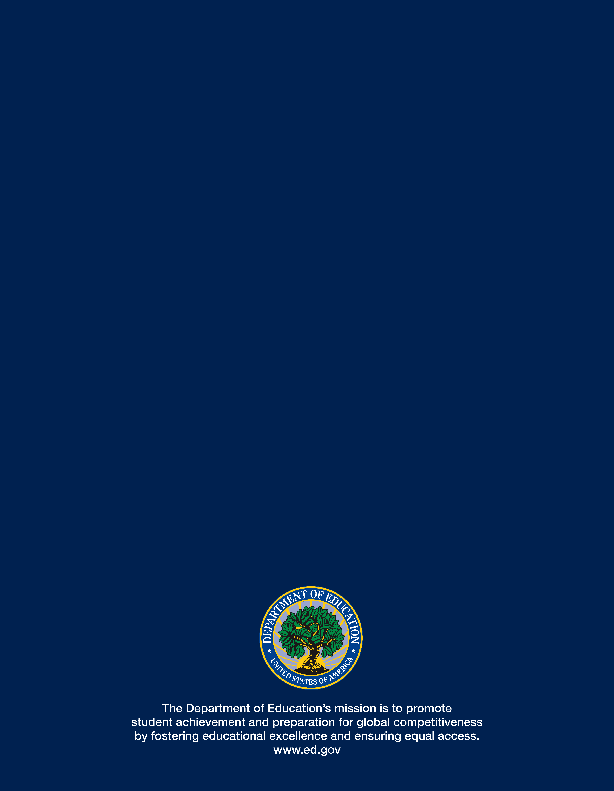

The 60 largest urban districts were selected with certainty; districts composed entirely of special education schools and vocational-technical schools and independent charter schools that are their own districts, were excluded from the district sampling frame. To obtain the NETTS teacher survey sample, schools were selected from the districts in the district survey, and then a stratified sample of teachers was selected from the sampled schools (schools were stratified by poverty and grade level). Although the sampling process was sequential, entities at each level were selected at random (e.g., teachers were randomly selected from staff rosters from each of the schools in the sample).
For schools, “higher poverty” was defined as above a specified cutoff in terms of the percentage of students who were eligible for the free or reduced-price lunch program. The dividing line between higher-poverty and lower-poverty schools was selected to ensure that for each school type (elementary, middle, or high school), there would be the same number of teachers in the higher-poverty and the lower-poverty groups, as reported in the NCES Common Core of Data (CCD). Elementary schools with 29.7 percent of their students eligible for free or reduced-price lunches were classified as higher poverty. For middle and high schools, the poverty thresholds were 24.3 percent and 15.9 percent, respectively.
This statistic is based on a subsample of 448 districts from which participating schools and teachers were drawn.
The district survey asked whether the district stored specific types of data electronically and then whether teachers could access each type of electronically stored data. The teacher survey asked whether the teacher had access to “an electronic data management system that provided you with student data.”
The numbers reported in this brief include responses of these 393 teachers; the alternate value for the statistic that would change significantly if these cases were excluded is provided in a table note for Exhibit 8.
For each system use, an omnibus test for differences in the proportion of teachers using the system in that way was conducted. For the three uses for which the omnibus test was significant at p<.05, every possible pair-wise combination of teacher categories was examined. Significance levels for the post-hoc tests were set using the Benjamin and Hochberg (1995) procedure for controlling false discovery rates. Only one of the individual pairwise comparisons (the difference between elementary and middle and high school math teachers using a student data management system to identify skill gaps) attained significance.

