PUBLIC NOTICE
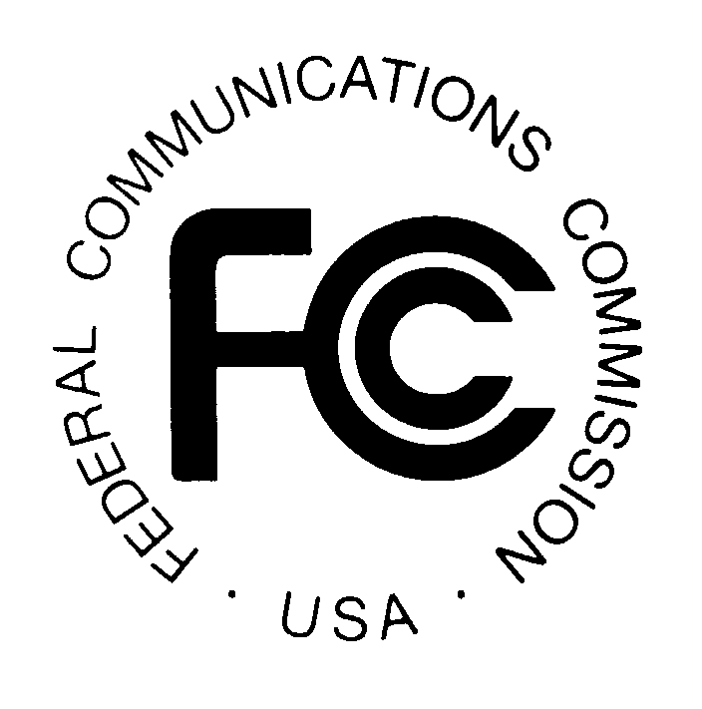
FEDERAL COMMUNICATIONS COMMISSION
445 12th STREET, S.W.
WASHINGTON, D.C. 20554 DA 00-0695

News media information 202/418-0500 Fax-On-Demand 202/418-2830 Internet: http://www.fcc.gov ftp.fcc.gov

CABLE SERVICES BUREAU ACTION July 30, 2026

CORRECT USAGE OF “ENR” AND “ELECTRONIC NEWSROOM”
FOR PURPOSES OF THE CLOSED CAPTIONING RULES

The Commission has learned that some members of the public are using the trademarked term “ENR” to refer to the generic captioning technology known as the electronic newsroom technique and that this may cause confusion. The Commission wishes to remind the public that its closed captioning rules no longer use the term “ENR” and instead refer to the “electronic newsroom technique,” which does not refer to any particular company or its products.

By an order released June 10, 1999, the Commission revised the wording of 47 C.F.R. § 79.1(e)(3), which deals with the acceptability, for meeting closed captioning requirements, of the method of captioning known as the electronic newsroom technique. Order, DA 99-1133 (June 10, 1999). Since its inception, the rule was intended to refer to a generic captioning methodology that generates captions using the output of news script computer or teleprompter systems. Prior to the revision, the rule referred to this technology as the "so-called 'electronic newsroom' or ENR technique." The Commission learned, however, that the rule’s reference to “ENR” might be confused with the term "ENR" used by Comprompter, Inc. of La Crosse, Wisconsin as the trademark for one of its products. Comprompter, Inc. also uses the term “Electronic NewsRoom” (note capitalization) in reference to this product. Accordingly, the Commission deleted usage of the term “ENR” and substituted the generic term “electronic newsroom technique.”

The closed captioning rule, as amended, intends no reference to Comprompter, Inc. The rule should not be read to indicate the Commission’s disapproval of Comprompter’s ENR product. Rather, the rule should be read in its generic sense and not as reflecting any view by the Commission as to that company or its products.

For further information, please contact:
Marcia Glauberman, Cable Services Bureau, (202) 418-7200, TTY (202) 418-7172
David Senzel, Office of the General Counsel, (202) 418-1760

-- FCC --

