Unit 5: Light Search and Rescue Operations

In this unit you will learn about:

- Search and Rescue Sizeup: How to size up the situation in which the search and rescue teams will operate.

- Conducting Search Operations: How to search systematically for disaster victims.

- Conducting Rescue Operations: Safe techniques for lifting, leveraging, cribbing, and victim removal.

Unit 5: Light Search and Rescue Operations
Objectives | At the conclusion of this unit, the participants should be able to:  - Identify sizeup requirements for potential search and rescue situations.  - Describe the most common techniques for searching a structure.  - Use safe techniques for debris removal and victim extrication.  - Describe ways to protect rescuers during search and rescue.
Scope | The scope of this unit will include:  - Introduction and Unit Overview.  - Search and Rescue Sizeup.  - Conducting Search Operations.  - Conducting Rescue Operations.  - Unit Summary.
Estimated Completion Time | 2 hours 30 minutes
Training Methods | The lead Instructor will begin this session by welcoming the participants to Unit 5: Light Search and Rescue Operations, and will introduce the instructors for the unit. The Instructor will then present a brief overview of this unit, including making the distinction between search and rescue, the goals of search and rescue, search and rescue priorities, and the steps involved in effective search and rescue.  Next, the Instructor will review the sizeup process as it applies to search and rescue. At this time, the Instructor will emphasize the most dangerous construction-related hazards (e.g., unreinforced masonry construction for earthquakes). The Instructor will emphasize the importance of rescuer safety in all sizeup decisions. Participants will complete sizeup exercises using either the scenarios provided or locally prepared scenarios.  The next section will deal with search techniques for locating potential victims. The Instructor will identify the types of voids that may be created through structural collapse, the types of collapses that CERT members should avoid, and the methods that searchers can use for locating victims and documenting their positions within lightly or moderately damaged structures.  Finally, the Instructor will describe rescue techniques and methods for lifting, debris removal, and finally, victim removal. The instructors will demonstrate leveraging and cribbing. The instructors will also demonstrate using lifts and drags as victim removal techniques, and the participants will practice those techniques under instructor observation. At the end of this section, the group will participate in a simulation involving both debris removal and victim removal.

Resources Required | - Community Emergency Response Team Instructor Guide  - Community Emergency Response Team Participant Manual  - Visuals 5.1 through 5.26  - CERT cribbing video (VT 317)
Equipment | In addition to the equipment listed at the front of this Instructor Guide, you will need the following equipment for this session:  - A computer with PowerPoint software  - A computer projector and screen  - 1 mannequin  - 1 blanket  - Large, flat object (e.g., table) and pieces of wood for leveraging/cribbing  - 1 pry bar or long 2" x 4"
Preparation | For the exercise titled, Gathering Facts, scenarios have already been developed. Copies of the scenario appears in the Participant Manual, and are included on pages 5-18 and 5-19 in this Instructor Guide. You should feel free to alter these scenarios to reflect the community's needs.  The exercise, titled, Search and Rescue Sizeup, requires the preparation of scenarios that are realistic for your community. Be sure to prepare the scenarios in advance of the session and have copies for each participant. Include the following types of information in the scenarios:  - Type of event  - Intensity/severity/duration  - Occupancy affected  - Current/forecast weather conditions  - Time of day and week  - Other factors that may affect search and rescue operations  Information that is provided about assessment of probable damage in relation to types of construction focuses primarily on earthquake damage. If other types of disasters (e.g., tornadoes, hurricanes, or floods) are likely to occur in your area, obtain and add information about their probable impact on various types of construction.

Notes | Remember as you work through this unit with the group, stress the role of the CERT in search and rescue. The participants must come away from the training with an understanding of their limitations, and the attitude that their safety is paramount, even above that of the victims.  A suggested time plan for this unit is as follows:  Introduction and Unit Overview 5 minutes  Search and Rescue Sizeup 45 minutes  Conducting Search Operations 35 minutes  Conducting Rescue Operations 60 minutes  Unit Summary 5 minutes  Total Time: 2 hours 30 minutes
Remarks | Search and rescue sizeup is based on the model introduced in Unit 2: Fire Safety. Review the section carefully and develop examples of damage levels based on the hazards faced and the types of structures that are common to your community. Provide these examples at appropriate points in the instruction to illustrate important learning points.

Unit 5: Light Search and Rescue Operations

 |  |  | Introduction and Unit Overview
 | Introduce Unit |  | Introduce this session by welcoming the participants to Unit 5 of the CERT training program.  Introduce the Instructors for this session and ask any new instructors to describe briefly their experience with search and rescue operations.
 | Visual 5.1 |  |  | Search and Rescue Operations  - Sizeup  - Search involves:  - Locating victims.  - Documenting location.  - Rescue involves procedures and methods to extricate victims  Visual 5.1
Explain that search and rescue consists of three separate operations:

- Sizeup involves assessing the situation and determining a safe action plan (using the nine-step sizeup model).

- Search involves locating victims and documenting their location.

- Rescue involves the procedures and methods required to extricate the victims.

 |  |  | Point out that experience from previous disasters has shown that immediately after almost every disaster, the first response to trapped victims is by spontaneous, untrained, and well-intentioned persons who rush to the site of a collapse in an attempt to free the victims.

 |  |  | Introduction and Unit Overview (Continued)
 | Instructor’s Note |  |  | Use the example from the earthquake in Mexico City, where spontaneous efforts saved 800 lives—but cost the lives of more than 100 people—to add emphasis to this discussion.  Point out that the Mexico City example is not isolated, but is part of a larger pattern of behavior in emergencies, ranging from accidental drowning in which the would-be rescuer also drowns, to the massive influx of volunteers following major disasters.
Emphasize that, more often than not, these spontaneous rescue efforts result in serious injuries and compounded problems.

Point out that, however well-meaning, rescue efforts should be planned and practiced in advance.

 | Visual 5.2 |  |  |  | Decision To Attempt Rescue  - Risk involved to the rescuer  - Greatest good for greatest number of people  Visual 5.2
Explain that the decision to attempt a rescue should be based on two factors:

- The risks involved to the rescuer

- The overall goal of doing the greatest good for the greatest number of people

 |  |  | Introduction and Unit Overview (Continued)
 | Visual 5.3 |  |  | Goals of Search and Rescue  - Rescue greatest number in shortest amount of time  - Rescue lightly trapped victims first  Visual 5.3
Explain that the goals of search and rescue operations are to:

- Rescue the greatest number of people in the shortest amount of time.

- Rescue lightly trapped victims first.

Stress, however, that the most important person in a rescue attempt is the rescuer.

 |  |  | Introduction and Unit Overview (Continued)
 | Visual 5.4 |  |  | Effective Search and Rescue  - Effective sizeup  - Rescuer safety  - Victim safety  Visual 5.4
Explain that effective search and rescue operations hinge on:

- Effective sizeup.

- Rescuer safety.

- Victim safety.

 |  |  | Tell the participants that this unit will focus on the components of an effective search and rescue operation—sizeup, search, and rescue—and the methods and techniques that rescuers can use to locate and safely remove victims.

 |  |  | Introduction and Unit Overview (Continued)
 |  |  | Objectives
 | Visual 5.5 |  |  |  | Unit Objectives  - Identify sizeup requirements for potential search and rescue situations.  - Describe the most common techniques for searching a structure.  - Use safe techniques for debris removal and victim extrication.  - Describe ways to protect rescuers during search and rescue.  Visual 5.5
Tell the participants that at the end of this unit, they should be able to:

- Identify sizeup requirements for potential search and rescue situations.

- Describe the most common techniques for searching a structure.

- Use safe techniques for debris removal and victim extrication.

- Describe ways to protect rescuers during search and rescue operations.

 | Instructor’s Note |  |  | Ask if anyone has any questions about what will be covered in this unit.

 |  |  | Search and Rescue Sizeup
 | Introduce Topic |  | Introduce this topic by reminding the participants that, like every other CERT operation, search and rescue requires sizeup at the beginning of the operation and continually as long as the operation continues.
 | Visual 5.6 |  |  | CERT Search and Rescue Sizeup  - Gather Facts  - Assess Damage  - Consider Probabilities  - Assess Your Situation  - Establish Priorities  - Make Decisions  - Develop Plans of Action  - Take Action  - Evaluate Progress  Visual 5.6
 | PM, PP. 5-3 through 5-7 |  | Remind the group that sizeup is a 9-step process and was presented in Unit 2. Refer the participants to the CERT Search and Rescue Sizeup Checklist in the Participant Manual, and review the steps briefly. Tell the group that this section will focus on sizeup as it relates to search and rescue operations.

 | PM, P. 5-3 | CERT Search and Rescue Sizeup Checklist

Step 1: Gather Facts

Time

- Does the time of day or week affect search and rescue efforts?  How? |  | 
Type Of Construction

- What type(s) of structure(s) is(are) involved?

- What type(s) of construction is (are) involved?

Occupancy

- Are the structures occupied?  If yes, how many people are likely to be affected? |  | 
- Are there special considerations (e.g. children, elderly)?  If yes, what are the special considerations? |  | 

 | PM, P. 5-4 | CERT Search and Rescue Sizeup Checklist

 | Yes |  | No
Step 1: Gather Facts (Continued)

Weather

- Will weather conditions affect your safety?  If yes, how will your safety be affected? |  | 
- Will weather conditions affect the search and rescue situation?  If yes, how will the search and rescue situation be affected? |  | 
Hazards

- Are hazardous materials involved?  If yes, what hazardous materials? |  | 
- Are any other types of hazards likely to be involved?  If yes, what other hazards? |  | 

 | PM, P. 5-5 | CERT Search and Rescue Sizeup Checklist

 | Yes |  | No
Step 2: Assess and Communicate the Damage

- Take a lap around the building. Is the damage beyond the CERT team’s capability? |  | 
If yes, what special requirements or qualifications are required?

- Are normal communication channels functioning? |  | 

Step 3: Consider Probabilities

Life Hazards

- Are there potentially life-threatening hazards?  If yes, what are the hazards? |  |  | 
Additional Damage

- Is there great risk or potential for more disaster activity that will impact personal safety?  If yes, what are the known risks? |  |  | 

Step 4: Assess Your Own Situation

- What resources are available with which you can attempt the search and rescue?

- What equipment is available?

 | PM, P. 5-6 | CERT Search and Rescue Sizeup Checklist

 | Yes |  | No

Step 5: Establish Priorities

- Can a search and rescue be safely attempted by CERT members?  If no, do not attempt a search and rescue. |  | 
- Are there other, more pressing needs at the moment?  If yes, list. |  | 

Step 6: Make Decisions

- Where will deployment of available resources do the most good while maintaining an adequate margin of safety?

Step 7: Develop Plan of Action

- Determine how personnel and other resources should be deployed.

 | PM, P. 5-7 | CERT Search and Rescue Sizeup Checklist

Step 8: Take Action

- Put the plans into effect.

Step 9: Evaluate Progress

- Continually size up the situation to identify changes in the:

- Scope of the problem.
- Safety risks.
- Resource availability.

- Adjust strategies as required.

 |  |  | Search and Rescue Sizeup (Continued)
 |  |  | Step 1: Gather Facts
 | Introduce Step 1 |  | Introduce step 1 by telling the group that the facts of the situation must guide their search and rescue efforts.
 | Visual 5.7 |  |  |  | Step 1: Gather Facts  Consider the:  - Time of event and day of week.  - Type of structure.  - Construction type.  - Weather.  - Hazards.  Gather facts accurately.  Visual 5.7
When gathering facts, CERT members need to consider:

- The time of the event and day of the week. At night, more people will be in their homes, so the greatest need for search and rescue will be in residential settings. Conversely, during the day, people will be at work, so the need will be in commercial buildings.

Some emergency services are not available—or not available in the same numbers—during the evenings or on weekends. Search and rescue operations may also be affected by where people are located in their homes and the amount of daylight available.

 | Instructor’s Note |  |  | Provide and discuss locally relevant examples of planning factors, to develop an understanding of the effects of each factor.
- The type of structure. The purpose for which the structure was designed may indicate the likely number of victims, and their location.

- Construction type. Some types of construction are more susceptible to damage than others.

 |  |  | Search and Rescue Sizeup (Continued)
 | Instructor’s Note |  |  | Mention that the amount of damage likely to be found in different types of construction will be covered in a few minutes.
- Weather. Severe weather will have an effect on victims and rescuers alike and will certainly hamper rescue efforts. Forecasts of severe weather should be considered as a limiting factor on the time period during which search and rescue can occur.

- Hazards. Knowledge of other potential hazards in the general and immediate areas is important to search and rescue efforts. Time lost trying to locate and shut off utilities, for example, can have a big impact in terms of loss of life.

Stress the need for accurate fact-gathering before attempting to assess damage.

 | Instructor’s Note |  |  | Point out that, by this point in the sizeup, CERT members should have a good idea of whether the incident was caused by terrorism. Stress that CERT members should never initiate search and rescue operations if they suspect that:  - A biological, chemical, or radiological weapon has been used.  - There may be secondary explosive devices inside the building.  Emphasize that, if a possible terrorist situation exists, they should leave the area immediately.

 |  |  | Search and Rescue Sizeup (Continued)
 |  |  | Exercise: Gathering Facts
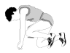 | Conduct Exercise |  | This exercise is an interactive activity to give the participants the opportunity to consider some of the facts that CERT search and rescue teams will need to gather during sizeup.  Instructions: Use the following steps to facilitate this exercise:
 | PM, P. 5-10 |  | - Refer the participants to Scenario in the Participant Manual.
 | Instructor’s Note |  |  | This scenario is an example; you should feel free to change the scenario to fit the community's needs.
- Ask the group to brainstorm the following questions:

- What does this scenario tell you about the facts that must be gathered?
- What impact could these facts have on search and rescue operations?

 | Record Responses |  | - Record the group's responses on chart paper.  - Discuss the group's responses and provide feedback on how their planning might be improved.

 | PM, P. 5-10 | Scenario

At 2:30 p.m. on Tuesday, August 9, a squall line passed through your town. Because of the difference in barometric pressure on either side of the front, the squall line was preceded by a “gust front” with straight-line winds of more than 70 miles per hour. The gust front was followed by continued strong winds and extremely heavy rain. Electricity was knocked out throughout the town.

You activate in accordance with Standard Operating Procedures (SOPs) for CERT. On the way to the staging area at the local high school, you notice considerable damage, including felled trees and utility lines. Many streets are impassable, making you take a roundabout route to the high school. As you make your way to the staging area, you see that the roof has blown off of a large portion of a local strip shopping center and that the exterior wall on the west end of the structure has collapsed.

After reaching the staging area, you check in with the Logistics Team Leader, who assigns you to Search and Rescue Team 2. Although CERT teams cannot venture into the section of the shopping center that has collapsed, Search and Rescue Team 2 will be searching near the collapsed area to see if there are victims in that area.

Questions:

- What does this scenario tell you about the probable density for the affected area?

- What does this scenario tell you about the facts that must be gathered?

 | PM, P. 5-11 | Scenario

- What impact could these facts have on search and rescue operations?

- What kinds of search and rescue operations are probable?

- What, if any, are the constraints that search and rescue personnel may face in this scenario?

- Can these constraints be overcome within the established CERT mission? If so, how?

 |  |  | Search snd Rescue Sizeup (Continued)
 |  |  | Step 2: Assess and Communicate Damage
 | Instructor’s Note |  |  | The following information on probable damage and the table, Probable Severity and Type of Damage Based on Construction Type, on page 5-12 in the Participant Manual relates to earthquakes. If other types of disasters (e.g., tornadoes, hurricanes, or floods) are likely in your area, add information about the probable impact on various types of construction and what you would consider light, moderate, and heavy damage to structures.
 | Introduce Step 2 |  | Introduce step 2 by pointing out that there are general guidelines for assessing damage. When in doubt about the condition of a building, CERT members should always use the more restrictive assessment. If unsure about whether a building is moderately or heavily damaged, CERTs should assume heavy damage. Emphasize, however, that the CERT mission changes depending on the amount of structural damage.
 | Visual 5.8 |  |  |  | Step 2: Assess and Communicate Damage  CERT mission changes if:  - Damage is light.  - Damage is moderate.  - Damage is heavy.  Consider structure type and age.  Never enter a structure with heavy damage!  Visual 5.8
Explain how the CERT mission changes.

- If damage is light (superficial or cosmetic damage broken or cracked plaster, minor damage to the interior contents) . . .

. . The CERT mission is to locate, triage, and prioritize removal of victims.

 |  |  | Search and Rescue Sizeup (Continued)
- If damage is moderate (visible signs of damage, decorative work damaged or fallen, many visible cracks in plaster, major damage to interior content, building is on its foundation) . . .

. . . The CERT mission is to locate, stabilize, and immediately evacuate victims to a safe area while minimizing the number of rescuers inside the structure.

- If damage is heavy (partial or total collapse, tilting, obvious structural instability, building off its foundation, heavy smoke or fire, hazardous materials inside, gas leaks, rising or moving water) . . .

. . . The CERT mission is to secure the building perimeter and warn others of the danger in entering the building.

 | Visual 5.9 |  |  | Search and Rescue Sizeup  Slight Damage  Visual 5.9
Point out the types of damage in Visual 5.9. Explain why the damage shown in this photo constitutes slight damage:

- Superficial damage

- Broken windows

- Fallen or cracked plaster

- Minor damage to the interior contents

 |  |  | Search and Rescue Sizeup (Continued)
 | Visual 5.10 |  |  | Search and Rescue Sizeup  Moderate Damage  Visual 5.10
Point out the types of damage in Visual 5.10. Explain why the damage shown in this photo constitutes moderate damage:

- Visible signs of damage

- Decorative work damaged or fallen

- Many visible cracks in plaster

- Major damage to interior contents

- Building still on foundation

 |  |  | Search and Rescue Sizeup (Continued)
 | Visual 5.11 |  |  |  | Search and Rescue Sizeup  Heavy Damage  Visual 5.11
Point out the types of damage in Visual 5.11. Explain why the damage shown in this visual constitutes heavy damage:

- Partial or total collapse

- Tilting

- Obvious structural instability

- Building off foundation

 |  |  | Warn the participants that they must not enter a building with heavy damage under any circumstances.
 | Instructor’s Note |  |  | Mention that in the next session the participants will learn more about formulating rescue strategies based on the damage assessment.
Urge the participants to look at a building from all sides by doing a "lap around."

Stress that the participants must communicate their findings to the CERT command post or responding agencies.

Search and Rescue Sizeup (Continued)
Tell the group that after—or in conjunction with— the damage assessment, CERT personnel must consider probable amounts of damage based on the type and age of construction. Explain that experienced search and rescue personnel can determine probable damage to a structure based on the event and the types of structures involved.

Step 3: Consider Probabilities

Stress that, because the CERTs will be working in such close proximity to the dangerous situation, considering what will probably happen and what could happen are of critical importance. Urge the participants to identify potentially life-threatening hazards with an eye toward:

- How stable the situation really is. Even within a structure that appears from the outside to have only minimal or moderate damage, nonstructural damage or instability inside the structure can pose real danger to the rescue team. CERT members should think about what they already know about the structure that’s been damaged. Are lawn chemicals, paints, or other potentially hazardous materials stored within the structure? How are they stored? Where are they? It won’t take CERT members much time to answer these types of questions, but the answers could make a huge difference in how they approach the search.

- What else could go wrong. Based on the information gathered during steps 1 and 2 of the sizeup, CERT members should take a few moments to play “What if?” to try to identify additional risks that they may face. What if the electricity fails during the search? What if a wall that appears stable shifts and collapses? Applying “Murphy’s Law” to the situation could save the CERT team’s lives.

- What it all means for the search and rescue. Based on the probabilities, CERTs should think about what they can do to reduce the risks associated with the probabilities that they have identified. Is a spotter necessary to look for movement that could indicate a possible collapse and warn the rescue team? Is some remedial action required to stabilize nonstructural hazards before beginning the search? CERT search and rescue teams must remember that their own safety is the first priority.

 |  |  | Search and Rescue Sizeup (Continued)
 |  |  | Step 4: Assess Your Situation
Remind the participants that sizeup is a building process, with each step building upon the previous steps until the decision is made to begin the search and rescue operation (or that the situation is unsafe). Then, urge the group to draw on everything they’ve learned from steps 1 through 3 to assess their situation to determine:

- Whether the situation is safe enough to continue.

- The risks that rescuers will face if they continue.

- What resources will be needed to conduct the operation safely (and what resources are available).

Point out that assessing resources is extremely important to search and rescue operations.

 | Ask Question |  |  | When you talk about “resources,” what are you referring to?
 |  |  | Acknowledge the group’s responses.
 | PM, P. 5-15 |  | Refer the participants to the table titled, Search and Rescue Resource Planning Questions, in the Participant Manual.

 | PM, P. 5-15 | Search and Rescue Resource Planning Questions

Resource | Planning Questions
Personnel | - Who lives and/or works in the area?  - During which hours are these people most likely to be available?  - What skills or hobbies do they have that might be useful in search and rescue operations?  - What might be the most effective means of mobilizing their efforts?
Equipment | - What equipment is available locally that might be useful for search and rescue?  - Where is it located?  - How can it be accessed?  - On which structures (or types of structures) might it be most effective?
Tools | - What tools are available that might be useful for lifting, moving, or cutting disaster debris?

 |  |  | Search and Rescue Sizeup (Continued)
 | Visual 5.12 |  |  |  | Search and Rescue Sizeup  - Personnel  - Tools  - Equipment  Visual 5.12
Tell the group that search and rescue resources include:

- Personnel. Who lives and/or works in the area? When are they likely to be available? Do they have skills that might be useful in search and rescue operations? How can their efforts be mobilized? Drawing on personnel resources that may be available, even if only to watch the situation and free CERT resources for tasks requiring specialized training, can make search and rescue operations more efficient.

- Tools. What tools are available that might be useful for lifting, moving, or cutting debris?

- Equipment. What equipment is available that might be useful for search and rescue? Where is it located? How can it be accessed? On which structures (or types of structures) might it be most effective?

 | Instructor’s Note |  |  | Provide the participants with examples of tools and equipment that they might need for search and rescue operations.
 |  |  | Point out that considering each of these questions will facilitate action planning.

Search and Rescue Sizeup (Continued)

Step 5: Establish Priorities

Introduce this step by telling the group that, after evaluating the situation, their next step is to determine:

- What should be done.

- In what order.

Remind the group that the safety of CERT members is always the first priority and will dictate some of their other priorities. For example, removing or mitigating known hazards must be completed before teams begin to search. Urge the participants to think through the situation logically to determine how they should approach the operation.

Step 6: Make Decisions

Tell the group that they are at the point in the sizeup where they will make decisions about where to deploy their resources to do the most good, while maintaining an adequate margin of safety. Suggest that many of their decisions will be based on the priorities established during step 5 and remind them that those priorities are based on (in order):

- The safety of CERT members.

- Life safety for victims and others.

- Protection of the environment.

- Protection of property.

Search and Rescue Sizeup (Continued)

Step 7: Develop Plans of Action

Tell the group that step 7 is where all of the information they have about the situation comes together. During step 7, the team leader will decide specifically how the team will conduct its operation, considering the highest priority tasks first.

Remind the participants that action plans do not need to be written, but suggest that, when search and rescue operations are required, the situation is probably complex enough that a written plan of some type should be developed. Point out that even a simple written plan will:

- Help focus the operation on established priorities and decisions.

- Provide documentation to be given to responding agencies when they arrive.

- Provide documentation that can be used, if necessary, after the incident.

Urge the participants to keep a notebook for jotting notes when developing an action plan. These notes should include changes to the plan that are made based on new information that comes in.

Step 8: Take Action and Step 9: Evaluate Progress

Point out that the plan developed during step 7 is put into action during step 8. Continue by emphasizing that step 9, Evaluate Progress, is the most critical, not only in terms of evaluating whether the plan works, but also from a safety standpoint.

Also, remind the group that sizeup is ongoing and that information gained during step 9 needs to be fed back into the decisionmaking process for possible revision of priorities and updated action planning.

 |  |  | Search and Rescue Sizeup (Continued)
 |  |  | Safety Considerations
Tell the group that regardless of the severity of structural damage, rescuer safety must be the primary concern.

Point out that the two most frequent causes of rescuer deaths are:

- Disorientation.

- Secondary collapse.

 | Visual 5.13 |  |  | Safety Considerations  - Make rescuer safety your primary concern.  - Use a buddy system.  - Be alert for hazards.  - Use safety equipment.  - Rotate teams.  Teamwork = Success  Visual 5.13

 |  |  | Search and Rescue Sizeup (Continued)
 | PM, P. 5-17 |  | Refer the participants to Safety Considerations in the Participant Manual. Caution the participants that they must follow these guidelines during all search and rescue operations:  - Use a buddy system. Always work in pairs, with a third person acting as a runner.  - Be alert for hazards (e.g., power lines, natural gas leaks, hazardous materials, sharp objects, overhead objects that could fall, etc.).  Caution the group that they should never attempt to search an area where water is present.
 |  |  | - Use safety equipment. Wearing gloves and a helmet will protect a rescuer's hands and head. Also, tell the group that the primary cause of rescuer problems after working in a structural collapse is breathing dust, so a dust mask is essential.
 | Instructor’s Note |  |  | Tell the group that dust masks will not filter very fine particles, nor will they filter chemicals or biological agents. Stress that if the use of chemical or biological agents is suspected, CERTs must evacuate to an upwind location and notify first responders.
- Have backup teams available to allow rotating of teams, prevent fatigue, and ensure help if a team gets into trouble. Have teams drink fluids and eat to keep themselves fresh.

Remind the group that successful search and rescue depends on teamwork.

 |  |  | Search and Rescue Sizeup (Continued)
 |  |  | Exercise: Search and Rescue Sizeup
 | Conduct Exercise |  | Purpose: This exercise is an interactive activity to give the participants an opportunity to practice some of the thinking processes involved in planning and search and rescue sizeup. The brainstorming required will help the participants to begin to assess their neighborhoods or workplaces in terms of building structures, hazardous materials, safety precautions that need to be taken, etc. The exercise will be based on several different types of local buildings (one for each small group) for the most probable type of disaster that the community will face.
 | Instructor’s Note |  |  | Display visuals of local buildings to increase the reality of the scenario.
 |  |  | Instructions: Use the following steps to conduct this exercise:
 | Provide Scenario |  | - Assign the participants to groups of four or five.  - Provide each group with a local scenario (with slides, if possible) describing a local building in a disaster event that is realistic for the community.
 | Record Responses |  | - Ask the groups to designate a recorder and, given the disaster and the specific building, answer the following questions:  - What are the pertinent facts that must be gathered?  - What kind of prediction can you make regarding damage, based on the incident and the building construction?  - What probable search and rescue problems can you identify?  - What specific safety considerations can you identify?
- Ask each group to select a spokesperson to present the group's responses to the class.

- Discuss each group's responses and provide feedback about how their search and rescue sizeup might be improved.

 |  |  | Search and Rescue Sizeup (Continued)
 | Instructor’s Note |  |  | Ask the group if anyone has any questions about anything covered to this point in the session.
 |  |  | Explain that the next section will deal with how to conduct search operations.

 |  |  | Conducting Search Operations
 | Introduce Topic
 | Visual 5.14 |  |  | Conducting Search Operations  Inspect area by:  - Employing search techniques based on sizeup.  - Locating potential victims.  Visual 5.14
Tell the participants that when the decision is made to initiate search operations, CERT members must inspect the area assigned by the CERT Area Team Leader.

Explain that the search operation involves two processes:

- Employing search techniques based on the sizeup

- Locating potential victims

Point out that by using these processes, search operations will be more efficient, thorough, and safe. They will also facilitate later rescue operations. Explain that, although the processes are related, this section will address them one at a time.

 |  |  | Locating Potential Victims
 | Introduce Locating Potential Victims |  | Tell the participants that the first step in locating potential victims is to conduct a sizeup of the interior of the building to gather more precise information about damage and to develop priorities and plans.  Explain by saying that the data gathered will provide more information about areas of entrapment—or voids.

 |  |  | Conducting Search Operations (Continued)
 | Instructor’s Note |  |  | Provide examples of how to use the information gathered to find out more information about areas of entrapment.
 | PM, PP. 5-19 & 5-20 |  | Point out that there are several types of voids. Refer the participants to the illustrations titled, Voids, in the Participant Manual, and discuss each type of void.
 | Instructor’s Note |  |  | If you wish, use a visual demonstration to illustrate the various effects of a building collapse. Lincoln Logs or building blocks make particularly good visual tools.
 | Visual 5.15 |  |  |  | Conducting Search Operations  Pancake Void  Visual 5.15
Explain that pancake voids are most common in buildings that were constructed before 1933. They are created by the weakening or destruction of load-bearing walls, which allows the floors to collapse into each other.

Remind the group of the danger of unreinforced masonry structures. Stress that, if CERT members see pancake voids, this is considered heavy damage, and they should get out immediately.

 | PM, P. 5-19 & 5-20 | Voids

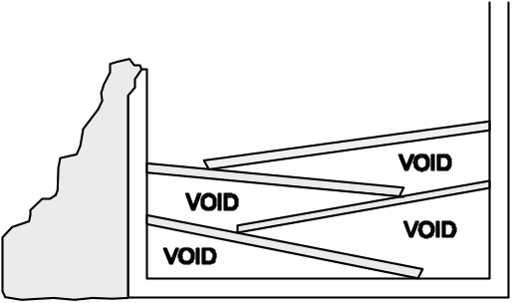

Pancake Void

Pancake Void, in which floors collapse diagonally onto each other, creating voids in the areas where the floors remain attached to the walls.

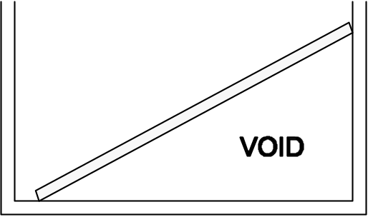

Lean-to-Void

Lean-To Void, in which a collapsed wall or floor leans against an outside wall, creating a void where the floor remains attached to the wall.



“V” Void

“V” void, in which the floor or wall collapses at or near the center, creating voids on either end next to the walls.

 |  |  | Conducting Search Operations (Continued)
 | Instructor’s Note |  |  | Provide several examples of pancake voids that have occurred other than in pre-1933 construction. For example:  - The bridge collapse in Oakland during the Loma Prieta Earthquake.  - The apartment complex collapse following the Northridge Earthquake.  Try to provide several nonearthquake-related examples.
 | Visual 5.16 |  |  |  | Conducting Search Operations  Lean-to Void  Visual 5.16
Tell the group that lean-to voids are created when a collapsed wall or floor is resting against an outside wall. A victim trapped in a lean-to void has the greatest chance of being alive.

Stress that lean-to voids also indicate structural instability. If CERT members see lean-to voids, they should note the location for professional responders but leave the building immediately!

 |  |  | Conducting Search Operations (Continued)
 | Visual 5.17 |  |  | Conducting Search Operations  “V” Void  Visual 5.17
Explain that “V” voids are created by a “V” collapse of a floor or wall (the middle collapses and the ends lean against an outside wall). Remind the group that a “V” void creates two lean-to voids, one on either side of the collapse, in which victims can be trapped—but stress that the sloping floor caused by the “V” collapse presents a severe potential hazard to the rescue team.

Stress that if CERT members encounter “V” voids, they should leave the building immediately.

 |  |  | Conducting Search Operations (Continued)
 | Visual 5.18 |  |  |  | Conducting Search Operations  Individual Voids  Visual 5.18
 |  |  | Explain that individual voids are spaces into which the victim may have crawled for protection. Examples of individual voids include bathtubs and the space underneath desks. Children may seek shelter in smaller spaces like cabinets.
 | Ask Question |  |  | Ask if anyone has any questions about the types of voids before continuing.
Tell the group that, after identifying the possible areas of entrapment, CERT members must:

- Determine the potential number of victims.

- Identify the most probable areas of entrapment.

Point out that some of this information may be known through planning, but CERT members may need to get some information by talking to bystanders or those who are familiar with the structure.

 |  |  | Conducting Search Operations (Continued)
 | Explain Questions |  | Explain that CERT members should ask questions when talking with these individuals, including:  - How many people live (or work) in the building?  - Where would they be at this time?  - What is the building layout?  - What have you seen or heard?  - Has anyone come out?  - What are the normal exit routes from the building?  Caution the group that bystanders may be confused by the event. They may tend to exaggerate potential numbers or may not even remember the event accurately. Tell the group to gather as much information as they can, though, because it will be useful for planning search priorities and implementing the search.

 |  |  | Conducting Search Operations (Continued)
 |  |  | Search Methodology
 | Visual 5.19 |  |  | Effective Search Methodology  - Indicates rescuer location  - Prevents duplication of effort  Visual 5.19
Introduce this section by telling the group that an effective search methodology:

- Indicates rescuer location.

- Prevents duplication of effort.

 | Visual 5.20 |  |  | Search Methods  - Call out to victims.  - Use systematic search pattern.  - Stop frequently to listen.  - Triangulate.  - Mark searched areas to document results.  - Report results.  Visual 5.20

 |  |  | Conducting Search Operations (Continued)
Tell the group that experienced search and rescue personnel have found these search methods to be effective:

- Begin the search by calling out to victims. Shout something like, "If anyone can hear my voice, come here." If any victims respond, give them further directions such as "Stay here" or "Wait outside" (depending on the condition of the building). Ask victims who respond for any information that they may have about the building or others who may be trapped.

- Use a systematic search pattern. Ensure that all areas of the building are covered. Examples of systematic search patterns to use include:

- Bottom-up/top-down.
- Right wall/left wall.

 | Instructor’s Note |  |  | Remind the group that those who do respond may be in shock and confused. Suggest that, when giving directions to victims, CERT members should look directly at the victims, speak in short sentences, and keep their directions simple.
 |  |  | - Stop frequently to listen. Listen for tapping, movement, or voices.
 | Visual 5.21 |  |  |  | Conducting Search Operations  Triangulation  Visual 5.21

 |  |  | Conducting Search Operations (Continued)
 |  |  | - Triangulate. Triangulation enables rescuers to view a single location from several perspectives. Three rescuers, guided by victim sounds, form a triangle around the area and direct flashlights into the area. The light shining from different directions will eliminate shadows that could otherwise hide victims.
- Mark searched areas to document results. Make a single diagonal slash next to the door just before entering a structure. Make an opposite slash (creating an "X") when all occupants have been removed and search and rescue efforts have been completed. The "X" signals to other potential searchers that the area has already been searched. This method:

- Indicates rescuer location.
- Prevents duplication of effort.

- Report results. Keep complete records both of removed victims and of victims who remain trapped or are dead. Report this information to emergency services personnel when they reach the scene.

 | Instructor’s Notes |  |  | Following this review of search methods, the instructor(s) should demonstrate how to conduct a search in a room, including search patterns (e.g., right wall/left wall) and marking next to doors. The demonstration can be done in any room; tables, chairs, and other items can be used to simulate debris.  Ask the participants if anyone has any questions about the procedures for planning and conducting search operations or the methods involved in an effective search.
 |  |  | Tell the participants that the next section will deal with conducting rescue operations.

 |  |  | Conducting Rescue Operations
 | Introduce Topic |  | Introduce this topic by telling the participants that rescues involve three primary functions.
 | Visual 5.22 |  |  | Conducting Rescue Operations  Primary Functions:  - Creating safe rescue environment  - Lift objects out of the way.  - Use tools to move objects.  - Remove debris.  - Triaging or stabilizing victims  - Removing victims  Visual 5.22
Explain that conducting rescue operations includes:

- Creating a safe rescue environment by lifting objects out of the way, using tools to move objects, and removing debris.

- Triaging or stabilizing victims.

- Removing victims when required by the sizeup.

Explain that each of these topics will be addressed separately.

 |  |  | Conducting Rescue Operations (Continued)
 |  |  | Creating a Safe Environment
 | Visual 5.23 |  |  | Creating a Safe Environment  Goals:  - Maintain rescuer safety.  - Triage in lightly and moderately damaged buildings.  - Evacuate victims quickly from moderately damaged buildings—minimize injury.  Visual 5.23
Tell the participants that there are three goals for all rescue operations:

- To maintain rescuer safety

- To triage in lightly and moderately damaged buildings

- To evacuate victims as quickly as possible from moderately damaged buildings while minimizing additional injury

 |  |  | Emphasize that none of these goals can be achieved without creating as safe an environment as possible before attempting rescue. There are, therefore, certain precautions that rescuers must take to minimize risk.

 |  |  | Conducting Rescue Operations (Continued)
 | Visual 5.24 |  |  | Precautions to Minimize Risk  Safe Environment:  - Know your limitations.  - Follow safety procedures.  - Remove debris by:  - Leveraging.  - Cribbing.  Visual 5.24
- Know your limitations. Many volunteers have been injured or killed during rescue operations because they did not pay attention to their own physical and mental limitations. CERT rescuers should take the time to eat, drink fluids, rest, and relax so that they can return with a clear mind and improved energy.

- Follow safety procedures. CERT members should always use the proper safety equipment required for the situation and follow established procedures, including:

- Working in pairs.
- Never entering an unstable structure.
- Lifting by bending the knees, keeping the back straight, and pushing up with the legs.
- Carrying the load close to the body.
- Lifting and carrying no more than is reasonable.

 | PM, P. 5-24 |  | Refer the participants to the diagram titled, Proper Body Positions for Lifting, in the Participant Manual.

 | PM, P. 5-24 | Proper Body Position for Lifting

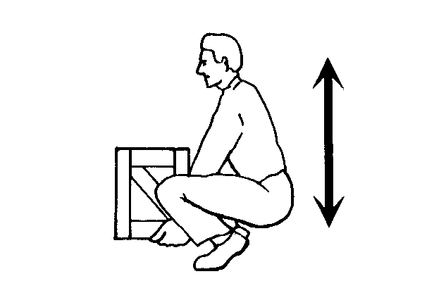
Proper Body Position for Lifting showing the back straight and lifting with the knees.

 |  |  | Conducting Rescue Operations (Continued)
 |  |  | Tell the participants that they may encounter situations in which debris needs to be moved to free victims. In these situations, CERT rescuers should consider leveraging and cribbing to move and stabilize the debris until the rescue is complete.
- Leveraging is accomplished by wedging a lever under the object that needs to be moved, with a stationary object underneath it to act as a fulcrum. When the lever is forced down over the fulcrum, the far end of the lever will lift the object.

- A crib is a wooden framework used for support or strengthening. Box cribbing means arranging pairs of wood pieces alternately to form a stable rectangle.

 | Instructor’s Note |  |  | Demonstrate leveraging and cribbing for the group.
 | PM, Behind Unit 5 |  | Refer the participants to the section, titled Additional Materials, at the end of Unit 5 in the Participant Manual, for a description of a leveraging and cribbing operation and an illustration of procedures for box cribbing.
 | Instructor’s Note |  |  | These materials are also included in this Guide for your reference, starting on page AD-5-3.
Explain that leveraging and cribbing are used together by alternately lifting the object and placing cribbing materials underneath the lifted edge to stabilize it. Safety is number 1: "Lift an inch; crib an inch."

Caution that leveraging and cribbing should be gradual—both for stability and to make the job easier. It may also be necessary to use leveraging and cribbing at more than one location (e.g., front and back) to ensure stability.

 |  |  | Conducting Rescue Operations (Continued)
 | Instructor’s Note |  |  | Emphasize that leveraging and cribbing at opposite ends should never be done at the same time because doing so will increase the instability of the debris. Suggest that, if leveraging is required at both ends, the participants should lift and crib at one end, then repeat the process at the other end.
 |  |  | Warn the participants that when they are able to achieve sufficient lift, they should remove the victim and reverse the leveraging and cribbing procedure to lower the object. Stress that they must never leave an unsafe condition.
 |  |  | Tell the group that when they must remove debris to locate victims, they should set up a human chain and pass the debris from one person to the next. Caution them, however, to set up the chain in a position that will not interfere with rescue operations. Also, remind them to wear leather gloves to protect their hands.
 | Instructor’s Note |  |  | Ask the participants if anyone has any questions about conducting rescue operations.
 | Ask Question |  |  | Ask the group several "What would you do if?" questions to ensure that they understand the material. When asking the questions, set up a brief scenario and ask what the participants would do in that situation.
 |  |  | When it is clear that the participants understand the concepts of conducting rescue operations, tell them that the next section will cover removing victims.

 |  |  | Conducting Rescue Operations (Continued)
 |  |  | Removing Victims
 | Visual 5.25 |  |  | Removing Victims  Types of victim removal include:  - Self-removal or assist.  - Lifts and drags.  Allow victims to extricate themselves when possible.  Visual 5.25
Introduce this section by explaining that there are two basic types of victim removal:

- Self-removal or assist

- Lifts and drags

Explain that it is usually best to allow an ambulatory victim to extricate himself or herself. Caution the group, however, that sometimes ambulatory victims are not as strong and uninjured as they think they are. When victims become free from entrapment, they may need assistance to exit the structure.

 |  |  | Conducting Rescue Operations (Continued)
 | Visual 5.26 |  |  | Extrication Method  Depends upon:  - General stability of immediate environment.  - Number of rescuers available.  - Strength and ability of rescuers.  - Condition of victim.  Visual 5.26
Explain that the type of extrication method selected should depend on the:

- General stability of the immediate environment.

- Number of rescuers available.

- Strength and ability of the rescuers.

- Condition of the victim.

Explain that the participants will learn the basic types of victim removal and will have the opportunity to practice some of the techniques.

 |  |  | Caution the participants that, if safety and time permit, they should not use lifts and drags to remove victims when closed-head or spinal injury is suspected. In such cases, the spine must be stabilized using a backboard. Doors, tables, and similar materials can be used as improvised backboards. Stress that the backboard must be able to carry the person, and that proper lifting techniques must be used. When moving victims, rescuers must use teamwork and communication, and keep the victim's spine in a straight line. Remember, rescuer safety and the condition of the building will dictate the approach.

 |  |  | Conducting Rescue Operations (Continued)
 | Instructor’s Note |  |  | Review the symptoms of head and spinal injury if necessary.
 | PM, PP. 5-27 & 5-28 |  | Point out that there are several types of lifts and carries. Refer the participants to the illustrations titled, Types of Lifts and Carries, in the Participant Manual. For example, if some participants are physically able and the victim is small, they may use the one-person arm carry to lift and carry the victim themselves by:  - Reaching around the victim's back and under the knees.  - Lifting the victim while keeping the rescuer's back straight and lifting with the legs.
 | Instructor’s Note |  |  | Demonstrate this carry using a participant volunteer as the victim. Then, have all participants who are physically able pair up and practice the carry themselves. Note: Consider the size of the victim and the distance he or she needs to be carried before using this carry.  Give permission for participants to opt out of any carry with which whey don’t feel comfortable. Remind the participants that CERT members’ safety is the number one priority.
Tell the participants that another way for a single rescuer to lift a victim safely is by using the one-person pack-strap carry. Using this method, the rescuer should:

- Step 1: Stand with his or her back to the victim.

- Step 2: Place the victim's arms over the rescuer's shoulders and grab the hands in front of the rescuer's chest.

 |  |  | - Step 3: Hoist the victim by bending forward slightly, until his or her feet just clear the floor.
 | Instructor’s Note |  |  | Demonstrate this lift using two instructors. Then have the participant pairs practice the lift.

 | PM, P. 5-27 | Types of Lifts and Carries

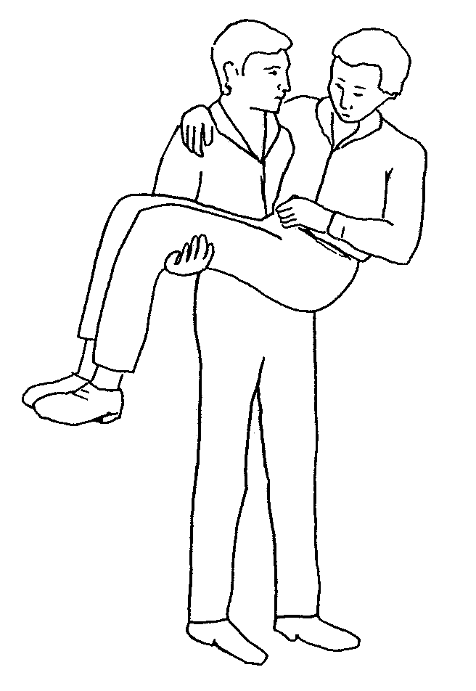
One-Person Arm Carry

One-Person Arm Carry, which shows the rescuer holding the victim around the victim’s back and under the knees.

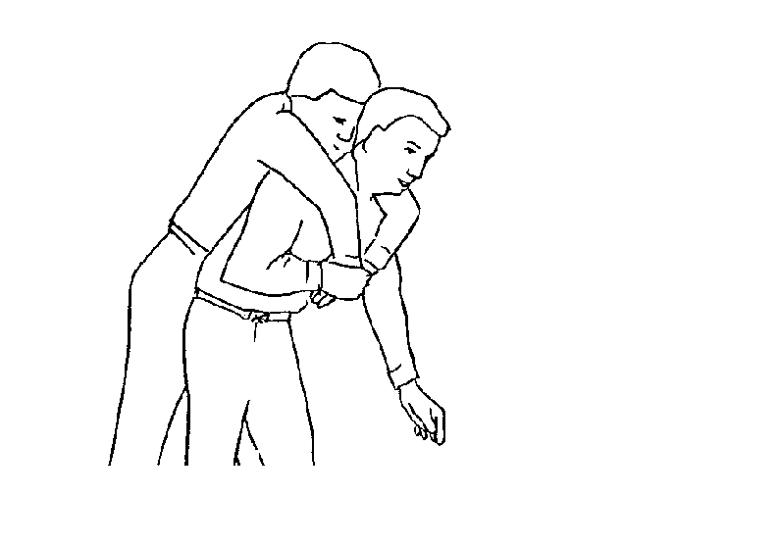
One-Person Pack-Strap Carry

One-Person Pack-Strap Carry in which the rescuer places the victim’s arms over his or her shoulder and grabs the victim’s hands over his or her chest, then hoists the victim by bending over slightly.

 | PM, P. 5-28 | Types of Lifts and Carries

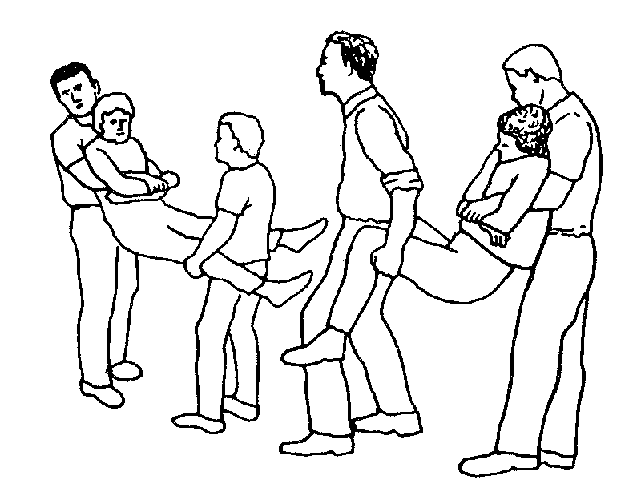

Two-Person Carry

Two-Person Carry in which rescuer 1 squats at the victim’s head and grasps the victim from behind at the midsection. Rescuer 2 squats between the victim’s knees, grasping the outside of the knees. Both rescuers rise to a standing position.

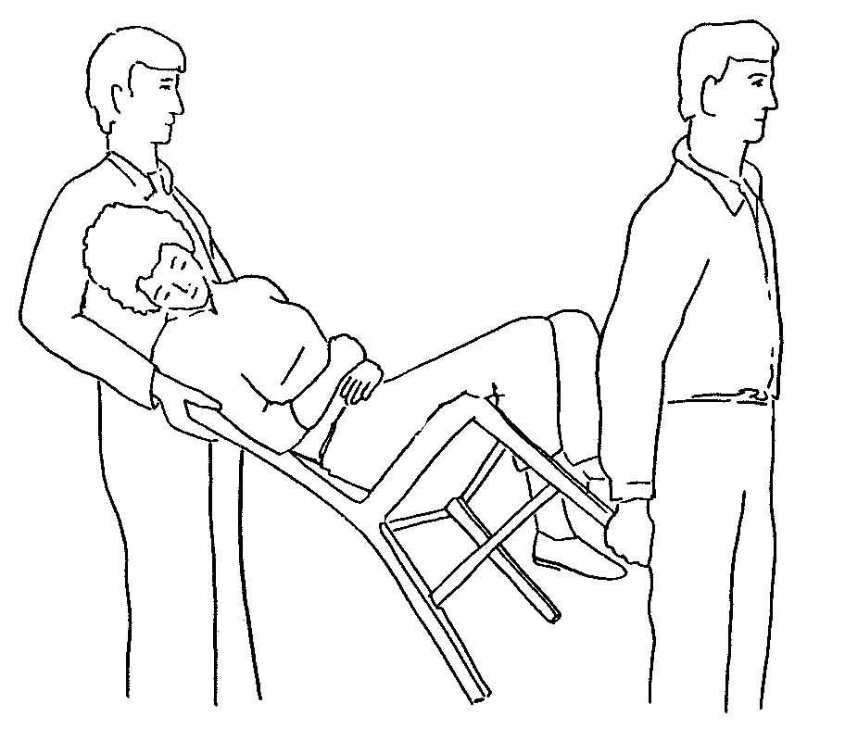
Chair Carry

Chair Carry in which the victim is placed in a chair and tilted backward as rescuers lift the victim. This carry requires two rescuers.

 |  |  | Conducting Rescue Operations (Continued)
Explain that victim removal is easier when multiple rescuers are available. With two rescuers, a victim may be removed using a two-person lift.

- Rescuer 1: Squat at the victim's head and grasp the victim from behind around the midsection. Reach under the arms and grasp the victim's forearms.

- Rescuer 2: Squat between the victim's knees, facing either toward or away from the victim. Grasp the outside of the victim's legs at the knees.

- Both rescuers: Rise to a standing position, keeping backs straight and lifting with the legs. Walk the victim to safety.

 | Instructor’s Note |  |  | Demonstrate this lift using a participant volunteer as the victim. Allow all participants who are physically able to practice the lift: Assign the participants into groups of three (two rescuers and one victim), and rotate roles so that each person has a chance to try the two rescuer positions.
Demonstrate that two rescuers can also remove a victim by seating him or her on a chair:

- Rescuer 1: Facing the back of the chair, grasp the back uprights.

- Rescuer 2: Facing away from the victim, reach back and grasp the two front legs of the chair.

- Both rescuers: Tilt the chair back, lift, and walk out.

 | Instructor’s Note |  |  | Using a sturdy chair, demonstrate this carry using two instructors as rescuers and a volunteer participant as a victim. Then, have all participants who are physically able practice the carry, working in the same three-person groups.

 |  |  | Conducting Rescue Operations (Continued)
Tell the participants that they can use the blanket carry for victims who cannot be removed by other means. Caution the participants that the blanket carry requires at least six rescuers to ensure stability for the victim and that one rescuer must be designated the lead person:

- Step 1: Lay a blanket next to the victim.

- Step 2: Tuck the blanket under the victim, and roll the victim into the center of the blanket.

- Step 3: With three rescuers squatting on each side and grasping a "handle," the lead person checks the team for even weight distribution and correct lifting position.

- Step 4: The lead person calls out, "Ready to lift on the count of three: One, two, three, lift."

- Step 5: The team lifts and stands in unison— keeping the victim level—and carries the victim feet first.

Point out that the team must also lower the victim together, using the following steps:

- Step 1: The lead person calls out, "Ready to lower on the count of three: One, two, three, lower."

- Step 2: The team lowers the victim in unison, exercising caution to keep the victim level.

 | Instructor’s Note |  |  | Ask participants to volunteer to demonstrate the blanket carry. Make sure that all participants have an opportunity to practice using the carry.
 |  |  | Explain that a variety of materials—such as blankets—can be used as improvised stretchers.

 |  |  | Conducting Rescue Operations (Continued)
 | PM, PP. 5-29 & 5-30 |  | Point out that rescuers can also drag a victim out of a confined area by grasping either under the arms or by the feet and pulling across the floor. (Refer the participants to the diagram, titled Correct Drag Techniques, in the Participant Manual for an illustration.) Caution the participants, however, that unless there is no other way to remove the victim and the victim's removal is time critical, they should not use this drag when debris may cause additional injury.

 | PM, P. 5-29 & 5-30 | Correct Drag Techniques

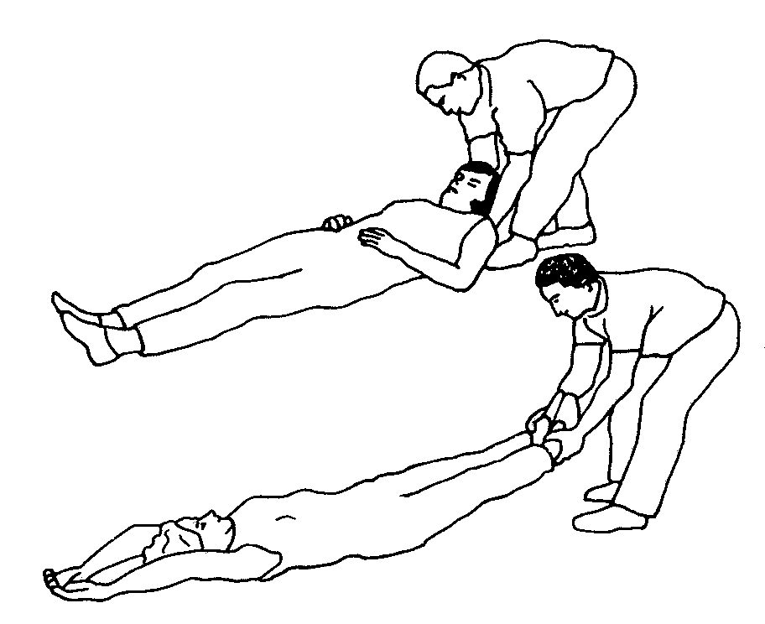

Correct Drag Technique

Correct Drag Technique, showing the rescuer grasping the victim by either the feet or shoulders and dragging him or her clear of the hazard.

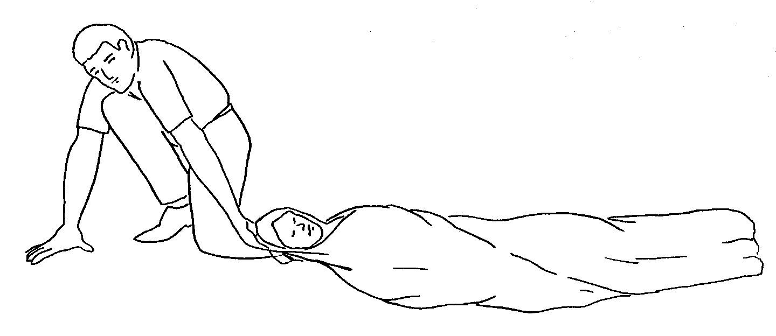
Blanket Drag

Blanket Drag, showing the victim wrapped in a blanket with the rescuer squatting at the victim’s head. The rescuer grasps the blanket behind the victim’s head and drags him or her clear of the hazard.

 |  |  | Conducting Rescue Operations (Continued)
Explain also that, when necessary, one rescuer can use the blanket drag by following these steps:

- Step 1: Wrap the victim in a blanket.

- Step 2: Squat down and grasp an edge of the blanket.

- Step 3: Drag the victim across the floor.

 | Instructor’s Note |  |  | Ask the participants if anyone has any questions about rescue operations or victim removal.
 |  |  | Explain that the participants will now have an opportunity to practice some of the victim removal techniques.
 |  |  | Exercise: Removing Victims
 | Conduct Exercise |  | Purpose: This exercise will provide the participants with an opportunity to practice the removal of victims from a collapse situation, using leveraging/cribbing and drags and carries. The participants will be assigned into groups and assigned to do a room search, locate victims, and remove the victims. By using two or three rooms simultaneously, so that there are several "rescues" occurring at once, a more realistic scenario can be created.

 |  |  | Conducting Rescue Operations (Continued)
 |  |  | Instructions: Use the following steps to conduct this exercise:
- Assign the participants to groups of six. Ask two members of each group to be victims first.

- Arrange the victims at the collapse site(s), using desks, shelves, etc., to represent debris. Place other items haphazardly around the victims. Make sure that there are items available that can serve as levers (e.g., 2" x 4"s) and fulcrums.

- Instruct the groups to enter their respective "collapse site" rooms, do a room search, locate the victims and use leveraging and cribbing procedures to free them, and use appropriate lifts and drags to remove the victims from the room (and, if possible, from the building).

 | Instructor’s Note |  |  | Instructors should observe each group and correct errors that they see.
 |  |  | - Have the teams rotate roles so that there are two new victims. Rearrange the victims and "debris," and repeat the exercise until each participant has had an opportunity to practice being a rescuer.
 |  |  | - Discuss the exercise with the entire group, focusing on any differences between the teams' techniques and experiences.

 |  |  | Unit Summary
 | Present Key Points |  | Summarize the key points in this unit:  - Search and rescue consists of three different activities that must be planned carefully and practiced in advance. The decision to attempt a rescue should be based on:  - The risks involved.  - Achievement of the overall goal of doing the greatest good for the greatest number.  - The objectives of search and rescue are to:  - Maintain rescuer safety at all times.  - Rescue the greatest number of people in the shortest amount of time.  - Rescue the lightly trapped victims first.  - Remind the participants that CERTs are restricted to light search and rescue. Their mission when dealing with heavily damaged structures or situations that are clearly unsafe (e.g., rising or swiftly-moving water) is to warn others.  - Search and rescue sizeup follows the same process as does sizeup for other CERT operations. Sizeup continues throughout search and rescue efforts and provides information about how to proceed. Should sizeup indicate that evacuation is necessary, the CERT mission is to ensure safety and organization during the evacuation.
- When the decision to begin search operations is made, CERT searchers must:

- Employ appropriate search techniques.
- Locate potential victims.

- Locating victims means completing a sizeup of the building interior to identify areas of entrapment, then conducting a search that:

- Is systematic and thorough.
- Avoids unnecessary duplication of effort.
- Documents results.

 |  |  | Unit Summary (Continued)
- Rescue involves three main functions:

- Creating a safe environment
- Triaging or stabilizing victims
- Removing victims based on the sizeup

Rescue operations hinge on maintaining rescuer safety, which requires CERT members to recognize their own limitations. CERT members should never attempt anything that exceeds their limitations at that point in time.

Leveraging and cribbing may be used to remove debris and give access to trapped victims.

Victims can be removed in a number of ways, depending on:

- Their condition.

- The number of rescuers available.

- The strength and ability of the rescuers.

- The stability of the environment.

Remind the participants of the lifts and drags that they found easier to accomplish and suggest that they use those drags and carries when circumstances permit.

If the building’s condition allows, victims with suspected head or spinal injury should be stabilized on some type of backboard before being removed. If possible, these removals should be deferred to trained EMS personnel.

 | Instructor’s Note |  |  | Ask the participants if anyone has any questions about anything covered in this unit.
 |  |  | Homework Assignment
Ask the group to read and become familiar with Unit 6: CERT Organization and Unit 7: Disaster Psychology before the next session.

Thank the participants for attending the session. Remind them of the time and location of the next session, if necessary.

