Going Further
Quality Assurance and the ISIR Analysis Tool
Hands - On Session
During this session we will work through the new School Verification Analysis (Shared) Report. This report is designed to show what types of students are the most likely to be verified with little consequence to their aid eligibility and – when using random sample data – which records not selected by current verification would experience a major change if they were. We will follow the following work plan:
- Review the Ad hoc report writer Report Assistant
- Run the new School_Verfication_Analysis shared report
- Take a behind the scene tour of the new School_Verfication_Analysis report
- Analyze your own school’s results
- Share results and discuss how to apply them
- If time permits – get your feedback for improvement

This session assumes that all participants have uploaded sample data and set their school verification flags.

Does any one need to apply for amnesty?

If any school has not loaded data we ask that they partner up with someone else who has.

If a school has uploaded their data, but has not set the school verification flags, we ask that they substitute the CPS_Verification_Analysis report in all instructions referencing the School_Verification_Analysis. The two reports are very similar to each other. The only difference between the two reports is which verification flag they use in the analysis.

Step 1: Review Report Assistant

Action: Log into the Tool

- Log into the ISIR Analysis Tool by clicking on the ISIR Analysis Tool icon available on the desktop or launching Microsoft Explorer, going to favorites, and selecting ISIR Analysis Tool. These will link to the FAA Acess to CPS Online Home Page http://www.fafsa.ed.gov/FOTWWebApp/faa/faa.jsp
- From the menu bar – Select Analysis of Data.
- Select continue.
- If the Security Alert box displays, select yes.
- The Data Analysis page should display.
- In the domain trean, click on the the box next to IA Tool folder.

Action: Open Report Assistant

To Access the Custom Report folder to create an Ad hoc report:

- Click on the box next to Reporting Objects folder on the left toolbar.
- Click on the next to Custom Reports folder.
- Right click on Ad Hoc.
- From the drop down menu, select Report Assistant.
- Maximize the Report Assistant window.

Define new fields

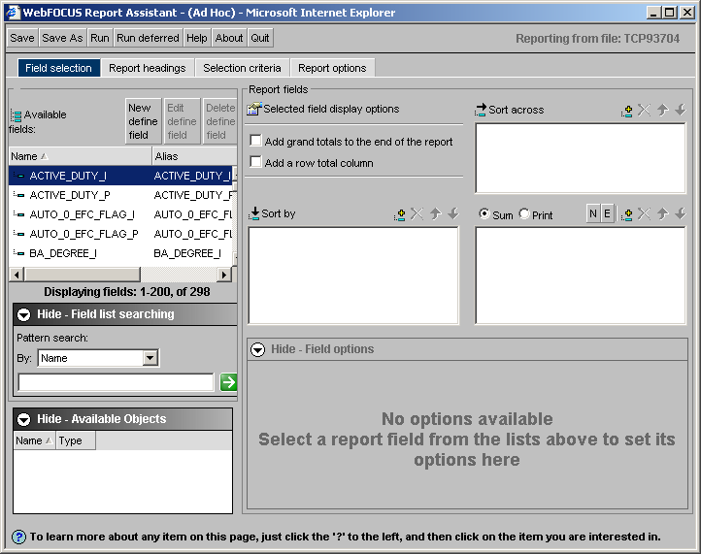
Buttons
Tabs
Row groupings
Column groupings
Report Values
Available fields
Field Options

The Buttons
The seven buttons that run along the top to screen are available in all tabs. Use them to:
- Save – save the current report settings
- Save as – save the current report settings under a new name
- Run – execute the report
- Run deferred – not currently supported
- Help – access the off the shelf Report Assistant online help documentation
- About – display technical information about the version of Report Assistant being used
- Quit – leave Report Assistant

The Tabs
Use the four tabs below the buttons to:
- Field selection – select fields, define new fields, choose how to include fields in reports, and set display options
- Report headings – enter heading and footing text
- Selection criteria – limit the records included in the report
- Report options – select the format for report output (e.g., HTML, Excel, etc.)

The Field Selection Tab
Report Assistant opens in the Field Selection tab. This is appropriate, as users will spend the vast majority of their time authoring Ad hoc reports working under this tab. Let’s just take a quick guided tour. Feel free to “click along” on your own computer during this “tour” or simply follow along with the instructor as we point out various aspects of the Field Selection tab.

To select fields use the box labeled “Available Fields.” Simply highlight the field(s) you would like to include in your report. Hint – to select multiple fields hold down the control key.

You have choices in how you include the selected fields in a report. Fields can be “Report Values” or be used to define “Column or Row Groupings.” See the annotated screen shot above. You place highlighted fields in the desired box by clicking on the “yellow/teal, plus/minus sign” icon above the desired box. If you want to group records based on their value, place the selected field(s) in either “Sort by” or “Sort across” windows. If you want the report to reflect the values the individual or aggregated values of the selected field in the box under Sum and Print area. You can add as many fields as you want to the boxes.

Clicking Sum or Print above the report values box changes the options available for displaying the values of select fields in this box. Select Print when you want to the report to be a listing of all individual student values for the selected fields and to select Sum when want a report summarizing the values of multiple students in a single statistic (e.g., average or sum). Note that the default has changed from Print to Sum.

When you highlight a field in the report value box, you can make formatting selections in the Field Options box. When Print is selected the options are: Plain Field Value: Number of distinct values; Percentage; and Total. When Sum is selected the options are: Plain Field Value; Average Square; Average; Count; Count Distinct; Number of distinct values; Show first in group; Show last in group; Maximum; Minimum; Percentage; Count Percentage; Row Percentage; Sum; and Total.

Report Assistant has a function called New Define Field that allows you to define new fields that reflect either the values of currently available fields and/or the results of calculations. Once defined you can use any newly defined field just as you would any available field, (e.g. as an element in a report or selection criteria).

Action: Define New Field

To create a new field, click on New Define Field button.
- Wait for the define Field Creator window to load.
- In the Field area in the upper left-hand corner of the calculator window, enter a name for the new field. For this example enter EFC_Change. We will create a field that calculates the change between the initial EFC and paid-on EFC.
- Click the (List) icon on the right side of the screen to get a listing of fields. Scroll down and double click on EFC_P. Notice this field is added to the calculator window.
- On the calculator pad, click the - (minus) sign to the left of the number 4.
- Under the List icon double click EFC_I.
- On the calculator pad, click the OK to close the calculator pad. You should be back to the Field Selection tab.
- Find the newly defined field in the Available fields window. They are listed alphabetically. Note the function symbol that indicates defined fields. Also note that when you highlight ---- also the activated buttons that would allow you to Edit define field or Delete define field. Report Assistant can only display 200 fields at once. Clicking Next at bottom of the list, will display additional fields.

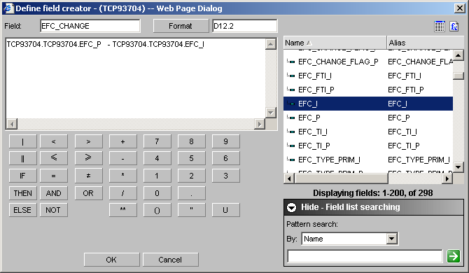

Action: Add New Field to Report

Follow these following instructions to add the new “EFC_Change” as a report value.
- Highlight EFC_Change in the Available Fields box.
- Click the yellow/teal “plus/minus sign” icon above the report values box, just to the right of the sum/print options.
- Select the Print option above the report values box.
- In the report values box confirm that EFC_Change in the report values box is highlighted.
- In the field options box confirm that the default “(Plain field value)“ is selected.

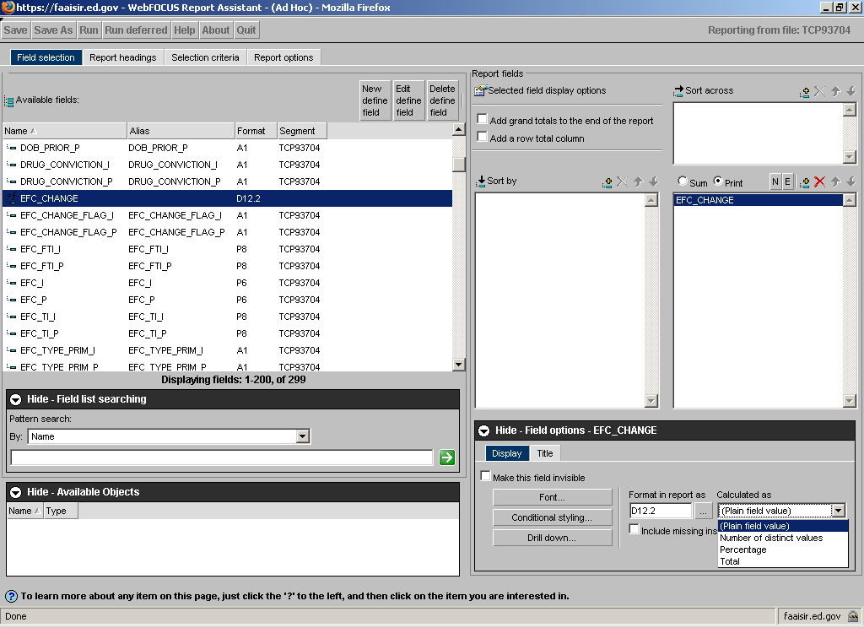

The Report Headings Tab
Clicking on the Report headings tab allows you to enter information to be displayed at the top (Heading) and bottom (Footing) of each page of the report. We will not be adding any information on this tab today, but we did want to show this tab breifly. You may “click along” with the instructor or simply just watch the screen in front during this section of the training.

After selecting the Report headings tab under Page Heading you may enter any desired heading. On the bottom of screen, under Page Footing contains by default “Report Sample Size: <TOT.STUDCNTR.” This will display “Report Sample Size: #” with the number being the count of students who satisfy any selection criteria imposed. You enter any desired changes in the Page Footing box. There are a variety of formatting options for the text in the Heading and Footing (e.g., justification, font, etc.).

Action: Add Selection Criteria

The Selection Criteria Tab
There are two ways to add selection criteria. There are predefined “available filters.” You may also use any available field(s) to define your own logical conditions. Let’s look at an example of both.
- Click the Selection Criteria tab at the top of the screen
- In the Available Filters (bottom of screen), scroll down and double click on the desired filter. In this example double click the funnel icon next to Dependent Students.
- In the Available Fields area, scroll down and double click on any field you want to include in a logical condition. For this example scroll down and double click on: PAR_TAX_FIG_I
- To complete the “Where” statement, select the Field Operator Down button and select EQUAL TO. Click on SELECT VALUES and click on the Constant radio button and enter 2. Select OK

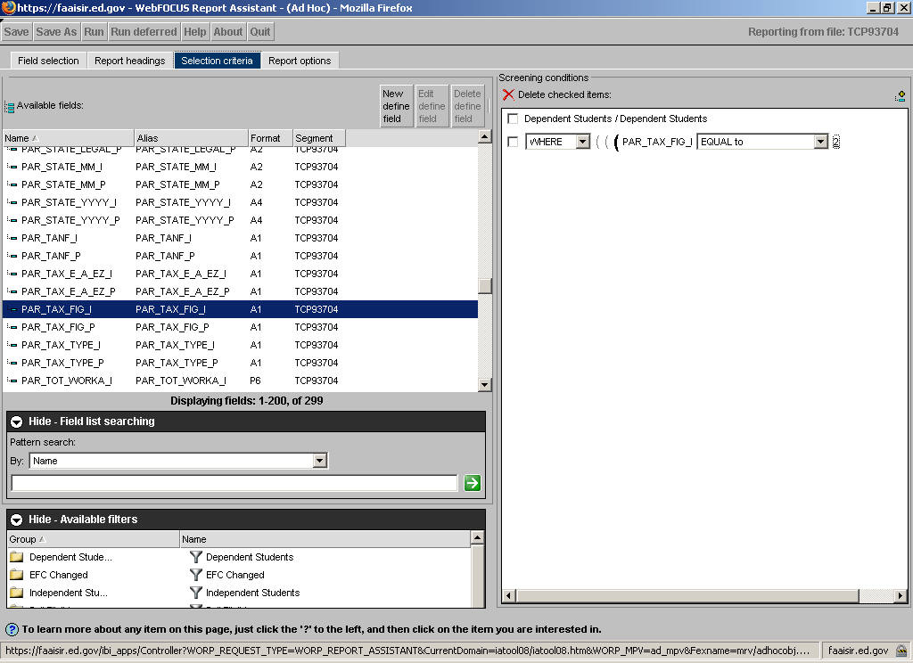

Action: Select Report options

The Report Options Tab
To select the report format:
- Prior to running the report, select the Reports Options tab.
- Under the Generate Report As section, click on the down arrow and select. EXL-97 – Excel 97. (You may also select another version of Excel depending upon the version you have on your computer)

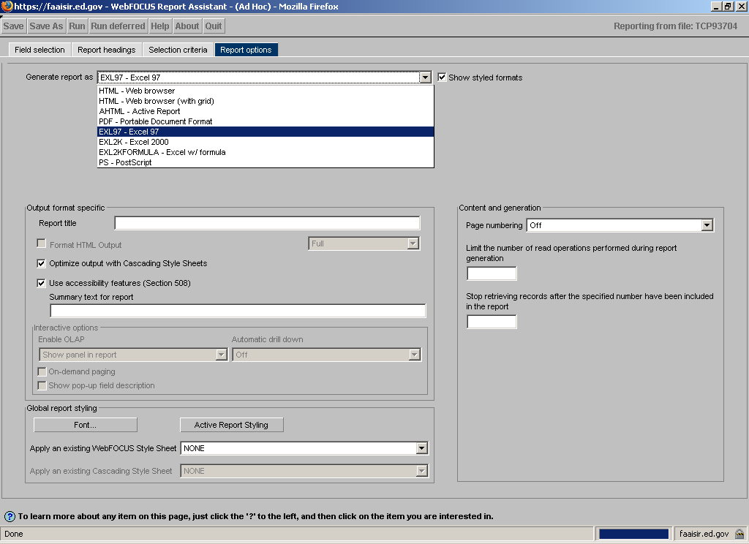

Action: Save the report and run

To Save and Run the AD hoc Report:
- Select the Save button. Helpful hint: Do not use spaces when naming your report. Use the underscore bar. In the description box enter the name EFC_CHANGE_LISTING
- Generally we recommend you check the Share Report to make your AD Hoc report available for use by any QA school, but since this is just a training exercise leave that box empty.
- After entering the name of the report, click OK.
- On the tool bar, click Run. The Ad Hoc Report will display in Excel Format – You may get a window asking you how to download the file being generated. Choose Open to launch the Excel document.
- The report should be a column of numbers that reflect the change in EFC for the records who were dependent students and had estimated parental tax information.
- You can now save this report as an Excel Workbook on the desktop. Within Excel click File, SAVE AS, and then enter a name such as EFC_CHANGE_LISTING. Under the SAVE AS section, click on the down arrow and select Microsoft Excel Workbook as the type. Click SAVE. You may receive a pop up box regarding formatting. If so, simply click YES.
- Exit Excel by clicking on the red “X” in the top right-hand corner. This will bring you back to the Report Assistant.

Action: Modify to display average change

In addition to creating lists of data from the Tool, you can use Report Assistant to present summary information. To demonstrate this, let’s modify the report we just finished and create a second report that displays the average EFC change rather than a list of all of the changes.
- Click on the Field Selection tab.
- Change the selection of Print to Sum above the report values box.
- Confirm that EFC_CHANGE in the report values box is highlighted.
- In the Field Options box, click on the arrow () under “Calculated as” and select Average.
- Select the Save As button. Enter the name EFC_CHANGE_AVG in the description box.
- After entering the name of the report, click OK.
- On the tool bar, click Run. The Ad Hoc Report will display in Excel Format.
- The report should be single value that reflects the average change in EFC for the records who were dependent students and had estimated parental tax information.
- You can now save this report as an Excel Workbook on the desktop. Within Excel click File, SAVE AS, and then enter the EFC_CHANGE_AVG. Under the SAVE AS section, click on the down arrow and select Microsoft Excel Workbook as the type. Click SAVE. You may receive a pop up box regarding formatting. If so, simply click YES.
- Close Excel.
- To go back to the domain tree close out of the report we just ran by selecting the X in the to right hand corner of the report.

Any questions on the Report Assistant review?

Step 2: Run the new School Verification Analysis Report

We have created two new shared reports – School_Verification_Analysis and CPS_Verification_Analysis – that we hope will help you see what types of students your current verification procedures may be missing as well as identify the types of students that your current selection procedures may be burdening unnecessarily. We designed the reports to minimize the amount of “programming” work you have to do. Other than the verification selection criteria they use in defining the results, the School and CPS versions are identical.

Action: Access Shared Report

From the domain tree of the ISIR Tool:
- Click on Shared Reports folder.
- Go to + Brigham Young University and select + Custom Reports
- Right Click on “School Verification Analysis” and select “Save As My Report” and select “OK.”

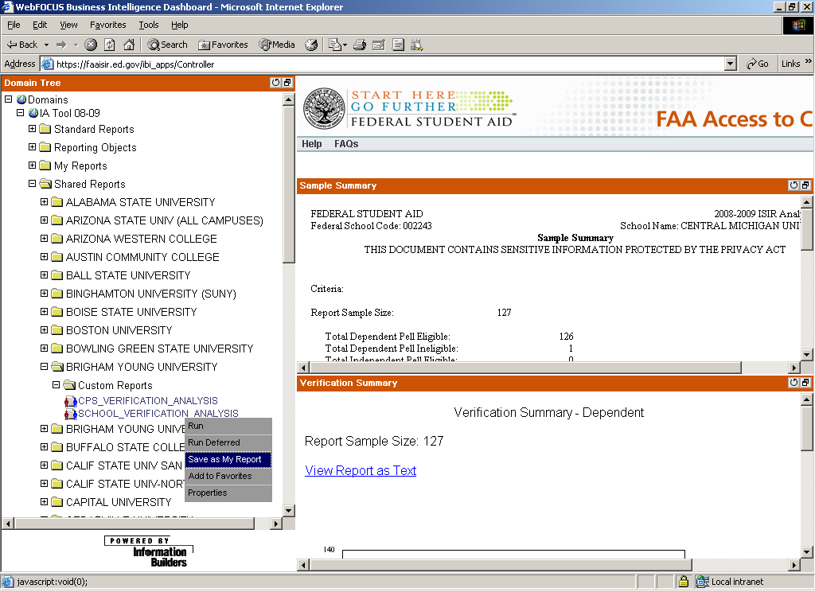

These “reports” will produce counts of specific types of students by whether or not they were selected for verification and whether or not they experienced a “major change” in eligibility for need based aid. As explained below you have the option of setting your own threshold as to what change in EFC constitutes a “major” change.

Cutting and pasting the output of these reports into Excel templates we have prepared will produce a series of 24 graphs that allow you to “see” your results in a format that we hope helps you identify areas in verification procedures to tweak. As explained in more detail below these templates do assume that the information is in a specific order, therefore it is essential that you not modify the content of the report. Your data uploaded into ISIR Tool must contain at least some records that are dependent students and (this sample year) some records not normally selected for the verification. Again other than the labels they apply to the output the two versions (School and CPS) of the two templates are the same. During this training we will work exclusively on the School verification version. If you are so inclined, you could follow the exact same steps for the CPS verification version when you get home.

Action: Run Shared Report

- Go to My Reports and click on custom reports then left click on School_Verification_Analysis.
- This will run the report and generate an Excel workbook.
- If you get a warning box asking for instructions on how to handle the downloading of the file, click OPEN.
- IMPORTANT – BUT RARELY AN ISSUE – make sure that that the EXCEL output contains all the combinations of SELECTED_BY_SCHOOL and MAJOR_CHANGE in the order indicated below. The vast majority of schools should have all their bases covered. Note there are 2 merged rows between the field name and the values. If any row is missing, simply use Excel to insert a row in the right location(s). You do not need to add any content to the row. A blank row will correctly position whatever data are there.

SELECTED_BY_SCHOOL | MAJOR_CHANGE
NO | NO
 | YES
YES | NO
 | YES

- JUST AS IMPORTANT – BUT EVEN MORE RARE – You must have some dependent students in the data uploaded in the Tool for the information to be in the right location for the graphs produced by the templates. In the unlikely event that you have ONLY independent records uploaded and want to run the shared report and use the templates, you must highlight cells 1C to 1AC, Select insert, and choose columns. This will correct the placement of data when only independent records are present.
- After confirming all data is in the position assumed by the template, left click in the box next to column A – this will copy entire sheet.
- Open the “School Verification Graphs” Excel document from the Desk Top.
- Paste the information generated by the School_Verification_Analysis Report by placing the cursor on A1 in the “Paste Data Here” tab of the School Verification Graph Excel template, right click and select paste.
- Click through the tabs of the bottom of the School Verification Graphs Excel Workbook to review your 24 graphs.
- Save the Excel spreadsheet.

That’s all there is to running the report. Are there any questions about how to run the shared report and paste the results into the Excel template before we take a brief tour in Report Assistant to understand how the results were generated?

Step 3: Tour the new School Verification Analysis Report

Depending on how we are doing on time, we may truncate this “step” during the training session, but we did want to let you know – in at least written form – how the shared report produced its results. Also note that there are two easy to use options that will allow you to tailor the report to your school’s needs.

Action: Touring the School Verification Analysis Report

- Go to My Reports and click on Custom Reports then right click on “School Verification Analysis” and select Report Assistant. Report Assistant should open as indicated on the next page.

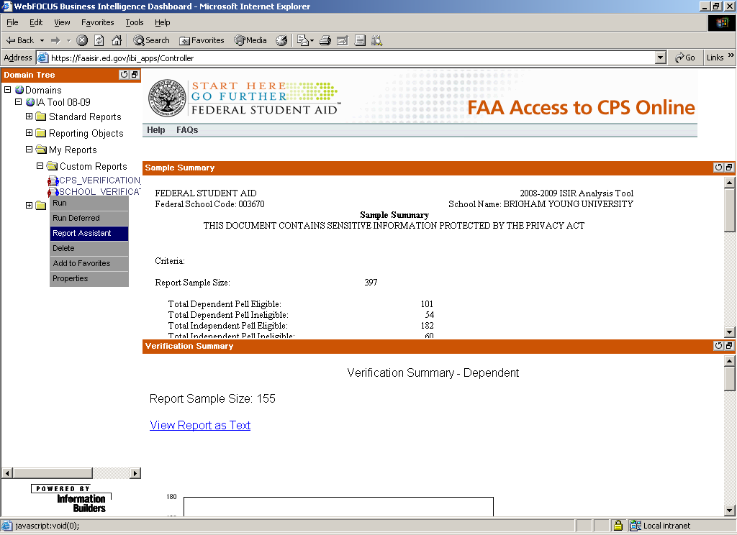

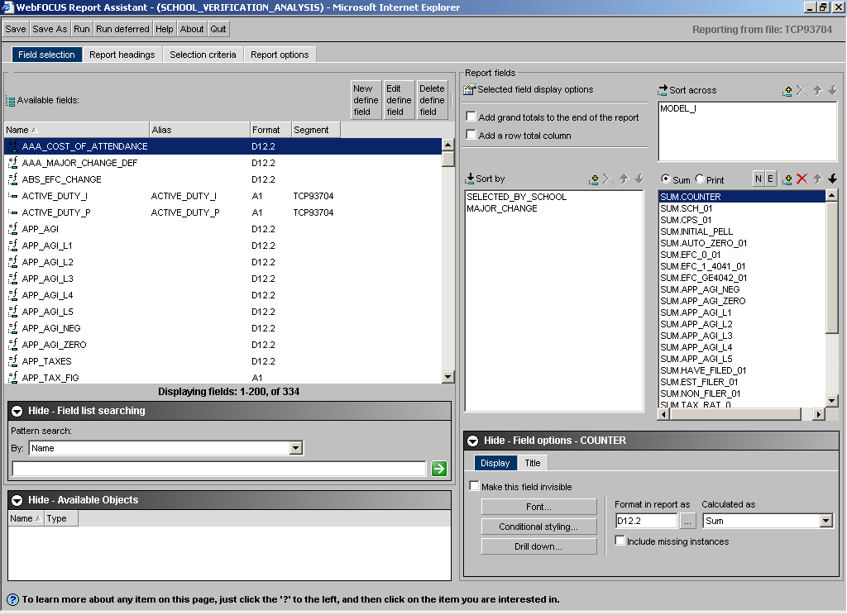

- Note the first two defined fields in the Available Fields box: AAA_COST_OF_ATTENDANCE and AAA_MAJOR_CHANGE_DEF. You have the option to customize these two fields.
- The report uses the AAA_COST_OF_ATTENDANCE field as a selection criteria; selecting only students who have an EFC (initial or paid on) less than the specified value. By default this value is set to $17,336 – the national average for in-state public four-year students in 2007-08. To change this highlight AAA_COST_OF_ATTENDANCE and click on the Edit Define Field button. Change the value to reflect the average cost of attendance at your school or some other meaningful threshold, e.g., your school’s EFC threshold for packaging grant aid or a maximum EFC for eligibility for a state scholarship. Click OK.
- By default the report will define as a major change in aid eligibility any change to a Pell award or an absolute value change to EFC in excess of 400. If you would prefer a lower or higher EFC threshold, highlight AAA_MAJOR_CHANGE_DEF. Click on the Edit Define Field button. Change the value to any positive number you like. The higher you set your EFC threshold, the more exclusively your results will reflect only changes to Pell awards. Click OK.
- The report uses MODEL_I (D for dependent students and I for independent students) to SORT ACROSS. This means that the report will display columns of all information first – from left to right – for dependent students and then display values for independent students. The order is determined alphabetically; D comes before I. Warning if your database contains only independent students, the graphs in the template will be mislabeled.
- The report uses SELECTED_BY_SCHOOL (No and Yes) and MAJOR_CHANGE (No and Yes) to SORT BY. This means that the first row of data in the report will display information for records that were not selected by school verification and did not experience a major change. The second row will also reflect those students not selected by school verification; however these records will have experienced a major change. The third row of data will include students who were selected by the school but did not experience a major change. The final row will contain students that were selected by the school and did experience a major change. The order here is determined alphabetically – No comes before Yes – and the order of fields in the sort by box. Warning if your database does not contain at least one record in each of the first three rows, the graphs in the template will be mislabeled.
- Review how SELECTED_BY_SCHOOL was defined. Highlight SELECTED_BY_SCHOOL in the Available Fields box. Click on the Edit Define Field button. Just look. To make sure you don’t change anything click Cancel.
- Review how MAJOR_CHANGE was defined. Highlight MAJOR_CHANGE in the Available Fields box. Click on the Edit Define Field button. Click Cancel.
- Review how ABS_EFC_CHANGE was defined. Highlight ABS_EFC_CHANGE in the Available Fields box. Click on the Edit Define Field button. Click on the “Fx” function symbol on the far right and top of the define field window. Scroll down to “ABS” and hold the cursur over this function to display the description, “Returns the absolute value of its argument.” Click Cancel.
- Note all the entries in the Report Values boxes are sums.
- Review how COUNTER was defined. Highlight COUNTER in the Available Fields box. Click on the Edit Define Field button. Note that it is simply 1 for every case, so the sum would be simply the total number of cases in a particular row and column of the report. Click Cancel.
- All the other fields in the report are “conditional” 1’s. That is, they are 1 if and only if the record satisfies the logical condition implied by the field’s name. For example review how EST_FILER was defined. Highlight EST_FILER in the Available Fields box. Click on the Edit Define Field button. This field is 1 if “APP_FIG” is equal to ‘2’. What is APP_FIG? Click Cancel.
- Review how APP_FIG was defined. Highlight APP_FIG in the Available Fields box; note how many other “APP’s” there are. These follow the same logic. Click on the Edit Define Field button. Note that the formula assigns the applicable parent ISIR field if the student is dependent and the student field if not. Click Cancel.
- Click on the Report Heading tab, review content. It is important to NOT add or delete any rows to the heading.
- Click on the Selection Criteria tab, review content. Note how AAA_COST_OF_ATTENDANCE field is used.
- Click on the Report Option tab. Note that Excel 97 is selected. We recommend leaving this option as is, even if you have a more recent version of Microsoft Office.
- If you made any changes to AAA_COST_OF_ATTENDANCE or AAA_MAJOR_CHANGE_DEF be sure to save the report, by clicking the Save button.
- If you want to stick with the AAA_COST_OF_ATTENDANCE and AAA_MAJOR_CHANGE_DEF defaults, click on the Quit button.

This completes the “tour” of the new, shared report. We are now ready to analyze the results. Any questions before we do?

If you made a change to either of the modifiable fields and would like analyze results reflecting those selections, you will need to rerun the report and paste that information into the template. At this time any school that wants to rerun the report, go back to the “Action: Run Shared Report” heading above and rerun the report.

Step 4: Analyze your Results

During this section of the training we will be going through a series of PowerPoint slides that mirror the illustrative graphs contained in this training manual. After explaining how to analyze the results in general, we will ask each of you to apply this lesson to your own results with the help of an analytic worksheet. The analytic worksheet should not be necessary once you get the hang of using the graphs, but we think the worksheet helps develop that understanding.

There are two types of graphs contained in the “Graph” template. The first type denoted by D# or I# tabs, graphs the percent of records in the indicated category of students who:

- Were selected for verification and experienced a major change in aid eligibility – Black
- Were selected for verification and did not experience a major change in aid eligibility – Light Blue
- Were not selected for verification and experienced a major change in aid eligibility – Dark Blue
- Were not selected for verification and did not experience a major change in aid eligibility – White

We have designed this first type of graph to make it easy for you to identify the types of students your current verification procedures may be missing (dark blue) or may be selecting unnecessarily (light blue). These are the graphs you should concentrate on. The goal of your analysis is quite simple; “get rid of the blues” by modifying your verification efforts to target (turn dark blue to black) or eliminate records without a major change form your verification efforts (turn light blue to white). For training purposes we keep our discussion of these new graphs fairly simplistic. That is, we talk about how to interpret the results in isolation. In practice we encourage you to use these reports in combination with other information to apply more nuanced modifications to your verification procedures.

If blue is “bad” than perfect results would be like TV in the 1950s, just black and white. Note that the accuracy of your students’ initial application is the only thing that determines the percent your school “should” verify.
Examples of Verification Perfection
80%
30%
50%
0%
0%
0%
0%
0%
0%
20%
70%
50%
0%
10%
20%
30%
40%
50%
60%
70%
80%
90%
100%
Not selected without
major change
Not selected with
major change
Selected without
major change
Selected with major
change

It is probably not realistic to assume that any school would ever be able to achieve 100 percent accuracy in all the verification selection criteria. Don’t be discouraged if a little blue remains.
The first step in analyzing these results is to identify categories of students who are the most “blue.” It is probably easier to do this sequentially. First identify the types of students with the highest percents not selected with a major change (dark blue) and then go back through to identify which students had the highest percent of selected without major change (light blue).
As good as it is likely to get
80%
30%
20%
60%
40%
5%
5%
5%
5%
5%
5%
5%
5%
5%
5%
10%
60%
70%
30%
50%
0%
10%
20%
30%
40%
50%
60%
70%
80%
90%
100%
Not selected
without major
change
Not selected
with major
change
Selected without
major change
Selected with
major change

After you identify the students most likely to be missed by verification (dark blue), you need to consider whether or not it makes sense to add ALL students in the identified category to your verification criteria. This depends, of course, on the total percentage of students of this type who experienced a major change to aid eligibility. Consider the percent of records that were selected for verification with a major change (black). If there is high percent of major changes not being selected and a high percent major changes that are being selected, it might makes sense to go ahead and verify the entire group. See an illustration of the sliding scale you could apply to your own results below. When your results fall in the “maybe” region try to think of other information you could use to distinguish the subset of students that need verification from those that do not.

When is it a good idea to add a group to your verification criteria based on a
high percentage of "not selected with major change" records?
5%
25%
45%
30%
20%
10%
35%
35%
35%
30%
20%
10%
0%
10%
20%
30%
40%
50%
60%
70%
80%
90%
100%
Probably Not
Maybe
Definitely
Not selected
without major
change
Not selected with
major change
Selected without
major change
Selected with
major change

Likewise after you identify the students most likely to be selected unnecessarily by verification (light blue), you need to consider whether or not it makes sense to simply exclude ALL students in the identified category from verification. This will depend on the total percentage of students of this type who didn’t experience a major change. An easy way to see this in the graph is to consider the percent of records not selected for verification without major change (white). If there is high percent of no major changes not being selected and a high percent of no major changes being selected, it might makes sense to go ahead exclude the entire group. See an illustration of this below. When your results fall in the “maybe” region try to think of other information you could use to distinguish the subset of students that do not need verification from those that do.
When is it a good idea to exclude a group from verification based on a high
percentage of "selected without major change" records?
25%
15%
45%
45%
45%
25%
15%
5%
25%
45%
5%
5%
0%
10%
20%
30%
40%
50%
60%
70%
80%
90%
100%
Probably Not
Maybe
Definitely
Not selected without major
change
Not selected with major
change
Selected without major change
Selected with major change

While we encourage you to focus on the graphs that display the percentage breakdowns of verification selection and major change status, you also need to consider the number of records your findings are based on before you make changes to your verification criteria. The second type of graph, denoted by D#N or I#N, are stacked bar charts that represent records selected for verification are represented in black and those not selected are indicated by white. Here is an example of this type of graph.

Generally speaking the larger the numbers of records, the more confidence you can place in the results. As a minimum, you should have at least five applicable records that you selected for verification before you use your results as a basis to reduce the scope of current verification efforts. Likewise, you should have at least five applicable records that were not selected for verification before you consider expanding verification based on the corresponding finding. So if there are four or fewer applicable records we recommend foregoing any analysis. When there are 5 to 24 records, take you results with a grain of salt.

Action: Complete the analytic worksheets

What we would like you to do now is to go through your results and complete the two worksheets on the following pages.

First, go through tabs D2, D3, D4, D5, and D6 in the Excel template to identify the three categories of dependent students with the largest percentage of major changes who were not selected for school verification (dark blue). We are skipping D1 because it contains summary information for all dependent students. When you have identified these three groups list them on the worksheet and fill in the percent not selected with a major change (dark blue) and percent selected with a major change (black). Next, refer to the D#N tab corresponding the D# graph to find out how many records were not selected for verification. For example if you found on tab D5 that dependent students whose parents will not file a tax return were very likely to not be selected for verification and experience a major change, refer to tab D5N to get the number of “will not file” records not selected for verification. Leave the final column blank until you get all the other data filled in on both worksheets.

Do the same for independent students using tabs I2, I3, I4, I5, and I6 and the corresponding I# tabs.

Move on to the second worksheet and complete a similar process. Only this time identify the three categories among dependent and independent students who were the most likely to be selected for verification without experiencing a major change to aid eligibility (light blue). Record this percent and the percent not selected without a major change (white) on the worksheet. Use the appropriate “N” tabs to find and record the number of records selected for verification in the relevant groups.

After completing the first four columns of the two worksheets apply the results by answering the two questions. We provide rule of thumb guidance to answering these questions. You should feel empowered to draw your thresholds differently.

Should you change the way you treat ALL records in this category based on the percents recorded in the second and third columns of the worksheet?
    - if sum of the two percents totals less than 40% then “No”
    - if the sum is between 40-70% then “Maybe”
    - if the sum is higher then 70% then “Yes”

Based on record count, how confident are you?
    - If less than 5, not at all – in fact if this wasn’t a training exercise we should even consider answering the first question
    - If 5 to 25 – only a little confident, but the closer to 25 the better I feel
    - If more than 25, pretty confident, but this is still just one sample

Take the next 20 minutes to complete on you own.

Highest Percent Not Selected with Major Change
Type of Student | Percent Not Selected with Major Change (Dark Blue) | Percent Selected Major Change (Black) | # of records not selected | Applying of results:  - Would it be a good idea to add student group to verification?  - Based on record count, how confident are you?
Dependent Students
Independent Students

Highest Percent Selected without Major Change
Type of Student | Percent Selected without Major Change (Light Blue) | Percent Not Selected without Major Change (Black) | # of records selected | Applying the results:  - Would it be a good idea exclude student group to verification?  - Based on record count, how confident are you?
Dependent Students
Independent Students

Step 5: Share Results and Discuss How to Apply

Now that every one has completed the worksheets, please form groups of no more than four schools. We want everyone to go over their “answers” in a group setting. Please review the other schools in your groups work, and ask questions if you don’t understand or disagree with how they have applied their results discuss. Remember be polite, we are all learning.

After “checking” everyone’s work discuss:
- Did any student categories appear on multiple schools lists?
- Can schools see any connections to their selection criteria from these results?
- Which one worksheet will school be able to fill in with 2009-10 (non-sample) data?
- Which threshold for applying results – enough cases or high combined percent – was the most difficult to meet?

20 minutes allotted for group discussion

If time permits

Step 6: Your Feedback

If there is time, we would like to get your reaction and ideas for further enhancement of the analysis possible in the Tool. What else would you like to see? Some ideas to get you thinking:

- What additional filters would you want to have the option of applying to these shared reports?
- What additional student groupings would you want to define in these shared reports?
- Are there other measures beyond “major change to aid eligibility” would you want to define in reports similar to these shared reports?

We are looking forward to addressing your needs with the recently purchased Active Reports add on. If possible we may be able demonstrate how apply some of your ideas for further analysis by editing the existing shared report templates or by manipulating the data differently in Excel template.

If we run out of time or you think of something after the session ends, please send any and all ideas for improving these shared reports and templates to David.Rhodes@ed.gov and Anne.Tuccillo@ed.gov. We would also welcome ideas for other additional analyses.

