A Case Study on Data Harmonization and the Role of Business Gateway

Introduction: Understanding Harmonization and the Role of Business Gateway
All federal, state and local organizations collect data. While compliance with data collection requirements is a necessary cost for businesses to operate in the United States, businesses often report the same information, multiple times, to the same or even different parts of government, yielding unnecessary burden. The effort to reduce unnecessary burden on citizens and business by simplifying reporting processes and improving the reuse and distribution of information across Federal, State, and local agencies is called data harmonization. As unnecessary burden sustains an environment that is complex and expensive for businesses and government alike, data harmonization subsequently cuts costs and allows businesses to focus on operations instead of reporting requirements.

The Business Gateway Initiative (BG), managed by the Small Business Administration (SBA) with support from twenty-one partner agencies, serves as an incubator of technologies designed to improve the delivery of services to the nation’s small business community by providing a single access point to government services and information. Consistent with the Small Business Paperwork Relief Act (SBPRA) of 2002 and the Paperwork Reduction Act (PRA) of 1995, one of the ways that the Business Gateway Initiative attempts to reduce burden on the businesses community is by pursuing technology architectures that would render obsolete the traditional process of submitting duplicative, overlapping, and paper-based forms to various government agencies.

In 2006, the Business Gateway team, working in partnership with the Departments of Labor (DoL) and Interior (DoI) and the Department of the Treasury, attempted to streamline the coal industry’s reporting process after end-users expressed the need for collapsing forms and reduced reporting burden. As a result, the development team successfully facilitated the creation of a Single-Source Coal Reporting (SSCR) pilot. Based on the success of the SSCR pilot, the Office of Management and Budget (OMB) placed Presidential Management Agenda (PMA) milestones in the Business Gateway Initiative’s 2007 and 2008 Scorecards to implement additional data harmonization projects under the following guidelines:

- Harmonization of data/forms: reducing the amount of inputs by businesses through reduction of forms and/or the effective reuse of data across federal agencies
- Harmonization of information: organizing information in such a way that businesses can easily and quickly find the key information they need in regards to working with the federal government
- Harmonization of compliance: organizing compliance information in an easy-to-find and understandable manner, and implementing automated compliance tools that will aid businesses in identifying all of the compliance requirements for their particular industry

Over the last four years, the Business Gateway team identified over 20 data harmonization opportunities (see appendix A). For each opportunity, both government and industry stakeholders were approached to gauge the validity of the opportunity and to solicit participation in a data harmonization project. Research to date has proven that while many data harmonization opportunities have been identified, very few of them have been realized, despite the Business Gateway team’s best efforts and thorough investigation.

The purpose of this report is to explain the approach the Business Gateway Program took in identifying and pursuing data harmonization opportunities. Our experience is described in five specific case studies which are documented in the sections that follow. This report also highlights critical success factors for achieving success in future data harmonization efforts.

Case Study One

Agency-State-Industry: The Coal Mining Single-Source Harmonization Project

Project Overview
The Business Gateway team established core criteria to evaluate potential data harmonization opportunities. During the evaluation, the following questions were asked to gauge the viability of the project:

- Data redundancy: Does the measurement of duplicative data take into account the number of times data must be submitted, and/or various forms simultaneously submitted which contain common data elements?
- Owners/Champions: Are there people inside the industry or a key federal agency that will advocate for a data harmonization project, and government officials who believe in the initiative enough to dedicate resources to make the effort a reality?
- Small business impact: Will there be a significant impact on the business community, particularly small businesses? (Note: Research indicates that small businesses are often unable to absorb regulatory costs (or pass them onto customers), delegate employees to fulfill compliance paperwork, or hire outside sources to design automated systems as easily as their larger counterparts)
- Added value to government: Does the project offer a significant return on investment, reasonable cost, and a relatively short execution timeframe? Does it shorten government processing time and/or reduce cost per transaction?

In the case of the Single-Source Coal Reporting (SSCR) project, industry identified an opportunity to streamline reporting requirements on businesses for a particular industry segment. Complaints by the coal mining business community to state agencies gave impetus for the project. It was the end users who presented the possibility of, and the need for, collapsing forms and reducing burdens on their businesses. 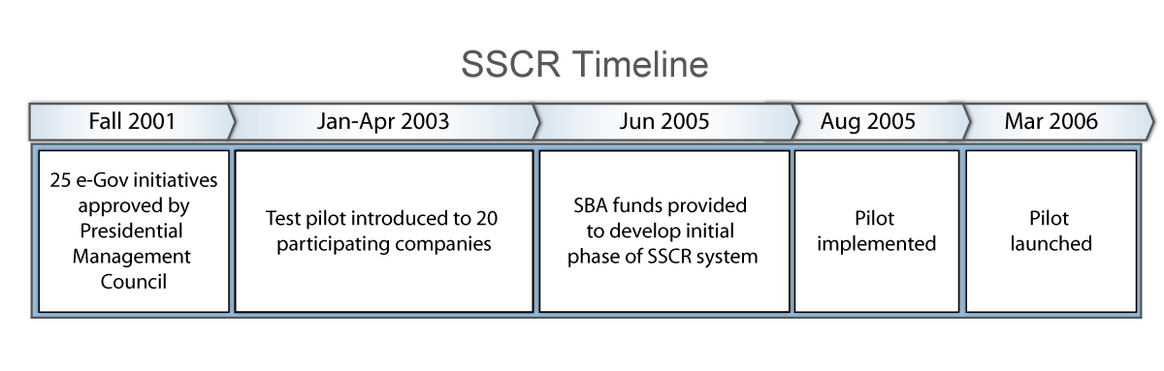
Several states and federal agencies were imposing highly redundant reporting requirements on coal mines with varying deadlines, on both a quarterly and annual basis. Prior to the SSCR pilot, each surface coal mining company reported the tons of coal mined in a given month to:

- Office of Surface Mining (OSM), Bureau of Land Management (BLM), and Minerals Management Service (MMS) in the Department of the Interior
- Internal Revenue Service (IRS) in the Department of the Treasury
- Energy Information Administration (EIA) in the Department of Energy
- Mine Safety and Health Administration (MSHA) in the Department of Labor
- State governments

In total, about 1,000 companies reported on approximately 3,000 coal permits each quarter, to multiple government agencies.
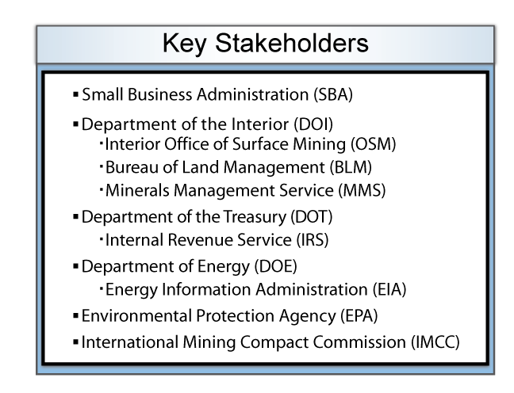
The goal of SSCR, therefore, was to streamline the coal reporting process. Simply put, the participants sought to consolidate multiple agency reporting processes into a single, automated process. Through a more convenient and customer-focused interface, improved data processing capabilities eliminated redundant data collection and defined common data definitions across agencies.

Approach
All agencies involved in the reporting process were invited to the initial strategy meetings. A coalition was built among the interested federal agencies, state representatives, and industry associations. As expected, some agencies opted out for a variety of reasons. Agencies that opted out included the Internal Revenue Service (IRS), the Environmental Protection Agency (EPA), and the Environmental Information Agency (EIA). The remaining organizations indicated they were fully committed to bringing the project to fruition. For instance, the involvement of the International Mining Compact Commission (IMCC) played an important role in building a successful project team. The IMCC acted as an agenda-free facilitator and, at the same time, provided strong industry content knowledge. The Coal Vertical was also fortunate in having a champion in the leader of the Department of Interior’s (DOI), Office of Surface Mining (OSM). State governments and Mine Safety and Health Administration (MSHA) in the Department of Labor (DOL) were stakeholders also involved from design to implementation. It is important to note that the participating agencies were self motivated, which indicated that there was value not only for the businesses but also for the agencies as well. A further indication of this value was the fact that the project managers maintained focus and kept the project moving forward through a variety of challenges.

After the Coal Vertical project team was assembled, six months were spent developing a program charter and OMB Exhibit 300 business case. In this process, the Coal Vertical project team clearly identified the business problem, validated a Return on Investment (ROI) and offered a conceptual solution. This upfront work had a significant impact on the project’s ability to be successful.

However, the Coal Vertical project team was ill-prepared to address issues surrounding the project outside of the scope of technical implementation, including security, OMB Information Collection Request (ICR) numbers, and Memorandums of Understanding (MOUs) between the agency partners. Delays occurred each time specific government-wide matters (i.e., digital signatures) had to be addressed. The Coal Vertical project manager acted as a buffer between the logistical issues and the technology solutions. Through this experience, the project manager realized the need for the Business Gateway Project Management Office (PMO) to create a standard framework and management structure to expedite future harmonization projects, as outlined in the analysis below.

The Coal Vertical project team proceeded to resolve the technical and logistic implementation challenges and, with the support of 20 participating companies and agencies necessary for success, the Single-Source Coal Reporting e-Form test pilot ran from January through April 2003. For the pilot, OSM modified its E-filing website to allow companies to report excise taxes to the IRS, and safety and production data to MSHA and the state of Pennsylvania, while filing quarterly Coal Reclamation Fee Reports with OSM. The industry test companies reported that Single Source Coal Reporting significantly simplified the reporting process with an 80% reduction in reporting time.
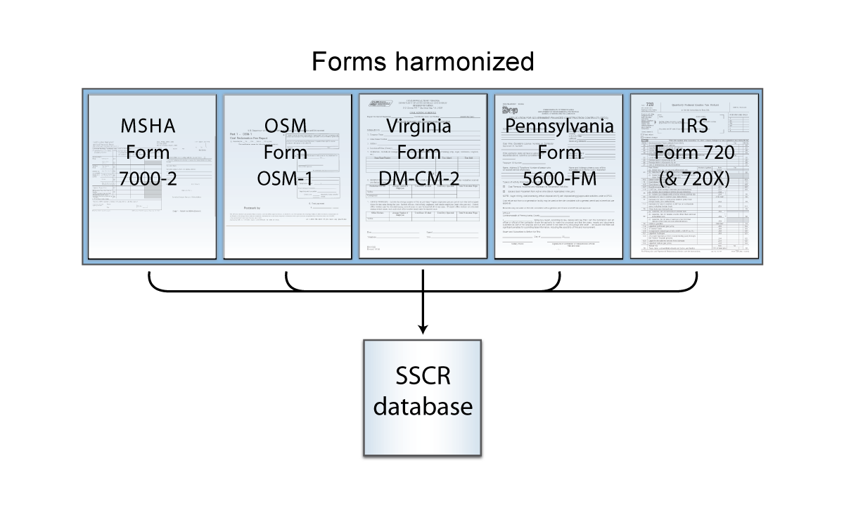
In June 2005, the Business Gateway Initiative provided $275,000 to fund the first-phase development of the SSCR system. SSCR was implemented in August 2005 and launched in March 2006, employing an eForms solution. Although there was a recommendation for an open source solution, the project team selected a proprietary solution offered by Probaris, Inc., in which users log on to the SSCR application to download their quarterly packages and complete mining reports. The completed quarterly packages are then submitted to a server, where they are forwarded to the database server to be stored in the SSCR database. The server extracts SSCR data elements from the form and participating agencies and states can utilize a web services interface to pull the SSCR data. The SSCR data standard utilized a methodology and supporting framework which can serve as a process model example for other emerging verticals undertaking similar data harmonization efforts. While this brought about a realization of the many goals of harmonization, recent feedback from the participating organizations reflects frustration with increasing licensing fees and operating expenses which ensued from the proprietary solution. Given the user frustrations over cost, it seems there should have been more attention to the total cost of ownership and a greater willingness to utilize open-source software.

Analysis and Lessons Learned
Despite post-implementation technology concerns, SSCR is acknowledged as a success.
The Coal Vertical reduced the reporting burden on industry while reducing agencies’ processing and maintenance costs. The resulting product increased accuracy and consistency of data collected across agencies and complies with the President’s Management Agenda performance goals.

Emerging as a prototype for future harmonization opportunities, the success of the Coal Vertical demonstrates how a strong project selection process, willing stakeholders, and a solid enterprise architecture provide a very significant opportunity to reduce the burden on businesses that interact with the federal government.

The following steps have been recognized as significant to the execution of SSCR and may provide guidance for future harmonization implementations.

- Involve top management from the very beginning to ensure the necessary support and commitment from all levels of the participating organizations
- Involve industry associations and end users in all key steps of the process:
  - Involve industry specifically on the business process issue and end user experience
  - Allow industry to provide the impetus and sponsorship of the project for validation of business case
- Establish project roles and responsibilities. The harmonization team should observe the project’s commencement by holding an initial kick-off meeting, or series of meetings as necessary, to train team members/management involved with the effort. Together, the team should also discuss outreach to funding partners, a dated project plan, and other issues relevant to the project’s inception.
- Create a rigorous process for evaluating potential harmonization projects
- Assemble the right subject matter experts early in the project to validate the potential for harmonizing data and reducing the burden for any particular project
- Implement a formal Go/No-Go decision process for Governance Board input and approval

Case Study Two

Agency-State: Trucking Registration Forms

Project Overview
Trucking companies have long been subject to safety requirements, including documentation of various safety plans, by the Department of Transportation (DOT). Truckers transporting various types of goods are also required to submit safety-related paperwork to the Department of Commerce (DOC) and may encounter additional filing burdens related to the Chemical Safety Act (2007), due to the emerging regulations pursuant from the terrorist attacks of September 11, 2001. While paperwork for trucking is seen as burdensome by the American Trucking Association (ATA), the new complexity of additional regulatory promulgation has increased the burden.

The concept of harmonizing safety-related filings, aimed to enable trucking companies to enter data comprehensively into a single portal, could in turn, be used by relevant federal agencies as needed. The harmonization of safety-related filings would ease the regulatory and paperwork burden currently imposed on trucking companies, many of which are small businesses. This initial research portrayed the trucking industry as a strong candidate for data harmonization.

Approach
In 2004, Business Gateway worked with DOT officials to harmonize trucking forms, but the effort proved fruitless due to a lack of enthusiasm by DOT management. The following year, Business Gateway analyzed the DOT’s Federal Motor Carrier Safety Administration (FMSCA), and found the registration process itself to be exceedingly complicated. Conversations with the American Truckers’ Association (ATA) further revealed that the trucking industry shouldered a great burden due to the complexity of the forms. An ATA member identified previous registration consolidation attempts by the Commonwealth of Pennsylvania resulting in PA-1, an ineffective “phone book-sized” form. Reluctantly, the Business Gateway team did not find a significant amount of redundancy within the various forms of reporting (HAZMAT and safety log books; tax forms; etc). The effort was abandoned because the complexity of a process was not felt to meet the objectives of data harmonization.

Analysis and Lessons Learned
The lack of substantial duplicative data elements hindered the trucking harmonization effort from proceeding. After previous explorations on tax/regulatory filings, the Business Gateway team attempted to revive harmonization efforts following the 2007 passage of the Chemical Safety Act. Despite the determination that the burden did not meet data harmonization criteria, Business Gateway continued to hold discussions with DOT (FMCSA) officials to assist them in streamlining their registration forms. However, a lack of agreement on approach and potential solutions effectively blocked progress on this effort.

Case Study Three

Multiple Agencies: Import/Export Forms

Project Overview
The International Trade Data System (ITDS) was established to implement a secure, government-wide method for the electronic collection, storage, use, and dissemination of international trade data among approximately 30 participating government agencies. Following the terrorist attacks of September 11, 2001, the ITDS pilot was discontinued due to operational concerns and was subsequently incorporated into the development of the Automated Commercial Environment (ACE). ACE serves as the central access point connecting U.S. Customs and Border Protection (CBP) with other government agencies and the trade community. Currently, the ITDS Board of Directors and U.S. Customs and Border Protection are working together to aid participating agencies as they prepare to integrate, deploy, and sustain their data requirements in ACE.

Approach
Based upon ITDS’s approach to importing paperwork, the Business Gateway team examined the possibility of broadening ITDS to support a unified approach to exporting paperwork. However, interviews with key individuals involved in the process revealed that the current environment is not conducive for harmonization efforts, for several reasons:

- The work accomplished in the early stages of the project was sufficient to bridge the harmonization requirements for the related agencies
- The implementation date for export modernization is not likely to go into effect until after 2010, as the project is driven by the U.S. Customs and Border Protection funding stream
- Given the current state of the project and the Business Gateway team’s lack of subject matter expertise in this area, there is not an opportunity to provide added value

Analysis and Lessons Learned
The agencies that comprise of the Trade Promotion Coordinating Committee (TPCC) are supportive of ITDS/ACE and have dedicated resources to comply with this complex harmonization effort. Business Gateway resolved that it would not be advantageous to ITDS/ACE to collaborate at this time, as the program’s future plans are in progress.

Case Study Four

Agency Partnership: Environmental Protection Agency

Project Overview
Since 2006, the Business Gateway Initiative has evaluated harmonization potential within the Environmental Protection Agency (EPA), specifically in three subject areas: small batch chemical, iron/steel industries and pesticide registrations.

Subject Area 1: As one of the most heavily regulated industries in the United States, small batch chemical industry stakeholders included the Environmental Protection Agency (EPA), the Food and Drug Administration (FDA), the Department of Transportation (DOT), and the Occupational Health and Safety Administration (OSHA). Further research with associations, however, proved that the industry was not ripe for Business Gateway’s data harmonization methodology. The actual regulatory burden focused on the collection and distillation of copious data. The EPA, as the chief regulating industry, had already corrected most of the previously redundant information collection requests.

Subject Area 2: The Business Gateway team met with the American Iron and Steel Institute, a trade association that represents large steel mills, and with the Steel Manufacturers of America (SMA), a trade association that represents mid-size steel manufacturers. Neither group felt their industry was a viable candidate for Business Gateway’s data harmonization methodology. As a result, research was curtailed in February 2006.

Subject Area 3: In conjunction with the examination of the EPA’s pesticide registration process, the Business Gateway team held several interviews with trade associations, including the Responsible Industry for a Sound Environment (RISE) and CropLife America. While the groups were concerned that reported data was not submitted frequently enough to warrant a major harmonization effort, it was found there was room for improvement in the label-update process. This effort was eventually discarded when it determined that implementation costs could not be funded.

The Organization for Economic Cooperation and Development (OECD), an international cooperative which develops chemical templates for international data submissions, was yet another opportunity housed under the pesticide registration umbrella. The project would have required a consistent funding stream, as it would likely yield an extensive, long-term effort to facilitate the creation of an all-inclusive, international pesticide-permitting portal. The Business Gateway team determined that, while promising, the opportunity involved an excessive amount of risk, and deferred research to concentrate on more feasible options.

Approach
Despite the progress EPA has made in addressing issues impacting the small business community, there are still concerns regarding the amount of effort and time currently employed to ensure accuracy within the pesticide reporting process. In collaboration with the EPA web content managers, the Business Gateway team analyzed the existing pesticide registration and compliance content of the EPA website with the aim of suggesting adaptations that result in a more relevant and user-friendly approach to small business participation. In doing so, Business Gateway and EPA could potentially reduce the time required by small businesses to gather a broader understanding of these issues, thereby increasing efficiency and reducing burden for both end users and the EPA itself.

In February 2008, Business Gateway identified the following areas of the EPA’s online pesticide registration data as demonstrating potential content management simplification needs:

- Language: Overall wording may be excessively confusing to small business owners, who do not have the ability to devote time or resources to acquire consultants, lawyers, SMEs, etc, as larger businesses do. Simplifying the site language could ease some of this burden.
- Search function: Search results may not lead small business owners to their intended destination. More prominent placement of content, such as tabs explaining “Where do I go to….; How do I…” could address this issue by helping users locate information already available to them.
- Content arrangement: Positioning content in the format of general guides to specific regulations/ standards could also assist in simplification efforts.
- Determination of ‘people value’: Organizing content in a step-by-step process format may help small business owners visualize their actions. Information that is currently split between several pages could be consolidated to achieve this.
- Tutorials: Flash interactive tutorials could also be valuable visual tools used to explain oft-misinterpreted content.

Analysis and Lessons Learned
In some cases, such as the EPA’s online pesticide reporting process, agencies were more receptive to the idea of harmonization through a content partnership than as a process forced upon them. Business Gateway is optimistic about the potential business case of future pesticide content partnerships. Harmonization efforts are currently on hold while Business Gateway resources are devoted to continue the execution of an evolving harmonization project with NASA’s procurement office.

Case Study Five

Agency-Internal: National Aeronautics and Space Administration

Project Overview

In 2007, Business Gateway began to investigate harmonization opportunities in NASA’s Financial/Property Management Offices and in NASA’s Education Office. Collaborative analysis with NASA representatives uncovered a greater need, and opportunity for, harmonization of forms in the Procurement Information Collections, which houses 90% of NASA’s information collection burden.

Approach

Through a series of meetings with NASA representatives, Business Gateway gained a clear understanding of the harmonization feasibility and the burden affecting the business community. The Business Gateway team subsequently provided NASA with an analysis of burden reduction, through consolidation of Procurement Information Collection Requests (ICR). In June 2008, NASA’s Office of Procurement resolved to adopt two of the recommendations proposed by Business Gateway:

- NASA information requests 2007-0085, 2007-0086, and 2007-0087, in the area of Acquisition Process - Bids and Proposals for Contracts: Combined, the three information collection requests comprising the required submissions for contract award consideration, and representing more than 50% of NASA’s Office of Procurement’s total ICR budget, closing in on nearly two million burden hours. The information requests will be consolidated prior to their expiration in April 30, 2010.
- NASA information requests 2007-0092, 2007-0093, and 2007-0048, in the areas of Cooperative Agreements with Commercial Firms, Grants and Cooperative Agreements with State and Local Governments, and Patent Reports under Grants and Cooperative Agreements: NASA previously administered an internal review of these information collection requests, prior to data harmonization collaboration with the Business Gateway team. The burden associated with each request was reduced at the time of their renewals in 2008. NASA determined that further consolidation of these requests will be conducted as an administrative exercise, and are to be initiated immediately by the agency.

Analysis and Lessons Learned

The representative from NASA’s Office of Procurement described the acquisition ICR consolidation as “a major step in streamlining information collection. It is estimated that a significant reduction in burden hours will be achieved at the time of consolidation, as there appears to be some duplication with approved Federal information collections.” NASA also referenced the harmonization collaboration with the Business Gateway Initiative in their February Information Collection Budget (see appendix).

NASA continues to work with the Business Gateway Team to investigate new opportunities. The agency remains open to suggestions and recommendations, thus proving that data harmonization success can be achieved with the support of a willing agency.

General Analysis: Themes and Trends
Despite the Business Gateway Initiative’s best efforts and thorough investigation into a number of opportunities, achievements in the data harmonization area have been limited and many options have ultimately been discarded for a variety of reasons. The Business Gateway team regularly discussed the various activities and identified four common factors that have hindered the implementation of a data harmonization opportunity:

- Lack of Subject Matter Expertise: The Business Gateway Program was not equipped with the resources or manpower to provide subject matter expertise in discussions with agencies considering data harmonization. Although the Business Gateway team provided facilitation of the process, without a profound understanding of the subject matter, agencies remain unconvinced they should engage in data harmonization proposals.

- Lack of Funding: Without the ability to fund proposed harmonization efforts, the Business Gateway team encountered reluctance when approaching agencies about funding an initiative outside of the planned budget. In these instances, harmonization was often viewed as an acceptable, promising idea but ultimately not mission-critical.

- Lack of Authority: The Business Gateway Initiative did not have the authority to compel agencies to harmonize. Ultimately, participation in a harmonization effort requires commitment and support from willing stakeholders. Further, association with an OMB milestone adds additional scrutiny to agencies, many of which were already active and engaged with internal activities.

- Privacy Concerns: Mounting security concerns over personally identifiable information collections hinder harmonization opportunities, even more so as electronic processes are leveraged. The impact of policies, such as OMB memorandum M-O7-16, Safeguarding Against and Responding to the Breach of Personally Identifiable Information, place additional constraints on progress for consolidating data collections/reporting and sharing the information.

Achieving Future Harmonization Success
Based on the above mentioned limitations, The Business Gateway team in concurrence with the Advisory Group determined that the program is not an effective leader for implementing data harmonization efforts. The team wholeheartedly believes in the objectives of the data harmonization concept and feels future success can still come to pass if led by a more appropriate organization, such as the Office of Information and Regulatory Affairs (OIRA) within OMB or SBA’s Office of Advocacy. If such a change in leadership were implemented, the Business Gateway Initiative would still be utilized as a supporting tool, since the program is in a unique position to contribute to data harmonization efforts indirectly through its content partnerships with various government agencies. Future harmonization attempts should consider the following lessons learned when researching opportunities.

- Stress a Partnership Opportunity Over Harmonization “Enforcement”
The label “data harmonization” can be a confusing and misleading concept at the outset of a burden dialogue. The Business Gateway team observed that stakeholders were more willing to discuss harmonization when the term itself was avoided. Instead of initially targeting agencies with a harmonization approach, the Business Gateway team found that agencies were willing to partner with the program in other ways to reduce burden, namely sharing content and simplifying access to services. After the initial partnering, the concept –and label– of data harmonization became more lucid. Dialogue subsequently flowed when stakeholders recognized harmonization as a partnership opportunity, rather than something being done to them. Partnership discussions also revealed that data harmonization already exists within agencies – but may not necessarily termed “harmonization.”

- Identify Viable Harmonization Opportunities/Engage Industry
While researching opportunities, every possibility of burden reduction within each opportunity should be examined. However, what appears to be a harmonization opportunity may, upon further review, show limitations, as shown in the Trucking case study. On-going research revealed that while burdensome due to complexity, the safety-related filings in the trucking industry were not duplicative, and therefore did not meet the original definition of harmonization.

When a known opportunity fits the harmonization definition, engagement of industry associations/end-users can assist in identifying real issues currently affecting the business community, thus ensuring meaningful reduction of burden, and encouraging the process to focus on the end user.

- Solicit Management Support
Organizational commitment is a key factor in a successful harmonization effort, as evidenced in the NASA case study. NASA leadership encouraged the research of several internal opportunities to identify meaningful burden reduction and ultimately consolidated three information requests, representing nearly two million burden hours.

However, without the support of top management, harmonization efforts are not seen as a priority in the agency. Reluctance by top management can hinder allocation of necessary resources and divert team members to concentrate on projects of higher priority. The Business Gateway team found that many initial harmonization opportunities were halted at this stage, including an opportunity focused on the Federal Emergency Management Agency (FEMA)’s post-disaster inspection reporting. Though an opportunity was clear, FEMA management was simply unable to allocate resources for harmonization since efforts reacting to lessons learned from Hurricane Katrina were given top focus.

The full support of management results in committed resources and provides an added benefit – a cross-agency champion. Should cross-agency issues develop, data harmonization team members may not be fully equipped to resolve them without an internal champion. In this regard, the support of OMB is an additional element providing visibility and credibility to harmonization efforts.

- Amass Expertise
Experience has shown that the most knowledgeable people are often times working within the agencies using the forms/data in question. A lesson learned from the SSCR project is to assemble two teams of experts – one team handling larger policy and cross-governmental agency issues, and a second team focusing on technical implementation including legal requirements, Federal Enterprise Architecture requirements, and security/privatization.

Conclusion
The value data harmonization provides is significant to both end users of the small business community and government agencies alike. Research from the Business Gateway Initiative’s data harmonization efforts concludes that there appears to be ample government-wide data harmonization opportunities and critical elements are necessary to ensure their successful implementation. When these critical elements are combined with limitations of the lead program, the task to identify and implement an opportunity becomes even more challenging. To implement a data harmonization solution via the chosen methodology, the lead agency should possess expertise, authority, and financial resources while willing stakeholders must conform to the appropriate federal and legal standards. Therefore, the Business Gateway Initiative recommends that future efforts should be led by an agency with more fitting characteristics. Future lead agencies can continue to leverage the Business Gateway Program as a tool, drawing on the program’s distinctive ability to form cross-government content partnerships. The Business Gateway team is strongly encouraged that data harmonization under these circumstances can simplify reporting requirements for businesses, reducing unnecessary burden and allowing the business community to focus on running their businesses, not government requirements.

APPENDIX A

Agencies/Industries Approached for Potential Data Harmonization

- Shipbuilders Council of America: simplifying regulatory compliance
- Synthetic Organic Chemical Manufacturers Association: redundant reporting requirements in the small-batch chemical industry
- American Iron and Steel Institute: burden reduction assistance
- American Foundry Society: burden reduction assistance
- National Paint and Coatings Association: burden reduction assistance
- Cement Manufacturing (Portland Cement): burden reduction assistance
- Steel Manufacturers of America: burden reduction assistance
- American Truckers Association: eliminating redundancy in tax filings and safety reporting
- Consumer Specialty Products Association: eliminating redundancy between the Fed Gov and states
- Biopesticide Industry Alliance: simplifying the registration process
- Croplife America: streamlining pesticide registration processes
- Printing Industries of America: eliminating redundancy industry reporting system
- National Federation of Independent Businesses: burden reduction assistance
- National Association for Home Care and Hospice: redundancy in forms across different agencies
- American Association of Meat Processors: meat processing sub-sector forms
- American Forest and Paper Association: heavily regulated industry
- Immigration: form redesign effort
- Office of Government Contracting and Business Development: eliminating redundancy through shared database
- EPA: streamlining filing of Confidential Statement of Formula forms/facilitating international portal project
- NASA: Procurement office information collections
- USDA: eliminating redundant pesticide filings
- ITDS: unified approach to exporting paperwork

APPENDIX B
Excerpt from NASA’s FY 2010 Information Collection Budget

National Aeronautics and Space Administration

BURDEN REDUCTION INITIATIVE

Office: Office of Procurement

Initiative Title: Analysis of forms used in NASA’s acquisition process, leading to consolidation of information collections.

Description: NASA uses many information collection instruments to support the Agency’s acquisition process. For example, forms to collect information on bids and proposals, purchase orders and bank card orders, and reports for contracts, while similar, vary depending on their overall value. For this initiative, NASA is working with the President’s Business Gateway E-Government Initiative to identify and assess these related collection activities and how they can be discontinued or consolidated. The initiative also includes other information collections indirectly supporting the acquisition process, including information collections used to establish cooperative agreements, grants, Space Act Agreements, and other acquisition arrangements.

This initiative has made excellent progress. To date, analysis of the affected collections has resulted in the information collection 2800-0088 being discontinued. A burden decrease of 803,040 hours was affected. 2700-0088 was an authorized collection of two redundant reports (inventions and property) which information are also collected by other NASA ICRs, 2700-0009 and 2700-0017, respectively. Further analysis is continuing and additional burden reductions are anticipated.

Estimated Burden Reduction: Up to 1,000,000 hours

Collection(s) Affected: 2700-0009, 2700-0017, 2700-0047, 2700-0048, 2700-0054, 2700-0063, 2700-0073, 2700-0085, 2700-0086, 2700-0087, 2700-0088, 2700-0089, 2700-0092, 2700-0095, 2700-0101, and 2700-0124.

Expected Date of Completion: September 30, 2009

Potential Hurdles to Completion: Review and consolidation of legacy acquisition systems.

