Status Report to the Court
Number Twenty-One

For the Period
January 1, 2005 through March 31, 2005



May 2, 2005

TABLE OF CONTENTS

I. INTRODUCTION 1
II. SECRETARY GALE NORTON’S OBSERVATIONS 2
A. INFORMATION TECHNOLOGY 4
B. CADASTRAL SURVEY 11
C. MINERALS MANAGEMENT SERVICE 14
D. OFFICE OF HISTORICAL TRUST ACCOUNTING 16
III. OFFICE OF THE SPECIAL TRUSTEE FOR AMERICAN INDIANS 25
A. TRUST REVIEW AND AUDIT 27
B. OST-OFFICE OF THE CHIEF INFORMATION OFFICER 29
1. RECORDS MANAGEMENT 29
C. TRUST ACCOUNTABILITY 33
1. TRUST BUSINESS PROCESS MODELING 33
2. TRUST DATA QUALITY AND INTEGRITY 36
3. INDIAN FIDUCIARY TRUST TRAINING PROGRAM 39
4. RISK MANAGEMENT 41
5. REGULATIONS, POLICIES AND PROCEDURES 42
D. FIELD OPERATIONS 44
1. APPRAISAL 44
E. TRUST SERVICES 47
1. CURRENT ACCOUNTING ACTIVITIES 47
IV. BUREAU OF INDIAN AFFAIRS 52
A. TRUST REGULATIONS, POLICIES AND PROCEDURES 52
B. FRACTIONATION 55
C. PROBATE 58
ACRONYMS AND ABBREVIATIONS 60

- INTRODUCTION

This Status Report to the Court Number Twenty-One (Report) represents the period from
January 1, 2005, through March 31, 2005. The Report is presented for the purpose of informing the Court on the progress of trust reform activities occurring during this reporting period, and progress of the historical accounting of individual Indian beneficiary funds managed by Interior.

This Report is prepared in a manner consistent with previous reports to the Court. Each manager in charge of an area of trust administration and the director of the historical accounting project are submitting reports on the progress of their respective activities.

A glossary of acronyms and abbreviations is included in this Report. The glossary is located at the end of the Report.

- SECRETARY GALE NORTON’S OBSERVATIONS

Interior staff reported continuing progress during this reporting period. Implementation of the Fiduciary Trust Model continued on schedule. We are implementing FTM initially at two pilot BIA agencies, Concho and Anadarko. At these pilot sites, we introduced new systems to process work, substantially eliminated backlogs in recording vital information into the new title system, and distributed probates. We plan to soon send new performance statements to all beneficiaries, giving them more detailed information on their trust assets and trust income. Across the country, follow-on agencies will use the lessons learned at the pilot agencies to improve their work processes and eliminate many of the backlogs in processing information. It is our goal for each agency to eventually be operating at the same high standard at the end of this process.

A primary FTM goal is providing ready access to information for beneficiaries. Our new beneficiary call center, modeled after a major private sector call center, handled more than 13,000 calls during its first four months of operation. We were able to address 93 percent of the inquiries during the initial call. We needed to refer only seven percent of the calls to trust officers or BIA officials for further resolution.

As reported previously, the American Indian Probate Reform Act requires Interior to notify Indian Country about its provisions before the law fully takes effect. We drafted a notice during this reporting period and began mailing it to approximately 290,000 beneficiaries. We are also publishing the notice in the Federal Register and local newspapers. We expect the notice requirements to be completed during the next reporting period. I will then be able to certify, as required by the Act, that the notice has been given. Many of the provisions of the new law will become effective one year from the date of my certification. Last quarter, I reported we were training selected BIA, OST and call center employees about the Act. These employees are now trained and available to answer questions as beneficiaries receive our mailings.

Congress has held several hearings during this reporting period wherein the impact of the Cobell litigation and the FY2006 trust activity appropriations were discussed. A number of members expressed concerns about using funds for litigation and accounting, instead of for other programs with more direct benefit for Indian people. As previously reported, our FY2005 budget request for historical accounting was $109 million. However, Congress reduced that amount during the appropriation process to $57.2 million. Our FY2006 budget proposal requests approximately $135 million.

During this reporting period, the historical accounting project team focused its efforts on judgment and per capita accountings and high-dollar land-based accountings. As a result, approximately 47,000 judgment and per capita accounts have been reconciled since the beginning of this project. The accounting work continues to disclose very few accounting discrepancies.

Approximately 400 million pages of records have been collected to be used in completing the historical accounting. Although plaintiffs continue to report to the press and the Court that few records exist, the facts show otherwise. Far more records exist than anyone anticipated when the accounting exercise began several years ago. Of course, having records is only the first step in accounting. Scanning, indexing, and creating electronic files so that the records are readily usable by accountants is very time consuming and very expensive. Thus far, over 110,000 boxes of records have been indexed and more than seven million pages of records have been scanned.

As the Court is aware, Interior asked its Inspector General to verify the security of its computer systems through penetration testing. Although this process is designed to identify vulnerabilities, we were disappointed that it did find some. Steps taken to address these findings immediately have been described in documents already submitted to the Court. On the more encouraging side, Interior ranked in the top one-third of federal agencies in the annual House Government Reform Committee computer security rating.

During this reporting period, the President nominated Lynn Scarlett to be the Deputy Secretary for the Department. I am very pleased with her nomination. Her experience as the Assistant Secretary for Policy, Management and Budget of the Department will serve her well in this new position. Also during this reporting period, Assistant Secretary for Indian Affairs David Anderson resigned. At my request, James Cason, Associate Deputy Secretary for the Department, agreed to temporarily assume the duties of the Assistant Secretary for Indian Affairs. In addition, Patrick Ragsdale was selected to be the Director of the Bureau of Indian Affairs. Mr. Ragsdale has an extensive background in all areas of the BIA. He moved to his new position from being the Director of Trust Review and Audit in the Office of the Special Trustee for American Indians.

  - INFORMATION TECHNOLOGY

Introduction

This section describes the status of Interior IT systems, particularly the systems that house or provide access to IITD or provide various computing capabilities, including functions critical to the proper administration of the individual Indian trust responsibilities within Interior. In addition, this section describes various efforts being made to improve IITD security within Interior, pursuant to OMB Circular A-130 Appendix III, and the status of Internet connectivity.

Accomplishments and Completions

Computer Security:

Interior continues to make progress in ensuring IT security and, in particular, addressing the potential risks associated with unauthorized access to IITD from the Internet. A primary focus for this reporting period has been validating and improving the C&A packages completed previously. C&A packages for systems with IITD were reviewed, and deficiencies noted and addressed. The most noteworthy accomplishments and completions during the reporting period are described below.

Prevention and Monitoring

- Interior continued testing Internet-accessible systems against the SANS Top 20 vulnerability list. For the fourth consecutive reporting period, no hosts were found to have vulnerabilities listed in the SANS Top 20.
- The Interior Inspector General continued unannounced penetration testing exercises for Internet-facing systems, completing reviews for three bureaus and offices during this reporting period. These bureaus and offices detected and blocked some intrusion attempts, but vulnerabilities of varying degrees that could be exploited were noted by the OIG. Bureau and office reports have been provided to Interior OCIO and deficiencies are being incorporated into the POA&M process for remediation. As Interior notified the Court on April 8, 2005, the IG memorandum to BLM stated that, “[the OIG] could have easily compromised the confidentiality, integrity and availability of the identified Indian Trust data residing on those systems.” Those systems/servers were promptly disconnected from the Internet. The OIG expects to continue penetration testing for all bureaus and offices throughout FY2005.
- BIA completed a major replacement and/or upgrade of most of the workstations that are connected to the BIA network. BIA updated over 5000 computer workstations with current versions of both the operating system and the virus protection software. The upgrades are expected to significantly enhance BIA’s ability to centrally manage and protect its critical applications throughout the network.
- BLM installed a new Bureau-wide monitoring system following the successful implementation of VBNS services. This is expected to allow BLM telecommunications specialists to respond much faster to any outbreaks of virus or other threats causing unusual bandwidth utilization. Unusual bandwidth utilization may indicate the need for investigation for potential attacks.
- BLM completed approximately 40% of its migration from BLM's Active Directory to the Department's Active Directory. BLM expects to complete the migration by May 1, 2005.

Policies and Guidance

- The Interior CIO issued a memorandum, “Re-Accreditation of Bureau of Indian Affairs Information Systems,” to the Assistant Secretary for Indian Affairs on January 26, 2005. As a result of independent review by the Interior CIO of BIA C&A packages, the AS-IA was asked to update 12 packages and re-accredit those systems when complete. During this reporting period, these C&A packages were updated and the systems re-accredited.
- The Interior CIO issued a memorandum, “Re-Accreditation of Bureau of Land Management Information System,” to the Assistant Secretary for Land and Minerals Management on January 27, 2005. Upon independent review by the Interior CIO, the Assistant Secretary for Land and Minerals Management was asked to update one package and re-accredit the trust system when complete. During this reporting period, this C&A package was updated and the system re-accredited.
- The Interior CIO issued a memorandum, “Fiscal Year 2004 Federal Information Security Management Act Report on the Department of the Interior’s Security Program,” to the Inspector General on February 4, 2005. This memorandum responded to and requested clarification of portions of the OIG’s 2004 annual FISMA report.
- The Interior CIO and the Director of the Office of Acquisition and Property Management jointly issued OCIO Directive 2005-001, “Internet Protocol Version 6 (IPv6).” The directive provides policy for department-wide deployment of next generation internetworking protocols. IPv6 is designed to expand available IP address space, improve end-to-end security, and improve quality of service.

Training and Awareness

- A revised version of IT security awareness training was deployed in January 2005 and the annual cycle of training was reset. The latest version of the training incorporates updates to Department guidance and OIG recommendations for content. With just over two months of the training delivered, 42% of Interior staff (30,172 of 71,729) has completed training. Interior is pursuing 100% completion by July 29, 2005.
- The quarterly MMS Information Security Awareness Newsletter, Winter 2004, was distributed to employees and contractors on January 25, 2005, to keep users abreast of IT security issues.
E-Authentication and HSPD-12

- Interior signed a MOU with GSA to support the development and implementation of a common, government-wide electronic authentication service.
- A logical access deployment plan was created and approved by the E-Authentication workgroup outlining Interior’s plans for implementing the information technology components of HSPD-12. The plan consists of objectives, goals, bureau and office milestones, and the strategy for meeting the mandates outlined in HSPD-12.

Plans of Action and Milestones

Interior made progress in both identifying and completing corrective actions this quarter, accomplishing an overall 6% reduction in outstanding actions. Through extensive C&A activities by bureaus and offices, as well as normal review processes such as management control reviews and audits by the Interior OIG, Interior identified an additional 58 program and 367 system weaknesses during the last reporting period. The efforts of the bureaus and offices resulted in resolving 35 program and 465 system weaknesses, and an overall decrease in the number of weaknesses reported through POA&M.

A-130 Certification and Accreditation:

C&A reviews conducted by a qualified third party have been completed for 54 C&A packages in this reporting period. Twenty-two of the 54 C&A package reviews were repeated for trust systems to ensure that deficiencies noted from initial reviews were addressed. Remaining C&A packages (102 or 60%) are scheduled for review in this fiscal year. Bureaus and offices completed comprehensive reviews of the trust systems or systems containing trust data, updated and improved the documentation, and re-scored the C&A packages. After updating and improving the documentation, re-scoring the C&As resulted in significant increases per element, with many packages receiving the highest possible score in the elements of risk assessment, system security plans and system test and evaluation.

IT Systems Architecture:

Phase 3B – Business Reference Model

Eight bureaus and offices collected and populated information for Phase 3B in the DEAR. Phase 3B focused on cross-mapping Interior’s system inventory to the functions and activities performed by the system as defined in the OMB and Interior BRM. The Interior BRM details at a more granular level the functions and activities performed within Interior. This cross-mapping supports Interior’s modernization blueprint analyses for determining potentially duplicative systems and systems that may benefit from integration, thus improving overall portfolio management. Interior now expects to validate Phase 3B populated data and make appropriate updates and corrections during the next reporting period.
- MMS completed the DEAR Phase 3B update in February 2005, including the review, verification and correction of all previous inventories.
- MMS started activities to prepare for DEAR Phase 4 to validate the previous inventory efforts. MMS initiated planning for the new inventory which maps the Interior DRM to existing or planned IT systems.
- BIA completed 75% of activities associated with relating Indian Affairs systems to components of the Federal Enterprise Architecture Service Reference Model, and identifying relationships between those systems and the main, infrastructural components in the TRM.
- BIA incorporated the Interior TRM into the BIA repository.

DOI Land and Resource Management System

Interior bureaus and offices reviewed the draft DLRM FRD, which identifies the high-level functional and performance requirements that were gathered in a series of meetings with subject matter experts across Interior. Review comments were addressed and changes were incorporated in the document. Briefings are planned with Interior bureaus and offices to complete the approval process. After approval of the FRD, this project is expected to enter the acquisition phase.

Leasing System Module Independent Verification and Validation

The DLRM system is expected to provide a long-term solution for the legacy functionality of the CGI leasing software module, formerly a part of the TAAMS project. As an interim solution:
- The TESC directed OST to proceed with UAT of the salvageable portion of the TAAMS leasing module. The formal UAT occurred March 29-30, 2005. The results are expected to be reported during the next reporting period.
- Initial work on data quality efforts to support conversion from the legacy systems has begun.

TrustNet

- As reported in the last status report to the Court, OHA had connected its Arlington office, two field offices, and its ZANTAZ connection to the Department’s ESN operations. OHA's ZANTAZ connection is a point-to-point connection between OHA and the ZANTAZ facility. ZANTAZ is not directly connected to the ESN. During the current reporting period, all remaining OHA field office connections were routed through the ESN operations. With the completion of this task, OHA’s wide area network is connected to ESN.
- SOL completed its move to ESN in February 2005, and expects to complete C&A activities during the next reporting period.

ZANTAZ

- BIA sent to ZANTAZ back-up tapes of the two e-mail servers that had not been copying e-mail to the ZANTAZ Digital Safe from July to December 2004. ZANTAZ restored these BIA back-up tapes to the Digital Safe. Interior reported on this incident to the Court January 31, 2005.
- As reported to the Court on March 18, 2005, SOL discovered it was not using a buffer server. Following this discovery, a buffer server was installed.
- Also noted in the report to the Court of March 18, 2005, when NBC upgraded its ZANTAZ software, its e-mails likely did not travel to the ZANTAZ Digital Safe on February 15-17, 2005. NBC expects to send back-up tapes from these days to ZANTAZ to permit inclusion of these e-mails in the Digital Safe.
- Also noted in the report to the Court of March 18, 2005, due to a network problem, SOL e-mails queued for three days in early March before being forwarded to the Digital Safe.
- The OSM VPN connection to ZANTAZ was down March 8-11, 2005, which delayed the transmission of live e-mail messages to the ZANTAZ Digital Safe. Also in March, OSM discovered an additional potential problem in the transmission of live e-mail messages to the ZANTAZ Digital Safe. Interior is investigating these incidents.

Current Status

A-130 Certification and Accreditation:

Ninety-four percent of Interior systems have full authority to operate (ATO) status. While this reflects a reduction from the previous reporting period, none of the remaining systems remanded to IATO contain IITD. Based on internal quality reviews of the relevant C&A packages, BLM remanded six systems to IATO status until supporting documentation could be corrected. Common supporting documentation is often included by reference; Interior is now requiring inclusion of each referenced document in hard copy with each C&A package. Interior continues its active management and appropriate response to quality review issues as part of FISMA-required management of deficiencies.

Although not required by FISMA or A-130, Interior expects to perform a 100% quality review of the C&A packages by the end of FY2005. C&A reviews conducted by a qualified third party have been completed for 40% of the bureau and office accreditations. Areas in C&A packages identified for improvement are expected to be tracked using the POA&M process. This process resulted in successful review and improvement of several trust system C&A documents.

Reports:

- Interior issued its second quarter FISMA update to OMB identifying that 98% of systems have completed contingency plans with 91% of those plans having been tested. The overall number of POA&M deficiencies decreased by 6% as 500 issues were closed, but 425 added.
- The U. S. House of Representatives Government Reform Committee (Rep. Tom Davis, Chairman) published its annual FISMA report card, raising Interior from an “F” in FY2003 to a “C+” in FY2004. This places Interior above the average federal grade, ranking in the top third of the 24 listed agencies.
- Federal Computer Week issued its annual Fed 100 for 2005, a listing of 100 federal IT professionals recognized for their efforts to improve IT in the federal government. In the Fed 100, Brian Burns, AS-IA, CIO, is noted for his progress in providing American Indian Tribes access to better technology.

Delays and Obstacles

There are many challenges that must be addressed regarding the integration, performance, funding, security, and data integrity of Interior IT systems. Interior initiated or completed steps to address some of the challenges reported in this and previous reporting periods. However, delays and obstacles listed here still impede progress in achieving Interior’s IT management goals:

Litigation

- Employee fears about becoming personally implicated in the Cobell litigation continue to undermine creativity and decision-making. This impediment has worsened within Interior as depositions have been scheduled for many Interior employees, including those without decision-making authority.
- Uncertainty over reconnection status is hampering progress on several IT projects which would improve efficiency and IT security.

Funding

- Funding availability will continue to dictate the timing of IT-related initiatives. Interior’s FY2005 budget will require managing a variety of IT-related requirements and tradeoffs.

Denied Internet Access

- Several Interior bureaus and offices (BIA, OHA, OST and SOL) have not been permitted by the Court to have Internet access since December 5, 2001. Lack of Internet access impedes work processes and the ability to communicate effectively, both internally and externally. Maintaining security on internal systems is more difficult without access to the Internet for research, reporting, and patch management. Similarly, promulgation of policy and training is substantially hampered by the lack of interconnectivity and Internet access.
- Lack of Internet access limits Interior’s ability to provide services to Indian beneficiaries. As noted in GAO testimony before the House of Representatives Committee on Resources, Indian Issues: Timeliness of the Tribal Recognition Process Has Improved, but It Will Take Years to Clear the Existing Backlog of Petitions (GAO-05-347T), on February 10, 2005, “The main impediment to completely implementing the Strategic Plan and to making all of the information that has been compiled more accessible to the public is the fact that BIA continues to be disconnected from the Internet because of ongoing computer security concerns involving Indian trust funds.”

Assurance Statement

I concur with the content of the information contained in the Information Technology section of the Status Report to the Court Number Twenty-One. The information provided in this section is accurate to the best of my knowledge.

Date: April 26, 2005

Name: Signature on File
W. Hord Tipton
Interior Chief Information Officer

  - CADASTRAL SURVEY

Introduction

Cadastral surveys provide assurance that land boundaries for individual Indian and tribal trust lands are identified appropriately. By federal law, surveys of Indian lands are to be performed under BLM’s direction and control. Official surveys, whether preexisting or new, identify the location of land boundaries of Indian trust assets and determine official acreage. The official surveys are integral to realty transactions, resource management activities, litigation support and the federal system of patent, allotment and survey records maintained by BLM. Ownership information, distribution of trust assets, and management of trust accounts may be related to or based upon information recorded in official surveys.

Accomplishments and Completions

Training

The latest LTIC class, attended by 32 individuals from BIA, BLM, OST and tribal governments across the country, was held during this reporting period. The attendees were a mix of cadastral surveyors, realty specialists/officers, resource managers, attorneys, self-governance specialists, leasing compliance officers/managers, accountants, paralegal specialists, natural resource specialists, public service directors, probate clerks and agency superintendents.

BLM presented a course for BLM employees on the impact of the Indian Self-Determination and Education Assistance Act and the Tribal Self-Governance Act on providing commercial activities related to cadastral services.

GCDB Data Collection for High Priority Areas

The fourth GCDB pilot project to develop a CGIS was funded in this reporting period. BIA, OST, BLM and the four participating Tribes continue to implement these projects.

Interagency Agreements for Cadastral Survey Services

A modification to the BIA-BLM interagency agreement for FY2005 funding was signed during this reporting period. This modification provides supplemental funding to BLM for cadastral survey services on trust and restricted lands throughout Indian country.

Interior Indian Trust Lands Boundary Standards (Draft)

BIA, BLM, OST and tribal representatives attended two working group meetings and finalized the draft standards, together with relevant portions of the departmental and bureau manuals and handbooks. These drafts were then distributed to BIA, BLM, OST and Tribes for comments.
Current Status

Funding of the Recommendations Outlined in the FTM

During this reporting period, representatives of the Cadastral Survey Program presented to the TESC recommendations and a budget necessary to achieve the FTM goals as they relate to cadastral surveys. FY2005 funds were allocated for this purpose in this reporting period. FY2006 and FY2007 budget requirements are being developed.

The first six BLM Indian land surveyor positions were advertised during this reporting period. It is anticipated that these positions will be filled during the next reporting period. These six surveyors are expected to be located in the following BIA regional offices: Southern Plains, Eastern Oklahoma, Midwest, Great Plains, Navajo and Northwest. The remaining six BIA regions are expected to receive their BLM Indian land surveyors in FY2006.

Missing BIA Indian Service Survey Records and Unofficial Survey Records

BLM and OTR have begun to discuss searching for survey-related records. As previously reported, BLM continues to search, on an as needed basis, for records and unofficial surveys performed by BIA surveyors in the 19th and 20th centuries. These surveys records may be found filed with inactive BIA records that may be at agency locations or stored at the AIRR.

Delays and Obstacles

Disconnection from the Internet

The Court-ordered disconnection from the Internet continues to adversely impact the way communications are handled between BLM, BIA, OST and SOL, including the way CARS is being implemented.

Limited Resources

Addressing the majority of cadastral survey services needs is dependent upon future funding of FTM initiatives.

Assurance Statement

I concur with the content of the information contained in the Cadastral Survey section of the Status Report to the Court Number Twenty-One. The information provided in this section is accurate to the best of my knowledge.

Date: April 21, 2005

Name: Signature on File
Donald A. Buhler
Chief Cadastral Surveyor
Bureau of Land Management

  - MINERALS MANAGEMENT SERVICE

Introduction

Minerals Revenue Management, an MMS program, is responsible for collecting, accounting for, and distributing mineral revenues from both federal and Indian mineral leases, and for evaluating industry compliance with laws, regulations and lease terms. MRM maintains reported information and distributes revenues at the lease level. BIA maintains individual Indian ownership records that are used to provide information to OST for disbursement of the lease revenues to individual Indian beneficiaries.

Current Status

Indian Oil Rule

As previously reported, a proposed rule for valuing crude oil produced from Indian leases is expected to be published by August 31, 2005. MMS held three public workshops to gather preliminary comments and conduct preliminary consultation in anticipation of publishing a new proposed rule regarding Indian oil royalty valuation. The Oklahoma City workshop, held on March 8, 2005, included 14 representatives (8 industry and 6 Indian). The March 9, 2005, Albuquerque workshop included 6 representatives (2 industry and 4 Indian). The Billings workshop was held on March 16, 2005, and included 9 representatives (1 industry, 7 Indian, and 1 BIA). Indian representatives at these workshops included both tribal and individual Indian mineral owners.

Payment Receipt Date Verification

The MRM’s upgrade to the PeopleSoft software was successfully completed January 17, 2005. With the completion of the PeopleSoft upgrade, software changes and system enhancements are underway. As previously reported, once completed and tested, further errors are expected to be prevented. MMS will then devote resources to identify prior errors in the Indian mineral revenue distribution file.

Assurance Statement

I concur with the content of the information contained in the Minerals Management Service section of the Status Report to the Court Number Twenty-One. The information provided in this section is accurate to the best of my knowledge.

Date: April 21, 2005

Name: Signature on File
Cathy J. Hamilton
Chief of Staff
Minerals Revenue Management
Minerals Management Service

  - OFFICE OF HISTORICAL TRUST ACCOUNTING

Introduction

OHTA was established by Secretarial Order No. 3231 on July 10, 2001, and is charged with planning, organizing, directing and executing the historical accounting of IIM and tribal trust accounts.

Current Status

Judgment IIM Accounts

OHTA continues to perform historical accounting procedures on Judgment IIM accounts. During this reporting period, OHTA completely reconciled an additional 3,345 accounts in Subgroups as follows: 902 accounts in Subgroup A, 1,676 accounts in Subgroup B, 411 accounts in Subgroup C, and 356 accounts in Subgroup D. Of the 40,046 Judgment IIM accounts completely reconciled as of March 31, 2005, quality control review has been completed for 38,475 accounts. OHTA expects to complete quality control review of the other 1,571 completely reconciled accounts during the next reporting period.

As more data—particularly from the “Paper Records Era”—are collected and keyed into the transaction listings, some accounts are reclassified into Subgroups different from their original classification. The following tables present the total number of Judgment IIM accounts in each Subgroup reconciled as of March 31, 2005, including accounts reconciled in previous reporting periods. The tables also report balances and throughput.

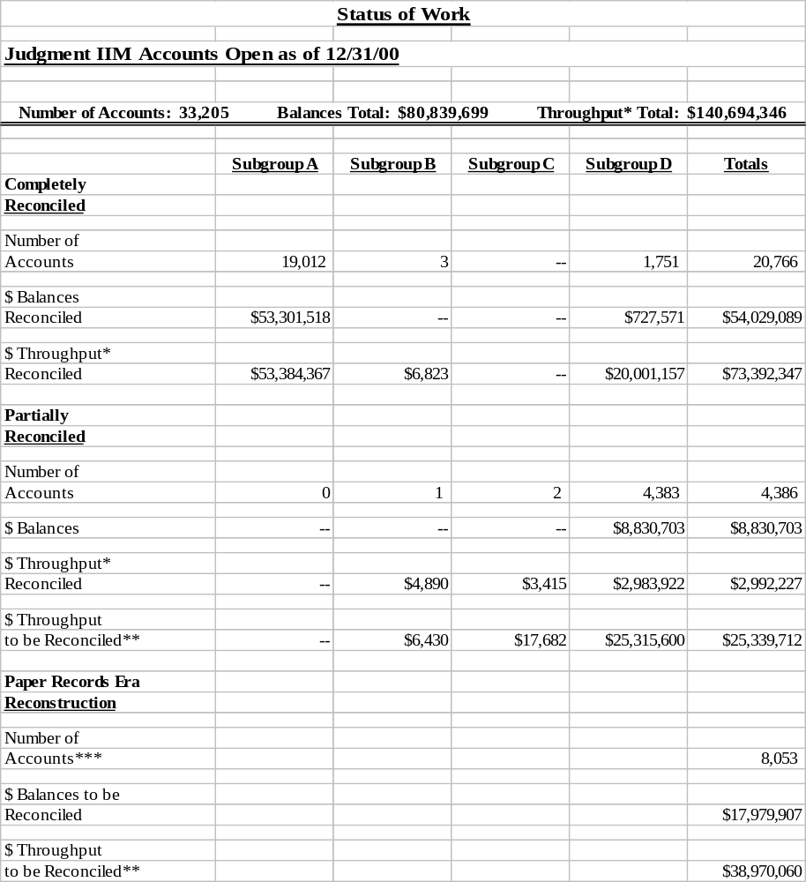

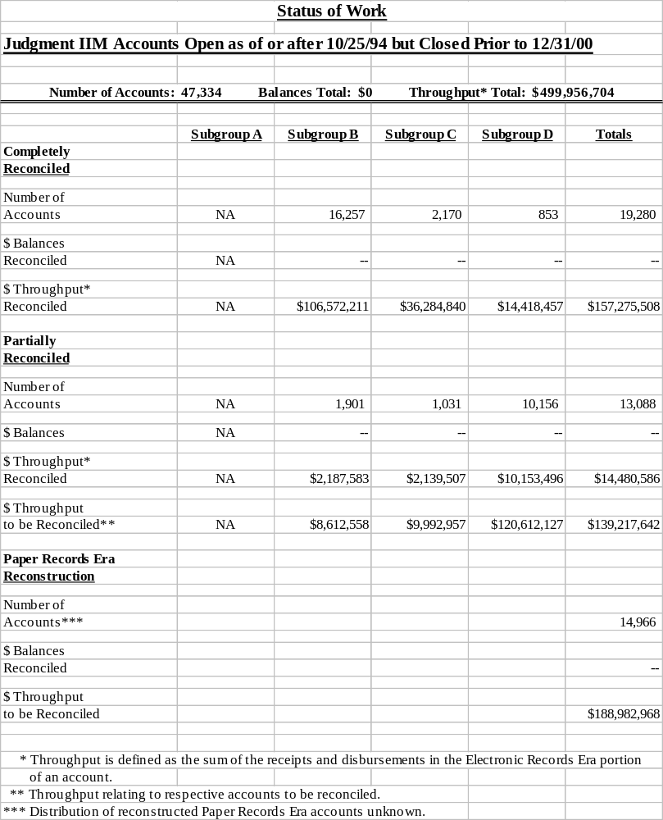
A majority of the remaining Judgment IIM accounts (as well as some Per Capita IIM accounts) require conversion of transaction data from manual ledgers to electronic format. As of March 31, 2005, OHTA has searched approximately 3,300 boxes of stored records for manual ledgers required to complete the account history for Judgment and Per Capita IIM accounts that originated in the “Paper Records Era.” Approximately 250,000 transactions for 27,000 Judgment and Per Capita IIM accounts have been located and entered into electronic format as a result of this effort.

Per Capita IIM Accounts

OHTA continues to perform historical accounting procedures on Per Capita IIM accounts. During this reporting period, OHTA completely reconciled an additional 198 accounts in Subgroups as follows: 158 accounts in Subgroup A, 30 accounts in Subgroup B, and 10 accounts in Subgroup C. Of the 7,558 Per Capita IIM accounts completely reconciled as of March 31, 2005, quality control review has been completed for 7,360 accounts. OHTA expects to complete quality control review of the other 198 completely reconciled accounts during the next reporting period.

As more data—particularly from the “Paper Records Era”—are collected and keyed into the transaction listings, some accounts are reclassified into Subgroups different from their original classification. The following tables present the total number of Per Capita IIM accounts in each Subgroup reconciled as of March 31, 2005, including accounts reconciled in previous reporting periods. The tables also report balances and throughput.

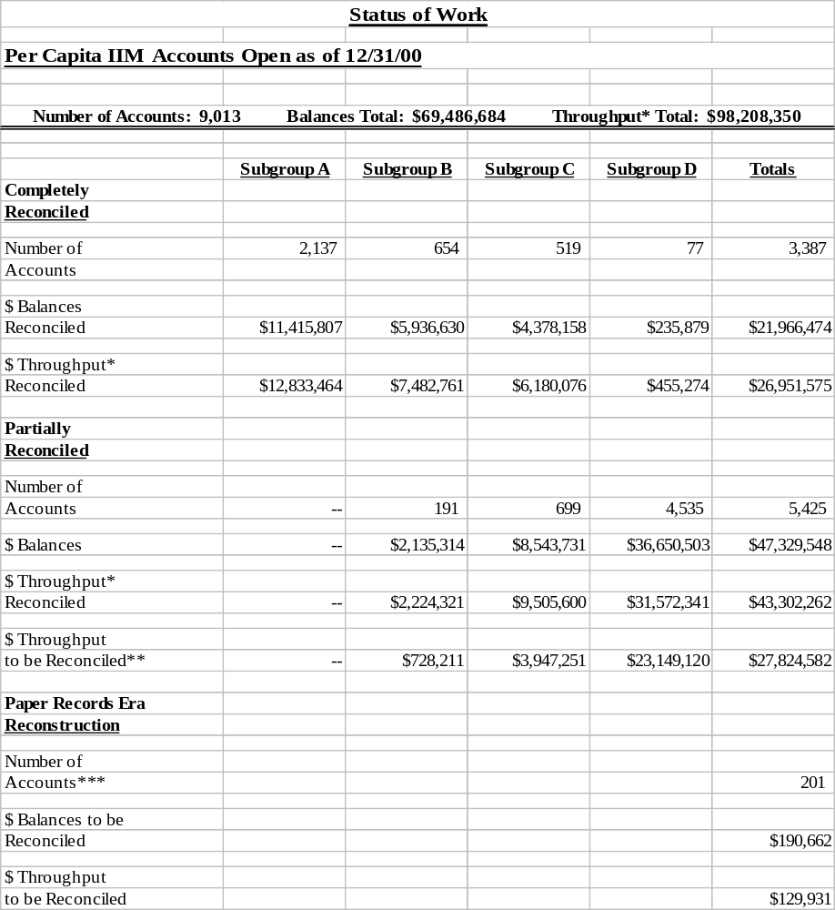
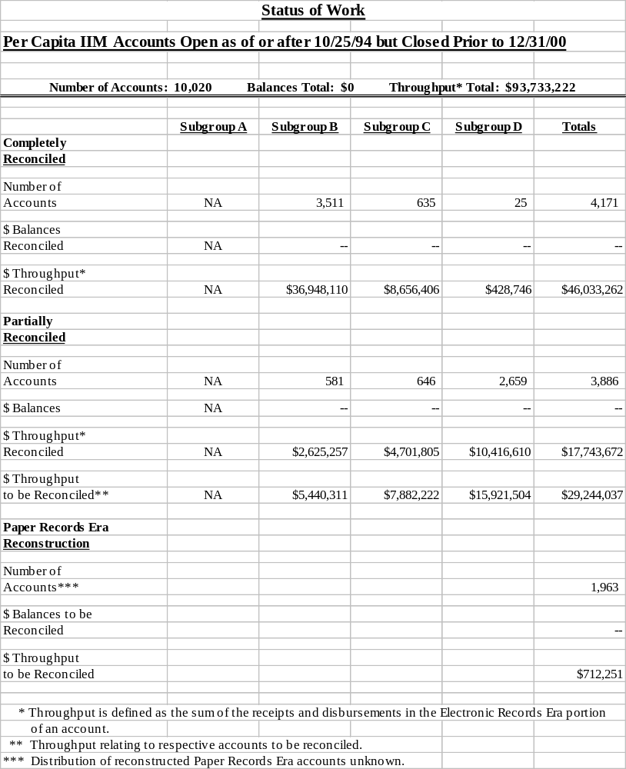

Mailings to Judgment and Per Capita IIM Account Holders

During this reporting period, OHTA mailed an additional 2,335 Historical Statements of Account with an accompanying transmittal letter explaining the Statement, bringing the total number of Statements mailed to Judgment IIM account holders to 11,872. A toll-free telephone number is available to account holders and/or their parents or guardians in the event they have questions about the mailings.

On March 24, 2005, the Department of Justice filed a Third Submission with the U.S. District Court in compliance with the May 28, 2004, Order regarding Historical Statements of Account. This Third Submission transmits four generic letters with accompanying redacted Statements requesting approval from the Court to use these letters for the next mailing of 28,107 Statements to Judgment and Per Capita account holders.

Land-Based IIM Accounts

OHTA continues to conduct reconciliation work on High-Dollar Transactions identified as equal to or in excess of $100,000, and on National Sample Transactions under $100,000 in Land-Based IIM accounts. A final report on this work is expected during FY2005 when reconciliation is completed.

OHTA SDA Distribution Project

The results of the OHTA SDA Distribution Project, as of March 31, 2005, are provided in the following table.

SDA Distribution Progress

 | Number of  Accounts |  |  | Dollars
SDA that remained to be resolved as of December 31, 2004 -  Reported in the Status Report to the Court Number Twenty | 12,919 |  | 34,208,548
Interest posted on undistributed SDA and additional  collections (net of disbursements thereof) credited to SDA  during this reporting period | -- |  | 1,763,023
SDA resolved during this reporting period | (321) |  | (3,634,892)
SDA remaining to be resolved as of March 31, 2005 | 12,598 |  | $32,336,679

The following table reflects the SDA dollars resolved by type of recipient during this reporting period. Recipients in the “other” category include transfers to the Miscellaneous Receipts Account at Treasury, account reclassifications and transfers to the Federal Finance System.

 | Transfers  to IIM Accounts |  | Transfers  to Tribal Accounts |  | Paid to Non-Indian Third Party |  | Other |  | Total
Dollars resolved during this reporting period | $1,012,969 |  | $2,171,536 |  | $121,822 |  | $328,565 |  | $3,634,892

Imaging/Coding – Individual Indian Trust Documents

OHTA’s IIM imaging and coding efforts continued during this reporting period, and the updated Coding and Imaging Manual is now expected to be released during the next reporting period. As of March 31, 2005, OHTA had completed the following imaging and coding work.

Imaging and Coding Progress

 | Pages Scanned | Documents Coded | Documents Loaded into Accounting Reconciliation Tool
Work results from July 9, 2003 (commencement of imaging and coding), through December 31, 2004 – Reported in the Status Report to the Court Number Twenty | 6,400,046 | 223,390 | 223,339
Work results during this reporting period | 666,999 | 15,476 | 13,667
Cumulative results through the end of this reporting period | 7,067,045 | 238,866 | 237,006

Delays and Obstacles

OHTA’s ability to search for trust records necessary to its ongoing historical accounting projects has continued to be impacted by limited access to certain records, including: 1) records being prepared for shipment, in transit to the AIRR, or being processed by NARA; and 2) records held in Albuquerque because of Court orders in Pueblo of Laguna v. United States, Jicarilla Apache v. United States, and Osage Nation and/or Tribe of Indians of Oklahoma v. United States. In addition, OHTA has reached the maximum capacity for the number of people who can work in the archival storage area at the Lenexa FRC. OHTA and OTR have negotiated a contract with NARA to expand record storage and workspace at the Lenexa FRC for the purpose of conducting expanded imaging, coding and document searching of the records. OHTA expects the expansion to be completed during the next reporting period.

For fiscal years 2003 through 2005, the enacted appropriations have been below the President’s requests. This has prevented OHTA from making the progress it projected in the January 6, 2003, Plan filed with the Court.

Assurance Statement

I concur with the contents of the information contained in the Office of Historical Trust Accounting section of the Status Report to the Court Number Twenty-One. The information provided in this section is accurate to the best of my knowledge.

Date: April 27, 2005

Name: Signature on File
Bert T. Edwards, Executive Director
Office of Historical Trust Accounting

- OFFICE OF THE SPECIAL TRUSTEE FOR AMERICAN INDIANS

Introduction

The Office of the Special Trustee for American Indians was created by the American Indian Trust Fund Management Reform Act of 1994. The 1994 Act provides direction to the Department of the Interior on accounting for Indian trust funds and reforming the operation of the Indian fiduciary trust. The Special Trustee’s responsibilities under the Act include creating a comprehensive strategic plan for the operation of the trust and providing oversight of the accounting for Indian trust funds and the reform of the trust.

In addition to the role of the Special Trustee set forth in the Act, the Secretary assigned other duties to the Special Trustee, including accounting and investing of collected funds, developing a risk management program, managing a reengineering effort of the trust business processes and creating an audit and review function to grade the performance of various Interior bureaus and offices and Tribes that perform fiduciary trust functions.

Special Trustee’s Observations

Trust Initiatives for the 21st Century

Work continued on the development of an implementation plan that will result in the installation of the Fiduciary Trust Model throughout Interior. Extensive work was done at the Anadarko and Concho BIA pilot agency offices to convert title systems, reduce backlogs and improve business processes.

Trust Review and Audit

OTRA continued its work of evaluating trust operations at various BIA agencies and Tribes. Several reports are now final and corrective action plans are expected to be prepared for agencies and Tribes where deficiencies in operations were found. In particular, a report concerning the sale of rights-of-way in the Navajo Region is being drafted by OTRA. The report is expected to be made available to the Navajo Region office and a corrective action plan requested during the next reporting period.

Appraisals

Interior’s Appraisal Services Directorate, Chief Appraiser has selected a deputy who will principally be in charge of the contract between OST and Interior ASD. This person is expected to be employed and begin a full review of the OAS program during the next reporting period. Recruitment for five additional review appraisers began during this reporting period and these appraisers are expected to be hired during the next reporting period. As a result of turnover and time requirements of hiring new appraisers, the backlog of appraisals has grown. Additional concerns of the Chief Appraiser focus on needed training of existing appraisers and hiring contract appraisers timely.

In order to resolve the issue of methodology for appraising renewals of rights-of-way, I have directed the ASD, Chief Appraiser to use his professional judgment and follow the USPAP guidelines for these kinds of appraisals. He is expected to have a policy developed for this kind of appraisal during the next reporting period, which the field appraisers can use as guidance. Finally, new appraisals of certain rights-of-way previously appraised by former Navajo Region appraiser Anson Baker are expected to be completed during the next reporting period.

American Indian Probate Reform Act

The notice required by AIPRA has been developed. Publication of the notice as required by the Act began during this reporting period by Interior’s initiating the mailing of notices to Indian owners of trust or restricted land. Additional mailings and publication of the notice in newspapers and the Federal Register are expected to occur during the next reporting period. After the notice requirements are met, the Secretary is expected to execute a certification that the notice has been provided. One year from the date of her certification, the probate provisions become effective. In addition, some other sections of the Act do not take effect until one year after certification.

Conclusion

I am satisfied that trust reform is moving forward. The work at Concho and Anadarko indicates that BIA and OST employees are committed to improving their management of the trust. Together with the implementation of new trust IT systems and conversion of many old legacy systems to new systems, productivity should increase and the ability to stay current and eliminate backlogs is expected to improve greatly the delivery of services to beneficiaries of the trust.

Weaknesses continue in the administration of the appraisal program. In response, the ASD Chief Appraiser has committed his resources to improve delivery of services to bring appraisals current, particularly with regard to the requirements of the ILCA program. Further, the time required entering data into new systems is a challenge to trust reform. OST continues to provide contractors to assist with data entry functions to ensure that new IT systems can be used as soon as possible as systems of record.

Assurance Statement

The comments and observations are provided by the Special Trustee for American Indians and reflect the opinion of the Special Trustee only.

Date: April 21, 2005

Name: Signature on File
Ross O. Swimmer
Special Trustee for American Indians
  - TRUST REVIEW AND AUDIT

Introduction

OTRA reports directly to the Special Trustee for American Indians. OTRA was created by OST as a response to trust initiatives developed during the tribal consultation process of 2002. OTRA conducts performance audits, examinations and reviews of Interior entities as well as Tribes that manage fiduciary trust activities. Examinations are routinely conducted at locations that perform trust operations, and are planned to result in a performance rating.

Current Status

Indian Trust Examinations

During this reporting period, OTRA initiated field work on appropriate trust examinations for FY2005. The examination plan provides coverage for FY2005 of 32% of all trust income transactions and 42% of trust assets. This plan is expected to bring the two-year totals to 58% and 68% respectively.

OTRA staff issued one final and ten draft reports for examinations performed at various agencies and Tribes within the Southern Plains and Eastern Oklahoma regions. These examinations were part of the pilot test reported in the previous report to the Court. Once comments from respective agencies and Tribes are received and incorporated into the report, these ten reports will be finalized. Comments must be received within 30 days from the issue date of the report.

Annual Interior Indian Trust Funds Financial Statement Audit

The Indian trust funds financial statement audit, required by the American Indian Trust Fund Management Reform Act of 1994, is conducted by an independent auditor under OIG management. The independent auditor initiated work on the FY2005 audit during this reporting period and is expected to continue through the first quarter of FY2006.

Annual Audit Corrective Actions

During this reporting period, in response to the FY2004 audit, OST managers reported progress on implementing corrective action plans addressing material weaknesses, non-compliance issues and management letter comments.

Compliance Reviews

During this reporting period, 11 cases were in inventory. One case was closed without the need for a final report. Field work or report drafting continued on the remaining ten.

Indian Trust Rating System

The first version of the “Trust Examination Guide” was issued and is being utilized by OTRA to conduct examinations. Work continues to expand and modify the “Trust Examination Guide” to include examination planning, final report writing and close-out of the examination.

Delays and Obstacles

Lack of Internet access impedes OTRA’s work processes and its ability to communicate effectively, both internally and externally.

Assurance Statement

I concur with the content of the information contained in the Trust Review and Audit section of the Status Report to the Court Number Twenty-One. The information provided in this section is accurate to the best of my knowledge.

Date: April 20, 2005

Name: Signature on File
D. Jeff Lords
Acting Director, Office of Trust Review and Audit
Office of the Special Trustee for American Indians

  - OST-OFFICE OF THE CHIEF INFORMATION OFFICER

- RECORDS MANAGEMENT

Introduction

The Office of Trust Records was established in 1999 to develop and implement a program for the economical and efficient management of trust records, consistent with the 1994 Act, the Federal Records Act and other statutes and implementing regulations. The OTR records management program has been developed and implemented, and continues to evolve, to ensure that necessary Indian records are maintained, records retention schedules are consistent with retention needs, and records are safeguarded throughout their life-cycles.

Accomplishments and Completions

American Indian Records Repository

During this reporting period, approximately 12,920 indexed boxes of inactive Indian records were moved to the AIRR in Lenexa, KS, from OTR’s facilities in Albuquerque, NM. Approximately 104,370 indexed boxes are located in the AIRR as of the end of this reporting period.

Records Indexing Project

Indexing of approximately 111,611 boxes was completed by the end of this reporting period. Priority for the indexing of boxes of Indian records continued to be given to those boxes of records potentially responsive to tribal trust litigation, and included boxes required by OHTA for litigation discovery requests.

Approximately 5,000 boxes of records, including approximately 1,200 boxes from SPRO and Anadarko Agency reported in the previous report to the Court, were moved from BIA/OST locations and OTR to the Lenexa Annex for indexing during this reporting period. Once indexed, these boxes will be stored in the AIRR.

Record Keeping Requirements

During this reporting period, NPS and the Fish and Wildlife Service amended prior certifications sent to the Assistant Deputy Secretary that had stated that neither agency maintained Indian fiduciary trust records. As reported in the Status Report to the Court Number Seventeen, the prior certifications had indicated NPS and FWS had assessed their respective record series and that no record series had been identified as containing IFTR. Each agency has identified a subset of one records series as potentially containing IFTR. Each agency has taken steps to protect and prevent destruction of these records. Also during this reporting period, BLM provided its certification to the Assistant Deputy Secretary that it had completed the identification of BLM records series containing IFTR and has identified the series as permanent in its records schedules.

Training

OTR provided records management training for 38 BIA-identified records contacts during this reporting period.

Equipment Purchases

OTR provided 54 pieces of fireproof filing equipment to OST and 402 pieces to BIA programs during this reporting period.

Current Status

Safeguarding Records

During this reporting period, the contractor finished the report on the 283 boxes of records that were or may have been damaged or contaminated by mold, mildew, mouse droppings or other adverse elements. Out of the 283 boxes assessed, 140 boxes were determined to have some records within them where portions of the record are illegible or unclear. The contractor estimated that less than 1% of the total pages of records assessed for this project are completely illegible. The report was transmitted to NARA for review and to request assistance in remediation of the records. It is anticipated that OTR and NARA will begin to address remediation of damaged records after NARA completes its review of the report during the next reporting period.

Record Keeping Requirements

A Federal Register Notice was published on February 2, 2005, announcing tribal consultation meetings on the proposed language for management of fiduciary trust records that will be negotiated for the FY2006 funding agreements for compacted and contracted Tribes. All meetings were concluded during this reporting period. Written comments will be accepted through April 1, 2005. It is anticipated that comments and remarks received from the Tribes during the consultation period will be evaluated in the next reporting period.

Site Assessments

During this reporting period, OTR furnished written site assessment reports of BIA records programs at the following agencies: Osage, Miami, Talihina, Chickasaw, Okmulgee, Zuni, Ramah and Wewoka. OTR furnished written reports on the site assessments of OST records programs at the following offices: Eastern Oklahoma Region office and Osage Agency. Reports of tribal records programs were sent to OTRA for transmittal to the following Tribes: Osage Nation, Eastern Shawnee Tribe of Oklahoma, Chickasaw Nation of Oklahoma, Choctaw Nation and the Wyandotte Nation. OTR forwarded the site assessment report on the Creek Nation to OTRA during the previous reporting period, but inadvertently did not report it in the previous report to the Court.

OTR completed records management site assessments of BIA and OST programs located at the SWRO and BIA programs at Jicarilla and Mescalero Agencies during March 2005. It is anticipated these reports will be completed and forwarded in the next reporting period.

Records Retention Schedules

OTR sent the following electronic systems records schedules to the BIA for final review and approval: Anadarko Real Estate Module (REM); Indian Forestry Database (InfoDat); Continuous Forest Inventory (CFI); and Geographic Information System (GIS). Once BIA approval is received, OTR will forward the systems records schedules to the Archivist of the United States for approval. It is anticipated that this will occur in the next reporting period.

Records Evaluation

As reported in the Status Report to the Court Number Twenty, some boxes of materials provided to attorneys conducting discovery for tribal trust litigation were found to contain torn documents. Thirty-one boxes were set aside by OTR for evaluation by OST because they were marked by the OST field office located in the BIA SWRO as containing duplicates or other non-record material.

These boxes remain at OTR pursuant to a litigation hold. Once the boxes are released, OST can carry out its plans to verify whether any potential records in these boxes are also filed at the field office. OST plans to do this by taking the boxes to the field office and comparing documents to documents maintained at the field office. This review is intended to determine whether the contents might be federal/trust records or whether the contents had been properly marked as non-record duplicates. OST will implement its plan when SOL informs OST that the boxes can be returned to OST.

Delays and Obstacles

Lack of Internet access continues to hinder OTR’s ability to provide access to the record index database for authorized users of the records. If Internet access were available, authorized researchers could conduct their searches remotely from their respective work sites and only visit OTR when necessary to inspect specific boxes.

Assurance Statement

I concur with the content of the information contained in the Records Management section of the Status Report to the Court Number Twenty-One. The information provided in this section is accurate to the best of my knowledge.

Date: April 26, 2005

Name: Signature on File
Ethel J. Abeita
Director, Office of Trust Records
Office of the Special Trustee for American Indians

  - TRUST ACCOUNTABILITY

- TRUST BUSINESS PROCESS MODELING

Introduction

Interior is working to build a highly effective fiduciary trust services organization by implementing the business objectives contained in the CTM. Those business objectives are being used to guide implementation of the FTM. Implementation of the FTM is a collaborative effort of BIA, OST, BLM, MMS and OHA, and is integrated with Interior’s other trust reform initiatives. The FTM is being implemented to transform the current trust business processes into more efficient, consistent, integrated and fiscally responsible business processes that meet the needs and priorities of the beneficiaries.

Accomplishments and Completions

During this reporting period, the “To-Be” Model and the resulting FTM were filed with the Court.

FTM - General

An FTM implementation team meeting was held February 1-3, 2005, in Albuquerque. Draft language addressing outstanding issues related to direct pay and fee interests has been forwarded to senior management for review and comment. The FTM project schedules and the AIPRA implementation schedule were consolidated into a single trust reform implementation schedule.

Standardized handbook development guidance has been finalized and approved by TPMC and BIA Office of Trust Services. This guidance has been issued to BIA handbook team leaders and provides a standard template for developing drafts. TPMC reengineering staff has been heavily involved with the BIA handbook teams to bring elements of the FTM into operation.

A “General Guidance and References” handbook (containing commonly used acronyms, general authorities, etc.) has been drafted by the reengineering staff and submitted to BIA for review.

Organizational Impacts

On March 9, 2005, OHA published regulations in the Federal Register authorizing the transfer of the BIA ADM positions to OHA. This transfer enabled the creation of a single adjudication office for probate, as outlined in the FTM, which began operations as a newly formed OHA Probate Hearings Division. The objective is to improve the level of service to beneficiaries through timely adjudication of trust estates.

The FTM implementation team requested OAS create an Indian Minerals Valuation Unit to perform minerals valuations for acquisition purposes. A proposal was presented to and accepted by the TESC. OAS is expected to respond to a proposed implementation schedule during the next reporting period. Responsibility for valuations for mineral leases would remain with BLM.

As recommended in the FTM, BLM and BIA have initiated the placement of BLM cadastral surveyors in regional offices, and the development of a certified federal survey program.

Ownership

Consistent with the Fiduciary Trust Model, BLM, BIA and OST have jointly drafted the Interior Indian Trust Lands Boundary Standards for the preparation of boundary evidence in land or resource transactions for the benefit of individual Indians and Indian Tribes. These standards are expected to streamline the delivery of trust cadastral services by standardizing and formalizing existing best practices. These draft standards, together with relevant portions of the departmental and bureau manuals and handbooks, were distributed to BIA, BLM, OST and Tribes for comment.

Land and Natural Resource Management

The reengineering staff has developed a proof-of-concept prototype designed to provide an automated solution to current manual leases produced in the field. The prototype includes mandatory provisions that automatically populate depending upon the type of land use authorization. An additional set of optional provisions that can be selected is included, and the prototype provides flexibility to include unique provisions that may arise during land use authorization negotiations. It is expected during the next reporting period that OST and BIA will explore the feasibility of testing the prototype’s functionality at BIA’s pilot agencies.

Trust Beneficiary Call Center

TBCC successfully completed a pilot test to connect the Concho and Anadarko agencies to the TBCC tracking system. The connection will allow FTOs and staff to document and track beneficiary calls, walk-ins and correspondence.

Current Status

Since beginning operations in December 2004 through the end of this reporting period, the TBCC received 13,141 calls and provided a first-line resolution for 93% (12,221) of these calls. First-line resolution means the person answering the call resolved the inquiry without referral or escalation.

TBCC completed a roll-out schedule for re-directing toll-free calls to TBCC. The roll-out will be implemented by region, and is expected to begin in June 2005 and finish in December 2005. Re-directing the toll-free calls to TBCC is expected to relieve some of the workload for Interior staff in field locations.

During this reporting period, reengineering staff continued to develop training curriculum to support the implementation of Phase 1 projects, and to develop job skills models for clarifying roles performed in each of the FTM business processes.

TPMC continued developing a communication strategy to promote the implementation of FTM business processes to internal and external stakeholders. Implementation of a communication plan is expected to begin during the next reporting period.

Delays and Obstacles

Major obstacles affecting the ability of Interior to build a trust services delivery model include:
- lack of Internet access, and
- sheer complexity of reengineering the existing trust business processes to achieve integrated and consistent business processes.

Assurance Statement

I concur with the content of the information contained in the Trust Business Process Modeling section of the Status Report to the Court Number Twenty-One. The information provided in this section is accurate to the best of my knowledge.

Date: April 20, 2005

Name: Signature on File
John Bennett
Acting Deputy Special Trustee, Trust Accountability
Office of the Special Trustee for American Indians

- TRUST DATA QUALITY AND INTEGRITY

Introduction

The success of trust reform depends, in part, on the accuracy of data generated from the maintenance of trust assets, ownership of trust assets, distribution of trust income, and management of trust accounts. The DQ&I project focuses on accomplishing three initiatives: (1) validating/correcting current CDE to their respective source documents, (2) implementing Post-QA review processes which will help ensure that on-going updates to CDE remain accurate, and (3) providing trust transaction and real property asset statements to beneficiaries, after CDE validation/correction has been completed for a location. CDE are defined as those trust data elements that are needed to provide: (1) timely and accurate payments to beneficiaries, (2) timely and accurate transaction listings and asset inventories to beneficiaries, and (3) effective management of the assets. Examples of CDE are beneficiary name, account number, tract identification number, and land ownership interests.

Accomplishments and Completions

During this reporting period, TPMC's contractors completed the following tasks, which eliminated or reduced backlogs:

- Completed re-labeling of 998 Farming and Grazing files for the Anadarko Agency to complete this 1,429 file re-labeling task.

- Completed re-labeling 226 Anadarko Agency Unitization & Communitization files.

- Processed 743 Concho and Anadarko Agency probate orders by: (1) verifying 2,663 landowner ID numbers, (2) encoding 3,009 landowner ID numbers into the land title system, and (3) copying the probate orders for distribution to various LTROs for posting.

- Researched 121 Papago Agency probate orders, of which 78 required encoding into IRMS.

Current Status

The DQ&I project continued at: (1) SPRO-LTRO for all SPRO agency/field office locations (Anadarko Agency, Concho Agency, Pawnee Agency, Horton Agency and Shawnee Field Office), (2) GPRO-LTRO for the Pine Ridge Agency, (3) Pima Agency and (4) PRO-LTRO for the Palm Springs Field Office, Northern California Agency and Southern California Agency.

During this reporting period, TPMC's contractor:

- Supported the Concho Agency with research and correction of cases where a beneficiary had been assigned more than one unique landowner ID number in the various trust systems. These landowners with multiple ID numbers were identified during the CDE validation/correction task; 209 out of 390 landowner IDs were researched during the reporting period.

- Encoded Concho Agency encumbrance effective/expiration dates into the land title system. During the reporting period 95% of 2,872 encumbrance effective/expiration dates were encoded.

- Encoded Anadarko Agency encumbrance effective/expiration dates into the land title system. During the reporting period, 15% of 9,945 encumbrance effective/expiration dates were encoded.

- Supported Fort Belknap Agency's SDA distribution efforts, by encoding 46 out of 247 probate orders into IRMS. Of the 803 Fort Belknap Agency probate orders inventoried last reporting period, 247 were identified to be encoded by the contractor.

- Assisted PRO-LTRO with determining the correct landowner ID number in the land title system. 169 out of 535 BIA certified IDs have been verified in the land title system.

- Encoded 152 of the 252 Concho Agency CDEs previously identified for BIA correction. BIA corrected 79 of the variances and the remaining 21 will be returned to BIA for further research and correction, and are expected to be completed during the next reporting period.

- Encoded 90.4% of the Anadarko Agency CDE corrections for which TPMC's contractor was originally responsible. Research efforts on the remaining tracts are ongoing but are significantly more time-intensive than was previously experienced. The contractor also encoded 40.7% of the Anadarko Agency CDE previously identified for BIA correction. These tasks are expected to be completed during the next reporting period.

- Encoded into the land title system an additional 37 Concho Agency CDE and 13,470 Anadarko Agency CDE, which did not exist in the former BIA legacy land title system, for a total of 9,487 encoded at Concho and 14,881 at Anadarko. Examples of these CDE are: (1) agency contract number, (2) document effective date and (3) document cancellation date. This task is expected to be completed during the next reporting period.

Delays and Obstacles

During this reporting period, the following delays and obstacles impeded the progress of the DQ&I project:

- Securing timely BIA trust system logon IDs and security profile set-ups.

- Lack of access to the Internet, which has resulted in: (1) communication delays; (2) adverse project coordination issues; (3) increased administrative program costs; and (4) the overall DQ&I project being unable to take full advantage of available information technology.

Assurance Statement

I concur with the content of the information contained in this Trust Data Quality and Integrity section of the Status Report to the Court Number Twenty-One. The information provided in this section is accurate to the best of my knowledge.

Date: April 26, 2005

Name: Signature on File
John E. White
Trust Reform Officer
Office of the Special Trustee for American Indians

- INDIAN FIDUCIARY TRUST TRAINING PROGRAM

Introduction

Interior has a continuing responsibility to provide adequate staffing, supervision and training for trust fund management and accounting activities. Fiduciary trust training is essential to the success of Interior’s trust reform efforts and forms an integral part of all training for Interior employees who are involved in the management of Indian trust assets.

Accomplishments and Completions

OST offered three sessions of the course, Fiduciary Overview Program, presented by Cannon Financial Institute, with 76 BIA, OST, MMS and tribal personnel attending during this reporting period. A total of 670 people have attended this course since March 2003. This course compares and contrasts the federal Indian trust administered through Interior with private sector trusts administered through banks and other financial institutions.

Cannon personnel presented the Fiduciary Behavior and Asset Management specialty courses to 42 OST and BIA personnel. These two courses are part of the previously reported certification program. Additional sessions of these courses are expected to be presented during the next reporting period.

During this reporting period, OST training staff conducted 16 sessions to provide training in TFAS, CSS, StrataVision and the historical query database to 219 OST, BIA and contractor staff.

The New Hire Handbook for the Supervisor was distributed to BIA and OST supervisors during this reporting period.

34 OST trust officers, BIA superintendents and deputy superintendents for trust completed the three-week orientation program for trust. This course is expected to be presented again during the next reporting period.

OST coordinated training sites and produced training materials for the AIPRA that was held the last two weeks of this reporting period for 170 BIA, OST and tribal employees.

Current Status

Construction continues on the NIPTC in Albuquerque and is expected to be completed by the end of CY2005.

Coordination efforts are underway for TFAS, CSS, Stratavision, Historical Query, TAAMS, and Interagency Handbook training for OST and BIA staff at Concho and Anadarko agencies. Training is expected to begin during the next reporting period.

Delays and Obstacles

The lack of Internet access inhibits electronic communication with other governmental agencies and contractors, hinders the research of training tools and potential contractors, and restricts OST’s ability to access online training programs.

Assurance Statement

I concur with the content of the information contained in the Indian Fiduciary Trust Training Program section of the Status Report to the Court Number Twenty-One. The information provided in this section is accurate to the best of my knowledge.

Date: April 15, 2005

Name: Signature on File
Dianne M. Moran
Director, Trust Training
Office of the Special Trustee for American Indians

- RISK MANAGEMENT

Introduction

The objectives of the risk management initiative are to design, deliver, and implement a comprehensive risk management program that includes extensive management controls for monitoring and evaluating Interior’s Indian trust asset management program. The risk management program continues to be implemented by TPMC. OTRA monitors and evaluates management corrective action plans to mitigate control deficiencies.

Accomplishments and Completions

At the beginning of this reporting period, risk management contracts were awarded for: 1) content development and training; and 2) system maintenance and enhancement.

Current Status

MMS initiated its identification of business processes for the purpose of developing information needed to assess and mitigate risks using the RM-PLUS tool. BLM and OST began validating their previously-identified business processes and risk factors.

During the next reporting period, BIA is expected to provide a point of contact necessary to implement the risk management program.

Delays and Obstacles

The lack of Internet access complicates the implementation and use of RM-PLUS since it was designed as a web-based application.

Assurance Statement

I concur with the content of the information contained in the Risk Management section of the Status Report to the Court Number Twenty-One. The information provided in this section is accurate to the best of my knowledge.

Date: April 20, 2005

Name: Signature on File
John Bennett
Acting Deputy Special Trustee, Trust Accountability
Office of the Special Trustee for American Indians

- REGULATIONS, POLICIES AND PROCEDURES

Introduction

OTP in OST was established on April 21, 2003, to assist Interior in establishing “consistent, written policies and procedures for trust fund management and accounting” as stated in the 1994 Act. OTP oversees and facilitates the development, promulgation and coordination of trust-related regulations, policies, procedures and other materials to guide the proper discharge of Interior’s fiduciary responsibilities. OTP is separate from BIA’s PPA, which is responsible for policies, procedures and regulations affecting all BIA activities. PPA activities thus are reported in the BIA section of the reports to the Court.

Accomplishments and Completions

The investment policy for tribal and IIM funds was completed and issued.

The procedure for making claims on missing or lost Treasury checks was completed and issued.

Current Status

OTP continues to convert frequently-used paper forms into fillable electronic forms. These forms are then placed on Infonet where they can be retrieved from any workstation, filled in electronically and printed.

As a result of extensive comments received, additional work by OTP is necessary to amend the draft of an OST Directives Handbook and Manual. Publication is expected by the end of CY2005.

A meeting was held between program SMEs and OTP to finalize the Disbursing DOP. A similar meeting to finalize the Reporting and Reconciliation DOP is scheduled for the next reporting period.

25 CFR 124 – Deposits of Proceeds of Lands Withdrawn for Native Selection under the Alaska Native Claims Settlement Act. Final approval and publication of the rule is expected by the end of the next reporting period.

25 CFR 1200 – American Indian Trust Fund Management Reform Act. The rule has been reassigned to a special working group for substantive review and change. Publication is expected by the end of CY2005.

Delays and Obstacles

Lack of access to the Internet and its repository of online statutes, the Federal Register and other resources continues to present challenges to this office.

Assurance Statement

I concur with the content of the information contained in the Office of Trust Regulations,
Policies and Procedures section of the Status Report to the Court Number Twenty-One. The
information provided in this section is accurate to the best of my knowledge and belief.

Date: April 28, 2005

Name: Signature on File
Richard V. Fitzgerald, Director
Office of Trust Regulations, Policies and Procedures
Office of the Special Trustee for American Indians

  - FIELD OPERATIONS

- APPRAISAL

Introduction

The Office of Appraisal Services is responsible for the Indian land valuation program, which was established to provide impartial estimates of market value for a variety of real property interests on land owned in trust or restricted status by individual Indians, Alaska Natives and Indian Tribes. Various regulations governing Indian trust land actions require valuations. To meet this requirement, an appraisal or other valuation method is used to ensure that fair and just compensation is received on Indian land transactions. The types of land actions are varied. Major types include commercial, industrial, recreational, agricultural and other types of leases; rights-of-way; land sales and land exchanges; grazing and range permits and assessment of trespass damages.

Accomplishments and Completions

An Indian Minerals Valuation Unit is being established as a part of the ASD to support the sale and acquisition of minerals on federal and Indian lands. This is expected to incorporate the FTM’s proposed Indian minerals sale and acquisition initiative.

The Deputy Chief Appraiser position was filled during this reporting period.

Current Status

NBC-ASD, in coordination with OST, continues to conduct a comprehensive analysis of OAS staffing and training requirements. An assessment of the vacant regional appraiser position located in the Eastern Region was completed, and the position is expected to be advertised during the next reporting period.

Work continued on a directive to address the proper appraisal methods and techniques to be used by OAS appraisers. The directive is expected to be issued during the next reporting period.

Work continues to revise and update the OAS appraisal handbook, in conjunction with an updated department-wide appraisal handbook. This project still is expected to be completed during FY2005.

Work continues on the cooperative effort between OAS and NBC to establish regional contracts with independent contractors to perform appraisals and alleviate backlogs. A revised scope of work for a blanket purchase order in the Northwest Region has been developed and is expected to be readvertised during the next reporting period. This approach will be duplicated in those regions where this approach may be proven to be successful. The use of contractors is expected to be considered as part of the staffing analysis discussed above.

OAS advertised five review appraiser positions to fill critical needs in the Northwest, Rocky Mountain, Midwest and Navajo Regions.

Appraisal Backlog

As of this reporting period, the appraisal backlogs are as follows:

 | Appraisal Backlog  As of 12/31/04 | Appraisal Backlog  As of 03/31/05
Northwest | 51 | 166
Rocky Mountain | 152 | 139
Midwest | 14 | 21
Western | 37 | 9
Southwest | 8 | 6
E. Oklahoma | 55 | 33
Navajo | 182 | 203
Pacific | 7 | 13
Alaska * | 135 | 318
Eastern | 0 | 0
Southern Plains | 6 | 1
Great Plains | 46 | 80
Total | 693 | 989

*Due to extreme weather conditions, Alaska appraisers inspect properties during the summer months and complete the reports during the winter months.

This table does not include appraisal backlog information from the compacted and contracted Tribes. In the MOUs that are currently being negotiated with Tribes, reporting backlog information on a quarterly basis is required. This information is expected to be incorporated into future reports to the Court.

Delays and Obstacles

The inability to utilize the Internet as a tool to communicate with outside contacts to research comparable sales and other information is a continuing hardship.

Assurance Statement

I concur with the content of the information contained in the Appraisal section of the Status Report to the Court Number Twenty-One. The information provided in this section is accurate to the best of my knowledge.

Date: April 26, 2005

Name: Signature on File
Brian M. Holly, MAI
Appraisal Services Directorate
National Business Center

  - TRUST SERVICES

- CURRENT ACCOUNTING ACTIVITIES

Introduction

Current accounting activities focus on: a) whereabouts unknown accounts; b) trust funds accounting system; c) special deposit accounts; d) small balance accounts; and e) accounting discrepancies.

WAU are classified as such for various reasons, including (a) new accounts established without an address, (b) mail returned for invalid address and (c) account holder refused or did not claim mail. A variety of methods and means are used to locate WAU account holders.

TFAS is a generic term for a COTS trust fund accounting system that provides the basic receipt, accounting, investment, disbursing and reporting functions common to commercial trust funds management operations. All IIM accounts have been converted to this system.

SDA are temporary accounts for the deposit of trust funds that cannot immediately be credited to the proper account holders. As explained in the BIA/OST Interagency Handbook Procedures, this type of account is to be used only as an exception to the rule that trust funds immediately be deposited to the credit of, and then distributed as soon as practicable to, the individual and tribal beneficiaries. The SDA project has two sub-projects: the retrospective (pre-January 1, 2003 receipts) and the prospective (post-December 31, 2002 receipts) phases. OHTA has responsibility for “resolution” (i.e., research and distribution of funds) of the retrospective phase, while BIA has comparable responsibility for the prospective phase. This section of the report to the Court thus addresses only the prospective phase.

Small balance accounts are defined as those with balances of $.01 - $1.00 and no activity in the preceding eighteen months. Management expenses for these accounts are considerable, in part because (as directed by Congress) annual statements must be sent to these account holders.

Various accounting discrepancies that existed prior to the conversion to TFAS still need research and resolution. Some may impact individual accounts. At present, OST has a daily and monthly reconciliation process in place to ensure that transactional reporting to Treasury is accurate and that any discrepancies are researched and reconciled during the next accounting period. While this process ensures resolution of current discrepancies in timely fashion, separate research and reconciliation efforts are needed to address the pre-TFAS discrepancies.

- Whereabouts Unknown Accounts

Accomplishments and Completions

During this reporting period, TPMC staff conducted WAU beneficiary outreach at the Pima Agency, Winnebago Agency, Santee Sioux Tribe, Omaha Tribe of Nebraska, Resighini Rancheria, Yurok Tribe and Karuk Tribe of Northern California. As a result of these outreach efforts, TPMC received current addresses for 138 WAU account holders.

Current Status

Priority continues to be placed on securing current addresses for account holders of the rolling top 100 highest dollar balance WAU accounts. During this reporting period, 16 of the top 100 WAU accounts, with combined account balances in excess of $2 million, were updated with current addresses. During the next reporting period, OST expects to hire a contractor to focus exclusively on securing current addresses for or determining the status of the top 100 WAU accounts.

During this reporting period, 2,129 accounts were added to the WAU list and 5,721 account holders were located. As of March 31, 2005, there were 48,587 WAU accounts with a combined balance of $73,934,529.95. The following table illustrates the number of accounts stratified by account balance and WAU category:

Account balance | Correspondence/  Check Returned | Account  Setup  No  Address | Awaiting  Address Confirmation | Refused/  Unclaimed  Mail | Total
Equal to or over $100,000 | 21 | 9 | 0 | 0 | 30
Under $100,000 and equal to or over $50,000 | 40 | 12 | 0 | 0 | 52
Under $50,000 and equal to or over $5,000 | 2,422 | 860 | 0 | 2 | 3,284
Under $5,000 and equal to or over $1,000 | 6,682 | 1,890 | 1 | 5 | 8,578
Under $1,000 and equal to or over $100 | 9,445 | 3,725 | 2 | 8 | 13,180
Under $100 and equal to or over $1 | 12,766 | 5,490 | 2 | 14 | 18,272
Under $1 | 3,593 | 1,582 | 8 | 8 | 5,191
Total | 34,969 | 13,568 | 13 | 37 | 48,587

Delays and Obstacles

The influx of WAU accounts categorized as “Account Setup No Address” causes the total number of WAU accounts to remain relatively constant. These accounts primarily result from probates lacking addresses for individual heirs.

There are 19,834 supervised IIM account holders (minors, emancipated minors, adults in need of assistance, and non-compos mentis) coded as WAU. Updating supervised account addresses presents a challenge because, in addition to securing the current address, BIA Social Services must also verify the address changes to these accounts. OST plans to work with BIA leadership to get the appropriate approvals to update 253 account addresses that have been obtained.

The lack of Internet access limits communication effectiveness. OST and its contractor must rely primarily on mail and telephone communication with IIM account holders.

- Trust Funds Accounting System

Current Status

OST continued working with BIA and systems contractors to produce statements of assets for beneficiaries at the two pilot agencies, Concho and Anadarko. Review of the data during testing indicated that the program offices needed to clear some data anomalies. After clean-up of the data is completed, statements of assets are expected to be mailed in the fourth quarter of FY2005.

c. Special Deposit Account Activity

Current Status

BIA has the responsibility for distribution of SDA funds received since January 1, 2003 (prospective receipts). It is the policy of BIA to distribute funds within 30 days of receipt into SDA. During this reporting period, there were 10,508 receipt transactions posted in SDA. Of these, 3,895 were aged more than 30 days as of March 31, 2005.

During this reporting period, aged funds were held in 113 more SDA than in the previous reporting period. Undistributed aged receipts increased by 1,414 and the combined dollar amount increased by $3,418,888.46. As of March 31, 2005, funds were held in SDA with a combined dollar amount of $5,685,462.08 which represented 5,262 undistributed receipts aged over 30 days from January 1, 2003, through March 31, 2005. As of March 31, 2005, there were 1,146 receipts in 243 SDA for a combined dollar amount of $632,363.95 aged over one year.

During this reporting period, TPMC staff concentrated on assisting agency staff in performing work necessary to distribute aged receipts at the Fort Belknap, Fort Hall, Rosebud, Pima and Eastern Navajo agencies. TPMC staff and contractors spent a combined six weeks at these five agencies. Through these efforts, in coordination with the efforts of BIA, aged receipts totaling $3.4 million were distributed from SDA during the reporting period. In addition, OST staff and contractors provided guidance and training to agency staff in: (1) encoding lease and allotment numbers on transactions; (2) accessing reports from an electronic storage application; and (3) utilizing aging reports in SDA management.

During this reporting period, OST contractor staff also assisted Papago, Pima and Fort Belknap agencies with encoding a backlog of probate orders to BIA’s distribution ownership system, which is necessary prior to distribution of funds.

Delays and Obstacles

Some BIA agencies still are not utilizing StrataVision to obtain current aging reports to assist in the monitoring and management of their SDA receipt activity. OST continues to make training available to encourage the use of StrataVision.

- Small Balance Accounts

As of March 31, 2005, there were 14,811 accounts that have a $.01 - $1.00 balance with no activity for the previous 18 months. The total sum included in those accounts is $2,102.07. Statements are sent to account holders for these accounts on an annual basis pursuant to direction from Congress.

e. Accounting Discrepancies

Interior’s proposal to resolve the difference between the subsidiary account ledger (liabilities) and the IIM investment pool (assets), of approximately $6 million, has been approved by OMB. Authorizing and appropriating legislation is expected to be submitted to Congress during the next reporting period.

OST is waiting for guidance from SOL on whether non-trust WAU may be transferred to the Treasury Unclaimed Moneys Account. When the guidance is received, OST’s draft procedure for such transfers is expected to be put into final form.

OST plans to work with SOL to develop a solution for the resolution of pre-1994 unposted interest. Consideration will be given to the comments previously received from the private sector. Legislation may be necessary.

Assurance Statements

I concur with the content of the information contained in the Accounting Discrepancies subsection of the Current Accounting Activities section of the Status Report to the Court Number Twenty-One. The information provided in this subsection is accurate to the best of my knowledge.

Date: May 2, 2005

Name: Signature on File
Margaret Williams
Deputy Special Trustee, Trust Services
Office of the Special Trustee for American Indians

I express no opinion on the content of the Accounting Discrepancies subsection, above. I concur with the content of the information contained in the balance of the Current Accounting Activities section of the Status Report to the Court Number Twenty-One, and this information is accurate to the best of my knowledge.

Date: April 21, 2005

Name: Signature on File
John Bennett
Acting Deputy Special Trustee, Trust Accountability
Office of the Special Trustee for American Indians

- BUREAU OF INDIAN AFFAIRS

  - TRUST REGULATIONS, POLICIES AND PROCEDURES

Introduction

The Office of Planning and Policy Analysis in the Office of the Assistant Secretary – Indian Affairs was established on April 21, 2003. PPA is responsible for developing and promulgating Indian Affairs directives. PPA is separate from OST’s Office of Trust Regulations, Policies and Procedures, whose activities are reported in the OST section of the status reports to the Court.

Accomplishments and Completions

25 CFR 15 and 43 CFR 4 - Probate of Indian Trust Estates – The final rule consolidating the ADM and ALJ positions into OHA was published during this reporting period.

Current Status

25 CFR 161 - Navajo Partitioned Lands Grazing Permits – The Navajo Nation’s special session of its Intergovernmental Relations Committee, to consider legislation approving the proposed regulation for final publication in the Federal Register, was rescheduled. The completion date for this regulation remains undetermined.

25 CFR 162 Subparts C & D – Residential Leases and Business Leases – The final rule continues on schedule for publication by the end of the third quarter of FY2005.

25 CFR 216 - Surface Exploration, Mining, and Reclamation of Lands – The project continues on schedule and publication of the final rule is still expected by the end of the first quarter of FY2007.

25 CFR 243 - Reindeer in Alaska – Changes have been made to the proposed rule as a result of public comments. The information collection part of the Federal Register notice is being prepared for submittal to OMB for approval. The final rule now is expected to be published by the end of the third quarter of FY2005.

The following projects are in various stages of completion, and they are expected to be published by the end of the fourth quarter of CY2005:

25 CFR 151 - Acquisition and Disposal Handbook – Consists of four parts:
- Fee-to-Trust (in editing)
- Trust-to-Trust (in initial drafting)
- Trust-to-Fee (in initial drafting)
- Government-to-Government (in initial drafting)

25 CFR 162 - Surface Leasing Handbook – Consists of three parts:
- Business (in initial drafting)
- Residential (in initial drafting)
- Agriculture (in initial drafting)

25 CFR 166 - Grazing Permits Handbook (in initial drafting)

25 CFR 169 – Rights-of-Way Handbook (in editing)

National Environmental Policy Act Compliance Handbook – The project is in the final approval stage and publication now is expected during the next reporting period.

IAM Parts 1, 2, 3 and 7 containing delegations of authority – The project is on hold while issues related to reorganization are resolved.

IAM Part 13 - Indian Self-Determination –The project now is scheduled for publication by the end of the fourth quarter of FY2005.

BIAM Conversion to IAM

The following BIAM parts are in the process of being converted to the IAM:

35 BIAM Information Resources Management – The IAM has been finalized and is awaiting final approval. Publication is expected by the end of the third quarter of FY2005. The handbook is expected to be published by the end of the fourth quarter of FY2005.

46 BIAM Facilities Management – The workgroup has received final comments on the IAM and the corresponding handbook and is incorporating them into the final draft. Completion is still expected by the end of the third quarter FY2005.

51 BIAM Indian Rights Protection – No activity has taken place with this project. The completion date remains undefined.

54 BIAM Resources/Land – The completion date remains undefined.

54 BIAM Real Property Management – The completion date remains undefined.

57 BIAM Road Construction – A draft outline of this IAM now is complete. The completion date for the final IAM remains undefined.

58 BIAM Road Maintenance – Work groups have been convened and are working on converting the BIAM to IAM/handbook format. A second draft has been completed and sent to BIA management for review. The completion date remains undefined.

66 BIAM Social Services – No additional activities have taken place with this project. The completion date remains undefined.

Delays and Obstacles

Lack of access to the Internet has hindered PPA’s ability to research statutes and departmental manuals and makes distribution of documents for review by Tribes more difficult and costly.

Assurance Statement

I concur with the content of the information contained in the Trust Regulations, Policies and Procedures - BIA section of the Status Report to the Court Number Twenty-One. The information provided in this section is accurate to the best of my knowledge.

Date: April 20, 2005

Name Signature on File
Bruce Blanchard
Acting Director, Office of Planning and Policy Analysis
Bureau of Indian Affairs

  - FRACTIONATION

Introduction

Fractionation of Indian trust and restricted land stems from the federal Indian policy of the 19th Century. Fractionation occurs as land passes from one generation to the next and more and more heirs or devisees acquire an undivided interest in the land. This is a complex and potentially emotionally-charged issue, due primarily to cultural differences, historical legacy and family associations of the present owners with the original Indian owners of those lands. Efforts to address this complex issue are coordinated primarily through the BIA Indian Land Consolidation Office, which seeks to help Tribes make use of the opportunities offered by the Indian Land Consolidation Act, as amended in 2000. ILCO is operating pilot projects and, from there, a nationwide plan is being implemented to promote consolidation of the ownership of Indian land.

Accomplishments and Completions

- Acquired 17,921 fractional interests during this reporting period, for a cumulative total of 135,582 interests for ILCP in the Midwest, Northwest, Western, Eastern Oklahoma, Navajo, Rocky Mountain and Great Plains Regions. Of the total interests acquired, 89% were interests of less than 2% ownership in the respective tracts of land.
- Acquired a cumulative total equivalent of 115,462.55 acres for the project reservations.
- Finalized a cooperative agreement with the Confederated Salish and Kootenai Tribe for performance of non-inherently federal ILCP activity on the Flathead Reservation.
- Began active acquisition programs for the Navajo Nation and the Crow Reservations.
- Added three reservations (Grand Portage, Ho Chunk, Bois Forte) in the Midwest Region and have begun active acquisition programs for each reservation.
- Developed and implemented procedures to assure compliance with Cobell Court orders with regard to written communication to potential sellers.

Current Status

ILCO now is managing active acquisition programs for 18 reservations within seven BIA regions. The Winnebago Tribe of Nebraska officially withdrew from ILCP in January 2005, because of a disagreement over the use of the national contractor to acquire fractionated interests on that reservation. The Tribe may reconsider and rejoin the program in the future.

Current ILCP activities include:

- Implementing ILCO’s national expansion strategy;
- Targeting and acquiring Youpee interests;
- Developing the Land Consolidation Tracking System, which is expected to be operational and available to all ILCP acquisition sites by the end of May 2005. LCTS is an automated case management system that is expected to be located on BIA’s intranet. The new system should enable ILCP to track acquisition cases from receipt of an application to the final recording of an approved deed. The system will also automate use of standard forms and maintain a data base for report and outreach purposes;
- Testing of MAD/LCP, which was completed on seven of the 14 reservations within the Great Plains Region. The system is currently operating at the Pine Ridge and Rosebud Reservations. MAD/LCP adds two components, an accounting module and an appraisal module to the MADS to accommodate ILCP acquisition activities. The accounting upgrade will process ILCP purchase payments, keep track of purchase balances, track income related to the lien, print the form for a satisfaction of lien, and change the owner account number, upon satisfaction of the lien, from the ILCP purchase account to the Tribal Proceeds of Labor account. The appraisal module will interface with ILCP to post electronically appraised values to the owner master file and print out land owner inventories with appraised values. It is anticipated that all participating locations within the Great Plains Region will have this system operational by the end of this fiscal year.

Delays and Obstacles

- Providing support to the Great Plains and Southwest region LTROs to assist with recording ILCP deeds, re-vesting Youpee interests, researching ownership files and recording to ownership records reduces the availability of ILCP funds for acquisitions of land interests.
- The need to reconcile ownership records causes delays in the expansion of ILCP. Reconciliation is expected to improve as a result of the ongoing implementation of the CGI title system.
- Recruiting qualified staff at remote locations is a challenge.
- Probate backlog and Youpee issues continue to impede the land-purchase transaction process.
- Lack of Internet access results in slower processing of applications from potential sellers and hinders searches for WAU account holders.
- Lack of receipt of surface and subsurface values has delayed some acquisition programs and may delay expansion efforts because the values are not being received in a timely manner to coincide with projected acquisition activity. Land acquisitions for the Crow Reservation will be limited until a reservation-wide appraisal is available.
- Lack of a case management and tracking system outside of the Great Plains and Midwest regions impacts on current administrative and reporting requirements and may delay future expansion efforts because work activities will remain highly labor intensive. Ongoing discussions with the AS-IA, CIO are aimed at identification and deployment of a case management and tracking tool to assist all remaining project sites.
- Continuing delay in obtaining timely access for BIA and contract employees to various BIA computer systems including CGI Title, IRMS, MADS, Lotus Notes, and TFAS creates delays in the timely acquisition of fractionated interests because users are unable to access critical data, information and communication systems. ILCO is working with the AS-IA OCIO to resolve the matter.
- Lack of adequate staff at the AS-IA, Office of Budget Management, Division of Accounting Operations, had resulted in untimely encoding of program expenditures to FFS in January 2005. This was resolved when one additional staff member was added. However, as ILCP expands to include more reservations, the Division of Accounting Operations may receive increased requests to encode program expenditures in a timely manner. It is important that timely encoding to FFS is accomplished because Interior’s Budget Office and OMB use data from FFS to verify the amounts expended through ILCP. Timely encoding also enables ILCO to do accurate projections and confirm expenditures for reporting purposes.

Assurance Statement

I concur with the content of the information contained in the Fractionation section of the Status Report to the Court Number Twenty-One. The information provided in this section is accurate to the best of my knowledge.

Date: April 20, 2005

Name: Signature on File
Robert R. Jaeger
Director, Indian Land Consolidation Office
Bureau of Indian Affairs

  - PROBATE

Introduction

Federal law permits Indian owners to pass title to their trust assets by testamentary devise or by intestate succession, and imposes upon Interior the duty of determining the legal heirs. In order to perform this duty, BIA, OHA and OST coordinate their work to accomplish the probate process.

Accomplishments and Completions

Case Preparation

As of the end of this reporting period, 11,799 probate cases were in the case preparation stage.

Case Adjudication

In this reporting period, Interior implemented a major provision of the FTM by consolidating all Indian probate adjudication functions in a new Probate Hearings Division within OHA. The Division is dedicated exclusively to Indian probate adjudications. ALJs, IPJs, attorneys and support positions from most of OHA’s field offices were realigned to the new division; and 10 ADMs and 10 support positions from BIA were transferred to OHA. Regulations reflecting the consolidation were published at 45 FR 11804 (March 9, 2005). Currently, the Probate Hearings Division has approximately 50 positions; when fully staffed, it will have approximately 90 positions.

In this reporting period, deciding officials received 1,063 cases and issued decisions on 676 cases.

Case Closure

In this reporting period, OST distributed funds and closed 1,139 accounts in TFAS representing 1,085 estates. TFAS, as of the end of March 2005, contained 28,132 open estate accounts, which is an increase of 85 from the 28,047 estate accounts at the end of the last reporting period.

Current Status

Probate Case Management and Tracking System

As previously reported, ProTrac was developed to provide probate case tracking information and to assist in the management of probate cases within BIA, OHA and OST. Each BIA regional office and corresponding agencies continued in the process of encoding new cases, examining “initial load” cases and making corrections. Data cleanup continued for this period, with the end goal to replace the monthly manual spreadsheet report described in previous reports. The monthly manual caseload spreadsheet report is scheduled to be discontinued in June 2005, and ProTrac will then be the source of probate data. Meetings were scheduled, to be held in the next reporting period, to verify and validate codes, forms and reports in ProTrac, and finalize corrections. The meeting regarding program enhancements to ProTrac, reported in the previous report to the Court, has been postponed.

Probate Handbook

As previously reported, Interior’s draft handbook of Indian probate procedures, dated September 30, 2003, was circulated in final draft form and reviewed by field probate users. Publication is now expected in the beginning of the third quarter of CY2005, with addenda to be provided later to address AIPRA provisions.

Delays and Obstacles

The following obstacles have been identified as having an impact on the progress of the probate program:
- Lack of access to the Internet, which includes the inability to use electronic mail communication between OHA and BIA/OST;
- Fractionation of ownership of Indian lands;
- Numerous initiatives competing for resources (e.g., Youpee revestitures, Cobell requirements, CGI title conversion, realty system development);
- Cultural diversities regarding the subject of death;
- Implementation of the probate reorganization has impacted available resources.

Assurance Statement

I concur with the content of the information contained in the Probate section of the Status Report to the Court Number Twenty-One. The information provided in this section is accurate to the best of my knowledge.

Date: April 27, 2005

Name: Signature on File
William Titchywy
Special Projects Director
Western Region
Bureau of Indian Affairs

ACRONYMS AND ABBREVIATIONS

1994 Act (or Act) American Indian Trust Fund Management Reform Act of 1994
A-130 Office of Management and Budget Circular A-130 Appendix III
ADM Attorney Decision Makers
AFMSS Automated Fluid Mineral Support System
AIPRA American Indian Probate Reform Act
AIRR American Indian Records Repository
ALJ Administrative Law Judges
ARO Alaska Region office
ART Accounting Reconciliation Tool
AS-IA Assistant Secretary-Indian Affairs
ASD Appraisal Services Directorate
ATO authority to operate
BIA Bureau of Indian Affairs
BIAM Bureau of Indian Affairs Manual
BLM Bureau of Land Management
BOR Bureau of Reclamation
BPA Blanket Purchase Agreement
BRM Business Reference Model
C&A Certification and Accreditation
CARS Cadastral Automated Request System
CDE Critical Data Elements
CFI Continuous Forest Inventory
CGI Software vendor successor to TAAMS vendor
CGIS Cadastral Geographic Information Systems
CIFTA Certified Indian Fiduciary Trust Analyst
CIFTS Certified Indian Fiduciary Trust Specialist
CIO Chief Information Officer
CISSP Certified Information System Security Professional
COTS Commercial off-the-shelf
CSIRC Computer Security Incident Response Capability
CSIRT Computer Security Incident Response Team
CSS Customer StrataStation
CTM Comprehensive Trust Management Plan
DAA Designated Approving Authority
DEAR DOI Enterprise Architecture Repository
DLRM DOI Land and Resource Management
DOP Desk Operating Procedure
DM Departmental Manual
DOI Department of the Interior
DQ&I Data Quality and Integrity
DRM Data Reference Model
ENA Eastern Navajo Agency
EORO Eastern Oklahoma Region office
ERO Eastern Region office
ESN Enterprise Services Network
FAR Federal Acquisition Regulation
FIMO Farmington Indian Minerals Office
FISMA Federal Information Security Management Act
FRC Federal Records Center
FRD Functional Requirements Document
FTM Fiduciary Trust Model
FTO Fiduciary Trust Officer
GAO Government Accountability Office
GCDB Geographic Coordinate Data Base
GIS Geographic Information System
GLAD Great Lakes Agency Database System
GPRO Great Plains Region office
GPS Global Positioning System
GSA General Services Administration
GSS General Support Systems
HSPD-12 Homeland Security Presidential Directive 12
IAM Indian Affairs Manual
IATO Interim Approval to Operate
IFTR Indian Fiduciary Trust Records
IG Inspector General
IIM Individual Indian Money
IITD Individual Indian Trust Data
ILCA Indian Land Consolidation Act
ILCO Indian Land Consolidation Office
ILCP Indian Land Consolidation Project
InfoDat Indian Forestry Database
Interior Department of the Interior
IP Internet Protocol
IPJ Indian Probate Judges
IPv6 Internet Protocol Version 6
IRM Information Resources Management
IRMS Integrated Records Management System
IRS Internal Revenue Service
ISA Information Security Assessment
IT Information Technology
IV&V independent verification and validation
LAN Local area network
LCTS Land Consolidation Tracking System
LRIS Land Records Information System
LTIC Land Tenure in Indian Country
LTRO Land Titles and Records Office
MA Major Applications
MAD/LCP Management Accounting Distribution/Land Consolidation Program
MADS Management Accounting Distribution System
MMD Missing Mandatory Documents for Unrestricted Accounts
MMS Minerals Management Service
MOU Memorandum or Memoranda of Understanding
MRM Minerals Revenue Management
MWRO Midwest Region office
NARA National Archives and Records Administration
NBC National Business Center
NIPTC National Indian Programs Training Center
NIST National Institute of Standards and Technology
NPS National Park Service
NRO Navajo Region office
NWRO Northwest Region office
O&G Oil and Gas
OAS Office of Appraisal Services
OCIO Office of the Chief Information Officer
OHA Office of Hearings and Appeals
OHTA Office of Historical Trust Accounting
OIG Office of the Inspector General
OMB Office of Management and Budget
OSM Office of Surface Mining
OST Office of the Special Trustee for American Indians
OTFM Office of Trust Funds Management
OTP Office of Trust Regulations, Policies and Procedures
OTR Office of Trust Records
OTRA Office of Trust Review and Audit
PLSS Public Land Survey System
PMSO Project Management Support Office
POA&M Plans of Actions and Milestones
Post-QA Post Quality Assurance
PPA Office of Planning and Policy Analysis
PRO Pacific Region office
ProTrac Probate Case Management and Tracking System
QA Quality Assurance
QC Quality Control
RAF Recommended Action Forms
RDRS Royalty Distribution and Reporting System
REM Real Estate Module
RFP Request for Proposal
RM-PLUS Risk Management Assessment/Evaluation tool
RMRO Rocky Mountain Region office
SANS SysAdmin, Audit, Network, Security
SDA Special Deposit Accounts
SDLC System Development Life Cycle
SMEs Subject Matter Experts
SMS System Management Servers
SOL Office of the Solicitor
SPRO Southern Plains Region office
SSA Social Security Administration
SSM System Security Manager
SSP System Security Plan
ST&E Security Test and Evaluation
STIGs Security Technical Implementation Guides
SUS System Update Servers
SWRO Southwest Region office
TAAMS Trust Asset and Accounting Management System
TAP Technical Architecture Profile
TBCC Trust Beneficiary Call Center
TESC Trust Executive Steering Committee
TFAS Trust Fund Accounting System
TPMC Trust Program Management Center
TRAC Trust Tracking and Coordination
Treasury Department of the Treasury
TRM Technical Reference Model
TRO Temporary Restraining Order
UAT User Acceptance Testing
USGS United States Geological Survey
USPAP Uniform Standards of Professional Appraisal Practice
VBNS Very High Performance Backbone Network Service
VPN Virtual Private Network
WAN Wide area network
WAU Whereabouts Unknown
WRO Western Region office

This report contains information on the broad trust reform efforts underway at Interior. Accordingly, it may include information on reform efforts that are not within the scope of the Cobell litigation.
This system was not identified in the OIG report referenced above.
Subgroup A contains Judgment IIM accounts with receipt deposit(s) and monthly interest postings through December 31, 2000, and no disbursement of funds. Subgroup B contains only Judgment IIM accounts with receipt deposit(s) and monthly interest postings with a single disbursement. Subgroup C contains only Judgment IIM accounts with receipt deposit(s) and monthly interest postings with multiple disbursements. Subgroup D contains accounts with both (1) Judgment transactions with receipt deposit(s) and monthly interest postings, and (2) land-based transactions (income from land interests owned by the account holder).
Subgroup A contains Per Capita IIM accounts with receipt deposit(s) and monthly interest postings through December 31, 2000, and no disbursement of funds. Subgroup B contains only Per Capita IIM accounts with receipt deposit(s) and monthly interest postings with a single disbursement but do not necessarily disburse the entire balance of the account. Subgroup C contains only Per Capita IIM accounts with receipt deposit(s) and monthly interest postings with multiple disbursements but do not necessarily disburse the entire balance of the account. Subgroup D contains accounts with both (1) Per Capita transactions with receipt deposit(s) and monthly interest postings, and (2) land-based transactions (income from land interests owned by the account holder).

