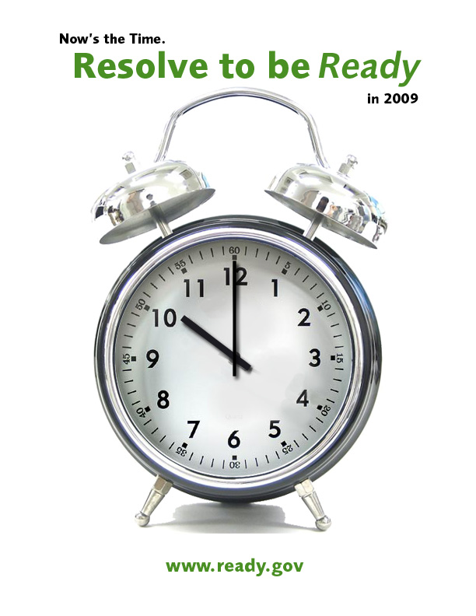



November 24, 2008

Dear Partners in Preparedness:

As the New Year approaches, the Department of Homeland Security’s Ready Campaign is once again reminding people that Now’s the Time. Resolve to be Ready in 2009. While nearly 50 percent of Americans make New Year's Eve resolutions, very few manage to keep them. The Ready Campaign would like to make an emergency preparedness resolution easy to keep by providing the tools and resources needed to take the three important steps: get a kit, make a plan and be informed. We hope you will join the Ready Campaign this Holiday Season in promoting Resolve to be Ready.

Enclosed you will find a toolkit to help your organization develop internal and external messages to encourage your members, employees, constituents, customers and community to make a New Year’s resolution to prepare for emergencies. You will also find Web banners for your organization’s Web site, a sample e-mail and a PowerPoint that you can share with your key constituents.

You can also visit www.ready.gov or call 1-800-BE-READY to learn more about how to prepare for emergencies and how to receive free materials, including family emergency plan templates and sample business continuity plans. Additionally, you can help spread the message throughout your community by partnering with other local organizations to host and arrange activities and events around New Year’s Eve.

If you have questions or would like to showcase your organization’s involvement in Resolve to be Ready 2009, please e-mail ready@dhs.gov. We wish you a very happy and safe New Year!

Sincerely,

Erin Streeter
Director, Ready Campaign
U.S. Department of Homeland Security

Tool Kit Table of contents

Materials and Documents | Page Number
Sample Ideas Organizations Can Use to Encourage Preparedness | 4
Ideas for Utilizing New Media | 5
Resolve to be Ready Web Banners | 6
Resolve to be Ready Poster | 7
Sample E-mail Promoting Resolve to be Ready | 8
Sample Newsletter Article | 9
Preparedness Tips to Include in Newsletters | 10
Resolve to be Ready Information / Talking Points | 11
Media Pitch Template | 13
Media Training Quick-Reference Guide | 14
Event Media Advisory Template | 16
Press Release Template | 17
Resolve to be Ready 2008 Highlights | 18
Rex Costume Order Form | 20
Ordering Ready Materials | 21
Ready Materials Order Form | 22

SAMPLE IDEAS ORGANIZATIONS CAN USE TO
ENCOURAGE EMERGENCY PREPAREDNESS AMONG MEMBERS/EMPLOYEES/CUSTOMERS/CONSTITUENTS/COMMUNITies

- Get involved with your community’s New Year’s Eve celebrations. Many towns across the country host First Nights which are family-friendly New Year’s Eve celebrations. These types of events provide a good opportunity for your organization to get emergency preparedness materials and information in the hands of your community members. There are a variety of ways you can get involved, including: handing out emergency preparedness materials, registering for a table to disseminate information, or creating a community sign-up for those who Resolve to be Ready. You can even get Rex, the ReadyKids mascot, involved! See page 20 for more information on ordering Rex. For more information on First Nights, please visit http://www.firstnightintl.org/welcome.php.

- Encourage people to keep their resolution. One way to do this is to post the three simple steps people can take to keep their emergency preparedness or send them out via e-mail. Another option is to have people sign pledge cards as a constant reminder of their resolution.

- Display the contents of an emergency kit at your company's reception desk. This will serve as a great visual reminder of the importance of emergency preparedness for your employees or office visitors as they come into the office. Next to the display, provide handouts of Ready’s emergency supply kit checklist so that people know how to assemble their own kits.

- Host a drive for people affected by a recent emergency such as a local family displaced by a fire, or local families affected by flooding. Use this opportunity to encourage your employees/community members to think about their own family's emergency preparedness.

- Organize an emergency preparedness event for your community or office. Rent Rex, the Ready Kids mascot, and have activities for children to learn about the importance of having a family emergency plan. For more information on renting Rex, see page 20.

- Reach out to your local Citizen Corps Council to find out if they are organizing any New Year’s events that your organization can sponsor. You can find local Citizen Corps contacts by visiting www.citizencorps.gov.

- Contact your local American Red Cross Chapter to schedule a Be Red Cross Ready workplace or community presentation. Or, find out if your organization can help sponsor or facilitate any preparedness events they may be holding in affiliation with their Be Red Cross Ready campaign, which educates and engages people in first aid and CPR training or preparedness actions throughout the year. To locate the Red Cross Chapter in your area, visit: http://www.redcross.org/where/chapts.asp.

- As you plan your organization’s holiday events, consider weaving in a preparedness theme. If you’re hosting a dinner, consider giving each employee a flashlight or NOAA Weather Radio to include in their emergency supply kit at home.

IDEAS FOR UTILIZING NEW MEDIA TO ENCOURAGE PREPAREDNESS

Ready would like to recommend utilizing new media to promote emergency preparedness. This could be done in a variety of ways, such as on your blogs, MySpace or Facebook pages, podcasts, or Twitter.
Also, please follow the Ready Campaign on Twitter (readydotgov) and feel free to use our planned Twitter messages in your own messages.

Planned Twitters
- Give the gift of peace-of-mind by getting prepared for emergencies.
- Winter is coming, do you have a blanket in your car?
- Do you know how to shut off water valves?
- It’s almost 2009. Have any of the items in your emergency kit expired?
- Always keep your car's gas tank more than half full for emergency use and to keep the fuel line from freezing in cold weather.
- Never leave candles unattended. Make sure you have a flashlight with extra batteries in your kit.
- Do you have an emergency kit in your car?
- In case of a blackout, keep plastic containers with water in your refrigerator and freezer to help keep food cold for several hours.
- Are your emergency contact numbers up-to-date?
- Have an electric garage door opener? Find out where the manual release lever is located and learn how to operate it in case your power goes out.
- Does your community have an e-mail or text alert system? Visit their Web site to find out.
- Watches = severe weather is possible in upcoming days. Warnings = severe conditions have begun or will begin soon.
- Do you want to get preparedness training in the New Year? Find out how at www.citizencorps.gov.
- ATMs may not work during a power outage, so make sure you have extra cash at home.
- Help your community or your office get Ready in 2009. Visit ready.gov to get started.
- The end of the year is a good time to back up computer files and operating systems.
- It’s almost the New Year! Now’s the Time. Resolve to be Ready in 2009.

Resolve to be ready web banners
Post any of these banners on your Web site. Electronic versions are available for download by visiting http://www.ready.gov/america/about/resolve2009.html
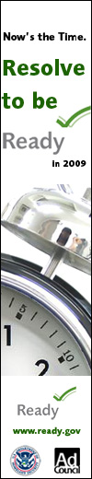








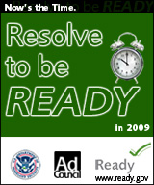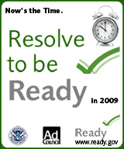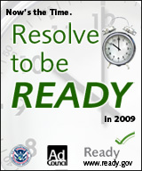

Resolve to be ready POSTER

This poster can be posted on community and office bulletin boards, at events, or any high-traffic locations in your community. Electronic versions are available for download by visiting http://www.ready.gov/america/about/resolve2009.html.

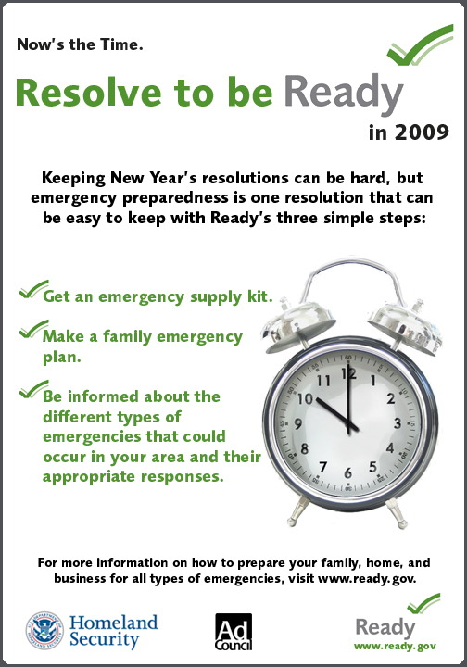

SAMPLE E-MAIL ANNOUNCeMENT ENCOURAGing EMERGENCY PREPAREDNESS AMONG MEMBERS/EMPLOYEES/CUSTOMERS/CONSTITUENTS/Communities

Dear MEMBERS:

This New Year’s Eve, nearly 50 percent of Americans will make at least one resolution as they look toward 2009. ORGANIZATION wants to encourage our MEMBERS/COMMUNITY to make preparing for an emergency a resolution that is both important and easy to keep.

Now’s the Time. Resolve to Be Ready in 2009. It just takes three steps:
- Get an emergency supply kit.
- Make a family emergency plan.
- Be informed about the different types of emergencies that could occur in your area and their appropriate responses.

<To help everyone take these steps to get prepared, ORGANIZATION is proud to be hosting/sponsoring/organizing EVENT. EVENT DESCRIPTION.>

ORGANIZATION encourages you to visit www.ready.gov to learn how to prepare your family, home and business for all types of emergencies including natural and man-made disasters. The Web site offers free downloadable resources, including family emergency plan templates and sample business continuity plans and provides you with tools to make a New Year’s resolution that will bring you and your loved ones peace of mind.

Wishing you a happy and safe New Year, and remember, Now’s the Time. Resolve to Be Ready in 2009.

Sincerely,

NAME
TITLE, ORGANIZATION

Sample EMERGENCY PREPAREDNESS NEWSLETTER/WEB SITE ARTICLE
Include articles about emergency preparedness in your newsletters, local newspaper or on your Web site. Below is an article that you can use. It should be bylined by Erin Streeter, Director of the Ready Campaign.

Additionally, please feel free to utilize our Ready public service advertising (PSAs) in your newsletters. They can be downloaded for free from the Ad Council’s PSA Central Web site: http://psacentral.adcouncil.org/psacentral.

“Now’s the Time. Resolve to be Ready in 2009”
By Erin Streeter, Director, Ready Campaign

Planning is a daily part of our routine. We plan our holiday activities, weekend activities and grocery store visits. We plan our children’s schedules and daily tasks. And, without a doubt, endless lists often follow. There is one particular list that deserves to be checked twice – and it’s not your holiday shopping list. We’re talking about reviewing your emergency preparedness checklist and developing an emergency preparedness plan for your family.

As the New Year approaches, the Department of Homeland Security’s Ready Campaign is encouraging everyone to Resolve to be Ready in 2009. While nearly 50 percent of Americans make New Year's Eve resolutions, very few manage to keep them, but this is one resolution that can be easy to keep with Ready’s three simple steps:

- Get an emergency supply kit.
- Make a family emergency plan.
- Be informed about the different types of emergencies that could occur in your area and their appropriate responses.

The Ready Campaign encourages you to take a few extra minutes at the beginning of this new year to plan in case of an emergency. Consider the following questions: Have you spoken to your children’s schools about their shelter-in-place and/or evacuation plans?; Do you know the evacuation plan at work?; If your cell phone was inoperable how would you get in touch with your family?; Do you have a family meeting place and an out-of-town contact? These are just a few of the questions you should consider as you are developing your emergency plan.

Free preparedness resources, such as a Family Emergency Plan template and an Emergency Supply Kit Checklist are just a click away at www.Ready.gov or www.listo.gov. The Ready Web site also has a special section for kids, ages 8-12, (Ready Kids) and small- to medium-sized businesses (Ready Business). Be sure to check it out – print out your emergency plan template and emergency supply kit list and begin planning with your family today.

Emergencies will happen, but taking action now can help us minimize the impact they will have on our lives. Remember, Now’s the Time. Resolve to be Ready in 2009.

PREPAREDNESS TIPS to INCLUDE IN YOUR NEWSLETTER

For Families:
- Get an emergency supply kit. Be sure to consider additional items to accommodate family members’ special needs:
  - Prescription medications and glasses
  - Infant formula and diapers
  - Pet food, extra water for your pet, leash and collar
  - Important family documents such as copies of insurance policies, identification and bank account records in a waterproof, portable container
  - Books, games, puzzles or other activities for children
- Make sure your family has a plan in case of an emergency. Before an emergency happens, sit down together and decide how you will get in contact with each other, where you will go and what you will do in an emergency.
  - Determine a neighborhood meeting place, a regional meeting place and an evacuation location.
  - Identify an out-of-town emergency contact. It may be easier to make a long-distance phone call than to call across town, so an out-of-town contact is important to help communicate among separated family members. Be sure every member of your family knows the out-of-town phone number and has coins or a prepaid phone card to call the emergency contact. You may have trouble getting through, or the telephone system may be down altogether, but be patient.
  - You may also want to inquire about emergency plans at places where your family spends time, such as a place of employment. If no plans exist, consider volunteering to help create one.
- Talk to your neighbors about how you can work together in the event of an emergency. You will be better prepared to safely reunite your family and loved ones during an emergency if you think ahead and communicate with others in advance.

For Parents:
If you are a parent, or guardian of an elderly or disabled individual, make sure schools and care providers have emergency response plans:
- Ask how they will communicate with families during a crisis.
- Ask if they store adequate food, water and other basic supplies.
- Find out if they are prepared to "shelter-in-place" if need be, and where they plan to go if they must get away.

For Workplaces:
- Take a critical look at your heating, ventilation and air conditioning system to determine if it is secure or if it could feasibly be upgraded to better filter potential contaminants, and be sure you know how to turn it off if you need to.
- Think about what to do if your employees can't go home.
- Make sure you have appropriate supplies on-hand.

For Communities:
- Find out what kinds of disasters, both natural and man-made, are most likely to occur in your area and how you will be notified. Methods of getting your attention vary from community to community. One common method is to broadcast via emergency radio and TV broadcasts. You might hear a special siren, or get a telephone call, or emergency workers may go door-to-door. Contact a nearby Citizen Corps Council for help with emergency planning, or work with your local government and emergency management office to help start a Council in your area. Visit citizencorps.gov to find local Councils or learn how to start one in your community.

For additional tips and information, visit www.ready.gov

RESOLVE TO BE READY BACKGROUND INFORMATION/TALKING POINTS

Resolve to be Ready
- Resolve to Be Ready is an effort by the Ready Campaign and its partners to encourage Americans to make a New Year’s resolution to prepare for emergencies by following three simple steps:
  - Get an emergency supply kit
  - Make a family emergency plan
  - Be informed about the types of emergencies that can occur in your area and their appropriate responses.

Ready Campaign

Ready is a national public service advertising campaign designed to educate and empower Americans to prepare for and respond to emergencies including natural disasters and potential terrorist attacks.
  - Ready America – provides information to all individuals and also includes specialized information for pet owners, older Americans, and individuals with disabilities and other special needs.
  - Ready Business (launched in 2004) helps owners and managers of small- to medium-sized businesses prepare their employees, operations and assets in the event of an emergency.
  - Ready Kids (launched in 2006) helps parents and teachers educate children, ages 8 – 12, about emergencies and how they can help get their family prepared.
- Spanish language information is available through, Listo America, Listo Negocios and Listo Niños.

Visit www.ready.gov or call 1-800-BE-READY for information about emergency preparedness.

Emergency Supply Kit
- The Ready Campaign recommends that a basic emergency supply kit include:
  - One gallon of water per person per day, for three days – and remember to include water for your pets, too
  - It’s important to store at least a three-day supply of non-perishable food. Select foods that require no refrigeration, preparation or cooking and little or no water and choose foods your family will eat: ready-to-eat canned meats, peanut butter, protein or fruit bars, dry cereal or granola
  - A manual can opener and eating utensils
  - Battery-powered or hand crank radio and a NOAA Weather Radio with tone alert and extra batteries for both
  - Flashlight and extra batteries
  - First aid kit
  - Whistle to signal for help
  - Dust mask, to help filter contaminated air and plastic sheeting and duct tape to shelter-in-place
  - Moist towelettes, garbage bags and plastic ties for personal sanitation
  - Wrench or pliers to turn off utilities
  - Local maps
  - Important family documents such as copies of insurance policies, identification and bank account records in a waterproof, portable container
- The Ready Campaign also encourages people to consider the special needs of their family members:
  - Prescription medications, extra pair of contact lenses and glasses
  - Infant formula and diapers
  - Pet food, extra water for your pet, leash and collar
  - Books, games, puzzles or other activities for children
- For a complete list of items, visit www.ready.gov to download a free emergency supply checklist or call 1-800-BE-READY.

Family Emergency Plan
- Families may not be together when an emergency happens and you may not have access to cell phones, gas stations, grocery stores or some of the other things that you are used to having every day.
- A family emergency plan allows families to work together to develop a meeting place, establish an out-of-town contact and gather essential information that would help them to stay connected in the event of an emergency.
- Download a free template at www.ready.gov.

Stay Informed
- Ready.gov contains information about different types of emergencies, as well as contact information for cities and states across the country.
- Call 1-800-BE-READY

MEDIA PITCH TEMPLATE

This pitch is meant to be sent with your Media Advisory or your Press Release and is used in a similar fashion to a cover letter.

Subject: Now’s the Time. Resolve to Be Ready in 2009.

Hi <REPORTER>,

As we enter the New Year, <ORGANIZATION> is urging <TOWN/COMMUNITY/REGION> to make preparing for an emergency a New Year’s resolution that is both important and easy to keep.

It just takes three steps:
  - Get an emergency supply kit.
  - Make a family emergency plan.
  - Be informed about the different types of emergencies that could occur in your area and their appropriate responses.

To help everyone take these steps to get prepared, <ORGANIZATION> is proud to be <HOSTING/SPONSORING/ORGANIZING> <EVENT>. <EVENT DESCRIPTION>.

Additionally, <ORGANIZATION> is encouraging <TOWN/COMMUNITY/REGION> to visit www.ready.gov to learn how to prepare their families, homes and businesses for all types of emergencies including natural and man-made disasters.

If you are interested, <SPOKESPERSON, TITLE> is available to speak with you about <EVENT> and provide simple ways that individuals, families, businesses and communities can get Ready for any emergency. If you would like to speak with <SPOKESPERSON> or need any additional information, please feel free to contact me at <E-MAIL ADDRESS AND/OR PHONE NUMBER>

Wishing you a happy and safe New Year, and remember, Now’s the Time. Resolve to Be Ready in 2009.
Thank you,
NAME
TITLE, ORGANIZATION

MEDIA TRAINING QUICK-REFERENCE GUIDE

Consider the following tips when you’re preparing to represent your organization in media relations activities that involve pitching stories to reporters and conducting interviews about Resolve to be Ready 2009.

Talking to Reporters – Making Your Pitch
- If you don't know the reporter, you will have less than 30 seconds to get his/her attention. Get to the point quickly.
- Always ask if the reporter is on deadline before you begin. If they are, ask when a better time would be to call. Exceptions to the rule are radio and TV talk shows. Call when the show is not on the air.
- Tell the reporter why you are calling - "I saw your story on... and thought you might be interested in something my organization is doing about …" or "I'm calling to let you know about …"
- If you don't know the answer to a question the reporter raises, tell them that you do not know but that you will try and find out for them and call back.
- If a reporter is on deadline and is brusque, don't let that shake you. It is essential in this situation that you respond courteously to their situation by offering to call back, ask when would be the best time to call back, find out if you can fax or e-mail the information, etc. Others may be brusque even when not on deadline. Don't take it personally.
- If the reporter asks you to fax or e-mail something, confirm their fax number or e-mail address. Many organizations change their fax numbers frequently. Follow up with a fax or e-mail immediately.
- Reporters are hardly ever at their desks - although your chances are best in the morning. Don't hesitate to leave brief messages for reporters outlining your pitch. You can do this more than once, but try not to leave more than two messages. Try to keep your pitch very short, ask them to call, offer to fax or e-mail info, and say that you will call back.
- Share what is working about your media "pitch" - and what isn't working - with your colleagues. It may take a couple of calls to get your pitch down, and when you find what works, share it.
- Be prepared to have conversations with reporters who know a lot about the issue. If you finish your 30-second pitch and cannot answer reporters' inquiries, you won't be able to sell your story.
- Reporters want to be sure you know what you are talking about. Remember that your pitch should be simple, interesting, short, and clear. But, your knowledge should go to a deeper level.
- Keep a log with good notes about your press outreach. Record reporters' interests, key questions; note what the next steps are. Does the reporter want more info? Do you need to make a follow-up call in a few days? Record any follow-up activities on the log.
- If a reporter says no, respect it. Do not keep harping or bothering him/her about the same story or angle. No doesn't mean "don't ever call me again." It just means don't call again with the same pitch/story. Don't be afraid to call another time with a new story, or very interesting new angle, breaking news, etc.

The Newspaper Interview
DO
- Prepare. Practice your answers.
- Answer all questions on a positive note.
- Talk in simple terms and keep it short.
- Keep statistics to a minimum.
- Be honest, responsive and factual.
- Offer to obtain additional information when appropriate.
- Repeat key message points to ensure the reporter has a grasp of your ideas.

DON’T
- Improvise. Stick to your message(s)!
- Repeat negative examples or words used by the questioner. This will reinforce negative ideas in the audience’s mind. Answer positively.
- Ramble. Say what you want to say as clearly and concisely as possible.

The TV Interview: What to Wear
TV is a visual medium. Viewers quickly form an impression or opinion based solely on what they see. Never let what you are wearing distract from what you are saying! Always check your appearance before any on-camera interview.
YES
- Conservative, dark-colored suits are best. For men, a splash of color can come from your tie, but keep it simple.
- Solid colors. For men, powder blue shirts are best for TV.

- Hair should be neat and away from the face.

- Men … sit on your suit coat to ensure wrinkle-free look.

NO
- Flashy colors, stripes, checks, plaids or floral prints
- Distracting jewelry
- Carrying bulky items in pockets
- Light-sensitive glasses
- Chewing gum
- Carrying pagers or cell phones

The TV Interview: Body Language
Always remember to have relaxed, friendly body language, eye contact and posture.
YES
- High energy and confidence
- Friendly smile and relaxed demeanor
- Direct eye contact with the interviewer
- Occasional hand gestures to emphasize your point

NO
- Slouch or sit uncomfortably straight
- Shift your eyes or gaze away from the interviewer. Never look directly into the camera or at the TV monitor.
- Play with pens, glasses, buttons or microphones
- Touch your face or hair or fix your clothes while on-camera
- Swivel in your chair
- Bounce your leg or cross your legs

MEDIA ADVISORY TEMPLATE FOR RESOLVE TO BE READY EVENTS

This media advisory template is designed to be tailored to your event and to be used for alerting the media and inviting the media to your event.

MEDIA ADVISORY

Attention News Directors and Assignment Editors

Write a HEADING - (Example: <cOMPANY> HOLDS NEW YEAR’S BASH WITH PREPAREDNESS THEME AND FAMILY ACTIVITIES) - IncLuDE Catchy title and some details

GIVE a brief description here – 3 or 4 sentences maximum. include and explain as briefly as possible the 5 w’s of what’s happening: who, what, when, where and why. Please be sure to bold the important/factual elements – so they catch the reader’s eye.

****PHOtos or interview opportunities-If Available****

Who: Includes the organization name, executive directors, management, quoted sources, sponsors, speakers, etc.

What: The name of the event, what the event is about

Where: place
address

When: FuLL DATE AND TIME

WHY: This information may not always be relevant, but it will be important if you are putting together a fundraising event or an awareness campaign

URL: url If available

Contact: Your name, organizer
Phone Number
E-mail Address

RESOLVE TO BE READY 2009 PRESS RELEASE TEMPLATE

The Ready Campaign will be distributing a national press release to promote Resolve to be Ready 2009. This press release template is designed to be tailored so you can send it to your own local media announcing your efforts.

Press Release

<Month, Day Year>
Contact: <Contact Name>, <Phone>

<ORGANIZATION> Encourages Americans to Resolve to Be Ready in 2009

<CITY, STATE> – The New Year is a perfect time to Resolve to be Ready and <ORGANIZATION> is proud to be promoting emergency preparedness for 2009. To help spread the message and make its employees and members of the community better prepared, <ORGANIZATION> is <INSERT EVENT INFORMATION HERE>. Sponsored by the Department of Homeland Security’s (DHS) Ready Campaign, Resolve to be Ready is a nationwide effort designed to increase awareness as well as encourage individuals, families businesses and communities to take action and prepare for emergencies in the New Year.

Keeping New Year’s resolutions is challenging, but making resolutions that are simple and realistic is the key to success. By following the Ready Campaign’s three simple steps, being Ready for emergencies can be an easy resolution to keep: 1) Get an emergency supply kit; 2) Make a family emergency plan; and 3) Be informed about the types of emergencies that can happen in your area and their appropriate responses.

<INSERT QUOTE FROM YOUR ORGANIZATION HERE>

<INSERT EVENT DETAILS HERE>

Emergencies can range from inconvenient to devastating, but by making this resolution and following these simple steps in advance, you will minimize the impact on you, your family and your businesses and give yourself greater peace of mind. For more information, visit www.ready.gov The Web site includes free information, checklists and guidelines about the two other key components of preparedness – developing a family emergency plan and being informed.

RESOLVE TO BE READY 2008 HIGHLIGHTS

In 2008, many individuals, communities and organizations across the nation joined the Ready Campaign in spreading the message of Resolve to be Ready. They held events as well as developed initiatives to educate their neighbors, co-workers and employees on how to prepare for emergencies before they happen. Included below are a few examples of the many ways people got the message out last year.

Business Emergency Response Toolkit
Citizen Corps Council, Santa Rosa County, Florida
“We have started a business continuity initiative where we are providing a Business Emergency Response Toolkit (BERT) to every business in the county. We solicited sponsorships to raise $6,500 to create 2,500 BERT bags. After these bags are distributed early in 2008, we have Michigan State bringing their Critical Incident Protocol ‘Public/Private Partnership’ program to the region. We are hoping that these initiatives combined with the recent addition of a business continuity desk in our EOC will provide a starting point for businesses to get prepared for all hazards.”

Inclusion in Yearly Planning Process
Warner Robins Chamber of Commerce, Board of Directors Member, Georgia
“As a member of the Warner Robins Chamber of Commerce Board of Directors, I felt it was vital that we share this information with our members. At our annual Goals Conference, I made a proposal that this be added to our program of work. This year, we will have information and kits available to all member businesses that are interested in starting a plan or just getting more information for themselves.”

CERT Classes
Citizens Corps Council, Maine Township, Illinois
“Maine Township, IL Citizen Corps Council will be hosting several CERT Classes in 2008 including two Skills Roundup Days, as well as Medical Reserve Corps Training. Additionally, our Neighborhood Watch program will have a recruiting drive with training from the Cook County Sheriffs Police. Lastly, at this time, the Council will be assisting another area with the formation of a new Citizen Corps Council that will serve close to 35,000 residents. The Township’s Council has been asked to take the lead for this initiative which will include a CERT program, an MRC Program as well as a Neighborhood Watch program. The expectation is that by the end of the year this new council will have trained over 5,000 people. Overall, the sub-organizations under the Maine Township Citizen Corps Council will participate in multiple community events that will include festivals, safety days, National Night Out Against Crime, Walk Against Drug Abuse, fire department open houses and the Susan G. Kommen Walk Against Breast Cancer.”

Radio Outreach
REACT International, Maryland
“We are making it a goal to spread the message out over our radio system which can be picked up on a standard scanner by millions of people in VA, NC, MD, DE, and Washington D.C.”

Community Outreach and Events

Clifton Park Citizen Corps in Albany, NY
The Clifton Park Citizens Corps planned the following efforts for the 2008 Ready Campaign, and many other activities throughout the year:
- National Night Out Against Crime will take place on the first Tuesday in August at the Clifton Park athletic complex. We will have emergency preparedness displays, sign-ups for CERT training and Basic First Aid and CPR. In addition, police crime prevention and equipment displays, K-9 demos and Officers speaking with kids and families. The local volunteer fire departments will showcase trucks and equipment. Clifton Park’s Mobile Fire Prevention Bus-Classroom and the Sheriff's Mobile Command Vehicle will be open for tours and demos. There will be a free throw contest for kid’s ages 6-13 years with t-shirts for all participants.
- Brochures and info will be provided to the 8 elementary schools
- A 9-11 Memorial Service at Spirit Park will recognize the emergency responders in our community. Appreciation awards will be presented to the ‘Most Community Minded’ Volunteer Fire Department, which signed up the largest number of persons to Town's RUOK? Special Needs Registry during our registration drive - there are 6 in Town.
- Clifton Park Citizen Corps Web site will host "Ready" materials, links and information, calendar of events, classes and training schedules, as well as photos of volunteers in action throughout the year.
- Clifton Park Citizen Corps in Albany, NY

Inclusion on Local Web Site
Ohio Department of Public Safety
“We're going to put materials on our ready.ohio.gov site and issue a press release for the week between Christmas and New Years—as people start thinking of their New Year's resolutions.”

Involvement at Community Events
Emergency Services Volunteers & Citizen Corps Council in Denton County, Texas
“We plan to provide emergency preparedness education at local fairs, retirement centers, Fire Department open houses and many more city and county events.”

Newsletter Article
International Bottled Water Association in Alexandria, Virginia
“We are running an article featuring the Ready Campaign’s messages in our member weekly newsletter, IBWA News Splash.”

Local Preparedness Campaign
Citizen Corps Council in Bristol, Virginia-Tennessee
“We are planning to provide a campaign for businesses, media and residents for the Bristol area.”

Support
www.Survival-Goods.com
“We are pleased to give our personal guarantee to the Ready campaign on our involvement in Resolve to be Ready 2008. We’ll do all we can to help prepare as many families, schools and businesses throughout the entire US during this next coming year!”

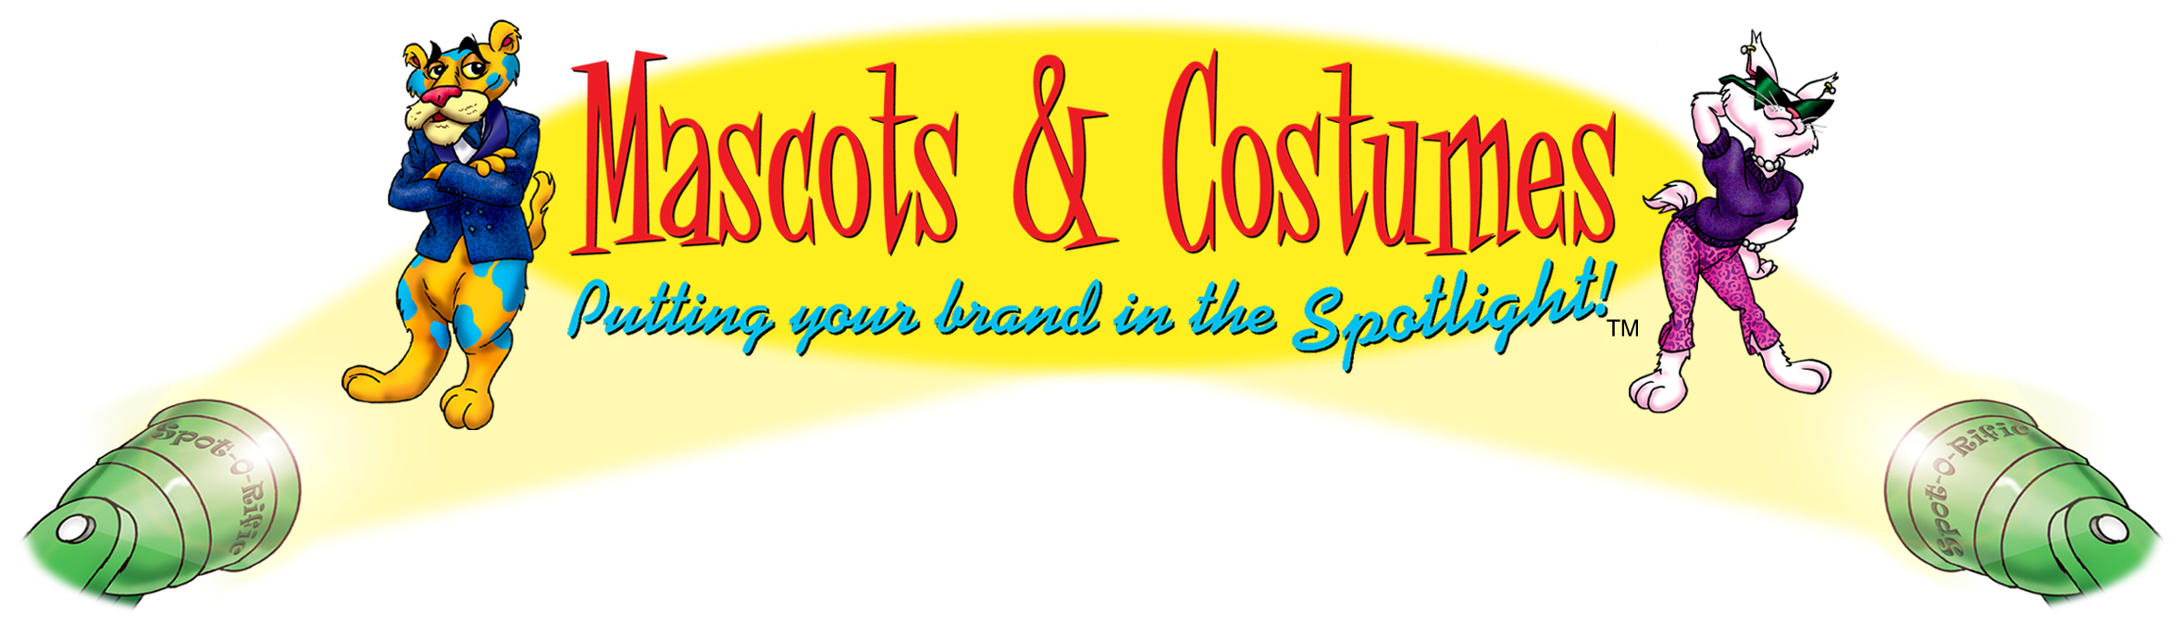


“Rex” the Ready Kids Mascot

Brought to you by the U.S. Department of
Homeland Security and The Advertising Council

Important:

All reservations must be made two weeks in advance. NO EXCEPTIONS!

Requests will be taken on a first come, first serve basis.

(Approximately six uses per month available.) A confirmation e-mail will be

sent upon receipt of the request to inform you of the availability.

This contract must be filled out with all the correct information.

Rental fee is $150.00 plus shipping costs.

Date Needed: _____________________ Date Returning: _________________________
Organization Name: _______________________________________________________
Organization Contact: ______________________________________________________
Contact Phone: _____________________ Contact E-mail: _______________________
Address: _________________________________________________________________
City: _____________________ State: __________ Zip: __________
Credit Card Information - Name: _____________________________________________
Expiration Date: _____________________ CVS: ______________________________

IMPORTANT INFORMATION:
I have read and fully understand the following financial and maintenance responsibilities invoiced in the use of this costume:
- I agree to pay for any damage that occurs to the costume while it is in my possession.
- I acknowledge the rental agreement stating that I may only keep the costume for three days upon receipt. (i.e. Friday – Monday) or I will be charged for $50 per day.
- I will arrange and pay for the costume to be returned by the date indicated.
- I agree to pay $150 + shipping for its three-day use and comply with all instructions including maintenance, repacking and return of the costume.
- If the costume can’t be returned by set date, I will contact M&C to reschedule.

2841 Oakland Avenue, Minneapolis, MN 55407-1301 • (612) 874-8176 • Fax (612) 874-6003
www.mascotsandcostumes.com E-mail Address: contract.service@mascotsandcostumes.com

ORDERING READY MATERIALS

Homeland Security’s Ready PSAs, produced and distributed by the Ad Council, are available to be shared with your members, employees, stakeholders, etc. Include new Ready print ads in your organization or community newsletters and publications, or post or play them in your break room or at local community centers and libraries. You can also provide copies to your local newspapers, television and radio stations and encourage them to air the PSAs. Note that there are also localizable versions available to state and local governments. You may view all of the Ready PSAs at www.ready.gov.

To download or order copies of the TV, radio, print, Internet or outdoor PSAs, visit the Ad Council’s PSA Central Web site at http://psacentral.adcouncil.org/psacentral. All available materials are provided free of charge. Please check the PSA Central Web site for the various lengths and sizes available for the public service announcements (PSAs).

Ready brochures and pamphlets are also available free of charge. There are materials for Ready America, Ready Business, Ready Kids, and also brochures for pet owners, older Americans and Americans with disabilities and special needs.

Ready materials are available free in limited supply. To order Ready materials, please call the FEMA warehouse at 1-800-480-2520 or fax the attached request form to 301-362-5335.

In the event that you need a quantity of materials that exceeds what can be ordered for free, Ready provides a couple of options. All the brochures can be downloaded off www.ready.gov, at http://www.Ready.gov/america/publications/allpubs.html. Additionally, if you would like to have the brochures professionally printed at your own expense, Ready will send you the source files.

Having brochures professionally printed at your own expense will allow you the option to localize the brochures by placing your local emergency contact information on the back cover.

*** Important Note: Please allow 4 to 6 weeks for the shipping of these materials. To receive materials more quickly, you can select express mail at your own expense, and will need to provide your DHL or FedEx number on the order form. ***

