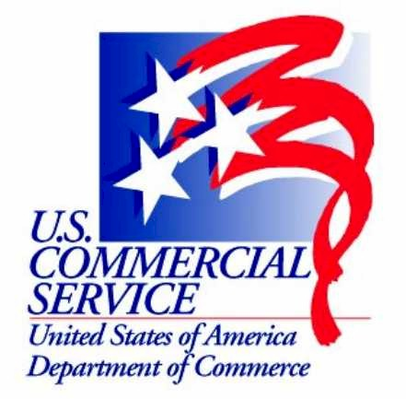
TRAVEL & TOURISM TEAM AND THE U.S. DEPARTMENT OF COMMERCE

Let us help you attain your international goals. We can assist with the following:

- Development of an international marketing strategy
- Obtaining market research and statistics on international markets
- Identifying partners/reps for you to work with in international markets
- One-to-one counseling on international markets and the opportunities they hold (done by staff in the U.S. and abroad at U.S. Embassies/Consulates)

The International Trade Administration (ITA) is the trade promotion branch of the U.S. Department of Commerce. Within ITA, the U.S. Commercial Service and Trade Development are the two primary government agencies that are actively involved in outreach to support travel and tourism exports. http://www.ita.doc.gov

U.S. Commercial Service – U.S. offices: The U.S. Commercial Service has nearly 100 offices located throughout the U.S.A., known as Export Assistance Centers. Staff in these offices work in unison with staff in the international offices to provide export counseling to U.S. businesses and destinations interested in entering or increasing their presence in international markets. Services include one-to-one counseling, market research and partner identification. http://www.export.gov , http://www.buyusa.gov/eme/tra.html

U.S. Commercial Service – International Offices: The U.S. Commercial Service carries out an in-market international sales promotion in the U.S. Embassies and Consulates in principal cities throughout the world. It serves as a bridge to assist U.S. destinations identify their best partners overseas and promote themselves effectively on a global basis, and to assist U.S. companies in their international marketing efforts with the local travel industry. http://www.export.gov

Manufacturing and Services – Office of Travel & Tourism Industries serves as the National Tourism Office for tourism policy coordination and representation internationally. It is also the primary source of international travel statistics in the United States, and provides technical assistance in conjunction with the Commercial Service for expanded exports. http://tinet.ita.doc.gov

For further information, please contact Mark Weaver, Director, Fort Worth EAC, 808 Throckmorton Street, Fort Worth, Texas 76102, tel: 817-392-2673, email: mark.weaver@mail.doc.gov

