March 9, 2009

Dear Team General Manager:

As President Pat O’Conner informed you, Minor League Baseball™ has agreed to partner with FEMA’s Ready Campaign and National Office of Citizen Corps for the sixth straight year! Together, over the last five years, we’ve reached millions of baseball fans with our message and we’re excited about what 2009 will bring.

As such, Minor League Baseball™ games provide a great opportunity to raise community awareness for emergency preparedness and encourage residents to become educated and trained in emergency response skills and to volunteer to support community safety.

We encourage you and your team to use the attached toolkit to educate fans on how they can better prepare themselves, their families, businesses and communities for an emergency. Partnering with your local Citizen Corps Council, Boys Scouts and/or Office of Emergency Management is also a great way to make your event an even bigger success. Another thing you might want to consider is having Rex, the Ready Kids mascot, make a special guest appearance.

Last season, more than 30 Minor League Baseball™ teams from across the country participated in this effort, and we need your help to make this year bigger and better. We hope you and your team will take part in our efforts to make your community and its residents more prepared during the 2009 season.

If you have any questions or would like to register your team as a Minor League Baseball™ Ready participant, please call Ingela Hartman at 717-232-5554 x129 or e-mail ready@dhs.gov. If you need any assistance finding your local Citizen Corps Council, Boys Scouts or Office of Emergency Management, please don’t hesitate to contact us for help.

We hope you will help us spread the message of preparedness at your stadium, and we look forward to working with you in 2009.

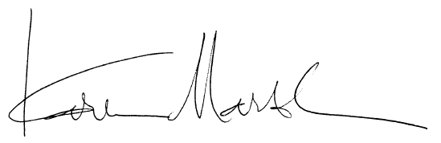
Sincerely,
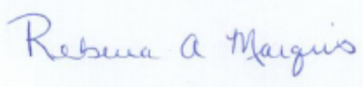

Rebecca Marquis Karen Marsh
Deputy Director, Ready Campaign Director, Community Preparedness Division/Citizen Corps
U.S. Department of Homeland Security Federal Emergency Management Agency, DHS

Enclosures
Minor League Baseball™, the Ready Campaign and Citizen Corps:
Making Fans Better Prepared for Emergencies

Overview ~ The Ready Campaign
The Ready Campaign is a national public service advertising campaign designed to educate and empower Americans to prepare for and respond to emergencies including natural disasters and potential terrorist attacks. The goal of the campaign is to get Americans involved and ultimately increase the level of basic preparedness across the nation. Ready and Listo, its Spanish language version, ask individuals to do three key things: get an emergency supply kit; make a family emergency plan; and be informed about different types of emergencies that could occur and their appropriate responses.

For the last five years, individual Minor League Baseball™ teams across the nation have supported Ready in a variety of ways, including featuring campaign advertisements, messages, special events and materials at their games. If you’ve been involved in the past, we strongly encourage you to get involved again this year. If you have not been involved in past years, we urge you to find ways to get involved and spread the preparedness message at your ballpark.

Overview ~ Citizen Corps
Administered nationally by DHS, Citizen Corps is the nationwide grassroots movement to actively involve everyone in America in making our communities and our nation safer and better prepared for all hazards and threats. We all have a role in hometown security and Citizen Corps provides local opportunities for everyone to prepare, train, and volunteer.

At the local level, Citizen Corps Councils bring community and government leaders together to involve community members and organizations in all-hazards emergency preparedness, planning, prevention, mitigation, response, and recovery. These Councils enable collaborative planning between government and civic leaders and provide localized support for: outreach and educational efforts to the public; training and exercises that effectively integrate emergency responders, volunteers with a response role, and the general public; and volunteer programs that augment the full range of emergency response services.

The Ready Campaign encourages representatives from your team to not only reach out to your local Citizen Corps to help orchestrate your Ready event, but also to participate as members of your local Citizen Corps Council year-round. To learn more and to get involved, contact your nearest Citizen Corps Council by visiting www.citizencorps.gov.

Potential Activities for the 2009 Season
There are many ways that you and your team can participate in this important effort. Below are several examples of how teams can support Ready, but please feel free to implement your own ideas:

Leverage Community Partnerships
- Many teams already host “Boy Scout Nights” throughout the season. During these games, local Boy Scouts can distribute Ready brochures, which helps them complete the requirements toward their Emergency Preparedness merit badge. It also fosters skills that help them better prepare themselves, their families, and their communities for emergencies. To order Ready materials for distribution, please use the order form included on page 10 of this kit. To order Citizen Corps and other emergency preparedness materials, please use the order form included on page 11 of this kit and contact FEMA's Distribution Center at 1-800-480-2520 or contact your local emergency management office. To coordinate distribution by Boy Scouts, please contact your local Boy Scout Council (www.scouting.org).
- In previous years, teams have really benefited from partnering with their local Citizen Corps Council as they are able to educate residents on evacuation plans, shelter-in-place plans, alerts and warnings, training and exercise opportunities, and volunteer programs. They could do this by setting up a table or simply by handing out materials.

Share Public Service Advertisements (PSA) and Special Announcements
- Ready encourages you to include Ready print ads in your game program or to run Ready TV ads on the stadium video monitors. To download or order copies of all Ready TV, radio, print, or outdoor PSAs, see page 9 of this toolkit.
- For stadiums with video monitors, your announcers could read Ready messaging to draw attention prior to showing our PSAs:
  - JumboTron Ad Introduction – “Everyone should have a plan in the event of an emergency. For more information, visit www.ready.gov. Please turn your attention to the JumboTron for a public service advertisement about the Ready campaign brought to you by the U.S. Department of Homeland Security and The Advertising Council.”
- For stadiums without video monitors, you could encourage your local team to have the announcers read Ready messaging:
- Without JumboTron – “For the past six years, Minor League Baseball™ has partnered with the U.S. Department of Homeland Security’s Ready Campaign, the Boy Scouts, and FEMA’s Citizen Corps Program in a national effort designed to educate and empower Americans to prepare for and respond to potential emergencies. The Ready Campaign encourages everyone to take three easy steps: get an emergency supply kit; make a family emergency plan; and be informed. Be sure to stop by and see your <LIST VOLUNTEERS> in the <LOCATION AT BALLPARK> to receive more information on how you and your family can be better prepared.”

Special Activities
Create special events at your stadium that are fun, but also help educate your community on the importance of emergency preparedness. Some sample ideas include:
- Have Rex the Ready Kids mascot make an appearance. Rex could throw out the first pitch, showcase some of the necessary items to include in an emergency kit or hand out emergency kits to select ticket holders. To learn how to order Rex, please see page 8.

- Sponsor a “Ready Kit Race” during inning breaks. Team officials could select children to take part in a race around the bases, collecting emergency supply items and placing them in a box or bucket at home plate. For example, batteries could be placed at first base, a water bottle at second base and a whistle at third base.

- Select a young fan from the audience to answer questions on emergency preparedness for prizes. Questions might include:

- What is NOT one of the three steps you can take to help your family be prepared for emergencies?
- Eat your vegetables
- Get a kit
- Make a plan
- Be Informed
- What should a Family Communications Plan include?
- Information about how we would get in touch with each other during an emergency
- Where we would meet
- How we would remain in contact
- All of the above
- How much water should you have in your Ready Kit?
- One small water bottle for each person
- One gallon for the whole family
- One gallon of water per person per day
- One gallon of water for the family per day
- Which of the following is NOT an important part of an emergency supply kit?
- Flashlights and batteries
- Warm blankets
- Your Jonas Brothers poster
- Food

- How quickly can a fire spread through a house?
- 10 minutes
- As little as five minutes
- 30 minutes
- 45 minutes
- In an emergency, what number should you dial to contact the police and fire department?
- 911
- 111
- 711
- 311
- What is a tornado?
- A violent storm that appears as a funnel-shaped cone
- The movement of the earth along the cracks in the earth’s surface
- A tropical storm with an ‘eye’
- A giant wave
- In an emergency, what should you have available to hear news and official reports about what is occurring?
- A battery-powered radio
- A CD player
- A board game
- DVD player

Training for Park Personnel
Emergency preparedness is important all year long. During the third game of the 1989 World Series, the Loma Prieta earthquake hit the San Francisco area. The Superdome, Astrodome and Qualcomm Stadium facilities were used as mass shelters during hurricanes and wildfires. These events are perfect examples of why it is vital that park personnel be appropriately trained. Contact your local baseball team to discuss improving the security of your facilities, to schedule CERT training for park personnel and concession workers, and to discuss shelter management.

Share Your Success
The Ready Campaign would love to hear from you with any additional thoughts or ideas you have for partnerships or any successes you’ve had in past years with spreading Ready’s preparedness message. If you are interested in sharing your ideas, please contact Ready at ready@dhs.gov.

Frequently Asked Questions (FAQ)
Q: How do we find local organizations and resources for our community?
A: Citizen Corps, FEMA’s grassroots effort, localizes preparedness messages and provides opportunities for citizens to get emergency response training; participate in community exercises; and volunteer to support local first responders. To learn more and to get involved, contact your nearest Citizen Corps Council or visit www.citizencorps.gov for more information.

In addition, the Ready Campaign works closely with state and local government agencies to prepare our nation for emergencies. Visit the Ready America section of www.ready.gov, click on Community and State Information with the map image, and then click on your state to find local emergency preparedness resources and information.

Q: We’d like to distribute materials to fans as they enter the ballpark. What can we distribute and how can I get these materials?
A: Teams and Citizen Corps Councils can distribute emergency preparedness tri-fold brochures and emergency supply lists to fans. To view materials, go to www.ready.gov/america or http://www.citizencorps.gov/ready/cc_pubs.shtm. You can order free brochures using the order forms on page 10 and 11 of this toolkit. To order Citizen Corps and other emergency preparedness materials, contact your local emergency management office or FEMA's Distribution Center at 1-800-480-2520.
You can distribute these brochures through your own venues at the park such as a stand or at ticket points. One of the most successful ways that we’ve found is by working through Homeland Security and the Boy Scouts of America partnership.

Q: What if we would like to have emergency preparedness demonstrations and first responders at the ballpark to answer questions?
A: Contact your state or local Office of Emergency Management or Citizen Corps Council, citizencorps.gov, to discuss ways to have uniformed emergency responders and community outreach educators on-hand for demonstrations or to staff information booths. You can also visit the Ready America section of Ready.gov, click on Community and State Information with the map image, and then click on your state to find local emergency preparedness resource and information.

Q: I want to use the new Ready PSAs during my game and place the print ads in our program. How can I get them?
A: To download or order copies of all TV, radio, print or outdoor PSAs visit the PSA Central Web site at http://psacentral.adcouncil.org/psacentral/signon.do. The site makes it easy to browse and preview current PSA materials for Ad Council campaigns. Please select “Emergency Preparedness” under the “Campaign” pull-down menu to access all Ready PSAs. Everything available for download or order on this site is provided free of charge.
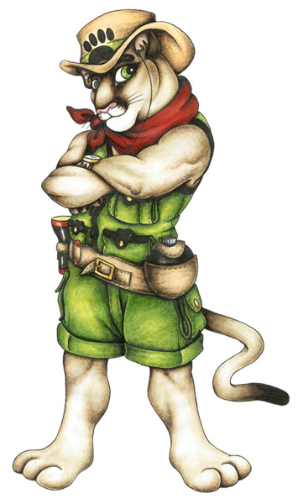
Q: How can we reserve the Rex costume?
A: All reservations and requests for the Rex costume must be coordinated through your state or local Citizen Corps Council or Office of Emergency Management. These organizations are responsible for ordering the costume and providing the official talent to portray Rex at your events. It is strongly recommended that requests are submitted at least four weeks prior to your event. Please see the Rex order form on page 8.

Media Outreach
The Ready Campaign has provided a media advisory and press release template for you to publicize your team’s participation with Ready to local media outlets. If you need help with this effort, please feel free to reach out to ready@dhs.gov.

MEDIA ADVISORY TEMPLATE FOR COMMUNITY EVENTS

MEDIA ADVISORY
Attention News Directors and Assignment Editors

Write a HEADING - (Example: <team> partners with Homeland Security’s ready campaign and Citizen Corps to help families prepare for emergencies) - IncLuding Catchy title and some details

GIVE a brief description here – 3 or 4 sentences maximum. include and explain as briefly as possible the 5 w’s of what’s happening: who, what, when, where and why. Please be sure to bold the important/factual elements – so they catch THE reader’s eye.

****PHOtos or interview opportunities (If Available)****

Who: Include the organization name, executive directors, management, quoted sources, sponsors, speakers, etc.
What: The name of the event, what the event is about
Where: place
address
When: FuLL DATE AND TIME
WHY: <Your team’s> Fans need to know how to be prepared in the event of an emergency
URL: url If available
Contact: Your name, organizer
Phone Number
Email Address

<DATE- I.E.May 4,> 2009
Press Release Contact: XXXXX

<TEAM NAME> TEAM UP WITH HOMELAND SECURITY <and PARTNERING ORGANIZATION(S) NAME> TO PROMOTE EMERGENCY PREPAREDNESS

<TEAM NAME> <and PARTNERING ORGANIZATION(S) NAME > Encourage Fans to
Take Steps to Prepare
YOUR LOCAL CITY, STATE – The <TEAM NAME> are teaming up with the U.S. Department of Homeland Security’s Ready Campaign <and PARTNERING ORGANIZATION(S) NAME> to educate and encourage their fans to prepare for emergencies in their homes, businesses and communities.
This is the sixth consecutive season that Minor League Baseball™ is promoting emergency preparedness among its fans. The <TEAM NAME> are part of a nationwide effort and will host their very own Ready Night at the ballpark on <DATE- I.E.- Friday, May 4> to share the Ready Campaign message.

“Minor League Baseball™ has been an invaluable partner in our efforts to prepare all Americans for emergencies that may occur such as natural disasters or potential terrorist attacks,” said Ready Campaign Deputy Director Becky Marquis. “With the help of Minor League Baseball™ and groups like Citizen Corps and the Boy Scouts of America, we’re able to reach millions of baseball fans and encourage them to get an emergency supply kit, make a family emergency plan and be informed about the different types of emergencies that can occur in their area.”

At <DAY- I.E. Friday’s> <TEAM NAME> game, the team will air the Ready public service advertisements and <PARTNERING ORGANIZATION NAME> will distribute the Ready brochures to fans. The brochure and other materials available at www.ready.gov provide a wealth of information to help fans and their communities prepare for and respond to potential emergencies. <ADD OTHER ACTITIVIES HERE>

<Insert a quote from Citizen Corps Official>

<Add in if partnering with Boy Scouts: Local Boy Scout Troop # XXX is taking part in this effort as they work toward earning an Emergency Preparedness merit badge and a Good Turn for America Award, which fosters joint community service projects between the Boy Scouts and organizations like the U.S. Department of Homeland Security.>

<Please consider inserting a quote from partnering local Boy Scout official>

<Please consider inserting a quote from team’s General Manager>

TEAM BOILERPLATE
Team Description

###



“Rex” the New Ready Kids
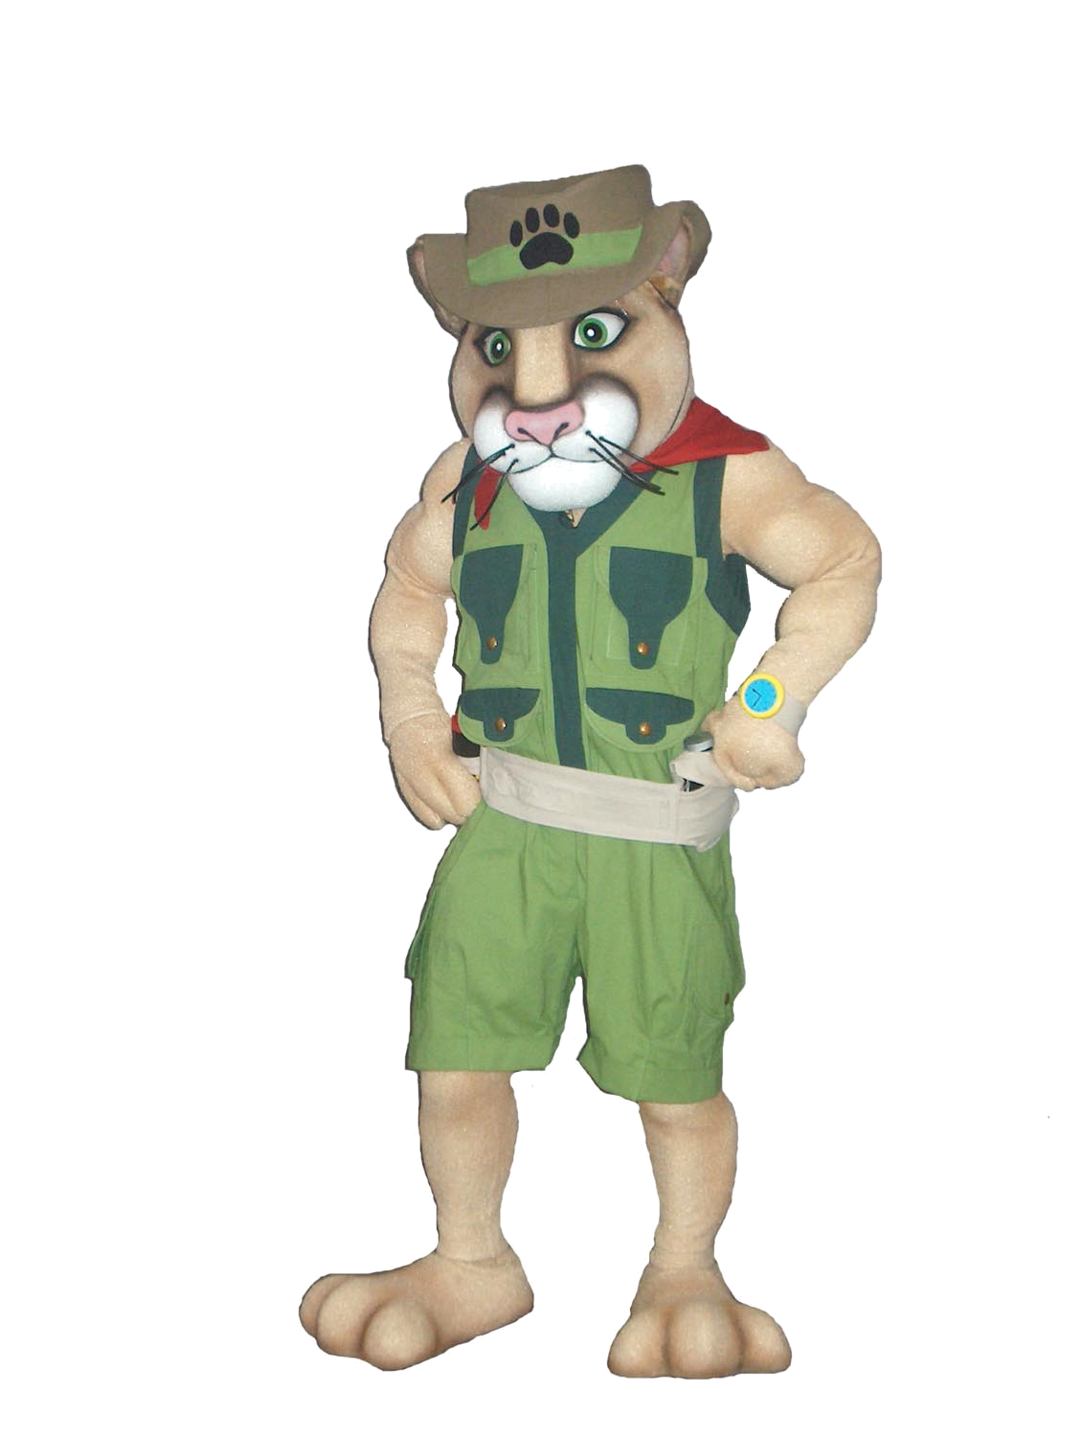
Mascot Now Available For Use

Brought to you by the U.S. Department of Homeland Security and The Advertising Council

Important:

All reservations must be made two weeks in advance. NO EXCEPTIONS!

All reservations and requests for the Rex costume must be coordinated through your state or local Citizen Corps Council or Office of Emergency Management.

Requests will be taken on a first come first served basis.

(Approximately six uses per month available.) A confirmation E-mail will be sent upon receipt of the request to inform you of the availability.

This contract must be filled out with all the correct information.

Rental fee is $150.00 plus shipping costs.

Date Needed: _____________________ Date Returning: ________________________
Organization Name: _______________________________________________________
Organization Contact: _____________________________________________________
Contact Phone: _____________________ Contact Email: _______________________
Address: ________________________________________________________________
City: _____________________ State: __________ Zip: __________
Credit Card Information - Name: _____________________________________________
Expiration Date: _____________________ CVS code: _____________________________

IMPORTANT INFORMATION:
I have read and fully understand the following financial and maintenance responsibilities invoiced in the use of this costume:
- I agree to pay for any damage that occurs to the costume while it is in my possession.
- I acknowledge the rental agreement stating that I may only keep the costume for three days upon receipt. (i.e. Friday – Monday) or I will be charged for $50 per day.
- I will arrange and pay for the costume to be returned by the date indicated.
- I agree to pay $150 + shipping for its three-day use and comply with all instructions including maintenance, repacking and return of the costume.
- If the costume can’t be returned by set date, I will contact M&C to reschedule.

2841 Oakland Avenue, Minneapolis, MN 55407-1301 (612) 874-8176 • Fax (612) 874-6003
www.mascotsandcostumes.com E-mail Address: contract.service@mascotsandcostumes.com
Ordering Ready Materials

Homeland Security’s Ready PSAs, produced and distributed by the Ad Council, are available to be shared with your staff and fans. Include new Ready print ads in your team’s newsletters and publications, or post or play them around the stadium. You may view all of the Ready PSAs at Ready.gov.

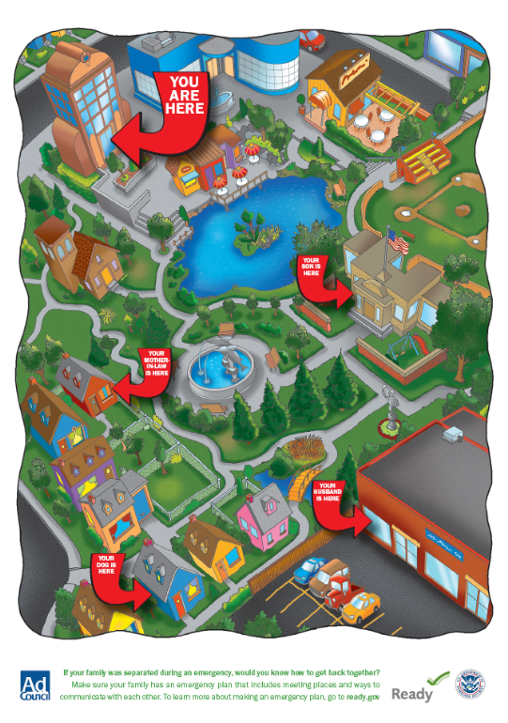
To download or order copies of the TV, radio, print, Internet or outdoor PSAs, visit the Ad Council’s PSA Central Web site at http://psacentral.adcouncil.org/psacentral. All available materials are provided free of charge. Please check the PSA Central Web site for the various lengths and sizes available for the public service announcements (PSAs).

In connection with the airing of the PSA, please keep in mind the following limitations that must be followed in connection with the PSA:

- Use the PSA in donated media space or time, meaning that the space or time was not paid for;

- If you visually or verbally tag the PSA with local sponsor information, please do not include any references to commercial advertisers or their logos;

- Also, please do not alter or use the body of any PSA for any other purpose or provide it to any third parties. Doing so will violate our contracts with the performers and contributors.

Ready brochures and pamphlets are also available free of charge in limited supply. There are materials for Ready America, Ready Business, Ready Kids, and also brochures for pet owners, older Americans, and Americans with disabilities and special needs.

To order Ready materials, please call the FEMA warehouse at
1-800-480-2520 or fax the attached request form to 301-362-5335.

In the event that you need a quantity of materials that exceeds what can be ordered for free, Ready provides a couple of options. All the brochures can be downloaded off Ready.gov, at http://www.Ready.gov/america/publications/allpubs.html. Additionally, if you would like to have the brochures professionally printed at your own expense, Ready will send you the source files.

Having brochures professionally printed at your own expense will allow you the option to localize the brochures by placing your local emergency contact information on the back cover.

*** Important Note: Please allow 4 to 6 weeks for the shipping of these materials. To receive materials more quickly, you can select express mail at your own expense, and will need to provide your DHL or FedEx number on the order form. ***

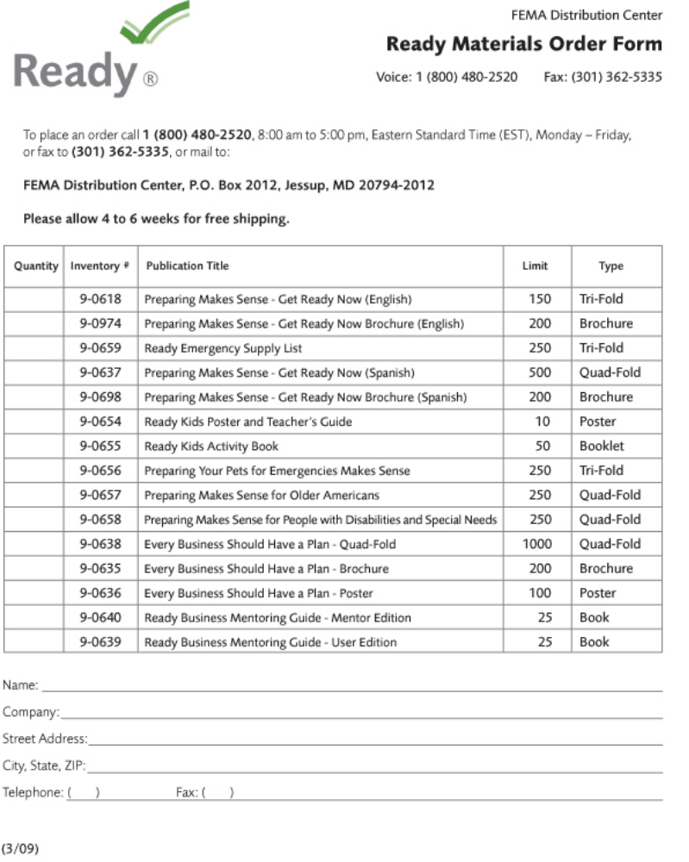

###



To place an order for Citizen Corps and other emergency preparedness materials, please call 8:00 am – 5:00 pm (EST), Monday - Friday the FEMA Distribution Center at 1-800-480-2520.

Publication Title (Inventory Number) | Limit | Type
Citizen Corps Brochure: Preparing Makes Sense. Get Involved Now. (9-0511) | 1000 | Tri-fold
Community Emergency Response Team (CERT) Brochure (9-0489) | 250 | Tri-fold
FEMA -Disaster Preparedness Activity Book: Ages 4-7 | 25 | Activity Book
FEMA- Disaster Preparedness Activity Book: Ages 8-11 | 25 | Activity Book
FEMA- Preparing for Disaster (9-1984) | 30 | Pamphlet
FEMA- Preparing for Disaster for People with Disabilities and other Special Needs (9-1987) | 30 | Pamphlet
FEMA Food and Water in an Emergency (9-1985) | 30 | Pamphlet
FEMA- Fact Sheet : Hurricanes (0-0047) | 1000 | Handout
FEMA- Fact Sheet: Floods (0-0435) | 250 | Handout
FEMA- Fact Sheet: Tornados (0-0436) | 250 | Handout
FEMA- Fact Sheet: Thunderstorms (0-0437) | 250 | Handout
FEMA -Fact Sheet: Earthquakes (0-0439) | 250 | Handout

###

