March 9, 2009

Dear Citizen Corps Council:

We’re pleased to inform you that Minor League Baseball™ and the Boy Scouts of America have agreed to partner with FEMA’s Ready Campaign and National Office of Citizen Corps for the sixth straight year! Together, over the last five years, we’ve reached millions of baseball fans with our message and we’re excited about what 2009 will bring.

Each season, ballparks around the country serve as gathering places for friends and family. This provides the perfect opportunity to raise community awareness for emergency preparedness and encourage community residents to get trained in emergency response skills and volunteer to support community safety. We also know what an important resource a stadium can be for a community if a disaster does occur, and this is a great way for you to meet the stadium owners and invite them to get involved with your area’s emergency preparedness efforts.

We encourage you to reach out to your local Minor League Baseball™ team and use the attached toolkit to educate fans on how they can prepare themselves and their families, and become involved in their communities. In addition, we encourage you to partner with local youth groups, such as Boy Scouts troops, to make your Minor League Baseball™ event an even bigger success. You could also consider having Rex, the Ready Kids mascot, make a special guest appearance at the stadium.

Last season, more than 30 Minor League Baseball™ teams from across America participated in this effort, and we need your help to make this year bigger and better. We hope you will reach out to your local Minor League Baseball™ team and partner with them during the 2009 season to help make your community and its residents more prepared.

To find your local Minor League Baseball™ team, please visit www.minorleaguebaseball.com or contact the Ready Campaign. If you have any questions or would like to register your Council as a Minor League Baseball™ Ready participant, please contact Ingela Hartman by phone at 717-232-5554 x129 or e-mail ready@dhs.gov.

We hope you will join us in spreading the message of preparedness in our country’s Minor League Baseball™ stadiums. We look forward to working with you in 2009.

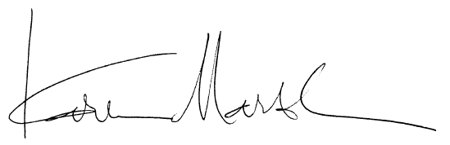
Sincerely,
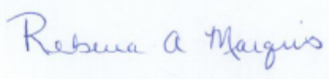

Rebecca Marquis Karen Marsh
Deputy Director, Ready Campaign Director, Community Preparedness Division/Citizen Corps
U.S. Department of Homeland Security Federal Emergency Management Agency, DHS

Enclosures
Minor League Baseball™, the Ready Campaign and Citizen Corps:
Making Fans Better Prepared for Emergencies

Overview
The Ready Campaign is a national public service advertising (PSA) campaign designed to educate and empower Americans to prepare for and respond to emergencies including natural disasters and potential terrorist attacks. The goal of the campaign is to get Americans involved and ultimately increase the level of basic preparedness across the nation. Ready and Listo, its Spanish language version, ask individuals to do three key things: get an emergency supply kit; make a family emergency plan; and be informed about different types of emergencies that could occur and their appropriate responses.

Ready messages have been distributed through television, radio, print, outdoor and Internet PSAs; Web sites (www.ready.gov and www.listo.gov); toll-free phone lines (1-800-BE READY and 1-888-SE LISTO); and a variety of partnerships. For the last five years, individual Minor League Baseball™ teams across the nation have supported Ready and Citizen Corps in a variety of ways including featuring campaign advertisements, messages, special events and materials at their games. If you’ve been involved with your local teams in the past, we appreciate your support and encourage you to get involved again this year. If you have not been involved in past years, we urge you to reach out to your local teams and find ways to get involved and spread the preparedness message in your area.

Potential Activities for the 2009 Season
There are many ways that Citizen Corps Councils can work with local Minor League Baseball™ teams to participate in this important effort. Below are several examples of how teams can support Ready and Citizen Corps:

Leverage Community Partnerships
- Many Minor League Baseball™ teams already host “Boy Scout Nights” throughout the season. During these games, local Boy Scouts can distribute Ready and Citizen Corps brochures and other emergency preparedness materials. Through participation in this outreach effort, the Boy Scouts may complete some of the requirements toward their Emergency Preparedness merit badge. It also fosters skills that help them better prepare themselves, their families, and their communities for emergencies. To order Ready materials for distribution, please use the order form included on page 10 of this kit. To order Citizen Corps and other emergency preparedness materials, please use the order form included on page 11 of this kit and contact FEMA's Distribution Center at 1-800-480-2520 or contact your local emergency management office. To coordinate distribution by Boy Scouts, please contact your local Boy Scout Council (www.scouting.org).
- In previous years, teams have been great supporters of the Citizen Corps mission so this is also a great opportunity for you to showcase the efforts of your Citizen Corps Council, including educating residents on evacuation plans, shelter-in-place plans, alerts and warnings, and local hazards; training and exercise opportunities; and volunteer programs. You could do this by setting up a table or handing out materials.

Share PSAs
- Ready has encouraged Minor League Baseball™ teams across the country to include Ready print ads in their game programs or to run Ready television ads on their stadium video monitors. To download or order copies of all Ready television, radio, print, or outdoor PSAs, see page 9 of this toolkit.
- For stadiums with video monitors, you could encourage your local team to have the announcers read Ready messaging to draw attention prior to showing the PSAs:
  - JumboTron Ad Introduction – “Everyone should have a plan in the event of an emergency. For more information, visit www.ready.gov. Please turn your attention to the JumboTron for a public service advertisement about the Ready campaign brought to you by the U.S. Department of Homeland Security and The Advertising Council.”
- For stadiums without video monitors, you could encourage your local team to have the announcers read Ready messaging:
- Without JumboTron – “For the past six years, Minor League Baseball™ has partnered with the U.S. Department of Homeland Security’s Ready Campaign, the Boy Scouts, and FEMA’s Citizen Corps Program in a national effort designed to educate and empower Americans to prepare for and respond to potential emergencies. The Ready Campaign encourages everyone to take three easy steps: get an emergency supply kit; make a family emergency plan; and be informed. Be sure to stop by and see your <LIST VOLUNTEERS> in the <LOCATION AT BALLPARK> to receive more information on how you and your family can be better prepared.”

Link to Ready
- Place special baseball-themed Ready Web banners and/or links to the Ready Web site on your Web site. If you would like to include a link to Ready.gov on your Web site, we invite you to use one of the official Ready graphics below. Visit http://www.ready.gov/america/milb/banners.html and download by right-clicking on the graphic and selecting "Save Picture As..." or Mac users can "Control-Click" and "Save Image to Desktop." A “Zip File” link is also available.





Training for Ballpark Personnel
During the third game of the 1989 World Series, the Loma Prieta earthquake hit the San Francisco area. The Superdome, Astrodome, and Qualcomm Stadium facilities have been used as mass care shelters during hurricanes and wildfires. These events are perfect examples of why it is vital that representatives from local ballparks participate on their local Citizen Corps Council and be appropriately trained for disasters. Citizen Corps Councils should consider contacting local baseball teams to discuss the following: possible Council participation, improving the safety and security of their facilities, scheduling disaster training such as CERT for ballpark personnel and concession workers, and possible sheltering options at the ballpark during a disaster.

Special Activities
Citizen Corps Councils should consider working with local Minor League Baseball™ teams to create special events at stadiums that are fun, but also help educate the public on the importance of emergency preparedness. Some sample ideas include:
- Have Rex the Ready Kids mascot make an appearance. Rex could throw out the first pitch, showcase some of the necessary items to include in an emergency kit or hand out emergency kits to select ticket holders. To learn how to order Rex, please see page 8.
- Sponsor a “Ready Kit Race” during inning breaks. Team officials could select children to take part in a race around the bases collecting emergency supply items and placing them in a box or bucket at home plate. For example, batteries could be placed at first base, a water bottle at second base and a whistle at third base.
- Team officials can select a young fan from the audience to answer questions on emergency preparedness for prizes. Questions might include:

- What is NOT one of the three steps you can take to help your family be prepared for emergencies?
- Eat your vegetables
- Get a kit
- Make a plan
- Be Informed
- What should a Family Communications Plan include?
- Information about how we would get in touch with each other during an emergency
- Where we would meet
- How we would remain in contact
- All of the above
- How much water should you have in your Ready Kit?
- One small water bottle for each person
- One gallon for the whole family
- One gallon of water per person per day
- One gallon of water for the family per day
- Which of the following is NOT an important part of an emergency supply kit?
- Flashlights and batteries
- Warm blankets
- Your Jonas Brothers poster
- Food

- How quickly can a fire spread through a house?
- 10 minutes
- As little as five minutes
- 30 minutes
- 45 minutes
- In an emergency, what number should you dial to contact the police and fire department?
- 911
- 111
- 711
- 311
- What is a tornado?
- A violent storm that appears as a funnel-shaped cone
- The movement of the earth along the cracks in the earth’s surface
- A tropical storm with an ‘eye’
- A giant wave
- In an emergency, what should you have available to hear news and official reports about what is occurring?
- A battery-powered radio
- A CD player
- A board game
- DVD player

Share Your Success
The Ready Campaign would love to hear from you with any additional thoughts or ideas you have for partnerships or any successes you’ve had in past years with spreading Ready’s preparedness message. If you are interested in sharing your ideas, please contact Ready at ready@dhs.gov.

Media Outreach
We have provided a media advisory and press release template for you to publicize your Citizen Corps Council and team’s participation with Ready to local media outlets. If you need help with this effort, please feel free to reach out to the Ready at ready@dhs.gov.

MEDIA ADVISORY TEMPLATE FOR COMMUNITY EVENTS

MEDIA ADVISORY
Attention News Directors and Assignment Editors

Write a HEADING - (Example: <team> partners with ready campaign and Citizen Corps to help families prepare for emergencies)

GIVE a brief description here – 3 or 4 sentences maximum. include and explain as briefly as possible the 5 w’s of what’s happening: who, what, when, where and why. Please be sure to bold the important/factual elements – so they catch THE reader’s eye.

****PHOtos or interview opportunities - (If Available)****

Who: Include the organization name, executive directors, management, quoted sources, sponsors, speakers, etc.
What: The name of the event, what the event is about
Where: place
address
When: FuLL DATE AND TIME
WHY: <Your team’s> Fans need to know how to be prepared in the event of an emergency
URL: url If available
Contact: Your name, organizer
Phone Number
Email Address

<DATE- I.E.May 4,> 2009
Press Release Contact: XXXXX

<TEAM NAME> TEAM UP WITH THE READY CAMPAIGN AND CITIZEN CORPS TO PROMOTE EMERGENCY PREPAREDNESS

<TEAM NAME> and Citizen Corps Encourage Fans to
Take Steps to Prepare
YOUR LOCAL CITY, STATE – The <TEAM NAME> are teaming up with the U.S. Department of Homeland Security’s Ready Campaign and the <NAME> Citizen Corps Council to educate and encourage their fans to prepare for emergencies in their homes, businesses and communities.
This is the sixth consecutive season that Minor League Baseball™ is promoting emergency preparedness among its fans. The <TEAM NAME> are part of a nationwide effort and will host their very own Ready Night at the ballpark on <DATE- I.E.- Friday, May 4> to share the Ready Campaign and Citizen Corps message.

“Minor League Baseball™ has been an invaluable partner in our efforts to prepare Americans for emergencies that may occur,” said Ready Campaign Deputy Director Becky Marquis. “With the help of Minor League Baseball™ and our Citizen Corps partners, we’re able to reach millions of baseball fans and encourage them to get an emergency supply kit, make a family emergency plan and be informed about the different types of emergencies that can occur in their area.”

At <DAY- I.E. Friday’s> <TEAM NAME> game, the team will air the Ready public service advertisements and the <NAME> Citizen Corps Council will distribute the Ready, Citizen Corps, and other emergency preparedness brochures to fans. The brochure and other materials available at www.ready.gov and www.citizencorps.gov provide a wealth of information to help fans and their communities prepare for and respond to potential emergencies. <ADD OTHER ACTITIVIES HERE>

<Insert a quote from Citizen Corps Official>

<Add in if partnering with Boy Scouts: Local Boy Scout Troop # XXX is taking part in this effort as they work toward earning an Emergency Preparedness merit badge.>

<Please consider inserting a quote from partnering local Boy Scout official>

<Please consider inserting a quote from team’s General Manager>

CITIZEN CORPS BOILERPLATE
Citizen Corps Description

###



“Rex” the New Ready Kids
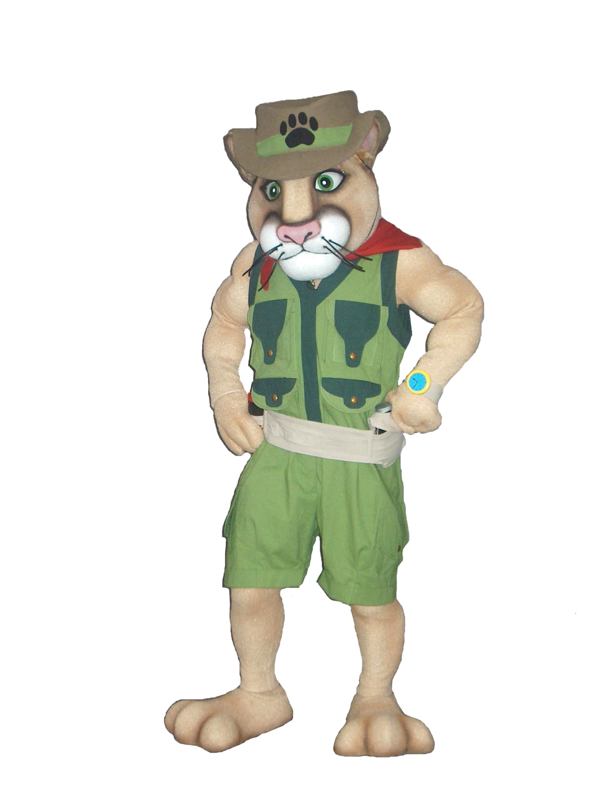
Mascot Now Available For Use

Brought to you by the U.S. Department of Homeland Security and The Advertising Council

Important:

All reservations must be made two weeks in advance. NO EXCEPTIONS!

All reservations and requests for the Rex costume must be coordinated through your state or local Citizen Corps Council or Office of Emergency Management.

Requests will be taken on a first come first served basis.

(Approximately six uses per month available.) A confirmation E-mail will be sent upon receipt of the request to inform you of the availability.

This contract must be filled out with all the correct information.

Rental fee is $150.00 plus shipping costs.

Date Needed: _____________________ Date Returning: ________________________
Organization Name: _______________________________________________________
Organization Contact: _____________________________________________________
Contact Phone: _____________________ Contact Email: _______________________
Address: ________________________________________________________________
City: _____________________ State: __________ Zip: __________
Credit Card Information - Name: _____________________________________________
Expiration Date: _____________________ CVS code: _____________________________

IMPORTANT INFORMATION:
I have read and fully understand the following financial and maintenance responsibilities invoiced in the use of this costume:
- I agree to pay for any damage that occurs to the costume while it is in my possession.
- I acknowledge the rental agreement stating that I may only keep the costume for three days upon receipt. (i.e. Friday – Monday) or I will be charged for $50 per day.
- I will arrange and pay for the costume to be returned by the date indicated.
- I agree to pay $150 + shipping for its three-day use and comply with all instructions including maintenance, repacking and return of the costume.
- If the costume can’t be returned by set date, I will contact M&C to reschedule.

2841 Oakland Avenue, Minneapolis, MN 55407-1301 (612) 874-8176 • Fax (612) 874-6003
www.mascotsandcostumes.com E-mail Address: contract.service@mascotsandcostumes.com
Ordering Ready & Citizen Corps Materials

Ready PSAs, produced and distributed by the Ad Council, are available for the Minor League Baseball™ partnership effort. Include Ready print ads in your local team’s newsletters and publications, or post or play them around the stadium. You may view all of the Ready PSAs at www.ready.gov.

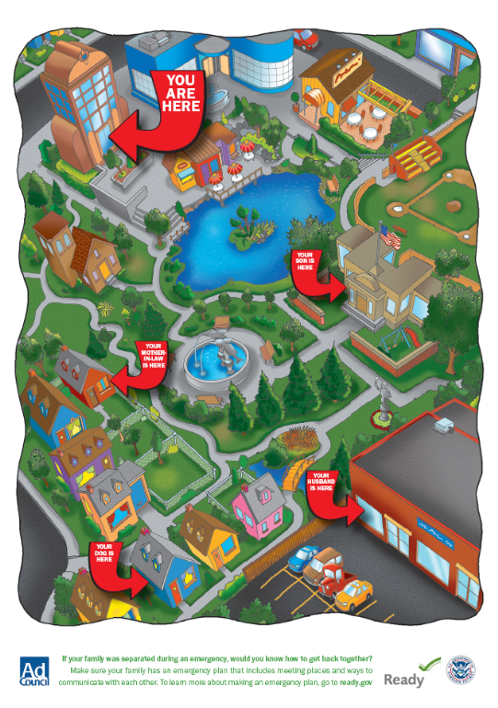
To download or order copies of the television, radio, print, Internet or outdoor PSAs, visit the Ad Council’s PSA Central Web site at http://psacentral.adcouncil.org/psacentral. All available materials are provided free of charge and no team can charge for the placement of these ads. Please check the PSA Central Web site for the various lengths and sizes available for the PSAs.

In connection with the airing of the PSA, please keep in mind the following limitations that must be followed in connection with the PSA:

- Use the PSA in donated media space or time, meaning that the space or time was not paid for;

- If you visually or verbally tag the PSA with local sponsor information, please do not include any references to commercial advertisers or their logos;

- Also, please do not alter or use the body of any PSA for any other purpose or provide it to any third parties. Doing so will violate our contracts with the performers and contributors.

Ready, Citizen Corps, and other emergency preparedness brochures and pamphlets are also available free of charge in limited supply. There are materials for Ready America, Ready Business, Ready Kids, and also brochures for pet owners, older Americans, and Americans with disabilities and special needs.

To order materials, please call the FEMA Distribution Center at
1-800-480-2520 or fax the attached request form to 301-362-5335.

In the event that you need a quantity of materials that exceeds what can be ordered for free, we provide a couple of options. All the brochures can be downloaded from either www.ready.gov or www.citizencorps.gov, at http://www.Ready.gov/america/publications/allpubs.html or http://www.citizencorps.gov/ready/cc_pubs.shtm. Additionally, if you would like to have the brochures professionally printed at your own expense, we will send you the source files.

Having brochures professionally printed at your own expense will allow you the option to localize the brochures by placing your local emergency contact information on the back cover.

*** Important Note: Please allow 4 to 6 weeks for the shipping of these materials. ***

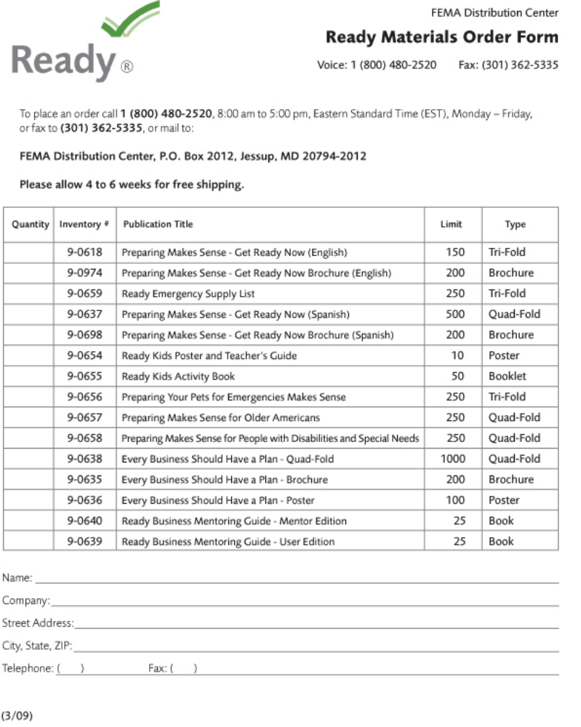



To place an order for Citizen Corps and other emergency preparedness materials, please call 8:00 am – 5:00 pm (EST), Monday - Friday the FEMA Distribution Center at 1-800-480-2520.

Publication Title (Inventory Number) | Limit | Type
Citizen Corps Brochure: Preparing Makes Sense. Get Involved Now. (9-0511) | 1000 | Tri-fold
Community Emergency Response Team (CERT) Brochure (9-0489) | 250 | Tri-fold
FEMA -Disaster Preparedness Activity Book: Ages 4-7 | 25 | Activity Book
FEMA- Disaster Preparedness Activity Book: Ages 8-11 | 25 | Activity Book
FEMA- Preparing for Disaster (9-1984) | 30 | Pamphlet
FEMA- Preparing for Disaster for People with Disabilities and other Special Needs (9-1987) | 30 | Pamphlet
FEMA Food and Water in an Emergency (9-1985) | 30 | Pamphlet
FEMA- Fact Sheet : Hurricanes (0-0047) | 1000 | Handout
FEMA- Fact Sheet: Floods (0-0435) | 250 | Handout
FEMA- Fact Sheet: Tornados (0-0436) | 250 | Handout
FEMA- Fact Sheet: Thunderstorms (0-0437) | 250 | Handout
FEMA -Fact Sheet: Earthquakes (0-0439) | 250 | Handout

###

