2004 Committee of Visitors Report for the

NSF Lower Atmosphere Research Section

Date of COV: September 14-16, 2004
Programs: Atmospheric Chemistry, Climate Dynamics, Large-Scale Dynamic Meteorology, Mesoscale Dynamic Meteorology, Paleoclimate, Physical Meteorology

Section: Lower Atmosphere Research Section
Division: Atmospheric Sciences
Directorate: Geosciences

Committee Membership:

Dennis L. Hartmann, Chair, University of Washington
Steven B. Bertman, Western Michigan University
Ping Chang, Texas A&M University
William B. Curry, Woods Hole Oceanographic Institution
Clara Deser, National Center for Atmospheric Research
Anthony Illingworth, University of Reading
Luisa T. Molina, Massachusetts Institute of Technology
Michael C. Morgan, University of Wisconsin, Madison
Thomas Schlatter, Forecast Systems Laboratory, NOAA (retired)
Daniel Schrag, Harvard University
Wayne H. Schubert, Colorado State University
Bjorn Stevens, University of California, Los Angeles

Table of Contents

1. Overview of Findings and Recommendations 3
2. COV Review Process 4
3. Response to 2001 COV Report 4
- Integrity and Efficiency of the Program’s Process and Management 6
A.1 Merit Review Quality and Effectiveness 6
A.2 Merit Review Implementation 9
A.3 Selection of Reviewers 10
A.4 Portfolio of Awards Under Review 12
A.5 Management of the Program Under Review 17
5. Outputs and Outcomes 19
B.1 Outcome Goal for People 19
B.2 Outcome Goal for Ideas 23
B.3 Outcome Goal for Tools 28
- Other topics 34
C.1 Areas in Need of Improvement 34
C.2 Program Performance 35
C.3 Agency-Wide Performance Issues 35
C.4 Other Relevant Issues 36
C.5 COV Review Improvements 36
Signature Block 36

1. Overview of Findings/Recommendations

Integrity and efficiency of Program’s Process and Management.

The Committee of Visitors for the NSF Lower Atmosphere Research Section (LARS) finds that the Section is very well managed, is efficient and supports a broad portfolio of innovative and important research. A strong consensus emerged among the COV members that the program is vibrant. Its vitality is expressed in a continuing record of funding worthy, innovative, risky, collaborative and multi-disciplinary proposals and stems directly from the quality of the section leadership and program officers. To a person we found them to be extraordinarily devoted to ensuring the fairness of the review process and, in the broadest possible sense, the advancement of the field as a whole.

Reviews and the decision process appear to be very fair and effective. In each of the jackets considered, the program officers gave a thoughtful analysis of the decision process based on the information provided by the reviewers and the program officers’ own knowledge of the subject. In most cases the key questions of the reviewers were shared with the PI, and the PI responded constructively. Decisions were reached within 6 months in 80% of cases in 2003. The COV believes that the success rate in the section is aided by the program officer’s willingness to work with investigators, particularly new ones, to improve proposals without resubmission.

The programs respond to new developments as they occur by continually evolving the portfolio of research that is supported under each of the program areas within the section. Growth in the overall level of funding for the section in the past 3-5 years has been modest.

Outputs and Outcomes.

The Section accounts for much of the fundamental research that NSF supports to provide a basis for understanding and prediction of weather, climate and air quality. These are important areas for human safety and economic prosperity, and have had an important impact that can be measured in new ideas, new infrastructure and important contributions by LARS scientists to national and international science and policy assessments.

The committee reviewed the successful efforts of LARS to develop human resources by funding the research of leading scientists, supporting outstanding young scientists through regular research grants and CAREER awards, supporting graduate students to conduct original research and funding Research Experiences for Undergraduates Programs.

The LARS has also supported the development of new ideas that have steadily evolved the science addressed by the section over the past three years. Examples of the development and refinement of ideas are cited in the report.

Important tools have also been developed with funding from LARS, including integrated data sets from field programs, new instruments and observing facilities, and computational facilities.

2. The COV Review Process

The Committee of Visitors met at NSF on 14-16 September 2004. The committee was provided with a binder full of useful summary information prior to the meeting. After a welcome by the Division Director, Jarvis Moyers, Section Head, Pamela Stephens outlined the COV process and gave an overview of the Lower Atmosphere Research Section (LARS). Overviews of the six programs within the Section were then given by each of the associated program officers. After discussion of procedural issues and conflict of interest provisions, the committee split into six groups of two to begin reviewing jackets (proposal folders). The goal was to review about ten percent of the jackets from the 2001-2003 period, and attempt to sample a broad spectrum of awards and declinations for a wide variety of activities and from a wide variety of investigators. Although the individual programs within the section were each reviewed separately, the responses to the core questions in the report template were addressed to the section as a whole. In general we found that the review process and standards do not differ significantly among the six programs.

During the first day the COV also met with Margaret Leinen, Assistant Director for Geosciences. During the first afternoon a meeting of the committee was held to discuss progress and apportion writing responsibilities. The second day was a combination of jacket review in program groupings and plenary meetings to discuss responses to the questions posed in the report template. On the morning of the third day the committee met with the ATM Division and LARS leadership and the program officers to discuss our conclusions. A draft of the report was written during the meeting. A revised draft was distributed via email after the meeting for approval by the committee.

3. Response to the 2001 COV Report

The 2001 COV Report for LARS made a number of recommendations. These seem to have been well addressed.

1. Program officers do work with new investigators to improve their proposals in light of reviewer comments. LARS supports a relative large number of new investigators, about 30%.

2. Program officers do provide an evaluation of the past performance of investigators in their evaluation (Form 7).

3. Program officers do seem able to use their judgment to properly weight the work of panels against the mail reviews received on a particular suite of proposals.

4. It does seem that program officers and division management are aware that the scientific planning and motivation for a large project must be well established before facility requests are approved. They also are aware that proposals for field programs or other large projects should stand the same tests for intellectual merit as other unsolicited proposals. These issues will require continued vigilance.

5. Funding rates for minority and female investigators are not significantly different than those for other groups.

6. Workload and staffing at the program officer level remain concerns, particularly when gaps occur between the departure of one IPA and the arrival of the next.

FY 2004 REPORT TEMPLATE FOR

NSF COMMITTEES OF VISITORS (COVs)

Date of COV September 14-16, 2004
Program/Cluster: Lower Atmosphere Research Section
Division: Atmospheric Sciences
Directorate: Geosciences
Number of actions reviewed by COV: 134 Awards: 86 Declinations: 48 Other:
Total number of actions within Program/Cluster/Division during period being reviewed by COV: 1348 Awards: 613 Declinations: 735 Other:
Manner in which reviewed actions were selected:
Actions were selected for review by the COV from complete lists for each of six programs, with advice from program officers about which might be good examples of high-risk projects, new investigators, etc. We tried to pick a distribution of awards and declinations from each program, including both unsolicited single investigator proposals and proposals for participation in group activities such as field programs or climate process teams, which might have involved a panel review as well as mail reviews.

4. PART A. INTEGRITY AND EFFICIENCY OF THE PROGRAM’S PROCESSES AND MANAGEMENT

A.1 Questions about the quality and effectiveness of the program’s use of merit review procedures. Provide comments in the space below the question. Discuss areas of concern in the space provided.

QUALITY AND EFFECTIVENESS OF MERIT REVIEW PROCEDURES | YES, NO,  DATA NOT AVAILABLE, or NOT APPLICABLE
Is the review mechanism appropriate? (panels, ad hoc reviews, site visits)  Comments:  The COV finds that the present review mechanism is appropriate. The majority of proposals to the core programs of LARS receive ad hoc reviews. These are sufficient in number and quality to ensure a thorough and well-balanced review process. Other programs such as ESH within the Paleoclimate Program, ACE-ASIA within the Atmospheric Chemistry Program, and RICO and Climate Process Teams receive an appropriate mix of panel and ad hoc reviews. | YES
Is the review process efficient and effective?  Comments:  The COV finds the review process to be highly effective and efficient. The percentage of proposals processed within 6 months of receipt in LARS shows significant increases over the 3-yr period of this COV review, from an average across the 6 programs of 49% in 2001, 62% in 2002, to 80% in 2003. The COV commends LARS for this improvement. Of the sample of proposals read by the COV (10%), there were approximately 4-6 ad hoc reviews per proposal, even when the program directors had difficulty getting reviewers to respond. This is excellent. The COV commends the efforts of the program officers for maintaining the proposal jackets in such good order and providing continuity and stability to the programs. | YES
Are reviews consistent with priorities and criteria stated in the program’s solicitations, announcements, and guidelines?  Comments:  The COV finds the reviews consistent with the priorities and criteria stated in the program’s solicitations, announcements and guidelines. | YES
Do the individual reviews (either mail or panel) provide sufficient information for the principal investigator(s) to understand the basis for the reviewer’s recommendation?  Comments:  Yes, the COV finds that almost all of the individual reviews, and all of the collective reviews for a given proposal, provide sufficient information for the principal investigator(s) to understand the basis for the reviewer’s recommendation. Moreover, the program directors do an excellent job of explaining/interpreting the reviews (which are sometimes disparate) to the PI(s).  Program officers request responses from PIs to referee comments and work with the PIs to improve the quality of proposals. The committee feels that this constructive feedback from program officers to PIs may reduce the number of proposal submissions and increase the success rate of proposals within LARS. | YES
Do the panel summaries provide sufficient information for the principal investigator(s) to understand the basis for the panel recommendation?  Comments:  The COV reviewed jackets from four panels. The panel summaries provided sufficient information for the PI(s) to understand the basis for the panel recommendation. | YES
Is the documentation for recommendations complete, and does the program officer provide sufficient information and justification for her/his recommendation?  Comments:  The COV finds the level of thoughtfulness and thoroughness of the program officers’ review of each proposal and the ad hoc/panel reviews extraordinary. The information provided by the program officers represents much more than a simple summary of the ad hoc/panel reviews. Moreover, the program officers go out of their way to give PI(s) (particularly new PIs) feedback on their proposals and a chance for the PI(s) to respond in light of reviewer comments. This process is very constructive for new PIs and the COV commends the program officers for this. The documentation of the program officers’ review process for each proposal is outstanding (see “Form 7”). The COV was extremely impressed by the creative and flexible implementation of the Form 7 vehicle by the Program Officers. | YES
Is the time to decision appropriate?  Comments:  The COV finds the time to decision appropriate (80% of proposals submitted in 2003 were processed within 6 months). | YES
Discuss issues identified by the COV concerning the quality and effectiveness of the program’s use of merit review procedures:

The COV is extremely pleased with the quality and effectiveness of the program’s use of merit review procedures. In particular, the number and quality of ad hoc reviews for each proposal, the conscientious efforts of the program officers to reach a reasoned recommendation for each proposal and to convey that recommendation in a highly constructive manner to the principal investigator(s), the completeness of each proposal jacket, and the timely manner in which proposals are processed, are exemplary. The COV recommends that LARS exercise particular care in judging proposals that cross divisional boundaries to ensure that they are reviewed with the same care as proposals that fit within a single division.

A.2 Questions concerning the implementation of the NSF Merit Review Criteria (intellectual merit and broader impacts) by reviewers and program officers. Provide comments in the space below the question. Discuss issues or concerns in the space provided.

IMPLEMENTATION OF NSF MERIT REVIEW CRITERIA | YES, NO,  DATA NOT AVAILABLE, or NOT APPLICABLE
Have the individual reviews (either mail or panel) addressed whether the proposal contributes to both merit review criteria?  Comments:  Especially by the end of the review period, the vast majority (>90%) of reviews substantially comment on both review criteria. Criterion 1 is considered to be of primary importance, and none of the proposals evaluated was declined strictly on the basis of Criterion 2. In many reviews Criterion 2 focused strictly on graduate student education, but there are strong indications that the community is beginning to embrace Criterion 2 and place higher value on broader educational and outreach goals, as well as the societal benefit of the work. | YES
Have the panel summary reviews addressed whether the proposal contributes to both merit review criteria?  Comments:  Panels were very conscientious and thorough in their use of the review criteria in the jackets evaluated. | YES
Have the review analyses (Form 7s) addressed whether the proposal contributes to both merit review criteria?  Comments:  The review analyses addressed both criteria seriously in every case examined. During this review period, program officers tended to define Criterion 2 more broadly than the majority of ad hoc reviewers and commented on contributions the research is making to society through public policy, through outreach, or through capacity-building in the community. In fact, several examples of decisions that were strongly influenced by criterion 2 were found by the COV in the set of jackets reviewed. | YES
Discuss any issues or concerns the COV has identified with respect to NSF’s merit review system.

Many reviewers interpreted the “Summary” section of the review forms differently. Some used it to synthesize while others simply reiterated previous comments. NSF may wish to indicate to reviewers exactly what is desired here. Is it a succinct summary statement reviewing the substance of the reviewer’s evaluation or something else?

A.3 Questions concerning the selection of reviewers. Provide comments in the space below the question. Discuss areas of concern in the space provided.

Selection of Reviewers | YES , NO,  DATA NOT AVAILABLE,  or NOT APPLICABLE
Did the program make use of an adequate number of reviewers for a balanced review?  Comments:  In general, the target of four reviews was maintained throughout. In some cases, it was difficult to get more than three reviews, even though the program officers made great efforts to obtain them. | YES
Did the program make use of reviewers having appropriate expertise and/or qualifications?  Comments:  Program officers have an excellent knowledge of the reviewer base and their expertise, and make excellent use of that knowledge. In cases where proposals crossed disciplines, program officers went to great lengths to ensure balanced reviews, consulting experts at NSF outside the Division, and requesting additional reviews from the different disciplines. | YES
Did the program make appropriate use of reviewers to reflect balance among characteristics such as geography, type of institution, and underrepresented groups?  Comments:  A casual view of the institutions of the proposers suggests that a reasonable geographical representation would be obtained if the reviewers were chosen from the pool of proposers. But we were given no data on the geographical or institutional representation of the reviewers, and did not have the time or inclination to try to derive representative data from the jackets. | DATA NOT AVAILABLE
Did the program recognize and resolve conflicts of interest when appropriate?  Comments:  The program officers appear to be especially vigilant in this regard. | YES
Discuss any concerns identified that are relevant to selection of reviewers.

The number of international reviews appears to be relatively low. While international reviewers could provide an additional source of independent reviewer expertise, the experience of the program officers is that international reviewers are often less willing to provide reviews than domestic reviewers. The COV believes that the additional perspective of international reviewers is worth pursuing, if this can be done in an efficient manner.

A.4 Questions concerning the resulting portfolio of awards under review. Provide comments in the space below the question. Discuss areas of concern in the space provided.

RESULTING PORTFOLIO OF AWARDS | APPROPRIATE,  NOT APPROPRIATE,  OR DATA NOT AVAILABLE
Overall quality of the research and/or education projects supported by the program.  Comments:  As outlined in section B, the research and education projects funded by the section continue to serve as the foundation for many of the important and creative developments in our field. These include the evolution of new strategies for developing and assessing climate models and initiatives that improve our ability to forecast weather over a range of timescales and the many natural hazards related to it. Educational initiatives sponsored by the section have also had an impact on deepening connections among mathematicians, statisticians and the atmospheric science community. | Appropriate
Are awards appropriate in size and duration for the scope of the projects?  Comments:  Overall awards averaged very close to the stated target amount and duration of $128,000 and 3 years. Across the section they averaged $129,000 and 3.04 years respectively for 2003 with a slight tendency toward increasing proposal size over the three-year period of the review (increasing from $106,000 in 2001). Average award amounts varied across the programs with award amounts tending to be larger and longer in atmospheric chemistry, reflecting the more experimental and instrumental nature of this program. Despite the close conformity of the proposal amounts and lengths to section wide goals this did not appear to reflect rigidity in the award process; our review revealed numerous instances where program officers exercised good judgment when working with PIs to revise budgets and time-lines in ways that best advanced the science. | Appropriate
Does the program portfolio have an appropriate balance of:  - High Risk Proposals?  Comments:  For this and several of the ensuing questions relating to the appropriate balance of the portfolio, our assessment was based on an evaluation of select proposals identified by the program officers as exemplary of particular qualities, i.e., high risk, multidisciplinary, etc. Overall the program officers were able to identify an appropriate number of what they called high-risk proposals. The subset of these we randomly reviewed uniformly illustrated the acumen of the program officers as they repeatedly intervened, often quite imaginatively, to ensure that creative or novel, yet risky, ideas/proposers were given a chance to succeed. Typically these high-risk proposals were identified by favorable reviews on the basic scientific ideas, but low numeric ratings due to a reviewer’s skepticism regarding the feasibility of the project, or the lack of a track record by an investigator. In several cases (ATM-0124927 being one, and ATM-0137589 being another which is also featured in section B) these risks have already paid dividends. | Appropriate
Does the program portfolio have an appropriate balance of:  - Multidisciplinary Proposals?  Comments:  Program officers were also able to identify a healthy number of proposals as multi-disciplinary. These typically exemplified a willingness of program officers to work across programs and divisional boundaries. Based on our review we believe that the ability of these proposals to succeed is a direct reflection of the willingness of program officers to consult with experts outside of their narrow range of expertise when collecting reviews, and to think broadly about how their program relates to the broader needs of the science. | Appropriate
Does the program portfolio have an appropriate balance of:  - Innovative Proposals?  Comments:  Across the program portfolio innovation is evident in every conceivable respect. Worth singling out in this respect are a number of instances where creative proposals from PIs from other disciplines not traditionally funded by LARS are bringing new ideas to bear on longstanding problems. | Appropriate
Does the program portfolio have an appropriate balance of:  - Funding for centers, groups and awards to individuals?  Comments:  The bulk of the section's support is to single PI projects, however numerous examples of collaborative proposals both among diverse groupings of PIs and across agencies were evident in our review. In a limited number of cases large awards were given in support of groups maintaining facilities valued and used by the broader community. The support for the COLA group, and the investment in the cloud radar group at the University of Wyoming are examples of this. | Appropriate
Does the program portfolio have an appropriate balance of:  - Awards to new investigators?  Comments:  Support to new PIs within the section was significantly higher (as a percentage of all awards) than it was within the directorate and about on par with the foundation as a whole (with the section identifying approximately 30% of all awards being to "new" investigators). A subset of these, 25 awards, were given as CAREER awards. Although the success rate of new proposers was significantly less than that of established investigators we were pleased to see many instances of constructive mentoring of new investigators by the program officers. In some cases this mentoring took the form of helping guide resubmissions of denied proposals, but more often it was expressed in terms of program officers taking an active interest in proposals and helping PIs sharpen their plans, objectives, or methodologies in response to criticisms raised through the review process. | Appropriate
Does the program portfolio have an appropriate balance of:  - Geographical distribution of Principal Investigators?  Comments:  This was difficult to judge based on the data provided and the fact that there exist regional biases in the geographic distribution of atmospheric science programs (i.e., disproportionately large relative to the population in places like Wyoming, Colorado), which are difficult to adjust for simply by scanning the distribution of PIs. A survey of the Paleoclimate Program alone found awards across 27 states and overall we found no evidence of obvious bias in the distribution of principal investigators. | Appropriate
Does the program portfolio have an appropriate balance of:  - Institutional types?  Comments:  Examples of funding to a range of institutions including small businesses, non-profit organizations, a variety of colleges, large research universities abound. Although balance was difficult to assess quantitatively the distribution of awards among institutions did seem to reflect our sense of the relative degree of activity among those institutions. | Appropriate
Does the program portfolio have an appropriate balance of:  - Projects that integrate research and education?  Comments:  A very large fraction of awards help fund graduate education. For instance, one award supports the integration of a field school as part of an upcoming field program. Participants in the program will lecture to graduate students participating in the program, and research time with the experimental facilities will be provided to the students to allow them to design their own mini-experiment within the larger field campaign. Another example includes the incorporation of undergraduate engineering students from an exclusively female engineering school in the development of new instrumentation at a neighboring research university, as well as a healthy mix of REU, RUI and CAREER proposals which more naturally address these objectives. | Appropriate
Does the program portfolio have an appropriate balance:  - Across disciplines and subdisciplines of the activity and of emerging opportunities?  Comments:  A spirit of openness and collegiality appears to characterize the work of the program officers. Many instances were found where creative efforts were made to bridge gaps across programs, ensure balance and address emerging areas. A particular example is the creative response of nearly every program within the section in addressing emerging interests in aerosol processes across the section. No evidence of parochialism was found. Indeed repeatedly we noted efforts by program officers to anticipate multi-disciplinary opportunities in dynamics and chemistry, ocean-atmosphere and biophysical interactions. Likewise efforts to nurture emerging areas (aerosol research, annular mode studies within large-scale dynamic meteorology) were also evident. | Appropriate
Does the program portfolio have appropriate participation of underrepresented groups?  Comments:  This is stated with the caveat that data was not collected in a fashion that made this easy to determine with any significance and the fact that the field as a whole tends to be acutely under-represented by certain population groups (African-American, Native-American, Hispanic). Thus our determination should be interpreted as our inability to discern any obvious bias. This is supported by the tendency of funding rates to be commensurate for women, minorities and the general PI population. Overall 15% of proposals had female PIs, with the rate being somewhat higher (as one would hope) for new proposers (20% of CAREER awards).  We were concerned about our ability to address many of the above issues because the data were not easily available, as discussed further in Section C5. | Appropriate
Is the program relevant to national priorities, agency mission, relevant fields and other customer needs? Include citations of relevant external reports.  Comments:  As stated at the outset, the program continues to fund the science that serves as the foundation for many of the important developments in our field. It continues to support the development of broad community initiatives ranging from a very active field/experimental community to important facilities ranging from ground based remote sensors to satellite and modeling facilities.  The science supported by this section is relevant to national priorities in weather, climate and air quality. This is evident from a number of agency and NRC documents such as the Strategic Plan for the U.S. Climate Change Science Program USCCSP (2003), and the report of the Intergovernmental Panel on Climate Change (IPCC, 2001). A list of relevant NRC reports can be found on the web page of the Board on Atmospheric Sciences and Climate http://www7.nationalacademies.org/basc/publications.html). Examples include: Global Air Quality(2001), A Climate Services Vision(2001), Weather Forecasting Accuracy for FAA Traffic Flow Management(2002), Abrupt Climate Change: Inevitable Surprises(2002). Tracking and Predicting the Atmospheric Dispersion of Hazardous Material Releases: Implications for Homeland Security(2002), Critical Issues on Weather Modification Research(2003), Understanding Climate Change Feedbacks(2003), Where the Weather Meets the Road: A Research Agenda for Improving Road Weather Services(2004). | Appropriate
Discuss any concerns identified that are relevant to the quality of the projects or the balance of the portfolio.

Our only concern relating to these questions is a perception that NSF does not collect data as part of the proposal evaluation process in a way that properly reflects its evaluation criteria as embodied by the above questions. If NSF would collect and synthesize information regarding the nature of the proposers’ and reviewers’ institutions, race/ethnicity/gender of the PI, their geographic location, and the designation of the proposal as high-risk, multi-disciplinary, innovative, etc, future committees would be in a position to more quantitatively evaluate these questions. Our subjective judgment based on limited data is that these issues are being well addressed in LARS, however.

Our one other comment is to reiterate the introductory comments of our report, namely that the strength of the program, particularly its ability and record of funding innovative, risky, collaborative and multi-disciplinary proposals, stems directly from the quality of the program officers. To a person we found them to be very knowledgeable and extraordinarily devoted to ensuring the fairness of the review process and, in the broadest possible sense, the advancement of the field as a whole.

A.5 Management of the program under review. Please comment on:

Management of the program.

Comments:
LARS is managed by effective leadership at the division, section, and program level. Their expertise in the disciplines for which they have responsibility allows program officers to identify appropriate reviewers for proposals and to make well-reasoned discretionary decisions in cases for which reviews are inconsistent. The management policy in ATM of having both permanent and rotating staff is a healthy one, which provides each program with good organizational memory and a continual import of fresh perspective and ideas.

The COV has learned that LARS is planning a reorganization wherein the Large-Scale Dynamic Meteorology and Climate Dynamics programs will merge and the Mesoscale Dynamical Meteorology and Physical Meteorology programs will also merge. This merger was encouraged by the changing nature of proposed research in the affected programs and facilitated by recent staff changes within these programs. While the reorganization seems justified, the COV feels it is very important to preserve the working relationship between the program officers and reviewer community, particularly as expressed in the thoughtful syntheses found in Form 7. The particular concern here is that program officers will more frequently deal with subject areas and communities with which they are not familiar, if the programs within the section are reduced in number and broadened in scope. In addition, it is important to maintain the balance of priorities within the section and programs. One possible side effect of the reorganization is that it will be more difficult to recruit top-quality individuals if they are not solely responsible for a coherent component of the section, but rather have shared or subordinate responsibility for a larger grouping of disciplines.

Responsiveness of the program to emerging research and education trends.

Comments:
The program is responsive to emerging research and supportive of educational initiatives. This responsiveness is fostered because the program officers are fully engaged in the review process. These emerging trends are reflected in the submitted proposals and program directors can decide to direct funds to emerging areas, if such decisions are consistent with the scientific evaluations of the reviewers.

LARS has participated successfully to varying degrees in CMG, ITR, bio-complexity awards, nano (Martin, Harvard chemistry), etc.

The COV commends the program managers and division director for the fine job they have done with the funds available.

Program planning and prioritization process (internal and external) that guided the development of the portfolio under review.

Comments:
Budgets are determined by the historical distribution of funded activities in a particular program. If strong growth or opportunity occurs within a particular program area, then funding increases for that program when possible. The fear of “unfunded mandates” at the program manager level appears to actively discourage the pursuit of additional funds for new research initiatives.

The COV encourages LARS to conduct periodic reviews focused on identifying emerging research trends within and between all programs. We hope that the larger atmospheric sciences community is able to contribute to these discussions and that the results of these reviews are shared with the community.

Discuss any concerns identified that are relevant to the management of the program.

When there is a gap in staffing during periods of transition of rotating staff, a work overload results for existing program staff. If at all possible, gaps in staff should be avoided by early recruitment of rotating program officers.

5. PART B. RESULTS: OUTPUTS AND OUTCOMES OF NSF INVESTMENTS

B. Please provide comments on the activity as it relates to NSF’s Strategic Outcome Goals. Provide examples of outcomes (nuggets) as appropriate. Examples should reference the NSF award number, the Principal Investigator(s) names, and their institutions.

B.1 OUTCOME GOAL for PEOPLE: Developing “a diverse, competitive and globally engaged workforce of scientists, engineers, technologists and well-prepared citizens.”

The Lower Atmospheric Sciences Section has employed programs at several educational and career levels to develop a diverse, recognized, and competitive group of atmospheric scientists. Judging by the accomplishments and honors of the individuals, the programs appear to be very successful. The list of PIs supported by the LARS section includes a very large number of recently elected members of the National Academy of Sciences, and recipients of a variety of prestigious scientific medals and awards. The LARS programs included educational training for graduate students, research experiences for undergraduate students, as well as early career support for new Ph.D.s.

Much of the effort came through the normal grants programs. During FY01–03, 618 awards by the grants program supported graduate education for a total of 640 students. During the same period, there were 25 awards for a diverse group of junior investigators in the NSF CAREER program. In addition to providing support for undergraduates within many awards, the section made a total of 8 awards to develop large projects in the Research Experiences for Undergraduates program. The COV review found several novel and exciting examples within these programs, some of which are described below.

Early Career Advancement:

The Climate Dynamics Program co-funded the project "Dissertations Initiative for the Advancement of Climate Change Research" (DISCCRS) led by C. Susan Weiler, Whitman College. DISCCRS is a new program to foster collaboration of new scientists across the natural sciences. The program was aimed at recent Ph.D.s and underrepresented groups. Among the 109 U.S. registrants, 40% were female and 10% were under-represented minorities.

Amy Clement, University of Miami, is supported by an NSF CAREER award for research and educational activities. The project, “The Earth’s Climate: Understanding the Past and Educating for the Future” (ATM-0134742), will investigate one of the outstanding problems in climatology, the origins and mechanisms of ice age climate variability. The educational activities will promote climate awareness for graduate and undergraduate students at the university and for the Miami general public as well.

John Seeley, Oakland University, is supported by an NSF CAREER award to develop the techniques for the analysis of atmospheric trace gases (ATM-0094185). The PI is developing a new instrument for two-dimensional gas chromatography, which will allow for the clear resolution of hydrocarbons from oxygenated and nitrogenated organic compounds. The PI trains undergraduate and graduate students and is very active in outreach efforts to teachers and the community.

David Thompson, Colorado State University, is supported by an NSF CAREER award for “Analysis of Annular Modes in the Atmospheric General Circulation.” The project (ATM-0132190) includes research investigations into climate variability caused by the southern hemisphere annular mode, curriculum development, mentoring of graduate students and opportunities for undergraduate participation in research. Thompson was a recipient of the American Geophysical Union Macelwane Award, which recognizes outstanding research accomplishments by young researchers in the geophysical sciences.

Undergraduate Research and Education:

An ADVANCE Fellows proposal titled “Langrangian Balloon for Atmospheric Research” (ATM-0137589) by Paul Voss, University of Massachusetts, was awarded to develop a new, neutrally buoyant balloon capable of carrying a variety of instruments for atmospheric sounding. A major part of the research program is the integration of research using the instrument with instruction and research experiences for undergraduate students at Smith College, the home institution of the PI’s spouse. Thus the award also provides the opportunity for continued advancement of a two-career couple.

Two REU programs within the Paleoclimate Program were notable because they included undergraduate research experiences in interesting and difficult field locations and boosted training of under represented groups. The first award, “REU Site: The Nyanza Project – Interdisciplinary Tropical Lake Studies Associated with the International decade of East African Lakes (IDEAL)’, by Andrew Cohen, University of Arizona, offers interdisciplinary research and training for undergraduates, graduate students and secondary school teachers (ATM-0223920). The program joins American students and mentors with African counterparts for a season on teaching and research at the field site, providing a rich experience of teaching, research and cultural exchange. The second award, “Holocene and Modern Climate Change in the High Arctic: Establishing an REU site on Svalbard, Norway”, by Al Werner, is funded by the Paleoclimate program and the Office of Polar Programs (OPP-0244097). The project includes the participation of Mt. Holyoke College, University Center on Svalbard, Hampshire College, University of Massachusetts, Bates College, and Northern Illinois University. The experience includes research projects designed and executed by the students during the summer field season, analysis during the following academic year, culminating with a project symposium during the spring semester.

Several awards were made for research opportunities at small colleges: Matthew J. Elrod, Oberlin College, received funding for a program “Overall Rate Constant and Nitrate Branching Ratio Measurements for the Reactions of Alkene-Derived Peroxy Radicals with Nitric Oxide (ATM-0352537). This award followed a successful and productive NSF CAREER. In addition, Keith Beyer, Lutheran College, was awarded a grant titled “Solid-Liquid Phase Diagrams of Aqueous Inorganic and Organic Substances of Upper Tropospheric Importance (ATM-0304966). This award is to conduct original research in a topical area of interest in a small undergraduate college by involving undergraduate students extensively in laboratory studies and data analysis.

LARS Scientists Receiving Awards – FY2001-2004

During the last three years, atmospheric scientists have been the recipients of many prestigious awards. Some examples are:

In 2001, C. D. Keeling, Scripps Institution of Oceanography was awarded the National Medal of Science “for his pioneering and fundamental research on atmospheric and oceanic carbon dioxide, the basis for understanding global carbon cycle and global warming." Keeling has been a long-time recipient of LARS funding and his recent NSF awards include ATM-0120527.

The American Geophysical Union presented Macelwane awards to two researchers for outstanding research contributions by young scientists. In 2001 Daniel Schrag, Harvard University, received his award for his contributions to paleoceanography and earth history. In 2004, David Thompson, Colorado State University, received his award for contribution to understand large-scale climate variability and modes of atmospheric circulation. Recent NSF awards to Schrag include ATM-0214328 and to Thompson include ATM-0320959.

The American Geophysical Union Roger Revelle medal, awarded “for outstanding accomplishments or contributions toward the understanding of the Earth's atmospheric processes”, was awarded to Ralph Cicerone, University of California, Irvine, in 2002 and to Inez Fung, University of California, Berkeley, in 2004. Recent NSF awards to Cicerone include ATM-0121153 and to Fung include ATM-9987457.

The first Gilbert Walker Gold Medal for the Year 2001 was awarded to Prof. Jagadish Shukla, President of the Centre for Ocean Land Atmospheric Research, USA. The award has been instituted by the Indian Meteorological Society to be given biennially to an eminent Indian or foreign scientist of international recognition, in the field of monsoon studies. The award honors international scientists who have made significant contributions to monsoon studies. Recent NSF awards to Shukla include ATM-0332910.

Mario J. Molina, Massachusetts Institute of Technology, received the Heinz Award in Environment in 2003 for his research on atmospheric pollution and its effects on humans. Recent NSF awards to Molina include ATM-0308748.

Paul Wennberg, California Institute of Technology, was named MacArthur Fellow in 2002. He was recognized for his research of human impacts on the atmosphere and for developing new tools and analytic methods for measuring and understanding its chemistry. Recent NSF awards to Wennberg include ATM-0094670.

LARS Scientists – Recent Elections to National Academy of Sciences

Over the past three years, six scientists supported by LARS have been elected to the National Academy of Sciences. They are listed below, with biographies taken from the National Academy of Sciences web site (www.nas.edu):

Bender, Michael L.; Professor, Department of Geosciences, Princeton University, Princeton, N.J. Bender has made major advances in sedimentary geochemistry, the biogeochemistry of oxygen, and paleoclimatology. His studies provided a framework to understand how biologically active elements are recycled back into seawater. He also helped to show that ocean productivity is high and that the land biosphere sequesters about one-quarter of industrial carbon-dioxide emissions.

Cerling, Thure E.; Professor, Department of Geology and Geophysics, University of Utah, Salt Lake City. Cerling is a leading authority on the geochemistry of processes occurring at or near the surface of the Earth. He has applied novel geochemical methods to study the geological record of ecological change, the evolution of modern mammals and other terrestrial life, the evolution of landscapes, and the chemical composition of the atmosphere.

Denton, George H.; Libra Professor of Geological Sciences and Quaternary Studies, University of Maine, Orono. Denton is a glacial geologist who is an expert on the Earth's glacial history and on global cryosphere evolution. He has focused on the development of the Antarctic ice sheet and its sensitivity to global warming. He has also investigated the abrupt climate changes that dominated the last glacial cycle, providing key insights on glacial changes in the Southern hemisphere.

Fung, Inez Y.; Professor and Director, Center for Atmospheric Sciences, University of California, Berkeley. Fung is an innovator in tracing the sources, sinks, and transport of carbon dioxide, methane, and other substances that regulate Earth's climate. She presented the first three-dimensional transport model of atmospheric carbon dioxide that realistically included the biosphere. She also pioneered the interpretation of satellite observations of reflected radiation from plant life.

Ramanathan, Veerabhadran; Victor C. Alderson Professor and Director, Center for Clouds, Chemistry, and Climate, Scripps Institution of Oceanography, University of California, San Diego, La Jolla. Ramanathan is an international leader in global climate studies. An atmospheric physicist, he identified chlorofluorocarbons and ozone as significant factors in human-induced climate change. In important experiments he also demonstrated that soot can play an unexpectedly large role in the Earth's thermal budget.

Tolbert, Margaret A.; Professor, Department of Chemistry and Biochemistry, University of Colorado, Boulder. Tolbert is a pioneer in laboratory studies of atmospheric surface chemistry and of microphysics. In landmark works, she identified the role of surface reactions on solid and liquid stratospheric clouds, proposed a new phase for some polar stratospheric clouds, and demonstrated certain key cirrus cloud processes in mid-latitude ozone depletion.

LARS Scientists – Recent Elections to National Academy of Engineering

Robert E. Dickinson, Professor, Earth and Atmospheric Sciences, Georgia Institute of Technology, Atlanta. For pioneering contributions to a wide range of topics in atmospheric dynamics and earth system modeling.

B.2 NSF OUTCOME GOAL for IDEAS: Enabling “discovery across the frontier of science and engineering, connected to learning, innovation, and service to society.”

Examples abound of important research discoveries within LARS. The COV highlights just a few of them here, at least one from each program area.

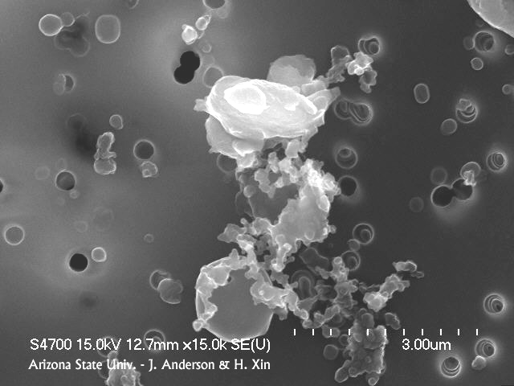
Atmospheric Chemistry

The ACE–Asia program was a major international collaborative effort that involved scientists from the US, PR China, Korea, Japan, the UK, and other countries. The atmospheric chemistry program recommended a total of 25 awards during FY 2000 and 2001. ACE-Asia has resulted in over 60 peer-reviewed publications through 2003, with many more in 2004 and still to come, including an ACE-Asia special issue in the Journal of Geophysical Research. Results from ACE-Asia have improved our understanding of how atmospheric aerosols influence the chemical and radiative properties of the Earth’s atmosphere. The work
Fig. 1: Complex aggregate of soot, mineral particles (upper), and a non-soot carbonaceous particle. (SEM micrograph by James Anderson (Arizona State U.)

of two investigators is highlighted below.

James Anderson, Arizona State University (ATM-0002513),

used an electron microscope to study single particles collected

both on the ground and by aircraft in the outflow region. He demonstrated that the dust transported from Asia across the Pacific is mixed with black carbon and inorganic components derived from urban pollution.

Gregory Carmichael, University of Iowa (ATM-0098122) studied a dust cloud from a major Chinese Storm in April 2001 that passed over the continental US, and across the Atlantic to the Azores. This Chinese dust storm had such a large impact on visibility in Colorado that it was featured in national newscasts. The progression of the dust outbreak from the source region in China into the Pacific was observed by the ACE-Asia stationary and mobile platforms as well as described by predictive models guiding the aircraft and describing atmospheric layers in terms of their major sources (dust, urban pollution, biomass burning, and clean air) and their vertical and horizontal extent.

Large-Scale Dynamic Meteorology

Particularly timely in view of the current active hurricane season are results by T.N. Krishnamurti at Florida State University (ATM-0108741). He devised a “Super-Ensemble,” a statistical combination of five operational global prediction models and the Florida State global spectral model. The global ensemble prediction outperforms each of its members routinely and, in particular, reduces systematic errors substantially for a number of common forecast parameters, including precipitation, in forecasts out to five days. Specifically, the annual global mean sea level pressure systematic errors in five-day forecasts are generally in the range of +/- 1 hPa, compared to errors as high as 8 hPa in individual models. Similarly, systematic errors in two-day forecasts of 500 hPa geopotential height were in the range of +/- 10 meters, compared to errors as high as 60 meters in individual models. Of great practical significance, forecast errors in hurricane track and intensity were smaller in the Super-Ensemble predictions than in any of the separate global models during the 2002 hurricane season.
Fig. 2: Reduction of track and intensity errors for hurricanes in the Atlantic basin for the 2002 season for predictions made with individual global models and the Florida State University Super-Ensemble forecast (red).

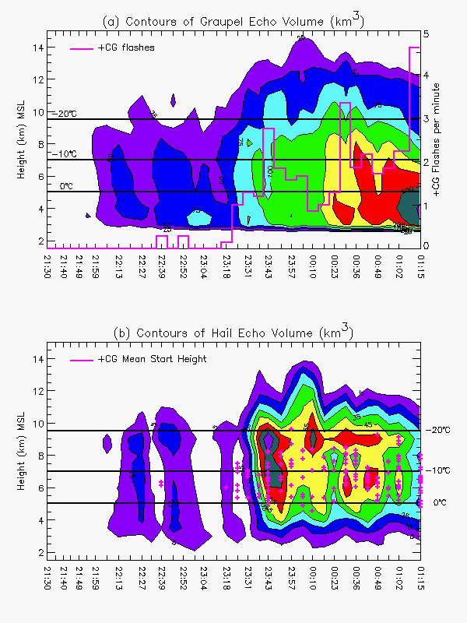

Fig. 3: Top panel shows the association of positive cloud-to-ground flashes with graupel (pellets of soft hail). Bottom panel shows that the height of origin of the positive cloud-to-ground flashes is typically around the –10ºC level and is associated with regions of hail. (From Rutledge, ATM-0309303, presentation at meeting of the American Geophysical Union, fall 2003)

Physical Meteorology

The Severe Thunderstorm Electrification and Precipitation Study (STEPS) field experiment was conducted in May-June 2000. Physical Meteorology supported six grants from FY01-03 that examined the field data: ATM-0309303 (Rutledge), ATM-0233268 (MacGorman), ATM-0245147 (Detwiler), ATM-0221512 (Lyons), ATM-0222011 (Cummer), and ATM-0220842 (Marshall). A lightning mapping array developed by P. Krehbiel at New Mexico Tech provides raw data about the three-dimensional branching of individual lightning discharges and the way in which individual flashes propagate. A key finding is that positive cloud-to-ground strokes may arise from a variety of sources: shear-displacement of the upper positive charge relative to the lower negative charge, removal of negative charge by precipitation, leaving the positive charge exposed to the ground, or a dipole structure inverted from the usual positive-over-negative.
The Dynamics and Chemistry of Marine Stratocumulus (DYCOMS-II) field experiment was the focus of six grants from FY2001-2003: ATM-0097053 (Stevens), ATM-0094956 (Vali), ATM-0103951 (Snider), ATM-0104707 (Twohy), ATM-0004444 (Bandy) and ATM-0107738 (Gerber). Stratocumulus clouds make a major contribution to the earth’s albedo. Thus, anything that substantially changes the coverage of these clouds will have an impact on global climate. DYCOMS-II sought to determine the factors controlling entrainment of dry air into the tops of stratocumulus clouds and the roles of drizzle in modifying these clouds or causing them to dissipate. Entrainment was measured in several different ways and the uncertainty in the measurements was quantified—a major boost for those who try to model these clouds. The formation of drizzle is governed by the sizes and growth rates of cloud droplets and so is influenced by the cloud condensation nuclei in the air parcels forming the clouds. Cloud radar indicates that cellular structures where drizzle forms within stratocumulus clouds are exceptionally complex.
Mesoscale Dynamic Meteorology

Paul Markowski and Michael Fritsch at Pennsylvania State University (ATM-0133506) addressed the question “Why does moist convection organize into discrete thunderstorms on some occasions but as large regions of overturning (slabs) on other occasions?” Using a numerical model, they found that a critical factor in thunderstorm organization was the strength and depth of the cold pool produced by evaporative cooling. The vertical profiles of wind, temperature, and humidity within the environment surrounding the storms were found to exert strong, non-linear influences on cold-pool properties. Generally, “slab-like” convection is favored in an environment with a shallow mixed layer, low cloud base, and strong low-level wind shear.

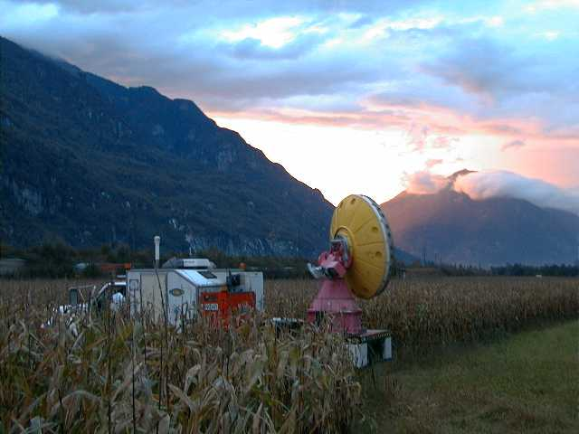Robert Houze of the University of Washington (ATM-0221843) investigated conditions that enhance orographic precipitation in mid-latitude baroclinic waves. The critical physical factor is whether the flow is unblocked (low-level air flows over the mountains, atmospheric stability is low, and low-level winds are strong) or blocked (low-level air flows around the mountains, atmospheric stability is high, and low-level winds are weak). In the blocked case, air passing over the ridge tops originates at relatively high altitude whereas in the unblocked case, low-level air that rises over the mountains provides a moisture source not available in the blocked case. When the low-level air is lifted, raindrops grow rapidly by coalescence at low levels and graupel forms just above the freezing level. The coalescence-produced drops and melted graupel particles significantly enhance precipitation beyond what typically occurs in the blocked case.
Fig. 4: Doppler on Wheels deployed in the Mesoscale
Alpine Programme. Courtesy of Joshua Wurman.

Climate Dynamics

It is well known that the troposphere affects the stratosphere through upward propagation of waves. Recent studies suggest that changes in stratospheric circulation can also extend downward into the troposphere. The well-documented correlation between stratosphere and troposphere anomalies in observations has been attributed to the stratosphere-troposphere coupling. Two new investigations supported by the Climate Dynamics Program suggest that the stratosphere-troposphere coupling may have important bearing on climate variability/change and climate predictability in the high-latitude Southern Hemisphere (SH) and Northern Hemisphere (NH).
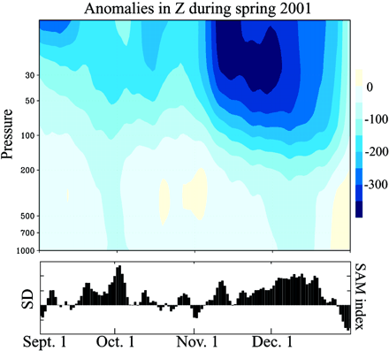
David Thompson (ATM-0132190), collaborating with Susan Solomon, explored a number of different data sets covering the last 30 years and showed that the Antarctic climate change over the past several decades, consisting of the observed warming trend over the Antarctic Peninsula and Patagonia and a cooling trend over eastern Antarctica and the Antarctic plateau, can be linked to the trend in the lower stratospheric polar vortex. They propose that photochemically-induced cooling associated with Antarctic ozone depletion strengthens the SH stratospheric polar vortex, causing the tropospheric SH annular mode to shift toward its high-index polarity, which in turn affects surface conditions over Antarctic continent.
Fig; 5: (Top) Geopotential height anomalies (meters) averaged 65°-90°S during spring 2001 based on data from the NCEP-NCAR reanalysis. (Bottom) Standardized values of the SAM index (not inverted), as defined in (30). In the bottom panel, vertical tick marks denote 1 SD of the SAM index.
Through observational analyses and statistical modeling, Mark Baldwin (ATM-002485) found that persistent circulation anomalies in the lowermost stratosphere may increase the "memory" of the climate system and enhance its predictability. In particular, these studies show that the time scale of the Arctic Oscillation, a dominant mode of climate variability in the high-latitude NH, is greatest during winter, which is coincident with the longest NH annular mode time scale in the lowermost stratosphere. Furthermore, long-lived Arctic Oscillation anomalies tend to follow stratospheric NH annular mode anomalies of the same sign. This stratospheric “memory” effect could lead to extended-range forecasts of the monthly-mean Arctic Oscillation during boreal winter that are well beyond the 7-10 day limit of deterministic weather prediction.

Andrew Vogelmann at Scripps Institute of Oceanography received a Small Grant for Exploratory Research (ATM 0109135) to examine the large uncertainty in the effects of aerosols on the earth’s radiation balance. Recognizing that most global climate models consider the effect of aerosols on incoming solar radiation but few consider the effect of aerosols on infrared (IR) radiation, he examined clear-sky IR spectra obtained during a cruise across the western Pacific Ocean. He discovered aerosol forcings up to 10 W m⁻², values that are quite large compared to the 1-2 W m⁻² estimated for greenhouse gas accumulations since the beginning of the industrial revolution. Prompted by this finding, Andrew will collaborate with Bill Collins of NCAR to include aerosol IR effects in the next version of the NCAR Community Climate System Model.

Paleoclimate

Lonnie Thompson and Ellen Mosley-Thompson of Ohio State University (ATM-9910172) led a team of researchers to the summit of Mt. Kilimanjaro to collect ice cores from the receding glacier there. They extracted a climate record that would otherwise likely have been lost within decades because of rapid melting. A surprising finding was that catastrophic droughts, some lasting hundreds of years, plagued the region around Tanzania 8300, 5200 and 4000 years ago. The ice core samples provided a record back to 11,700 years ago, when the summit glaciers began forming. Lake Chad, now covering 17,000 square kilometers, was once more than twenty times larger. Learning the causes of such droughts is of immense importance because they put heavy stress on the large populations that dwell in the tropics.

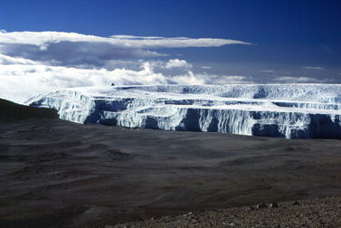

Fig. 6: Summit glacier on Mt. Kilimanjaro in Tanzania, Africa.

B.3 OUTCOME GOAL for TOOLS: Providing “broadly accessible, state-of-the-art S&E facilities, tools and other infrastructure that enable discovery, learning and innovation.”

The Lower Atmosphere Research Section has supported research leading to the development of a wide variety of databases, new facilities and new instruments. Below we highlight eight achievements that are described in more detail below. The first three are databases resulting from large field projects that address important issues:

- Atmospheric aerosol and ii) water vapor, and iii) mesoscale convective systems and associated wind damage.

Support has been provided to develop four national facilities that provide:
iv) Improved water vapor and temperature sounding from space
v) A new dedicated climate model computing facility.
vi) An airborne cloud radar available for community use.
vii) A national lightning triggering facility.

plus
viii) An instrument for analyzing trace gases developed by a career award researcher:

1. Asian Pacific Regional Aerosol Characterization Experiment (ACE-Asia)

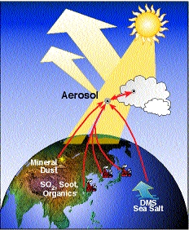
ACE-Asia took place during the spring of 2001 off the coasts of China, Japan and Korea and involved multiple aircraft (including the NSF C-130, and the U.S. Navy Twin Otter), ships (including the NOAA R/V Ron Brown), satellites, and surface sites (in particular the highly instrumented site at Gosan, Korea). The most comprehensive measurements ever of hemispheric aerosol emission and transport were carried out. The goal of the experiment was to assess the regional climatic and atmospheric chemical effects of a continental-scale mixture of dust and pollution. Measurements were focused on determining the physical, chemical, and optical properties of these particles, including their horizontal and vertical distribution. Results from ACE-Asia have improved our understanding of how atmospheric aerosols influence the chemical and radiative properties of the Earth’s atmosphere. The data base resulting from this activity is available to the community.

2. The International Water Vapor Project (IHOP).

-21 awards worth $3,339,717 in FY 2002.
-16 awards worth $1,660,220 in FY 2003.

Refractivity bias as measured by the S-Pol radar and AERI (Atmospheric Emitted Radiance Interferometer) during IHOP (from presentation by Pettet, et al. to the 2nd International IHOP_2002 Science Workshop)

The overarching goal of IHOP is to improve the characterization of the four-dimensional distribution of water vapor and to apply this knowledge to gain improved understanding and prediction of convection and associated precipitation. This goal is congruent with the quantitative precipitation forecasting (QPF) objective of the US Weather Research Program (USWRP), and NSF support of IHOP was the major NSF contribution to the USWRP in FY 2002. The IHOP objectives include research on numerical QPF, convective initiation, relationship between atmospheric water vapor and boundary layer processes, and instrumentation tests. The IHOP may be a harbinger of a paradigm shift in the mesoscale observational sciences. The IHOP experiment took place over the Southern Great Plains of the US from 13 May to 25 June 2002 and relied upon a large number of mobile and transportable observational facilities that were repositioned on a daily basis as opposed to a large number of fixed, observational facilities. A summary of preliminary results from IHOP can be found in Weckworth, et al., 2004, Bulletin of the American Meteorological Society, Volume 86 (2), 253-277.

3. BAMEX, the Bow Echo and Mesoscale Convective Vortices Experiment.

13 ATM awards in FY 2003 with a total value of $1,628,677.

The goal of BAMEX is to study the life cycle of mesoscale convective systems with an emphasis on damaging surface wind events and mesoscale convective vortices. From 1995-2000 such windstorms resulted in over $1.4 billion in property damage and 72 deaths. BAMEX employed a large number of mobile and transportable observational systems that were deployed on a forecast basis. The field campaign documented numerous long-lived mesoscale convective systems, many producing strong surface winds and exhibiting mesoscale rotation (See figure below.) BAMEX is described in Davis et al. 2004 Bulletin of the American Meteorological Society, Volume 85 (8), 1075-1094.
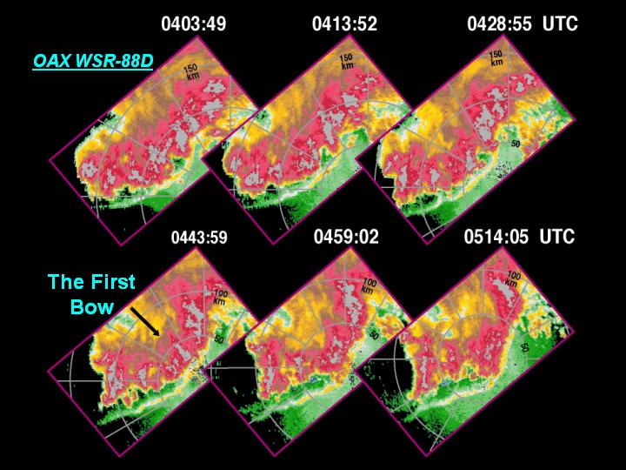

Radar images from the Omaha WSR-88D on 6 July 2003 during BAMEX (courtesy of report given to the BAMEX workshop by Wakimoto, et al.)

4. Constelation Observing System for Meteorology, Ionosphere and Climate (COSMIC) (ATM 9908671, Rocken, UCAR)

In 1999, NSF, in partnership with NASA, NOAA, the US Air Force and US Navy, entered into an agreement with Taiwan to build and launch a fleet of six GPS/MET low earth-orbiting satellites designed to improve and dramatically expand the GPS/MET proof-of-concept measurements. Called COSMIC, for Constellation Observing System for Meteorology, Ionosphere and Climate, the new project cost $100M. $80M has been provided by Taiwan and $20M by the five US agencies. Launch is scheduled for September 2005. The system measures the refraction of GPS radio waves as they pass through the atmosphere by radio occultation (RO) techniques, and from these measurements one derives electron density in the upper (charged) atmosphere and vertical profiles of density in the lower (neutral) atmosphere. The potential from COSMIC is shown by the following figure in which the red dots indicate the current global radiosonde network (the mainstream observational network for operational weather and climate prediction) and the green dots show the added COSMIC soundings. COSMIC will be launched in late 2005.

COSMIC is co-funded at NSF by ATM’s CDP, LDM, MDM, PMP, AER, and by OPP. The CDP Program Director serves as the Chair of the COSMIC Interagency Working Group.

Initial analyses and evaluation of GPS RO soundings from the earlier GPS/MET and other projects indicate highly accurate temperature soundings and useful water vapor soundings can be obtained with this system.
Reference: http://www.cosmic.ucar.edu/

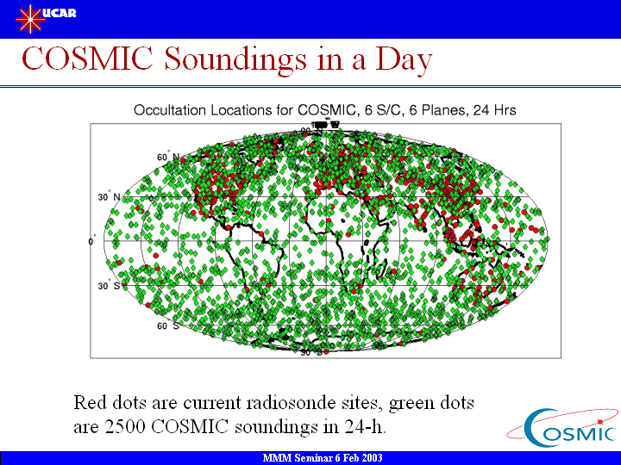

5. THE CLIMATE SIMULATION LABORATORY (ATM-9732655, NCAR Cooperative Agreement, Al Kellie, SCD).
The Climate Simulation Laboratory (CSL), a dedicated climate model computing facility in support of the multi-agency Climate Change Science Program, is administered by the Divisions of Atmospheric Sciences, Ocean Sciences and Mathematical Sciences at NSF and managed by CDP. The CSL computational facilities are housed, operated, and maintained by the Scientific Computing Division (SCD) of the National Center for Atmospheric Research (NCAR), located in Boulder, Colorado. The purpose of the CSL is to provide high performance computing and data storage systems to support large-scale, long-running simulations of the earth's climate system (defined as the coupled atmosphere, oceans, land and cryosphere, and associated biogeochemistry and ecology, on time scales of seasons to centuries), including appropriate model components, that need to be completed in a short calendar period. A large simulation is one that requires many thousands, of processor hours for its completion and usually produces many gigabytes of model output that must be archived for analysis and intercomparison with other simulations and with observations.
Reference: http://www.scd.ucar.edu/csl/overview_2.html

6. AIRBORNE CLOUD RADAR (G.Vali, U of Wyoming, A Pazmany, U Mass; grants ATM-0094956 and ATM-0095163).

The Physical Meteorology Program has provided long-term support for the development and operation of the Wyoming Cloud Radar. This has been a collaborative project in which scientists from the University of Massachusetts have provided engineering and technical expertise and scientists at the University of Wyoming have guided the development to produce an airborne system
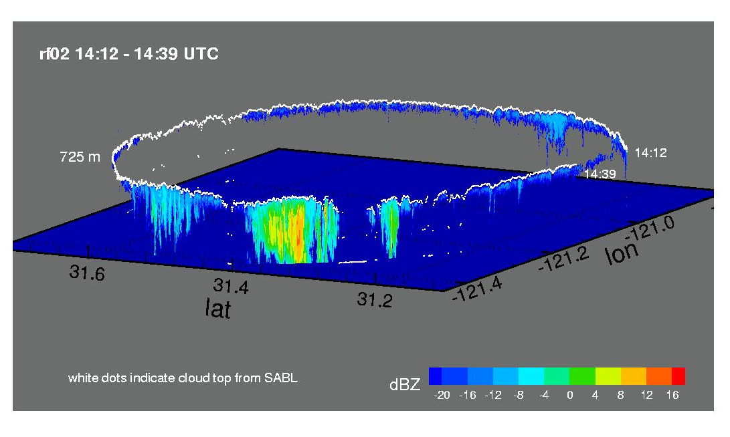
Figure Caption: Downward looking reflectivity showing cellular precipitation features localized in a region of homogeneous stratocumulus. The downward looking lidar, and radar show that the precipitation features are associated with nearby breaks in the cloud. Far from the precipitation features the lack of radar reflectivity is indicative of the lack of drizzle size drops. These measurements were made using the Scanning Aerosol Backscatter Lidar (SABL) and the Wyoming Cloud Radar mounted on the NCAR/NSF C130 flying 180km circular flight legs above cloud top as part of the DYCOMS-II field study which took place in July 2001 West Southwest of San Diego CA.
for studies of clouds and precipitation. This radar, operating with a wavelength of 3.2 mm, provides high sensitivity and the ability to resolve fine-scale structures in clouds. In a continuation of this work, grants ATM-0094956 and ATM-0095163 supported continued improvement of the capabilities of the radar and operation in several field studies. A second antenna was added to permit sensing in two different directions for dual-Doppler measurements of wind fields. One of the applications of the system was in the DYCOMS-II experiment in July 2001, where it measured the detailed cloud structure in the mixing region near cloud top and also provided sensitive detection of drizzle drops. This long-term investment has now led to a new facility that is revealing the exceptionally detailed structure present in many cloud systems.

7. THE INTERNATIONAL CENTER FOR LIGHTING RESEARCH AND TESTING. (ATM-0003994, Rakov and Uman, U of Florida)

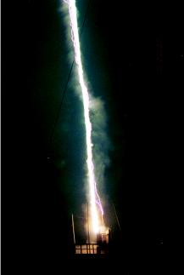
The center for lightning research and testing at Camp Blanding, Florida was established primarily with funding by the Electric Power Research Institute and has continued with support from NSF, Florida Light and Power, the University of Florida, and several other groups.

The key to the effectiveness of this facility has been its ability to trigger lightning to strike at or near the center of the instrumented array. This is accomplished, when local conditions are suitable, by firing a rocket that trails a fine wire. Despite some early concern regarding the realism of the lightning strikes that are produced, this has proven to be an exceptionally valuable tool for the study of the properties and the effects of lightning. The facility operates not only to support the research of the Principal Investigators (V. Rakov and M. Uman at the University of Florida) but also as a site where many members of the international community come to conduct their research. The final report for grant ATM-0003994, which included the years 2001-2003, listed 15 collaborators on publications, 17 groups that were partners in the research, 36 journal articles, and more than 50 conference papers or articles in transactions published or accepted in this period that resulted from research at this center.
Example of Triggered Lightning strike at the International Center for Lightning Research and Testing. University of Florida ATM-0003994, Rakov and Mazur.

8. NEW INSTRUMENTION:

Development of the GC x GC technique and evaluation of the impact of n-aldehydes on tropospheric chemistry (John Seeley, Oakland University, ATM-0094185)

The theme of this project is to develop techniques for the analysis of atmospheric trace gases. For the research component, a two-dimensional gas chromatography (GC x GC) method was developed as a tool for characterizing the volatile organic composition of the atmosphere. This approach can generate high-speed and high-resolution separations with the sensitivity and quantitative precision of a conventional gas chromatograph, while providing a rugged instrument suited for field deployment. For atmospheric chemistry, the biggest advantage of GC x GC analysis is that hydrocarbons can be clearly resolved from oxygenated and nitrogenated organic compounds. The PI is investigating the possible commercialization of his instrument.

Laboratory and field studies were performed to determine the significance of n-aldehydes in the troposphere. Preliminary findings indicate that earlier reports of these compounds in the atmosphere were likely partially based on artifacts of the sampling procedures used rather than produced by lake waters and other natural sources.

Dr. Seeley involves graduate and undergraduate students in his research, but he also reaches out to his local community and provides opportunities for high school students and teachers to get involved in environmental measurements. He has developed some simple experiments for use in laboratory courses that allow students to quantify the levels of important atmospheric species without requiring elaborate or expensive equipment. A simple method for measuring surface ozone was adapted in a design based on easily and cheaply available materials and components, and high school teachers and students are trained to apply this method for measurements in the ambient atmosphere.

The PI participates in annual workshops involving high school chemistry teachers and the OU Chemistry Department faculty, and has also established research activities involving high school teachers and students centered on learning about atmospheric ozone and making field measurements.

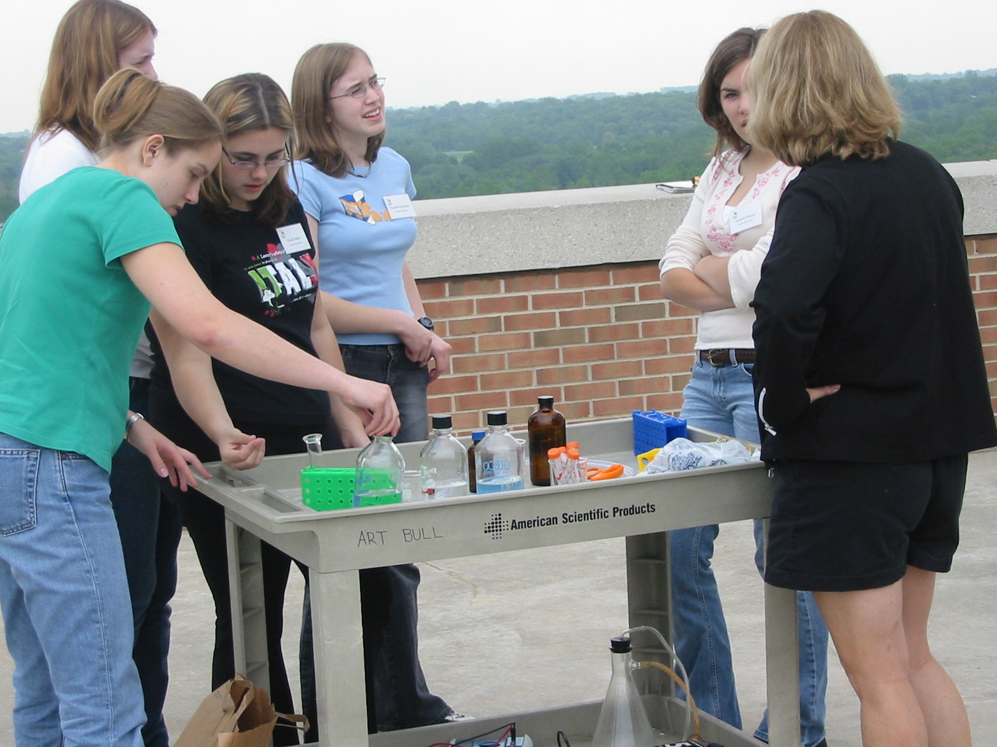
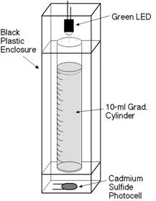
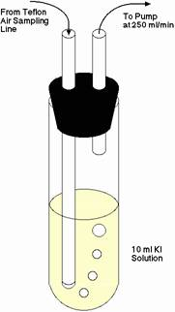

High school teacher and students preparing to measure atmospheric ozone
Components for ozone measurement system

PART C. OTHER TOPICS

C.1 Please comment on any program areas in need of improvement or gaps (if any) within program areas.

The committee finds no serious gaps or weaknesses in the program areas. However, in thinking ahead, the committee offers the following incomplete list of research opportunities that fall under the LARS umbrella, and point to the continuing vitality and importance of lower atmosphere research.

Mesoscale Data Assimilation: Assimilation of cloud and hydrometeor data into mesoscale forecast models is a developing area. Data assimilation strategies for exploiting information from new remote and in situ measurements are sorely needed. The problem is multi-disciplinary in that it entrains instrument specialists, data assimilation experts, numerical modelers, and cloud physicists. Progress on this problem will lead to better forecasts of clouds and precipitation.

Air Quality and Climate Change Linkage: The atmospheric residence times of urban air pollutants such as ozone and particulate matter are long enough to influence air quality over broad regional and even global scales. Further, these species also contribute to global warming: one of the largest uncertainties in climate change science is related to the potentially very large impacts of particles on cloud properties. In addition, global warming may influence the emissions, formation, transport and deposition of a variety of air pollutants.

Scale Interactions and Multi-scale Modeling: Interactions between very different spatial scales is a fundamental problem in understanding and predicting weather, climate and air quality. New approaches to these problems and the parameterizations they engender may be found through new multi-scale modeling and stochastic modeling concepts and tools.

Hydrology: Interactions between mesoscale dynamic meteorology and climate dynamics are important for issues of changing water cycles over land during global warming and cycles of drought and flood.

Aerosol-Cloud Interactions: Aerosol cloud interaction during climate change is an important area that spans climate dynamics, atmospheric chemistry and physical meteorology.

Ice Physics: The issue of cirrus clouds and their role in climate is raising fundamental questions about our understanding of ice formation at low temperatures and pressures.

C.2 Please provide comments as appropriate on the program’s performance in meeting program-specific goals and objectives that are not covered by the above questions.

This item was dealt with adequately in the previous sections.

C.3 Please identify agency-wide issues that should be addressed by NSF to help improve the program's performance.

The LARS comprises a number of well-managed and high quality programs with much potential for growth of novel programs that are intellectually meritorious and of great practical significance. Improved mechanisms are needed whereby the LARS managers and the communities of scientists they support can bring these ideas forward to compete most successfully for new resources. A safe path by which ideas deserving enhanced support can be brought up from below does not appear to exist. Managers feel that additional resources for opportunities that are not well aligned with agency-wide initiatives will occur only through reallocation of funds from within existing budgets. This discourages managers from developing and nurturing such initiatives that would help maintain the pressure LARS should be placing on NSF for additional resources. We feel that the community of scientists would be best served if LARS, at the section level, put more effort into developing such initiatives that cut across programs and can best compete for resources within NSF.

C.4 Please provide comments on any other issues the COV feels are relevant.

The handling of interdisciplinary climate problems that cross boundaries between traditional NSF categories remains a problem. Examples are funding for coupled air-sea interactions in the climate system can be disadvantaged both within OCE and ATM. Similarly, interactions of biological and physical processes in the determination of atmospheric carbon dioxide may not have a natural home in the NSF structure.

During our visit we learned that Large-Scale Dynamical Meteorology and Climate Dynamics will be merged into one section, and Physical Meteorology and Mesoscale Dynamic Meteorology will be merged into one section, reducing the total number of sections from 4 to 6. We hope that this can be accomplished without sacrificing the strong linkage between the expertise of the program officers and the pool of proposals that they administer. We feel that the knowledge of the program officers about the subject areas they deal with is an important ingredient to success. The next COV should probably review how well this reorganization is working.

C.5 NSF would appreciate your comments on how to improve the COV review process, format and report template.

Our only concern relating to these questions was a perception that NSF does not collect data as part of the proposal evaluation process in a way that makes it easy to address the evaluation criteria in the above questions (See also discussion at the end of Section A4). By collecting and synthesizing information regarding the nature of the proposing institution, race/ethnicity/gender of the PI, their geographic location, and the designation of the proposal as high-risk, multi-disciplinary, innovative, etc, NSF could provide future committees with information to more quantitatively evaluate the efficacy of the section in addressing the goals implied by these questions. The following specific points can be made.

1. The distinction between investigators that are ‘new’ to NSF and those that are ‘new’ to science (junior people) is not clear in the statistics provided. This point was also made by the previous COV for LARS in 2001.

2. We found the proposal jackets and particularly the form 7 documentation to be very useful in following the progress of proposals and the rationale for the decisions in each case. However, time is short and it is important to choose wisely so that a broad range of types of proposals can be read in a short time. Program officers can be and were helpful in this regard. The balance between guidance to a broad set of proposals and freedom to view any of the proposals in the portfolio was about right.

SIGNATURE BLOCK:

_______________________________________-________

For the COV for the Lower Atmosphere Research Section
Dennis L. Hartmann
Chair

