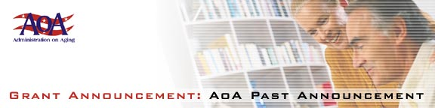

[Federal Register: June 21, 2002 (Volume 67, Number 120)] [Notices] [Page 42265]
From the Federal Register Online via GPO Access [wais.access.gpo.gov]
[DOCID:fr21jn02-73]

-----------------------------------------------------------------------

DEPARTMENT OF HEALTH AND HUMAN SERVICES

Administration on Aging

[Program Announcement No. AoA-02-10]

Fiscal Year 2002 Program Announcement; Availability of Funds and
Notice Regarding Applications

AGENCY: Administration on Aging, HHS.

ACTION: Announcement of availability of funds and request for
applications.

-----------------------------------------------------------------------

SUMMARY: The Administration on Aging announces that under this program
announcement it will accept applications for funding in fiscal year
2002 under the Older Americans Act, title VI, Grants for Native
Americans, part B-Native Hawaiian Program.

Purpose of grant awards: The purpose of these grants is to provide
nutrition and supportive services to Native Hawaiian elders.

Eligibility for grant awards and other requirements: Eligibility
for grant awards is limited to public and/or nonprofit private
organizations having the capacity to provide services for Native
Hawaiians that (1) will serve at least 50 Native Hawaiian individuals
who have attained 60 years of age or older, and (2) demonstrates the
ability to deliver supportive services and nutrition services. For the
purposes of title VI, part B, the term "Native Hawaiian" means an
individual any of whose ancestors were natives of the area, which
consists of the Hawaiian Islands prior to 1778.

DATES: The deadline date for the submission of applications is August
20, 2002.

ADDRESSES: Application kits are available by writing to the U.S.
Department of Health and Human Services, Administration on Aging,
Yvonne Jackson, Director, Office of American Indian, Alaskan Native and
Native Hawaiian Programs, 330 Independence Ave., SW., Washington, DC
20201 or by calling 202/619-2713. Applications must be postmarked on or
before August 20, 2002. An original and two copies of the application
are to be mailed to Margaret A. Tolson, Director, Office of Grants
Management, 330 Independence Ave., SW., Washington, DC 20201.

Dated: May 30, 2002

Josefina G. Carbonell,
Assistant Secretary for Aging.
[FR Doc. 02-15654 Filed 6-20-02; 8:45 am]
BILLING CODE 4154-01-P

