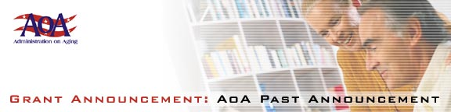

Innovative Programs and Activities of National Significance under the National Family Caregiver Support Program

[Federal Register: June 18, 2001 (Volume 66, Number 117)][Notices][Page 32824-32825]From the Federal Register Online via GPO Access [wais.access.gpo.gov]
[DOCID:fr18jn01-96]
-----------------------------------------------------------------------
DEPARTMENT OF HEALTH AND HUMAN SERVICES
Administration on Aging
[Program Announcement No. AoA-01-08]
Fiscal Year 2001 Program Announcement; Availability of Funds and
Notice Regarding Applications

AGENCY: Administration on Aging, HHS.

ACTION: Announcement of availability of funds and request for applications for innovative programs and activities of national significance under the National Family Caregiver Support Program, title III-E, sections 375 and 376, of the Older Americans Act as amended (Pub. L. 106-501). These grants and cooperative agreements are to develop services and systems which demonstrate new or improved approaches to sustaining the efforts of families and other informal caregivers of older individuals and grandparents of older individuals who are relative caregivers of children.

-----------------------------------------------------------------------

SUMMARY: The Administration on Aging announces that under this program announcement it will hold a competition for grants and cooperative agreements for approximately 24 to 28 projects nationwide. The projects will be approved for varying periods and amounts from one to three years and a maximum federal share of $250,000 per year. Funding after the first year is contingent on the availability of federal funds and
the grantee's performance relative to project goals and the grantee's compliance with the terms and conditions of the grant. The federal share of the costs of any of the projects will not exceed 75 percent. The purpose of these projects is to demonstrate new or improved approaches to sustaining the efforts of families and other informal caregivers.

The deadline date for the submission of applications is August 10,
2001. Eligibility for grant awards is limited to public and/or nonprofit agencies, organizations, and institutions with demonstrated expertise in aging and caregiving.

Application kits are available by writing to the Department of
Health and Human Services, Administration on Aging, Office of Program
Operations and Development, 330 Independence Ave., SW., Wilbur J. Cohen
Building, Room 4733, Washington, DC 20201, by calling 202/619-0011, or on the web at http://www.aoa.gov/t4/fy2001.

Dated: June 13, 2001.
Norman L. Thompson,
Acting Principal Deputy Assistant Secretary for Aging.
[FR Doc. 01-15286 Filed 6-15-01; 8:45 am]
BILLING CODE 4154-01-U

