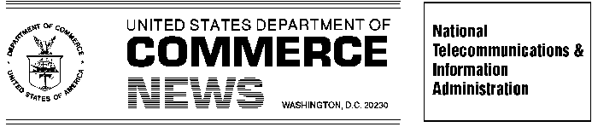
For Immediate Release Contact: Clyde Ensslin or Ranjit de Silva

March 5, 2004 202-482-7002
Commerce To Host Wireless Sensor Technologies Forum April 1st
Panel Discussions Will Examine Marketplace Expansion “From RFID to Smart Dust”

Wireless sensor technologies, the next highly anticipated billion-dollar market for the information technology sector, will be explored at a U.S. Department of Commerce Forum on April 1, 2004 that addresses the current and potential uses of sensor technologies by both industry and government as well as the public policy implications of widespread deployment.

Panel discussions will be moderated by Federal Communications Commissioner Kevin J. Martin and senior Commerce Department officials including Jon W. Dudas, Acting Under Secretary for Intellectual Property and Director of the U.S. Patent and Trademark Office; Michael D. Gallagher, Acting Assistant Secretary for Communications and Information; Elizabeth Prostic, Chief Privacy Officer; and Benjamin H. Wu, Deputy Under Secretary for Technology.

"Designing an appropriate regulatory framework for wireless sensor technologies requires an understanding of different policy objectives. We look forward to a lively discussion," said Acting Under Secretary Dudas.

“Widespread use of wireless sensor technologies is moving from factory floors to store shelves to family living rooms,” said Acting Assistant Secretary Gallagher. “We want to make sure government is a smart consumer. We also need to explore the implications for spectrum management and privacy, and we must adopt policies that maintain our economic competitive advantage,” Gallagher said.

The Department of Commerce's National Telecommunications and Information Administration, U.S. Patent and Trademark Office, and Technology Administration will host the half-day forum. The first panel will address the present and future market for sensor technologies. Panelists will include developers, manufacturers, market analysts, and industry and government users. The second panel will address public policy issues facing sensor technologies such as spectrum use, privacy and security, and intellectual property. Panelists will include representatives from industry and government, as well as public policy analysts.

The Wireless Sensor Technologies Forum will be held from 9:00 a.m. to 1:15 p.m. at the U.S. Department of Commerce, 1401 Constitution Avenue, N.W., Auditorium, Washington, D.C. More information is available on the NTIA Web site at www.ntia.doc.gov.

# # #

