TECHNICAL APPENDIX
TO THE NTIA COMMENTS ON THE BPL NPRM

EXECUTIVE SUMMARY

In response to the Federal Communication Commission’s BPL Notice of Proposed Rulemaking (NPRM), NTIA’s Phase 1 study of Broadband over Power Line (BPL) systems summarized Federal Government usage of the 1.7 – 80 MHz frequency range, presented measurement and modeling results for BPL emissions, defined interference risks to radio reception in the immediate vicinity of overhead power lines used by Access BPL systems, suggested refinements to measurement guidelines applicable to BPL systems, and identified means for mitigating local interference should it occur. NTIA identified a number of issues requiring further study during its Phase 2 investigation of BPL. A number of these issues are addressed in this technical appendix to NTIA’s comments on the BPL NPRM: the recommended antenna height for measuring emission levels; an appropriate height correction factor for use with measurements performed at a height of 1 meter; where to measure emissions relative to the BPL device and the attached power lines; and the aggregation of BPL emissions via ionospheric propagation.

Numerical Electromagnetic Code (NEC) models of a variety of power line models show a substantial variability in the height at which the peak field strength occurs. This variability can be seen over frequency and power line topology. In all cases where the operating frequency is above 6 MHz, the peak field strength occurred at heights greater than 1 meter. Analysis of the difference between peak field strength at any height and the peak field strength at 1 meter, or “height correction factor,” showed that 80% of the values are less than 4 to 6 dB. In light of these results, NTIA recommends that measurements be performed at a height of 1 meter and a height correction factor of 5 dB be applied.

NTIA found from the NEC power line models that the locations all along the length of the power line where the field strength is at its peak, both at heights of 1 meter and overall, vary widely. For any given power line configuration, at some frequencies the peak occurs adjacent to or near the BPL device, while at other frequencies the peak occurs at substantial distances from the BPL device at an impedance discontinuity. There are also many frequencies where the field strength peaks at various distances along the power line. Thus, NTIA recommends that field strength measurements be performed at a 10 meter horizontal distance from an Access BPL power line, at points all along key segments of the power line where the maximum field strength from BPL emissions is expected to occur. In its ongoing Phase 2 study, NTIA will continue to investigate emissions along the power lines and recommend criteria for choosing representative segments of power lines to measure.

NTIA’s worst-case oriented analysis of ionospheric propagation and aggregation of emissions from Access BPL systems indicates that interference via this mechanism will not occur in the near term. Considering realistically dispersed deployments of BPL systems, it would take hundreds of thousands of Access BPL devices operating under existing rules to cause a 1 dB increase in median noise. Under NTIA’s recommended rule elements, chiefly the 5 dB height correction factor and power control, it would take millions of BPL devices to increase the median noise by 1 dB. NTIA will continue to analyze the long-term potential for interference due to aggregation via ionospheric propagation in its ongoing Phase 2 study.

In its Phase 1 study, NTIA analyzed the interference risks in terms of geographic locations where interference may occur to representative federal radio receivers due to outdoor, overhead Access BPL systems conforming to Part 15 rules for Class B digital devices above 30 MHz. NTIA extended the interference risk analysis to include operation at Class A emissions limits above 30 MHz. Relative to operation under the Class B limit, the results for Class A show an increase of approximately 40 – 50% in the distances at which receiver operation at a given percentage of locations would experience a given noise floor increase. NTIA evaluated the effectiveness of its recommendations for a measurement height correction factor and found that it only slightly reduces interference risks for nearby land-mobile receivers. After applying the height correction factor, most locations within 15 meters of an Access BPL power line will experience a noise floor increase of 10 dB or more at operating frequencies between 1.7 MHz and 30 MHz. To further protect land-mobile operations, other risk reduction techniques should be employed, such as power control and avoidance of use of mobile service frequencies in physically adjacent Access BPL network elements. NTIA will further investigate these recommendations in its ongoing Phase 2 study.

NTIA will continue to investigate these and other issues identified in its Phase 1 report as requiring further study. These include: determination of the equivalent field strength limits for the FCC’s proposed ten meter measurement distance that reflects realistic decay of BPL signal strength with distance; the ratio of electric field to magnetic field below 30 MHz for suitable estimation of the electric field with a loop antenna in the near field; the protection requirements for sensitive or critical frequencies used by the Federal Government; and extending the interference risk analysis to include any resulting recommendations to enhance the Commission’s Part 15 rules applicable to BPL systems.

TABLE OF CONTENTS

VOLUME I
EXECUTIVE SUMMARY ……………………………………………………........ |  | ii
TABLE OF CONTENTS ………………………………………………………....... |  | iv
SECTION 1 | INTRODUCTION
1.1 | Background ……………………………………………………... | 1-1
1.2 | Objectives ……………………………………………………..... | 1-2
1.3 | Approach ………………………………………………………... | 1-2
SECTION 2 | ANALYSIS OF MEASUREMENT ANTENNA HEIGHT
2.1 | Introduction ……………………………………………………... | 2-1
2.2 | Power Line Models ………………………………....................... | 2-1
2.3 | Height Corresponding to Peak Field Strength ……....………….. | 2-4
2.4 | Antenna Measurement Height Correction Factor ………………. | 2-18
2.5 | Conclusion …………………………………………………........ | 2-28
SECTION 3 | MEASUREMENT DISTANCE ALONG POWER LINE AWAY FROM BPL DEVICES
3.1 | Introduction ……………………………………………………... | 3-1
3.2 | Methodology …………………………………………………..... | 3-1
3.3 | Results …………………………………………………..………. | 3-1
3.4 | Conclusion ……………………………………………………… | 3-11
SECTION 4 | IONOSPHERIC PROPAGATION OF BPL SIGNALS
4.1 | Introduction ……………………………………………………... | 4-1
4.2 | Analytical Modeling of Skywave Propagation ………………... | 4-1
4.3 | Results ……...…………………………………………………… | 4-3
4.4 | Conclusion ……………………………………………………… | 4-4
SECTION 5 | INTERFERENCE RISK ANALYSIS
5.1 | Introduction ……………………………………………………... | 5-1
5.2 | BPL Operations at Current Part 15 Rules Above 30 MHz ...…… | 5-1
5.3 | Antenna Height Correction Factor Applied to the Land-Mobile Receiver Case ……………………………………………............ | 5-5
5.4 | Conclusion ……………………………………………………… | 5-5

SECTION 1
INTRODUCTION
  - BACKGROUND

NTIA’s Phase 1 study of Broadband over Power Line (BPL) systems summarized Federal Government use of the 1.7 – 80 MHz frequency range, presented measurement and modeling results for BPL emissions, defined interference risks to radio reception in the immediate vicinity of overhead power lines used by Access BPL systems, suggested refinements to Part 15 measurement guidelines applicable to BPL systems, and identified means for mitigating local interference should it occur. Propagation and aggregation of emissions from BPL systems and the associated BPL deployment models were suggested as issues requiring further study.

Critical review of the assumptions underlying the BPL interference risk analyses revealed that compliance measurement procedures rather than field strength limits are the leading cause of high perceived interference risks. As applied in current practice to BPL systems, Part 15 measurement guidelines do not fully address certain unique characteristics of BPL radiated emissions. NTIA recommended the following supplemental BPL compliance measurement guidelines that derive from existing Part 15 measurement guidelines:

- Measurement of emissions from both the BPL devices and power lines to which they are attached.
- Measurement of BPL systems exhibiting the maximum potential frequency reuse.
- Use of measurement antenna heights at or above the height of power lines, possibly in connection with an adjustment factor accounting for field strength levels at other heights.
- Measurement at a distance of ten meters from the BPL device and power lines.
- Application of a distance extrapolation factor that reflects the radiation characteristics of BPL systems.
- Measurement of emissions with the BPL devices variously tuned to all frequencies at which it is capable of operating.
- Below 30 MHz, measurement using a calibrated rod antenna or a loop antenna in connection with appropriate factors relating magnetic and electric field strength levels.
- Careful selection of representative BPL installations that produce the highest levels of radiated emissions.
- Controls available to the operator must not be capable of causing generation of field strength in excess of the limiting values.

NTIA suggested in its Phase 1 report to further study the effectiveness of these recommended supplemental measurement guidelines.

  - OBJECTIVE
The objectives of this technical appendix are to offer specific recommendations to enhance Part 15 measurement guidelines applicable to Access BPL systems, to expand upon the interference risk analysis provided in NTIA’s Phase 1 study report to include an assessment of the effectiveness of NTIA’s recommended height correction factor, and to evaluate the potential impact on federal radiocommunications due to ionospheric propagation and aggregation of BPL emissions.

  - APPROACH
NTIA analyzed BPL field strength to determine the measurement height corresponding to the peak field strength and a reasonable height correction factor to employ when conducting measurements at the current Part 15 measurement height guideline of 1 meter (Section 2). NTIA also analyzed the locations corresponding to peak field strength along the power line in response to the Commission’s proposal in the BPL NPRM to perform measurements only at specific locations (Section 3). NTIA evaluated BPL signal aggregation and ionospheric propagation to provide initial worst-case estimates of the potential increase in noise (Section 4). The interference risk analysis from NTIA’s Phase 1 study was expanded to include operation employing current Part 15 Class A digital device emission limits for frequencies above 30 MHz and the risk reduction from NTIA’s recommended measurement height correction factor (Section 5).

SECTION 2
ANALYSIS OF MEASUREMENT ANTENNA HEIGHT

  - INTRODUCTION
Most federal radio receiver antennas are located at heights above 2 meters. The limited measurements from the Phase 1 study indicated that the level of radiated emissions was greater at the height of the power lines than at a 1 meter height. In NTIA’s Phase 1 study, preliminary NEC modeling yielded similar results, leading to a recommendation to measure BPL emissions with an antenna situated near the height of the power lines. As an alternative, NTIA recommended that measurements performed at a height of 1 meter include a correction factor to account for the greater field strength at greater heights.

  - POWER LINE MODELS
A number of power line models were created using the NEC software to gain a greater understanding of the effects various physical topologies might have on the electric fields radiated by BPL signals on power lines. The electric field strength results in any polarization, over a range of heights and at any position along the length of the power line model were then evaluated statistically.
NTIA evaluated nineteen different power line topologies to calculate three-axis electric field values in a vertical grid located 10 meters from the power line (FCC-proposed measurement distance in the BPL NPRM), at heights ranging from 1 to 20 meters in one meter increments. These calculations were made horizontally along the length of the modeled power lines in one-meter increments, and at frequencies from 2 to 50 MHz (in 2 MHz increments). Eighteen relatively simple power line topologies are listed in Table 2-1. The orientation of power line conductors for these topologies is depicted in Figure 2-1.

Table 2-1: Power line topologies used to model antenna measurement height
Model Name | Number of Wires | Wire  Configuration | Multi-grounded neutral with 3 transformers | Wire  Spacing
tri26 | 2 | triangular-horizontal | not included | 0.6 meters
tri210 | 2 | triangular-horizontal | not included | 1.0 meters
tri36 | 3 | triangular-horizontal | not included | 0.6 meters
tri310 | 3 | triangular-horizontal | not included | 1.0 meters
tri26n | 2 | triangular-horizontal | included | 0.6 meters
tri210n | 2 | triangular-horizontal | included | 1.0 meters
tri36n | 3 | triangular-horizontal | included | 0.6 meters
tri310n | 3 | triangular-horizontal | included | 1.0 meters
ver1 | 1 | vertical | not included | n/a
ver26 | 2 | vertical | not included | 0.6 meters
ver210 | 2 | vertical | not included | 1.0 meters
ver36 | 3 | vertical | not included | 0.6 meters
ver310 | 3 | vertical | not included | 1.0 meters
ver1n | 1 | vertical | included | n/a
ver26n | 2 | vertical | included | 0.6 meters
ver210n | 2 | vertical | included | 1.0 meters
ver36n | 3 | vertical | included | 0.6 meters
ver310n | 3 | vertical | included | 1.0 meters

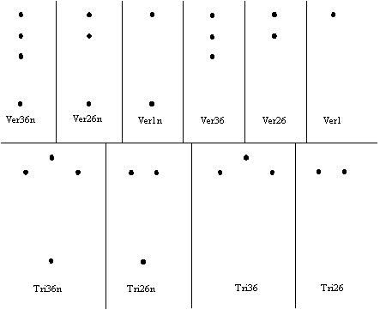
Figure 2-1: Power line topologies

All modeled power lines were 340 meters in length, and consisted of eight segments of catenary (hanging) wires (with catenary lengths of 43 meters each) between nine utility poles. The models were fed on a segment next to the model axis on one of the outside wires. All wires were assumed to be copper, and all models with neutral wires included three simulated distribution transformers wired between one of the phases and neutral, with 7.7 Ω of real impedance. On the models with a neutral wire, the neutral was connected to ground at each transformer point (in the center of the model and at each end).

Vertical-alignment models were designed such that all wires (including the neutral, if any) were arranged in a vertical line. Triangular-horizontal models with three wires were designed with the middle wire 0.25 meter higher than the outer two. The neutral wire (if one was included) was centered under the phase wires.

NTIA also constructed an extensive NEC model based upon an actual MV distribution branch in one of the BPL deployment areas where NTIA conducted field measurements. This model was designed using power line maps as well as actual observation (Figure 2-2).

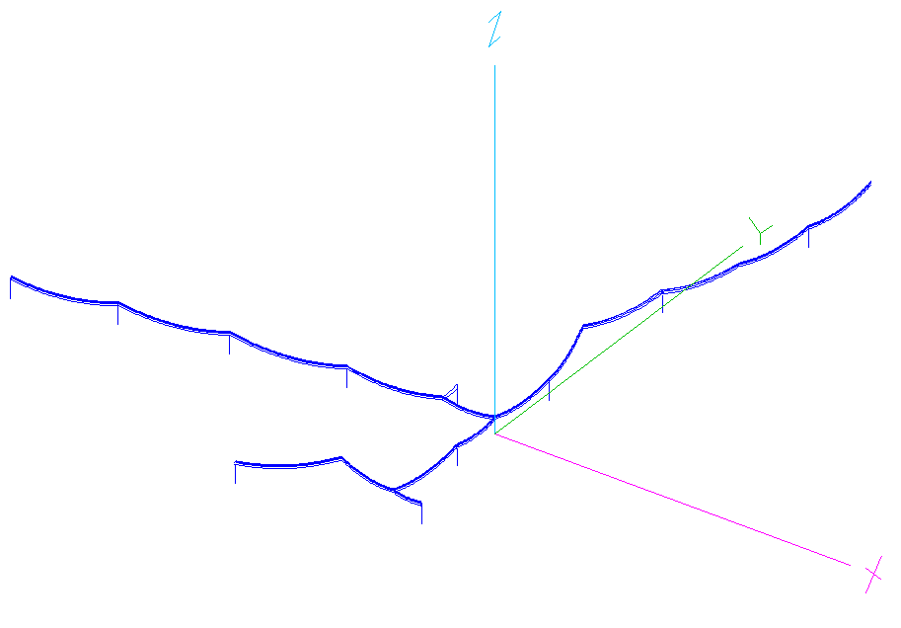
Figure 2-2: NEC model of actual power line carrying BPL signals

The model consisted of three-phase and multi-grounded neutral wiring. Included in the model are “risers” (connections of all three phases to underground wiring having a characteristic impedance of 30Ω), wire intersections, transformers and neutral grounds. Along most of the power line, the wiring topology is vertical, but at one pole (at a riser) it shifts to a horizontal-triangular configuration and then back to vertical.

The model covered an area of some 240,000 square meters (600m × 400m), and was designed (segmented and tested) at 4.303 MHz, 8.192 MHz, 22.957 MHz and 28.298 MHz (frequencies which corresponded with measurement frequencies in the field).

  - HEIGHT CORRESPONDING TO PEAK FIELD STRENGTH
Figures 2-3 through 2-20 show the heights where the peak electric field strength occurred over the frequency range of 2 – 50 MHz for the various power line topologies described in Section 2.2.
Figure 2-3: Height corresponding to peak field strength, vs. frequency – tri36 topology

Figure 2-4: Height corresponding to peak field strength, vs. frequency – tri36n topology

Figure 2-5: Height corresponding to peak field strength, vs. frequency – tri310 topology

Figure 2-6: Height corresponding to peak field strength, vs. frequency – tri310n topology

Figure 2-7: Height corresponding to peak field strength, vs. frequency – ver36 topology

Figure 2-8: Height corresponding to peak field strength, vs. frequency – ver36n topology

Figure 2-9: Height corresponding to peak field strength, vs. frequency – ver310 topology

Figure 2-10: Height corresponding to peak field strength, vs. frequency – ver310n topology

Figure 2-11: Height corresponding to peak field strength, vs. frequency – tri26 topology

Figure 2-12: Height corresponding to peak field strength, vs. frequency – tri26n topology

Figure 2-13: Height corresponding to peak field strength, vs. frequency – tri210 topology

Figure 2-14: Height corresponding to peak field strength, vs. frequency – tri210n topology

Figure 2-15: Height corresponding to peak field strength, vs. frequency – ver26 topology

Figure 2-16: Height corresponding to peak field strength, vs. frequency – ver26n topology

Figure 2-17: Height corresponding to peak field strength, vs. frequency – ver210 topology

Figure 2-18: Height corresponding to peak field strength, vs. frequency – ver210n topology

Figure 2-19: Height corresponding to peak field strength, vs. frequency – ver1 topology

Figure 2-20: Height corresponding to peak field strength, vs. frequency – ver1n topology

For the model based upon an actual Access BPL power line structure (Figure 2-2), electric field simulations were performed at heights of 1 meter and 2 to 20 meters (in two-meter increments) for the entire area adjacent to the power line structure. The latter simulation was completed using NEC’s “Near Field Along a Line” command (“LE”), which calculates electric fields for vectors along and perpendicular to a line. This more accurately depicts real-world measurement conditions in which measurements would be taken along these vectors. Figures 2-21 through 2-23 illustrate the variation in field strength in all three polarizations at 1 meter and at the height of the power lines (12 meters). Figure 2-24 shows the height corresponding to the peak field strength in any polarization at ten meters from the power line, for the four frequencies evaluated with this model.
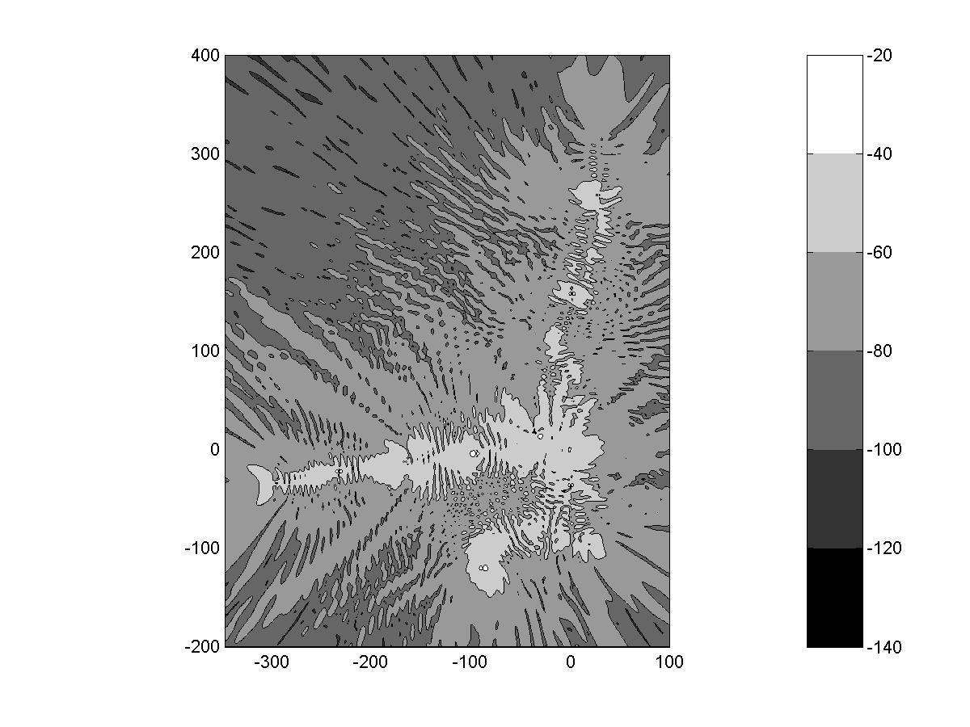
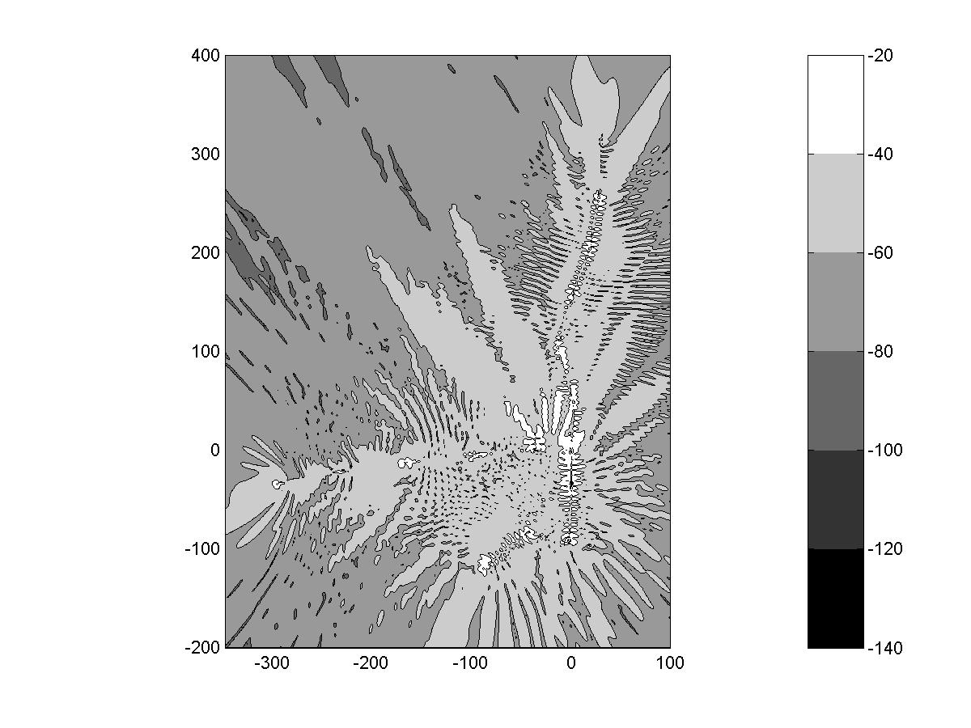
Figure 2-21: X-axis electric field values surrounding power line structure at 28.298 MHz. Top: 1 meter height. Bottom: 12 meter height. Axis values in meters; relative electric field values in dB.

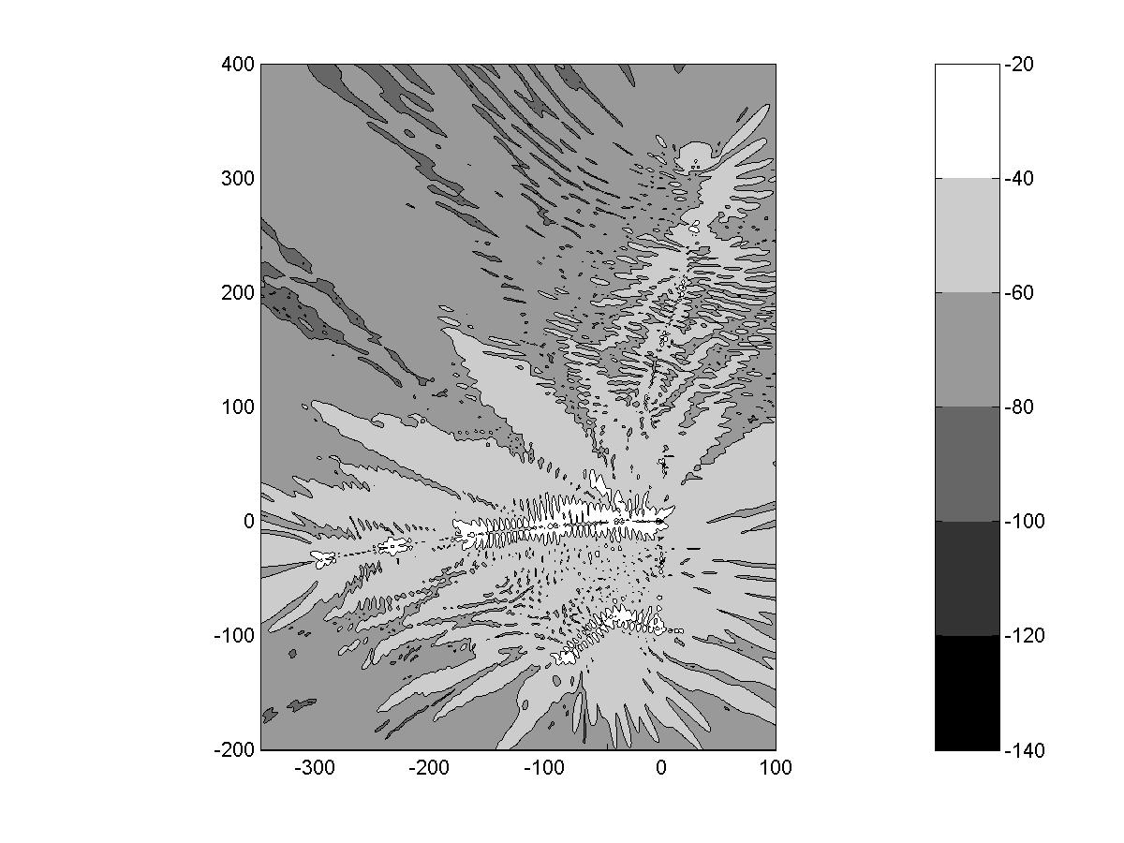
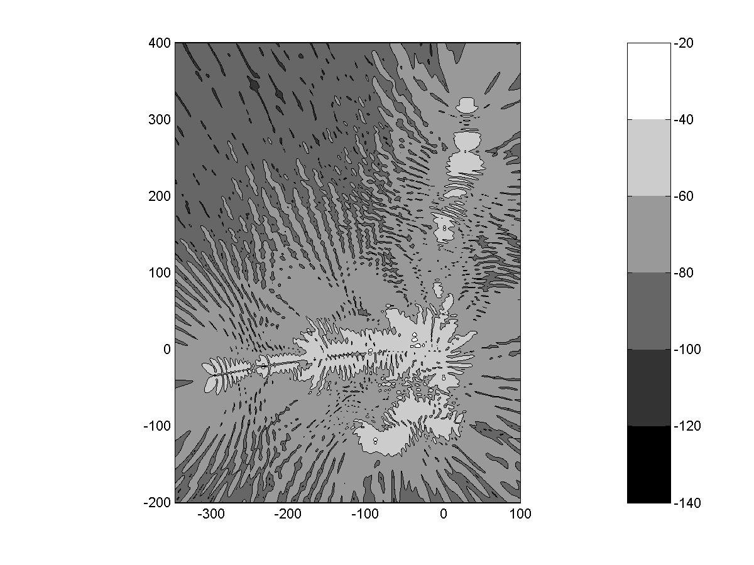
Figure 2-22: Y-axis electric field values surrounding power line structure at 28.298 MHz. Top: 1 meter height. Bottom: 12 meter height.

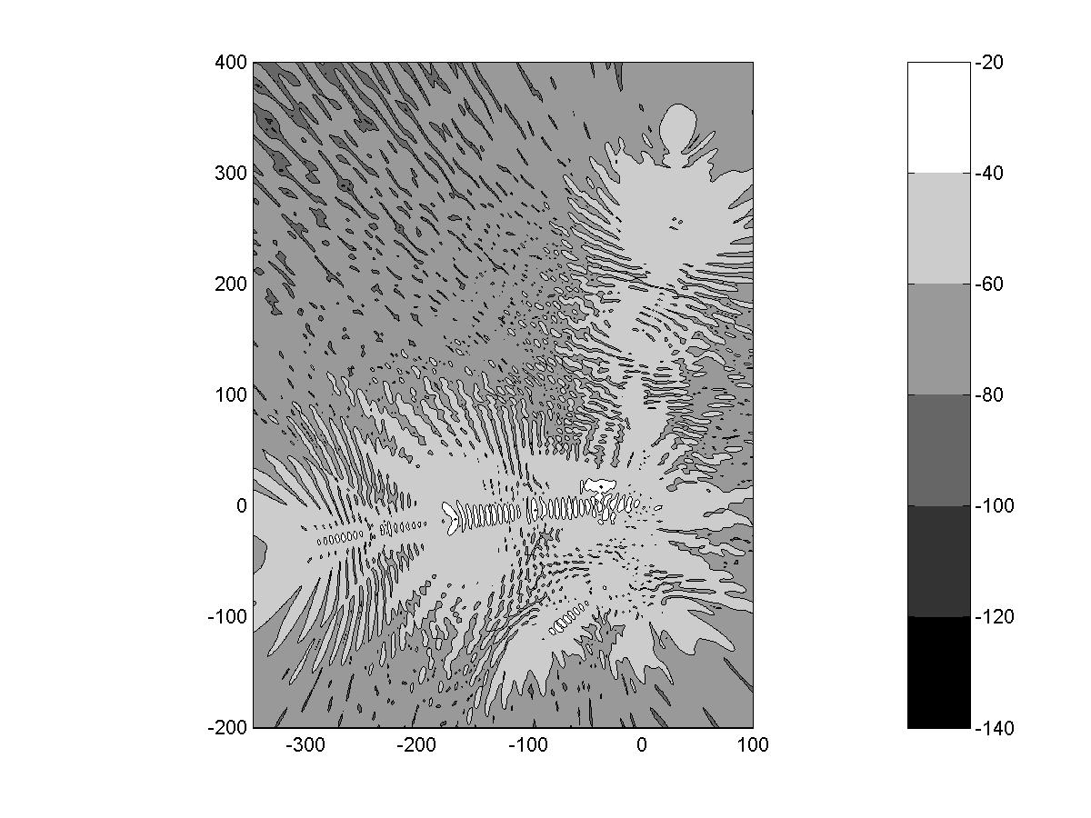
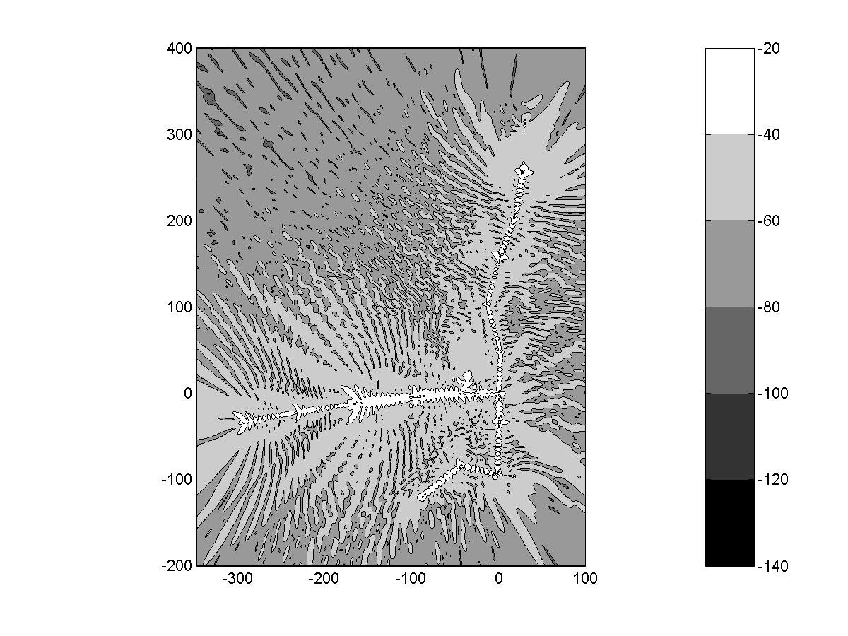
Figure 2-23: Z-axis electric field values surrounding power line structure at 28.298 MHz. Top: 1 meter height. Bottom: 12 meter height.
Figure 2-24: Height corresponding to peak field strength, vs. frequency for the power line model shown in Figure 2-2.

  - ANTENNA MEASUREMENT HEIGHT CORRECTION FACTOR
NTIA has found through measurements and simulations that existing Part 15 compliance measurements performed at an antenna height of 1 meter will likely underestimate the overall peak electric field strength of BPL emissions. Determination of peak field strength over all heights for Part 15 compliance measurement purposes can be accomplished either through direct measurement at various heights and directions, or by application of a correction factor to measurements made with a standard 1 meter antenna height. NTIA evaluated the above power line configurations using the NEC software to determine a suitable height correction factor when field strength measurements are performed at a 1 meter height.

Calculations of peak field strength vs. height for the eighteen simple power line models described earlier are shown in Figures 2-25 through 2-42. The peak electric field strength at each height was determined from the 80th percentile values of field strength along the length of the power line. The 80th percentile values eliminate the localized peaks that are unlikely to be encountered by a radio receiver randomly located in close proximity to an Access BPL power line. Use of the 80th percentile value is consistent with international measurement standards that seek 80% compliance with an 80% degree of confidence.

Figure 2-25: Difference between peak field strength at any height and the peak field strength at 1 meter, based on 80th percentile values; tri36 power line topology

Figure 2-26: Difference between peak field strength at any height and the peak field strength at 1 meter, based on 80th percentile values; tri36n power line topology

Figure 2-27: Difference between peak field strength at any height and the peak field strength at 1 meter, based on 80th percentile values; tri310 power line topology

Figure 2-28: Difference between peak field strength at any height and the peak field strength at 1 meter, based on 80th percentile values; tri310n power line topology

Figure 2-29: Difference between peak field strength at any height and the peak field strength at 1 meter, based on 80th percentile values; ver36 power line topology

Figure 2-30: Difference between peak field strength at any height and the peak field strength at 1 meter, based on 80th percentile values; ver36n power line topology

Figure 2-31: Difference between peak field strength at any height and the peak field strength at 1 meter, based on 80th percentile values; ver310 power line topology

Figure 2-32: Difference between peak field strength at any height and the peak field strength at 1 meter, based on 80th percentile values; ver310n power line topology

Figure 2-33: Difference between peak field strength at any height and the peak field strength at 1 meter, based on 80th percentile values; tri26 power line topology

Figure 2-34: Difference between peak field strength at any height and the peak field strength at 1 meter, based on 80th percentile values; tri26n power line topology
Figure 2-35: Difference between peak field strength at any height and the peak field strength at 1 meter, based on 80th percentile values; tri210 power line topology

Figure 2-36: Difference between peak field strength at any height and the peak field strength at 1 meter, based on 80th percentile values; tri210n power line topology

Figure 2-37: Difference between peak field strength at any height and the peak field strength at 1 meter, based on 80th percentile values; ver26 power line topology

Figure 2-38: Difference between peak field strength at any height and the peak field strength at 1 meter, based on 80th percentile values; ver26n power line topology

Figure 2-39: Difference between peak field strength at any height and the peak field strength at 1 meter, based on 80th percentile values; ver210 power line topology

Figure 2-40: Difference between peak field strength at any height and the peak field strength at 1 meter, based on 80th percentile values; ver210n power line topology

Figure 2-41: Difference between peak field strength at any height and the peak field strength at 1 meter, based on 80th percentile values; ver1 power line topology

Figure 2-42: Difference between peak field strength at any height and the peak field strength at 1 meter, based on 80th percentile values; ver1n power line topology
  - CONCLUSION
The figures in Section 2.3 show substantial variability of the height at which the peak field strength occurs. This variability can be seen over frequency and power line topology. In all cases where the operating frequency is above 6 MHz, the peak field strength occurred at heights greater than 1 meter. Below 6 MHz, the wavelengths are greater than four times the modeled power line height (12 meters) and under such conditions, it is expected that increased in-phase coupling between the power line and ground will lead to the highest values of electric field at or near ground level as explained below.

A long wire radiator is linearly polarized in the plane formed by the wire and the radial vector from the center of the wire to the observation point. Therefore, the direction of the linear polarization changes from point to point. Near ground, the polarization is almost vertical, especially when the height of the wire is small compared to wavelength. This is evident from graphical depiction of the vertical electric field in Figure 2-17 (p. 2-14) and comparison of this field with the two horizontal fields at 1 meter, as shown in Figures 2-15 and 2-16 (p. 2-12 and p. 2-13).

The figures illustrating the height for peak field strength, and the difference between the overall peak field strength and the peak at 1 meter show variability over the frequency range and also show variability from one power line structure to the next. One reason for this is that the ratio of the measurement height to wavelength changes and another reason is that all calculations are performed at a distance of 10 meters from the BPL energized power line. The figures in Section 2.4 show that the difference between peak field strength at any height and the peak field strength at 1 meter tends to range from about 4 to 6 dB.

Calculations for the real-world power line model (see Figure 2-2) produced results in substantial agreement with these findings. This model consists of a topology most closely resembling that of the “ver36n” model (over most of its extent, this model has a three-phase vertical with neutral configuration). The 80th-percentile data for this model levels off at just above 4 dB at higher frequencies, as does the data for “ver36n.”

In light of the variability of height where peak field strength occurs, NTIA recommends that measurements be performed at a height of 1 meter and use of a height correction factor of 5 dB. This will eliminate the need for an exhaustive search for the peak field in the height dimension, which could require considerable time and would not provide any statistical easement.

SECTION 3
MEASUREMENT DISTANCE ALONG POWER LINE AWAY FROM BPL DEVICES

  - INTRODUCTION
As noted in NTIA’s Phase 1 report, compliance measurement testing commissioned by BPL equipment vendors and service providers has generally focused on radiated emissions measured on radials from the BPL device under test. However, current FCC guidelines also state that the Part 15 devices and all attached wiring should be considered when measuring radiated emissions. In the Commission’s BPL NPRM, the proposed measurement guidelines specify the measurement locations along the power line away from a BPL device. In this section, NTIA evaluates the location along the length of the power line where the peak field strength occurs and the likelihood of finding the peak level at the prescribed locations.
  - METHODOLOGY
Field strength predictions from the power line models described in Section 2 were evaluated for the location of peak field strength along the length of the power line. The data correspond to the location 10 meters from the power line where the field strength was at its peak at a height of 1 meter and the location where the field strength was at its overall peak.
  - RESULTS
Figures 3-1 through 3-18 show the location where field strength is at its peak level along the power line for a variety of simulated power line configurations and over the frequency range of 2 to 50 MHz. Distances are expressed in terms of wavelengths away from the BPL device. The locations along the power line (10 meters from the power line) where the overall peak and the peak at a measurement height of 1 meter occur are displayed in each figure.

Figure 3-1: Location of peak field strength along the power line – tri36 topology

Figure 3-2: Location of peak field strength along the power line – tri36n topology

Figure 3-3: Location of peak field strength along the power line – tr310 topology

Figure 3-4: Location of peak field strength along the power line – tri310n topology

Figure 3-5: Location of peak field strength along the power line – ver36 topology

Figure 3-6: Location of peak field strength along the power line – ver36n topology

Figure 3-7: Location of peak field strength along the power line – ver310 topology

Figure 3-8: Location of peak field strength along the power line – ver310n topology
Figure 3-9: Location of peak field strength along the power line – tri26 topology

Figure 3-10: Location of peak field strength along the power line – tri26n topology
Figure 3-11: Location of peak field strength along the power line – tri210 topology

Figure 3-12: Location of peak field strength along the power line – tri210n topology

Figure 3-13: Location of peak field strength along the power line – ver26 topology

Figure 3-14: Location of peak field strength along the power line – ver26n topology

Figure 3-15: Location of peak field strength along the power line – ver210 topology

Figure 3-16: Location of peak field strength along the power line – ver210n topology

Figure 3-17: Location of peak field strength along the power line - ver1 topology

Figure 3-18: Location of peak field strength along the power line – ver1n topology

  - CONCLUSION
From the figures in Section 3.3, the locations all along the length of the power line where the field strength is at its peak, both at heights of 1 meter and overall, vary widely. For any given power line configuration, at some frequencies the peak occurs adjacent to or near the BPL device, while at other frequencies the peak occurs at substantial distances from the BPL device at an impedance discontinuity. There are also many frequencies where the field strength peaks at various distances along the power line. The variability of these results from power line to power line is due to different degrees of asymmetry in the power line structures and the fact that the electric field was calculated at a fixed horizontal distance (10 meters) from the power lines. The signal source was positioned on an outer conductor at a small positive (x-axis) offset from the center of the power line structure. The results are more asymmetric when a neutral wire is added to the power line structure, due to introduction of additional asymmetry. These results argue against use of the measurement locations proposed in the Commission’s BPL NPRM. NTIA recommends that field strength measurements be performed at a 10 meter horizontal distance from an Access BPL power line, at points all along key segments of the power line where the maximum field strength from BPL emissions is expected to occur. In its ongoing Phase 2 study, NTIA will continue to investigate emissions along the power lines and recommend criteria for choosing representative segments of power line to measure.

SECTION 4
IONOSPHERIC PROPAGATION OF BPL SIGNALS

  - INTRODUCTION
Sky wave ionospheric propagation may occur above the power line horizon for frequencies between 1.7 MHz and 30 MHz, as discussed in NTIA’s Phase 1 report. Sky wave propagation may be represented by rays which are refracted and reflected from the ionosphere and is responsible for signal transmission to distances ranging from hundreds to thousands of kilometers, depending on elevation angle of the radiated field, frequency and parameters of the ionosphere that exhibit temporal and spatial variability. The ionosphere, which ranges from about 60 to 600 km in height, acts as a low-conductivity dielectric. In general, sky waves are reliable for radiocommunications up to about 30 MHz, above which this mode of propagation is sporadic.

Sky waves suffer large losses mainly due to ionospheric absorption and polarization coupling losses. In a widespread deployment of BPL systems, there may be aggregation of co-frequency BPL emissions toward the ionosphere. The modeling results in the Phase I report suggest that there is relatively strong radiation in directions above the power line horizon (i.e., higher than radiation toward directions below the power lines), and so, aggregation of BPL signals at locations above power lines may be more significant than at lower heights where BPL signal propagation is less efficient.

  - ANALYTICAL MODELING OF SKY WAVE PROPAGATION
The goal of this preliminary analysis of aggregation and ionospheric propagation from widespread deployment of BPL systems was to gauge whether it could lead to interference in the near-term (next few years). Accordingly, the analysis has a worst-case orientation.

To make predictions regarding the large-scale effects of a widespread BPL deployment, NTIA employed the VOACAP HF propagation software developed at its Institute of Telecommunication Sciences (ITS). NTIA modeled propagation under a range of times, months and frequencies to determine potentially worst-case I/N conditions. In this process, NTIA used VOACAP’s “point-to-point” mode to find potential time, seasonal and frequency combinations that produced the highest I/N levels between several points around the nation. VOACAP’s “area” mode was then used to further refine these predictions by determining the geographic coverage of relatively high I/N levels due to single transmitters placed around the nation as propagation factors were varied.
Using these values, NTIA then ran VOACAP in its area mode to obtain interfering signal and noise power values in a fixed 31×31-point grid of receiving points covering the United States and centered on Kansas City, Missouri. For this step, NTIA placed BPL devices in the geographic center of each county in the United States (including Alaska and Hawaii). Each of the BPL transmitters (corresponding to a county) was assigned a radiated power that would produce field strength at the level of the Part 15 limit as measured using existing procedures. The total radiated power of each BPL device is shown in Table 4-1. These power levels were scaled by the number of active BPL devices expected to serve the urban households in each county.
Table 4-1: BPL Total Radiated Power
Frequency (MHz) | Power (dBW/Hz)
4 | -104.26
15 | -101.79
25 | -99.35
40 | -123.15

Several other factors were taken into consideration when predicting the interference-to-noise ratio. BPL devices will not all operate at the Part 15 limit; therefore, the average field strength was assumed to be 4 dB below the Part 15 limit. The analysis was based on RMS values; therefore an adjustment was made to convert the quasi-peak BPL signal level to an RMS level. Finally, since the devices in the system do not all operate at the same frequency, an allowance of 6 dB was given (i.e., 1 in 4 BPL injectors are assumed to be co-frequency). These adjustment factors are listed in Table 4-2.

Table 4-2: Adjustment Factors
Factor | Adjustment (dB)
Devices operating at levels below Part 15 limits | 4
Quasi-Peak to RMS S/N difference | 3
Co-frequency distribution factor | 6
Total | 13

All simulated BPL transmitters were given an average antenna pattern based upon the NTIA NEC far-field simulations of a complex power line model (Figure 2-2). This model was based upon a real Medium Voltage (MV) power line configuration at a test BPL deployment area. The NEC-derived far-field patterns were arithmetically averaged over azimuth, assuming a random distribution of power line orientations, which resulted in gain patterns with variation in elevation only.

The VOACAP program’s variable inputs for this analysis are listed in Table 4-3.
Table 4-3: VOACAP Input Parameters
Variable | Value | Comment
Smoothed Sunspot Number (SSN) | 150 | Yields efficient propagation
Month | December | Yields good propagation and low noise
Time (UTC) | 18:00 | Yields good propagation and low noise
Frequency (MHz) | 23 | Yields good propagation and low noise
Manmade Noise at 3 MHz (dBW/Hz) | -164 | Relatively low value
BPL Total Radiated Power (dBW/Hz) | -100 | Maximum coupled BPL power for compliance with limit*

4.3 RESULTS
Aggregated output for a simulated nationwide deployment of over 700,000 Access BPL devices is depicted in Figure 4-1. The calculated hourly median I/N (VOACAP refers to it as S/N) level under these circumstances are greater than –17 dB over the continental United States, with hourly median I/N levels through much of the central United States between -8.4 dB and -11 dB. Thus, the highest expected hourly median increase in ambient noise due to the assumed extensive deployment of BPL devices would be less than 1 dB.

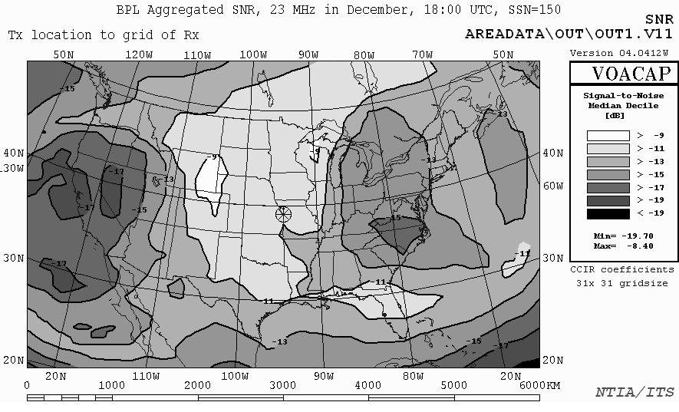
Figure 4-1: Aggregated BPL I/N levels due to ionospheric propagation
(Existing Rules, Worst-Case Oriented Analysis)
4.4 CONCLUSION
NTIA’s worst-case oriented analysis of ionospheric propagation and aggregation of emissions from Access BPL systems indicates that interference via this mechanism will not occur in the near term. Considering realistically dispersed deployments of BPL systems, it would take hundreds of thousands of Access BPL devices operating under existing rules to cause a 1 dB increase in median noise. Under NTIA’s recommended rule elements, chiefly the 5 dB height correction factor and power control, it would take millions of BPL devices to increase the median noise by 1 dB.

SECTION 5
INTERFERENCE RISK ANALYSES

  - INTRODUCTION
In its Phase 1 study, NTIA analyzed the risk of interference to various representative federal radio systems assuming BPL devices are operating at Class B emissions limits above 30 MHz under the current Part 15 rules. The interference risks were evaluated for two interfering signal thresholds: a doubling of receiver noise floor (I+N/N = 3 dB) that would result in interference in a low percentage of cases, and a ten fold increase in receiver noise floor (I+N/N = 10 dB) that would result in interference in a moderate percentage of cases. This section extends the Phase I study interference risk analyses to include operation of BPL devices at current Part 15 limits for Class A digital devices. In addition, the effect of NTIA’s recommended 5 dB height correction factor is evaluated for the case of a land-mobile receiver in close proximity to an Access BPL power line.
  - BPL OPERATIONS AT CURRENT PART 15 RULES ABOVE 30 MHz
NTIA analyzed four representative federal radio systems assuming operation at Class A emissions limits above 30 MHz. Figures 5-1 through 5-3 show the percent of locations, by distance from the Access BPL power lines, which could experience a noise floor increase of 3 or 10 dB. Both Class A and B results are plotted for land mobile, fixed and maritime stations, respectively.

Figures 5-4 through 5-6 illustrate the noise floor increase that an aeronautical receiver would experience at various altitudes and horizontal distances from the centroid of an area where BPL systems are deployed. As in the NTIA Phase 1 study, this deployment area has a 10 kilometer radius and the assumed density of co-frequency active BPL devices was one per square kilometer. Both Class A and B results are shown for the aeronautical receiver operating at an altitude of 6, 9 and 12 kilometers.

Figure 5-1: Percent of locations, by distance, exceeding the specified (I+N/N) levels at 40 MHz – Land-mobile receiver

Figure 5-2: Percent of locations, by distance, exceeding the specified (I+N)/N levels at 40 MHz – Fixed receiver

Figure 5-3: Percent of locations, by distance, exceeding the specified (I+N)/N levels at 40 MHz – Maritime receiver

Figure 5-4: Calculated (I+N)/N level for an aeronautical receiver at the specified distance and 6 km altitude from a BPL deployment, with 300 BPL devices visible to the receiver in a 314 km² area – 40 MHz

Figure 5-5: Calculated (I+N)/N level for an aeronautical receiver at the specified distance and 9 km altitude from a BPL deployment, with 300 BPL devices visible to the receiver in a 314 km² area – 40 MHz

Figure 5-6: Calculated (I+N)/N level for an aeronautical receiver at the specified distance and 12 km altitude from a BPL deployment, with 300 BPL devices visible to the receiver in a 314 km² area – 40 MHz

  - ANTENNA HEIGHT CORRECTION FACTOR APPLIED TO THE LAND-MOBILE RECEIVER CASE
NTIA recommendations for enhancements to the Commission’s Part 15 rules applicable to BPL systems are expected to yield significant reductions in the interference risks to federal radiocommunications. In its Phase 1 study, NTIA showed that there exists a substantial risk of interference to a land-mobile receiver due to a BPL transmitter operating at FCC Part 15 limits as measured using existing Part 15 measurement procedures. For frequencies below 30 MHz, virtually all points close to an Access BPL power line would experience noise floor increases exceeding 10 dB. NTIA evaluated the probability that a land-mobile receiver would experience various levels of increased noise due to BPL interference, with the results shown in Table 5-1. Radiated power and noise are referenced to a 2.8 kHz bandwidth below 30 MHz and a 16 kHz bandwidth above 30 MHz. The table shows these probabilities with or without applying NTIA’s recommended 5 dB measurement height correction factor. The results above 30 MHz in Table 5-1 are based on Access BPL operating at the Class B limit.

Table 5-1: Percentage of locations exceeding the specified interference level, by frequency, for a land-mobile receiver within 15 meters of an Access BPL power line.
With Height Adjustment
Frequency | Radiated | Noise | (I+N)/N
(MHz) | Power (dBW) | (dBW) | 3 dB | 10 dB | 20 dB | 30 dB | 40 dB | 50 dB
4 | -74.79 | -111.31 | 98.01% | 81.54% | 28.27% | 0.00% | 0.00% | 0.00%
15 | -72.32 | -128.83 | 99.83% | 98.85% | 83.00% | 34.97% | 0.00% | 0.00%
25 | -69.88 | -135.61 | 99.54% | 97.52% | 78.07% | 39.32% | 0.45% | 0.00%
40* | -86.11 | -134.27 | 66.05% | 30.84% | 0.00% | 0.00% | 0.00% | 0.00%
Without Height Adjustment
Frequency | Radiated | Noise | (I+N)/N
(MHz) | Power (dBW) | (dBW) | 3 dB | 10 dB | 20 dB | 30 dB | 40 dB | 50 dB
4 | -69.79 | -111.31 | 99.33% | 93.17% | 54.69% | 6.16% | 0.00% | 0.00%
15 | -67.32 | -128.83 | 99.85% | 99.66% | 95.69% | 59.48% | 4.28% | 0.00%
25 | -64.88 | -135.61 | 99.78% | 98.97% | 92.11% | 58.53% | 18.52% | 0.00%
40Error: Reference source not found | -81.11 | -134.27 | 87.89% | 49.15% | 10.00% | 0.00% | 0.00% | 0.00%

  - CONCLUSION
Figures 5-1 through 5-6 show that the operation of BPL devices at the Class A emissions limits, rather than Class B limits above 30 MHz, as determined using existing Part 15 measurement procedures, increases the distances at which a given percentage of locations experience a specified increase in receiver noise floor. Relative to operation under the Class B limit, the results for Class A show an increase of approximately 40 – 50% in the distances at which receiver operation at a given percentage of locations would experience a given noise floor increase.

NTIA evaluated the effectiveness of its recommendations for a measurement height correction factor and found that it only slightly reduces interference risks for nearby land-mobile receivers. After applying the height correction factor, most locations within 15 meters of an Access BPL power line will experience a noise floor increase of 10 dB or more at operating frequencies between 1.7 MHz and 30 MHz. To further protect land-mobile operations, other risk reduction techniques should be employed, such as power control and avoidance of use of mobile service frequencies in physically adjacent Access BPL network elements. Radio frequency noise on power lines can vary by upwards of 20 dB throughout a day; therefore, adjustment of BPL signal power to the minimum level needed for proper BPL device operation should result in an overall lowering of interference risks. Precluding reuse of mobile service frequencies in adjacent BPL devices lowers the probability that a land-mobile receiver will be operating co-frequency with BPL network elements within a large contiguous portion of the area served by Access BPL.

Amendment of Part 15 regarding new requirements and measurement guidelines for Access Broadband over Power Line Systems, Notice of Proposed Rule Making, ET Docket No. 04-37, February 23, 2004 (“BPL NPRM”); Potential Interference from Broadband over Power Line (BPL) Systems to Federal Radiocommunications at 1.7 – 80 MHz, NTIA Report 04-413, BPL NPRM, April 28, 2004 (“NTIA Phase 1 Study”).
See NTIA Phase 1 Study, §6.
Id. at §9.4.
BPL NPRM, Appendix C, at ¶2.b.2.
In actual systems, all transformer impedances vary widely, based upon varying loads in the system. However, preliminary calculations found that changing transformer impedances had little impact upon the results.
See e.g., Information technology equipment – Radio disturbance characteristics – Limits and methods of measurement, CISPR 22:2003, (“CISPR 22”), Section 7.1.2 “The significance of the limits for equipment shall be that, on a statistical basis, at least 80% of the mass-produced equipment complies with the limits with at least 80% confidence.”
See 47 C.F.R. §15.31(g)-(k).
See BPL NPRM, Appendix C at ¶2.b.2 – “Testing shall be performed at distances of 0, ¼, ½, ¾, and 1 wavelength down the line from the BPL injection point on the power line. Wavelength spacing is based on the mid-band frequency…”
See e.g., Propagation of Radio Waves, Edited by M. P.M Hall, L. W. Barclay and M. T. Hewitt, IEE, London, 1996.
VOACAP is available from the NTIA Institute for Telecommunication Sciences, URL: http://elbert.its.bldrdoc.gov/hf.html.
For this preliminary analysis, NTIA assumed that a BPL injector has the data handling capacity to support an average of 30 customers, and 1 of 4 urban households is a BPL customer. In other words, one BPL injector was assumed per 120 urban households.
* The maximum coupled BPL power that yields compliance with field strength limits can vary substantially among different power lines.
See NTIA Phase 1 Study, at §6.
See NTIA Phase 1 Study, at §6.6.1.
* Analyzed assuming BPL device operating at the Part 15 Class B limit.
See 47 C.F.R. 15.31(f)(1)

