Evidence-Based Disease Prevention Grants Program


Background
The evidence-based disease prevention (EBDP) grants program is a public/private collaboration of the Administration on Aging (AoA) with the Atlantic Philanthropies, Centers for Disease Control & Prevention, Agency for Healthcare Research & Quality, Health Resources & Services Administration, Substance Abuse & Mental Health Services and others.

The goal is to increase older peoples’ access to programs that have proven to be effective in reducing their risk of disease, disability and injury.

Chronic Conditions & Older Adults

Chronic diseases and conditions exact an especially heavy health and economic burden on older adults due to associated long-term illness, diminished quality of life, and greatly increased health care costs. Approximately 80% of older Americans are living with at least one chronic condition, and 50% have at least two.¹

The good news is that much of the illness, disability, and death associated with chronic disease is avoidable through known prevention measures.

EBDP Programs

EBDP program refers to a program that closely replicates a specific intervention that has been tested
through randomly controlled clinical trials with the results published in peer-reviewed journals.

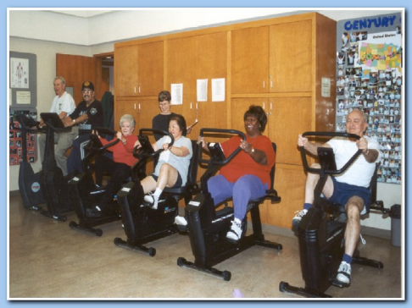

As a result of rigorous research and clinical trials, there are evidence-based model health programs in physical activity, diabetes, nutrition, smoking cessation, medication management, fall prevention, and chronic disease self-management that effectively improve the health of older adults.

AoA Awards

In September 2006, AoA awarded $13 million to 16 states to improve the health and quality of life for older Americans. In June 2007, AoA awarded an additional $5.7 million to eight additional states for the same purpose.

These awards support the delivery of evidence-based prevention programs for service providers of older adults, such as senior centers, nutrition programs, senior housing, projects and faith-based organizations.

Subject Areas
States may implement EBDP programs in the following subject areas:

Fall Prevention:
Among older adults, falls are the leading cause of injuries, hospital admissions for trauma and related deaths. The frequency, harm and costs associated

with falls make a community fall prevention program a cost-effective strategy for reducing functional decline and health care costs among high-risk seniors.

Physical Activity:
Regular physical activity can help prevent or control many of the health problems that often reduce the quality and length of life for older adults including obesity, arthritis, high blood pressure, diabetes, depression, and colon cancer.

Nutrition:
Two-thirds of older Americans are not eating the recommended five servings of fruits and vegetables a day.² Many older adults, including those with chronic diseases, can substantially benefit from programs that assist them in making healthful food choices.

Medication Management:
Older adults are particularly vulnerable to medication errors because of the number of medications they take and the biological changes of aging and disease.

Chronic Disease Self-Management:
Chronic disease self-management—providing patients the education, motivation and tools to make behavior changes—leads to improvement in health status, increased patient satisfaction, and in some cases, reductions in health care use and costs.

Depression:
Nearly 20% of U.S. adults 65 years and older experience depressive symptoms.3 the core components of depression self-management programs include screening and assessment, education for clients and family caregivers, referrals to
appropriate health professionals, and behavioral activation.

Technical Assistance
The AoA funds a National Resource Center to provide technical assistance to the grantees. The technical assistance includes national meetings, monthly conference calls, newsletters, the Center for Healthy Aging website and individual assistance.

Additional Information
For additional information on the EBDP initiative, please visit the EBDP National Resource Center at www.healthyagingprograms.org. The website includes descriptions of model EBDP programs, reports, and other resources related to this program and healthy aging.

For additional information and descriptions of the AoA EBDP Programs, please go to:
http://www.aoa.gov/prof/evidence/evidence.asp

References

¹“ The State of Health and Aging in America 2004,” Merck Institute of Aging and Health and Centers for Disease Control & Prevention.

²“ Medical Expenditure Panel Survey,” 2001. Merck Institute of Aging and Health and Centers for Disease Control & Prevention.

³“ The State of Health and Aging in America 2004,” Merck Institute of Aging and Health and Centers for Disease Control & Prevention.

4“ The State of Health and Aging in America 2004,” Merck Institute of Aging and Health and Centers for Disease Control & Prevention.

