ATTACHMENT 3: M&TE Required Calibration Labels
5006-3  M&TE Required Calibration Labels |  |   Records Use only
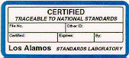 | Certified (blue border). The item has been calibrated by the Standards and Calibration Laboratory and meets all applicable specifications (after adjustments, if any).
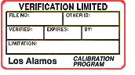 | Verification Limited (red border). The item has been calibrated by the user or by a calibrator other than the Standards and Calibration Laboratory but does not meet all applicable specifications (after adjustments, if any); or, the item has been calibrated by the user or by a calibrator other than the Standards and Calibration Laboratory over a limited subset of its available functions, ranges, or attributes.
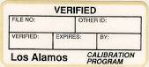 | Verified (tan border). The item has been calibrated by the user or by a calibrator other than the Standards and Calibration Laboratory and meets all applicable specifications (after adjustments, if any).
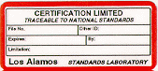 | Certification Limited (red border). The item has been calibrated by the Standards and Calibration Laboratory but does not meet all applicable specifications (after adjustments, if any); or, the item has been calibrated by the Standards and Calibration Laboratory over a limited subset of its available functions, ranges, or attributes.

