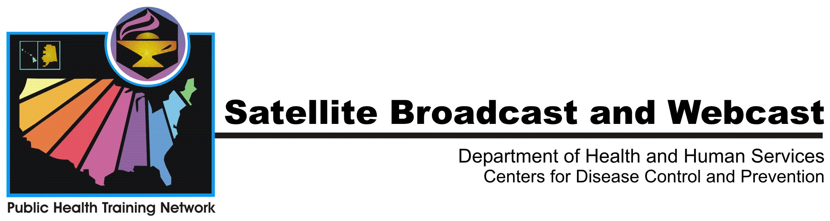
Preparing for Radiological Population
Monitoring and Decontamination
A National Center for Environmental Health and
Public Health Training Network (PHTN) Satellite Broadcast
March 9, 2006
1:00 - 3:00 PM Eastern Time
The terrorist attacks of 2001 in the United States and the subway attacks of 2004 and 2005 in Madrid, Spain, and London, England, showed that terrorists will go to great lengths to cause harm to people and disrupt their lives. Therefore, the risk that an overt or covert terrorist attack will occur involving radioactive materials is an unfortunate reality. If such an incident were to take place, hundreds of people could be exposed to radiation or contaminated with radioactive materials. In addition, hundreds of thousands could seek treatment for radiation exposure or reassurance that their health will not be affected. Most communities are not prepared to deal with the large volume of people who could seek screening and monitoring for radioactive contamination and possible exposure to radiation. The Centers for Disease Control and Prevention (CDC) is working to develop radiological population monitoring guidelines for communities on the basis of consultation from experts from federal, state, local, and academic organizations. This broadcast will cover the basic components of these guidelines in development. It will also help community leaders and public health workers prepare to conduct short- and long-term monitoring of people affected by a nuclear or radiological terrorist incident or an accidental release of radioactive materials into the environment. A question-and-answer session will enable participants nationwide to pose questions to panelists by toll-free telephone, fax, or TTY lines. In addition, questions may be e-mailed to rsb@cdc.gov both before and during the broadcast.

Goals
This program is designed to educate and inform the target audience on radiological population monitoring, including initial and long-term monitoring issues, considerations for establishing monitoring sites, and roles and responsibilities of local, state, and federal public health and emergency preparedness authorities.

Objectives
Following this broadcast, viewers should be able to
- define radiological population monitoring;
- describe examples of previous radiological population monitoring projects;
- describe challenges in planning for population monitoring;
- describe the role of local public health agencies in population monitoring;
- describe the role of federal agencies in population monitoring;
- identify populations, including special populations, for monitoring;
- describe basic procedures in population monitoring;
- identify populations for dose assessment;
- identify populations for dose reconstruction; and
- describe CDC’s current resources for planning population monitoring.
Target Audience
Federal, state, local, and territorial public health officials; public health practitioners; policy makers; first responders; community leaders and planners; community organizations; leaders of boards of health, hospitals, emergency management services, professional organizations, community-based health organizations, academic institutions, and federal agencies; and other people who seek to increase their understanding of population monitoring following a nuclear or radiological incident.

Faculty
Robert C. Whitcomb, PhD, Technical Team Lead,
Health Physicist,
Radiation Studies Branch, Division of Environmental Hazards and Health Effects (EHHE), National Center for Environmental Health (NCEH), CDC

Gregg Dempsey, Senior Science Advisor,
Radiation and Indoor Environments National Laboratory, Environmental Protection Agency

Kathleen Kaufman, Director, Los Angeles County Radiation Management, Radiation Management Program, Department of Health Services, County of Los Angeles, California

Questions
The broadcast will include a question-and-answer period.

You may submit questions via e-mail to rsb@cdc.gov.

During the broadcast you may call one of the following numbers to submit questions or comments.
Voice: 800-793-8598
Fax: 800-553-6323
TTY: 800-815-8152

For webcast technical assistance, call 800-728-8232.
Continuing Education Credit
Continuing education (CE) credit will be offered for various professions based on 110 minutes of instruction.

Registration Information
Visit CDC Training and Continuing Education Online at http://www.cdc.gov/phtnonline to register for CE credit or for a certificate of attendance for this broadcast. CE credit is available online only. Registration is not necessary to view this broadcast.

Site registration has begun.

Participant registration will be available beginning February 16, 2006.
Course numbers for live webcast or satellite broadcast:
Satellite Broadcast–SB0178
Webcast–WC0078
Course numbers for enduring materials:
Web-on-demand–WD0078
Videotape Course–VC0080
DVD–DV0017
CD-ROM–CB3126

CE credit for the live satellite broadcast and webcast (SB0178, WC0078) will be available from March 9, 2006, through April 10, 2006. CE credit for the enduring/self-study versions (WD0078, VC0080, DV0017, CB3126) of this program will be available from April 9, 2006, through April 9, 2009.
If you have questions about registration, call 1-800-41-TRAIN or e-mail ce@cdc.gov. When e-mailing a question, please include “Preparing for Radiological Population Monitoring and Decontamination” in the subject line.

Webcast Information
This program will be presented as a live webcast and will also be available for viewing after the live broadcast date at http://www.phppo.cdc.gov/PHTN.

Preparing for Radiological Population
Monitoring and Decontamination
A National Center for Environmental Health and
Public Health Training Network (PHTN) Satellite Broadcast
March 9, 2006
1:00 - 3:00 PM Eastern Time

Signal Test Date and Time
March 8, 2006
1:00 - 2:00 PM ET
Same coordinates for signal test and broadcast
Broadcast Dates and Times
March 9, 2006
1:00 - 3:00 PM ET
Color bars and tone begin 30 minutes before broadcast
C-Band  Satellite: Galaxy-3C  Longitude: 95 degrees West  Channel: 23C  Downlink Freq: 4160 MHz  Polarization: Horizontal  Audio Frequency: 6.2 & 6.8 | Ku-Band  Satellite: SBS-6  Longitude: 74 degrees West  Channel: 05K  Downlink Freq: 11823 MHz  Polarization: Horizontal  Audio Frequency: 6.2 & 6.8
This broadcast will be closed-captioned

To Contact Us During the Program:  Voice: 800-793-8598  [International callers 404-639-0180]  FAX: 800-553-6323  [International callers, 404-639-0181]  TTY: 800-815-8152  [International callers, 404-639-0182]  Technical Assistance for satellite downlinking ONLY: 800-728-8232  [International callers 404-639-1289] |  | Audiobridge Information  In the event you are unable to receive the signal on program day, you may join by audiobridge.  - USA Toll Free: 888-455-0041  - USA Toll Number: 1-210-839-8508  For security reasons, the pass code and leader’s name listed below will be required to join the call.  - Pass Code: 32280  - Leader: ANA BENSON  If you have problems during your audiobridge conference, you may call 800-728-8232 or International callers dial 404-639-1289.

