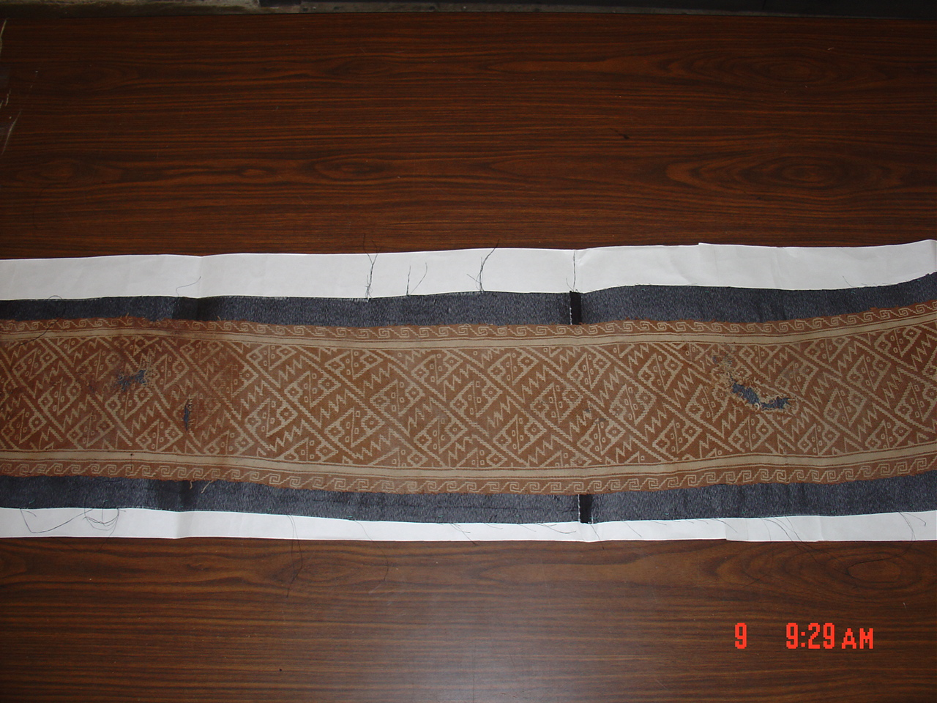

Item number 003

(textile: 148 x 19 cm, with three finished edges, one cut) Woven band of two natural (undyed) colors of cotton. On this side, the background is brown with cream-colored design elements consisting of interlocking stylized rays (as in “manta rays”). This is probably a double-sided textile, meaning that the design is the same on the back, but in opposite colors. The border design is an interlocking step and wave motif commonly seen in coastal textiles.

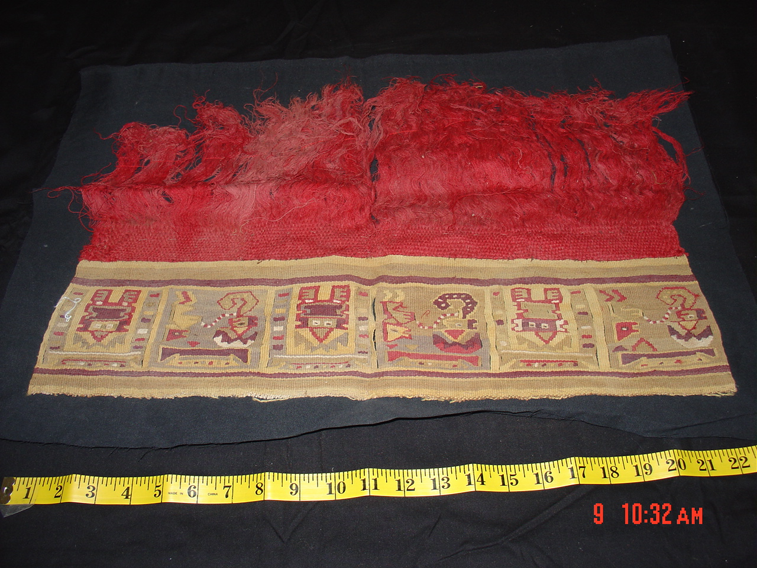

Item number 019

(Textile fragment 35 x 54 cm) The multi-colored tapestry-woven section at the top depicts alternating scenes of figures within architectural forms. The vivid red fringe may be camelid.

