General Services Administration
Washington, DC 20405
APD 2800.12B, CHGE 1
September 30, 1999
GSA ORDER
Subject: General Services Administration Acquisition Manual (GSAM)
1. Purpose. This order transmits a revision to the General Services Administration Acquisition Manual.
2. Background. This change:
a. Updates requirements for the Contracting Officers Warrant Program to reflect courses in the Governmentwide acquisition training contracts issued by GSA.
b. Clarifies appropriate use of the Governmentwide commercial purchase card as a payment method.
c. Extends the date of GSA's direct 8(a) contracting authority to January 1, 2000, under an extension to the Memorandum of Understanding (MOU) between GSA and the Small Business Administration (SBA).
d. Deletes guidance that duplicates the FAR.
e. Removes reproductions of forms available on-line.
3. Effective date. October 1, 1999.
4. Explanation of changes.
a. Section 501.6, Career Development, Contracting Authority, and Responsibilities, is revised to reflect course titles in the Governmentwide acquisition training contracts issued by GSA and to update course equivalencies.
b. Section 513.301, Governmentwide commercial purchase card, clarifies use of the Governmentwide commercial purchase card as a payment method in procurement actions that exceed the micropurchase threshold.
c. Section 519.870-1, Authority and applicability, extends the date of GSA's direct 8(a) contracting authority to January 1, 2000.
d. Section 519.1102, Applicability, deletes the exclusion for multiple award schedule contracts from price evaluation adjustment requirements. FAR 19.1102(b) now incorporates this exclusion.

Distribution: SPC 4048 Attachment
APD 2800.12B, CHGE 1
e. Section 553.3, Illustrations of Forms, is revised to update the list of forms available on-line and to delete the reproductions of Standard Form 2, U.S. Government Lease for Real Property, and GSA Form 3626, U.S. Government Lease for Real Property (Short Form), which are available on-line.
5. Filing instructions. Remove and insert the following pages to the GSAR:
Remove pages Insert pages
A-13 thru A-20 same
C-1 thru C-2 same
D-15 thru D-16 same
D-23 thru D-24 same
Subchapter H Table of Contents, v same
H-137 thru H-138 same
H-139 thru H-140 none
H-181 thru H-182 same
H-183 thru H-184 none

Ida M. Ustad
Deputy Associate Administrator
for Acquisition Policy

(v) Course tests must be administered by a GSA test control officer and scored by the Office of Acquisition Policy (MV). Instructors may not serve as test control officers for the same course. A current list of GSA test control officers is contained on GSA Insite at: http://insite.gsa.private/acqwork.
(3) Employees who complete courses in the Governmentwide acquisition curriculum from sources other than contractors on the Federal Supply Service acquisition training contract or an accredited college or university are cautioned that such courses may not be eligible for college credit unless the training organization has received a positive credit recommendation from American Council of Education. This includes training provided by designated GSA employees.
(4) The minimum training requirements apply to all contracting officers appointed on or after the date when the Governmentwide acquisition courses become available.
(i) Individuals holding a permanent warrant issued before the Governmentwide acquisition courses became available are not required to take additional training, other than the training required for continuing education. However, such contracting officers should give priority to completing any new COWP training requirements in fulfilling the continuing education requirement.
(ii) Individuals holding an interim warrant issued before the Governmentwide acquisition curriculum became available must complete the new training requirements prior to receiving a permanent warrant. A training course received before availablity of the Governmentwide curriculum may be used to satisfy a new course requirement if it meets both of the following conditions: the interim warrant holder completed and received training credit from GSA for the course before availability of the Governtwide acquisition curriculum, and the course is accepted as equivalent to one of the new required training courses (see 501.603-2(f)).
(c) Minimum training requirements.
(1) Micro-Purchase level candidates must receive on-the-job orientation or formal training in simplified acquisition procedures. Personnel who have completed any of the following courses meet the requirement: Small Purchases/Schedule Contracts, Simplified Acquisitions, Introduction to Contracting, Interactive Customer Assistance CD-ROM micro-purchase training, GSA disk titled "GSA Purchase Card Program, IMPAC (VISA)."
(2) Basic level candidates for:
(i) Fleet manager warrants must complete the Basic Fleet Management Procurement course (40 hours).
(ii) Fleet sales warrants must complete only the Fleet Sales course (40 hours) when commercial contractors will conduct fleet sales.
GSAM
APD 2800.12B, 09-01-99 A-13

(iii) Building manager warrants must complete the COR Mentor training course in addition to other courses required at this warrant level. The COR Mentor is a self-paced, on-line training course available at: http://www.faionline.com.
(3) Candidates for warrants at the simplified acquisition, intermediate, or senior levels currently serving and classified in 1102 or 1170 positions or in positions whose primary responsibility involved contracting for an uninterrupted period of 3 years do not have to take the basic level courses.
(4) Personal property sales warrant candidates who are classified in 1104 positions, excluding marketing positions, for an uninterrupted period of 3 years are not required to take the Personal Property Utilization and Disposal course.
(5) Construction contracting officer representative (COR) candidates with authority:
(i) Limited to the issuance of change orders up to $25,000 must complete the COR Mentor training course (available at http://www.faionline.com) and Construction Contracting.
(ii) Above the basic level must complete all courses required at the higher level.
(6) TSR-issuer candidates must receive on-the-job orientation or formal training on the proper procedures for issuing TSRs and on the responsibilities and obligations of contracting officers.
(7) Contracting officers with dual warrant authority (e.g., with authority to dispose of and to acquire goods and services) must complete the mandatory training required for both types of warrant authority, based on the appropriate warrant level.
(8) Other warrant level training is outlined in Figure 501-1.
(d) Testing out of a course. [Reserved]

GSAM
A-14 APD 2800.12B, CHGE 1, 10-1-99

 |  | CONTRACTING OFFICER CATEGORIES |  |  |  |  | WARRANT LEVELS
Courses | Hrs | DP | DR |  | R | All other CO’s | B | SA | Int | Sr
Acquisition or Procurement Planning I | 40 |  |  |  |  |  |  |  | XI | XI
Simplified Acquisitions | 40 |  |  |  |  |  | X | XI
Contract Formation I | 40 |  |  |  |  |  |  |  | XI | XI
Contracting by Sealed Bidding | 40 |  |  |  |  |  |  |  | XI | XI
Contract Administration I | 40 |  |  |  |  |  |  | X | XI | XI
Price Analysis | 40 |  |  |  |  |  |  |  | XI | XI
Cost Analysis | 40 |  |  |  |  |  |  |  | XI | XI
Negotiation Techniques | 40 |  |  |  |  |  |  |  | X | XI
Acquisition or Procurement Planning II | 40 |  |  |  |  |  |  |  |  | X
Contract Formation II | 40 |  |  |  |  |  |  |  |  | X
Contract Administration II | 40 |  |  |  |  |  |  |  | X | XI
Contract Law | 40 |  |  |  |  |  |  |  | X | XI
Intermediate Contract Pricing | 40 |  |  |  |  |  |  |  | X | X
Contracting for Architect/Engineer Services | 40 |  |  |  |  |  |  |  | XI | XI
Construction Contracting | 40 |  |  |  |  |  |  |  | XI | XI
Federal Real Property Leasing or Basic Lease Contracting | 40 |  |  |  |  |  |  | X | XI | XI
Cost and Price Analysis of Lease Proposals | 40 |  |  |  |  |  |  |  | XI | XI
Real Estate Law or Federal Real Property Lease Law | 40 |  |  |  |  |  |  |  | X | XI
Real Estate Appraisal Principles | 40 |  |  |  |  |  |  |  |  | X
Techniques of Negotiating Federal Real Property Leases | 40 |  |  |  |  |  |  | X | XI | XI
Personal Property Sales | 80 |  |  |  |  |  | X | X | X | X
Personal Property Utilization & Disposal | 32 |  |  |  |  |  | X | X | X | X
Disposal by Negotiation | 24 |  |  |  |  |  |  |  | X | X
Disposal Contract Law | 40 |  |  |  |  |  |  |  |  | X
Utilization & Disposal of Real Property | 32 |  |  |  |  |  |  |  | X | X
Fleet Sales (fleet sales personnel only) | 40 |  |  |  |  |  |  |  |  | X
Indicates required courses |  |  |  | DP Personal property disposal contracting officer
Indicates the course is required only for personnel handling the type of contract addressed in the training |  |  |  | DR Real property disposal contracting officer  R Realty leasing contracting officer  B Basic warrant
X Means the course is required for a permanent warrant |  |  |  | SA Simplified acquisition warrant  Int Intermediate warrant
I Means the course is required for an interim warrant |  |  |  | Sr Senior warrant
Figure 501-1. Warrant Course Requirements
GSAM
APD 2800.12B, CHGE 1, 10-1-99 A-15

(e) Educational requirements. Effective January 1, 2000, applicants for permanent warrants above the simplified acquisition level must meet the stated education requirements prior to receiving a warrant. HCAs may, at their discretion, make this requirement effective prior to January 1, 2000. These requirements apply to all candidates for permanent warrants, regardless of job series.
(1) Applicants at grades 5 through 12. Applicants for permanent warrants above the simplified acquisition level, who are at grades 5 through 12, must either have completed a 4-year course of study leading to a bachelor's degree or have completed 24 semester hours in any combination of the designated fields.
(2) Applicants at grades 13 and above. Applicants for permanent warrants above the simplified acquisition level, who are at grade 13 or above, must have completed a 4- year course of study leading to a bachelor's degree that included or was supplemented by at least 24 semester hours in any combination of the designated fields. The Senior Procurement Executive may waive one, but not both, of these educational requirements (i.e., either the requirement for a 4-year course of study or the requirement for 24 semester hours in designated fields), for applicants at grades 13 and above. The applicant must demonstrate significant analytical and decision-making capabilities, an acceptable job performance record, and qualifying experience.
(3) The designated educational fields are:
(i) Accounting.
(ii) Business.
(iii) Finance.
(iv) Law.
(v) Contracts
(vi) Purchasing
(vii) Economics.
(viii) Industrial management.
(ix) Marketing.

GSAM
A-16 APD 2800.12B, CHGE 1, 10-1-99

(x) Quantitative methods.
(xi) Organization and management.
(f) Course equivalencies.
(1) For employees who completed training prior to availability of the Governmentwide core curriculum, the following is a list of the courses contained in the Governmentwide curriculum and the course equivalencies that GSA will recognize. GSA cannot guarantee that other Federal agencies will accept the same substitutes.
Governmentwide Curriculum Course | Equivalent GSA Course
Acquisition or Procurement Planning I | Introduction to Contracting plus  Procurement Planning
Acquisition or Procurement Planning II | No equivalent
Contract Formation I | Contracting by Negotiation
Contract Formation II | Source Selection
Contract Administration I | Contract Administration
Contract Administration II | Advanced Contract Administration plus  Contract Termination
Price Analysis | Price Analysis
Cost Analysis | Cost Analysis
Intermediate Contract Pricing | No equivalent
Contract Law | Contract Law
Negotiation Techniques | Negotiation Techniques

(2) GSA employees who have successfully completed a GSA approved course are not required to complete the equivalent course in the Governmentwide curriculum for warrant purposes in GSA. There are no GSA courses considered equivalent to Acquisition or Procurement Planning II, Intermediate Contract Pricing, or Contract Formation II.
(3) Acceptance of course equivalencies extends only to GSA-approved courses successfully completed prior to availability of the Governmentwide curriculum. Requests to consider course equivalencies for training taken thereafter will not be considered or approved.
(4) Employees who attended courses approved as course equivalencies, prior to availability of the Governmentwide curriculum, are not required to complete the corresponding
GSAM
APD 2800.12B, CHGE 1, 10-1-99 A-17

course in the Governmentwide curriculum. GSA Insite at: http://insite.gsa.private/acqwork contains a list of course equivalencies for GSA courses.
(5) Employees are cautioned that GSA's determination concerning the acceptability of GSA-approved courses is not binding on other Federal agencies. Employees who wish to qualify for senior 1102 positions in other Federal agencies may want to complete the courses contained in the Governmentwide core curriculum, as fulfillment of the mandatory training requirements for 1102 positions at grades 13 and above, to ensure acceptability across Government.
501.603-3 Appointment.
(a) Authority to make micro-purchases or issue TSR's.
(1) HCAs may authorize division directors or higher level officials to delegate contracting authority to employees to:
(i) Make purchases not to exceed $2,500 (micro-purchases).
(ii) Issue TSRs for tariff services on, or in conjunction with, existing telephone systems, to regulated local exchange telephone companies.
(Officials so designated by the HCA may not redelegate their authority.)
(2) Memoranda delegating authority to issue TSRs must state that the authority does not apply to Rate Stabilization Plans or orders for new Centrex service on a site level basis, except for new locations that require interim, temporary, small or emergency service.
(3) Branch chiefs or equivalent or Regional FTS Program Support Branch Chiefs may request delegations of contracting authority for issuing TSRs. The memorandum requesting appointment must include all the following:
(i) Candidate's name, title, and organizational location.
(ii) Brief explanation of why authority is needed.
(iii) Brief description of the candidate's qualifications.
(iv) Statement that the candidate has received the required training.
(b) Authority to make other purchases.
(1) Nominations for appointment.
(i) The chairperson of COWB, or other designee established by the HCA, submits nominations for appointment.
GSAM
A-18 APD 2800.12B, CHGE 1, 10-1-99

(ii) Nominations are submitted on GSA Form 3410, Request for Appointment and must be accompanied by one of the following: a GSA Form 3409, Personal Qualifications Statement for Appointment as a Contracting Officer; a Standard Form 171, Personal Qualifications Statement, prepared and signed by the candidate; or a resume detailing the candidate's experience, education, and training relevant to the position.
(2) Certificate of Appointment.
(i) HCA's appoint contracting officers at the basic, simplified acquisition, intermediate, or senior level using Standard Form 1402, Certificate of Appointment. Appendix 501A provides suggested language for use in preparing SF 1402's. The examples shown in Appendix 501A are not meant to limit the issuance of warrants to only those contained in the Appendix.
(ii) The HCA gives the original Certificate of Appointment to the appointed contracting officer for display at his or her duty station.
(3) Types of appointments. Candidates are nominated for either an interim or permanent appointment.
(i) Interim appointments. Interim appointments are for a specified period of time. Personnel who hold interim simplified acquisition warrants must complete all training required for a permanent warrant within 1 year of the interim appointment. Personnel who hold interim warrants above the simplified acquisition level must complete all training and formal education required for a permanent warrant within 3 years of the interim appointment. A candidate for an interim warrant must have completed all courses required for an interim warrant and have the necessary experience prior to appointment.
(ii) Permanent appointments. A permanent appointment is made to a candidate who meets all requirements for experience, education, and training at the time the appointment is made. Permanent appointments may be made for a specified period if the need for contracting authority is limited to that time period.
(c) Training required for continued appointment for other than micro-purchase, TSR, or interim warrants.
(1) To maintain competency, you must complete formal or informal acquisition-related training as follows. The training may be accomplished through completion of a training class or through any of the examples cited in 501.603-3(c)(2) below.
(i) 16 hours every two years (for basic or simplified acquisition level warrants).
(ii) 40 hours every 2 years (for intermediate or senior level warrants).
GSAM
APD 2800.12B CHGE 1, 10-1-99 A-19

(2) To meet this requirement, you may attend:
(i) In-house training sessions.
(ii) Courses designed to broaden procurement knowledge (e.g., Contract Quality Assurance, Evaluating Contractor Performance, Alternative Dispute Resolution Procedures), including repeat courses taken for refresher training.
(iii) Courses related to procurement (e.g., Ethics, Standards of Conduct).
(iv) Lectures, seminars, or conferences conducted by nationally-recognized acquisition organizations or professional associations (e.g., National Contract Management Association, National Institute of Governmental Purchasing) or write papers or articles for these groups.
(v) Training to acquire knowledge of the product or service you are responsible for procuring (i.e., courses and in-house training sessions; attending contractor sponsored seminars, conferences, and trade shows; and site visits to a contractor's place of manufacture/performance to learn about manufacturing/operations processes).
(3) If you successfully complete a professional certification program offered by a nationally-recognized acquisition organization such as NCMA, NIGP, NAPM, or equivalent organization, you fulfill the continuing education requirements for contracting officers for a period of 3 years. The 3-year period begins on the effective date of your professional certification.
(d) Authority to make purchases for domestic and national security emergencies.
(1) If you have already been appointed as a contracting officer, you may enter into contracts on behalf of a GSA organization different from the organization specified in your Certificate of Appointment in response to a domestic or national security emergency (see GSA Order, National Emergency Management Program (ADM P 2400.18)).
(2) An HCA may grant higher contracting authority for use during emergencies in a basic or intermediate warrant.
(3) An HCA may appoint contracting officers with authority limited to entering into contracts required to respond to domestic or national security emergencies.
501.603-4 Termination.
(a) An appointing official may terminate your appointment at any time. Return the terminated warrant document to the appointing official if your appointment is terminated. At the HCA's discretion, a contracting officer whose appointment is terminated may retain the original warrant certificate.
GSAM
A-20 APD 2800.12B, CHGE 1, 10-1-99

SUBCHAPTER C--CONTRACTING METHODS AND CONTRACT TYPES
PART 513 SIMPLIFIED ACQUISITION PROCEDURES
513.003 Policy.
When you use an oral solicitation for an action over the micro-purchase threshold and the Service Contract Act applies, provide information on the Act and the applicable wage determination to potential contractors as part of the oral solicitation.
513.1 PROCEDURES
513.106-1 Soliciting competition.
(a) “Urgency”, as used in FAR 13.106-1(a)(1)(iii) and 13.106-1(b), includes situations which, if not corrected immediately, will result in unnecessary expenditure of funds, property damage, personal injury, or interruption of agency functions.
(b) To avoid unnecessarily restricting competition for urgent requirements, consider the following actions:
(1) Inviting prospective offerors to visit the site.
(2) Informing them orally of the exact requirements.
(3) Requesting them to prepare quotations.
513.106-3 Award and documentation.
(a) File documentation and retention. You may use GSA Form 2010, Small Purchase Tabulation Source List/Abstract, to document written and oral quotations.
(b) Special situations. Document the basis for rejecting a lower quotation if quotes or offers were evaluated based on price alone.
SUBPART 513.3 SIMPLIFIED ACQUISITION METHODS
513.301 Governmentwide commercial purchase card.
(a) GSA Order, Interim Guidance on Use of the Governmentwide Commercial Purchase Card Service (OAD 4200.8), establishes procedures for using the Governmentwide commercial purchase card to make purchases and payments.
GSAM
APD 2800.12B, CHGE 1, 10-1-99 C-1

(b) When you use the Governmentwide commercial card for a procurement that exceeds the micropurchase threshold, the card is a payment method. All procedures and documentation requirements that apply over the micropurchase threshold apply to the procurment action.
513.302 Purchase orders.
513.302-70 Purchase order and related forms.
(a) See GSA Order, Interim Guidance on Use of the Governmentwide Commercial Purchase Card Service (OAD 4200.8), for forms required for purchase card actions.
(b) Use GSA Form 300 or 300-1 (pin-feed format), Order for Supplies and Services, instead of OF 347, Order for Supplies or Services, when making purchases payable through the National Electronic Accounting and Reporting (NEAR) System.
(1) This form may also be used to make other purchases when a specific form is not prescribed. It may be used as a delivery or task order instead of SF 1449, Solicitation/Contract/Order for Commercial Items.
(2) Prepare and process GSA Form 300 following the instructions at 553.370-300-I. Use GSA Form 300A or 300-A(1) (pin-feed format), order for Supplies or Services (continuation), if additional space is needed.
(c) Use GSA Form 1458, Motor Vehicle Shop Work Order, Repair and Purchase Order, instead of the OF 347 when making purchases in connection with the maintenance, servicing or repair of GSA fleet management vehicles.
(d) Use GSA Form 3186, Order for Supplies or Services or GSA Form 3186-B, Order for Supplies or Services (EDI), instead of OF 347, Order for Supplies or Services, when making simplified acquisitions or placing orders against established contracts through the FSS-19 system.
(1) Use GSA Form 3186 for mail orders placed against established contracts.
(2) Document the file for a delivery, task, or purchase order transmitted to contractors electronically using Electronic Data Interchange (EDI) procedures by generating a GSA Form 3186-B.
(e) Use GSA Form 8002B, Motor Vehicle Delivery Order, to order fleet management vehicles. Do not use this form as a purchase order for simplified acquisitions. Use GSA Form 8002A to notify the consignee of the status of motor vehicle requisitions.
(f) The contracting director is responsible for safeguarding books of Standard Form 44’s and establishing procedures to account for purchases. Do not authorize use of this form if the seller’s accounting system requires production of an invoice as a matter of routine. Consider other authorized methods, giving preference to use of the Governmentwide commercial purchase card.
GSAM
C-2 APD 2800.12B, CHGE 1, 10-1-99

SUBPART 519.8 CONTRACTING WITH THE SMALL BUSINESS ADMINISTRATION (THE 8(a) PROGRAM)
519.803 Selecting acquisitions for the 8(a) program.
519.803-70 Contracting officer evaluation of recommendations for 8(a) set-aside(s).
(a) If you disagree with a recommendation by the Associate Administrator for Enterprise Development or the SBTA to set aside a procurement for award under the 8(a) program, discuss the matter with the official who made the recommendation. If you decide not to award the contract under the 8(a) program, forward a copy of the documentation required by FAR 19.202-1(e)(4) to the Office of Enterprise Development (E) within 10 working days.
(b) Once a contracting activity acquires a product or service successfully on the basis of an 8(a) set-aside, the activity must acquire all future requirements for that product or service using 8(a) set-aside procedures. If you determine that acquiring the product or service as an 8(a) set-aside is no longer in the Government's best interest, use the procedures in FAR 19.506 to withdraw a repetitive set-aside.

GSAM
APD 2800.12B, 09-01-99 D-15

519.803-71 Withdrawing or modifying 8(a) set-asides.
If you and the SBTA disagree over the withdrawal or modification of a set-aside, the SBTA must notify the Associate Administrator for Enterprise Development at the same time the matter is referred to the SBA PCR.
519.870 Direct 8(a) contracting.
519.870-1 Authority and applicability.
(a) Under a May 6, 1998, Memorandum of Understanding (MOU) between GSA and SBA, SBA delegated to GSA its authority under Section 8(a)(1)(a) of the Small Business Act to enter into prime contracts and Section 8(a)(1)(B) to subcontract the performance of the contracts to eligible 8(a) participants. To implement the MOU, GSA obtained a class deviation to the Federal Acquisition Regulation (FAR) permitting direct 8(a) contracting. This authority is effective through January 31, 2000.
(b) The delegation streamlines the acquisition process for requirements not exceeding the simplified acquisition threshold (SAT) by eliminating offering letters and acceptance letters. For acquisitions over the SAT, this delegation expedites the contracting process by shortening the period of SBA's acceptance of the requirement for the 8(a) program from 15 working days to 5 working days, and eliminating the requirement for multiple copies of the award document, SBA's signature, and the tripartite agreement.
(c) This authority applies to all 8(a) acquisitions conducted by FSS, FTS, and PBS. It does not apply to FSS’s multiple award schedule program.
519.870-2 Acquisitions at or under the SAT.
(a) For acquisitions over the micropurchase threshold but not over the SAT, use the simplified acquisition procedures of FAR Part 13 to issue purchase orders or contracts to 8(a) participants.
(b) You are not required to send offering letters to, nor obtain acceptance letters from, SBA.
(c) Use PRO-Net to establish that the selected 8(a) firm is a current program participant.
(d) Establish the price with the selected 8(a) firm and prepare and issue a purchase order or contract in accordance with FAR Part 13.
(e) Forward to the SBA District Office serving the 8(a) firm a copy of the purchase order or contract within 5 days after the order is issued.
519.870-3 Acquisitions exceeding the SAT.
(a) In addition to the requirements of FAR 19.804-2, the offering letter must:
GSAM
D-16 APD 2800.12B, CHGE 1, 10-1-99

519.1006-73 Procurement procedures for solicitations issued on or after February 1, 1999.
(a) Construction or trash/garbage collection services with an estimated value of $25,000 or less and procurement of A-E services with an estimated value of $50,000 or less. Follow the procedures in 519.1006-71 for these procurements.
(b) Procurements above the reserve levels in 519.1006-71(a). Use the following procedures for construction or trash/garbage collection services estimated to exceed $25,000 and A-E services estimated to exceed $50,000.
(1) Construction services in SIC Groups 15, 16, and 17.
(i) Contracting activities in Region 4, 7, and 9 must set-aside for small business procurements for construction services in SIC group 15 when there is a reasonable expectation of obtaining competition from two or more small businesses. If no such expectation exists, you may conduct the procurement on an unrestricted basis.
(ii) All Regions other than 4, 7, and 9 must procure construction services in SIC group 15 on an unrestricted basis.
(iii) All Regions must procure construction services in SIC groups 16 and 17 on an unrestricted basis.
(2) Trash/garbage collection services in PSC S205.
(i) Contracting activities in Regions 4 and 6 must be set aside for small business procurements for trash/garbage collection services when there is a reasonable expectation of obtaining competition from two or more small businesses. If no such expectation exists, you may conduct the procurement on an unrestricted basis.
(ii) All other Regions must procure these services on an unrestricted basis.
(3) Architect-Engineer services (all PSC codes under the Program).
(i) Contracting activities in Regions 2, 4, 7, 10, and the National Capitol Region must set aside for small business A-E procurements when there is a reasonable expectation of obtaining competition from two or more small businesses. If no such expectation exists, you may conduct the procurement on an unrestricted basis.
(ii) All other Regions must procure A-E services on an unrestricted basis.

GSAM
APD 2800.12B, 09-01-99 D-23

519.11 PRICE EVALUATION ADJUSTMENT FOR SMALL DISADVANTAGED BUSINESS CONCERNS
519.1102 Applicability.
In addition to the exceptions listed in FAR 19.1102(b), the price evaluation adjustment (PEA) does not apply to:
(a) Acquisitions of leasehold interests in real property.
(b) Orders placed under a Federal Supply Schedule.
519.1103 Procedures.
(a) Decision chart. Appendix 519B provides a decision chart to help you determine whether a PEA applies and how to apply it to a specific acquisition. Appendix 519C provides examples of how to apply both the PEA and the HUBZone price evaluation preference.
(b) Total contract amount. The PEA applies across the total contract amount, not just that portion proposed to be performed by the small business concern. For example, if the small business concern proposes to perform 80% of the work and subcontract 20% to large business concern, then the 10% adjustment applies to 100%.
(c) Single and multiple awards. Apply the PEA to each group of items on which you will make award. That is, if you will make one award, the PEA applies to 100% of the items. If you will make more than one award, the PEA applies to each group where the predominant SIC code and region, if applicable, is listed. Add other evaluation factors (e.g., transportation costs or rent-free use of Government facilities) to the offers before applying the PEA.
(d) Industries eligible by region. In a SIC major group authorized by region, the offeror’s address governs whether the PEA applies (i.e., not the place of performance or contract office location).
(e) Example. The following provides an example of how to apply the PEA. Assume you have an acquisition affected by the PEA and the PEA is 10%. You receive two offers; one from an SDB, and one from a non-SDB (e.g., a small or other than small business concern). The SDB’s price for the acquisition is $105,000, while the non-SDB's price is $100,000. You apply the PEA of 10% to the non-SDB’s price, making the evaluated price $110,000. The SDB wins the award because its price of $105,000 is less than the non-SDB’s evaluated price of $110,000. Note that you must still determine that the price ($105,000) proposed for award is considered fair and reasonable under the guidelines in FAR 15.404-1(b). Also note that the PEA does not necessarily apply to all other offerors (see FAR 19.1103(a)).

GSAM
D-24 APD 2800.12B, CHGE 1, 10-1-99

553.3 Illustrations of Forms
553.300 Scope of subpart.
553.300-70 Forms not illustrated.
553.370-300-I Instructions for using the GSA Form 300, Order for Supplies and
Services.
553.370-353-I Instructions for Completing GSA Form 353, Performance Evaluation & Facilities Report (PEFR).
553.370-618D GSA Form 618D, Statement to be Submitted When Work is
Performed Personally.
553.370-1378 GSA Form 1378, Record of, and Receipt for, Bids and Responses.
553.370-1458 GSA Form 1458, Motor Vehicle Shop Work Order, Repair and
Purchase Order.
553.370-1535A GSA Form 1535A, Recommendation for Award(s) (Continuation).
553.370-1602 GSA Form 1602, Notice Concerning Solicitation.
553.370-1678 GSA Form 1678, Status Report of Orders and Shipments.
553.370-1720 GSA Form 1720, Request for Release of Classified Information to U.S. Industry.
553.370-1766 GSA Form 1766, Structured Approach Profit/Fee Objective.
553.370-2689 GSA Form 2689, Procurement Not Set Aside.
553.370-2728 GSA Form 2728, Procurement Contract Register.
553.370-3186 GSA Form 3186, Order for Supplies or Services.
553.370-3186B GSA Form 3186B, Order for Supplies or Services (EDI).
553.370-3410 GSA Form 3410, Request for Appointment.
553.370-3471 GSA Form 3471, Abstract of Offers.
553.370-3521 Blanket Purchasing Agreement
553.370-3577 GSA Form 3577, Notice to Unsuccessful Offeror of Contract Award.
553.370-3521 Blanket Purchase Agreement
553.370-3611 GSA Form 3611, Cover Page Source Selection Information.
553.370-8002A GSA Form 8002A, Motor Vehicle Requisition Status.
553.370-8002B GSA Form 8002B, Motor Vehicle Delivery Order.

GSAM
APD 2800.12B, CHGE 1, 10-01-99 v

PART 553 FORMS
SUBPART 553.1 GENERAL
553.101 Requirements for use of forms.
Parts 501-552 and 570 prescribe the requirements for use of GSA forms illustrated or referenced in this part. You may identify the prescription as follows:
(a) Forms available on-line. The list of forms available on-line in 553.370-1 identifies the basic prescription for each referenced form.
(b) Illustrated forms. The prescription for each illustrated form is identified by a cross-reference shown on the illustration. When a form is mentioned in more than one place in this regulation, the section referenced on the illustration is the section that contains the basic prescription.
553.102 Current editions.
You must use the current edition of the forms identified in Subpart 553.3 unless otherwise authorized under this regulation.
553.170 Establishing and revising GSA Forms.
(a) If two or more GSA Services or Offices use a GSA form, the Office of Acquisition Policy maintains the form.
(b) If only one GSA Service or Office uses a GSA form or if the form is used for a contract type unique to one Service or Office (e.g., construction contracts), that Service or Office is responsible for maintaining the form.
(c) Any proposed new or revised GSA acquisition related form must be submitted to the Office of Acquisition Policy for review and concurrence.
SUBPART 553.3 ILLUSTRATIONS OF FORMS
553.300 Scope of subpart.
This subpart illustrates standard and GSA forms prescribed or referenced in Parts 501-551 and 570. Instructions on completing a form, if included, are identified by the suffix "I" after the GSAR section number.

GSAM
APD 2800.12B, 09-01-99 H-137
553.300-70 Forms not illustrated.
This subpart does not illustrate either:
(a) Standard forms illustrated in the FAR.
(b) Forms available on-line. You can access the forms listed below at the location indicated.
Reference | Form No. | Title | On-line Location
570.701 | Standard Form 2 | U.S. Government Lease for Real Property | http://www.gsa.gov/pbs/pe/stancla/stancla.htm
552.238-74 | GSA Form 72A | Contractor's Report of Sales | http://vsc.gsa.gov
570.702(b) | GSA Form 276 | Supplemental Lease Agreement | http://www.gsa.gov/forms
513.302-70(b) | GSA Form 300 | Order for Supplies and Services | http://www.gsa.gov/forms
513.302-70(b)(2) | GSA Form 300A | Order for Supplies and Services (Continuation) | http://www.gsa.gov/forms
509.106-2 | GSA Form 353 | Performance Evaluation & Facilities Report | http://www.gsa.gov/forms
509.105-1(a) | GSA Form 527 | Contractor's Qualifications and Financial Information | http://www.gsa.gov/forms
532.905-71(a) | GSA Form 1142 | Release of Claims | http://www.gsa.gov/forms
570.702(c) | GSA Form 1364 | Proposal to Lease Space | http://www.gsa.gov/forms
514.407-72 | GSA Form 1535 | Recommendation for Award(s) | http://www.gsa.gov/forms
513.106(c)(2) | GSA Form 2010 | Small Purchase Tabulation Source List/Abstract | http://www.gsa.gov/forms
532.905-70 | GSA Form 2419 | Certification of Progress Payments Under Fixed-Price Construction Contracts | http://www.gsa.gov/forms
501.603-3(b)(1) | GSA Form 3409 | Personal Qualifications Statement for Appointment as Contracting Officer | http://www.gsa.gov/forms
504.803(b) | GSA Form 3420 | Contract/Modification File Checklist File Format (Award) | http://www.gsa.gov/forms
503.104-5 | GSA Form 3617 | Record of Authorization of Access to Proprietary or Source Selection Information | http://www.gsa.gov/forms
570.702(a) | GSA Form 3626 | U.S. Government Lease for Real Property (Short Form) | http://www.gsa.gov/pbs/pe/stancla/stancla.htm

(Next page is H-141) GSAM
H-138 APD 2800.12B, CHGE 1, 10-1-99
553.370-3577 Notice to Unsuccessful Offeror of Contract Award.

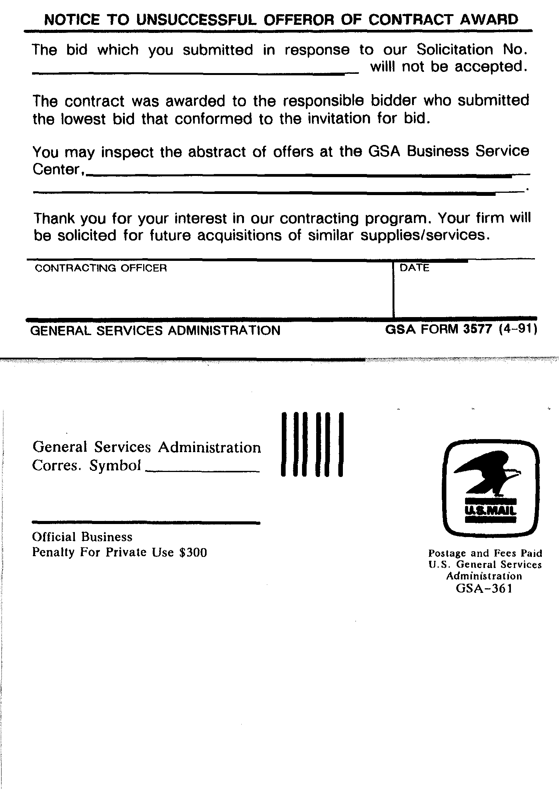
GSAM
APD 2800.12B, 9-01-99 H-181
[514.409-1]
553.370-3611 Cover Page Source Selection Information.
[503.104-5(b)(1)]

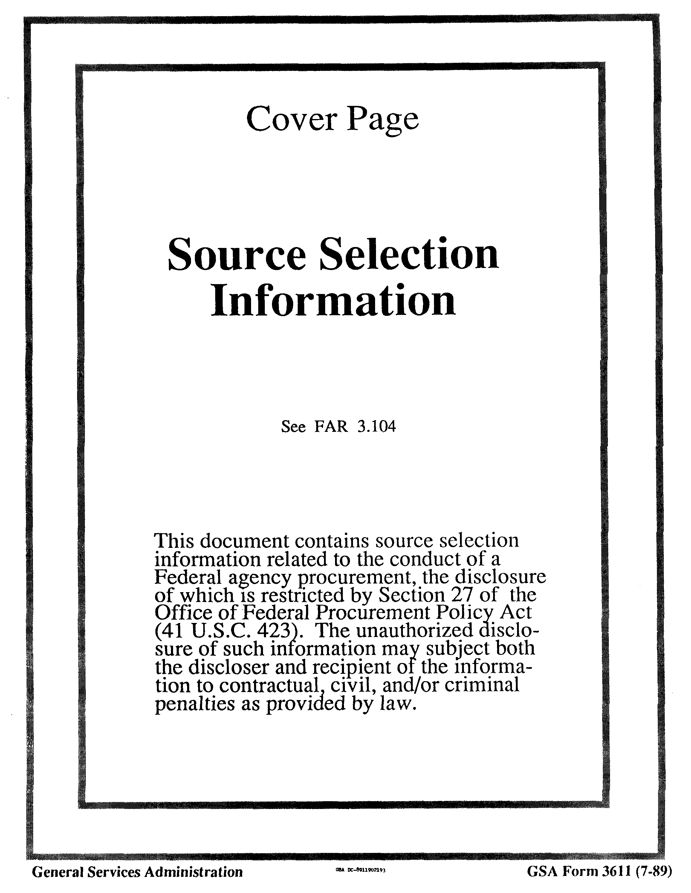(Next page is H-185) GSAM
H-182 APD 2800.12B, CHGE 1, 10-1-99

