Anatomy of an ARC Series Description

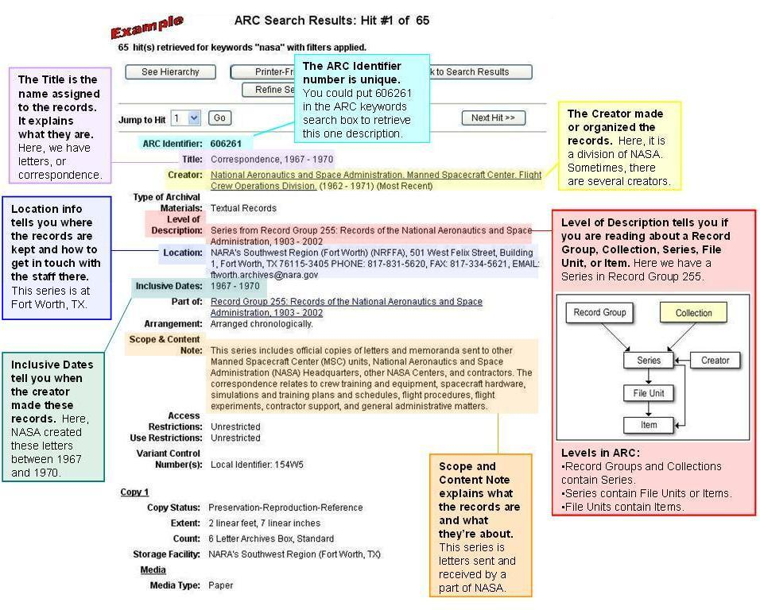



Visit the National Archives’ Archival Research Catalog (ARC) online:
http://www.archives.gov/research/arc/

