Tropical Cyclone Report
Unnamed Subtropical Storm
4-5 October 2005

Jack Beven and Eric S. Blake
National Hurricane Center
10 April 2006

As part of its routine post-season review, the Tropical Prediction Center/National Hurricane Center (TPC/NHC) on rare occasions identifies from new data or meteorological interpretation a previously unnoted tropical or subtropical cyclone. The TPC/NHC re-analysis of 2005 has revealed a short-lived subtropical storm near the Azores Islands, which increases the record count of tropical/subtropical storms during 2005 to 28.

- Synoptic History

An upper-level low formed just west of the Canary Islands on 28 September and moved generally westward for the next two days. A large but transient burst of convection developed near the low on 30 September, accompanied by the formation of a surface trough. The complex system moved generally westward to west-northwestward into a more unstable air mass, which allowed sporadic convection to develop. Surface observations and satellite cloud-motion winds indicate a broad surface low formed within the trough late on 3 October about 400 n mi southwest of São Miguel Island in the Azores. Convection increased in association with the surface low, and it is estimated that the system became a subtropical depression around 0600 UTC 4 October (Table 1 and Figure 1).

The depression turned northeastward in the warm sector ahead of an approaching cold front associated with a large non-tropical low northwest of the Azores. Additional development occurred, and it is estimated that the cyclone became a subtropical storm around 1200 UTC 4 October. The system reached an estimated peak intensity of 45 kt as the center passed through the eastern Azores later that day. The cyclone turned north-northeastward and merged with the approaching cold front early on 5 October. Late that day, the remains of the subtropical storm were absorbed by the non-tropical low. That low would evolve into Hurricane Vince a few days later.

- Meteorological Statistics

Observations in the subtropical cyclone (Figs. 2 and 3) include satellite-based Hebert-Poteat technique intensity estimates from the Tropical Analysis and Forecast Branch (TAFB) and the Satellite Analysis Branch (SAB), along with surface observations from the Azores and nearby ships. Microwave satellite imagery from NOAA polar-orbiting satellites and the NASA QuikSCAT satellite were also useful in tracking this system.

There are several pieces of evidence suggesting that this system had enough tropical characteristics to be considered a subtropical storm instead of a non-tropical low. The first is cloud patterns resembling those used in the subtropical cyclone intensity estimates of the Hebert-Poteat technique, which reflects that the system had sufficiently organized convection (Fig. 4). A second is the non-frontal nature of the surface low as depicted on TAFB surface analyses (not shown). Additionally, surface data in the Azores did not reveal any significant temperature changes from the passage of the cyclone, as all observed temperature changes in the area occurred west of the cold front. The final piece is data from the Advanced Microwave Sounding Unit (AMSU) on the NOAA polar-orbiting satellites. Figure 5 shows AMSU temperature imagery at 1517 UTC 4 October. Both the channel 5 image (corresponding to approximately 550 mb) and the channel 7 image (corresponding to approximately 200 mb) show a warm core, with the strongest signal in the channel 5 image.

The presence of the warm core at 200 mb suggests the possibility that the storm may have become fully tropical. However, the warm core is indistinct in channel 8 imagery (corresponding to approximately 100 mb; not shown), and satellite cloud-motion winds (not shown) indicate the presence of an upper-level trough over the storm near the time of peak intensity rather than the upper-level anticyclone that would be expected for a tropical cyclone. Additionally, the radius of maximum winds based on surface observations was large, about 75 n mi. These factors argue in favor of a subtropical rather than a tropical classification.

There were no ship reports of gale-force winds from this system. However, a ship with the call sign VRZN9 reported a pressure of 999 mb and 22-kt winds at 1800 UTC 4 October.

This system brought gale-force winds to the eastern portions of the Azores Islands. Santa Maria Island reported a 10-min average wind of 43 kt at 2100 UTC 4 October with a peak gust of 51 kt. The station reported a minimum pressure of 1006 mb at that time. Ponta Delgada on São Miguel reported 10-min average winds of 33 kt at 2230 UTC 4 October with a gust to 46 kt. The station reported a minimum pressure of 999 mb at 2100 UTC that day.

- Casualty and Damage Statistics

There were no reports of damage or casualties associated with this system.

- Forecast and Warning Critique

No official forecasts were issued for the subtropical storm, thus no verification is available. Operationally, it was treated as a non-tropical low. Post-storm analysis, including AMSU data that were not available in real time, indicated that the system had sufficient tropical cyclone characteristics to be considered a subtropical storm for 12-18 h.

Acknowledgements

Derrick Herndon and Chris Velden of the Cooperative Institute of Meteorological Satellite Studies at the University of Wisconsin provided post-storm analysis satellite data. David Roth of the Hydrometeorological Prediction Center in Washington, DC, also provided useful information on the system.

Table 1. Best track for the unnamed Subtropical Storm, 4-5 Oct 2005.
Date/Time  (UTC) | Latitude  (°N) | Longitude  (°W) | Pressure  (mb) | Wind Speed  (kt) | Stage
04 / 0000 | 33.8 | 31.8 | 1012 | 30 | low
04 / 0600 | 34.8 | 30.2 | 1009 | 30 | subtropical depression
04 / 1200 | 35.9 | 28.5 | 1004 | 35 | subtropical storm
04 / 1800 | 37.1 | 26.7 | 997 | 45 | "
05 / 0000 | 38.8 | 25.0 | 997 | 45 | "
05 / 0600 | 41.0 | 23.3 | 1000 | 40 | extratropical
05 / 1200 | 43.6 | 23.0 | 1002 | 40 | "
05 / 1800 |  |  |  |  | absorbed by larger low
04 / 1800 | 37.1 | 26.7 | 997 | 45 | minimum pressure

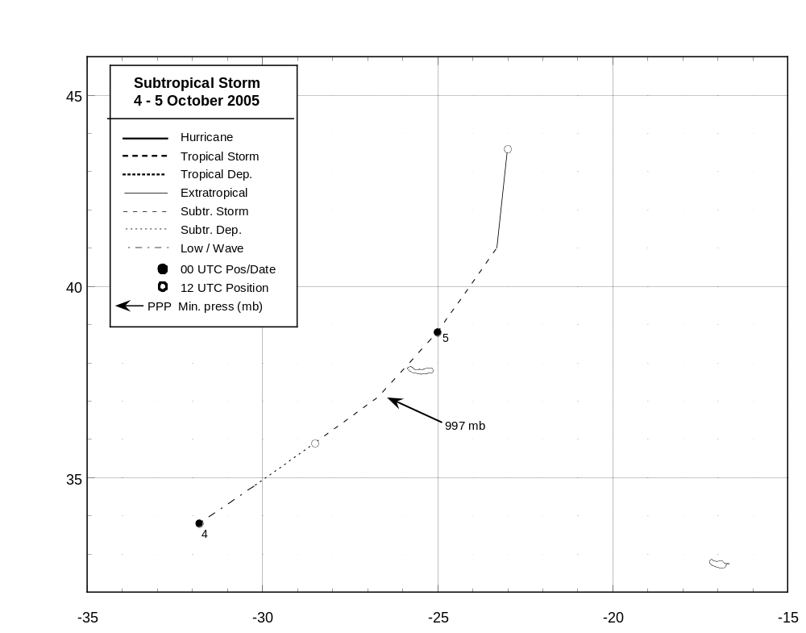
Figure 1. Best track positions for the unnamed subtropical storm, 4-5 October 2005.
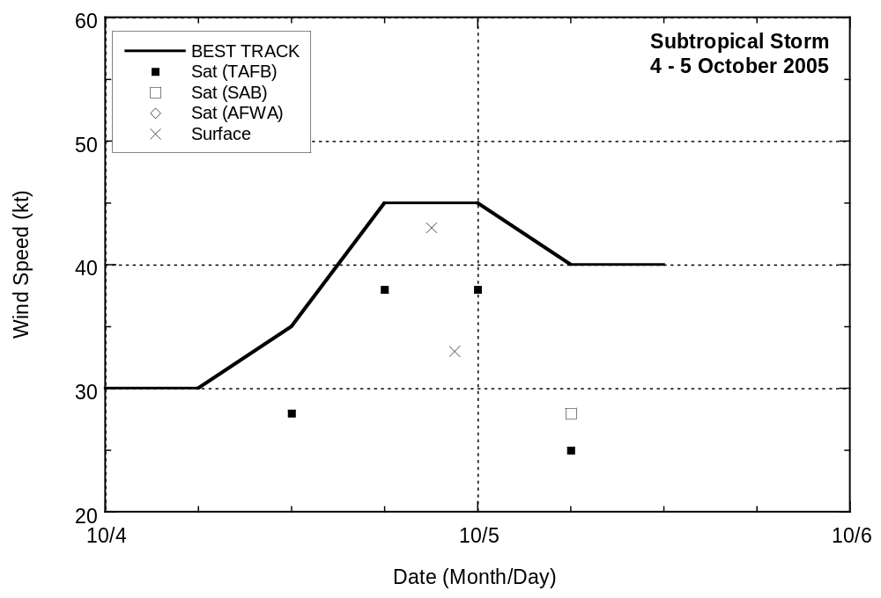
Figure 2. Selected wind observations and best track maximum sustained surface wind speed curve for the unnamed subtropical storm, 4-5 October 2005.
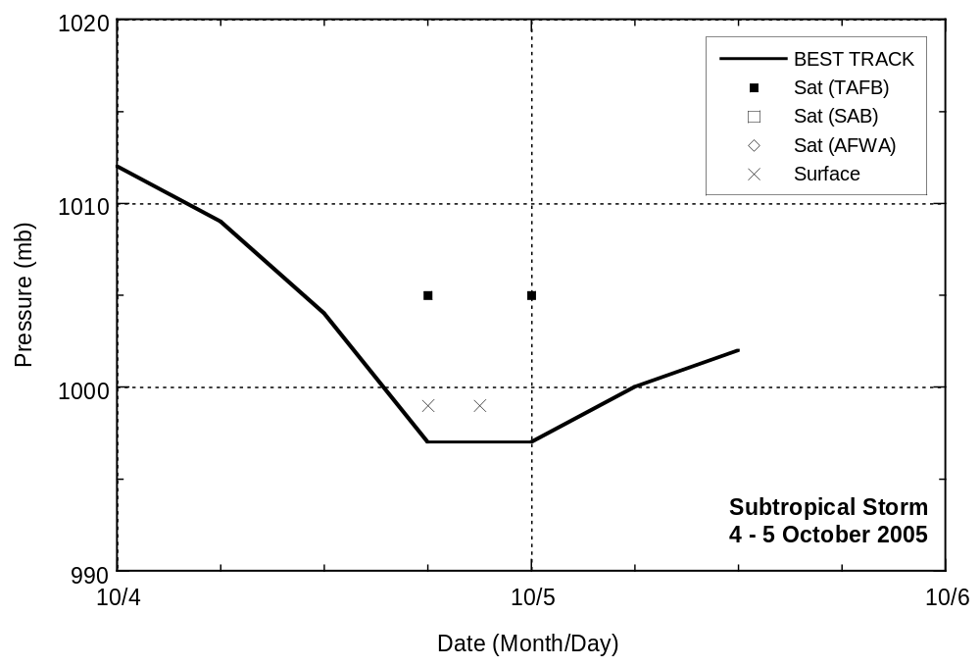
Figure 3. Selected pressure observations and best track minimum central pressure curve for the unnamed subtropical storm, 4-5 October 2005.
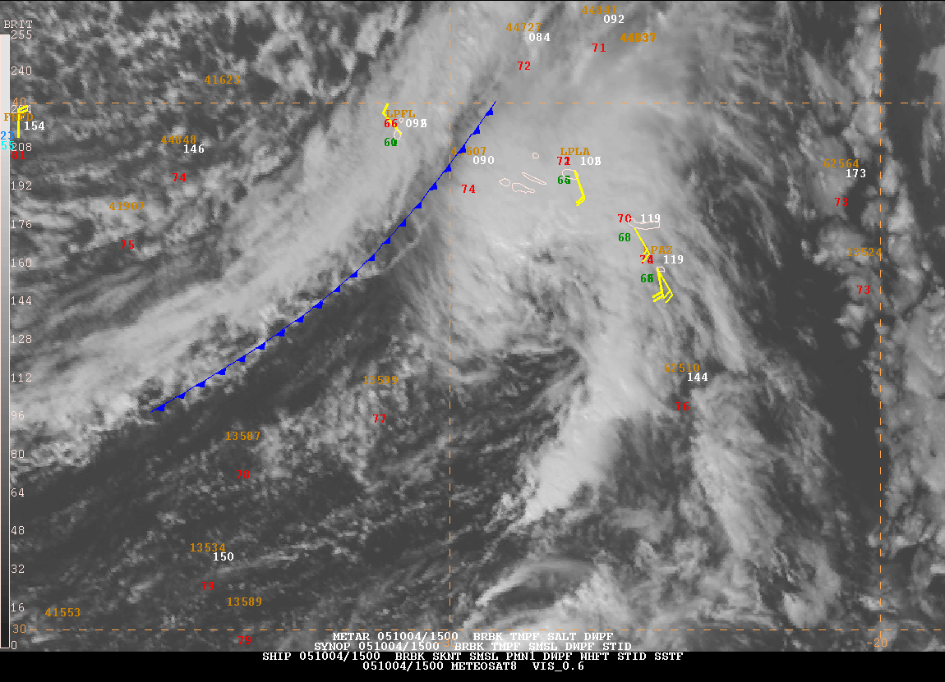
Figure 4. METEOSAT-8 visible image of the unnamed subtropical storm at 1500 UTC 4 October.
Surface observations are overlaid on the satellite imagery, and a cold front is analyzed to the west.
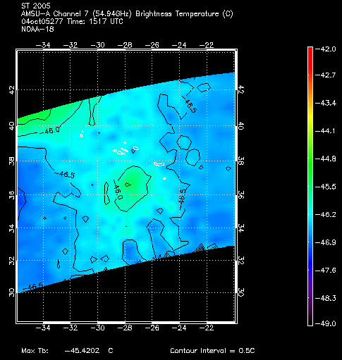
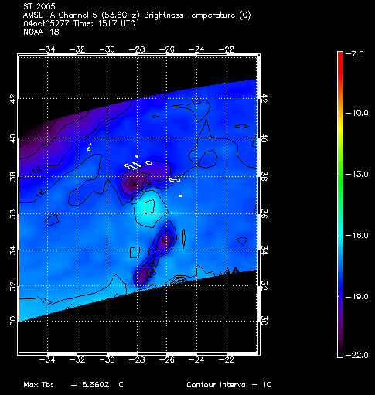
Figure 5. AMSU temperature imagery from NOAA-18 overpass of the unnamed subtropical storm at 1517 UTC 4 October. Channel 5 image from approximately 550 mb is on the left, while a channel 7 image from approximately 200 mb is on the right. Imagery courtesy of the Cooperative Institute for Meteorological Satellite Studies at the University of Wisconsin, Madison, Wisconsin. The storm center was near 36.5N 27.6W at this time.

