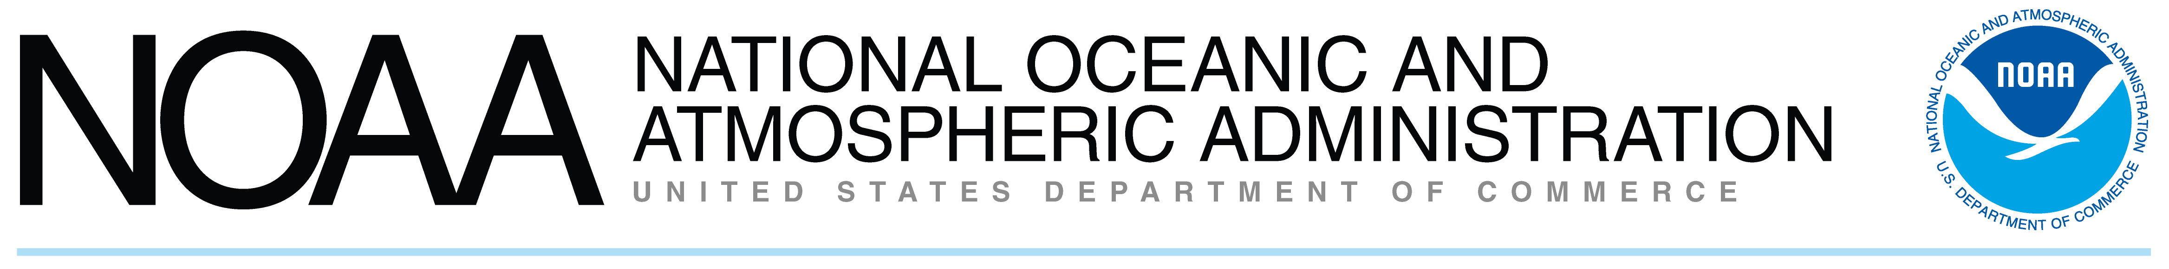
NOAA In Your State
Vermont
NOAA's work touches the daily lives of every person in the United States and in much of the world. Our products and services are the result of the hard work of NOAA’s dedicated staff and partner organizations located in program and research offices throughout the country. The following is a summary of NOAA programs based in, and focused on, your state. The entries are listed by statewide, region, and then by congressional districts and cities or towns.
  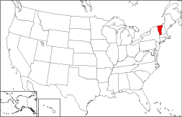
VT
Statewide
Office of Oceanic and Atmospheric Research (OAR)
NOAA's National Sea Grant College Program
Vermont Sea Grant Program
NOAA’s National Sea Grant College Program is a federal-university partnership that integrates research, education, and outreach (extension and communications). Sea Grant forms a network of 30 programs in all U.S. coastal and Great Lakes states and Puerto Rico. The Lake Champlain Sea Grant Project, based at the University of Vermont, is the newest member of the national Sea Grant network and supports the improved understanding, use and management of Lake Champlain, Lake George, the Basin’s inland waters and the Great Lakes in general. The Lake Champlain Sea Grant focuses the program’s outreach and research priorities on coastal communities and economies, coastal ecosystem health and public safety, and education and human resources development. Administered by the University of Vermont, the Lake Champlain project collaborates with Plattsburgh State University in New York.
http://www.uvm.edu/~seagrant

National Weather Service (NWS) and Office of Oceanic and Atmospheric Research (OAR)
Incident Meteorologist Program and Earth Systems Research Laboratory
Fire Weather Services and Support
The National Weather Service (NWS) fire weather forecasters are called Incident Meteorologists (IMETS). When a fire reaches a large enough size the IMETS are called out to the fire to provide constant weather updates and forecast briefings to the fire incident commanders at the fire. The IMETS are very important members of the fire fighting team, as changes in the fires are largely due to changes in the weather. To improve NWS fire weather services to the public, NOAA’s Earth System Research Laboratory (ESRL) conducts modeling, instrumentation and data services research. ESRL data dissemination and display systems are designed to be used by trained meteorologists, the US Forest Service, and the Bureau of Land Management. For example, the FX-Net thin client system and the Gridded FX-Net full function system are ESRL-developed software systems that are a critical part of the equipment the IMETS bring with them to the fire. These mobile PC–based client software packages are used by NWS forecasters at fires in all 50 states. Computer servers that communicate with the mobile PC clients are located in Hawaii, Alaska, Utah, Colorado, Texas and New York. The PC-base clients are also used by state emergency managers in many of the NWS regional areas. Other collaborators who work to improve NWS fire weather services include the University of Colorado in Boulder (CU), NCAR and private sector instrumentation companies.

Office of Oceanic and Atmospheric Research (OAR)
Earth System Research Laboratory
Ground Based GPS Meteorology
The Earth System Research Laboratory operates and maintains the Ground-Based GPS Meteorology project, currently consisting of more than 300 GPS water vapor observing systems that provide near real-time integrated precipitable water vapor (IPW) measurements for weather forecasting, climate modeling, observing system calibration and validation, and research. This project provides water vapor data available to all users.
http://www.gpsmet.noaa.gov/jsp/raob.jsp

VT-At Large
Burlington
National Weather Service (NWS)
Weather Forecast Office
Burlington WFO
Located at Burlington International Airport, this National Weather Service Weather Service Forecast office provides weather and flood warnings, daily forecasts and meteorologic and hydrologic data for 12 counties in central and northern Vermont and four counties in northern New York, with a total population of 809,000 residents.
http://www.erh.noaa.gov/btv/

Chittenden County
Office of Oceanic and Atmospheric Research (OAR)
Air Resources Laboratory
Atmospheric Integrated Research Monitoring Network
One of NOAA’s Atmospheric Integrated Research Monitoring Network (AIRMoN) sites is located in Chittenden County, VT. AIRMoN provides a research-based foundation for the routine operations of the nation’s deposition monitoring networks. Major ion data (sulfate, nitrate, pH, ammonium, sodium, chloride, and soil cations) are routinely in demand by scientists addressing process oriented studies concerned with the study of atmospheric fate and transport of various chemicals as well as numerous ecosystem issues. Other process studies of more limited duration address issues related to the maintenance of air quality, and the interaction of air pollution with the terrestrial, aquatic, and biospheric environments. Both monitoring and shorter term projects are relevant to climate, which is one driver of long-term variability and change in environmental quality
http://nadp.sws.uiuc.edu/AIRMoN

Montpelier
National Ocean Service (NOS)
National Geodetic Survey
Geodetic Advisor
The Geodetic Advisor is a jointly funded National Ocean Service (NOS) employee that resides in the state to provide liaison between NOS and the host state. The Geodetic Advisor guides and assists the state's charting, geodetic and surveying programs through technical expertise. This program also provides technical assistance in planning and implementing Geographic/Land Information System: (GIS/LIS) projects.
http://www.ngs.noaa.gov/ADVISORS/AdvisorsIndex.shtml

NOAA’s Office of Legislative Affairs
Tel: 202-482-4981 http://www.legislative.noaa.gov

