Registration Instructions for NIH Reviewers to Receive Reimbursement and Honoraria for Participation in NIH Peer Review
The NIH has implemented a new, simplified and secure registration process for reviewers to receive reimbursement and honoraria for their valued participation in NIH peer review meetings. The new registration system replaces the U.S. Treasury Central Contract Registration (CCR) system that the NIH used until May 2008 to facilitate these disbursements. If you are not registered in this new system — the Secure Payee Registration System (SPRS) — NIH will be unable to disburse your reimbursable expenses and honoraria.

All CCR records will expire. Please do not renew your CCR registration for this purpose and please disregard further communications from CCR related to your role as an NIH peer reviewer.

The NIH Office of Financial Management controls this secure payment site. However, only you can access this page containing your information, using your eRA Commons user name and password.

To complete the registration process you will need:
- Your NIH eRA Commons account username and password
- Your financial institution account and routing number
Note: If you have forgotten your Commons account login name, please contact your designated Institute/Center SREA Administrator. If you have forgotten your password, click on ‘Forgot Password?’ for help.

STEP 1. UPDATE RESIDENTIAL ADDRESS

- Log in to your eRA Commons account at https://commons.era.nih.gov/commons/.
- Click on Personal Profile on the light blue tab across the top of the screen.
- Click on Residential Address on the dark blue tab across the top of the screen.
- Enter the fields shown on the Residential Address screen. Fields marked with an asterisk are required fields. It is extremely important that the address entered here is your current residential address.
  - Foreign reviewers, this is the address where your check will be sent.
  - U.S. reviewers, this is the address where your tax documentation from the NIH will be sent.
- Click the submit button at the bottom of the screen.
- Once you enter information in the required fields, the ‘Secure Payee Registration System’ link becomes active at the bottom of the screen. Click on this link.

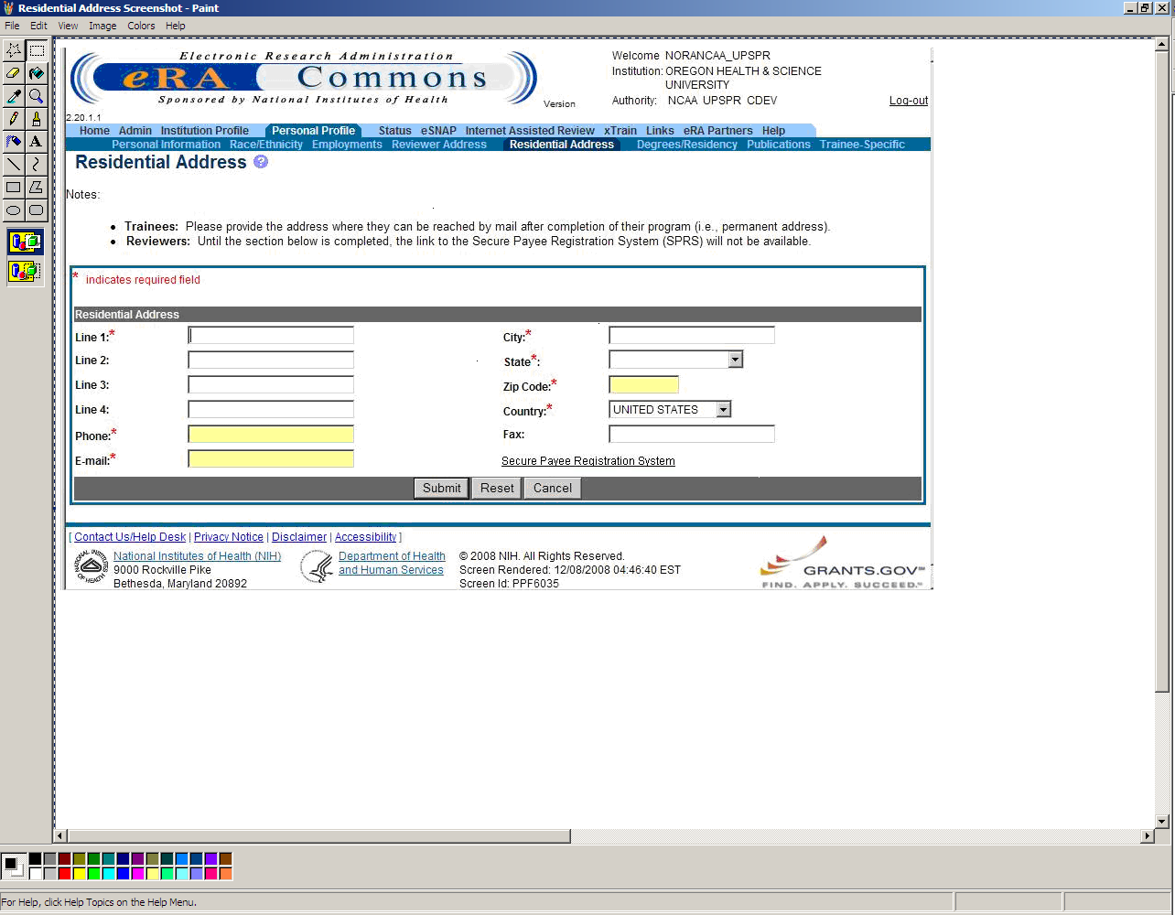
- You will be taken to a second screen where you will again log in, using your eRA Commons user name and password.

STEP 2. UPDATE SECURE PAYEE REGISTRATION SYSTEM

- The Secure Payee Registration System screen below will appear.
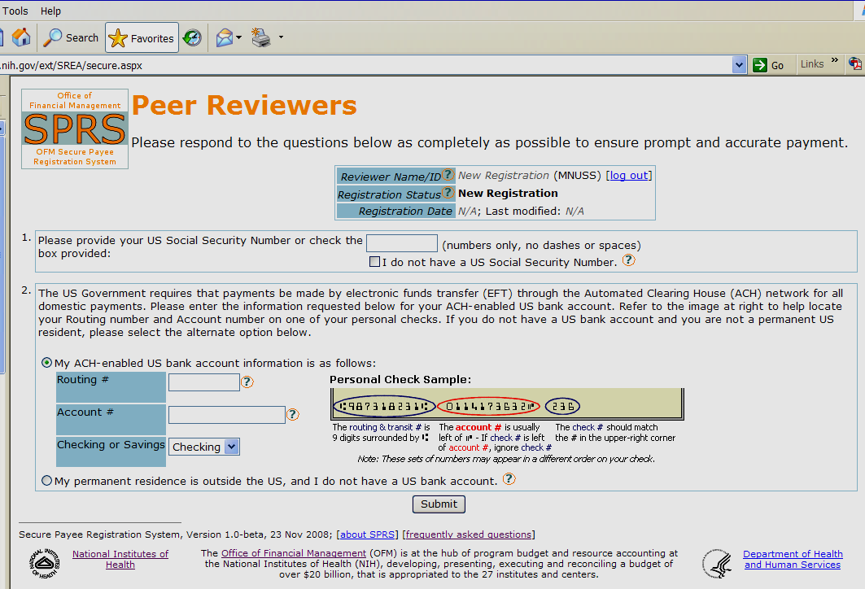

- In box 1, enter your U.S. Social Security Number (no dashes, just nine digits). If you do not have a Social Security Number, check the box that states ‘I do not have a U.S. Social Security Number.’
- If you have a U.S. bank account, enter your account number, routing number and account type (even if you don't live in the U.S.) and you will be reimbursed via direct deposit.
- If your permanent residence is outside the U.S. and you do not have a U.S. bank account, click the ‘My permanent residence is outside the U.S.’ radio button and your registration will be reviewed by the NIH Office of Financial Management. You may be contacted directly for more information if needed. If approved, a check will be mailed to you.
- Remember to click the ‘submit’ button to finalize the registration.
- Click on ‘Log Out’ next to your reviewer name near the right hand top of the screen.
- If you have questions, please click on the  icon for a list of Frequently Asked Questions.

Your registration is complete! Payment will be sent to you electronically via direct deposit if you live in the U.S., or by check if you live outside the U.S.

