Rhode Island

http://www.ridoe.net

Districts and schools

Number of districts (CCD) | 1993-94 | 2003-04
 | 36 | 38

Number of public schools (CCD) | 1993-94 | 2003-04
Elementary | 212 | 215
Middle | 51 | 57
High | 41 | 47
Combined | 2 | 4
Other | 3 | 5
Total | 309 | 328

Number of charter schools (CCD) | 2003-04
 | 8

Finances

Total current expenditures  (CCD, in thousands of dollars, adjusted for inflation to 2002-03) | 1993-94 | 2002-03
Instructional | $840,651 | $1,064,304
Noninstructional | 32,296 | 42,548
Support | 388,630 | 540,735
Total | 1,261,577 | 1,647,587

Per-pupil expenditures  (CCD, adjusted for inflation to 2002-03) | 1993-94 | 2002-03
 | $8,661 | $10,349

Sources of Funding
(CCD, 2002-03)

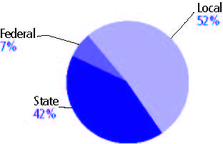

Title I allocation 2002-03 (ED; Includes Title I, Part A) | $43,155,247

Students

Public school enrollment (CCD) | 1993-94 | 2003-04
Pre-K | 465 | 1,431
K-8 | 103,603 | 108,426
9-12 | 38,470 | 47,812
Total (K-12) | 142,073 | 156,238

Race/ethnicity (CCD) | 1993-94 | 2003-04
American Indian/Alaskan Native | * | 1%
Asian/Pacific Islander | 3% | 3
Black, non-Hispanic | 7 | 8
Hispanic | 9 | 16
White, non-Hispanic | 81 | 71

Students with disabilities (OSEP) | 1993-94 | 2003-04
 | 13% | 16%

Students with limited  English proficiency (NCELA) | 1993-94 | 2003-04
 | 5% | 6%

Migrant students (OME) | 1993-94 | 2003-04
 | * | *

Eighth-grade students enrolled in Algebra I for high school credit (NAEP) | 1996 | 2003
 | 32% | -

Students eligible to participate in the Free or Reduced-Price Lunch Program, 2003-04 (CCD) | 55,792

All schools by percent of students eligible to participate in the Free or Reduced-Price Lunch Program, 2003-04† (CCD)
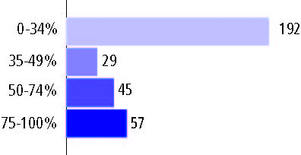
† 5 schools did not report

Staff

Number of FTE teachers (CCD) | 1993-94 | 2003-04
Elementary | 4,700 | 4,566
Middle | 2,239 | 3,033
High | 2,898 | 3,534
Combined | 62 | 76
Other | 8 | 17
Total | 9,907 | 11,226

Number of FTE non-teacher staff (CCD) | 1993-94 | 2003-04
Instructional aides | 1,320 | 2,526
Instructional coordinators | 78 | 190
Administrators | 524 | 719
Other | 3,697 | 4,537
Total | 5,619 | 7,972

Percentage of teachers with a major in the main subject taught, grades 7-12 (SASS) | 1994 | 2000
English | 94% | 74%
Mathematics | 81 | 82
Science | 94 | 81
Social Studies | 93 | 80

Percentage of core courses taught by highly qualified teachers, 2003-04 (As defined and reported by states, collected by ED)
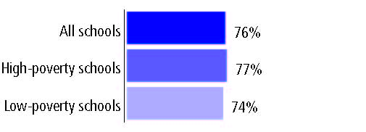

Outcomes

 | 1993-94 | 2000-01
High school dropout rate (NCES) | 5% | 5%
Avg. freshman graduation rate (NCES) | 74 | 74
College-going rate (IPEDS/NCES) | 65 | 66

NAEP state results
Reading, Grade 4 | 1994 | 2005
Proficient level or above | 32% | 30%
Basic level or above | 65 | 62
Math, Grade 8 | 1996 | 2005
Proficient level or above | 20% | 23%
Basic level or above | 60 | 63

Statewide Accountability Information:

State Accountability Website: http://www.infoworks.ride.uri.edu/2005/state/infoworks_statereport.pdf

State assessment for NCLB accountability: New Standards Reference Exam

State student achievement levels: Little evidence of achievement, Below the standard, Nearly Achieved the Standard, Achieved the Standard, Achieved the Standard with Honors

 |  | 2001-02  Annual measurable  objective starting point | Target  2003-04
Grade 4 | English Language Arts | 76.1% | 76.1%
 | Mathematics | 61.7 | 61.7
Grade 8 | English Language Arts | 68 | 68
 | Mathematics | 46.1 | 46.1
High school | English Language Arts | 62.6 | 62.6
 | Mathematics | 44.8 | 44.8

2003-04 NCLB accountability results, applied to 2004-05 school year
AYP outcomes and consequences | Title I schools |  | All schools |  | All districts
Made AYP | 111 | 76% | 258 | 82% | 29 | 89%
Identified for improvement:
Year 1 | 20 | 14% | 35 | 11% | 0 | 0
Year 2 | 13 | 9% | 13 | 4% | 2 | 6%
Corrective action | 5 | 3% | 9 | 3% | 3 | 8%
Restructuring | 1 | 1% | 1 | * | 1 | 3%
Exited improvement status (made AYP twice after missing twice or more, includes total “made” above) | 2 | 1% | 5 | 2% | 1 | 3%

Other indicator, 2003-04 | State target | State outcome
Elementary Indicator: Attendance rate | 90% | Met
Middle Indicator: Attendance rate | 90% | Met
High School Indicator: Graduation rate | 71.4% | Met

NCLB choice participation | Number of Title I students | Percent of eligible students
Title I school choice: | 39 | *
Supplemental educational services: | 2,191 | 23%

Student Achievement 2003-04

New Standards Reference Exam, used for NCLB accountability
Grade 3

English or Language Arts
Proficient Level or above for:
All students | n/a
Economically disadvantaged students | n/a
Migrant students | n/a
Students with disabilities | n/a
Students with limited English proficiency | n/a
Black, non-Hispanic students | n/a
Hispanic students | n/a
White, non-Hispanic students | n/a

Trend Data Not Available

New Standards Reference Exam, used for NCLB accountability
Grade 3

Mathematics
Proficient Level or above for:
All students | n/a
Economically disadvantaged students | n/a
Migrant students | n/a
Students with disabilities | n/a
Students with limited English proficiency | n/a
Black, non-Hispanic students | n/a
Hispanic students | n/a
White, non-Hispanic students | n/a

Trend Data Not Available

New Standards Reference Exam, used for NCLB accountability
Grade 4

English or Language Arts
Proficient Level or above for:
All students | 67%
Economically disadvantaged students | 52
Migrant students | #
Students with disabilities | 40
Students with limited English proficiency | 33
Black, non-Hispanic students | 53
Hispanic students | 47
White, non-Hispanic students | 74

Student achievement trend: English or Language Arts percent proficient level or above

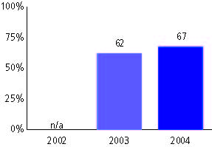

New Standards Reference Exam, used for NCLB accountability
Grade 4

Mathematics
Proficient Level or above for:
All students | 51%
Economically disadvantaged students | 36
Migrant students | #
Students with disabilities | 34
Students with limited English proficiency | 23
Black, non-Hispanic students | 32
Hispanic students | 31
White, non-Hispanic students | 60

Student achievement trend: Mathematics percent proficient level or above

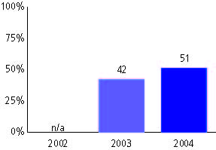

New Standards Reference Exam, used for NCLB accountability
Grade 5

English or Language Arts
Proficient Level or above for:
All students | n/a
Economically disadvantaged students | n/a
Migrant students | n/a
Students with disabilities | n/a
Students with limited English proficiency | n/a
Black, non-Hispanic students | n/a
Hispanic students | n/a
White, non-Hispanic students | n/a

Trend Data Not Available

New Standards Reference Exam, used for NCLB accountability
Grade 5

Mathematics
Proficient Level or above for:
All students | n/a
Economically disadvantaged students | n/a
Migrant students | n/a
Students with disabilities | n/a
Students with limited English proficiency | n/a
Black, non-Hispanic students | n/a
Hispanic students | n/a
White, non-Hispanic students | n/a

Trend Data Not Available

New Standards Reference Exam, used for NCLB accountability
Grade 6

English or Language Arts
Proficient Level or above for:
All students | n/a
Economically disadvantaged students | n/a
Migrant students | n/a
Students with disabilities | n/a
Students with limited English proficiency | n/a
Black, non-Hispanic students | n/a
Hispanic students | n/a
White, non-Hispanic students | n/a

Trend Data Not Available

New Standards Reference Exam, used for NCLB accountability
Grade 6

Mathematics
Proficient Level or above for:
All students | n/a
Economically disadvantaged students | n/a
Migrant students | n/a
Students with disabilities | n/a
Students with limited English proficiency | n/a
Black, non-Hispanic students | n/a
Hispanic students | n/a
White, non-Hispanic students | n/a

Trend Data Not Available

New Standards Reference Exam, used for NCLB accountability
Grade 7

English or Language Arts
Proficient Level or above for:
All students | n/a
Economically disadvantaged students | n/a
Migrant students | n/a
Students with disabilities | n/a
Students with limited English proficiency | n/a
Black, non-Hispanic students | n/a
Hispanic students | n/a
White, non-Hispanic students | n/a

Trend Data Not Available

New Standards Reference Exam, used for NCLB accountability
Grade 7

Mathematics
Proficient Level or above for:
All students | n/a
Economically disadvantaged students | n/a
Migrant students | n/a
Students with disabilities | n/a
Students with limited English proficiency | n/a
Black, non-Hispanic students | n/a
Hispanic students | n/a
White, non-Hispanic students | n/a

Trend Data Not Available

New Standards Reference Exam, used for NCLB accountability
Grade 8

English or Language Arts
Proficient Level or above for:
All students | 52%
Economically disadvantaged students | 35
Migrant students | #
Students with disabilities | 23
Students with limited English proficiency | 17
Black, non-Hispanic students | 36
Hispanic students | 30
White, non-Hispanic students | 59

Student achievement trend: English or Language Arts percent proficient level or above

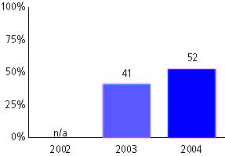

New Standards Reference Exam, used for NCLB accountability
Grade 8

Mathematics
Proficient Level or above for:
All students | 39%
Economically disadvantaged students | 19
Migrant students | #
Students with disabilities | 15
Students with limited English proficiency | 11
Black, non-Hispanic students | 16
Hispanic students | 14
White, non-Hispanic students | 49

Student achievement trend: Mathematics percent proficient level or above

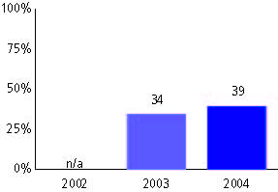

New Standards Reference Exam, used for NCLB accountability
High school

English or Language Arts
Proficient Level or above for:
All students | 53%
Economically disadvantaged students | 33
Migrant students | #
Students with disabilities | 22
Students with limited English proficiency | 9
Black, non-Hispanic students | 33
Hispanic students | 31
White, non-Hispanic students | 60

Student achievement trend: English or Language Arts percent proficient level or above

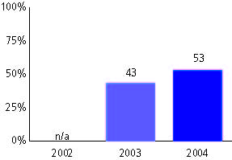

New Standards Reference Exam, used for NCLB accountability
High school

Mathematics
Proficient Level or above for:
All students | 44%
Economically disadvantaged students | 22
Migrant students | #
Students with disabilities | 15
Students with limited English proficiency | 10
Black, non-Hispanic students | 17
Hispanic students | 18
White, non-Hispanic students | 53

Student achievement trend: Mathematics percent proficient level or above

