Oregon

http://www.ode.state.or.us

Districts and schools

Number of districts (CCD) | 1993-94 | 2003-04
 | 280 | 200

Number of public schools (CCD) | 1993-94 | 2003-04
Elementary | 758 | 727
Middle | 198 | 224
High | 206 | 233
Combined | 40 | 37
Other | 13 | 4
Total | 1,215 | 1,225

Number of charter schools (CCD) | 2003-04
 | 23

Finances

Total current expenditures  (CCD, in thousands of dollars, adjusted for inflation to 2002-03) | 1993-94 | 2002-03
Instructional | $2,177,198 | $2,458,745
Noninstructional | 123,481 | 141,449
Support | 1,334,261 | 1,550,553
Total | 3,634,940 | 4,150,747

Per-pupil expenditures  (CCD, adjusted for inflation to 2002-03) | 1993-94 | 2002-03
 | $7,036 | $7,491

Sources of Funding
(CCD, 2002-03)

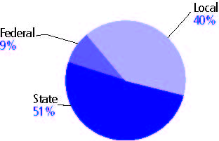

Title I allocation 2002-03 (ED; Includes Title I, Part A) | $115,317,070

Students

Public school enrollment (CCD) | 1993-94 | 2003-04
Pre-K | 826 | 365
K-8 | 365,358 | 374,249
9-12 | 148,127 | 166,879
Total (K-12) | 513,485 | 541,128

Race/ethnicity (CCD) | 1993-94 | 2003-04
American Indian/Alaskan Native | 2% | 2%
Asian/Pacific Islander | 3 | 4
Black, non-Hispanic | 2 | 3
Hispanic | 6 | 14
White, non-Hispanic | 87 | 77

Students with disabilities (OSEP) | 1993-94 | 2003-04
 | 10% | 11%

Students with limited  English proficiency (NCELA) | 1993-94 | 2003-04
 | 4% | 11%

Migrant students (OME) | 1993-94 | 2003-04
 | 5% | 7%

Eighth-grade students enrolled in Algebra I for high school credit (NAEP) | 1996 | 2003
 | 28% | 25%

Students eligible to participate in the Free or Reduced-Price Lunch Program, 2003-04 (CCD) | 221,160

All schools by percent of students eligible to participate in the Free or Reduced-Price Lunch Program, 2003-04† (CCD)

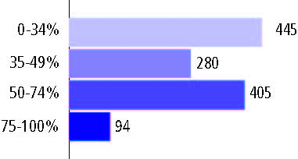
† 1 school did not report

Staff

Number of FTE teachers (CCD) | 1993-94 | 2003-04
Elementary | 12,726 | 12,243
Middle | 5,246 | 5,793
High | 7,382 | 7,618
Combined | 557 | 444
Other | 142 | 55
Total | 26,053 | 26,153

Number of FTE non-teacher staff (CCD) | 1993-94 | 2003-04
Instructional aides | 5,236 | 8,466
Instructional coordinators | 338 | 406
Administrators | 2,292 | 2,152
Other | 16,038 | 16,516
Total | 23,904 | 27,540

Percentage of teachers with a major in the main subject taught, grades 7-12 (SASS) | 1994 | 2000
English | 61% | 68%
Mathematics | 61 | 60
Science | 93 | 74
Social Studies | 79 | 57

Percentage of core courses taught by highly qualified teachers, 2003-04 (As defined and reported by states, collected by ED)

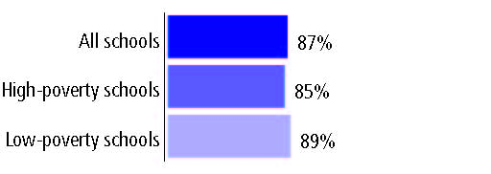

Outcomes

 | 1993-94 | 2000-01
High school dropout rate (NCES) | 7% | 5%
Avg. freshman graduation rate (NCES) | 73 | 68
College-going rate (IPEDS/NCES) | 57 | 51

NAEP state results
Reading, Grade 4 | 1994 | 2005
Proficient level or above | - | 30%
Basic level or above | - | 63
Math, Grade 8 | 1996 | 2005
Proficient level or above | 26% | 33%
Basic level or above | 67 | 72

Statewide Accountability Information:

State Accountability Website: http://www.ode.state.or.us/data/annreportcard/rptcard2004.pdf

State assessment for NCLB accountability: Oregon State Assessments

State student achievement levels: Very Low, Low, Nearly Meets, Meets Standards, Exceeds Standards

 |  | 2001-02  Annual measurable  objective starting point | Target  2003-04
Grade 3 | Reading | 40% | 40%
 | Mathematics | 39 | 39
Grade 8 | Reading | 40 | 40
 | Mathematics | 39 | 39
High school | Reading | 40 | 40
 | Mathematics | 39 | 39

2003-04 NCLB accountability results, applied to 2004-05 school year
AYP outcomes and consequences | Title I schools |  | All schools |  | All districts
Made AYP | 496 | 87% | 847 | 71% | 76 | 39%
Identified for improvement:
Year 1 | 29 | 5% | 29 | 2% | 14 | 7%
Year 2 | 2 | * | 2 | * | 1 | 1%
Corrective action | 2 | * | 2 | * | 0 | 0
Restructuring | 2 | * | 2 | * | 0 | 0
Exited improvement status (made AYP twice after missing twice or more, includes total “made” above) | 0 | 0 | 0 | 0 | 0 | 0

Other indicator, 2003-04 | State target | State outcome
Elementary Indicator: Attendance | 92% | Met
Middle Indicator: Attendance | 92% | Met
High School Indicator: Graduation rate | 68.10% | Met

NCLB choice participation | Number of Title I students | Percent of eligible students
Title I school choice: | 873 | 13%
Supplemental educational services: | 537 | 24%

Student Achievement 2003-04

Oregon State Assessments, used for NCLB accountability
Grade 3

Reading
Proficient Level or above for:
All students | 82%
Economically disadvantaged students | 73
Migrant students | 54
Students with disabilities | 52
Students with limited English proficiency | 59
Black, non-Hispanic students | 74
Hispanic students | 63
White, non-Hispanic students | 87

Student achievement trend: Reading percent proficient level or above

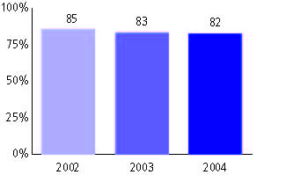

Oregon State Assessments, used for NCLB accountability
Grade 3

Mathematics
Proficient Level or above for:
All students | 81%
Economically disadvantaged students | 73
Migrant students | 58
Students with disabilities | 57
Students with limited English proficiency | 61
Black, non-Hispanic students | 71
Hispanic students | 63
White, non-Hispanic students | 86

Student achievement trend: Mathematics percent proficient level or above

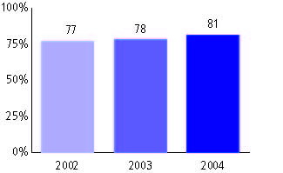

Oregon State Assessments, used for NCLB accountability
Grade 4

Reading
Proficient Level or above for:
All students | n/a
Economically disadvantaged students | n/a
Migrant students | n/a
Students with disabilities | n/a
Students with limited English proficiency | n/a
Black, non-Hispanic students | n/a
Hispanic students | n/a
White, non-Hispanic students | n/a

Trend Data Not Available

Oregon State Assessments, used for NCLB accountability
Grade 4

Mathematics
Proficient Level or above for:
All students | n/a
Economically disadvantaged students | n/a
Migrant students | n/a
Students with disabilities | n/a
Students with limited English proficiency | n/a
Black, non-Hispanic students | n/a
Hispanic students | n/a
White, non-Hispanic students | n/a

Trend Data Not Available

Oregon State Assessments, used for NCLB accountability
Grade 5

Reading
Proficient Level or above for:
All students | 76%
Economically disadvantaged students | 65
Migrant students | 46
Students with disabilities | 42
Students with limited English proficiency | 47
Black, non-Hispanic students | 65
Hispanic students | 54
White, non-Hispanic students | 81

Student achievement trend: Reading percent proficient level or above

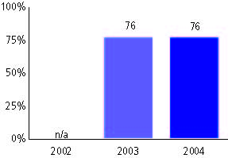

Oregon State Assessments, used for NCLB accountability
Grade 5

Mathematics
Proficient Level or above for:
All students | 78%
Economically disadvantaged students | 69
Migrant students | 56
Students with disabilities | 47
Students with limited English proficiency | 57
Black, non-Hispanic students | 66
Hispanic students | 60
White, non-Hispanic students | 82

Student achievement trend: Mathematics percent proficient level or above

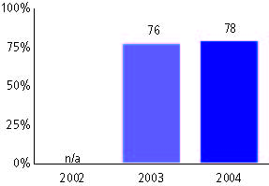

Oregon State Assessments, used for NCLB accountability
Grade 6

Reading
Proficient Level or above for:
All students | n/a
Economically disadvantaged students | n/a
Migrant students | n/a
Students with disabilities | n/a
Students with limited English proficiency | n/a
Black, non-Hispanic students | n/a
Hispanic students | n/a
White, non-Hispanic students | n/a

Trend Data Not Available

Oregon State Assessments, used for NCLB accountability
Grade 6

Mathematics
Proficient Level or above for:
All students | n/a
Economically disadvantaged students | n/a
Migrant students | n/a
Students with disabilities | n/a
Students with limited English proficiency | n/a
Black, non-Hispanic students | n/a
Hispanic students | n/a
White, non-Hispanic students | n/a

Trend Data Not Available

Oregon State Assessments, used for NCLB accountability
Grade 7

Reading
Proficient Level or above for:
All students | n/a
Economically disadvantaged students | n/a
Migrant students | n/a
Students with disabilities | n/a
Students with limited English proficiency | n/a
Black, non-Hispanic students | n/a
Hispanic students | n/a
White, non-Hispanic students | n/a

Trend Data Not Available

Oregon State Assessments, used for NCLB accountability
Grade 7

Mathematics
Proficient Level or above for:
All students | n/a
Economically disadvantaged students | n/a
Migrant students | n/a
Students with disabilities | n/a
Students with limited English proficiency | n/a
Black, non-Hispanic students | n/a
Hispanic students | n/a
White, non-Hispanic students | n/a

Trend Data Not Available

Oregon State Assessments, used for NCLB accountability
Grade 8

Reading
Proficient Level or above for:
All students | 59%
Economically disadvantaged students | 42
Migrant students | 23
Students with disabilities | 19
Students with limited English proficiency | 21
Black, non-Hispanic students | 43
Hispanic students | 32
White, non-Hispanic students | 64

Student achievement trend: Reading percent proficient level or above

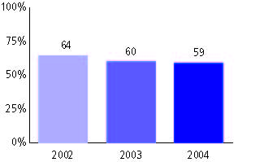

Oregon State Assessments, used for NCLB accountability
Grade 8

Mathematics
Proficient Level or above for:
All students | 59%
Economically disadvantaged students | 42
Migrant students | 26
Students with disabilities | 19
Students with limited English proficiency | 27
Black, non-Hispanic students | 39
Hispanic students | 32
White, non-Hispanic students | 63

Student achievement trend: Mathematics percent proficient level or above

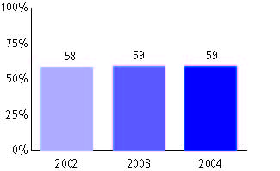

Oregon State Assessments, used for NCLB accountability
High school

Reading
Proficient Level or above for:
All students | 50%
Economically disadvantaged students | 31
Migrant students | 11
Students with disabilities | 12
Students with limited English proficiency | 10
Black, non-Hispanic students | 26
Hispanic students | 21
White, non-Hispanic students | 54

Student achievement trend: Reading percent proficient level or above

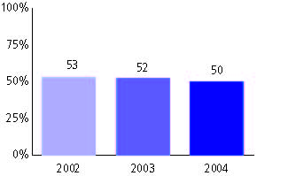

Oregon State Assessments, used for NCLB accountability
High school

Mathematics
Proficient Level or above for:
All students | 42%
Economically disadvantaged students | 24
Migrant students | 9
Students with disabilities | 8
Students with limited English proficiency | 13
Black, non-Hispanic students | 18
Hispanic students | 17
White, non-Hispanic students | 46

Student achievement trend: Mathematics percent proficient level or above

