New Hampshire

http://www.ed.state.nh.us

Districts and schools

Number of districts (CCD) | 1993-94 | 2003-04
 | 178 | 179

Number of public schools (CCD) | 1993-94 | 2003-04
Elementary | 293 | 298
Middle | 91 | 96
High | 77 | 78
Combined | n/a | 0
Other | n/a | 1
Total | 461 | 473

Number of charter schools (CCD) | 2003-04
 | -

Finances

Total current expenditures  (CCD, in thousands of dollars, adjusted for inflation to 2002-03) | 1993-94 | 2002-03
Instructional | $824,001 | $1,156,573
Noninstructional | 45,362 | 54,792
Support | 413,921 | 570,229
Total | 1,283,284 | 1,781,594

Per-pupil expenditures  (CCD, adjusted for inflation to 2002-03) | 1993-94 | 2002-03
 | $6,923 | $8,579

Sources of Funding
(CCD, 2002-03)

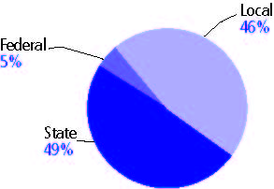

Title I allocation 2002-03 (ED; Includes Title I, Part A) | $29,733,465

Students

Public school enrollment (CCD) | 1993-94 | 2003-04
Pre-K | 1,292 | 2,221
K-8 | 134,367 | 139,320
9-12 | 49,098 | 65,325
Total (K-12) | 183,465 | 204,645

Race/ethnicity (CCD) | 1993-94 | 2003-04
American Indian/Alaskan Native | * | *
Asian/Pacific Islander | 1% | 2%
Black, non-Hispanic | 1 | 1
Hispanic | 1 | 2
White, non-Hispanic | 97 | 94

Students with disabilities (OSEP) | 1993-94 | 2003-04
 | 11% | 13%

Students with limited  English proficiency (NCELA) | 1993-94 | 2003-04
 | 1% | 1%

Migrant students (OME) | 1993-94 | 2003-04
 | * | *

Eighth-grade students enrolled in Algebra I for high school credit (NAEP) | 1996 | 2003
 | - | 27%

Students eligible to participate in the Free or Reduced-Price Lunch Program, 2003-04 (CCD) | 33,805

All schools by percent of students eligible to participate in the Free or Reduced-Price Lunch Program, 2003-04† (CCD)

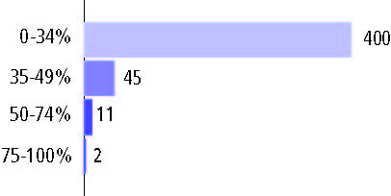
† 15 schools did not report

Staff

Number of FTE teachers (CCD) | 1993-94 | 2003-04
Elementary | 5,768 | 6,806
Middle | 2,711 | 3,658
High | 3,493 | 4,578
Combined | - | -
Other | - | 68
Total | 11,972 | 15,110

Number of FTE non-teacher staff (CCD) | 1993-94 | 2003-04
Instructional aides | 2,902 | 6,380
Instructional coordinators | 128 | 186
Administrators | 807 | 1,074
Other | 6,093 | 8,078
Total | 9,930 | 15,718

Percentage of teachers with a major in the main subject taught, grades 7-12 (SASS) | 1994 | 2000
English | 90% | 73%
Mathematics | 76 | 69
Science | 91 | 90
Social Studies | 90 | 88

Percentage of core courses taught by highly qualified teachers, 2003-04 (As defined and reported by states, collected by ED)

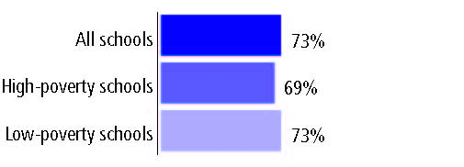

Outcomes

 | 1993-94 | 2000-01
High school dropout rate (NCES) | n/a | 5%
Avg. freshman graduation rate (NCES) | 81% | 78
College-going rate (IPEDS/NCES) | 56 | 59

NAEP state results
Reading, Grade 4 | 1994 | 2005
Proficient level or above | 36% | 39%
Basic level or above | 70 | 75
Math, Grade 8 | 1996 | 2005
Proficient level or above | - | 35%
Basic level or above | - | 78

Statewide Accountability Information:

State Accountability Website: http://www.ed.state.nh.us/education/doe/organization/curriculum/Assessment/materials04.htm

State assessment for NCLB accountability: New Hampshire Educational Improvement Assessment Program

State student achievement levels: Novice, Basic, Proficient, Advanced

 |  | 2001-02  Annual measurable  objective starting point | Target  2003-04
Grade 3 | Reading | 60% | 60%
 | Mathematics | 64 | 64
Grade 6 | Reading | 60 | 60
 | Mathematics | 64 | 64
High school | Reading | 70 | 70
 | Mathematics | 52 | 52

2003-04 NCLB accountability results, applied to 2004-05 school year
AYP outcomes and consequences | Title I schools |  | All schools |  | All districts
Made AYP | 194 | 78% | 336 | 73% | 102 | 76%
Identified for improvement:
Year 1 | 24 | 10% | 69 | 15% | 0 | 0
Year 2 | 2 | 1% | 2 | * | 0 | 0
Corrective action | 1 | * | 1 | * | 0 | 0
Restructuring | 0 | 0 | 0 | 0 | 0 | 0
Exited improvement status (made AYP twice after missing twice or more, includes total “made” above) | 1 | * | 1 | * | 0 | 0

Other indicator, 2003-04 | State target | State outcome
Elementary Indicator: Attendance | Meet or progress toward 90% | Met
Middle Indicator: Attendance | Meet or progress toward 90% | Met
High School Indicator: Graduation rate | Meet or progress toward 75% | Met

NCLB choice participation | Number of Title I students | Percent of eligible students
Title I school choice: | 1 | *
Supplemental educational services: | 15 | 13%

Student Achievement 2003-04

New Hampshire Educational Improvement Assessment
Program, used for NCLB accountability
Grade 3

Reading
Proficient Level or above for:
All students | 73%
Economically disadvantaged students | 53
Migrant students | 62
Students with disabilities | 32
Students with limited English proficiency | 31
Black, non-Hispanic students | 53
Hispanic students | 45
White, non-Hispanic students | 74

Student achievement trend: Reading percent proficient level or above

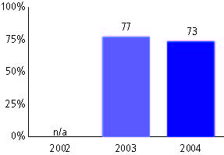

New Hampshire Educational Improvement Assessment
Program, used for NCLB accountability
Grade 3

Mathematics
Proficient Level or above for:
All students | 84%
Economically disadvantaged students | 72
Migrant students | 62
Students with disabilities | 60
Students with limited English proficiency | 59
Black, non-Hispanic students | 72
Hispanic students | 67
White, non-Hispanic students | 85

Student achievement trend: Mathematics percent proficient level or above

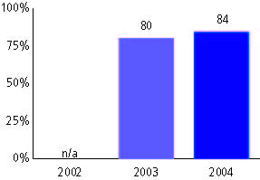

New Hampshire Educational Improvement Assessment
Program, used for NCLB accountability
Grade 4

Reading
Proficient Level or above for:
All students | n/a
Economically disadvantaged students | n/a
Migrant students | n/a
Students with disabilities | n/a
Students with limited English proficiency | n/a
Black, non-Hispanic students | n/a
Hispanic students | n/a
White, non-Hispanic students | n/a

Trend Data Not Available

New Hampshire Educational Improvement Assessment
Program, used for NCLB accountability
Grade 4

Mathematics
Proficient Level or above for:
All students | n/a
Economically disadvantaged students | n/a
Migrant students | n/a
Students with disabilities | n/a
Students with limited English proficiency | n/a
Black, non-Hispanic students | n/a
Hispanic students | n/a
White, non-Hispanic students | n/a

Trend Data Not Available

New Hampshire Educational Improvement Assessment
Program, used for NCLB accountability
Grade 5

Reading
Proficient Level or above for:
All students | n/a
Economically disadvantaged students | n/a
Migrant students | n/a
Students with disabilities | n/a
Students with limited English proficiency | n/a
Black, non-Hispanic students | n/a
Hispanic students | n/a
White, non-Hispanic students | n/a

Trend Data Not Available

New Hampshire Educational Improvement Assessment
Program, used for NCLB accountability
Grade 5

Mathematics
Proficient Level or above for:
All students | n/a
Economically disadvantaged students | n/a
Migrant students | n/a
Students with disabilities | n/a
Students with limited English proficiency | n/a
Black, non-Hispanic students | n/a
Hispanic students | n/a
White, non-Hispanic students | n/a

Trend Data Not Available

New Hampshire Educational Improvement Assessment
Program, used for NCLB accountability
Grade 6

Reading
Proficient Level or above for:
All students | 74%
Economically disadvantaged students | 54
Migrant students | 25
Students with disabilities | 31
Students with limited English proficiency | 27
Black, non-Hispanic students | 63
Hispanic students | 45
White, non-Hispanic students | 75

Student achievement trend: Reading percent proficient level or above

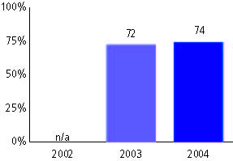

New Hampshire Educational Improvement Assessment
Program, used for NCLB accountability
Grade 6

Mathematics
Proficient Level or above for:
All students | 72%
Economically disadvantaged students | 53
Migrant students | 25
Students with disabilities | 35
Students with limited English proficiency | 40
Black, non-Hispanic students | 55
Hispanic students | 47
White, non-Hispanic students | 73

Student achievement trend: Mathematics percent proficient level or above

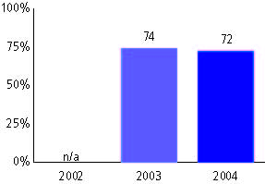

New Hampshire Educational Improvement Assessment
Program, used for NCLB accountability
Grade 7

Reading
Proficient Level or above for:
All students | n/a
Economically disadvantaged students | n/a
Migrant students | n/a
Students with disabilities | n/a
Students with limited English proficiency | n/a
Black, non-Hispanic students | n/a
Hispanic students | n/a
White, non-Hispanic students | n/a

Trend Data Not Available

New Hampshire Educational Improvement Assessment
Program, used for NCLB accountability
Grade 7

Mathematics
Proficient Level or above for:
All students | n/a
Economically disadvantaged students | n/a
Migrant students | n/a
Students with disabilities | n/a
Students with limited English proficiency | n/a
Black, non-Hispanic students | n/a
Hispanic students | n/a
White, non-Hispanic students | n/a

Trend Data Not Available

New Hampshire Educational Improvement Assessment
Program, used for NCLB accountability
Grade 8

Reading
Proficient Level or above for:
All students | n/a
Economically disadvantaged students | n/a
Migrant students | n/a
Students with disabilities | n/a
Students with limited English proficiency | n/a
Black, non-Hispanic students | n/a
Hispanic students | n/a
White, non-Hispanic students | n/a

Trend Data Not Available

New Hampshire Educational Improvement Assessment
Program, used for NCLB accountability
Grade 8

Mathematics
Proficient Level or above for:
All students | n/a
Economically disadvantaged students | n/a
Migrant students | n/a
Students with disabilities | n/a
Students with limited English proficiency | n/a
Black, non-Hispanic students | n/a
Hispanic students | n/a
White, non-Hispanic students | n/a

Trend Data Not Available

New Hampshire Educational Improvement Assessment
Program, used for NCLB accountability
High school

Reading
Proficient Level or above for:
All students | 78%
Economically disadvantaged students | 60
Migrant students | <10
Students with disabilities | 37
Students with limited English proficiency | 23
Black, non-Hispanic students | 60
Hispanic students | 55
White, non-Hispanic students | 79

Student achievement trend: Reading percent proficient level or above

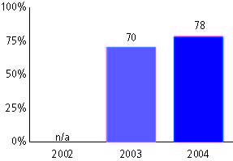

New Hampshire Educational Improvement Assessment
Program, used for NCLB accountability
High school

Mathematics
Proficient Level or above for:
All students | 65%
Economically disadvantaged students | 44
Migrant students | <10
Students with disabilities | 24
Students with limited English proficiency | 20
Black, non-Hispanic students | 44
Hispanic students | 40
White, non-Hispanic students | 66

Student achievement trend: Mathematics percent proficient level or above

