Michigan

http://www.mde.state.mi.us

Districts and schools

Number of districts (CCD) | 1993-94 | 2003-04
 | 558 | 553

Number of public schools (CCD) | 1993-94 | 2003-04
Elementary | 1,888 | 2,115
Middle | 537 | 646
High | 559 | 675
Combined | 57 | 171
Other | 55 | 262
Total | 3,096 | 3,869

Number of charter schools (CCD) | 2003-04
 | 202

Finances

Total current expenditures  (CCD, in thousands of dollars, adjusted for inflation to 2002-03) | 1993-94 | 2002-03
Instructional | $7,252,204 | $8,929,871
Noninstructional | 363,713 | 479,990
Support | 4,892,689 | 6,264,837
Total | 12,508,606 | 15,674,698

Per-pupil expenditures  (CCD, adjusted for inflation to 2002-03) | 1993-94 | 2002-03
 | $7,821 | $8,781

Sources of Funding
(CCD, 2002-03)

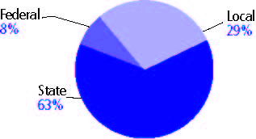

Title I allocation 2002-03 (ED; Includes Title I, Part A) | $420,799,581

Students

Public school enrollment (CCD) | 1993-94 | 2003-04
Pre-K | 15,165 | 21,146
K-8 | 1,067,300 | 1,174,601
9-12 | 419,468 | 512,762
Total (K-12) | 1,468,768 | 1,687,363

Race/ethnicity (CCD) | 1993-94 | 2003-04
American Indian/Alaskan Native | 1% | 1%
Asian/Pacific Islander | 1 | 2
Black, non-Hispanic | 17 | 20
Hispanic | 2 | 4
White, non-Hispanic | 78 | 73

Students with disabilities (OSEP) | 1993-94 | 2003-04
 | 9% | 12%

Students with limited  English proficiency (NCELA) | 1993-94 | 2003-04
 | 3% | 4%

Migrant students (OME) | 1993-94 | 2003-04
 | 1% | 1%

Eighth-grade students enrolled in Algebra I for high school credit (NAEP) | 1996 | 2003
 | 29% | 21%

Students eligible to participate in the Free or Reduced-Price Lunch Program, 2003-04 (CCD) | 570,422

All schools by percent of students eligible to participate in the Free or Reduced-Price Lunch Program, 2003-04† (CCD)
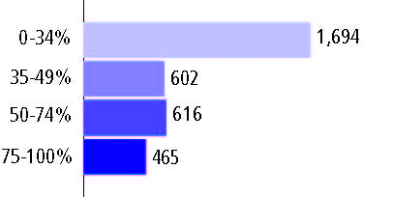
† 492 schools did not report

Staff

Number of FTE teachers (CCD) | 1993-94 | 2003-04
Elementary | 35,403 | 41,865
Middle | 15,223 | 19,623
High | 20,702 | 24,154
Combined | 1,105 | 3,249
Other | 721 | 3,040
Total | 73,154 | 91,931

Number of FTE non-teacher staff (CCD) | 1993-94 | 2003-04
Instructional aides | 12,629 | 25,170
Instructional coordinators | 915 | 3,457
Administrators | 6,599 | 8,241
Other | 68,873 | 72,152
Total | 89,016 | 109,020

Percentage of teachers with a major in the main subject taught, grades 7-12 (SASS) | 1994 | 2000
English | 67% | 64%
Mathematics | 61 | 68
Science | 73 | 72
Social Studies | 88 | 66

Percentage of core courses taught by highly qualified teachers, 2003-04 (As defined and reported by states, collected by ED)

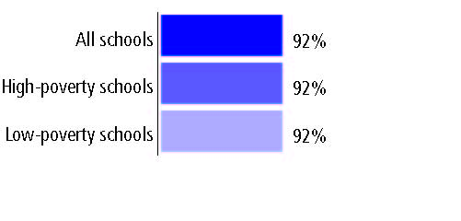

Outcomes

 | 1993-94 | 2000-01
High school dropout rate (NCES) | - | -
Avg. freshman graduation rate (NCES) | 74% | 75%
College-going rate (IPEDS/NCES) | 60 | 54

NAEP state results
Reading, Grade 4 | 1994 | 2005
Proficient level or above | - | 31%
Basic level or above | - | 62
Math, Grade 8 | 1996 | 2005
Proficient level or above | 28% | 30%
Basic level or above | 67 | 68

Statewide Accountability Information:

State Accountability Website: http://www.michigan.gov/documents/State_Report_Card_2003-04_120358_7.doc

State assessment for NCLB accountability: Michigan Educational Assessment Program

State student achievement levels: Basic, Below Basic, Met Exceptations, Exceeds Expectations

 |  | 2001-02  Annual measurable  objective starting point | Target  2003-04
Grade 4 | Reading or language arts | 38% | 38%
 | Mathematics | 47 | 47
Grade 8 | Reading or language arts | 31 | 31
 | Mathematics | 31 | 31
High school | Reading or language arts | 42 | 42
 | Mathematics | 33 | 33

2003-04 NCLB accountability results, applied to 2004-05 school year
AYP outcomes and consequences* | Title I schools |  | All schools |  | All districts
Made AYP | 1,847 | 80% | 2,775 | 77% | 431 | 80%
Identified for improvement:
Year 1 | n/a | n/a | 218 | 6% | 0 | 0
Year 2 | n/a | n/a | 72 | 2% | 0 | 0
Corrective action | n/a | n/a | 74 | 2% | 0 | 0
Restructuring | n/a | n/a | 147 | 4% | 0 | 0
Exited improvement status (made AYP twice after missing twice or more, includes total “made” above) | n/a | n/a | n/a | n/a | n/a | n/a
*AYP outcomes for this state are not available due to issues with data collection, measurement, or other reasons. For more information, please visit the state’s Web site, above.

Other indicator, 2003-04 | State target | State outcome
Elementary Indicator: Attendance | Meet or progress toward 80% | Met
Middle Indicator: Attendance | Meet or progress toward 80% | Met
High School Indicator: Graduation rate | 80% | Met

NCLB choice participation | Number of Title I students | Percent of eligible students
Title I school choice: | 340 | *
Supplemental educational services: | 11,444 | 11%

Student Achievement 2003-04

Michigan Educational Assessment Program, used for NCLB accountability
Grade 3

Reading or language arts
Proficient Level or above for:
All students | n/a
Economically disadvantaged students | n/a
Migrant students | n/a
Students with disabilities | n/a
Students with limited English proficiency | n/a
Black, non-Hispanic students | n/a
Hispanic students | n/a
White, non-Hispanic students | n/a

Trend Data Not Available

Michigan Educational Assessment Program, used for NCLB accountability
Grade 3

Mathematics
Proficient Level or above for:
All students | n/a
Economically disadvantaged students | n/a
Migrant students | n/a
Students with disabilities | n/a
Students with limited English proficiency | n/a
Black, non-Hispanic students | n/a
Hispanic students | n/a
White, non-Hispanic students | n/a

Trend Data Not Available

Michigan Educational Assessment Program, used for NCLB accountability
Grade 4

Reading or language arts
Proficient Level or above for:
All students | 62%
Economically disadvantaged students | 47
Migrant students | 40
Students with disabilities | 30
Students with limited English proficiency | 61
Black, non-Hispanic students | 43
Hispanic students | 48
White, non-Hispanic students | 66

Student achievement trend: Reading or language arts percent proficient level or above

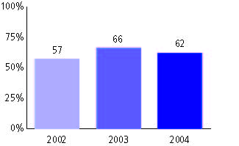

Michigan Educational Assessment Program, used for NCLB accountability
Grade 4

Mathematics
Proficient Level or above for:
All students | 71%
Economically disadvantaged students | 57
Migrant students | 52
Students with disabilities | 42
Students with limited English proficiency | 59
Black, non-Hispanic students | 51
Hispanic students | 58
White, non-Hispanic students | 77

Student achievement trend: Mathematics percent proficient level or above

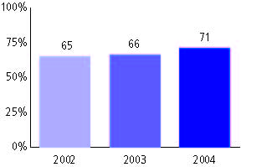

Michigan Educational Assessment Program, used for NCLB accountability
Grade 5

Reading or language arts
Proficient Level or above for:
All students | n/a
Economically disadvantaged students | n/a
Migrant students | n/a
Students with disabilities | n/a
Students with limited English proficiency | n/a
Black, non-Hispanic students | n/a
Hispanic students | n/a
White, non-Hispanic students | n/a

Trend Data Not Available

Michigan Educational Assessment Program, used for NCLB accountability
Grade 5

Mathematics
Proficient Level or above for:
All students | n/a
Economically disadvantaged students | n/a
Migrant students | n/a
Students with disabilities | n/a
Students with limited English proficiency | n/a
Black, non-Hispanic students | n/a
Hispanic students | n/a
White, non-Hispanic students | n/a

Trend Data Not Available

Michigan Educational Assessment Program, used for NCLB accountability
Grade 6

Reading or language arts
Proficient Level or above for:
All students | n/a
Economically disadvantaged students | n/a
Migrant students | n/a
Students with disabilities | n/a
Students with limited English proficiency | n/a
Black, non-Hispanic students | n/a
Hispanic students | n/a
White, non-Hispanic students | n/a

Trend Data Not Available

Michigan Educational Assessment Program, used for NCLB accountability
Grade 6

Mathematics
Proficient Level or above for:
All students | n/a
Economically disadvantaged students | n/a
Migrant students | n/a
Students with disabilities | n/a
Students with limited English proficiency | n/a
Black, non-Hispanic students | n/a
Hispanic students | n/a
White, non-Hispanic students | n/a

Trend Data Not Available

Michigan Educational Assessment Program, used for NCLB accountability
Grade 7

Reading or language arts
Proficient Level or above for:
All students | 55%
Economically disadvantaged students | 38
Migrant students | 29
Students with disabilities | 20
Students with limited English proficiency | 30
Black, non-Hispanic students | 34
Hispanic students | 40
White, non-Hispanic students | 62

Student achievement trend: Reading or language arts percent proficient level or above

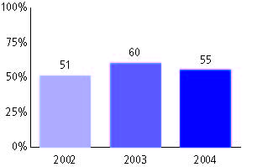

Michigan Educational Assessment Program, used for NCLB accountability
Grade 7

Mathematics
Proficient Level or above for:
All students | n/a
Economically disadvantaged students | n/a
Migrant students | n/a
Students with disabilities | n/a
Students with limited English proficiency | n/a
Black, non-Hispanic students | n/a
Hispanic students | n/a
White, non-Hispanic students | n/a

Trend Data Not Available

Michigan Educational Assessment Program, used for NCLB accountability
Grade 8

Reading or language arts
Proficient Level or above for:
All students | n/a
Economically disadvantaged students | n/a
Migrant students | n/a
Students with disabilities | n/a
Students with limited English proficiency | n/a
Black, non-Hispanic students | n/a
Hispanic students | n/a
White, non-Hispanic students | n/a

Trend Data Not Available

Michigan Educational Assessment Program, used for NCLB accountability
Grade 8

Mathematics
Proficient Level or above for:
All students | 61%
Economically disadvantaged students | 41
Migrant students | 33
Students with disabilities | 25
Students with limited English proficiency | 42
Black, non-Hispanic students | 33
Hispanic students | 46
White, non-Hispanic students | 69

Student achievement trend: Mathematics percent proficient level or above

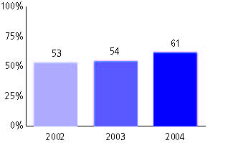

Michigan Educational Assessment Program, used for NCLB accountability
High school

Reading or language arts
Proficient Level or above for:
All students | 62%
Economically disadvantaged students | 42
Migrant students | 27
Students with disabilities | 21
Students with limited English proficiency | 27
Black, non-Hispanic students | 43
Hispanic students | 46
White, non-Hispanic students | 66

Student achievement trend: Reading or language arts percent proficient level or above

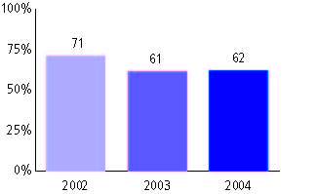

Michigan Educational Assessment Program, used for NCLB accountability
High school

Mathematics
Proficient Level or above for:
All students | 51%
Economically disadvantaged students | 31
Migrant students | 19
Students with disabilities | 18
Students with limited English proficiency | 26
Black, non-Hispanic students | 22
Hispanic students | 33
White, non-Hispanic students | 56

Student achievement trend: Mathematics percent proficient level or above

