Arkansas

http://arkedu.state.ar.us

Districts and schools

Number of districts (CCD) | 1993-94 | 2003-04
 | 315 | 311

Number of public schools (CCD) | 1993-94 | 2003-04
Elementary | 564 | 569
Middle | 161 | 200
High | 324 | 327
Combined | 6 | 8
Other | 15 | 24
Total | 1,070 | 1,128

Number of charter schools (CCD) | 2003-04
 | 13

Finances

Total current expenditures  (CCD, in thousands of dollars, adjusted for inflation to 2002-03) | 1993-94 | 2002-03
Instructional | $1,423,022 | $1,786,323
Noninstructional | 154,365 | 146,784
Support | 694,060 | 990,294
Total | 2,271,447 | 2,923,401

Per-pupil expenditures  (CCD, adjusted for inflation to 2002-03) | 1993-94 | 2002-03
 | $5,113 | $6,482

Sources of Funding
(CCD, 2002-03)

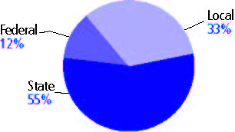

Title I allocation 2002-03 (ED; Includes Title I, Part A) | $106,001,974

Students

Public school enrollment (CCD) | 1993-94 | 2003-04
Pre-K | 1,132 | 2,573
K-8 | 312,340 | 318,225
9-12 | 125,931 | 132,712
Total (K-12) | 438,271 | 450,937

Race/ethnicity (CCD) | 1993-94 | 2003-04
American Indian/Alaskan Native | * | 1%
Asian/Pacific Islander | 1% | 1
Black, non-Hispanic | 24 | 23
Hispanic | 1 | 5
White, non-Hispanic | 74 | 70

Students with disabilities (OSEP) | 1993-94 | 2003-04
 | 10% | 12%

Students with limited  English proficiency (NCELA) | 1993-94 | 2003-04
 | 1% | 3%

Migrant students (OME) | 1993-94 | 2003-04
 | 3% | 4%

Eighth-grade students enrolled in Algebra I for high school credit (NAEP) | 1996 | 2003
 | 18% | 18%

Students eligible to participate in the Free or Reduced-Price Lunch Program, 2003-04 (CCD) | 226,389

All schools by percent of students eligible to participate in the Free or Reduced-Price Lunch Program, 2003-04† (CCD)

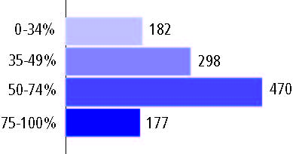
† 1 school did not report

Staff

Number of FTE teachers (CCD) | 1993-94 | 2003-04
Elementary | 12,480 | 13,464
Middle | 5,050 | 6,325
High | 7,623 | 9,544
Combined | 390 | 349
Other | 497 | 1,143
Total | 26,040 | 30,825

Number of FTE non-teacher staff (CCD) | 1993-94 | 2003-04
Instructional aides | 2,501 | 6,623
Instructional coordinators | 784 | 621
Administrators | 2,076 | 2,234
Other | 19,127 | 24,339
Total | 24,488 | 33,817

Percentage of teachers with a major in the main subject taught, grades 7-12 (SASS) | 1994 | 2000
English | 78% | 82%
Mathematics | 70 | 79
Science | 66 | 57
Social Studies | 70 | 64

Percentage of core courses taught by highly qualified teachers, 2003-04 (As defined and reported by states, collected by ED)

Outcomes

 | 1993-94 | 2000-01
High school dropout rate (NCES) | 5% | 5%
Avg. freshman graduation rate (NCES) | 77 | 74
College-going rate (IPEDS/NCES) | 48 | 53

NAEP state results
Reading, Grade 4 | 1994 | 2005
Proficient level or above | 24% | 29%
Basic level or above | 54 | 62
Math, Grade 8 | 1996 | 2005
Proficient level or above | 13% | 22%
Basic level or above | 52 | 64

Statewide Accountability Information:

State Accountability Website: http://www.as-is.org/reportcard/rc2003/

State assessment for NCLB accountability: Arkansas Benchmark Exams

State student achievement levels: Below Basic, Basic, Proficient, Advanced

 |  | 2001-02  Annual measurable  objective starting point | Target  2003-04
Grade 4 | Reading | 31.8% | 37.48%
 | Mathematics | 28.2 | 34.18
Grade 8 | Reading | 18.1 | 24.93
 | Mathematics | 15.3 | 22.36
High school | Reading | 19 | 25.75
 | Mathematics | 10.4 | 17.87

2003-04 NCLB accountability results, applied to 2004-05 school year
AYP outcomes and consequences | Title I schools |  | All schools |  | All districts
Made AYP | 523 | 64% | 789 | 77% | 310 | 100%
Identified for improvement:
Year 1 | 75 | 9% | 76 | 7% | 0 | 0
Year 2 | 6 | 1% | 61 | 6% | 0 | 0
Corrective action | 3 | * | 3 | * | 0 | 0
Restructuring | 1 | * | 1 | * | 0 | 0
Exited improvement status (made AYP twice after missing twice or more, includes total “made” above) | 0 | 0 | 0 | 0 | 0 | 0

Other indicator, 2003-04 | State target | State outcome
Elementary Indicator: Attendance | 92.70% | Met
Middle Indicator: Attendance | 92.70% | Met
High School Indicator: Graduation rate | 96.50% | Met

NCLB choice participation | Number of Title I students | Percent of eligible students
Title I school choice | 388 | *
Supplemental educational services | 3,369 | 23%

Student Achievement 2003-04

Arkansas Benchmark Exams, used for NCLB accountability
Grade 3

Reading
Proficient Level or above for:
All students | n/a
Economically disadvantaged students | n/a
Migrant students | n/a
Students with disabilities | n/a
Students with limited English proficiency | n/a
Black, non-Hispanic students | n/a
Hispanic students | n/a
White, non-Hispanic students | n/a

Trend Data Not Available

Arkansas Benchmark Exams, used for NCLB accountability
Grade 3

Mathematics
Proficient Level or above for:
All students | n/a
Economically disadvantaged students | n/a
Migrant students | n/a
Students with disabilities | n/a
Students with limited English proficiency | n/a
Black, non-Hispanic students | n/a
Hispanic students | n/a
White, non-Hispanic students | n/a

Trend Data Not Available

Arkansas Benchmark Exams, used for NCLB accountability
Grade 4

Reading
Proficient Level or above for:
All students | 68%
Economically disadvantaged students | 58
Migrant students | 52
Students with disabilities | 18
Students with limited English proficiency | 52
Black, non-Hispanic students | 49
Hispanic students | 60
White, non-Hispanic students | 76

Student achievement trend: Reading percent proficient level or above

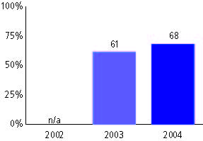

Arkansas Benchmark Exams, used for NCLB accountability
Grade 4

Mathematics
Proficient Level or above for:
All students | 64%
Economically disadvantaged students | 53
Migrant students | 51
Students with disabilities | 24
Students with limited English proficiency | 49
Black, non-Hispanic students | 38
Hispanic students | 56
White, non-Hispanic students | 74

Student achievement trend: Mathematics percent proficient level or above

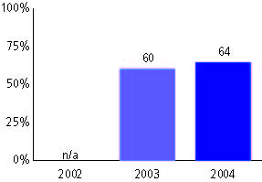

Arkansas Benchmark Exams, used for NCLB accountability
Grade 5

Reading
Proficient Level or above for:
All students | n/a
Economically disadvantaged students | n/a
Migrant students | n/a
Students with disabilities | n/a
Students with limited English proficiency | n/a
Black, non-Hispanic students | n/a
Hispanic students | n/a
White, non-Hispanic students | n/a

Trend Data Not Available

Arkansas Benchmark Exams, used for NCLB accountability
Grade 5

Mathematics
Proficient Level or above for:
All students | n/a
Economically disadvantaged students | n/a
Migrant students | n/a
Students with disabilities | n/a
Students with limited English proficiency | n/a
Black, non-Hispanic students | n/a
Hispanic students | n/a
White, non-Hispanic students | n/a

Trend Data Not Available

Arkansas Benchmark Exams, used for NCLB accountability
Grade 6

Reading
Proficient Level or above for:
All students | 41%
Economically disadvantaged students | 28
Migrant students | 27
Students with disabilities | 37+42 portfolios (299)
Students with limited English proficiency | 19+74 portfolios (252)
Black, non-Hispanic students | 19
Hispanic students | 33
White, non-Hispanic students | 49

Student achievement trend: Reading percent proficient level or above

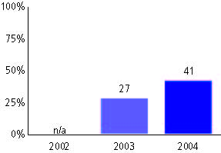

Arkansas Benchmark Exams, used for NCLB accountability
Grade 6

Mathematics
Proficient Level or above for:
All students | 40%
Economically disadvantaged students | 27
Migrant students | 28
Students with disabilities | 6+40 portfolio (297)
Students with limited English proficiency | 23+90 portfolio (252)
Black, non-Hispanic students | 16
Hispanic students | 35
White, non-Hispanic students | 49

Student achievement trend: Mathematics percent proficient level or above

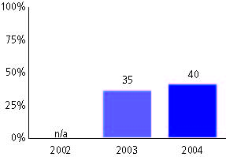

Arkansas Benchmark Exams, used for NCLB accountability
Grade 7

Reading
Proficient Level or above for:
All students | n/a
Economically disadvantaged students | n/a
Migrant students | n/a
Students with disabilities | n/a
Students with limited English proficiency | n/a
Black, non-Hispanic students | n/a
Hispanic students | n/a
White, non-Hispanic students | n/a

Trend Data Not Available

Arkansas Benchmark Exams, used for NCLB accountability
Grade 7

Mathematics
Proficient Level or above for:
All students | n/a
Economically disadvantaged students | n/a
Migrant students | n/a
Students with disabilities | n/a
Students with limited English proficiency | n/a
Black, non-Hispanic students | n/a
Hispanic students | n/a
White, non-Hispanic students | n/a

Trend Data Not Available

Arkansas Benchmark Exams, used for NCLB accountability
Grade 8

Reading
Proficient Level or above for:
All students | 51%
Economically disadvantaged students | 37
Migrant students | 28
Students with disabilities | 6
Students with limited English proficiency | 16
Black, non-Hispanic students | 27
Hispanic students | 38
White, non-Hispanic students | 60

Student achievement trend: Reading percent proficient level or above

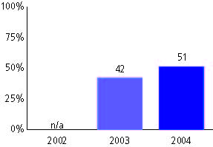

Arkansas Benchmark Exams, used for NCLB accountability
Grade 8

Mathematics
Proficient Level or above for:
All students | 31%
Economically disadvantaged students | 18
Migrant students | 16
Students with disabilities | -
Students with limited English proficiency | 8
Black, non-Hispanic students | 9
Hispanic students | 19
White, non-Hispanic students | 39

Student achievement trend: Mathematics percent proficient level or above

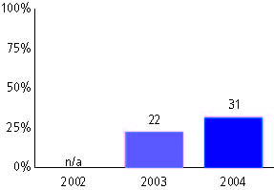

Arkansas Benchmark Exams, used for NCLB accountability
High school

Reading
Proficient Level or above for:
All students | 45%
Economically disadvantaged students | 26
Migrant students | 19
Students with disabilities | -
Students with limited English proficiency | 11
Black, non-Hispanic students | 18
Hispanic students | 27
White, non-Hispanic students | 54

Student achievement trend: Reading percent proficient level or above

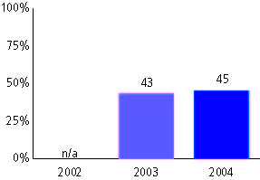

Arkansas Benchmark Exams, used for NCLB accountability
High school

Mathematics
Proficient Level or above for:
All students | 53%
Economically disadvantaged students | 39
Migrant students | 37
Students with disabilities | 12
Students with limited English proficiency | 24
Black, non-Hispanic students | 23
Hispanic students | 42
White, non-Hispanic students | 63

Student achievement trend: Mathematics percent proficient level or above

