State of West Virginia
Consolidated State Application
Accountability Workbook

for State Grants under Title IX, Part C, Section 9302 of the Elementary and
Secondary Education Act (Public Law 107-110)

REVISED

June 30, 2008



Steven L. Paine
State Superintendent of Schools

PART I: Summary of Required Elements for State Accountability Systems

Summary of Implementation Status for Required Elements of

State Accountability Systems

Status |  | State Accountability System Element | Page
Principle 1: All Schools
F | 1.1 | Accountability system includes all schools and districts in the state. | 4
F | 1.2 | Accountability system holds all schools to the same criteria. | 5
F | 1.3 | Accountability system incorporates the academic achievement standards. | 7
F | 1.4 | Accountability system provides information in a timely manner. | 8
F | 1.5 | Accountability system includes report cards. | 9
F | 1.6 | Accountability system includes rewards and sanctions. | 11

Principle 2: All Students
F | 2.1 | The accountability system includes all students. | 14
F | 2.2 | The accountability system has a consistent definition of full academic year. | 16
F | 2.3 | The accountability system properly includes mobile students. | 17

Principle 3: Method of AYP Determinations
F | 3.1 | Accountability system expects all student subgroups, public schools, and LEAs to reach proficiency by 2013-14. | 18
F | 3.2 | Accountability system has a method for determining whether student subgroups, public schools, and LEAs made adequate yearly progress. | 25
F | 3.2a | Accountability system establishes a starting point. | 27
F | 3.2b | Accountability system establishes statewide annual measurable objectives. | 29
F | 3.2c | Accountability system establishes intermediate goals. | 30

Principle 4: Annual Decisions
F | 4.1 | The accountability system determines annually the progress of schools and districts. | 32

STATUS Legend:
F – Final state policy
P – Proposed policy, awaiting State approval
W – Working to formulate policy

Status |  | State Accountability System Element | Page

Principle 5: Subgroup Accountability
F | 5.1 | The accountability system includes all the required student subgroups. | 34
F | 5.2 | The accountability system holds schools and LEAs accountable for the progress of student subgroups. | 35
F | 5.3 | The accountability system includes students with disabilities. | 36
F | 5.4 | The accountability system includes limited English proficient students. | 39
F | 5.5 | The State has determined the minimum number of students sufficient to yield statistically reliable information for each purpose for which disaggregated data are used. | 40
F | 5.6 | The State has strategies to protect the privacy of individual students in reporting achievement results and in determining whether schools and LEAs are making adequate yearly progress on the basis of disaggregated subgroups. | 42

Principle 6: Based on Academic Assessments
F | 6.1 | Accountability system is based primarily on academic assessments. | 43
Principle 7: Additional Indicators
F | 7.1 | Accountability system includes graduation rate for high schools. | 45
F | 7.2 | Accountability system includes an additional academic indicator for elementary and middle schools. | 46
F | 7.3 | Additional indicators are valid and reliable. | 47

Principle 8: Separate Decisions for Reading/Language Arts and Mathematics
F | 8.1 | Accountability system holds students, schools and districts separately accountable for reading/language arts and mathematics. | 48

Principle 9: System Validity and Reliability
F | 9.1 | Accountability system produces reliable decisions. | 50
F | 9.2 | Accountability system produces valid decisions. | 51
F | 9.3 | State has a plan for addressing changes in assessment and student population. | 53

Principle 10: Participation Rate
F | 10.1 | Accountability system has a means for calculating the rate of participation in the statewide assessment. | 54
F | 10.2 | Accountability system has a means for applying the 95% assessment criteria to student subgroups and small schools. | 55

STATUS Legend: F – Final State policy P – Proposed policy, awaiting State approval
W – Working to formulate policy

PART II: State Response and Activities for Meeting State Accountability System Requirements

PRINCIPLE 1. A single statewide Accountability System applied to all public schools and LEAs.

1.1 How does the State Accountability System include every public school and LEA in the State?

Every West Virginia public school and Local Education Agency (LEA) is required to make adequate yearly progress (AYP) and is included in the State Accountability System, as specified in West Virginia Board of Education Policy 2320.

For the purpose of determining AYP, West Virginia public schools are defined as those elementary and secondary schools established and maintained at public expense through the total basic foundation program/state aid formula outlined in W.Va. Code §18-9A-3 and W.Va. Code §18-9A-12. For the purposes of AYP determination, an elementary school is one that has a grade configuration that may include grades K-4, but does not contain grade 8 or higher. A middle school is a school that does not meet the definition of an elementary school and contains grade 8, but does not contain grade 12. A high school is any school that contains grade 12. The LEA is defined as the county school district.

Students who attend alternative education programs as defined in West Virginia Board of Education Policy 2418 are included in the state accountability system by having individual test scores aggregated in the results of the home county school district/school of referral.

The West Virginia Office of Education Performance Audits, through periodic on-site reviews completed at least once every three years, determines AYP for public schools without grades assessed (i.e., K-2 schools). The performance audit includes a review of informal reading and mathematics student assessment results and verifies compliance with legislation and policies required by the State of West Virginia.

There are approximately 41 small schools in West Virginia that do not have a total of 50 in the tested class levels. For those small schools, the Office of Education Performance Audits determines AYP using the total subgroup only and averaging the scores for the current year tested plus the previous two years in order to make the AYP decision more reliable.

Evidence*:
W.Va. Code §§18-1-2, 18-9A-3 and 18-9A-12
West Virginia Board of Education Policy 2418, http://wvde.state.wv.us/policies/p2418.html
West Virginia Board of Education Policy 2320

*Note: A policy citation that does not include a website address is an indication that the policy is under revision.
1.2 How are all public schools and LEAs held to the same criteria when making an AYP determination?

The current systems of assessment and accountability are defined in West Virginia Board of Education Policy 2340: Statewide Assessment System and proposed Policy 2320: A Process for Improving Education--Performance Based Accreditation System.

- The Accreditation System Policy 2320, Section 5 includes the state assessment, participation, graduation or attendance accountability standards revised to meet the No Child Left Behind (NCLB) federal language.

All West Virginia public schools and LEAs are systematically judged on the basis of the same criteria when making an AYP determination.

For the purpose of determining AYP, West Virginia public schools are defined as those elementary and secondary schools established and maintained at public expense through the total basic foundation program/state aid formula outlined in W.Va. Code §18-9A-3 and W.Va. Code §18-9A-12. For the purposes of AYP determination, an elementary school is one that has a grade configuration that may include grades K-4, but does not contain grade 8 or higher. A middle school is a school that does not meet the definition of an elementary school and contains grade 8, but does not contain grade 12. A high school is any school that contains grade 12. The LEA is defined as the county school district.

Students who attend alternative education programs as defined in West Virginia Board of Education Policy 2418 are included in the state accountability system by having individual test scores aggregated in the results of the home county school district/school of referral.

The West Virginia Office of Education Performance Audits, through periodic on-site reviews completed at least once every three years, determines AYP for public schools without grades assessed (i.e., K-2 schools). The performance audit includes a review of informal reading and mathematics student assessment results and verifies compliance with legislation and policies required by the State of West Virginia.

All students with disabilities in West Virginia public schools as defined under Section 602(3) of the Individuals with Disabilities Education Act (IDEA) amendments of 1997 and West Virginia Board of Education Policy 2419: Regulations for the Education of Exceptional Students, participates in the West Virginia Assessment Program. The Individualized Education Program (IEP) Team determines how students with disabilities will participate in the statewide assessment program (i.e., West Virginia Educational Standards Test (WESTEST) or West Virginia Alternate Performance Task Assessment (WV APTA)) as defined in West Virginia Board of Education Policies 2340 and 2419. The WV APTA yields reading/language arts and mathematics assessment results for inclusion in AYP determination.

West Virginia has identified five performance levels for the new assessments (WESTEST). WESTEST is comprised of custom-developed assessments that include multiple measures in the areas of reading/language arts, mathematics, science, and social studies. The assessments are administered in grades 3 through 8 and grade 10, and beginning in 2008-2009, these assessments will be administered in grades 3 through 8 and 11.

Students’ scores from the WV APTAare aggregated with those from the WESTEST for all students and each subgroup. The following process was developed to aggregate the scores from the WV APTA with those from the WESTEST for the school, district and state results. (See Section 5.3.)

Not more than 1% of the student scores on the APTA may be counted as Proficient in the county and state accountability calculations. The local school districts will identify the students whose scores will be excluded as proficient in the annual accountability calculation as per the language in Principle 5: 5.3 (page 39). .

All of the required subgroups, including students with disabilities, who are enrolled in a public school for a full academic year are included in the performance measures that determine AYP, accreditation status of schools and the approval status of LEAs. (West Virginia Board Policy 2320: A Process for Improving Education—Performance Based Accreditation System, 2003)

Evidence:
W. Va. Code §18-1-2
WV Board of Education Policy 2418, http://wvde.state.wv.us/policies/p2418.html
WV Board of Education Policy 2340
WV Board of Education Policy 2320
WV Board of Education Policy 2419, http://wvde.state.wv.us/policies/p2419.html
1.3 Does the State have, at a minimum, a definition of basic, proficient, and advanced student achievement levels in reading/language arts and mathematics?

West Virginia has defined five levels of student achievement for the WESTEST: distinguished, above mastery, mastery, partial mastery and novice. A general description of each of these levels is listed below:

■ Distinguished: Student demonstrates knowledge, comprehension, application, analysis, synthesis, and evaluation of skills, which exceed the standard.

■ Above Mastery: Student demonstrates knowledge, comprehension, application, and analysis of skills, which exceed the standard.

■ Mastery**: Student demonstrates knowledge, comprehension, and application of skills, which meet the standard.

■ Partial Mastery: Student demonstrates knowledge and recall of skills toward meeting the standard.

■ Novice: Student does not demonstrate knowledge and recall of skills needed to meet the standard.

For each of the content standards in reading and English language arts and mathematics, five levels of performance descriptors have been developed. Mastery Level is the Proficient Level of performance for West Virginia.

All of the WESTEST assessments are aligned to the content standards and descriptors. There are two cuts below proficient and two cuts above proficient as per the above-mentioned performance levels. In order to determine achievement levels, the four cut scores have been set on a composite scale using Bookmark methodology.
**West Virginia has identified the mastery level as meeting the proficient level specified in No Child Left Behind.

Evidence:
WV Board of Education Policy 2510
WV Board of Education Policy 2520.1
WV Board of Education Policy 2520.2
West Virginia Standard Setting Procedure
Request for Proposal for Alignment Study
1.4 How does the State provide accountability and adequate yearly decisions and information in a timely manner?

West Virginia provides decisions about adequate yearly progress (AYP) in time for LEAs to implement the required provisions of No Child Left Behind before the beginning of the next academic year.

Current West Virginia Board of Education Policy 2340 and W.Va. Code §18-2E-4 requires data input, scoring and the reporting of results to schools and parents. For the purpose of determining AYP, the West Virginia Department of Education ensures that results of the State academic assessment are available to the LEAs in a timely manner. (See Chart 1.)

Chart 1. Timeline
Timeline | Activity
May Test Administration Week (annually) | Statewide Assessment Administration
The week following Test Administration will become the Make-Up Week (annually) | Statewide Assessment Make-Up window
At the end of the testing window (annually) | Collection of information on students enrolled for full academic year
Six to Eight Weeks from Assessment Administration | Assessment vendor required to provide assessment results to the WVDE
Early August (annually) | Schools receive assessment results
Early August (annually) | Schools are notified of preliminary AYP status
No later than the first day of school | LEA notification to parents regarding school choice and supplemental services
No later than thirty days after preliminary identification of Schools/LEAs not meeting AYP (annually) | District/LEA Appeals Process Begins  Challenged agency renders final determination in response to appeal

Evidence:
W.Va. Code §18-2E-4
WV Board of Education Policy 2340
WV Board of Education Policy 2320
Right Response Summaries: Student, School, County and State
  - Does the State Accountability System produce an annual State Report Card?

West Virginia has published a State Report Card as required by W. Va. Code §18-2E-4 since 1989. Using the existing management information system, a No Child Left Behind (NCLB) Report Card for schools and LEAs are published annually according to NCLB requirements for state reporting.

The West Virginia Department of Education operates a management information system for all schools and all county boards of education. The system is on-line, is interactive and operates over a privately addressed Intranet. Standard data element definitions and codes are used statewide.

The West Virginia Department of Education collects from school files the information needed for state and federal reporting and decision-making. The enrollment collection contains information about the enrollment of the student attributes such as active special education, limited English proficient (LEP), migrant, grade level, gender, race, free/reduced lunch status, etc. This file is collected three times during the school year for NCLB purposes: mid-October, early February, and May (end of the testing window). Schools are required to verify the data submitted in these files to assure accuracy.

The NCLB Report Card includes information, in the aggregate, on student achievement at each proficiency level on the state academic assessment (WESTEST) including the West Virginia Alternate Performance Task Assessment (WV APTA), disaggregated by (1) all students, (2) race, (3) gender, (4) disability, (5) migrant status, (6) limited English proficiency status and (7) economically disadvantaged status. The report card includes the most recent two-year results in student achievement in reading/language arts and mathematics performance levels. The percent of students not tested, graduation rates for secondary schools and attendance rates for elementary/middle schools are reported in aggregate.

The professional qualifications of teachers in the State and the number of such teachers teaching with emergency or provisional credentials are provided on the State report card. The percent of classes not taught by highly qualified teachers are disaggregated by high poverty compared to low poverty schools.

The NCLB Report Card contains information on schools not making AYP according to NCLB, Section 1116. A listing of all schools that failed to make AYP for the year is reported.

The NCLB Report Card is published for libraries and schools in printed form and is made available to the public on the West Virginia Department of Education website.

Statewide assessment results are provided to the West Virginia Department of Education in August and the NCLB Report Card is made available to schools prior to the first day of October.

Evidence:
West Virginia State Code § 18-2E-4
1.6 How does the State Accountability System include rewards and sanctions for public schools and LEAs?

The system of assessment is defined in West Virginia Board of Education Policy 2340: Statewide Assessment System. The current accountability standards are described in proposed Policy 2320: A Process for Improving Education: Performance Based Accreditation System.

West Virginia’s state accountability system includes rewards and sanctions for public schools and LEAs. The State’s accreditation policy, West Virginia Board of Education Policy 2320, prescribes consequences for schools/LEAs that do not meet accreditation standards. These consequences range from revision of the Unified School Improvement Plan or Unified County Improvement Plan to possible State takeover of the school or LEA. In addition, all Title I public schools are subject to the requirements of Section 1116 of NCLB. (See Chart 2: West Virginia School Sanctions; and Chart 3: West Virginia LEA Sanctions.)

Chart 2. West Virginia School Sanctions
West Virginia School Sanctions
Not Meeting AYP After | State School  Policy 2320 | Title I School  Section 1116
Year 1 | Recommend Unified School Improvement Plan revision to address identified deficiencies | Recommend Unified School Improvement Plan and Title I Plan revision to address identified deficiencies
Year 2 | Temporary Accreditation Status  - Revise USIP with improvement date certain (1-5 yrs)  - Upgraded to Conditional Status when approved  - State will provide assistance | School Improvement  - Improvement Plan  - 10% of Title I allotment identified for staff development  - Technical Assistance (SEA & LEA)  - LEA must offer School Choice
Year 3 | Continue Conditional Status or be designated as Seriously Impaired if date certain not met  - State assigns Improvement Consultant Team  - State may designate a Distinguished Educator to provide assistance | School Improvement  - Previous year sanctions plus  - Supplemental Services for eligible students
Year 4 | Continue Conditional Status or be designated as Seriously Impaired  - Schools revise USIP with a date certain  - School Choice after 1 year as Seriously Impaired | School Improvement  - Previous year sanctions plus  - Corrective Action
Chart 2. West Virginia School Sanctions (continued)
Year 5 | Seriously Impaired Status  - Required State intervention with a monitor | School Improvement  - Previous year sanctions plus  - Develop a plan for Alternative Governance
Year 6 | Seriously Impaired Status  - State intervention and control which may include replacing the principal | School Improvement  - Previous year sanctions plus  - Implement Alternative Governance Plan

Chart 3. West Virginia LEA Sanctions
West Virginia LEA Sanctions
Not meeting AYP after | State LEA  Policy 2320 | Title I LEA  Section 1116
Year 1 | Recommend Unified County Improvement Plan revision to assist with school improvement | Recommend Unified County Plan and Title I County Plan revision to assist with school improvement
Year 2 | Recommend Unified County Improvement Plan revision to assist with school improvement | LEA Improvement  - LEA Two-Year Improvement Plan  - 10% 0f Title I allotment for Staff Development  - Technical SEA Assistance
Year 3 | County placed on Temporary Approval  - Revise UCIP with date certain set for improvement deadline | LEA Improvement  - Previous Sanctions
Year 4 | LEA continues Conditional Approval or is placed on Nonapproval Status if the date certain is not met  - State of Emergency declared (WV Code § 18-2E-5)  - LEA must pay for monitor of Seriously Impaired schools not meeting date certain | LEA Improvement  - Corrective Action
Year 5 | LEA continues Conditional Approval or placed on Nonapproval  - State intervention at the LEA level possible
Year 6 | LEA continues Conditional Approval or placed on Nonapproval  - State intervention at the LEA level possible
Rewards
Exemplary status is issued to a public school when the measure of the school’s student and school performance and progress substantially exceeds the minimal level performance on the standards adopted by the West Virginia Board of Education. The West Virginia Department of Education also recognizes exemplary programs in individual schools or LEAs that contribute to outstanding student performance. Title I schools that exceed the West Virginia performance standards are recognized as West Virginia Distinguished Schools.

Evidence:
WV Board of Education Policy 2320
West Virginia RFP for Supplemental Services Providers
Approved List of Supplemental Services Providers
West Virginia Office of Education Performance Audits Book of Ratings (Accountability Ratings)
PRINCIPLE 2. All students are included in the State Accountability System.

2.1 How does the State Accountability System include all students in the State?

All West Virginia public schools and LEA school systems (LEAs) are systematically judged on the basis of the same criteria when making an AYP determination using data collected through the West Virginia Education Information System (WVEIS). This system is the statewide management system for all public schools and LEAs. The system provides an on-line interactive Management Information System (MIS) for student management (student information, scheduling, grades and attendance) and financial applications (financial accounting, payroll, personnel, fixed assets and warehousing). All public schools and school systems use standard codes and definitions for data entry. The WVDE extracts data for state and federal reporting from these active files. Every student enrolled in the state has a record in WVEIS. Every student in the state has assessment results, which are imported, into the WVEIS data files. This allows student records to be matched for the determination of AYP.

For the purpose of determining AYP, West Virginia public schools are defined as those elementary and secondary schools established and maintained at public expense through the total basic foundation program/state aid formula outlined in W.Va. Code §19-9A-3 and W.Va. Code §18-9A-12. For the purposes of AYP determination, an elementary school is one that has a grade configuration that may include grades K-4, but does not contain grade 8 or higher. A middle school is a school that does not meet the definition of an elementary school and contains grade 8, but does not contain grade 12. A high school is any school that contains grade 12. LEA is defined as the county school district. (W. Va. Code § 18-1-2)

For all students in every public school and LEA, all data regarding assessment and attendance and/or graduation is collected for each student through the WVEIS and this data is used for reporting school, district and state accountability results.

Students in alternative education programs as defined in West Virginia Board of Education Policy 2418 are included in the state accountability system by having individual test scores aggregated in the results of the home county school district/school of referral.

The West Virginia Office of Education Performance Audits, through periodic on-site reviews completed at least once every three years, determines AYP for public schools without grades assessed (i.e., K-2 schools). The performance audit includes a review of informal reading and mathematics student assessment results and verifies compliance with legislation and policies required by the State of West Virginia.

All students with disabilities in West Virginia public schools as defined under Section 602(3) of the Individuals with Disabilities Education Act (IDEA) amendments of 1997 and West Virginia Board of Education Policy 2419: Regulations for the Education of Exceptional Students, participates in the West Virginia Assessment Program. The Individualized Education Program (IEP) Team determines how students with disabilities will participate in the statewide assessment program (i.e., WESTEST or WVAPTA) as defined in West Virginia Board of Education Policies 2340 and 2419. The WVAPTA yields reading/language arts and mathematics assessment results for inclusion in AYP determination.

All students with limited English proficiency in West Virginia public schools are required to participate in the West Virginia Statewide Assessment Program (West Virginia Board of Education Policy 2340: The Statewide Assessment Program). Limited English Proficiency (LEP), when used with reference to individuals, means (a) individuals who were not born in the United States or whose native language is a language other than English; (b) individuals who come from environments where a language other than English is dominant; and (c) individuals who are American Indian and Alaskan natives and who come from environments where a language other than English has had a significant impact on their level of English language proficiency, and who, by reason thereof, have sufficient difficulty speaking, reading, writing, or understanding the English language to deny such individuals the opportunity to learn successfully in classrooms, where the language of instruction is English. For purposes of making AYP determinations, West Virginia counts the scores of former LEP students in the LEP subgroup for two years after those students are no longer considered to be LEP. For accountability purposes, West Virginia State Board Policy 2320: A Process for Improving Education: Performance Based Accreditation System outlines the inclusion of all students with limited English proficiency (LEP) who have attended a school for a full academic year.

All of the required subgroups, including students with limited English proficiency, who are enrolled in a school for a full academic year are included in the performance level measures that determine AYP, accreditation status of schools and the approval status of LEAs.

West Virginia grants participation rate exemptions for students with a significant medical emergency.

Evidence:
W. Va. Code § 18-1-2
West Virginia Board of Education Policy 2320
West Virginia Board of Education Policy 2340
West Virginia Board of Education Policy 2419, http://wvde.state.wv.us/policies/p2419.html

2.2 How does the State define “full academic year” for identifying students in AYP decisions?

The following definition of students to be included in the accountability system through the completion of a full academic year has been developed by a statewide committee appointed by the West Virginia Board of Education and is being inserted in Policy 2320.

For inclusion in AYP determination
A student who is enrolled continuously in that school from the fifth instructional day of school to the spring testing window is included when determining if the school has made adequate yearly progress. A student is continuously enrolled if s/he has not transferred or dropped out of that school. A student who is enrolled continuously in the LEA from the fifth instructional day of school to the spring testing window is included when determining if the LEA has made adequate yearly progress. A student who is enrolled continuously in the state from the fifth instructional day of school to the spring testing window is included when determining if the state has made adequate yearly progress.

For the state and each LEA, and school to make AYP, 95% of the students enrolled at the time of testing in each subgroup must be assessed, as specified in Policy 2320.

Evidence:
W.Va. Code §§18-2E-1, 18-2E-1a, 18-2E-8 (c)(1)
WV Board of Education Policy 2340
WV Board of Education Policy 2320
WV Board of Education Policy 2510

2.3 How does the State Accountability System determine which students have attended the same public school and/or LEA for a full academic year?

The following definition of students to be included in the accountability system through the completion of a full academic year has been developed by a statewide committee appointed by the West Virginia Board of Education and is being inserted in Policy 2320.

For inclusion in AYP determination

All schools, LEAs and the State are held accountable for the AYP indicators:

A student who is enrolled continuously in that school from the fifth instructional day of school to the spring testing window is included when determining if the school has made adequate yearly progress.

A student who is enrolled continuously in the LEA district from the fifth instructional day of school to the spring testing window is included when determining if the LEA has made adequate yearly progress.

A student who is enrolled continuously in the state from the fifth instructional day of school to the spring testing window is included when determining if the state has made adequate yearly progress.

Additionally, a student is continuously enrolled if s/he has not transferred or dropped out of that school. Students who are serving suspensions/expulsions are still considered to be enrolled students.

Every student enrolled in West Virginia public schools is given a unique identification number that does not change as long as the student is enrolled in West Virginia public schools. The West Virginia Education Information System (WVEIS) uses these unique student identification numbers to track student enrollment and student achievement over time. Students not continuously enrolled for a full academic year at the school level are included in the determination for AYP at the local and state accountability levels. All students not enrolled for the full academic year at the school level are tracked by the unique identification number assigned to them by WVEIS.

Evidence:
WV Board of Education Policy 2320
PRINCIPLE 3. State definition of AYP is based on expectations for growth in student achievement that is continuous and substantial, such that all students are proficient in reading/language arts and mathematics no later than 2013-2014.

3.1 How does the state’s definition of adequate yearly progress require all students to be proficient in reading/language arts and mathematics by the 2013-2014 school year?

West Virginia’s definition of adequate yearly progress (AYP) requires all students to be proficient in reading/language arts and mathematics by the end of the 2013-14 school year and requires all students and each subgroup to be held accountable to meet all of the academic indicators used to measure AYP (percent proficient in reading/language arts and mathematics; percent of participation in the assessments; graduation rate for secondary schools; and attendance rate for elementary and middle schools). (See Chart 4.)

The West Virginia definition of AYP was submitted to the West Virginia State Board of Education in January 2003, and was submitted and approved by the United States Department of Education.

Chart 4. Accountability Subgroups and Academic Indicators
 | Academic Indicators |  | Participation Rate |  | Graduation/Attendance Rate *
 | Reading/LA  % Meeting Standard | Mathematics  % Meeting Standard | Reading/LA | Mathematics | Graduation/Attendance Rate *
All Students
Economically
Disadvantaged
R/E White
R/E Black
R/E Hispanic
R/E Asian
R/E American Indian/Alaskan
Students with Disabilities
LEP Students
* The school/LEA is not required to disaggregate graduation rate and attendance rate data into the subgroups for accountability unless the school/LEA is using the “Safe Harbor” provision to meet AYP.

All subgroups identified in Chart 4 are held accountable to the academic indicators of reading/language arts and mathematics. West Virginia has outlined a ten-year timeline for public schools to reach the goal of 100% of students proficient in reading/language arts and mathematics by the end of the 2013-14 school year. Annual intermediate goals have been established, beginning in the school year 2005–06, to ensure? increases in the percent of students proficient in reading/language arts and mathematics over the next eight years.

As West Virginia defines annual intermediate goals, the first increase has been established for the spring of 2007. The trajectories provide annual incremental increases to assure that West Virginia public schools and districts meet the goal of 100% proficiency in 2013-14.

The development of intermediate goals included the following assumptions for West Virginia:
Starting Point
Starting Point
- Calculate the starting point for determining AYP based on 2003-04 assessment data that followed the recommendations of the United States Department of Education. (See Chart 6 in this document.) This percent served as the standard for AYP for the 2003-04 school year.
Starting Point
Starting Point
- Recalculate the starting point, using the average of two years of assessment data (2003-04 and 2004-05) for reading/language arts and mathematics. This served as the AYP standard for the 2004-05 school year. These averages were used to determine intermediate goals and annual measurable objectives by grade configuration for the next eight years.

In the summer of 2005, elementary, middle and high school grade span starting points were established from two years of baseline data to determine the state-level projections for intermediate goals and annual measurable goals for reading/language arts and mathematics through 2014. The goals and objectives were set separately for reading/language arts and mathematics. Additionally, the goals and objectives may be different for each grade configuration. The annual measurable objectives are defined in Section 3.2b and the intermediate goals are defined in 3.2c. These objectives and goals will ensure? that all students will reach the proficient level of performance by 2013-2014.
.
GROWTH OBJECTIVE (“Safe Harbor” Provision)
If any student sub-groups do not meet or exceed the state annual measurable objectives, the public school or LEA is considered to have met AYP if the percent of students in the non-proficient subgroup:
1) Decreased by 10% on the reading/language arts and mathematics indicators from the preceding school year, and
- Made progress on one or more of the other indicators, or is at/above the target goal for that indicator.
95% participation rate?????

West Virginia’s assessment window includes ten school calendar days. The first week of the testing window is considered the test administration window and the second week is considered the make-up window.

The following six (6) West Virginia trajectories were calculated using the process outlined in Chart 6 (page 27) in this document.

- The first three (3) trajectories provide the percentage of progress required in reading for elementary, middle and secondary schools by intermediate goals and annual measurable objectives.
- The next three (3) trajectories provide the percentage of progress required in mathematics for elementary, middle and secondary schools by intermediate goals and annual measurable objectives

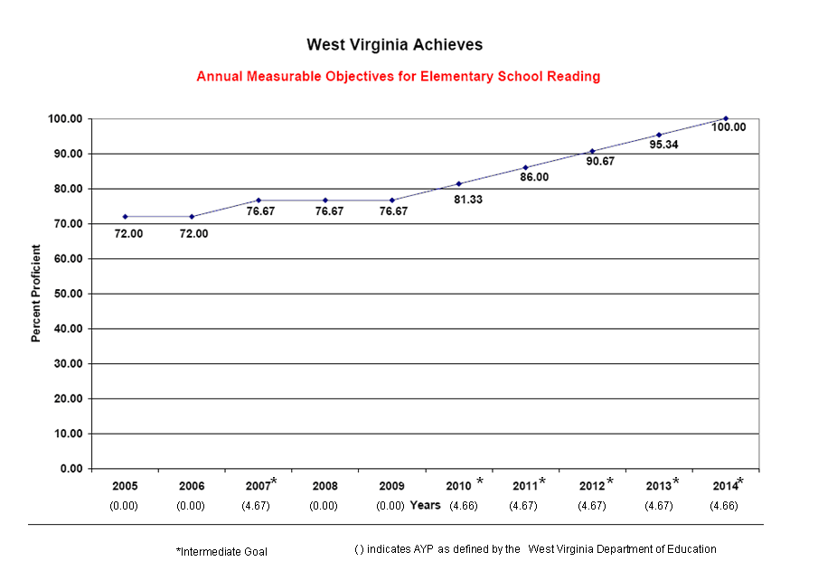
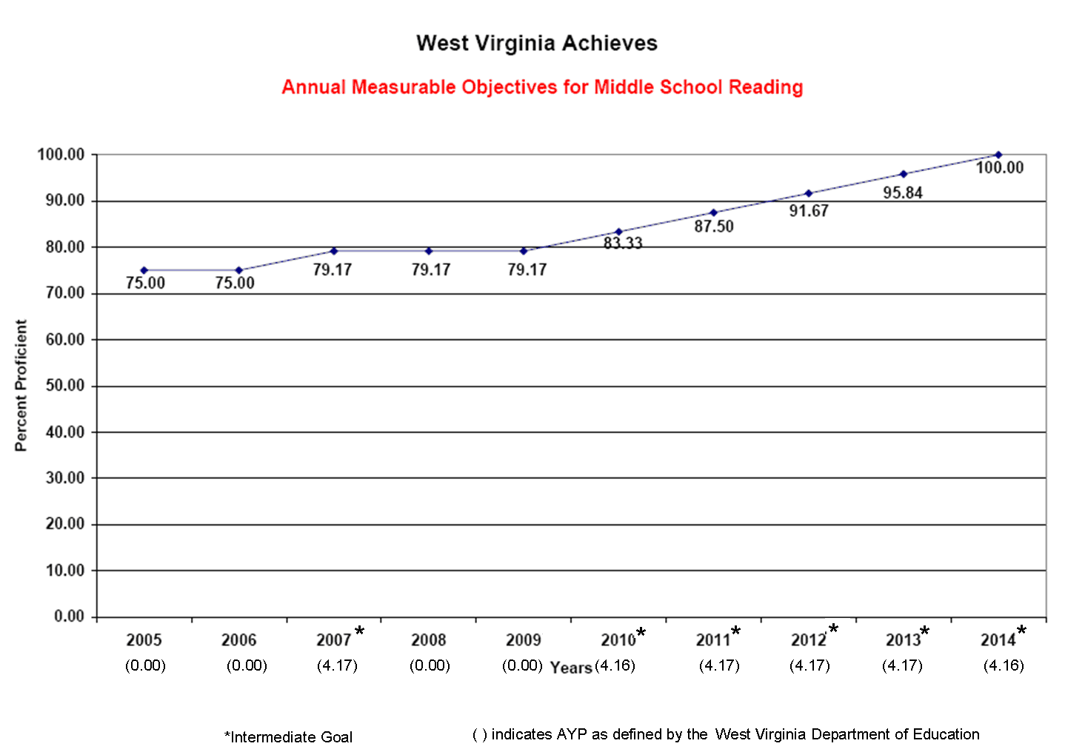
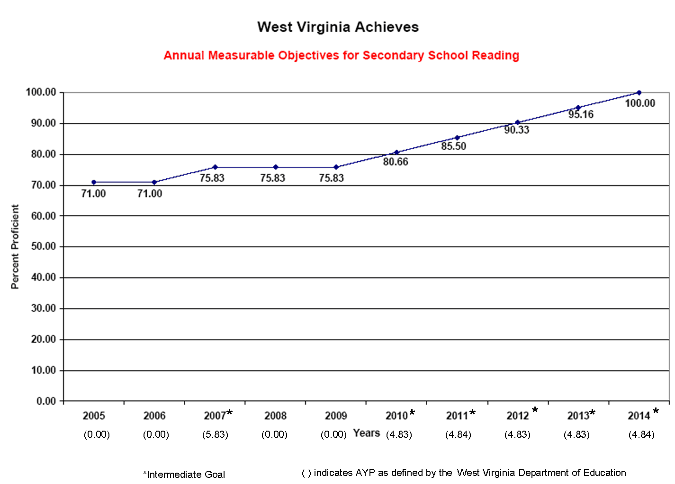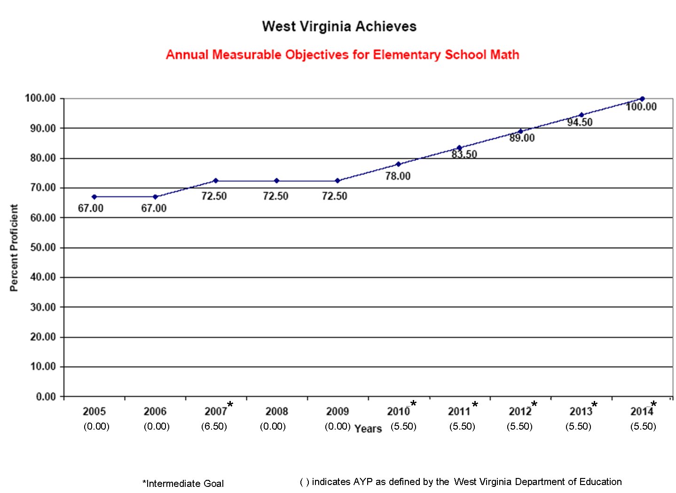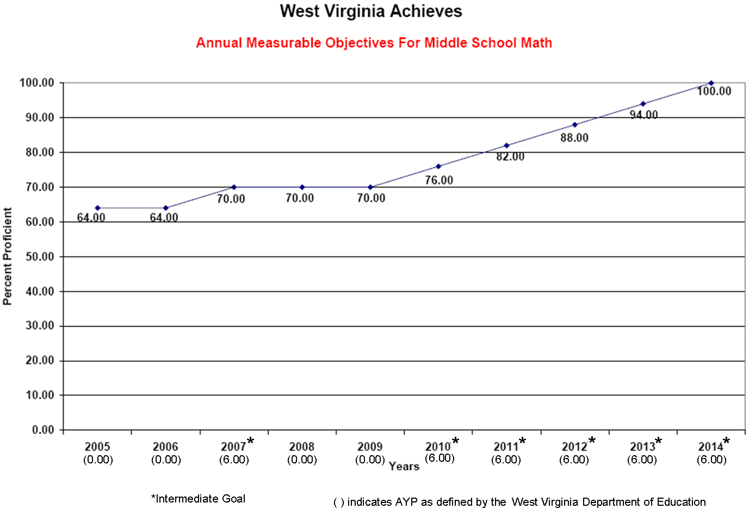

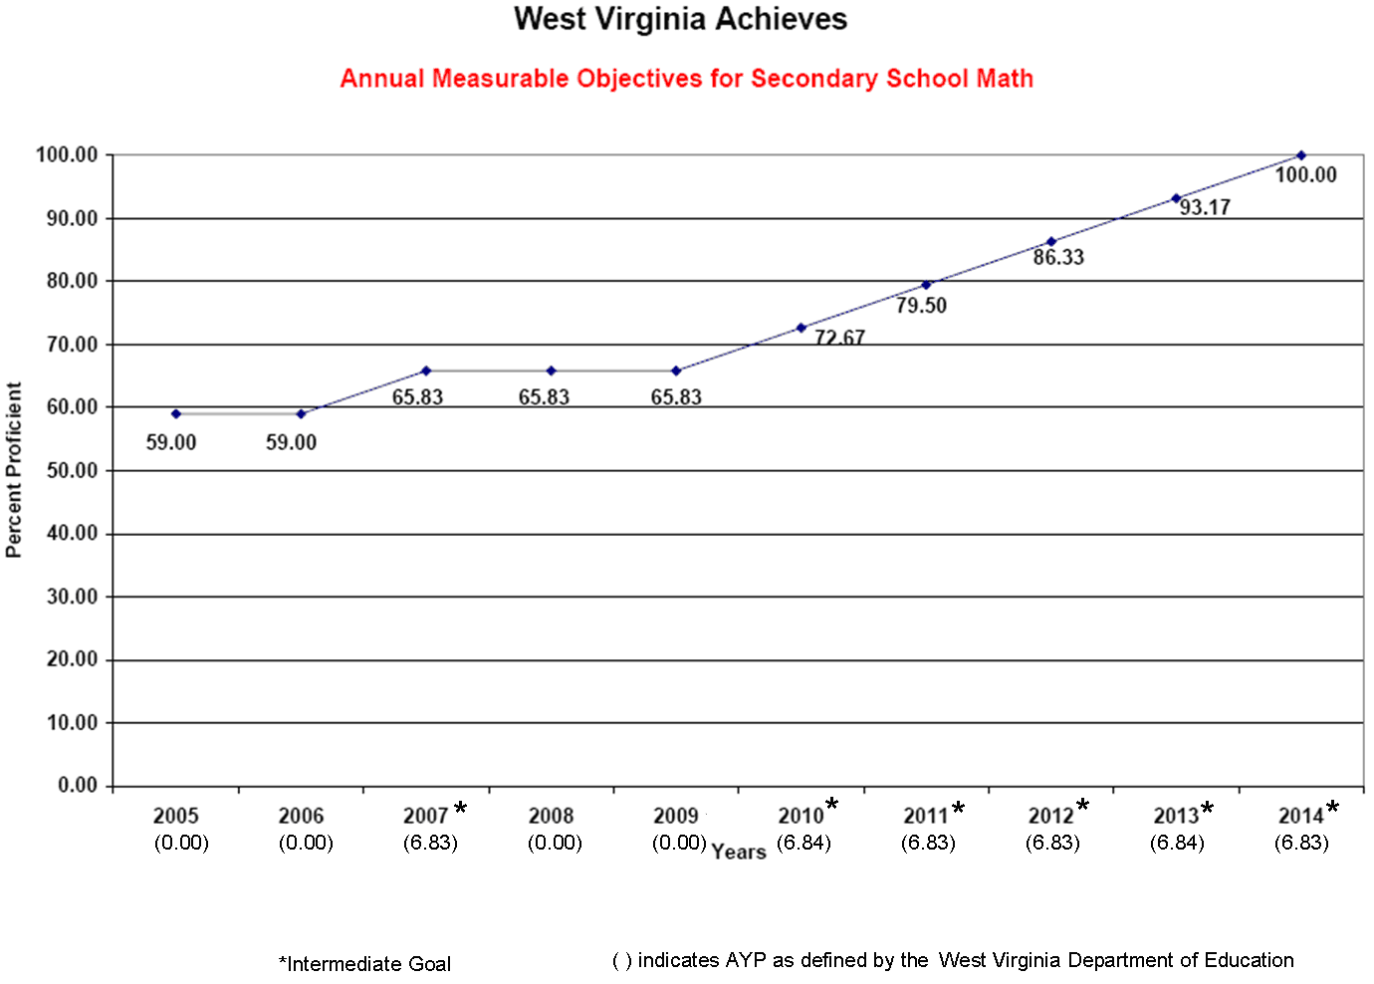
Evidence:
West Virginia Board of Education Policy 2340
West Virginia’s Request For Proposal for the Statewide Assessment Program (Executive Summary)
West Virginia’s State Consolidated Plan
West Virginia’s Statewide Assessment Schedule
3.2 How does the State Accountability System determine whether each student subgroup, public school and LEA makes AYP?

West Virginia’s State Accountability System bases its annual determination of whether each subgroup, public school and LEA makes AYP on the achievement of all students, including these subgroups: economically disadvantaged, racial/ethnic, students with disabilities and limited English proficient. West Virginia’s AYP calculation also incorporates the other academic indicators of graduation rate (for secondary schools) and attendance rate (for elementary and middle schools). (See Chart 4.)
(NOTE: For accountability purposes, the school or LEA is not required to disaggregate graduation rate and attendance rate data into the subgroups unless the school or LEA is using the “Safe Harbor” provision to meet AYP.)

West Virginia uses a decreasing trend calculation under the “Safe Harbor” provision to identify schools that failed to meet AYP by the method outlined in Chart 5. A West Virginia public school or LEA is considered to have made AYP if the percent of students in the non-proficient subgroup:
- Decreased by 10% from the preceding school year, and
- Made progress on the other academic indicators, or is at/above the target for that academic indicator, and
- Attained a 95% participation rate.

Chart 5. “Safe Harbor” Provision for AYP Determination with Accountability Subgroups and Indicators
 | Academic Indicators |  | Participation Rate |  | Graduation/Attendance Rate*
 | Reading/LA  % Meeting Standard | Mathematics  % Meeting Standard | Reading/LA | Mathematics | Graduation/Attendance Rate*
 | Decrease by 10% that percent of students from the preceding year in the school | Decrease by 10% that percent of students from the preceding year in the school | Attained a 95% Participation Rate | Attained a 95% Participation Rate | Meets or shows progress toward this indicator by that sub-group
All Students
Economically
Disadvantaged
R/E White
R/E Black
R/E Hispanic
R/E Asian
R/E American Indian/Alaskan
Students with Disabilities
LEP Students
*The school/LEA is not required to disaggregate graduation rate and attendance rate data into the subgroups for accountability unless the school/LEA is using the “Safe Harbor” provision to meet AYP.

Uniform averaging procedure
West Virginia uses a uniform averaging procedure for both grades and years. West Virginia averages the percent proficient across grades within a school and district to determine AYP. The percent proficient is calculated based on the number of tested students that were enrolled for a full academic year. The mean percent is calculated separately for reading and mathematics. In 2005, West Virginia began averaging the most recent two years of test scores (including the most recent year’s scores) and comparing the results to the current year’s test scores. The higher score is used to determine the district/school AYP status. Beginning in 2006, West Virginia averages the most recent three years of test scores (including the most recent year’s scores) and compares the results to the current year’s test scores. The higher score is used to determine the district/school AYP status.

Safe harbor provision
In 2005, West Virginia averaged the most recent two years of test scores (including the most recent year’s scores) and compares the results to the current year’s test scores. The higher score is used to determine whether the school or district achieved the ten percent reduction in the number of non-proficient students from the previous year. Beginning in 2006, West Virginia began averaging the most recent three years of test scores (including the most recent year’s scores) and comparing those results to the current year’s test scores. The higher score is used to determine whether the school or district achieved the ten percent reduction in the number of non-proficient students from the previous year.

Confidence interval
WVDE applies a confidence interval of 99% to reading/English language arts and mathematics assessment results for all subgroups to make final decisions for AYP determinations beginning in 2003-2004 and extending through 2013-2014. The use of confidence intervals is not applied to safe harbor calculations.

West Virginia’s data collection system, the West Virginia Education Information System (WVEIS), collects student, school and LEA data by unique identifiers and generates aggregate school, LEA and state report cards by the different subgroups for assessment scores, participation rates, graduation rate or attendance rate, gender and migrant status.

Evidence:
W.Va. Code §18-2E-4
West Virginia Board of Education Policy 2340
West Virginia Board of Education Policy 2320

3.2a What is the State’s starting point for calculating Adequate Yearly Progress?

Beginning in the 2003–04 school year, West Virginia set separate starting points for reading/language arts and mathematics for public schools by elementary, middle and high school grade spans, with the goal of having a common starting point statewide for all public schools with similar grade configurations based on WESTEST and WV APTA results. The starting points calculated based on 2004 assessment data served as the AYP standard for 2003-2004. West Virginia then recalculated the starting point, using the average of two years of assessment data (2003-04 and 2004-05) for reading/language arts and mathematics. This served as the AYP standard for the 2004-05 school year. These averages were used to determine intermediate goals and annual measurable objectives by grade configuration for the eight year span.

Chart 6. Calculating the Starting Point for AYP

Rank all West Virginia public schools in order according to the percent of students who scored at the proficient level or above in reading/language arts in spring, 2004. West Virginia calculated different starting points for public elementary, middle and high schools. The same process is used to calculate the starting point for mathematics. (In Steps 1 through 5, references are made to Chart 6a, Example A, found on the following page.)

1. In a chart similar to Example A, record the total students in the enrollment records for each school after they are ordered based on the percent of students who scored at the proficient level or above.

2. Beginning with the school with the smallest percent of proficient students in reading/language arts, calculate the cumulative enrollment. Referring to Example A, the cumulative enrollment for School X is 397 {200 (School Z) + 65 (School Y) + 132 (School X)}.

3. Multiply the total student enrollment for West Virginia public schools (top cumulative enrollment number) by 20 percent (.20) to find 20 percent of the total student enrollment. In the example, 20 percent of 1619 is 323.8. Rounding yields 324.

- Count up from the school with the smallest percent of students proficient in reading/language arts to identify the public schools whose combined school populations represent 20 percent of the total student enrollment (cumulative enrollment). From Example A, 20 percent of the total student enrollment is 324. To reach this number, the student populations from School X, School Y and School Z are combined.

5. Use the largest percent of students who scored at the proficient level in reading/language arts and mathematics from the public schools identified in Step 4. This percent is the minimum starting point for reading/language arts and mathematics. In Chart 6a, Example A, the minimum starting point is 30 percent (the percent of proficient students at School X).
Chart 6a. Example A
School Name | Percent of Students Proficient in Reading/Language Arts | Total students in enrollment records | Cumulative enrollment
School A | 54 % | 235 | 1619 (1384 + 235)
School B | 40 % | 400 | 1384 (984 + 400)
School W | 38 % | 587 | 984 (397 + 587)
School X | 30 % | 132 | 397 (265 + 132)
School Y | 29 % | 65 | 265 (200 + 65)
School Z | 20 % | 200 | 200

West Virginia’s definition of Adequate Yearly Progress:
- Percent of students meeting or exceeding the State’s proficient level
- Separate starting points for reading/language arts and mathematics by elementary, middle and high school grade spans
- Intermediate goals
- Annual objectives

Each intermediate goal reflects annual measurable objectives based on state performance as defined in the federal legislation. Additionally, the school growth (“Safe Harbor” provision described in Section 3.1) calculation is applied if the school or LEA did not meet AYP state annual objectives. The intermediate goals and annual objectives established by West Virginia guides public schools in reaching the target goal of 100% proficiency by the end of the 2013-14 school year.

Evidence:
West Virginia Board of Education Policy 2340
West Virginia Board of Education Policy 2320
West Virginia’s Calculations of Starting Points (when Spring 2004 assessment data is available)
3.2b What are the State’s annual measurable objectives for determining adequate yearly progress?

West Virginia has established annual intermediate goals/objectives for reading/language arts and mathematics for elementary, middle and high school grade configurations. These goals/objectives identify a single percent of students who must annually meet or exceed the proficient level of performance on the West Virginia Educational Standards Test (WESTEST) or the West Virginia Alternate Performance Task Assessment (WV APTA).

Beginning in 2004-05, West Virginia determined annual intermediate goals/objectives separately for reading/language arts and mathematics. The annual intermediate goals/objectives are used to determine AYP and serve as a guide to public schools in reaching the target goal by the end of the 2013-14 school year. These goals/objectives are the same for all public schools and LEAs for each grade configuration. The goals/objectives may be the same for more than one year. West Virginia determined these goals/objectives in 2004-05, and uses them to determine AYP for each public school and LEA by each student subgroup through 2013-14. (Refer to Section 3.1.)

West Virginia has identified annual measurable objectives that identify for each year a minimum percentage of students who must meet or exceed the proficient level of academic achievement on the State’s academic assessments. The State’s annual measurable objectives ensure that all students meet or exceed the State’s proficient level of academic achievement within the timeline. The annual measurable objectives are the same throughout the State for each public school, each LEA and each subgroup of students. West Virginia WESTEST Annual Measurable Objectives for 2006-2014 are as follows:

Year | Elementary  Reading | Middle School  Reading | High School Reading | Elementary  Mathematics | Middle School Mathematics | High School Mathematics
2006 | 72.00 | 75.00 | 71.00 | 67.00 | 64.00 | 59.00
2007 | 76.67 | 79.17 | 75.83 | 72.50 | 70.00 | 65.83
2008 | 76.67 | 79.17 | 75.83 | 72.50 | 70.00 | 65.83
2009 | 76.67 | 79.17 | 75.83 | 72.50 | 70.00 | 65.83
2010 | 81.33 | 83.33 | 80.66 | 78.00 | 76.00 | 72.67
2011 | 86.00 | 87.50 | 85.50 | 83.50 | 82.00 | 79.50
2012 | 90.67 | 91.67 | 90.33 | 89.00 | 88.00 | 86.33
2013 | 95.34 | 95.84 | 95.16 | 94.50 | 94.00 | 93.17
2014 | 100.00 | 100.00 | 100.00 | 100.00 | 100.00 | 100.00

Evidence:
West Virginia Board of Education Policy 2320
West Virginia Board of Education Policy 2340
3.2c What are the State’s intermediate goals for determining adequate yearly progress?

West Virginia has set annual objectives and intermediate goals for three grade configurations (elementary, middle and high school). The intermediate goals increase in equal increments toward the goal of having 100% of students proficient in 2013-14.

West Virginia’s intermediate goals assist schools and LEAs in determining the annual measurable growth objectives. These objectives define the percent of students necessary for 100% of the students to meet or exceed the proficient performance level by 2013-14. West Virginia determined the goals in 2004-05, and applies these goals to each school and LEA by subgroups to determine AYP status. Additionally, the “Safe Harbor” provision is applied to meet AYP in West Virginia.

West Virginia has identified intermediate goals consistent with the identified annual measurable objectives and the State’s definition of adequate yearly progress. West Virginia WESTEST Intermediate Goals for 2006-2014 are as follows:

Subject | Grade Span | Starting Point | Intermediate Goals for six Incremental Increases in years 2007, 2010, 2011, 2012, 2013, 2014
Reading | Elementary | 72 | 4.667
Reading | Middle School | 75 | 4.167
Reading | High School | 71 | 4.833
Mathematics | Elementary | 67 | 5.500
Mathematics | Middle School | 64 | 6.000
Mathematics | High School | 59 | 6.833

West Virginia has identified intermediate goals consistent with the identified annual measurable objectives and the State’s definition of adequate yearly progress.

“Safe Harbor” Provision: If any student subgroups do not meet the state annual measurable objectives, the public school or LEA may be considered to have met AYP if the percent of students in the non-proficient subgroup:

- Decreased by 10% on the reading/language arts and mathematics indicators from the preceding school year, and
- Made progress on one or more of the other indicators, or is at/above the target goal for that indicator, and
- Attained a 95% participation rate.

Example of Safe Harbor provision: If 70% of the students in a subgroup are not proficient in the first year, then the non-proficient subgroup must decrease the percent of non-proficient students by 7% (10 % of 70 %) when compared to the preceding year.

Evidence:
West Virginia Board of Education Policy 2320
PRINCIPLE 4. State makes annual decisions about the achievement of all public schools and LEAs.

4.1 How does the State Accountability System make an annual determination of whether each public school and LEA in the State makes AYP?

West Virginia currently makes annual determinations of AYP for all public schools and began to include the LEA in the AYP accountability system in 2004. West Virginia Code requires that the West Virginia Department of Education publish a report of school, LEA and state performance annually. West Virginia State Code §18-2E-5 and West Virginia Board of Education Policy 2320 require annual decisions regarding school performance before the beginning of each school year. All required AYP decisions for each public school and LEA are made annually.

Information used for AYP determination includes:
- the proficiency status of each student tested in the state based on the assessment results for the student. (Each student has a total mathematics and a total reading/language arts score and students’ proficiency is determined for each test as provided by the testing company contracted to score and report test results.)
- whether each student has completed a full academic year at the school, LEA, or state level as determined by a comparison of the roster of students enrolled by the fifth instructional day of school and who were continuously enrolled through the testing window in May (West Virginia students are continuously enrolled if they have not transferred or dropped out of school. All other situations constitute enrollment.)
- the number of students enrolled for a full academic year determined by comparing the number of continuously enrolled students with the number of tested students
- the percent of students enrolled for a full academic year
- the graduation rate for public high schools as determined by the formula indicated in Section 7.1 with information coming from the current Tenth Month Enrollment Report (June) and prior year dropout reports (by student)
- the attendance rate for public elementary and middle schools as determined by the Tenth Month Attendance register collection
- disaggregated test results, percent tested, graduation rate and attendance rate across the required subgroups

All required subgroups are identified based on subgroup membership indicated in the May enrollment collection. West Virginia notifies schools/LEAs of any subgroup that initially does not meet AYP in one year on any indicator (i.e., reading/language arts, mathematics, participation rate, attendance rate, or graduation rate); however, if that school/LEA successfully meets AYP for that same indicator the following year, that school/LEA is considered to have met the AYP standard and will not be identified for school improvement. This approach will reduce the error of falsely identifying schools in need of improvement.

Each school, LEA and sub-group is required to meet the annual objectives and intermediate goals. Each school and LEA, including all subgroups, is required to meet the 95% assessment participation rate indicator.

West Virginia has established a statewide starting point for the graduation rate indicator (for secondary schools) and the attendance rate indicator (for elementary and middle schools). West Virginia has applied a growth standard to public schools that did not meet or exceed the starting points for graduation or attendance. (See Principle 7.)

Public schools are accountable for all students who have been enrolled in the school for a full academic year. The LEA is accountable for all students who have been enrolled for a full academic year in that LEA. The SEA is accountable for all students who have been enrolled for a full academic year in that state. (See Section 2.2.)

The decision about whether a school has made AYP is currently the responsibility of the Office of Education Performance Audits (OEPA), under the direction of the West Virginia Board of Education. All accountability decisions are based on the information collected by the West Virginia Department of Education through its education information system and database, WVEIS, and from using the following electronic collections:

May Enrollment of Students
Tenth Month Enrollment Report (June)
Total Year Student Registration Record
Assessment Results by Student

Evidence:
West Virginia State Code §18-2E-5
West Virginia Board of Education Policy 2320
West Virginia Office of Education Performance Audits Book of Ratings (Accountability Ratings)
PRINCIPLE 5. All public schools and LEAs are held accountable for the achievement of individual subgroups.

5.1 How does the definition of adequate yearly progress include all the required student subgroups?

West Virginia’s definition of AYP includes measuring and reporting the achievement of subgroups of students by the indicators and subgroups that appear in Chart 7 (Accountability Subgroups and Academic Indicators). Currently, West Virginia reports school, LEA and state performance by the required student subgroups. This NCLB Report Card can be viewed at the West Virginia Department of Education website at http://wveis.k12.wv.us/nclb/.

Chart 7. Accountability Subgroups and Academic Indicators
 | Academic Indicators |  | Participation Rate |  | Graduation/Attendance Rate*
 | Reading/LA  % Meeting Standard | Mathematics  % Meeting Standard | Reading/LA | Mathematics
All Students
Economically
Disadvantaged
R/E White
R/E Black
R/E Hispanic
R/E Asian
R/E American Indian/Alaskan
Students with Disabilities
LEP Students
* The school/LEA is not required to disaggregate graduation rate and attendance rate data into the subgroups for accountability unless the school/LEA is using the “Safe Harbor” provision to meet AYP.

West Virginia’s definition of adequate yearly progress (AYP) requires all student subgroups to be proficient in reading/language arts and mathematics by the end of the 2013-14 school year. West Virginia has a 10-year timeline (according to the West Virginia Title I Compliance Agreement) by which all students reach proficient levels of performance. (See Section 3.1.)

West Virginia has a data collection system (WVEIS) that maintains all student, school, LEA and state data. This data is disaggregated and reported for all schools, LEAs and the state.

Evidence:
http://wveis.k12.wv.us/nclb/
5.2 How are public schools and LEAs held accountable for the progress of student subgroups in the determination of adequate yearly progress?

Using the West Virginia Education Information System, West Virginia can match student enrollment data with test results and with the other indicators to determine AYP for all required subgroups. Both school and LEA determinations of AYP are computed in this system. Each subgroup within the school or LEA must meet the objective for each indicator in order to make AYP.

West Virginia uses a uniform averaging procedure across grade levels in a school or LEA or the State to produce a single assessment score for reading/language arts and a single assessment score for mathematics. Using this data, the West Virginia Department of Education has determined the starting points by three grade configurations: elementary, middle and high school. Beginning in 2005, starting points determine intermediate goals and annual measurable objectives for schools at those grade configurations. (See Section 3.1.) Additionally, West Virginia applies the 95% participation rate, graduation rate and attendance rate to student subgroups to complete the determination of AYP.

West Virginia notifies schools/LEAs of any subgroup that initially does not meet AYP in one year on any indicator (i.e., reading/language arts, mathematics, participation rate, attendance rate, or graduation rate); however, if that school/LEA successfully meets AYP for that same indicator the following year, that school/LEA is considered to have met the AYP standard and is not identified for school improvement. This approach reduces the error of false identification of schools in need of improvement based on that standard.

The NCLB Report Card charts the progress of all groups of students and the status of each group in relation to annual measurable objectives based on the percent of students at the proficient level for reading/language arts and mathematics, the participation rate and the other academic indicators. The West Virginia Department of Education provides an accountability report card by the end of September of each year for state, LEA and school results that reflects this assumption.

Evidence:
West Virginia Board of Education Policy 2320
5.3 How are students with disabilities included in the State’s definition of adequate yearly progress?

All students with disabilities in West Virginia public schools are required to participate in the West Virginia Statewide Assessment Program as defined under section 602(3) of IDEA and West Virginia Board of Education Policies 2419 and 2340. West Virginia State Board Policy 2320: A Process for Improving Education Performance Based Accreditation System also outlines the inclusion of all students with disabilities who have been enrolled in a school for a full academic year in the accountability formula. Students with disabilities participate either in the WESTEST or in the WV APTAThe results of the students with disabilities are included in all AYP determinations.
West Virginia notifies schools/LEAs of the student with disabilities subgroup that initially does not meet AYP in one year on any indicator (i.e., reading/language arts, mathematics, participation rate, attendance rate, or graduation rate); however, if that school/LEA successfully meets AYP for that same indicator the following year, that school/LEA is considered to have met the AYP standard and is not identified for school improvement based on that standard.

West Virginia has identified five performance levels for the new assessments (WESTEST). WESTEST is comprised of custom-developed assessments that include multiple measures aligned to the content areas of reading/language arts, mathematics, science, and social studies. The WV APTA to the WESTEST is aligned with the state-adopted academic content standards and results are reported using alternate academic achievement (or performance) standards for grades 3 through 8 and 10. The assessments are administered in grades 3 through 8 and grade 10. All students are assessed at the grade at which they are enrolled and results are provided for all students at the grade at which they are enrolled. The percent of student scores in the WV APTA to the WESTEST, counted as proficient or above in determining AYP, will not exceed 1% of all students in the grades assessed at the district and the State levels.

Students’ scores from the WV APTAare aggregated with those from the WESTEST for all students and each subgroup. The following process is used to aggregate the scores from the WVAPTA with those from the WESTEST for the school, district, and state results. Two performance levels for the WV APTA are at Mastery and Above.

- The number of students scoring at the Awareness performance level on the WV APTA is added to the number of students scoring within the Novice performance level of the WESTEST.
- The number of students scoring at the Progressing performance level on the WV APTA is added to the number of students scoring within the Partial Mastery performance level of the WESTEST.
- The number of students scoring at the Competent performance level on the WV APTA is added to the number of students scoring within the Mastery performance level of the WESTEST.
- The number of students scoring at the Generalized performance level on the WV APTA is added to the number of students scoring within the Above Mastery performance level of the WESTEST.

All of the required subgroups, including students with disabilities, who are enrolled in a school for a full academic year are included in the performance measures that determine AYP, accreditation status of schools, and the approval status of LEAs. (West Virginia Board Policy 2320: A Process for Improving Education: Performance Based Accreditation System, 2003.) West Virginia has calculated a proxy to determine the percentage of special education students (as defined in the Individuals with Disabilities Education Act) that is equivalent to 2.0 percent of all students assessed. For the 2006-2007 school year, this proxy will be added to the percent of students with disabilities who are proficient. This adjusted percent proficient is what West Virginia will use to reexamine if the school made AYP for the 2005-06 school year. What follows is a step-by-step explanation.

- Calculate what 2.0 percent of the total number of students assessed within the State equates to solely within the Students with Disabilities (SWD) subgroup by dividing 2.0 by 17.024 %, the percentage of identified students with disabilities. This number (11.75), which is a constant for every school, is the basis for flexibility in school AYP determinations.
- Identify all schools that did not make AYP solely on the basis of the SWD subgroup and the proficiency rate of those students in each school.
- Calculate the adjusted percent proficient for each school's SWD subgroup. This adjustment is equal to the sum of the actual percent of proficient scores of this subgroup plus the proxy percent calculated in Step 1.
- Compare this adjusted percent proficient for each school identified in Step 2 to the State's annual measurable objective (AMO). This comparison is conducted without the use of confidence intervals or other statistical treatments.
  - If the adjusted proficiency rate for the school's SWD subgroup meets or exceeds the State's AMO, the school may be considered to have made AYP for the 2005-06 school year.
  - If the adjusted proficiency rate for the school's SWD subgroup does not meet or exceed the State's AMO, the school did not make AYP for the 2005-06 school year.
- This process is followed for reading and mathematics separately and also repeated at the district level, as needed.
The actual percent proficient is reported to parents and the public and West Virginia may also report the adjusted percent proficient.WVDE Procedure when Exceeding 1% of APTA Students in County for AYP calculations.

- In accordance with 34 C.F.R §200.13(c), the scores of all students with disabilities, including students taking the Alternate Performance Task Assessment (APTA), which is the state’s test on alternate academic achievement standards for students with significant cognitive disabilities, will be included in calculating adequate yearly progress (AYP). When calculating AYP for LEAs and the state, the number of students scoring proficient and above on the APTA included in the calculations will not exceed 1% of enrollment in the grades assessed in reading/language arts and mathematics.

- When the percentage proficient and above exceeds 1% at the LEA level, the state will notify the district of the number in excess. The LEA will determine which proficient scores to count as non-proficient and will notify the state. If the LEA fails to notify the state of its selection within the time specified, the state will randomly select students to be reported non-proficient for AYP calculations. Once the selection is made, the non-proficient scores will be counted in each applicable subgroup at the school, LEA and state level. Parents will be informed of the actual scores of students.

An Appeal Process Application will be posted on the Office of Education Performance Audits (OEPA) for those counties that wish to file an appeal to the 1% cap of proficient students for the purpose of the accountability calculation. This local appeal may be made upon receipt of the subgroup performance annually.
Evidence:
W. Va. Code §18-1-2
WV Board of Education Policy 2340
WV Board of Education Policy 2320
WV Board of Education Policy 2419, http://wvde.state.wv.us/policies/p2419.html
Alternate Assessment Contract with Measured Progress
Statewide Assessment Repor
5.4 How are students with limited English proficiency included in the State’s definition of adequate yearly progress?

All students with limited English proficiency in West Virginia public schools are required to participate in the West Virginia statewide assessment using appropriate accommodations and modifications (West Virginia Board Statewide Assessment Policy 2340). Limited English Proficiency (LEP), when used with reference to individuals, means (a) individuals who were not born in the United States or whose native language is a language other than English; (b) individuals who come from environments where a language other than English is dominant; and (c) individuals who are American Indian and Alaskan natives and who come from environments where a language other than English has had a significant impact on their level of English language proficiency, and who, by reason thereof, have sufficient difficulty speaking, reading, writing, or understanding the English language to deny such individuals the opportunity to learn successfully in classrooms, where the language of instruction is English.

Additionally, the West Virginia Board Policy 2320: A Process for Improving Education Performance Based Accreditation System outlines the inclusion of all students with limited English proficiency (LEP) who have been in a school for a full academic year in the accountability formula. The English Language Proficiency (ELP), the criteria for ELP (exit LEP status) are

- a student no longer meets the definition of LEP and no longer participates in alternative language programs nor receives monitoring services; and
b) a student scores above level five on the West Virginia Test of English Language Learning (WESTELL) for two consecutive years or tests proficient for two consecutive years on the Alternate Assessment, and
c) a student scores at mastery level or above on the West Virginia Educational Standards Test (WESTEST), Reading Language Arts Assessment (grades 3-8 and10) or Reading Language Arts end of course exams (grades 9 and 11) or student scores at mastery level or above on the Alternate Assessment.

For purposes of making AYP determinations, West Virginia counts the scores of former LEP students in the LEP subgroup for two years after those students are no longer considered to be LEP. The policies and documents have been revised to reflect the changes in the assessment program and the accountability and accreditation system.

All of the required subgroups, including students with LEP, who are enrolled in a school for a full academic year are included in the performance level measures that determine the AYP, accreditation status of schools and the approval status of county boards.
West Virginia notifies schools/LEAs of the LEP subgroup that initially does not meet AYP in one year on any indicator (i.e., reading/language arts, mathematics, participation rate, attendance rate, or graduation rate); however, if that school/LEA successfully meets AYP for that same indicator the following year, that school/LEA will have met the AYP standard and will not be identified for school improvement based on that standard.

The West Virginia Department of Education document, LEP Inclusion Documentation Form, addresses the participation of LEP students in the statewide assessment. This document outlines the criteria that a school-based team must evaluate for each individual LEP student to determine the appropriate participation in the WESTEST. LEAs may approve assessment with accommodations and modifications on a case-by-case basis for individual students.

For a LEP student who is also identified as a student with disabilities under IDEA, the IEP team determines whether the student participates in the WESTEST or meets the criteria for the WV APTA.

Evidence:
WV Board of Education Policy 2340
WV Board of Education Policy 2320
WV Board of Education Policy 2417
LEP Inclusion Documentation Form
5.5 What is the State’s definition of the minimum number of students in a subgroup required for reporting purposes? For accountability purposes?

Reporting Purposes:
The West Virginia Department of Education’s minimum “n” for reporting is ten (10) students. The NCLB Report Card does not report student data for less than ten (10) students. In addition, when the cell being reported is greater than 95% or less than 5%, only the symbols >95% or <5% are reported. This further reduces the possibility of inadvertently identifying information about individual students.

West Virginia Board Policy 2320: A Process for Improving Education: Performance Based Accreditation System outlines the achievement performance measures for reporting the “school’s total students and each subgroup (Migrant Students, Gender of Students, Students with Disabilities, Limited English Proficient Students, Economically Disadvantaged Students, Race/Ethnicity to include White, Black, Hispanic, Asian/Pacific Islander, and Alaskan/Native American) which contains 10 or more students.”

Accountability Purposes:
The West Virginia Department of Education’s minimum “n” for accountability is fifty (50) students. WVDE applies a confidence interval of 99% to reading/English language arts and mathematics assessment results for all subgroups to make final decisions for AYP determinations in the year 2003-2004 and extending through 2013-2014. The use of confidence intervals is not applied to “Safe Harbor” calculations.

West Virginia Board Policy 2320: A Process for Improving Education Performance Based Accreditation System outlines the achievement performance level measures for accountability as the “school’s total students and each subgroup (Students with Disabilities, Limited English Proficient, Economically Disadvantaged, and Race/Ethnicity to include White, Black, Hispanic, Asian/Pacific Islander, and Alaskan/Native American) that contains fifty or more students.”

Evidence:
WV Board of Education Policy 2340
WV Board of Education Policy 2320
WV Board of Education Policy 2419, http://wvde.state.wv.us/policies/p2419.html
WV Board of Education Policy 4350, http://wvde.state.wv.us/policies/p4350.html

  - How does the State Accountability System protect the privacy of students when reporting results and when determining AYP?

West Virginia uses a minimum “n” of 10 for reporting of school and LEA results. This minimum is acceptable for Family Educational Rights and Privacy Act (FERPA) requirements. Additionally, the State Board of Education Policy 4350: The Collection, Maintenance and Disclosure of Student Data assures the privacy rights of all students.

Individual student results are never reported to the public. In order to assure that individual students cannot be identified, school results are not publicly reported or displayed when the number of students in a subgroup is less than 10. Asterisks will be used on the NCLB Report Card when data has been suppressed.

Results greater than 95% are reported as “>95%” and results less than 5% are reported as “<5” in order to prevent the reporting of information that would violate the privacy of individual students.

Evidence:
W.Va. Code §§18-2E-1, 18-2E-1a, 18-2E-8 (c)(1)
West Virginia Board of Education Policy 4350, http://wvde.state.wv.us/policies/p4350.html
West Virginia Board of Education Policy 2419, http://wvde.state.wv.us/policies/p2419.html
WV Board of Education Policy 2320
WV Board of Education Policy 2510

PRINCIPLE 6. State definition of AYP is based primarily on the State’s academic assessments.

6.1 How is the State’s definition of adequate yearly progress based primarily on academic assessments?

West Virginia’s definition for AYP is based primarily on reading/language arts and mathematics assessments for all student subgroups. The 2003-2004 and 2004-2005 were the baseline data years for the assessment indicators. In 2005, annual measurable objectives and intermediate goals were set separately for reading/language arts and for mathematics by the three grade configurations (elementary, middle and high school).

To meet or exceed AYP, all student subgroups are required to 1) meet the state’s definition of proficient for reading/language arts and mathematics, or 2) beginning in school year 2005-06, increase the percent of students who are at the proficient level in that school or LEA based on 2003-2004 and 2004-2005 baseline data.

The assessments that are used to determine AYP calculations for schools and LEAs in West Virginia are designated by “X” within the following chart:

Chart 8. West Virginia’s Accountability Assessments

 | WESTEST |  | WV APTA
Grade | R/LA | M | R/LA | M
K
1
2
3 | X | X | X | X
4 | X | X | X | X
5 | X | X | X | X
6 | X | X | X | X
7 | X | X | X | X
8 | X | X | X | X
9
10 | X | X | X | X
11
12

The same performance level standards are applied to public schools and LEAs, disaggregating the data into the federally-defined subgroups to determine the minimum percent of students at or above the state performance level of proficient (Mastery) for the respective grade spans using the starting point calculations outlined in Chart 6. These calculations identified the percent of students making AYP for 2003-04 and 2004–05; were used to determine AYP intermediate goals/annual objectives based on state performance through 2013–14; and are used to determine annual growth objectives based on school performance up to 2013–14.
In addition to meeting the 95% assessment participation rate, a graduation rate is used as an indicator for public high schools and an attendance rate is used for elementary and middle public schools as indicators for determining AYP. Public schools and LEAs must 1) meet the graduation and attendance standards to meet the AYP requirements or 2) demonstrate growth toward the standards to meet the AYP requirements for the graduation and attendance indicators.

Evidence:
W.Va. Code §§18-2E-1, 18-2E-1a, 18-2E-8 (c)(1)
WV Board of Education Policy 2340
WV Board of Education Policy 2320
WV Board of Education Policy 2510
WVEIS website: http://wveis.k12.wv.us/nclb/
WV Key Activities Chart
WV Assessment Timeline
Quality Controls Documentation
WV Assessment Development Teacher Participation Lists
PRINCIPLE 7. State definition of AYP includes graduation rates for public high schools and an additional indicator selected by the State for public middle and public elementary schools (such as attendance rates).

7.1 What is the State definition for public school graduation rate?

For West Virginia, the graduation rate is measured using the number of students who graduate from a public high school with a regular diploma (not including a GED or any other diploma not fully aligned with the state’s academic standards) in the standard number of years. As per final Regulation 200.19 (B), West Virginia includes a provision for students with disabilities that allows the IEP team to determine the standard number of years for graduation. For students with limited English proficiency (LEP), the LEP committee will determine the standard number of years for graduation. The number of high school graduates and dropouts by grade has been reported to the West Virginia Department of Education for the last five years.

The calculation for West Virginia’s graduation rate is the method recommended by the National Center for Education Statistics (NCES): the total number of 4-year graduates divided by the sum of the total number of 4-year graduates plus the dropouts for the four years of high school for this class of graduates as represented in the following formula:

g_{t} /(g_{t}+ d¹²_{t} + d¹¹_{(t-1)} + d¹⁰_{(t-2)} + d⁹_{(t-3)})

Where:
g = graduates
t = year of graduation
d = dropouts
12, 11, 10, 9 = class level

The West Virginia Board of Education has established a graduation rate standard of 80%. Schools are considered to have met AYP if they meet or exceed the standard or if they have made improvement toward the standard.

For the AYP determination, the graduation rate calculation is used for accountability at the school/LEA levels, but is not calculated for each subgroup. However, for schools/LEAs that must use the “safe harbor” provision to meet AYP for the achievement indicator, the graduation rate standard must then be met by the subgroup(s) that failed to meet AYP on the assessment standards.

Evidence:
W.Va. Code §18-2E-4
WV Board of Education Policy 2320
WVEIS website: http://wveis.k12.wv.us/nclb/
7.2 What is the State’s additional academic indicator for public elementary schools for the definition of AYP? For public middle schools for the definition of AYP?

West Virginia schools have reported attendance rate annually for the last twelve years. The West Virginia Department of Education has selected attendance rate as the additional academic indicator for calculating AYP for elementary and middle schools. The calculation for the student attendance rate is:

[total days present / (total days present + total days absent)] X 100

State policy related to the attendance rate is under revision.

The West Virginia Board of Education has established an attendance rate standard of 90%. Schools are considered to have met AYP if they meet or exceed the standard or if they have made improvement toward the standard.

For the AYP determination, the attendance rate calculation is used for accountability at the school/LEA levels, but is not calculated for each subgroup. However, for schools/LEAs that must use the “safe harbor” provision to meet AYP for the achievement indicator, the attendance rate standard must then be met by the subgroup(s) that failed to meet AYP on the assessment standards.

Evidence:
W.Va. Code §§18-8-1, 18-8-1a, 18-8-2, 18-8-3, 18-8-4
WV Board of Education Policy 2340
WV Board of Education Policy 2320
WV Board of Education Policy 4110, http://wvde.state.wv.us/policies/p4110.html
WV Board of Education Policy 2510
WVEIS website: http://wveis.k12.wv.us/nclb/
7.3 Are the State’s academic indicators valid and reliable?

West Virginia has defined academic indicators that are valid and reliable as demonstrated by the use of clear definitions (e.g., United States Department of Education-recommended calculation formulas) for data elements and the use of a statewide system, West Virginia Education Information System (WVEIS) for data collection. The West Virginia Department of Education reviews data submitted by LEAs, including school/LEA graduation and attendance rates, and publishes this information in school/LEA/state report cards. The WVEIS database is monitored to verify the accuracy of these data.

West Virginia’s graduation rate calculation is consistent with the National Center for Education Statistics (NCES) completer formula with modifications that only 4-year graduates with standard diplomas are included. West Virginia includes a provision for students with disabilities IEP team to determine the standard number of years for graduation. Both the graduation rate and the attendance rate are subject to an auditing process conducted by the West Virginia Office of Education Performance Audits (OEPA) and are subject to monitoring at the LEA and state levels.

Evidence:
WV Board of Education Policy 2340
WV Board of Education Policy 2320
WV Board of Education Policy 2510
WVEIS website: http://wveis.k12.wv.us/nclb/
PRINCIPLE 8. AYP is based on reading/language arts and mathematics achievement objectives.

  - Does the state measure achievement in reading/language arts and mathematics separately for determining AYP?

For accountability purposes, using the WESTEST, achievement in reading/language arts and mathematics are measured separately for determining AYP.
District AYP is determined annually for districts. A district is identified for improvement status only if all grade spans, elementary, middle and high school fail to make AYP for the current year in one or more of the student groups. However, if at least one of the grade spans makes AYP, the district isnot identified for improvement. AYP for each grade span is calculated by considering the percent of students proficient for the grade span compared to the established AMO for that grade span. Confidence interval, minimum “n” size, “Safe Harbor” provision and uniform averaging provisions apply to this calculation.

A district identified for improvement status is removed from that status if the district makes AYP for two consecutive years or if at least one of the district’s grade spans make AYP for two consecutive years.

Evidence:
W.Va. Code §§18-2E-1, 18-2E-1a, 18-2E-8 (c)(1)
WV Board of Education Policy 2340
WV Board of Education Policy 2320
WV Board of Education Policy 2510
WVEIS website: http://wveis.k12.wv.us/nclb/
PRINCIPLE 9. State Accountability System is statistically valid and reliable.

9.1 How do AYP determinations meet the State’s standard for acceptable reliability?

The reliability of accountability system determinations are ensured? through:

- uniform averaging of scale scores across grade levels within the school and LEA to produce a single school or LEA score.

- multiple year averages to determine reading/language arts and mathematics proficient levels of performance for rating public schools. Two years of data (2003-04 and 2004-05 WESTEST and WV APTA) was used as the baseline for determining a starting point. West Virginia established the trajectory of intermediate goals and all annual objectives beginning in 2005-2006 and extending through 2013-14.
- statistical tests to support the minimum “n” decision.

A minimum subgroup size of 50 is used for accountability. WVDE applies a confidence interval of 99% to reading/English language arts and mathematics assessment results for all subgroups to make final decisions for AYP determinations beginning in the year 2003-2004 and extending through 2013-2014. The use of confidence intervals is not applied to “safe harbor” calculations.

Needs a statement before the bullets

- methods for determining an acceptable level of reliability for consistent decisions about cells for two years.

- “Safe Harbor” provision and evidence that this rule increases reliability of decisions about schools.

Evidence:

Assessment Data analysis from WESTEST and WV APTA (Spring, 2004)
  - What is the State’s process for making valid AYP determinations?

West Virginia’s accountability process is designed for construct validity and consequential validity.

Construct validity:

Components of the accountability system include content standards, assessment, data collection and reporting, the identification of schools for improvement, providing rewards and sanctions, and technical assistance to the purpose of improving West Virginia schools. The following components work in harmony to accomplish school improvement:

Assessment
The WESTEST and WV APTA results are the primary indicators on which AYP determinations are made for public schools and LEAs. Students with disabilities and LEP students may receive accommodations and modifications on the WESTEST or students with disabilities may be assessed through WV APTA, if they meet the criteria as determined by the IEP Team. Our assessment system provides technical data to include:

-Evidence of reliability and validity (See WESTEST website)
-Internal and external alignment studies (See WESTEST website)
-Internal and external bias studies (See WESTEST website)
-Systemic procedures for quality checks (See WESTEST website)

Data Collection
Enrollment information about students and their membership in specific subgroups is determined at the school level through programs provided by WVDE. Each school and LEA verifies the accuracy of the information contained in the files submitted to WVDE for enrollment and group identification purposes.

Accountability Policy 2320
The West Virginia Board of Education Policy 2320 requires that all students enrolled for a full academic year be included in the accountability formula. This policy also outlines the procedures for instituting and maintaining a valid system.

Consequential validity:

Reliable assessments aligned with content standards result in accurate identification of schools and LEAs in need of improvement. Accurate data collection and reporting supports the inferences drawn from the accountability system. Schools and LEAs have access to an appeals procedure following preliminary identification.

In order to increase the validity of accountability decisions, Policy 2320 includes the following Appeals Process:

- The West Virginia Board of Education determines preliminary identification of all schools and LEAs that have not met AYP according to the state criteria. The LEA will notify Title I schools who are identified for school improvement.
- Within 30 days of preliminary identification, the agency (LEA/school) reviews its data and may challenge its identification. The agency (LEA/school) not meeting AYP may appeal its status and provide evidence to support the challenge to the agency making the identification (West Virginia Board of Education or LEA).
- No later than thirty days after preliminary identification, the identifying agency reviews the appeal and makes a final determination of identification for school improvement. {Section 1116 (b) (2) (A) (B) (C)}

A valid and reliable accountability system has been designed that includes the requirements of NCLB. The new accountability system has been designed to create the most advantageous balance of 1) reliable results, 2) public confidence in the results, 3) including all public schools in the accountability formula, and 4) capacity building and development of resources to better serve West Virginia students and schools.

As the new West Virginia Accountability System is implemented, West Virginia regularly examines the validity and reliability of the data related to the determination of AYP and the decision consistency for holding public schools and LEAs accountable within this system. Updated analysis and reporting of decision consistency is shared with the public at appropriate intervals.

Additionally, the West Virginia Department of Education has created another system of monitoring students and schools to determine decision consistency of schools and districts not making AYP as compared to AYP accountability system and indexing system. West Virginia will provide evidence of validity for the accountability system.

Evidence:
W.Va. Code §§18-2E-1, 18-2E-1a, 18-2E-8 (c)(1)
WV Board of Education Policy 2340
WV Board of Education Policy 2320
WV Board of Education Policy 2510
WVEIS website: http://wveis.k12.wv.us/nclb/
WESTEST website: http://WESTEST.state.wv.us
West Virginia Office of Education Performance Audits Book of Ratings (Accountability Ratings)
Statistical analyses (Spring, 2004)

How has the State planned for incorporating into its definition of AYP anticipated changes in assessmentThe approved system of assessment and accountability is defined in West Virginia Board of Education Policies 2340: Statewide Assessment System and 2320: Performance Based Accreditation System.West Virginia has a cycle of review/revision of content standards, textbooks adoptions, and assessments. The West Virginia Department of Education is in the process of revising content standards and assessments for school year 2008-2009. The assessments will be developed and aligned to those grade level standards (grades 3-8 and 11) for the NCLB peer review and accountability requirements.

The new content standards have been written and are approved by the State Board of Education to be effective beginning in the 2008-2009 school year. West Virginia will submit the new content standards to the United States Department of Education in May of 2008 and will expect a letter of receipt to be returned to the State Superintendent of Schools.

The West Virginia Department of Education released a national Request for Proposal (RFP) in December of 2006. CTB McGraw-Hill was accepted as the vendor after a RFP review by 80-90 diverse state educators. WESTEST 2 will be 1) aligned to the new content standards and 2) redesigned to include 21st century content, rigor, context and relevance.

For reading/language arts, West Virginia will have performance based assessment items to address higher level thinking skills; specifically, writing prompts with accompanying reading passages in grades 3 -8 and grade 11. Mathematics (grades 3-8 and 11) and science assessments (one grade per programmatic level) will employ multiple choice type items and gridded like response to address the higher Depth of Knowledge (DOK) levels in the new CSOs.

The newly developed WESTEST2 assessments and the Writing Assessment will be field tested respectively in September of 2008 and spring of 2008. Additionally, West Virginia is in the process of releasing a Call for Proposal for the pre and post Alignment Studies for the new assessments to the new content standards.

Standard setting will be completed using impact data from the 2008 field tests. The first operational WESTEST 2 will be administered in May of 2009: a second standard setting, based on the 2009 operational test data, will take place in the summer of 2009. A third standard setting may need to be conducted that will be based on the 2010 operational tests. Adjustments to the cut scores/trajectory will be made accordingly. Upon completion of the new assessment program’s federal requirements, the new program of standards and assessments will be submitted for a federal peer review in January of 2010.

A school will be considered a new school under any one of the following conditions: 1) Two or more existing schools close and/or consolidate to form a new school. 2) A change in grade configuration that involved at least 50 percent of the former grade levels tested, either by elimination or addition. 3) A change of at least 50% of the student population from the previous year. The local board of education must request local the designation of being a new school. Based on the above criteria, the reconfigured or consolidated schools must have been submitted through the county long range Comprehensive Educational Facilities Plan and approved by the West Virginia Board of Education and the West Virginia School Building Authority. If two schools are combined, WVDE will use the "highest" AYP designation of the combined schools. The performance of new schools is tracked with student identification numbers on the data collection system, WVEIS and student results are available immediately. Students attending new public schools for the first year are included in the LEA and state levels for AYP determinations. In the second year of operation, students attending the new school are included in school, LEA, and state AYP determinations.

Evidence:
W.Va. Code §§18-2E-1, 18-2E-1a, 18-2E-8 (c)(1)
WV Board of Education Policy 2340
WV Board of Education Policy 2320
WV Board of Education Policy 2510
WVEIS website: http://wveis.k12.wv.us/nclb/
PRINCIPLE 10. In order for a public school or LEA to make AYP, the State ensures that it assessed at least 95 percent of the students enrolled in each subgroup.

10.1 What is the State’s method for calculating participation rates in the State assessments for use in AYP determinations?

The West Virginia Department of Education manages a statewide management information system (WVEIS) for schools and school systems. The schools are required by W.Va. Code §18-2-26(e) to use the system for student and financial applications. The student applications are the source of enrollment, student registration, and student biographic and demographic information.

To determine participation rates of students tested, a final Testing Pre-slug file (enrollment file for tested grades) is created and submitted to WVDE at the end of the testing window in May. The students identified as enrolled in the tested grades on the date of the final Testing pre-slug are those students who are expected to have taken the statewide assessment or WV APTA. Once the tests are scanned and scored, the file of students tested is matched against the Pre-slug enrollment file to determine who did and who did not take the test for each academic subject. The number of tested students divided by the number of enrolled students is the percent tested. The number enrolled but not tested divided by the number of students enrolled is the percent not tested.

The calculation for participation rate is:
(students not tested/students enrolled) x 100 = % not tested
(students tested/students enrolled) x 100 = % tested

Participation rate is determined for each subject and for each subgroup. West Virginia averages data over two and/or three years (including the most recent year) for calculating the participation rate of all students and all required subgroups and compare the results to the current year. The highest score is used to determine whether a school or LEA met the required 95% participation rate.

West Virginia grants participation rate exemptions for students with a significant medical emergency.

Evidence:
W.Va. Code §18-2-26(e)
W.Va. Code §§18-2E-1, 18-2E-1a, 18-2E-8 (c)(1)
WV Board of Education Policy 2340
WV Board of Education Policy 2320
WV Board of Education Policy 2510
WVEIS website: http://wveis.k12.wv.us

  - What is the State’s policy for determining when the 95% assessed requirement should be applied?

For determining AYP, West Virginia applies the 95% of total enrollment for grades tested for all schools and subgroups unless the subgroup has less than the minimum “n.” For subgroups less than the minimum “n,” the 95% assessed requirement is applied at the LEA and state levels. Students whose scores have been invalidated are included in the denominator, but not the numerator for participation rate calculations.

Evidence:
http://wveis.k12.wv.us

