NATIONAL ASSESSMENT OF
VOCATIONAL EDUCATION

FINAL REPORT TO CONGRESS

Executive Summary

2004

Marsha Silverberg
Elizabeth Warner
Michael Fong
David Goodwin

U.S. Department of Education
Office of the Under Secretary
Policy and Program Studies Service
U.S. Department of Education
Rod Paige
Secretary

Policy and Program Studies Service
Alan Ginsburg
Director

Program and Analytic Studies Division
David Goodwin
Director

June 2004

This report is in the public domain. Authorization to reproduce it in whole or in part is granted. While permission to reprint this publication is not necessary, the citation should be: U.S. Department of Education, Office of the Under Secretary, Policy and Program Studies Service, National Assessment of Vocational Education: Final Report to Congress, Washington, D.C., 2004.

To obtain copies of this report,

write to: ED Pubs, Education Publications Center, U.S. Department of Education, P.O. Box 1398, Jessup, MD 20794-1398;

or fax your request to: (301) 470-1244;

or e-mail your request to: edpubs@inet.ed.gov.

or call in your request toll-free: 1-877-433-7827 (1-877-4-ED-PUBS). If 877 service is not yet available in your area, call 1-800-872-5327 (1-800-USA-LEARN). Those who use a telecommunications device for the deaf (TDD) or a teletypewriter (TTY), should call 1-800-437-0833.

or order online at: www.ed.gov/pubs/edpubs.html.

This report is also available on the Department’s Web site at: www.ed.gov/rschstat/eval/sectech/nave/reports.html.

On request, this publication is available in alternate formats, such as Braille, large print, audiotape or computer diskette. For more information, please contact the Department’s Alternate Format Center (202) 260-9895 or (202) 205-8113.

►Acknowledgments

This final report of the National Assessment of Vocational Education (NAVE) benefited from the contributions of many persons, both inside the U.S. Department of Education and in other organizations. The NAVE staff would like to extend their appreciation to all of these individuals and to acknowledge those whose assistance was particularly crucial.

First, the work of the NAVE was conducted under the guidance of an Independent Advisory Panel, whose names and affiliations appear at the back of this report. Their insights and support were invaluable, and their constructive advice made both the interim and final NAVE reports better products.

Several colleagues at the Department played important roles. At the Office of Vocational and Adult Education (OVAE), we are especially grateful for the input and cooperation provided by Assistant Secretary Susan Sclafani, former Assistant Secretary Carol D’Amico, Deputy Assistant Secretary Hans Meeder, Dennis Berry, special assistant for research, Sharon Belli, OVAE’s original liaison to NAVE, and Braden Goetz in OVAE’s policy group. Our partnership with Lisa Hudson at the National Center for Education Statistics (NCES) was extremely productive. We also received useful advice from Alan Ginsburg, director of the Policy and Program Studies Service (PPSS) in the Office of the Under Secretary.

The foundation of this report is the analysis undertaken by a variety of contractors with whom we collaborated closely. For their careful work with the data and their help in interpreting results we would like to thank, in particular: (1) Karen Levesque, Gary Hoachlander, Denise Bradby, Bob Fitzgerald, Paula Hudis, Steve Klein, and Rosio Bugarin at MPR Associates, (2) Roberto Agodini, Joshua Haimson, John Deke, Tim Novak, and Stacey Uhl at Mathematica Policy Research, Inc., (3) Tom Bailey and his team at Teachers College, Columbia University, (4) Ivan Charner and Robin White at the Academy for Educational Development, and (5) Cathy Stasz and Sue Bodilly at the RAND Corporation.

We also appreciate the efforts of all those who helped with the production of the report. Angela Clarke and Ann Nawaz from PPSS assisted with early document preparation and report dissemination. Barbara Kridl, Andrea Livingston, Leslie Retallick, and the publishing staff of MPR Associates are responsible for editing the report and providing the cover and layout design. Edward Ohnemus in the Department’s Office of Public Affairs reviewed the report for publication.

Finally, we owe our gratitude to the many students and vocational educators across the country on whom our data and analyses are based. This report is written with sincere appreciation for their efforts.

In the end, the judgments expressed in this report are those of the authors. While they are employees of PPSS in the Office of the Under Secretary, this assessment is an independent study, as called for by law, and does not necessarily reflect the official views or policies of the U.S. Department of Education.

Marsha Silverberg
Elizabeth Warner
Michael Fong
David Goodwin

►Executive Summary

Eighty-five years ago the federal government first committed to vocational education as a national priority. Since then, the enterprise has grown to encompass a wide variety of activities, participants, and purposes. Currently, nearly half of all high school students and about one-third of college students are involved in vocational programs as a major part of their studies. Perhaps as many as 40 million adults—one in four—engage in short-term, postsecondary occupational training (Darkenwald and Kim 1998). These individuals come to vocational education for different reasons, participate in different ways, and take different paths afterwards. In an era in which strong skills and lifelong learning are rewarded, the nature and impact of student experiences in vocational education could have important implications for the nation’s workforce and America’s place in the global economy.

Federal efforts to improve the quality and availability of vocational programs are articulated, most recently, in the Carl D. Perkins Vocational and Technical Education Act (Perkins III). Passed in October 1998, this act reflects both continuity with previous vocational legislation and some substantive departures, specifically in funding and accountability. As policymakers begin to consider further changes in law—in anticipation of reauthorization scheduled for 2004—they will be examining vocational education as a field in transition, prompted by sweeping changes in federal, state, and local education and training priorities. This final report of the congressionally-mandated National Assessment of Vocational Education (NAVE) provides information to enable new policy to be responsive to these shifts.

A. Key Findings

The National Assessment of Vocational Education (NAVE) was charged with evaluating the status of vocational education and the impact of Perkins III. After more than three years of study NAVE finds that:

► Vocational education has important short- and medium-run earning benefits for most students at both the secondary and postsecondary levels, and these benefits extend to those who are economically disadvantaged.

► Over the last decade of academic reforms, secondary students who participate in vocational programs have increased their academic course taking and achievement, making them better prepared for both college and careers than were their peers in the past. In fact, students who take both a strong academic curriculum and a vocational program of study—still only 13 percent of high school graduates—may have better outcomes than those who pursue one or the other.

► While positive change is certainly happening at the high school level, secondary vocational education itself is not likely to be a widely effective strategy for improving academic achievement or college attendance without substantial modifications to policy, curriculum, and teacher training. The current legislative approach of encouraging “integration” as a way to move secondary vocational education toward supporting academics has been slow to produce significant reforms.

In large part, the pace and path of improvement are hampered by a lack of clarity over the program’s fundamental purpose and goal. Perkins III offers a conflicted picture of federal priorities for vocational education improvement—academic achievement, technical skills, high school completion, postsecondary enrollment and degree completion, and employment and earnings. Without a clearer focus for the federal investment—amounting to about 5 percent of local spending—around which to rally the commitment and efforts of vocational teachers, counselors, and administrators, ongoing program progress in any particular direction is less certain.

This overall assessment draws on evidence addressing three key NAVE questions:

1. How does, or can, vocational education improve the outcomes of secondary students who choose to enroll in vocational and technical programs?

2. What is the nature and impact of vocational education at the sub-baccalaureate level, and what is its relationship to current workforce development efforts?

3. Is the policy shift from set-asides and legislative prescription to flexibility and accountability likely to improve program quality and student outcomes? How do special populations fare?

1. How does, or can, vocational education improve the outcomes of secondary students who choose to enroll in vocational and technical programs?

Perkins III and its legislative predecessors have largely focused on improving the prospects for students who take vocational education in high school, a group that has historically been considered low achieving and noncollege-bound. However, students who participate most intensively in vocational programs—those we call occupational “concentrators”—are actually quite diverse; certainly, about a quarter never enroll in postsecondary education, but a substantial number (18 percent) go on to complete at least a baccalaureate degree. The vocational courses most high school students take improve their later earnings but have no effect on other outcomes that have become central to the mission of secondary education—such as improving academic achievement or college transitions (Table 1). Whether the program as currently supported by federal legislation is judged successful depends on which outcomes are most important to policymakers.

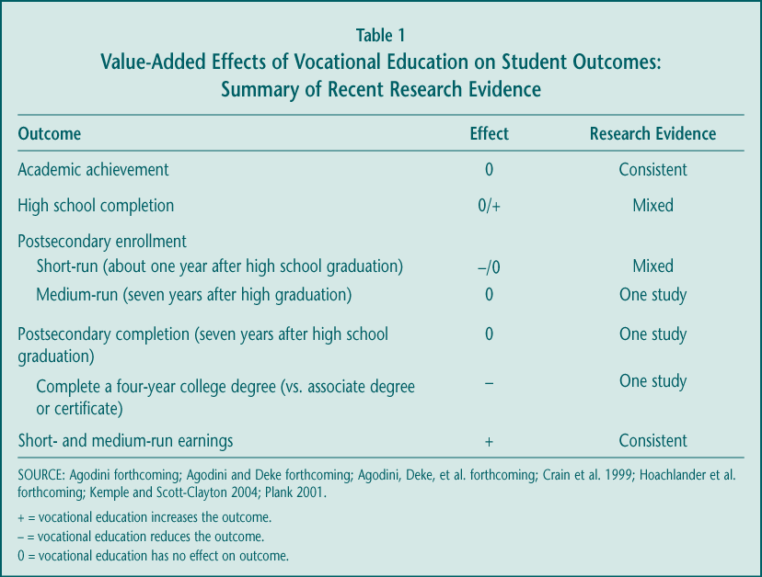

► The short- and medium-term benefits of vocational education are most clear when it comes to its longstanding measure of success—earnings. Several recent studies highlight the positive average effects of vocational course taking on annual earnings, measured just over a year or several years after high school graduation. Seven years after graduation, for example, students earned almost 2 percent more for each extra high school occupational course they took. That translates into about $450 per course, based on average earnings of about $24,000 (Figure 1); the benefit would be $1,350 more for the 45 percent of all high school graduates who take at least three occupational courses, including the quarter of graduates who concentrate their course taking in one program area (occupational concentrators).

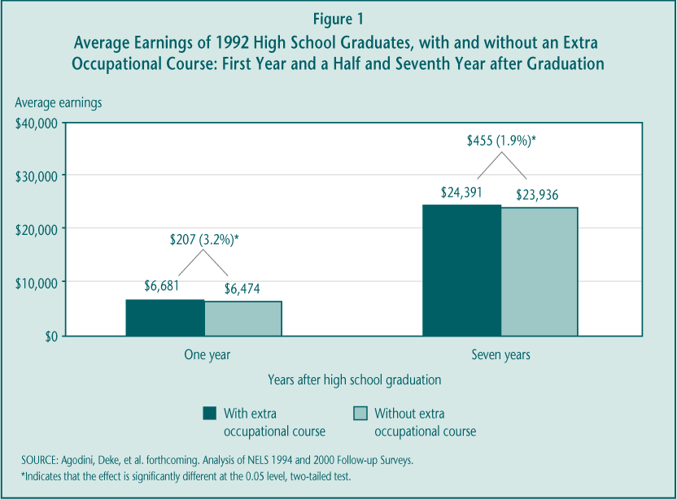

To varying extents, the studies indicate that these benefits extend to the large group of high school graduates who enroll in postsecondary education and training, to both economically and educationally disadvantaged students, to those with disabilities, and to both men and women. In addition, students who complete the “New Basics” academic curriculum as well as a concentration of occupational courses—about 13 percent of all graduates—earn more than similar students who complete the New Basics and little vocational education. However, the studies are more mixed on whether secondary vocational courses benefit the one-quarter of high school graduates who never enroll in postsecondary education, a group that has historically been the focus of vocational policy. There are also some important caveats to these earnings results. The evidence that vocational education increases wages—a proxy for a “better” job—is weaker, and it is likely that the benefits will continue to decline over time.

► Students in vocational programs of study have significantly increased their academic course taking and achievement over the last decade, although gaps remain. During the 1990s, successive groups of occupational concentrators took more, and more rigorous, academic courses along side their vocational curriculum (Table 2). By the end of the decade, the academic credit gap between them and students who took little or no vocational education had narrowed substantially. However, there were still differences between concentrators (51.1 percent) and non-concentrators (60.3 percent) in the proportion who completed the extensive New Basics core academic curriculum and larger gaps in the percent that completed a rigorous college preparatory curriculum (29.2 percent versus 46.2 percent).

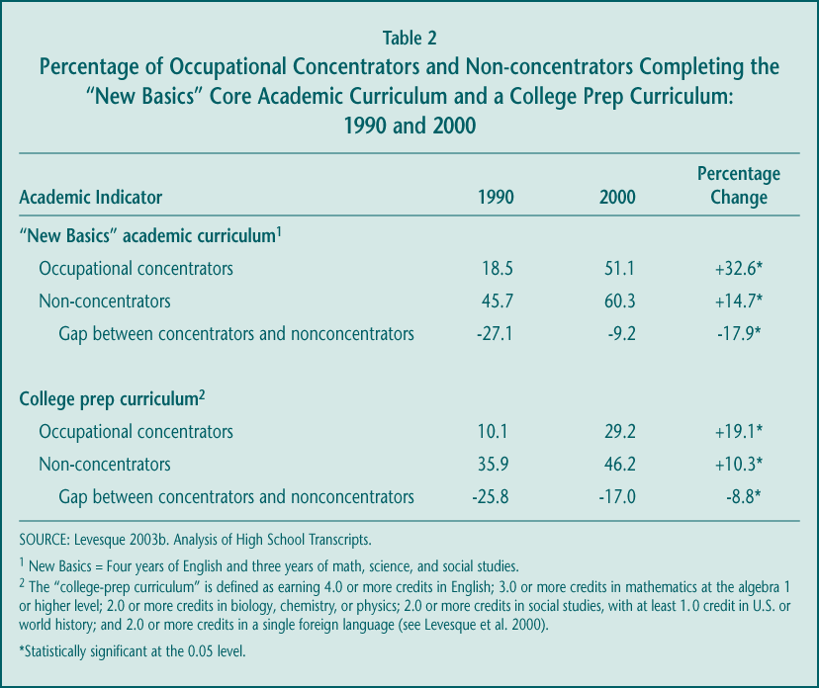

More importantly, occupational concentrators also made substantial progress on academic achievement (Figure 2). The National Assessment of Educational Progress (NAEP) 12th-grade test scores of occupational concentrators increased during the decade, by about 8 scale points in reading and 11 scale points in math. Students who took little or no vocational education increased their reading achievement by about 4 points in reading and experienced no increase in math achievement. As a result of these trends, the gap between concentrators and non-concentrators remained roughly stable in reading, while the gap in math achievement was reduced significantly.

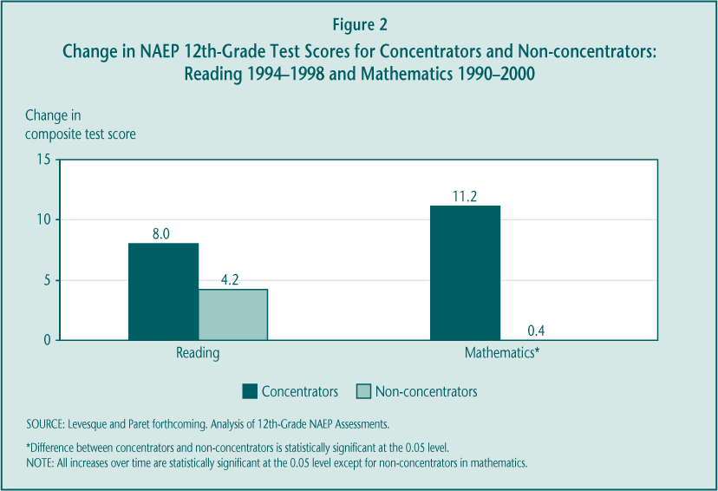

The NAEP assessments indicate that there has been substantial progress, but more work is necessary to raise the achievement levels of all students, particularly those in vocational programs. Most importantly, occupational concentrators are far less likely than non-concentrators to be proficient in reading or math, as defined by their most recent NAEP test scores (Figure 3). If proficiency on the 12th-grade NAEP assessments is associated with readiness for postsecondary education or success in the labor market, then these figures suggest a greater focus on academic improvement is needed.

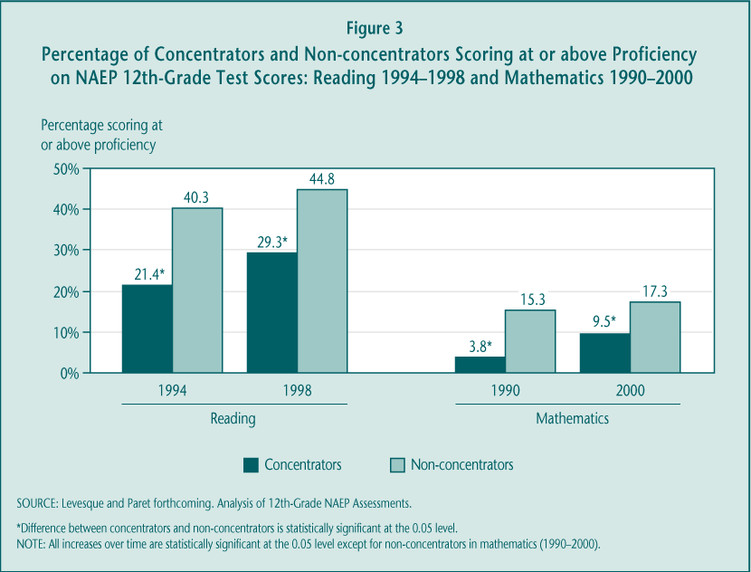

► There is little evidence that vocational courses contribute to improving academic outcomes. The noted improvements in academic performance are likely due to higher academic graduation requirements and increased emphasis on academic reforms. Both analyses of high school student data and randomized controlled studies indicate that, on average, vocational courses and programs do not themselves “add value” to academic achievement as measured by test scores. Not surprisingly, substituting additional academic courses for occupational courses does raise achievement. Moreover, although there is mixed evidence that vocational education reduces dropping out of school, the more rigorous studies suggest there is no effect.

► Postsecondary transition rates have increased; vocational courses neither hurt nor help most students’ chances of going on to college but are associated with a shift from earning a bachelor’s degree to earning an associate’s degree or certificate. Vocational education has long been stigmatized as for the “noncollege bound” or as a deterrent to college, although NAVE finds that neither of these concerns is well founded. The best available national trend data indicate that higher proportions of occupational concentrators are moving on to some form of postsecondary education or training, although they still participate overall at lower rates than do other students and in particular in four-year colleges and universities (Table 3). Many concentrators enroll later, so that by seven years after graduation nearly three-quarters versus 90 percent of all other students have participated to some extent.

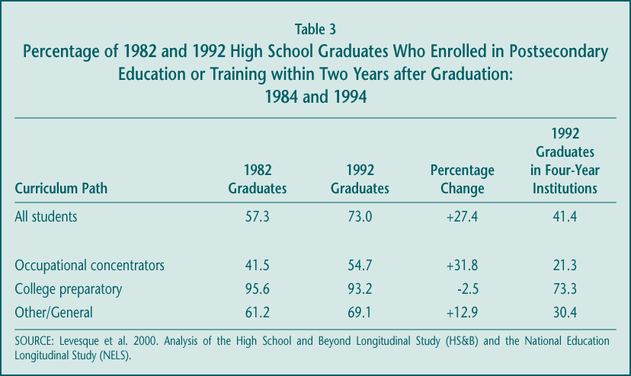

However, improvements in postsecondary enrollment do not appear related to vocational course taking. Studies of graduates in both the early and later 1990s indicate that vocational education itself has no effect on whether students ever attend postsecondary education or training. Moreover, among those who enroll, high school vocational education is associated with a lower likelihood of completing a bachelor’s degree program and a corresponding higher likelihood of completing an associate’s degree or certificate program.

► Secondary vocational education is a large component of high school course taking and serves a diverse set of students, but it is an increasingly smaller share of the overall curriculum. Nearly every student (96.6 percent) leaves high school having taken some vocational education, although the extent of student involvement varies. By almost any measure, participation remained stable during the last decade after an earlier period of decline, withstanding schools’ ongoing focus on academic improvement. While there was little change in the amount of vocational course work taken by high school students during the 1990s, students earned more academic credits, thus lowering vocational education’s share of the overall high school curriculum—from 21.8 percent in 1982 to 17.8 percent in 1990 to 16.2 percent in 2000 (Figure 4). Still, high school students earn, on average, more credits in vocational education (4.0) than in math (3.4) or science (3.1).

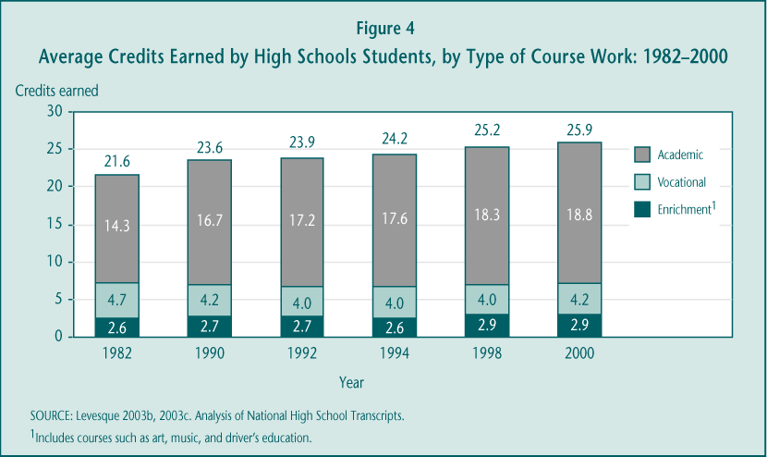

Those who participate most intensively—occupational concentrators—are a varied set of students. However, those who have disabilities or are male, come from lower-income or rural schools, or arrive at high school with low academic achievement participate more substantially than do other students. These patterns were generally stable during the last decade, although vocational education appeared to attract more academically talented students during the 1990s. Less progress was made on overcoming gender differences in vocational course participation.

► The Perkins quality improvement strategies may be too vague to drive change without clear direction. Perkins III carried over a variety of strategies from Perkins II—such as integration of academic and vocational instruction, an all aspects of the industry emphasis, linkages between secondary and postsecondary programs, collaboration with employers, and expanding the use of technology. Several of these strategies, including integration, are ill defined and that may be a barrier to wider implementation. In addition, little is known about their effectiveness in improving student outcomes. Perhaps more importantly, the practices are potentially targeted toward different outcomes: for example, technology might be expected to affect occupational-technical skills, integration to affect students’ academic achievement. The list does not reflect a focused purpose to the federal investment.

► Improving teacher quality will be important if vocational education is expected to alter its mission. Teachers have the most direct impact on instruction and the earnings benefits for many vocational students may suggest that this instruction is valued in the labor market. However, federal legislation over the past decade has tried to guide vocational education toward providing greater support for academic achievement; student outcomes and program implementation suggest that these efforts have been less successful. Current vocational teachers are less likely than academic teachers to have bachelors’ degrees and many do not feel they have received sufficient professional development on the key strategy of integration. Moreover, prospective high school vocational teachers (in vocational teacher training programs) score lower on basic reading and writing tests than do those preparing to be elementary school teachers and lower on math tests than other secondary teachers (Figure 5). Substantial investments in new recruitment and in-service training approaches may be required if federal legislation continues to make supporting academic achievement a priority for vocational education.

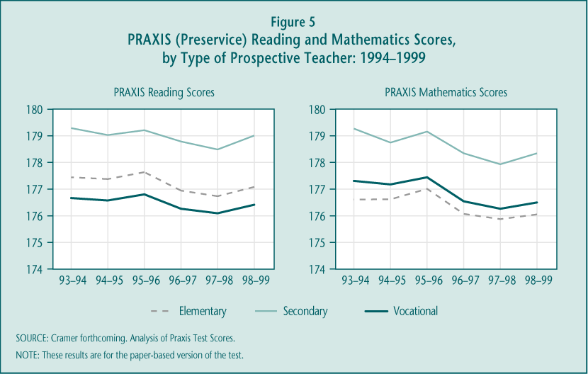

► Tech-Prep was a catalyst for certain vocational reform activities but, because few schools implement it as a comprehensive program of study, it is now playing less of a distinctive role. Efforts to promote both integration of academic and vocational instruction and articulation between secondary and postsecondary education were stimulated by the Tech-Prep Education Act in Perkins II. However, 12 years later, few schools implement Tech-Prep as a structured program with at least two years of clearly linked high school course work and at least two years of related postsecondary course work (the “two-plus-two” design). The most recent estimates suggest that about 10 percent of Tech-Prep consortia, representing 5 percent of Tech-Prep students overall, may be promoting this comprehensive two-plus-two approach. In 2001, only seven states reported that they require local grantees to implement Tech-Prep as a distinct program.

More typically schools implement individual components of the Tech-Prep model—maintaining articulation agreements, providing professional development on integration to academic or vocational teachers, or improving career guidance and planning. Many of these activities are becoming part of secondary vocational education more broadly, and little change has occurred at the postsecondary level to accommodate Tech-Prep students. As a result, Tech-Prep efforts now overlap substantially with those of regular vocational education.

2. What is the nature and impact of vocational education at the sub-baccalaureate level, and what is its relationship to current workforce development efforts?

Given the labor market value of college credentials, “lifelong learning,” and flexibility in skills, the role of sub-baccalaureate vocational education is increasingly important. Many different types of students, with different intentions, cross the doors of community colleges and other Perkins-eligible postsecondary institutions; even with this diversity, the institutions provide services from which most participating students benefit. Relatively low rates of retention are a concern, however, not only because federal policy has long encouraged postsecondary degree completion as a strategy for maintaining American economic competitiveness, but also because individual participants would reap much greater earnings advantage from staying long enough to earn a credential. An emphasis on degree completion may be at odds with the shorter-term training emphasized by the Workforce Investment Act (WIA). But at least so far, integration of decision-making and services between Perkins and WIA has been limited in most states.

► There are significant economic returns to postsecondary vocational education, with the greatest benefits for those who earn a credential. As was true at the secondary level, vocational education in community colleges appears to produce a substantial positive effect on earnings for the vast majority of participants. There are differences in these returns, depending on how much course work is completed (Table 4). Some postsecondary vocational participants do benefit from a year’s worth of vocational course taking even without attaining a credential, earning between 5 and 8 percent more than do high school graduates with similar characteristics. However, much higher economic rewards go to those who pursue significant amounts of postsecondary vocational education and earn a degree or certificate; female associate’s degree holders, for example, earn 47 percent more than similar students with a high school degree and males earn 30 percent more. These results represent the average effects of earning postsecondary degrees. Although many economists argue that the effects vary widely by occupational field, the available data did not permit fields of study to be analyzed separately.

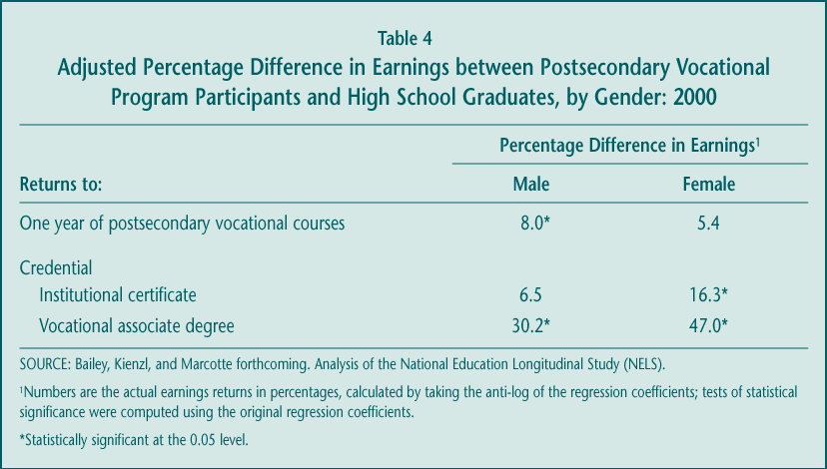

► Fewer than half of postsecondary vocational participants seeking a degree or certificate take enough courses to earn a credential. Like their academic counterparts, many vocational participants leave sub-baccalaureate institutions and programs having completed few courses; more than two-thirds of vocational majors complete the equivalent of a year or less of course work within a five-year time period. Even among those who enroll with the goal of earning a degree or certificate, fewer than half actually complete a credential of any kind (Figure 6). Taking student goals and characteristics into account, the completion rate for vocational majors is similar to that of academic majors, although vocational participants are more likely to earn a shorter-term credential (e.g., certificate) than they originally set out to attain. The relatively low completion rate among postsecondary vocational students is consistent across categories of students, including those in special population groups.

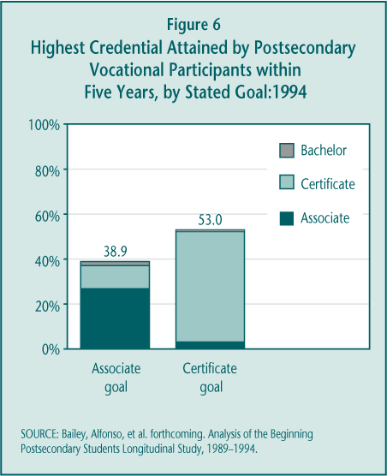

► Postsecondary vocational education serves a large and diverse population with varied expectations. About one-third of all students in undergraduate postsecondary education are considered to be in postsecondary vocational programs. These sub-baccalaureate vocational students vary in age, income, work experience, and previous college activity. Not surprisingly, then, they enroll with different goals—to get an associate’s degree or institutional certificate, to transfer and pursue a bachelor’s degree, to enhance their job skills, or to engage in personal enrichment activities; older students are more interested in obtaining job skills while younger students are more likely to aim for a credential (Figure 7). To accommodate this diversity, community colleges have to be particularly flexible institutions. Perkins III funds, which represent just 2 percent of vocational education expenditures in public two-year and less-than-two-year colleges, can be used to support almost any part of the enterprise.

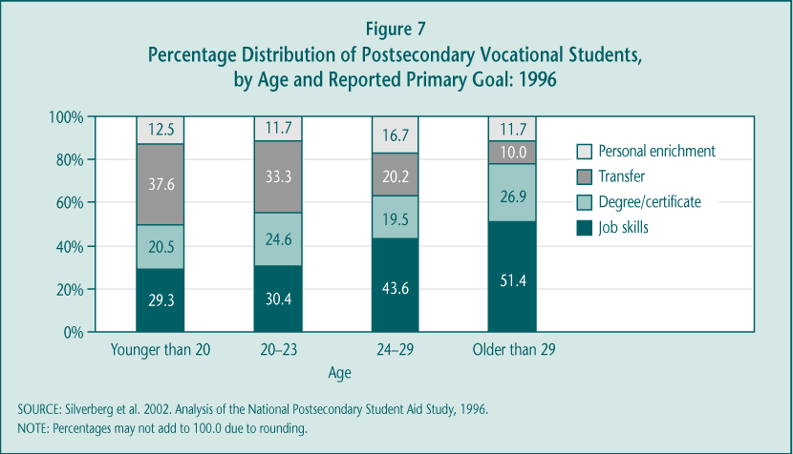

► Community colleges have had limited involvement in early implementation of WIA, citing both low emphasis on training and reporting requirements as disincentives. Early WIA implementation, during a period of economic expansion and job growth, primarily emphasized the development of new procedures and the delivery of employment information over the kinds of training activities Perkins-eligible institutions typically provide. There is some evidence that, with the recent economic downturn, both the availability of training vouchers and policy interest in training are increasing, but the lack of coordination between WIA and Perkins accountability measures reportedly still leads to substantial burden for participating institutions.

3. Is the policy shift from set-asides and legislative prescription to flexibility and accountability likely to improve program quality and student outcomes? How do special populations fare?

The funding and accountability changes enacted under Perkins III have been partially successful in addressing policymakers’ objectives, although much is still in development. Local grantees are receiving larger dollar amounts and case studies suggest they are able to distribute secondary Perkins funds to more schools, outcomes consistent with the goal of directing more money to the local rather than state levels. However, both the traditional ways in which grantees use their funds and early implementation of the higher stakes accountability system forecast at best slow change in vocational program quality. Despite serious commitment among state administrators, technical measurement and data quality problems hinder widespread use of performance data for program management at either the state or local levels. Given these deficiencies, it seems unlikely that, in the short run, the accountability system will have particular benefits for special population students, especially since identifying and collecting data on these students has proven to be particularly difficult for state and local officials. The effects of eliminating targeted set-asides intended to promote gender equity is currently unknown.

► The new law succeeded in sending a higher share of funds to the local level. The average size of local grants grew substantially between Perkins II and Perkins III (approximately 34 percent for secondary and 26 percent for postsecondary grantees) (Table 5). These increases cannot be fully explained by increases in federal appropriations that go to state grants (just over 15 percent) or a reduction in the number of grants awarded.

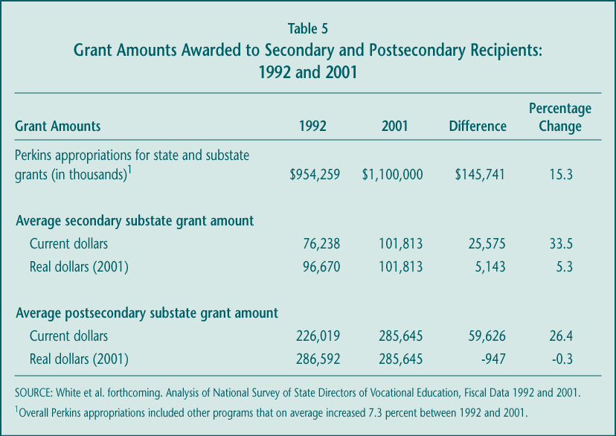

► Flexibility provisions are popular, but may be weakening the targeting of funds to high-poverty communities. Nearly 30 states at the secondary level and 20 at the postsecondary level use at least one of the flexibility provisions in Perkins III. The most common choice is the newly established “reserve fund” provision, which allows states to award 10 percent of local funds to programs in rural and other areas without using the poverty-weighted legislated formula. Perhaps as a result, the dollar advantage of high-poverty districts has declined since Perkins II (Table 6).

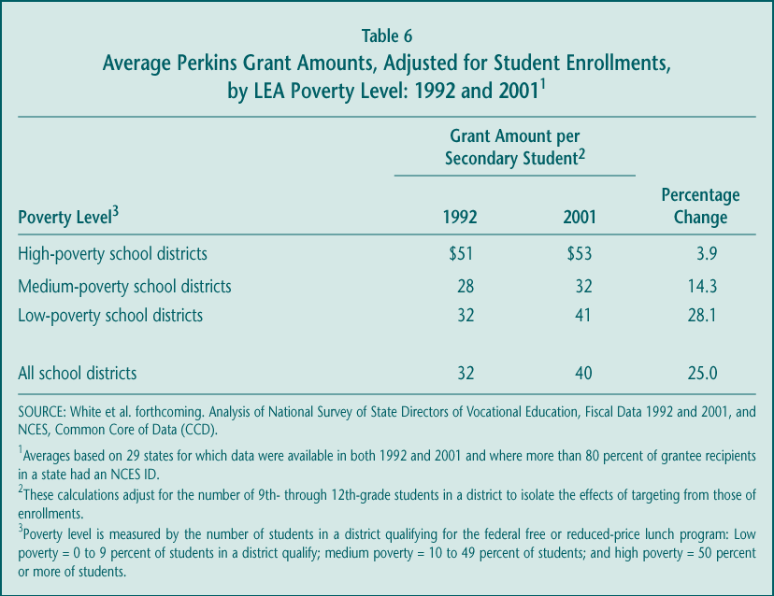

Perkins III also included several options to allow states to better coordinate federal vocational funds and activities with those of other federal programs. Only one state submitted to ED a “consolidated” plan to integrate vocational education with other education programs, and 12 states submitted “unified” plans in which they described their expected activities under some combination of the Perkins, WIA, Adult Education, and Vocational Rehabilitation laws. Although, under the ED Flex program, states received the authority to waive Perkins requirements, states generally did not exercise that authority.

► Implementation is progressing, but so far the performance measurement system is rarely viewed as a tool for program improvement. The current system, perhaps the first legislated accountability effort with significant “teeth,” is still evolving and state officials have demonstrated a serious commitment to it. However, several factors limit its likely impact on vocational programs and student outcomes in the next few years: (1) difficulty collecting data, (2) lack of validity or reliability of many adopted performance measures, and (3) inconsistent approaches to data collection and reporting within states. Certainly, the current system cannot provide a reliable, national picture of vocational education performance. Overall, the quality and reach of the Perkins accountability measures vary considerably by indicator, by state, within state, and sometimes even within local grantees’ programs. It is therefore unsurprising that relatively few states or districts use the performance data for consequential decision-making.

► Although there have been some cutbacks in staffing dedicated to special population services, the full effects on programs and students are unknown. Even with the elimination of the gender equity set-asides and coordinator requirements, many states continued to support these efforts, though the amount of staff time seems to have declined. In 2001, 23 states reported having at least one gender equity coordinator working full- or part-time, but case studies suggest these figures represent reductions from Perkins II. There were fewer observed effects at the local level, with other funding sources sometimes making up for the loss of Perkins gender equity grants. There were cutbacks in targeted programs and services in some communities, but how these might affect student outcomes cannot be known for several more years.

B. Options for Future Directions

Despite the current strengths of the vocational education system supported by Perkins III, there remain ongoing challenges for further improvement. Policymakers may wish to consider a variety of ways—encompassing broad or more specific strategies—in which to shape the course of these improvements.

1. Broad Strategies for Promoting Change

There are several possible options that have implications for the structure of a new or revised law. These broad strategies share a common goal of providing a clearer focus to federal priorities.

Transform Perkins into a program with clear, focused, and limited objectives.

The Perkins legislation authorizes a stream of funds that provides wide latitude to state and local grantees in terms of implementation and goals. The law’s reporting requirements reflect the historical accumulation of purposes that have been laid out for vocational education: improving students’ academic and technical skills, enhancing high school completion, promoting postsecondary enrollment and completion, and ensuring successful labor market entry and retention. All of these, it could be argued, are worthy objectives for federal policy to address at either the high school or college level, or both.

However, it is reasonable to question the capacity of any single law or any single program strategy to succeed on all of these fronts. The diffuse nature of federal priorities for this stream of funds both reflects and contributes to ambivalence among policymakers and educators about what “problem” is being addressed by the Perkins legislation, and impedes efforts to develop clear, focused, and tested education interventions designed to ameliorate the identified problem.

The federal investment could be more effective if directed toward a narrower set of goals around which program improvement strategies and accountability systems could be developed. There are some choices in moving in that direction:

► Emphasize immediate goal of education or workforce development. Decision-makers may want to weigh whether vocational education, or the activities the Perkins legislation supports, should most directly and immediately contribute to:

• Education, in which the emphasis is primarily on learning academic or occupational skills (or both) while enrolled in school; or

• Workforce development, in which the emphasis is primarily on job and other post-school outcomes.

These various objectives are certainly interrelated and clarifying the priorities does not imply that vocational education cannot also have other benefits. Studies clearly link higher levels of learning and of educational attainment to success in the work- place (see NAVE Interim Report [Silverberg et al. 2002]). The language in Perkins III and of vocational advocacy groups suggest that effective technical skills rest on a strong foundation of academic proficiency. The question is, however, which of these goals is most critical for Perkins-funded activities? A focus is important for the federal role of promoting continuing improvement.

► Separate the high school and postsecondary components of the Perkins Act versus keeping them joined in the structure of the law. In some sense, secondary and postsecondary vocational education share many qualities. Both are elective choices for students rather than a required curriculum. Both serve an increasingly diverse set of students, who have widely varying purposes for participating and hopes for what they will accomplish. When secondary vocational education was clearly a program for developing occupational skills and preparing for immediate employment, the strategies at the two levels were similar. However, that may no longer be the case. Because the mission of high schools and community and technical colleges differ, as do the challenges they face, policymakers may decide that federal vocational education should play a different role at each level. For example, although federal policy may charge secondary vocational education with reinforcing high schools’ learning objectives, policy may choose to more clearly tie postsecondary vocational education to workforce development outcomes.

Establishing separate policies and goals for vocational education at the two levels need not undermine the current federal emphasis on developing clear pathways from high school to postsecondary education. On the contrary, with two separate titles or sections, the law could more clearly articulate the specific responsibilities of secondary and postsecondary institutions to create and maintain those pathways.

Eliminate Tech-Prep as a separate title, folding its key activities into postsecondary institutions’ responsibilities.

Tech-Prep has spurred some important efforts but has not lived up to its promise of creating rigorous programs of technical study. The Tech-Prep title of the Perkins Act has become a funding stream like the larger state grant title in Perkins, allowing local consortia to supplement vocational education or other efforts associated generally with the spirit of the law (e.g., career development). Rarely are funds focused on developing the well-defined two-plus-two (2+2) programs that early Tech-Prep advocates promoted: integrated high school academic and vocational curricula that are “articulated”—linked through credit transfer agreements—to postsecondary programs. Instead, integration and articulation have been implemented more on a course-by-course basis. Moreover, these two key components of Tech-Prep have become more common priorities for vocational education generally, diminishing the distinctive role that Tech-Prep efforts might play. Finally, there is some evidence that Tech-Prep funds are not as well targeted to high-poverty areas as are the formula-driven basic grant funds under the Perkins Act.

Despite these limitations, Tech-Prep remains the catalyst for some initiatives and strategies that many consider worth preserving. Two, in particular—convening local partners to collaborate on postsecondary transition issues and updating articulation agreements—could instead become required activities for postsecondary Perkins grantees, many of whom already play this role as part of Tech-Prep consortia.

This strategy could, in effect, focus the Perkins-funded efforts of eligible postsecondary institutions on serving their younger students (those transitioning from high school) rather than on the older adult population. Such an emphasis might be warranted, because the younger students are less likely to be on a stable trajectory toward labor market success: they have more limited work histories and previous college or job training experience, and there is some evidence that earning a credential matters more for them than for older students. Given that Perkins grants represent about 2 percent of local community college spending on occupational education, a focus for federal funds on younger students might also strengthen current efforts to develop rigorous cross-level course sequences, pathways, or programs of study.

Streamline accountability requirements to align with the more focused objectives.

The current accountability provisions in Perkins III require secondary and postsecondary grantees to report on a broad array of student outcomes, both those that students achieve while in school (academic achievement, occupational-technical skill development, school completion) and those that define their paths after they leave (further education or training and employment). There are two reasons for reducing the number of indicators:

► To limit burden and improve performance data quality. Many states are finding it burdensome to meet all of the reporting obligations and their current performance measures and data collection approaches have limited validity and reliability, impeding reliance on them for significant program management decisions. Improvements in data quality and use are more likely if state and local grantees could concentrate their efforts on a smaller set of indicators.

► To focus program improvement activities. The accountability system is intended to motivate states, districts, and postsecondary institutions to manage their programs more effectively. A more limited set of performance indicators, closely aligned to policymakers’ priorities for the federal investment, could encourage more targeted improvement efforts.

2. Specific Strategies for Improved Performance

Although there are broad changes to the structure of the law that policymakers could pursue, there are also individual practices and strategies new legislation could promote that might improve particular outcomes (Table 7). Ideally, one set of strategies would be emphasized, tied to a clear declaration of federal priorities. However, the strategies could also be implemented in combination.

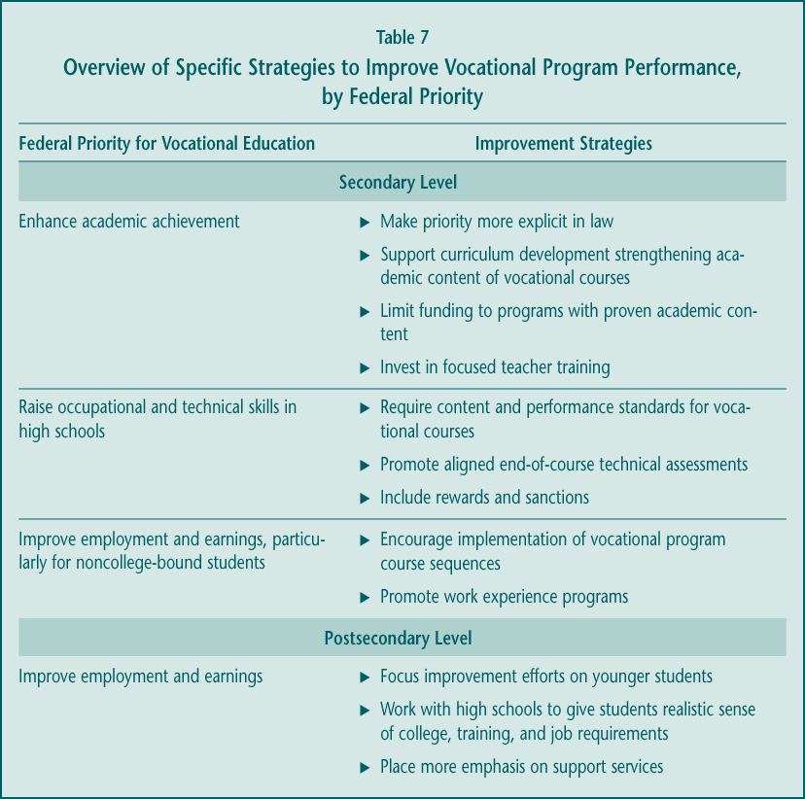

These specific approaches—summarized in Table 7—draw to a large extent on current research and evaluation analyses, most conducted under the NAVE.

3. Closing

Vocational education, increasingly known as career and technical education, is a longstanding program whose place in American education continues to evolve. The broadening of its goals, the ongoing diversity of participants, and the changing education and labor market climate in which it operates, suggest vocational education is a flexible option for schools and students.

With this flexibility comes some challenges, however. At the high school level, participation in vocational education is an elective choice that faces increasing pressure from emphasis on academic improvement. For both secondary and postsecondary vocational education, the wide range of participants and objectives raises a question about how effective a role federal policy plays and whether that policy can or should promote a clearer set of priorities. This final NAVE report is designed to contribute to that discussion, by providing the most up-to-date and comprehensive assessment of vocational education in the United States and of the effects of the Carl D. Perkins Vocational and Technical Education Act of 1998.

►References

Agodini, Roberto. Forthcoming. Achievement Effects of Vocational and Integrated Studies. Princeton, N.J.: Mathematica Policy Research, Inc.
Agodini, Roberto, and John Deke. Forthcoming. The Relationship between High School Vocational Education and Dropping Out. Princeton, N.J.: Mathematica Policy Research, Inc.
Agodini, Roberto, John Deke, Timothy Novak, and Stacey Uhl. Forthcoming. Vocational Education and Postsecondary Outcomes: Eight Years After High School. Princeton, N.J.: Mathematica Policy Research, Inc.
Bailey, Thomas R., Mariana Alfonso, Marc Scott, and Timothy Leinbach. Forthcoming. Educational Outcomes of Occupational Postsecondary Students. New York: Columbia University, Teachers College, Institute on Education and the Economy.
Bailey, Thomas R., Gregory Kienzl, and David Marcotte. Forthcoming. The Return to a Sub-Baccalaureate Education: The Effects of Schooling, Credentials, and Program of Study on Economic Outcomes. New York: Columbia University, Teachers College, Institute on Education and the Economy.
Crain, R., A. Allen, R. Thaler, D. Sullivan, G. Zellman, J. Little, and D. Quigley. 1999. The Effects of Academic Career Magnet Education on High Schools and Their Graduates. Berkeley, Calif.: University of California, National Center for Research in Vocational Education.
Cramer, Kevin. Forthcoming. The Vocational Teacher Pipeline: How Academically Well- Prepared Is the Next Generation of Vocational Teachers? Washington, D.C.: U.S. Department of Education, Office of the Under Secretary.
Darkenwald, Gordon, and Kwang Kim. 1998. Statistics in Brief: Adults’ Participation in Work-Related Courses: 1994–1995. Washington, D.C.: U.S. Department of Education, Office of Educational Research and Improvement, National Center for Education Statistics. NCES 98–309.
Hoachlander, Gary, Denise Bradby, Robert Fitzgerald, Marcel Paret, Peter Teitelbaum, W. Lee Holcombe, Christopher T. King, and Robert W. Glover. Forthcoming. Career and Technical Education in Two States: Participation and Student Outcomes. A report prepared by MPR Associates and the Ray Marshall Center for the Study of Human Resources, University of Texas at Austin for the National Assessment of Vocational Education. Washington, D.C.: U.S. Department of Education, Office of the Under Secretary.
Kemple, James, and Judith Scott-Clayton. 2004. Career Academies: Impacts on Labor Market Outcomes and Educational Attainment. New York: MDRC.
Levesque, Karen. 2003b. Trends in High School Vocational/Technical Coursetaking: 1982–1998. Washington, D.C.: U.S. Department of Education, Institute of Education Sciences, National Center for Education Statistics. NCES 2003–025.
Levesque, Karen. 2003c. “Analysis of 2000 High School Transcripts.” Tables prepared by MPR Associates for the National Assessment of Vocational Education. Washington, D.C.: U.S. Department of Education, Office of the Under Secretary.
Levesque, Karen, and Marcel Paret. Forthcoming. The Academic Achievement Gains of Occupational Concentrators and Nonconcentrators: 1990–2000. A report prepared by MPR Associates for the National Assessment of Vocational Education. Washington, D.C.: U.S. Department of Education, Office of the Under Secretary.
Levesque, Karen, Doug Lauen, Peter Teitelbaum, Martha Alt, and Sally Librera. 2000. Vocational Education in the United States: Toward the Year 2000. Washington, D.C.: U.S. Department of Education, Office of Educational Research and Improvement, National Center for Education Statistics. NCES 2000–029.
Plank, Stephen. 2001. Career and Technical Education in the Balance: An Analysis of High School Persistence, Academic Achievement, and Postsecondary Destinations. St. Paul, Minn.: National Center for Research in Career and Technical Education, University of Minnesota.
Silverberg, Marsha, Elizabeth Warner, David Goodwin, and Michael Fong. 2002. National Assessment of Vocational Education: Interim Report to Congress. Washington, D.C.: U.S. Department of Education, Office of the Under Secretary.
White, Robin, Ivan Charner, Gail Promboin, Amy Johnson, Glenn Nyre, and Richard Phelps. Forthcoming. The Structures and Challenges of Vocational Education Funding and Accountability Systems. A report prepared by the Academy for Educational Development for the National Assessment of Vocational Education. Washington, D.C.: U.S. Department of Education, Office of the Under Secretary.

The first federal legislation supporting vocational education was the Smith-Hughes Act of 1917.
Other federal programs, such as student financial aid, tax credits, and the Workforce Investment Act, help provide individuals with access to occupational training at the postsecondary level; the Perkins Act provides support to institutions and programs.
About 62 percent of Perkins funds are spent at the high school level.
Occupational concentrators are defined as students who earn at least 3.0 occupational credits in one program area.
The “New Basics” academic curriculum, as measured here, is equivalent to four years of English or language arts, and three years each of math, science, and social studies. Many states are moving to this standard for core high school graduation requirements.
Some students enroll in high school vocational education because they do not plan to attend college, so a negative relationship between vocational courses and postsecondary education might be expected. However, even controlling for college plans and other student characteristics, vocational courses have no effect, on average, on postsecondary enrollment.
The comparable completion rate for students entering four-year postsecondary programs seeking bachelor’s degrees is 61.9 percent; that is, almost two-thirds of students who enter these longer degree programs actually earn a credential of some kind (including less than a baccalaureate degree), compared to about half of students who enter shorter-term vocational associate degree programs.
Perkins III requires the NAVE to provide “findings and recommendations resulting from the assessment” (Section 114(c)).
Since federal vocational education legislation was enacted in 1917, the law has responded to changing needs and acquired new objectives. Initially, it was a way to prepare immigrant and rural populations to work in factories and on farms. At some point it became a form of training that might appeal to less academically oriented students, perhaps helping to keep them in school by engaging them in activities most relevant to future employment. Over time vocational education was supported as a strategy to keep the United States internationally competitive, by delivering advanced technical training to meet the needs of an increasingly high-tech economy. More recently, vocational education has been promoted as a strategy to enhance academic learning and provide a clearer pathway to success in college.
Requiring postsecondary institutions to be responsible would not preclude other Perkins institutions—secondary districts, high schools, area vocational centers, adult centers—from playing major roles in these activities, as is appropriate. However, designating the lead institutions in law may help ensure that the activities are a focus of funded efforts.

