Archived Information
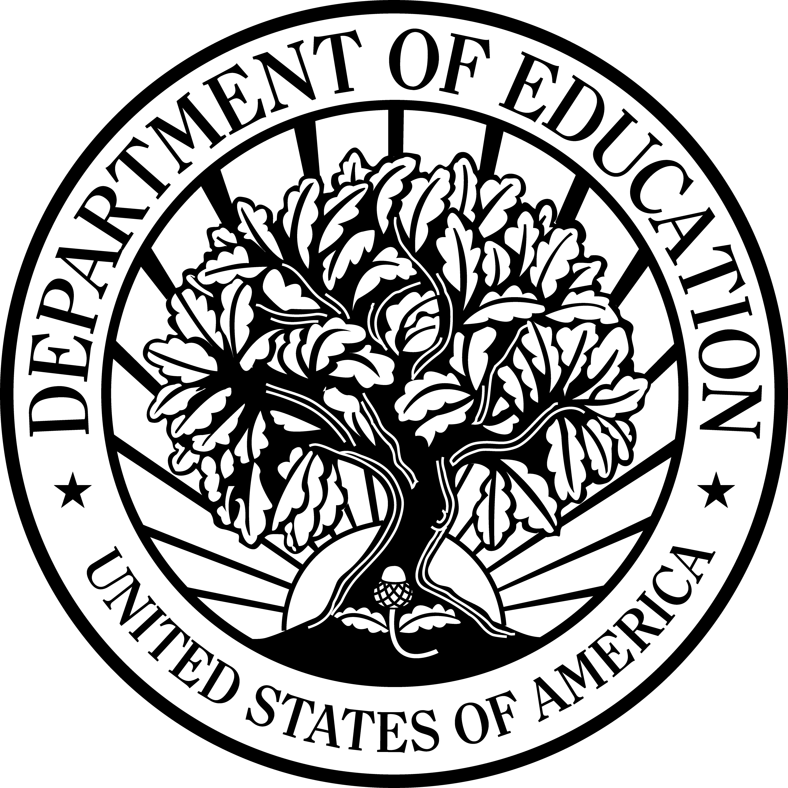
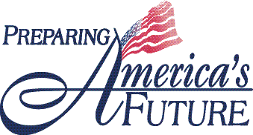

U.S. Department of Education

Office of Vocational and Adult Education
Fact Sheet Series

Secondary and Technical Education

The State Scholars Initiative
The OVAE Fact Sheet Series highlights efforts currently underway at the Office of Vocational and Adult Education (OVAE) to support the principles of the President’s No Child Left Behind Act of 2001. The principle(s) supported by this effort are checked.

- Increase Accountability and Academic Achievement
- Increase Options and Involvement for Parents and Students
  - Increase Flexibility and Reduce Bureaucracy
- Focus on What Works

Background

Each year nearly two-thirds of America’s high school graduates enter college. However, more than half of them will drop out before completing a four-year degree. Many fail to finish because they are not academically prepared for college-level work. According to the Education Trust, high school students should take four years of English, three years of math, science, and social studies, and two foreign language courses in order to be academically prepared for postsecondary education and the workplace.

Overview

The State Scholars Initiative (SSI) is designed to better prepare students academically by encouraging them to take more rigorous courses that reflect National Commission on Excellence in Education (NCEE) recommendations. Managed by the Center for State Scholars in partnership with OVAE, SSI was piloted by six states in the 2002-2003 school year. These states are: AR, TN, OK, IN, MD, and RI. Key components of this initiative include:

- Mentoring for middle and high school students in support of their enrollment and successful completion of more rigorous coursework
- Alignment of state and district policy structures to increase the rigor of courses to match criteria outlined in SSI
- Rigorous graduation requirements for all students
- Articulation of how high school curricula align with postsecondary curricula and workplace needs
- Partnerships with corporations and postsecondary institutions to create incentives for students to complete a rigorous course of study
- Evaluation of student outcomes, including student performance on standardized assessments, postsecondary enrollment, and remediation rates

Outcomes and Products

- Community partnerships that provide incentives to students to take more challenging courses
- Smoother transitions between high school and postsecondary education
- Promising practices that can be shared with communities across the country

Timeline

- Six additional states, CT, KY, MS, NJ, NM, and WA joined the Initiative in October 2003. Two states are expected to join in 2004-2005.

Contact

Rebecca.Arnold@ed.gov

Web Site
www.centerforstatescholars.org

