T. H. Rogers School Houston, TX
T.H. Rogers Houston, TX

280 students, grades K—5

Students qualifying for free or reduced price lunch 42%
Special Education students 42%

Student ethnicity:
White 25%
Hispanic 31%
Asian 29%
African American 16%
Committed to valuing all people, the T.H. Rogers Elementary School in Houston’s Galleria area brings three student populations together in a unique mix. Through its Vanguard program, it serves gifted and talented children in grades K-5; as the Regional Day School for the Deaf, it serves deaf students from pre-school through grade 5; and it serves students with multiple impairments from birth through grade 5.

A unique mix of students

The school’s mission is to be “a lighthouse beacon that safely guides all children into harbors of success.” The principal, Nancy Manley, believes that “children see value in all people and they learn that at a very young age. They get to know children who are different from them as people who have value.” The librarian adds, “No one can do everything, but everyone can do something.”

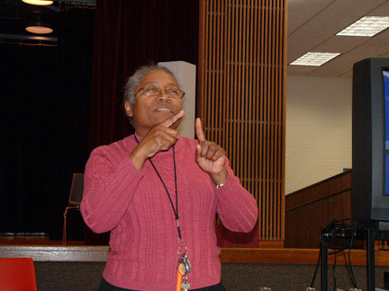
The mix of gifted, multiply impaired, and deaf children works because of children’s sensitivity. Even some gifted children may have other special education needs. “Gifted and Talented children are very sensitive so they are very protective of others,” a teacher explained. “Students touch our hearts and we touch their hearts.” Staff members describe the school as “a family environment.”

The T.H. Rogers staff is diverse in ethnicity, gender, and communication style. Many faculty members sign; several teachers who work with deaf students are themselves deaf, including the first Black deaf teacher to teach in Houston. Full-time registered nurses, occupational and physical therapists, as well as classroom teachers and paraprofessionals, round out the staff.
T.H. Rogers was the solution to two converging problems. In the 1970’s the school, then a middle school, faced a changing population and decreasing enrollment. At the same time the federal government began to mandate inclusive school practices. Billy Reagan, School Superintendent at the time, recalls visiting the beach at Galveston, Texas, watching the waves roll onto the shore and wondering, “Where would the multiply impaired students fare best?” The vision for a new school came to him: he would bring multiply impaired students together with gifted and talented students, who would be the most accepting of this population. This allowed highly qualified teachers to locate in one place to serve this diverse population. Some years later the Houston Independent School District decided to meet a shortage of certified teachers of the deaf by educating all deaf students at T.H. Rogers.
From Observers to Participants
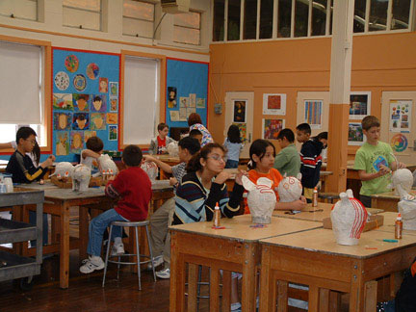
Many students with learning challenges come to the school with little or no formal learning experience. Teachers embrace this challenge and find pathways for learning. One teacher said, “Hopefully, children move from silent observers to active participants in the world.” A Multi-Sensory Room designed for students with severe or profound impairments offers a relaxing, comfortable environment and a chance to explore a variety of stimuli—audio, visual, tactile, and motor. Playing in this environment is often a first step in developing language and communication skills. Students build eye-hand coordination by using switches to control the environment, giving them the experience of cause and effect. A teacher and teacher aide staff the room, encouraging students to explore all their senses.
Both multiply impaired students and deaf students have difficulty with face-to-face communication; physical disabilities and motor coordination problems can make the production of speech difficult or impossible. Methods to support and augment students’ communication include an individual method of sign and gesture, standard signing and symbol systems, and electronic devices. A team decides on the most appropriate technology to augment a student’s communication. It may be “no tech,” “low tech,” or “high tech.”

“No tech” uses natural communication—gesturing, eye gazing, sign language. “Low tech” uses external modes such as drawing, pointing to pictures, digitized speech output systems, writing, and communication boards with familiar photographs of people and objects, line drawings, picture symbols, letter, numbers, and/or words pasted or printed on them. By touching the pictures with a finger, directing their eyes to them, or gesturing with some part of the body, students can “talk” by switching on a sound system. This helps students learn cause and effect, but also serves as a way to interact with others and control the environment.
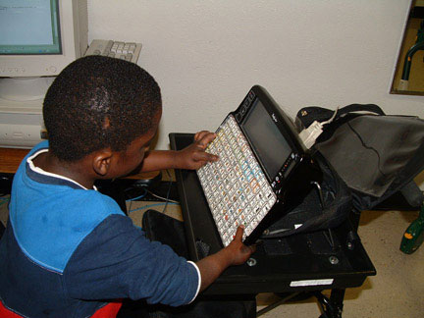
“High tech” uses computer-based devices, such as Pathfinder, an intricate keyboard with a unique system of icons, letter, and numbers that can be manipulated to form codes, words, and sentences in an audible digitized voice. For one student we observed, the Pathfinder, rigged to his walker, enabled him to communicate—a gift that allows him to share with others.
A student uses the Pathfinder Technology
Visual Phonics is an extraordinary method that allows deaf students to learn how to decode words, to write them, and to use their voices by reading the words aloud. A lack of phonics ability is the most crucial problem a deaf child faces in learning to read, because the child needs to link sounds with letters of the alphabet. Phonics is closely related to how the body articulates sound. A second grade class of deaf students using visual phonics was shown letters and students were asked to make the hand gesture that mimics how the mouth should move when pronouncing that sound. At the same time, they shaped their mouths in the correct position and “made” the sound. The students sounded out simple words in this way.
Expanding All Students’ Horizons
Despite the special features for these unique populations, all three groups of students come together on several levels. Students in the Vanguard and the deaf program share ancillary classes, physical education classes, assemblies, lunch, field trips, clubs and organizations, and extra-curricular activities. Paired by grade level, the two groups share common space. Deaf, Vanguard, and multiply impaired students unite for activities such as Kite Day (highlighting aerospace and wind machines), a traditional Field Day, Rogersburg (simulating a colonial town), Gardening and Native Plant programs, and other school-wide programs. All Vanguard students learn Sign Language to facilitate integration, and begin assisting the multiply impaired students in the primary grades, continuing through middle school.
The benefits to the multiply impaired and the deaf students were clear. The Vanguard students spoke eloquently about how they benefited. Visibly excited about their school and the children who attend it, they described learning about different people and their capabilities, rather than their disabilities. One student said, “I get to help with different learners and learn about different people.” A second grader said, “It is so special that we get to talk to the deaf students by signing.” Another student talked about learning how others were “normal” and could do so many things. All students said that they have learned not to stare and laugh. They appreciate this experience and know that others do not have the benefit of knowing what they know.
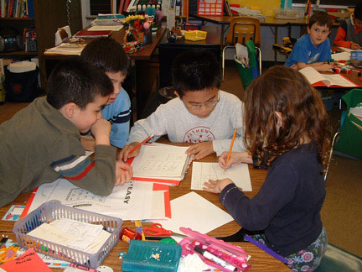
Gifted students also benefit from the school through opportunities they would not have in other schools. One fourth grader said at his old school he didn’t have to keep learning, but at T.H. Rogers, “Teachers are always pushing us to be our best.” The students like learning new languages, including sign language, and enjoy after-school activities such as chess, karate, music, art, and creative writing.
Teachers have one single goal: do what is best for students. “We are student-centered,” a teacher said. Even Vanguard students are at different levels, a teacher explained. Students in a 2nd grade class ranged from 3rd to 8th grade ability levels. Differentiation and multiple instructional strategies are necessary in all classrooms; teachers believe they can find ways to teach each child.
Teachers said that a competent and knowledgeable administrative team was an important element of the school’s success. The administration hires skilled teachers in tune with the school’s philosophy. Hiring is decentralized; potential teachers are interviewed by a panel of teachers, parents and administrators. They may be asked to demonstrate a lesson or present a portfolio of their work. Staff members are held to high expectations. Administrative staff conduct periodic “walk-throughs,” looking at practices and providing support. Teachers have opportunities to talk, work, and learn together. Each teacher has a laptop computer and can access district curriculum, pacing timelines, and lessons, as well as all of their students’ data, online. Teachers have a voice in the school through the standing committees of the site-based management team. Decisions made at the school are data-driven. Quarterly “Snapshot Assessments” allow for diagnostic planning.
The Vanguard curriculum is vertically aligned with the Texas Essential Knowledge and Skills and the Houston Independent School District’s Clarifying Learning to Enhance Achievement Results Curriculum and differentiated by depth, complexity, and pacing. The curriculum develops intellectual ability, critical thinking skills, and leadership ability in an environment where students work cooperatively with their peers. The Deaf reading curriculum uses a scripted program called Reading Mastery and Corrective Reading, adapted for the deaf. The “Visual Phonics” supports students’ seeing the sounds, which helps them break the reading code.
The school’s professional development centers on five strands, namely, best teacher practices, interpersonal skills, technology, current trends, and new employee training. The professional development program offers teachers choices whenever possible to meet the needs of a staff with diverse expertise and experience. One teacher talked about the opportunity to go to the Houston teachers’ Institute where she studied with a professor and wrote teaching units. Teachers feel that embedded professional development gives them the skills that they need to be successful with diverse populations.
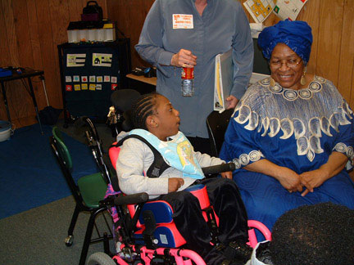
T.H. Rogers uses the best available communication technology, strengthened by a commitment to reach every child, to open the world to all its students, using all means possible to give every student access—and a voice.

