Oklahoma
http://sde.state.ok.us

School and Teacher Demographics

Per pupil expenditures | $6,019
(CCD, 2000-01)

Number of Districts | 544
(CCD, 2001-02)

Number of Charter Schools | 10
(CCD, 2001-02)

Number of Public Schools
(CCD)

 | 1993-94 | 2001-02
Elementary | 993 | 984
Middle | 341 | 345
High | 458 | 463
Combined | - | 1
Total | 1,792 | 1,793

Number of FTE Teachers
(CCD)

 | 1993-94 | 2001-02
Elementary | 19,946 | 20,577
Middle | 7,706 | 8,392
High | 9,703 | 11,125
Combined | - | 22
Total | 37,355 | 40,116

Percentage of teachers with a major in the main subject taught, grades 7-12 (SASS)

 | 1994 | 2000
English | 78% | 57%
Math | 74 | 70
Science | 62 | 67
Social Studies | 71 | 53

Sources of Funding
District Average
(CCD, 2000-01)
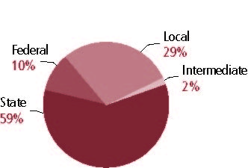

Student Demographics
Public school enrollment
(CCD)

 | 1993-94 | 2001-02
Pre-K | 5,456 | 25,707
K-8 | 434,412 | 417,805
9-12 | 162,511 | 175,124
Total (K-12) | 596,923 | 592,929

Race/ethnicity (CCD)

 | 1993-94 | 2001-02
American Indian/Alaskan Natives | 14% | 17%
Asian/Pacific Islander | 1 | 1
Black | 10 | 11
Hispanic | 3 | 6
White | 72 | 64
Other | - | -

Students with disabilities | 1993-94 | 2001-02
(OSEP) | 11% | 13%

Students with limited | 1993-94 | 2000-01
English proficiency | 4% | 7%
(ED/NCBE)

Migratory students | 1993-94 | 2001-02
(OME) | 1% | 1%
All schools by percent of students eligible to participate in the Free and Reduced-Price Lunch Program^{† (}CCD, 2001-02)
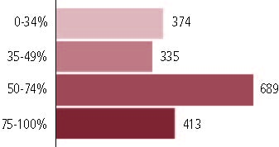

† 3 schools did not report.

Statewide Accountability Information

(Collected from states, January 2002 for 2001-02 school year.)

Statewide Goal for Schools on State Assessment
Seventy percent of students score Satisfactory on index for reading and math for 2001-02, baseline year.

Expected School Improvement on Assessment
Annual improvement toward Satisfactory rating.

Title I Adequate Yearly Progress (AYP) for Schools
Five percent gain in Satisfactory scores in schools with less than 50 percent Satisfactory in reading or math for 2001-02 baseline year. Meeting or exceeding statewide performanc e targets in math and reading.

Title I 2001-02

(ED Consolidated Report, 2001-02)

 | Schoolwide  Programs | Targeted Assistance | Total
Number of schools | 787 | 402 | 1,189
Number of schools | 66% | 28% | 100%
Schools meeting AYP Goal | 761 | 399 | 1,160
Schools meeting AYP Goal | 66% | 34% | 98%
Schools identified for Improvement | 25 | 3 | 28
Schools identified for Improvement | 89% | 11% | 2%

Title I Allocation | $109,173,930
(Includes Basic, Concentration, and LEA grants, Capital Expenditures, Even Start, Migrant Education, and Neglected and Delinquent, ED, 2000-2001)

NAEP State Results
 | Grade 4 | Grade 8

Reading, 2003
Proficient level and above | 26% | 30%
Basic level and above | 60 | 74

Math, 2003
Proficient level and above | 22% | 20%
Basic level and above | 73 | 64

Oklahoma

Student Achievement 2001-02

Assessment:
Oklahoma Core Curriculum Tests.

State Definition of Proficient:
Satisfactory.

Elementary School
Grade 5
Reading
Students in: | Unsatisfactory | Limited Knowledge | Satisfactory | Advanced
All schools | 15% | 21% | 56% | 7%
Title I schools
Economically Disadvantaged Students | 9 | 16 | 57 | 4
Students with limited  English proficiency | 17 | 39 | 41 | 3
Migratory students | 22 | 40 | 39 | 3
Students with Disabilities | 56 | 26 | 18 | 1

Grade 5
Mathematics
Students in: | Unsatisfactory | Limited Knowledge | Satisfactory | Advanced
All schools | 11% | 26% | 47% | 16%
Title I schools
Economically Disadvantaged Students | 6 | 20 | 50 | 10
Students with limited  English proficiency | 14 | 29 | 48 | 9
Migratory students | 17 | 34 | 46 | 10
Students with Disabilities | 43 | 37 | 18 | 3

Student Achievement Trend
Reading 5th grade Meets or Exceeds Satisfactory
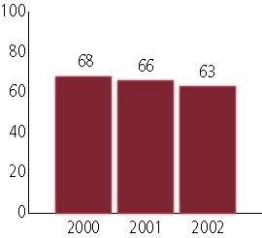

Middle School
Grade 8
Reading
Students in: | Unsatisfactory | Limited Knowledge | Satisfactory | Advanced
All schools | 10% | 20% | 62% | 8%
Title I schools
Economically Disadvantaged Students | 6 | 16 | 61 | 5
Students with limited  English proficiency | 19 | 30 | 48 | 3
Migratory students | 17 | 32 | 54 | 27
Students with Disabilities | 47 | 31 | 22 | 1

Grade 8
Mathematics
Students in: | Unsatisfactory | Limited Knowledge | Satisfactory | Advanced
All schools | 12% | 26% | 51% | 13%
Title I schools |  |  | 48 | 10
Economically Disadvantaged Students | 7 | 21 | 50 | 7
Students with limited  English proficiency | 18 | 36 | 38 | 7
Migratory students | 16 | 29 | 52 | 7
Students with Disabilities | 43 | 41 | 16 | 1

Student Achievement Trend
Mathematics 8th grade Meets or Exceeds Satisfactory
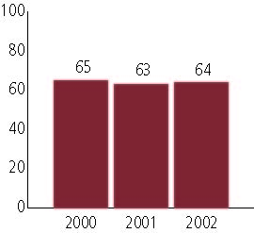

High School
Grade
English II
Students in: | Unsatisfactory | Limited Knowledge | Satisfactory | Advanced
All schools | 17% | 22% | 55% | 7%
Title I schools |  |  | 47 | 4
Economically Disadvantaged Students | 27 | 27 | 50 | 3
Students with limited  English proficiency | 40 | 35 | 25 | 1
Migratory students | 47 | 24 | 33 | 0
Students with Disabilities | 65 | 24 | 13 | 1

Grade††
Mathematics
Students in:
All schools
Title I schools
Economically Disadvantaged Students
Students with limited
English proficiency
Migratory students
Students with Disabilities

††High school mathematics assessment results not available for 2001-02.

High School Indicators | 1993-94 | 2000-01
High school dropout rate (CCD, event) | 5% | 5%
 | 1994-95 | 2000-01
Postsecondary enrollment  (NCES, High school grads enrolled in college) | 49% | 50%

