Massachusetts
http://www.doe.mass.edu

School and Teacher Demographics

Per pupil expenditures | $9,509
(CCD, 2000-01)

Number of Districts | 350
(CCD, 2001-02)

Number of Charter Schools | 43
(CCD, 2001-02)

Number of Public Schools
(CCD)

 | 1993-94 | 2001-02
Elementary | 1,170 | 1,202
Middle | 290 | 299
High | 226 | 288
Combined | 27 | 95
Total | 1,713 | 1,884

Number of FTE Teachers
(CCD)

 | 1993-94 | 2001-02
Elementary | n/a
Middle | n/a
High | n/a
Combined | n/a
Total | n/a

Percentage of teachers with a major in the main subject taught, grades 7-12 (SASS)

 | 1994 | 2000
English | 89% | 83%
Math | 76 | 73
Science | 89 | 79
Social Studies | 87 | 87

Sources of Funding
District Average
(CCD, 2000-01)
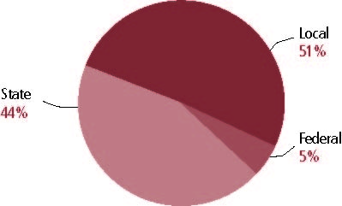

Student Demographics
Public school enrollment
(CCD)

 | 1993-94 | 2001-02
Pre-K | 13,178 | 20,666
K-8 | 625,344 | 678,829
9-12 | 232,208 | 273,644
Total (K-12) | 857,552 | 952,473

Race/ethnicity (CCD)

 | 1993-94 | 2001-02
American Indian/Alaskan Natives | * | *
Asian/Pacific Islander | 4% | 5%
Black | 8 | 9
Hispanic | 9 | 11
White | 79 | 76
Other | - | -

Students with disabilities | 1993-94 | 2001-02
(OSEP) | 15% | 13%

Students with limited | 1993-94 | 2000-01
English proficiency | 5% | 5%
(ED/NCBE)

Migratory students | 1993-94 | 2001-02
(OME) | * | *
All schools by percent of students eligible to participate in the Free and Reduced-Price Lunch Program (CCD, 2001-02)

Data Not Available

Statewide Accountability Information

(Collected from states, January 2002 for 2001-02 school year.)

Statewide Goal for Schools on State Assessment
Two years’ scores on Massachusetts Comprehensive Assessment System (MCAS): decrease percentage of students at failing level and increase percentage at Proficient or Advanced level.

Expected School Improvement on Assessment
Depending on baseline performance, increase average scaled scores.

Title I Adequate Yearly Progress (AYP) for Schools
Same as statewide goal.

Title I 2001-02

(ED Consolidated Report, 2001-02)

 | Schoolwide  Programs | Targeted Assistance | Total
Number of schools | 428 | 661 | 1,089
Number of schools | 39% | 28% | 100%
Schools meeting AYP Goal | 224 | 587 | 811
Schools meeting AYP Goal | 28% | 72% | 74%
Schools identified for Improvement | 203 | 56 | 259
Schools identified for Improvement | 78% | 22% | 24%

Title I Allocation | $194,487,901
(Includes Basic, Concentration, and LEA grants, Capital Expenditures, Even Start, Migrant Education, and Neglected and Delinquent, ED, 2000-2001)

NAEP State Results
 | Grade 4 | Grade 8

Reading, 2003
Proficient level and above | 40% | 43%
Basic level and above | 73 | 81

Math, 2003
Proficient level and above | 41% | 38%
Basic level and above | 84 | 76

Massachusetts

Student Achievement 2001-02

Assessment:
Massachusetts Comprehensive Assessment System.

State Definition of Proficient:
Students at this level demonstrate a solid understanding of challenging subject matter and solve a wide variety of problems.

Elementary School
Grade 4
English Language Arts
Students in: | Warning | Needs Improvement | Proficient | Advanced
All schools | 10% | 37% | 46% | 8%
Title I schools
Economically Disadvantaged Students
Students with limited  English proficiency | 36 | 47 | 15 | 1
Migratory students
Students with Disabilities | 31 | 50 | 18 | 1

Grade 4
Mathematics
Students in: | Warning | Needs Improvement | Proficient | Advanced
All schools | 19% | 42% | 27% | 12%
Title I schools
Economically Disadvantaged Students
Students with limited  English proficiency | 55 | 34 | 8 | 2
Migratory students
Students with Disabilities | 42 | 42 | 13 | 3

Student Achievement Trend
Reading 4th grade meets or exceeds Proficient
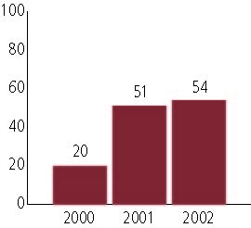

Middle School
Grade 7
English Language Arts
Students in: | Warning | Needs Improvement | Proficient | Advanced
All schools | 9% | 28% | 55% | 9%
Title I schools
Economically Disadvantaged Students
Students with limited  English proficiency | 47 | 39 | 14 | 1
Migratory students
Students with Disabilities | 30 | 47 | 22 | 1

Grade 8
Mathematics
Students in: | Warning | Needs Improvement | Proficient | Advanced
All schools | 33% | 33% | 23% | 11%
Title I schools
Economically Disadvantaged Students
Students with limited  English proficiency | 72 | 20 | 6 | 2
Migratory students
Students with Disabilities | 71 | 22 | 5 | 1

Student Achievement Trend
Mathematics 8th grade meets or exceeds Proficient
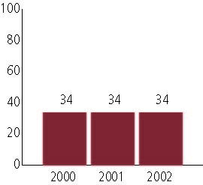

High School
Grade 10
English Language Arts
Students in: | Warning | Needs Improvement | Proficient | Advanced
All schools | 14% | 27% | 40% | 19%
Title I schools
Economically Disadvantaged Students
Students with limited  English proficiency | 54 | 33 | 12 | 1
Migratory students
Students with Disabilities | 45 | 35 | 16 | 2

Grade 10
Mathematics
Students in: | Warning | Needs Improvement | Proficient | Advanced
All schools | 25% | 31% | 24% | 20%
Title I schools
Economically Disadvantaged Students
Students with limited  English proficiency | 60 | 25 | 12 | 6
Migratory students
Students with Disabilities | 62 | 26 | 9 | 3

High School Indicators | 1993-94 | 2000-01
High school dropout rate (CCD, event) | 4% | 3%
 | 1994-95 | 2000-01
Postsecondary enrollment  (NCES, High school grads enrolled in college) | 65% | n/a

