Maine
http://www.state.me.us/education

School and Teacher Demographics

Per pupil expenditures | $8,232
(CCD, 2000-01)

Number of Districts | 282
(CCD, 2001-02)

Number of Charter Schools | 0
(CCD, 2001-02)

Number of Public Schools
(CCD)

 | 1993-94 | 2001-02
Elementary | 456 | 427
Middle | 125 | 127
High | 106 | 111
Combined | 14 | 15
Total | 701 | 680

Number of FTE Teachers
(CCD)

 | 1993-94 | 2001-02
Elementary | 6,660 | 6,997
Middle | 2,835 | 3,424
High | 3,822 | 4,434
Combined | 329 | 334
Total | 13,646 | 15,189

Percentage of teachers with a major in the main subject taught, grades 7-12 (SASS)

 | 1994 | 2000
English | 81% | 71%
Math | 68 | 64
Science | 67 | 63
Social Studies | 72 | 56

Sources of Funding
District Average
(CCD, 2000-01)
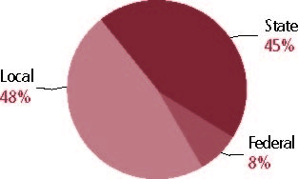

Student Demographics
Public school enrollment
(CCD)

 | 1993-94 | 2001-02
Pre-K | 1,036 | 1,300
K-8 | 152,981 | 140,430
9-12 | 59,632 | 61,229
Total (K-12) | 212,613 | 201,659

Race/ethnicity (CCD)

 | 1993-94 | 2001-02
American Indian/Alaskan Natives | - | 1%
Asian/Pacific Islander | - | 1
Black | - | 1
Hispanic | - | 1
White | - | 96
Other | - | -

Students with disabilities | 1993-94 | 2001-02
(OSEP) | 12% | 15%

Students with limited | 1993-94 | 2000-01
English proficiency | 1% | 1%
(ED/NCBE)

Migratory students | 1993-94 | 2001-02
(OME) | 4% | 6%
All schools by percent of students eligible to participate in the Free and Reduced-Price Lunch Program† (CCD, 2001-02)
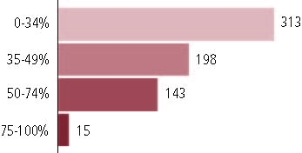

†21 schools did not report.

Statewide Accountability Information

(Collected from states, January 2002 for 2001-02 school year.)

Statewide Goal for Schools on State Assessment
Only performance reporting.

Expected School Improvement on Assessment
None.

Title I Adequate Yearly Progress (AYP) for Schools
Improve percentage of students moving up at four levels, improve subgroup performance, scores on local reading test.

Title I 2001-02

(ED Consolidated Report, 2001-02)

 | Schoolwide  Programs | Targeted Assistance | Total
Number of schools | 51 | 395 | 446
Number of schools | 11% | 28% | 100%
Schools meeting AYP Goal | 49 | 384 | 433
Schools meeting AYP Goal | 11% | 89% | 97%
Schools identified for Improvement | 2 | 10 | 12
Schools identified for Improvement | 17% | 83% | 3%

Title I Allocation | $38,832,372
(Includes Basic, Concentration, and LEA grants, Capital Expenditures, Even Start, Migrant Education, and Neglected and Delinquent, ED, 2000-2001)

NAEP State Results
 | Grade 4 | Grade 8

Reading, 2003
Proficient level and above | 36% | 36%
Basic level and above | 71 | 79

Math, 2003
Proficient level and above | 34% | 29%
Basic level and above | 83 | 74

Maine

Student Achievement 2001-02

Assessment:
Maine Educational Assessment.

State Definition of Proficient:
Score of 541 or above.

Elementary School
Grade 4
Reading
Students in: | Does Not Meet | Partially Meets | Proficient | Advanced
All schools | 10% | 42% | 48% | 1%
Title I schools
Economically Disadvantaged Students
Students with limited
English proficiency
Migratory students
Students with Disabilities

Grade 4
Writing
Students in: | Does Not Meet | Partially Meets | Proficient | Advanced
All schools | 23% | 63% | 14% | 1%
Title I schools
Economically Disadvantaged Students
Students with limited
English proficiency
Migratory students
Students with Disabilities

Student Achievement Trend
Reading 4th grade meets or exceeds Proficient
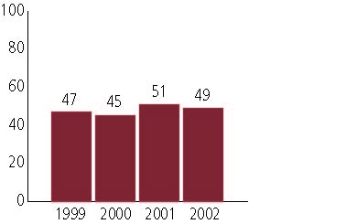

Middle School
Grade 8
Reading
Students in: | Does Not Meet | Partially Meets | Proficient | Advanced
All schools | 12% | 44% | 42% | 1%
Title I schools
Economically Disadvantaged Students
Students with limited
English proficiency
Migratory students
Students with Disabilities

Grade 8
Writing
Students in: | Does Not Meet | Partially Meets | Proficient | Advanced
All schools | 11% | 50% | 39% | 1%
Title I schools
Economically Disadvantaged Students
Students with limited
English proficiency
Migratory students
Students with Disabilities

Student Achievement Trend
Mathematics 8th grade meets or exceeds Proficient
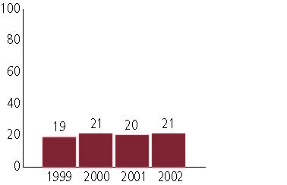

High School
Grade 11
Reading
Students in: | Does Not Meet | Partially Meets | Proficient | Advanced
All schools | 8% | 39% | 51% | 2%
Title I schools
Economically Disadvantaged Students
Students with limited
English proficiency
Migratory students
Students with Disabilities

Grade 11
Mathematics
Students in: | Does Not Meet | Partially Meets | Proficient | Advanced
All schools | 38% | 43% | 18% | 1%
Title I schools
Economically Disadvantaged Students
Students with limited
English proficiency
Migratory students
Students with Disabilities

High School Indicators | 1993-94 | 2000-01
High school dropout rate (CCD, event) | 3% | 3%
 | 1994-95 | 2000-01
Postsecondary enrollment  (NCES, High school grads enrolled in college) | 50% | 54%

