Vermont

http://www.state.vt.us/educ

Districts and schools

Number of districts (CCD) | 1993-94 | 2003-04
 | 285 | 300

Number of public schools (CCD) | 1993-94 | 2003-04
Elementary | 279 | 255
Middle | 29 | 25
High | 49 | 47
Combined | 18 | 31
Other | 3 | -
Total | 378 | 358

Number of charter schools (CCD) | 2003-04
 | -

Finances

Total current expenditures  (CCD, in thousands of dollars, adjusted for inflation to 2002-03) | 1993-94 | 2002-03
Instructional | $535,047 | $671,163
Noninstructional | 27,156 | 28,289
Support | 258,162 | 345,762
Total | 820,365 | 1,045,214

Per-pupil expenditures  (CCD, adjusted for inflation to 2002-03) | 1993-94 | 2002-03
 | $7,984 | $10,454

Sources of Funding
(CCD, 2002-03)

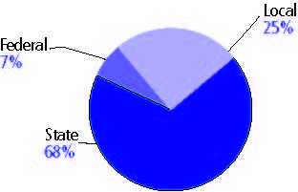

Title I allocation 2002-03 (ED; Includes Title I, Part A) | $27,005,035

Students

Public school enrollment (CCD) | 1993-94 | 2003-04
Pre-K | 2,024 | 3,027
K-8 | 72,804 | 63,702
9-12 | 27,377 | 32,091
Total (K-12) | 100,181 | 95,793

Race/ethnicity (CCD) | 1993-94 | 2003-04
American Indian/Alaskan Native | 1% | 1%
Asian/Pacific Islander | 1 | 2
Black, non-Hispanic | 1 | 1
Hispanic | * | 1
White, non-Hispanic | 97 | 96

Students with disabilities (OSEP) | 1993-94 | 2003-04
 | 9% | 12%

Students with limited  English proficiency (NCELA) | 1993-94 | 2003-04
 | 1% | 1%

Migrant students (OME) | 1993-94 | 2003-04
 | 1% | 1%

Eighth-grade students enrolled in Algebra I for high school credit (NAEP) | 1996 | 2003
 | 22% | 20%

Students eligible to participate in the Free or Reduced-Price Lunch Program, 2003-04 (CCD) | 27,109

All schools by percent of students eligible to participate in the Free or Reduced-Price Lunch Program, 2003-04† (CCD)
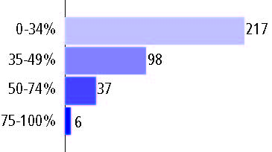

Staff

Number of FTE teachers (CCD) | 1993-94 | 2003-04
Elementary | 4,204 | 4,411
Middle | 846 | 765
High | 2,390 | 2,815
Combined | 603 | 720
Other | 3 | -
Total | 8,046 | 8,711

Number of FTE non-teacher staff (CCD) | 1993-94 | 2003-04
Instructional aides | 2,139 | 4,208
Instructional coordinators | 230 | 318
Administrators | 989 | 588
Other | 4,058 | 4,838
Total | 7,416 | 9,952

Percentage of teachers with a major in the main subject taught, grades 7-12 (SASS) | 1994 | 2000
English | 87% | n/a
Mathematics | 75 | 55%
Science | 81 | 77
Social Studies | 81 | 78

Percentage of core courses taught by highly qualified teachers, 2003-04 (As defined and reported by states, collected by ED)
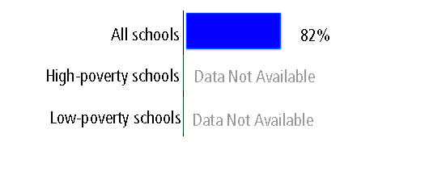

Outcomes

 | 1993-94 | 2000-01
High school dropout rate (NCES) | 5% | 5%
Avg. freshman graduation rate (NCES) | 86 | 80
College-going rate (IPEDS/NCES) | 51 | 45

NAEP state results
Reading, Grade 4 | 1994 | 2005
Proficient level or above | - | 38%
Basic level or above | - | 72
Math, Grade 8 | 1996 | 2005
Proficient level or above | 27% | 38%
Basic level or above | 72 | 78

Statewide Accountability Information:

State Accountability Website: http://crs.uvm.edu/schlrpt/cfusion/schlrpt04/vermont.cfm

State assessment for NCLB accountability: New Standards Reference Examinations

State student achievement levels: Little Evidence of Achievement, Below the Standard, Nearly Achieves the Standard, Achieves the Standard, Achieves the Standard with Honors

 |  | 2001-02  Annual measurable  objective starting point | Target  2003-04
Grade 4 | English and language arts | 300% | 300%
 | Mathematics | 175 | 175
Grade 8 | English and language arts | 300 | 300
 | Mathematics | 175 | 175
Grade 10 | English and language arts | 300 | 300
 | Mathematics | 175 | 175

2003-04 NCLB accountability results, applied to 2004-05 school year
AYP outcomes and consequences | Title I schools |  | All schools |  | All districts
Made AYP | 185 | 88% | 270 | 88% | 143 | 80%
Identified for improvement:
Year 1 | 16 | 8% | 25 | 8% | 8 | 3%
Year 2 | 0 | 0 | 0 | 0 | 0 | 0
Corrective action | 0 | 0 | 0 | 0 | 0 | 0
Restructuring | 0 | 0 | 0 | 0 | 0 | 0
Exited improvement status (made AYP twice after missing twice or more, includes total “made” above) | 1 | * | 2 | 1% | 0 | 0

Other indicator, 2003-04 | State target | State outcome
Elementary Indicator: VT-Dev. Read. Assessment | Less than 15% of students in lowest two proficiency levels | Met
Middle Indicator: New Standards Ref. Exam | Less than 15% of students in lowest two proficiency levels | Met
High School Indicator: Graduation rate or NSRE Reading: Basic Understanding performance | 75% or less than 15% of students in lowest two proficiency levels | Met

NCLB choice participation | Number of Title I students | Percent of eligible students
Title I school choice: | n/a | n/a
Supplemental educational services: | n/a | n/a

Student Achievement 2003-04

New Standards Reference Examinations, used for NCLB accountability
Grade 3

English and language arts
Proficient Level or above for:
All students | n/a
Economically disadvantaged students | n/a
Migrant students | n/a
Students with disabilities | n/a
Students with limited English proficiency | n/a
Black, non-Hispanic students | n/a
Hispanic students | n/a
White, non-Hispanic students | n/a

Trend Data Not Available

New Standards Reference Examinations, used for NCLB accountability
Grade 3

Mathematics
Proficient Level or above for:
All students | n/a
Economically disadvantaged students | n/a
Migrant students | n/a
Students with disabilities | n/a
Students with limited English proficiency | n/a
Black, non-Hispanic students | n/a
Hispanic students | n/a
White, non-Hispanic students | n/a

Trend Data Not Available

New Standards Reference Examinations, used for NCLB accountability
Grade 4

English and language arts
Proficient Level or above for:
All students | 82%
Economically disadvantaged students | 69
Migrant students | 61
Students with disabilities | 53
Students with limited English proficiency | 67
Black, non-Hispanic students | 62
Hispanic students | 74
White, non-Hispanic students | 82

Student achievement trend: English and language arts percent proficient level or above

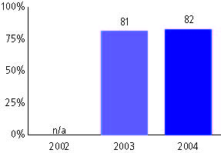

New Standards Reference Examinations, used for NCLB accountability
Grade 4

Mathematics
Proficient Level or above for:
All students | 75%
Economically disadvantaged students | 70
Migrant students | 44
Students with disabilities | 45
Students with limited English proficiency | 70
Black, non-Hispanic students | 55
Hispanic students | 64
White, non-Hispanic students | 76

Student achievement trend: Mathematics percent proficient level or above

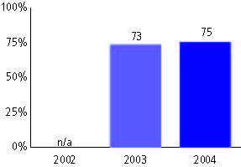

New Standards Reference Examinations, used for NCLB accountability
Grade 5

English and language arts
Proficient Level or above for:
All students | n/a
Economically disadvantaged students | n/a
Migrant students | n/a
Students with disabilities | n/a
Students with limited English proficiency | n/a
Black, non-Hispanic students | n/a
Hispanic students | n/a
White, non-Hispanic students | n/a

Trend Data Not Available

New Standards Reference Examinations, used for NCLB accountability
Grade 5

Mathematics
Proficient Level or above for:
All students | n/a
Economically disadvantaged students | n/a
Migrant students | n/a
Students with disabilities | n/a
Students with limited English proficiency | n/a
Black, non-Hispanic students | n/a
Hispanic students | n/a
White, non-Hispanic students | n/a

Trend Data Not Available

New Standards Reference Examinations, used for NCLB accountability
Grade 6

English and language arts
Proficient Level or above for:
All students | n/a
Economically disadvantaged students | n/a
Migrant students | n/a
Students with disabilities | n/a
Students with limited English proficiency | n/a
Black, non-Hispanic students | n/a
Hispanic students | n/a
White, non-Hispanic students | n/a

Trend Data Not Available

New Standards Reference Examinations, used for NCLB accountability
Grade 6

Mathematics
Proficient Level or above for:
All students | n/a
Economically disadvantaged students | n/a
Migrant students | n/a
Students with disabilities | n/a
Students with limited English proficiency | n/a
Black, non-Hispanic students | n/a
Hispanic students | n/a
White, non-Hispanic students | n/a

Trend Data Not Available

New Standards Reference Examinations, used for NCLB accountability
Grade 7

English and language arts
Proficient Level or above for:
All students | n/a
Economically disadvantaged students | n/a
Migrant students | n/a
Students with disabilities | n/a
Students with limited English proficiency | n/a
Black, non-Hispanic students | n/a
Hispanic students | n/a
White, non-Hispanic students | n/a

Trend Data Not Available

New Standards Reference Examinations, used for NCLB accountability
Grade 7

Mathematics
Proficient Level or above for:
All students | n/a
Economically disadvantaged students | n/a
Migrant students | n/a
Students with disabilities | n/a
Students with limited English proficiency | n/a
Black, non-Hispanic students | n/a
Hispanic students | n/a
White, non-Hispanic students | n/a

Trend Data Not Available

New Standards Reference Examinations, used for NCLB accountability
Grade 8

English and language arts
Proficient Level or above for:
All students | 69%
Economically disadvantaged students | 54
Migrant students | 42
Students with disabilities | 28
Students with limited English proficiency | 68
Black, non-Hispanic students | 66
Hispanic students | 73
White, non-Hispanic students | 69

Student achievement trend: English and language arts percent proficient level or above

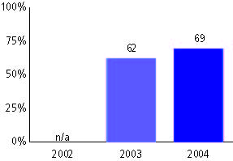

New Standards Reference Examinations, used for NCLB accountability
Grade 8

Mathematics
Proficient Level or above for:
All students | 73%
Economically disadvantaged students | 57
Migrant students | 51
Students with disabilities | 29
Students with limited English proficiency | 71
Black, non-Hispanic students | 60
Hispanic students | 67
White, non-Hispanic students | 73

Student achievement trend: Mathematics percent proficient level or above

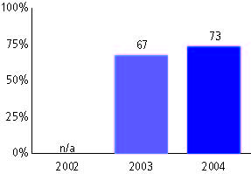

New Standards Reference Examinations, used for NCLB accountability
High school

English and language arts
Proficient Level or above for:
All students | 52%
Economically disadvantaged students | 34
Migrant students | 45
Students with disabilities | 12
Students with limited English proficiency | 42
Black, non-Hispanic students | 42
Hispanic students | 42
White, non-Hispanic students | 52

Student achievement trend: English and language arts percent proficient level or above

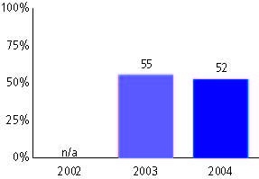

New Standards Reference Examinations, used for NCLB accountability
High school

Mathematics
Proficient Level or above for:
All students | 64%
Economically disadvantaged students | 46
Migrant students | #
Students with disabilities | 20
Students with limited English proficiency | 59
Black, non-Hispanic students | 45
Hispanic students | 44
White, non-Hispanic students | 64

Student achievement trend: Mathematics percent proficient level or above

