Texas

http://www.tea.state.tx.us

Districts and schools

Number of districts (CCD) | 1993-94 | 2003-04
 | 1,046 | 1,046

Number of public schools (CCD) | 1993-94 | 2003-04
Elementary | 3,385 | 3,686
Middle | 1,308 | 1,588
High | 1,148 | 1,417
Combined | 392 | 803
Other | 91 | 49
Total | 6,324 | 7,543

Number of charter schools (CCD) | 2003-04
 | 274

Finances

Total current expenditures  (CCD, in thousands of dollars, adjusted for inflation to 2002-03) | 1993-94 | 2002-03
Instructional | $12,235,063 | $18,347,986
Noninstructional | 1,236,823 | 1,535,497
Support | 7,162,154 | 10,516,120
Total | 20,634,040 | 30,399,603

Per-pupil expenditures  (CCD, adjusted for inflation to 2002-03) | 1993-94 | 2002-03
 | $5,578 | $7,136

Sources of Funding
(CCD, 2002-03)

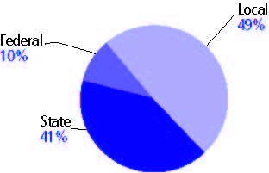

Title I allocation 2002-03 (ED; Includes Title I, Part A) | $1,018,467,898

Students

Public school enrollment (CCD) | 1993-94 | 2003-04
Pre-K | 119,253 | 192,402
K-8 | 2,560,407 | 2,938,303
9-12 | 927,177 | 1,199,136
Total (K-12) | 3,487,584 | 4,137,439

Race/ethnicity (CCD) | 1993-94 | 2003-04
American Indian/Alaskan Native | * | *
Asian/Pacific Islander | 2% | 3%
Black, non-Hispanic | 14 | 14
Hispanic | 36 | 44
White, non-Hispanic | 48 | 39

Students with disabilities (OSEP) | 1993-94 | 2003-04
 | 11% | 11%

Students with limited  English proficiency (NCELA) | 1993-94 | 2003-04
 | 12% | 15%

Migrant students (OME) | 1993-94 | 2003-04
 | 3% | 4%

Eighth-grade students enrolled in Algebra I for high school credit (NAEP) | 1996 | 2003
 | 25% | 25%

Students eligible to participate in the Free or Reduced-Price Lunch Program, 2003-04 (CCD) | 2,024,335

All schools by percent of students eligible to participate in the Free or Reduced-Price Lunch Program, 2003-04† (CCD)

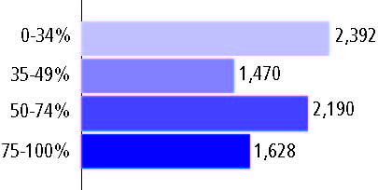

† 163 schools did not report

Staff

Number of FTE teachers (CCD) | 1993-94 | 2003-04
Elementary | 108,318 | 136,313
Middle | 50,976 | 65,023
High | 56,278 | 75,036
Combined | 7,099 | 8,218
Other | 1,473 | 3,057
Total | 224,144 | 287,647

Number of FTE non-teacher staff (CCD) | 1993-94 | 2003-04
Instructional aides | 38,816 | 58,741
Instructional coordinators | 1,257 | 1,238
Administrators | 13,286 | 37,454
Other | 154,913 | 209,416
Total | 208,272 | 306,849

Percentage of teachers with a major in the main subject taught, grades 7-12 (SASS) | 1994 | 2000
English | 71% | 64%
Mathematics | 65 | 57
Science | 70 | 57
Social Studies | 67 | 60

Percentage of core courses taught by highly qualified teachers, 2003-04 (As defined and reported by states, collected by ED)
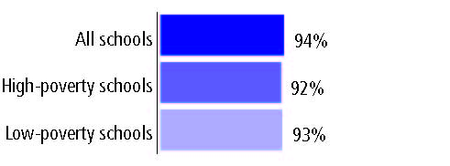

Outcomes

 | 1993-94 | 2000-01
High school dropout rate (NCES) | - | 4%
Avg. freshman graduation rate (NCES) | 66% | 71
College-going rate (IPEDS/NCES) | 50 | 53

NAEP state results
Reading, Grade 4 | 1994 | 2005
Proficient level or above | 26% | 29%
Basic level or above | 58 | 64
Math, Grade 8 | 1996 | 2005
Proficient level or above | 21% | 31%
Basic level or above | 59 | 72

Statewide Accountability Information:

State Accountability Website: http://www.tea.state.tx.us/student.assessment/reporting/results/swresults/taks/2004/index.html

State assessment for NCLB accountability: Texas Assessment of Knowledge and Skills

State student achievement levels: Did Not Meet the Standard, Met the Standard, Commended Performance

 |  | 2001-02  Annual measurable  objective starting point | Target  2003-04
Grade 4 | Reading | 47% | 47%
 | Mathematics | 33 | 33
Grade 8 | Reading | 47 | 47
 | Mathematics | 33 | 33
High school | Reading | 47 | 47
 | Mathematics | 33 | 33

2003-04 NCLB accountability results, applied to 2004-05 school year
AYP outcomes and consequences* | Title I schools |  | All schools |  | All districts
Made AYP | 4,494 | 89% | 6,516 | 89% | 955 | 88%
Identified for improvement:
Year 1 | 88 | * | 88 | * | 2 | *
Year 2 | 2 | * | 2 | * | 0 | 0
Corrective action | 1 | * | 1 | * | 0 | 0
Restructuring | 0 | 0 | 0 | 0 | 0 | 0
Exited improvement status (made AYP twice after missing twice or more, includes total “made” above) | 2 | * | 2 | * | 0 | 0

Other indicator, 2003-04 | State target | State outcome
Elementary Indicator: Attendance | Meet or exceed 90% | Met
Middle Indicator: Attendance | Meet or exceed 90% | Met
High School Indicator: Graduation rate | Meet or exceed 70% | Met

NCLB choice participation | Number of Title I students | Percent of eligible students
Title I school choice: | - | -
Supplemental educational services: | 45 | *

Student Achievement 2003-04

Texas Assessment of Knowledge and Skills, used for NCLB accountability
Grade 3

Reading
Proficient Level or above for:
All students | 90%
Economically disadvantaged students | 86
Migrant students | 81
Students with disabilities | 85
Students with limited English proficiency | 83
Black, non-Hispanic students | 85
Hispanic students | 87
White, non-Hispanic students | 96

Student achievement trend: Reading percent proficient level or above

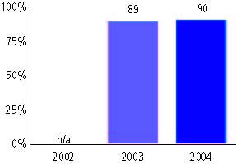

Texas Assessment of Knowledge and Skills, used for NCLB accountability
Grade 3

Mathematics
Proficient Level or above for:
All students | 89%
Economically disadvantaged students | 85
Migrant students | 83
Students with disabilities | 84
Students with limited English proficiency | 83
Black, non-Hispanic students | 81
Hispanic students | 86
White, non-Hispanic students | 95

Student achievement trend: Mathematics percent proficient level or above

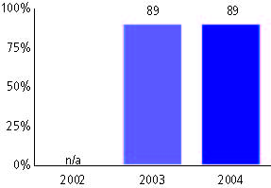

Texas Assessment of Knowledge and Skills, used for NCLB accountability
Grade 4

Reading
Proficient Level or above for:
All students | 85%
Economically disadvantaged students | 79
Migrant students | 74
Students with disabilities | 76
Students with limited English proficiency | 71
Black, non-Hispanic students | 77
Hispanic students | 80
White, non-Hispanic students | 93

Student achievement trend: Reading percent proficient level or above

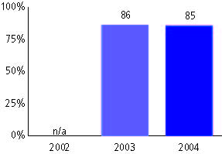

Texas Assessment of Knowledge and Skills, used for NCLB accountability
Grade 4

Mathematics
Proficient Level or above for:
All students | 85%
Economically disadvantaged students | 80
Migrant students | 77
Students with disabilities | 76
Students with limited English proficiency | 75
Black, non-Hispanic students | 75
Hispanic students | 81
White, non-Hispanic students | 93

Student achievement trend: Mathematics percent proficient level or above

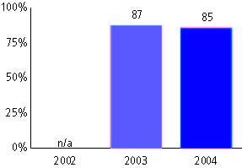

Texas Assessment of Knowledge and Skills, used for NCLB accountability
Grade 5

Reading
Proficient Level or above for:
All students | 79%
Economically disadvantaged students | 69
Migrant students | 60
Students with disabilities | 67
Students with limited English proficiency | 49
Black, non-Hispanic students | 70
Hispanic students | 71
White, non-Hispanic students | 90

Student achievement trend: Reading percent proficient level or above

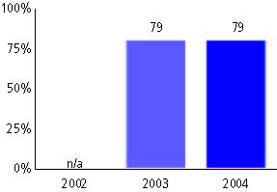

Texas Assessment of Knowledge and Skills, used for NCLB accountability
Grade 5

Mathematics
Proficient Level or above for:
All students | 81%
Economically disadvantaged students | 73
Migrant students | 81
Students with disabilities | 67
Students with limited English proficiency | 60
Black, non-Hispanic students | 69
Hispanic students | 76
White, non-Hispanic students | 90

Student achievement trend: Mathematics percent proficient level or above

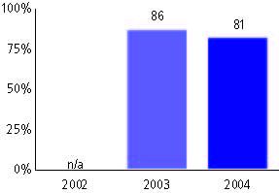

Texas Assessment of Knowledge and Skills, used for NCLB accountability
Grade 6

Reading
Proficient Level or above for:
All students | 86%
Economically disadvantaged students | 79
Migrant students | 70
Students with disabilities | 72
Students with limited English proficiency | 51
Black, non-Hispanic students | 81
Hispanic students | 80
White, non-Hispanic students | 94

Student achievement trend: Reading percent proficient level or above

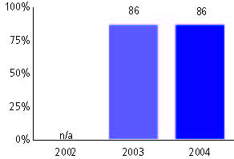

Texas Assessment of Knowledge and Skills, used for NCLB accountability
Grade 6

Mathematics
Proficient Level or above for:
All students | 77%
Economically disadvantaged students | 68
Migrant students | 62
Students with disabilities | 58
Students with limited English proficiency | 47
Black, non-Hispanic students | 63
Hispanic students | 70
White, non-Hispanic students | 88

Student achievement trend: Mathematics percent proficient level or above

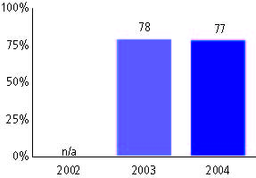

Texas Assessment of Knowledge and Skills, used for NCLB accountability
Grade 7

Reading
Proficient Level or above for:
All students | 83%
Economically disadvantaged students | 75
Migrant students | 68
Students with disabilities | 63
Students with limited English proficiency | 39
Black, non-Hispanic students | 73
Hispanic students | 77
White, non-Hispanic students | 91

Student achievement trend: Reading percent proficient level or above

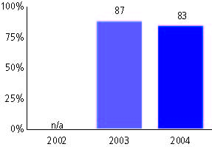

Texas Assessment of Knowledge and Skills, used for NCLB accountability
Grade 7

Mathematics
Proficient Level or above for:
All students | 70%
Economically disadvantaged students | 59
Migrant students | 53
Students with disabilities | 47
Students with limited English proficiency | 33
Black, non-Hispanic students | 54
Hispanic students | 62
White, non-Hispanic students | 83

Student achievement trend: Mathematics percent proficient level or above

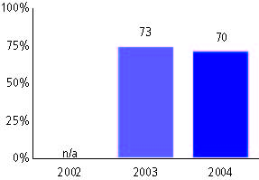

Texas Assessment of Knowledge and Skills, used for NCLB accountability
Grade 8

Reading
Proficient Level or above for:
All students | 89%
Economically disadvantaged students | 83
Migrant students | 76
Students with disabilities | 73
Students with limited English proficiency | 48
Black, non-Hispanic students | 85
Hispanic students | 84
White, non-Hispanic students | 95

Student achievement trend: Reading percent proficient level or above

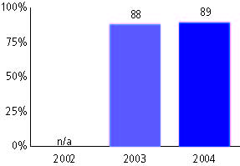

Texas Assessment of Knowledge and Skills, used for NCLB accountability
Grade 8

Mathematics
Proficient Level or above for:
All students | 66%
Economically disadvantaged students | 54
Migrant students | 47
Students with disabilities | 40
Students with limited English proficiency | 28
Black, non-Hispanic students | 49
Hispanic students | 57
White, non-Hispanic students | 80

Student achievement trend: Mathematics percent proficient level or above

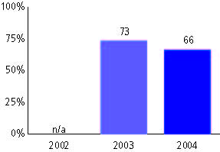

Texas Assessment of Knowledge and Skills, used for NCLB accountability
High school

Reading
Proficient Level or above for:
All students | 82%
Economically disadvantaged students | 73
Migrant students | 65
Students with disabilities | 53
Students with limited English proficiency | 34
Black, non-Hispanic students | 75
Hispanic students | 74
White, non-Hispanic students | 90

Student achievement trend: Reading percent proficient level or above

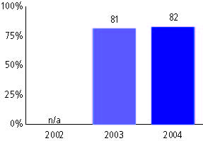

Texas Assessment of Knowledge and Skills, used for NCLB accountability
High school

Mathematics
Proficient Level or above for:
All students | 67%
Economically disadvantaged students | 53
Migrant students | 47
Students with disabilities | 35
Students with limited English proficiency | 32
Black, non-Hispanic students | 51
Hispanic students | 56
White, non-Hispanic students | 80

Student achievement trend: Mathematics percent proficient level or above

