Tennessee

http://www.state.tn.us/education

Districts and schools

Number of districts (CCD) | 1993-94 | 2003-04
 | 140 | 138

Number of public schools (CCD) | 1993-94 | 2003-04
Elementary | 942 | 978
Middle | 237 | 306
High | 255 | 294
Combined | 49 | 58
Other | 13 | 8
Total | 1,496 | 1,644

Number of charter schools (CCD) | 2003-04
 | 4

Finances

Total current expenditures  (CCD, in thousands of dollars, adjusted for inflation to 2002-03) | 1993-94 | 2002-03
Instructional | $2,708,024 | $3,647,986
Noninstructional | 231,559 | 278,082
Support | 1,272,385 | 1,748,705
Total | 4,211,968 | 5,674,773

Per-pupil expenditures  (CCD, adjusted for inflation to 2002-03) | 1993-94 | 2002-03
 | $4,739 | $6,118

Sources of Funding
(CCD, 2002-03)

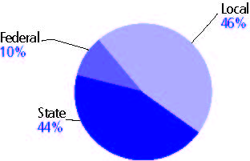

Title I allocation 2002-03 (ED; Includes Title I, Part A) | $185,694,729

Students

Public school enrollment (CCD) | 1993-94 | 2003-04
Pre-K | 9,976 | -
K-8 | 603,275 | 643,828
9-12 | 238,855 | 252,526
Total (K-12) | 842,130 | 896,354

Race/ethnicity (CCD) | 1993-94 | 2003-04
American Indian/Alaskan Native | * | n/a
Asian/Pacific Islander | 1% | n/a
Black, non-Hispanic | 23 | n/a
Hispanic | * | n/a
White, non-Hispanic | 76 | n/a

Students with disabilities (OSEP) | 1993-94 | 2003-04
 | 12% | 11%

Students with limited  English proficiency (NCELA) | 1993-94 | 2003-04
 | * | 2%

Migrant students (OME) | 1993-94 | 2003-04
 | * | 1%

Eighth-grade students enrolled in Algebra I for high school credit (NAEP) | 1996 | 2003
 | 18% | 20%

Students eligible to participate in the Free or Reduced-Price Lunch Program, 2003-04 (CCD) | n/a

All schools by percent of students eligible to participate in the Free or Reduced-Price Lunch Program, 2003-04† (CCD)

Staff

Number of FTE teachers (CCD) | 1993-94 | 2003-04
Elementary | 25,506 | n/a
Middle | 8,256 | n/a
High | 12,891 | n/a
Combined | 1,549 | n/a
Other | 168 | n/a
Total | 48,370 | n/a

Number of FTE non-teacher staff (CCD) | 1993-94 | 2003-04
Instructional aides | 8,981 | 14,430
Instructional coordinators | - | 1,117
Administrators | 5,137 | 6,319
Other | 31,647 | 34,670
Total | 45,765 | 56,536

Percentage of teachers with a major in the main subject taught, grades 7-12 (SASS) | 1994 | 2000
English | 73% | 73%
Mathematics | 59 | 51
Science | 52 | 53
Social Studies | 81 | 69

Percentage of core courses taught by highly qualified teachers, 2003-04 (As defined and reported by states, collected by ED)

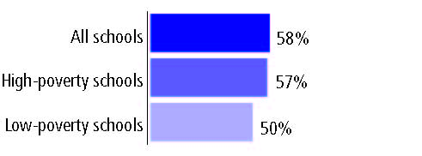

Outcomes

 | 1993-94 | 2000-01
High school dropout rate (NCES) | 5% | 4%
Avg. freshman graduation rate (NCES) | 66 | 59
College-going rate (IPEDS/NCES) | 54 | 62

NAEP state results
Reading, Grade 4 | 1994 | 2005
Proficient level or above | 27% | 27%
Basic level or above | 58 | 60
Math, Grade 8 | 1996 | 2005
Proficient level or above | 15% | 21%
Basic level or above | 53 | 61

Statewide Accountability Information:

State Accountability Website: http://evaas.sasinschool.com/tn_reportcard/welcome.jsp

State assessment for NCLB accountability: Tennessee Achievement Test

State student achievement levels: Below Proficient, Proficient, Advanced

 |  | 2001-02  Annual measurable  objective starting point | Target  2003-04
Grade 3 | Reading or language arts | 77.1% | 77.1%
 | Mathematics | 72.4 | 72.4
Grade 8 | Reading or language arts | 77.1 | 77.1
 | Mathematics | 72.4 | 72.4
High school | Reading or language arts | 86 | 86
 | Mathematics | 65.4 | 65.4

2003-04 NCLB accountability results, applied to 2004-05 school year
AYP outcomes and consequences* | Title I schools |  | All schools |  | All districts
Made AYP | 732 | 82% | 1,442 | 79% | 93 | 68%
Identified for improvement:
Year 1 | 84 | 9% | 118 | 7% | 25 | 18%
Year 2 | 0 | 0 | 0 | 0 | 0 | 0
Corrective action | 0 | 0 | 0 | 0 | 0 | 0
Restructuring | 44 | 5% | 47 | 3% | 0 | 0
Exited improvement status (made AYP twice after missing twice or more, includes total “made” above) | n/a | n/a | 8 | * | n/a | n/a
*AYP outcomes for this state are not available due to issues with data collection, measurement, or other reasons. For more information, please visit the state’s Web site, above.

Other indicator, 2003-04 | State target | State outcome
Elementary Indicator: Attendance | 92.5% | Met
Middle Indicator: Attendance | 92.5% | Met
High School Indicator: Graduation rate | 76% | Met

NCLB choice participation | Number of Title I students | Percent of eligible students
Title I school choice: | 839 | 2%
Supplemental educational services: | 4,870 | 33%

Student Achievement 2003-04

Tennessee Achievement Test, used for NCLB accountability
Grade 3

Reading or language arts
Proficient Level or above for:
All students | 84%
Economically disadvantaged students | 77
Migrant students | 49
Students with disabilities | 56
Students with limited English proficiency | 58
Black, non-Hispanic students | 74
Hispanic students | 73
White, non-Hispanic students | 88

Student achievement trend: Reading or language arts percent proficient level or above

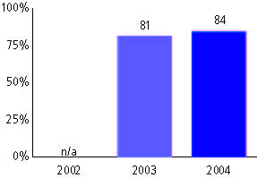

Tennessee Achievement Test, used for NCLB accountability
Grade 3

Mathematics
Proficient Level or above for:
All students | 81%
Economically disadvantaged students | 72
Migrant students | 52
Students with disabilities | 46
Students with limited English proficiency | 60
Black, non-Hispanic students | 66
Hispanic students | 72
White, non-Hispanic students | 87

Student achievement trend: Mathematics percent proficient level or above

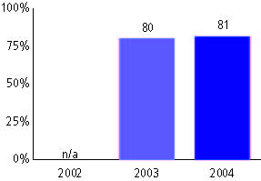

Tennessee Achievement Test, used for NCLB accountability
Grade 4

Reading or language arts
Proficient Level or above for:
All students | 81%
Economically disadvantaged students | 71
Migrant students | 54
Students with disabilities | 48
Students with limited English proficiency | 57
Black, non-Hispanic students | 68
Hispanic students | 71
White, non-Hispanic students | 86

Student achievement trend: Reading or language arts percent proficient level or above

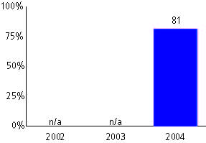

Tennessee Achievement Test, used for NCLB accountability
Grade 4

Mathematics
Proficient Level or above for:
All students | 80%
Economically disadvantaged students | 70
Migrant students | 58
Students with disabilities | 41
Students with limited English proficiency | 63
Black, non-Hispanic students | 65
Hispanic students | 72
White, non-Hispanic students | 86

Student achievement trend: Mathematics percent proficient level or above

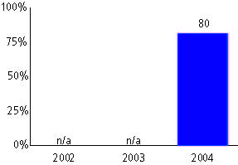

Tennessee Achievement Test, used for NCLB accountability
Grade 5

Reading or language arts
Proficient Level or above for:
All students | 83%
Economically disadvantaged students | 74
Migrant students | 49
Students with disabilities | 47
Students with limited English proficiency | 56
Black, non-Hispanic students | 73
Hispanic students | 72
White, non-Hispanic students | 87

Student achievement trend: Reading or language arts percent proficient level or above

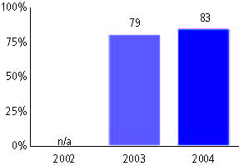

Tennessee Achievement Test, used for NCLB accountability
Grade 5

Mathematics
Proficient Level or above for:
All students | 84%
Economically disadvantaged students | 76
Migrant students | 52
Students with disabilities | 45
Students with limited English proficiency | 63
Black, non-Hispanic students | 72
Hispanic students | 75
White, non-Hispanic students | 89

Student achievement trend: Mathematics percent proficient level or above

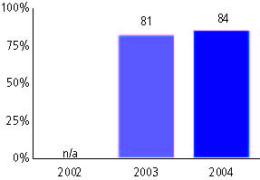

Tennessee Achievement Test, used for NCLB accountability
Grade 6

Reading or language arts
Proficient Level or above for:
All students | 81%
Economically disadvantaged students | 71
Migrant students | 44
Students with disabilities | 41
Students with limited English proficiency | 45
Black, non-Hispanic students | 67
Hispanic students | 72
White, non-Hispanic students | 86

Student achievement trend: Reading or language arts percent proficient level or above

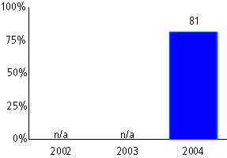

Tennessee Achievement Test, used for NCLB accountability
Grade 6

Mathematics
Proficient Level or above for:
All students | 80%
Economically disadvantaged students | 70
Migrant students | 54
Students with disabilities | 36
Students with limited English proficiency | 53
Black, non-Hispanic students | 64
Hispanic students | 71
White, non-Hispanic students | 86

Student achievement trend: Mathematics percent proficient level or above

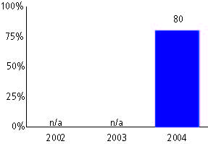

Tennessee Achievement Test, used for NCLB accountability
Grade 7

Reading or language arts
Proficient Level or above for:
All students | 80%
Economically disadvantaged students | 70
Migrant students | 49
Students with disabilities | 42
Students with limited English proficiency | 41
Black, non-Hispanic students | 66
Hispanic students | 69
White, non-Hispanic students | 85

Student achievement trend: Reading or language arts percent proficient level or above

Tennessee Achievement Test, used for NCLB accountability
Grade 7

Mathematics
Proficient Level or above for:
All students | 80%
Economically disadvantaged students | 69
Migrant students | 59
Students with disabilities | 36
Students with limited English proficiency | 48
Black, non-Hispanic students | 64
Hispanic students | 69
White, non-Hispanic students | 86

Student achievement trend: Mathematics percent proficient level or above

Tennessee Achievement Test, used for NCLB accountability
Grade 8

Reading or language arts
Proficient Level or above for:
All students | 81%
Economically disadvantaged students | 69
Migrant students | 27
Students with disabilities | 38
Students with limited English proficiency | 36
Black, non-Hispanic students | 66
Hispanic students | 66
White, non-Hispanic students | 86

Student achievement trend: Reading or language arts percent proficient level or above

Tennessee Achievement Test, used for NCLB accountability
Grade 8

Mathematics
Proficient Level or above for:
All students | 83%
Economically disadvantaged students | 73
Migrant students | 44
Students with disabilities | 39
Students with limited English proficiency | 59
Black, non-Hispanic students | 68
Hispanic students | 75
White, non-Hispanic students | 88

Student achievement trend: Mathematics percent proficient level or above

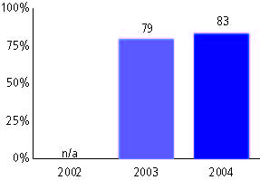

Tennessee Achievement Test, used for NCLB accountability
High school

Reading or language arts
Proficient Level or above for:
All students | 87%
Economically disadvantaged students | 78
Migrant students | 62
Students with disabilities | 51
Students with limited English proficiency | 57
Black, non-Hispanic students | 78
Hispanic students | 81
White, non-Hispanic students | 91

Student achievement trend: Reading or language arts percent proficient level or above

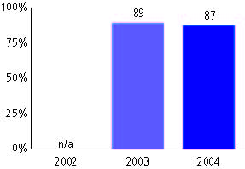

Tennessee Achievement Test, used for NCLB accountability
High school

Mathematics
Proficient Level or above for:
All students | 74%
Economically disadvantaged students | 61
Migrant students | 70
Students with disabilities | 36
Students with limited English proficiency | 56
Black, non-Hispanic students | 53
Hispanic students | 69
White, non-Hispanic students | 83

Student achievement trend: Mathematics percent proficient level or above

