National Summary

Districts and schools

Number of districts† (CCD) | 1993-94 | 2003-04
 | 14,882 | 14,468

Number of public schools† (CCD) | 1993-94 | 2003-04
Elementary | 50,978 | 53,583
Middle | 14,345 | 16,362
High | 15,715 | 18,191
Combined | 2,703 | 4,954
Other | 1,450 | 1,234
Total | 85,191 | 94,324

Number of charter schools† (CCD) | 2003-04
 | 3,041

Finances

Total current expenditures  (CCD, in thousands of dollars, adjusted for inflation to 2002-03) | 1993-94 | 2002-03
Instructional | $181,692,371 | $239,408,049
Noninstructional | 13,633,755 | 16,142,732
Support | 101,515,748 | 134,584,221
Total | 296,841,894 | 390,135,001

Per-pupil expenditures  (CCD, adjusted for inflation to 2002-03) | 1993-94 | 2002-03
 | $6,693 | $7,954

Sources of Funding
(CCD, 2002-03)
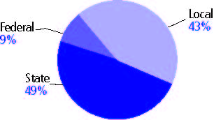

Title I allocation 2002-03 (ED; Includes Title I, Part A) | $11,688,664,000

Students

Public school enrollment† (CCD) | 1993-94 | 2003-04
Pre-K | 430,152 | 792,690
K-8 | 30,855,652 | 33,566,105
9-12 | 11,874,057 | 14,378,630
Total (K-12) | 42,729,709 | 47,944,735

Race/ethnicity (CCD) | 1993-94 | 2003-04
American Indian/Alaskan Native | 1% | 1%
Asian/Pacific Islander | 4 | 5
Black, non-Hispanic | 16 | 17
Hispanic | 13 | 20
White, non-Hispanic | 65 | 58

Students with disabilities (OSEP) | 1993-94 | 2003-04
Total includes only United States and District of Columbia | 8% | 12%

Students with limited  English proficiency (NCELA) | 1993-94 | 2003-04
 | 7% | 12%

Migrant students (OME) | 1993-94 | 2003-04
 | 1% | 3%

Eighth-grade students enrolled in Algebra I for high school credit (NAEP) | 1996 | 2003
 | 24% | 27%

Students eligible to participate in the Free or Reduced-Price Lunch Program, 2003-04† (CCD) | 17,666,507

All schools by percent of students eligible to participate in the Free or Reduced-Price Lunch Program, 2003-04† (CCD)

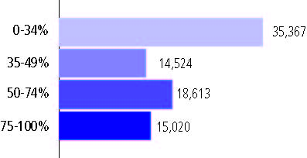
† 10,800 schools did not report

Staff

Number of FTE teachers† (CCD) | 1993-94 | 2003-04
Elementary | 1,188,518 | 1,325,917
Middle | 473,923 | 561,227
High | 655,858 | 747,099
Combined | 69,097 | 84,412
Other | 29,538 | 19,970
Total | 2,416,933 | 2,738,625

Number of FTE non-teacher staff† (CCD) | 1993-94 | 2003-04
Instructional aides | 450,519 | 685,355
Instructional coordinators | 31,939 | 44,377
Administrators | 170,695 | 231,774
Other | 1,676,780 | 1,975,762
Total | 2,329,933 | 2,937,268

Percentage of teachers with a major in the main subject taught, grades 7-12 (SASS) | 1994 | 2000
English | 78% | 70%
Mathematics | 72 | 67
Science | 74 | 75
Social Studies | 80 | 78

Percentage of core courses taught by highly qualified teachers, 2003-04† (As defined and reported by states, collected by ED)

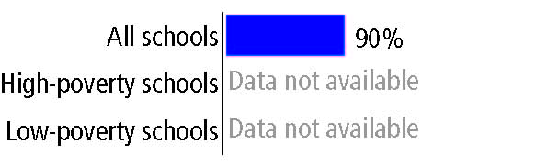

Outcomes

 | 1993-94 | 2000-01
High school dropout rate (NCES) | 5% | 5%
Avg. freshman graduation rate (NCES) | 75 | 72
College-going rate (IPEDS/NCES) | 58 | 63

NAEP state results
Reading, Grade 4 | 1994 | 2005
Proficient level or above | 28% | 30%
Basic level or above | 59 | 63
Math, Grade 8 | 1996 | 2005
Proficient level or above | 23% | 29%
Basic level or above | 61 | 68

