Montana

http://www.opi.state.mt.us

Districts and schools

Number of districts (CCD) | 1993-94 | 2003-04
 | 495 | 450

Number of public schools (CCD) | 1993-94 | 2003-04
Elementary | 487 | 441
Middle | 236 | 240
High | 174 | 175
Combined | 1 | 0
Other | 2 | 2
Total | 900 | 858

Number of charter schools (CCD) | 2003-04
 | -

Finances

Total current expenditures  (CCD, in thousands of dollars, adjusted for inflation to 2002-03) | 1993-94 | 2002-03
Instructional | $654,984 | $690,810
Noninstructional | 44,569 | 46,044
Support | 347,857 | 387,437
Total | 1,047,410 | 1,124,291

Per-pupil expenditures  (CCD, adjusted for inflation to 2002-03) | 1993-94 | 2002-03
 | $6,426 | $7,495

Sources of Funding
(CCD, 2002-03)

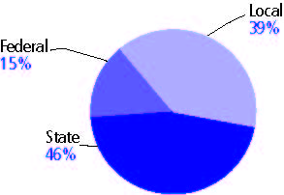

Title I allocation 2002-03 (ED; Includes Title I, Part A) | $40,458,865

Students

Public school enrollment (CCD) | 1993-94 | 2003-04
Pre-K | 483 | 664
K-8 | 115,509 | 99,250
9-12 | 46,111 | 48,092
Total (K-12) | 161,620 | 147,342

Race/ethnicity (CCD) | 1993-94 | 2003-04
American Indian/Alaskan Native | 10% | 11%
Asian/Pacific Islander | 1 | 1
Black, non-Hispanic | * | 1
Hispanic | 1 | 2
White, non-Hispanic | 88 | 85

Students with disabilities (OSEP) | 1993-94 | 2003-04
 | 10% | 12%

Students with limited  English proficiency (NCELA) | 1993-94 | 2003-04
 | 5% | 5%

Migrant students (OME) | 1993-94 | 2003-04
 | 1% | 2%

Eighth-grade students enrolled in Algebra I for high school credit (NAEP) | 1996 | 2003
 | 22% | 20%

Students eligible to participate in the Free or Reduced-Price Lunch Program, 2003-04 (CCD) | 50,053

All schools by percent of students eligible to participate in the Free or Reduced-Price Lunch Program, 2003-04† (CCD)

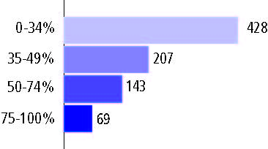
† 11 schools did not report

Staff

Number of FTE teachers (CCD) | 1993-94 | 2003-04
Elementary | 4,817 | 4,650
Middle | 2,083 | 2,198
High | 2,998 | 3,395
Combined | 7 | -
Other | 47 | 56
Total | 9,952 | 10,299

Number of FTE non-teacher staff (CCD) | 1993-94 | 2003-04
Instructional aides | 1,745 | 1,870
Instructional coordinators | 139 | 182
Administrators | 653 | 649
Other | 6,260 | 5,654
Total | 8,797 | 8,355

Percentage of teachers with a major in the main subject taught, grades 7-12 (SASS) | 1994 | 2000
English | 75% | 71%
Mathematics | 77 | 68
Science | 76 | 74
Social Studies | 79 | 67

Percentage of core courses taught by highly qualified teachers, 2003-04 (As defined and reported by states, collected by ED)

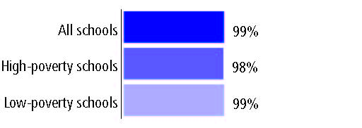

Outcomes

 | 1993-94 | 2000-01
High school dropout rate (NCES) | - | 4%
Avg. freshman graduation rate (NCES) | 85% | 80
College-going rate (IPEDS/NCES) | 54 | 54

NAEP state results
Reading, Grade 4 | 1994 | 2005
Proficient level or above | 35% | 36%
Basic level or above | 69 | 72
Math, Grade 8 | 1996 | 2005
Proficient level or above | 32% | 36%
Basic level or above | 75 | 80

Statewide Accountability Information:

State Accountability Website: http://www.opi.state.mt.us/ReportCard/Index.html

State assessment for NCLB accountability: Montana Comprehensive Assessment System

State student achievement levels: Nearing Proficient, Novice, Proficient, Advanced

 |  | 2001-02  Annual measurable  objective starting point | Target  2003-04
Grade 4 | Reading | 55% | 55%
 | Mathematics | 40 | 40
Grade 8 | Reading | 55 | 55
 | Mathematics | 40 | 40
High school | Reading | 55 | 55
 | Mathematics | 40 | 40

2003-04 NCLB accountability results, applied to 2004-05 school year
AYP outcomes and consequences* | Title I schools |  | All schools |  | All districts
Made AYP | 568 | 84% | 731 | 85% | 362 | 83%
Identified for improvement:
Year 1 | 31 | 5% | 31 | 4% | 0 | 0
Year 2 | 0 | 0 | 0 | 0 | 0 | 0
Corrective action | 4 | 1% | 4 | * | 0 | 0
Restructuring | 33 | 2% | 33 | 4% | 0 | 0
Exited improvement status (made AYP twice after missing twice or more, includes total “made” above) | n/a | n/a | n/a | n/a | n/a | n/a
*AYP outcomes for this state are not available due to issues with data collection, measurement, or other reasons. For more information, please visit the state’s Web site, above.

Other indicator, 2003-04 | State target | State outcome
Elementary Indicator: Attendance | Meet or progress toward 80% | Met
Middle Indicator: Attendance | Meet or progress toward 80% | Met
High School Indicator: Graduation rate | Meet or progress toward 80% | Met

NCLB choice participation | Number of Title I students | Percent of eligible students
Title I school choice: | 14 | 4%
Supplemental educational services: | 10 | *

Student Achievement 2003-04

Montana Comprehensive Assessment System, used for NCLB accountability
Grade 3

Reading
Proficient Level or above for:
All students | n/a
Economically disadvantaged students | n/a
Migrant students | n/a
Students with disabilities | n/a
Students with limited English proficiency | n/a
Black, non-Hispanic students | n/a
Hispanic students | n/a
White, non-Hispanic students | n/a

Trend Data Not Available

Montana Comprehensive Assessment System, used for NCLB accountability
Grade 3

Mathematics
Proficient Level or above for:
All students | n/a
Economically disadvantaged students | n/a
Migrant students | n/a
Students with disabilities | n/a
Students with limited English proficiency | n/a
Black, non-Hispanic students | n/a
Hispanic students | n/a
White, non-Hispanic students | n/a

Trend Data Not Available

Montana Comprehensive Assessment System, used for NCLB accountability
Grade 4

Reading
Proficient Level or above for:
All students | 66%
Economically disadvantaged students | 52
Migrant students | 57
Students with disabilities | 31
Students with limited English proficiency | 21
Black, non-Hispanic students | 54
Hispanic students | 56
White, non-Hispanic students | 70

Student achievement trend: Reading percent proficient level or above

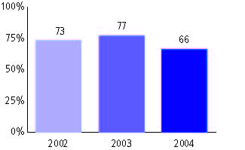

Montana Comprehensive Assessment System, used for NCLB accountability
Grade 4

Mathematics
Proficient Level or above for:
All students | 45%
Economically disadvantaged students | 33
Migrant students | 49
Students with disabilities | 22
Students with limited English proficiency | 15
Black, non-Hispanic students | 32
Hispanic students | 36
White, non-Hispanic students | 49

Student achievement trend: Mathematics percent proficient level or above

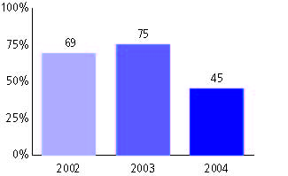

Montana Comprehensive Assessment System, used for NCLB accountability
Grade 5

Reading
Proficient Level or above for:
All students | n/a
Economically disadvantaged students | n/a
Migrant students | n/a
Students with disabilities | n/a
Students with limited English proficiency | n/a
Black, non-Hispanic students | n/a
Hispanic students | n/a
White, non-Hispanic students | n/a

Trend Data Not Available

Montana Comprehensive Assessment System, used for NCLB accountability
Grade 5

Mathematics
Proficient Level or above for:
All students | n/a
Economically disadvantaged students | n/a
Migrant students | n/a
Students with disabilities | n/a
Students with limited English proficiency | n/a
Black, non-Hispanic students | n/a
Hispanic students | n/a
White, non-Hispanic students | n/a

Trend Data Not Available

Montana Comprehensive Assessment System, used for NCLB accountability
Grade 6

Reading
Proficient Level or above for:
All students | n/a
Economically disadvantaged students | n/a
Migrant students | n/a
Students with disabilities | n/a
Students with limited English proficiency | n/a
Black, non-Hispanic students | n/a
Hispanic students | n/a
White, non-Hispanic students | n/a

Trend Data Not Available

Montana Comprehensive Assessment System, used for NCLB accountability
Grade 6

Mathematics
Proficient Level or above for:
All students | n/a
Economically disadvantaged students | n/a
Migrant students | n/a
Students with disabilities | n/a
Students with limited English proficiency | n/a
Black, non-Hispanic students | n/a
Hispanic students | n/a
White, non-Hispanic students | n/a

Trend Data Not Available

Montana Comprehensive Assessment System, used for NCLB accountability
Grade 7

Reading
Proficient Level or above for:
All students | n/a
Economically disadvantaged students | n/a
Migrant students | n/a
Students with disabilities | n/a
Students with limited English proficiency | n/a
Black, non-Hispanic students | n/a
Hispanic students | n/a
White, non-Hispanic students | n/a

Trend Data Not Available

Montana Comprehensive Assessment System, used for NCLB accountability
Grade 7

Mathematics
Proficient Level or above for:
All students | n/a
Economically disadvantaged students | n/a
Migrant students | n/a
Students with disabilities | n/a
Students with limited English proficiency | n/a
Black, non-Hispanic students | n/a
Hispanic students | n/a
White, non-Hispanic students | n/a

Trend Data Not Available

Montana Comprehensive Assessment System, used for NCLB accountability
Grade 8

Reading
Proficient Level or above for:
All students | 58%
Economically disadvantaged students | 41
Migrant students | 40
Students with disabilities | 18
Students with limited English proficiency | 12
Black, non-Hispanic students | 43
Hispanic students | 46
White, non-Hispanic students | 63

Student achievement trend: Reading percent proficient level or above

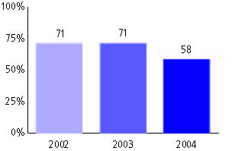

Montana Comprehensive Assessment System, used for NCLB accountability
Grade 8

Mathematics
Proficient Level or above for:
All students | 64%
Economically disadvantaged students | 48
Migrant students | 72
Students with disabilities | 21
Students with limited English proficiency | 16
Black, non-Hispanic students | 44
Hispanic students | 55
White, non-Hispanic students | 70

Student achievement trend: Mathematics percent proficient level or above

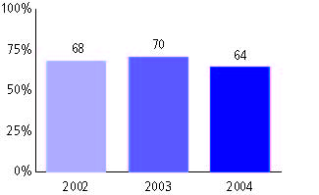

Montana Comprehensive Assessment System, used for NCLB accountability
High school

Reading
Proficient Level or above for:
All students | 63%
Economically disadvantaged students | 45
Migrant students | 50
Students with disabilities | 19
Students with limited English proficiency | 14
Black, non-Hispanic students | 45
Hispanic students | 51
White, non-Hispanic students | 66

Student achievement trend: Reading percent proficient level or above

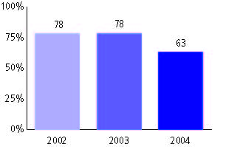

Montana Comprehensive Assessment System, used for NCLB accountability
High school

Mathematics
Proficient Level or above for:
All students | 60%
Economically disadvantaged students | 42
Migrant students | 63
Students with disabilities | 17
Students with limited English proficiency | 16
Black, non-Hispanic students | 31
Hispanic students | 44
White, non-Hispanic students | 65

Student achievement trend: Mathematics percent proficient level or above

