Mississippi

http://www.mde.k12.ms.us

Districts and schools

Number of districts (CCD) | 1993-94 | 2003-04
 | 149 | 152

Number of public schools (CCD) | 1993-94 | 2003-04
Elementary | 446 | 446
Middle | 168 | 188
High | 173 | 188
Combined | 78 | 61
Other | 25 | 14
Total | 890 | 897

Number of charter schools (CCD) | 2003-04
 | 1

Finances

Total current expenditures  (CCD, in thousands of dollars, adjusted for inflation to 2002-03) | 1993-94 | 2002-03
Instructional | $1,358,399 | $1,707,391
Noninstructional | 175,808 | 177,495
Support | 664,280 | 968,645
Total | 2,198,487 | 2,853,531

Per-pupil expenditures  (CCD, adjusted for inflation to 2002-03) | 1993-94 | 2002-03
 | $4,435 | $5,792

Sources of Funding
(CCD, 2002-03)

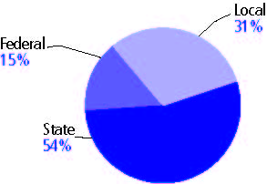

Title I allocation 2002-03 (ED; Includes Title I, Part A) | $157,215,840

Students

Public school enrollment (CCD) | 1993-94 | 2003-04
Pre-K | 1,060 | 2,208
K-8 | 357,016 | 350,402
9-12 | 131,112 | 127,333
Total (K-12) | 488,128 | 477,735

Race/ethnicity (CCD) | 1993-94 | 2003-04
American Indian/Alaskan Native | * | *
Asian/Pacific Islander | 1% | 1%
Black, non-Hispanic | 51 | 51
Hispanic | * | 1
White, non-Hispanic | 48 | 47

Students with disabilities (OSEP) | 1993-94 | 2003-04
 | 11% | 11%

Students with limited  English proficiency (NCELA) | 1993-94 | 2003-04
 | * | 1%

Migrant students (OME) | 1993-94 | 2003-04
 | 1% | 1%

Eighth-grade students enrolled in Algebra I for high school credit (NAEP) | 1996 | 2003
 | 18% | 16%

Students eligible to participate in the Free or Reduced-Price Lunch Program, 2003-04 (CCD) | 317,137

All schools by percent of students eligible to participate in the Free or Reduced-Price Lunch Program, 2003-04† (CCD)

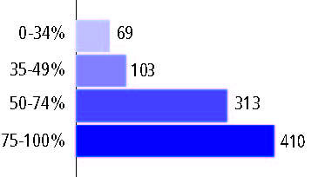
† 2 schools did not report

Staff

Number of FTE teachers (CCD) | 1993-94 | 2003-04
Elementary | 12,012 | 13,119
Middle | 5,172 | 7,756
High | 6,347 | 7,960
Combined | 3,301 | 2,402
Other | 418 | 349
Total | 27,250 | 31,586

Number of FTE non-teacher staff (CCD) | 1993-94 | 2003-04
Instructional aides | 8,886 | 8,603
Instructional coordinators | 399 | 671
Administrators | 2,311 | 2,743
Other | 19,881 | 23,769
Total | 31,477 | 35,786

Percentage of teachers with a major in the main subject taught, grades 7-12 (SASS) | 1994 | 2000
English | 66% | 55%
Mathematics | 72 | 60
Science | 73 | 66
Social Studies | 83 | 72

Percentage of core courses taught by highly qualified teachers, 2003-04 (As defined and reported by states, collected by ED)
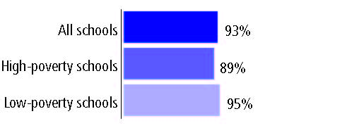

Outcomes

 | 1993-94 | 2000-01
High school dropout rate (NCES) | 6% | 5%
Avg. freshman graduation rate (NCES) | 64 | 60
College-going rate (IPEDS/NCES) | 69 | 63

NAEP state results
Reading, Grade 4 | 1994 | 2005
Proficient level or above | 18% | 18%
Basic level or above | 45 | 48
Math, Grade 8 | 1996 | 2005
Proficient level or above | 7% | 13%
Basic level or above | 36 | 51

Statewide Accountability Information:

State Accountability Website: http://www.mde.k12.ms.us/Account/RC4B/RC4B.htm

State assessment for NCLB accountability: Mississippi Curriculum Test

State student achievement levels: Minimal, Basic, Proficient, Advanced

 |  | 2001-02  Annual measurable  objective starting point | Target  2003-04
Grade 4 | Reading | 66% | 66%
 | Mathematics | 49 | 49
Grade 8 | Reading | 30 | 30
 | Mathematics | 23 | 23
High school | Reading | 16 | 16
 | Mathematics | 5 | 5

2003-04 NCLB accountability results, applied to 2004-05 school year
AYP outcomes and consequences* | Title I schools |  | All schools |  | All districts
Made AYP | n/a | n/a | 668 | 76% | 60 | 39%
Identified for improvement:
Year 1 | 65 | 7% | 65 | 7% | 36 | 24%
Year 2 | 2 | * | 2 | * | 0 | 0
Corrective action | 2 | * | 2 | * | 0 | 0
Restructuring | 2 | * | 2 | * | 0 | 0
Exited improvement status (made AYP twice after missing twice or more, includes total “made” above) | 0 | 0 | 0 | 0 | 0 | 0
*AYP outcomes for this state are not available due to issues with data collection, measurement, or other reasons. For more information, please visit the state’s Web site, above.

Other indicator, 2003-04 | State target | State outcome
Elementary Indicator: Attendance rate | 93% | Met
Middle Indicator: Attendance rate | 93% | Met
High School Indicator: Graduation rate | 72% | Met

NCLB choice participation | Number of Title I students | Percent of eligible students
Title I school choice: | 7 | *
Supplemental educational services: | 200 | 6%

Student Achievement 2003-04

Mississippi Curriculum Test, used for NCLB accountability
Grade 3

Reading
Proficient Level or above for:
All students | 84%
Economically disadvantaged students | 79
Migrant students | 71
Students with disabilities | 69
Students with limited English proficiency | 69
Black, non-Hispanic students | 76
Hispanic students | 79
White, non-Hispanic students | 94

Student achievement trend: Reading percent proficient level or above

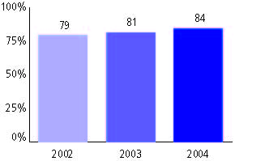

Mississippi Curriculum Test, used for NCLB accountability
Grade 3

Mathematics
Proficient Level or above for:
All students | 93%
Economically disadvantaged students | 89
Migrant students | 88
Students with disabilities | 83
Students with limited English proficiency | 92
Black, non-Hispanic students | 87
Hispanic students | 93
White, non-Hispanic students | 96

Student achievement trend: Mathematics percent proficient level or above

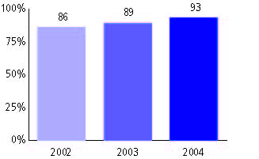

Mississippi Curriculum Test, used for NCLB accountability
Grade 4

Reading
Proficient Level or above for:
All students | 88%
Economically disadvantaged students | 83
Migrant students | 77
Students with disabilities | 70
Students with limited English proficiency | 70
Black, non-Hispanic students | 82
Hispanic students | 85
White, non-Hispanic students | 95

Student achievement trend: Reading percent proficient level or above

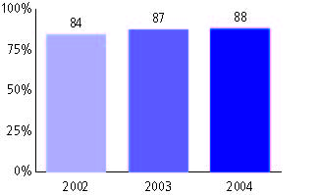

Mississippi Curriculum Test, used for NCLB accountability
Grade 4

Mathematics
Proficient Level or above for:
All students | 80%
Economically disadvantaged students | 72
Migrant students | 75
Students with disabilities | 61
Students with limited English proficiency | 79
Black, non-Hispanic students | 69
Hispanic students | 87
White, non-Hispanic students | 91

Student achievement trend: Mathematics percent proficient level or above

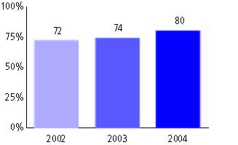

Mississippi Curriculum Test, used for NCLB accountability
Grade 5

Reading
Proficient Level or above for:
All students | 86%
Economically disadvantaged students | 80
Migrant students | 71
Students with disabilities | 65
Students with limited English proficiency | 63
Black, non-Hispanic students | 78
Hispanic students | 82
White, non-Hispanic students | 95

Student achievement trend: Reading percent proficient level or above

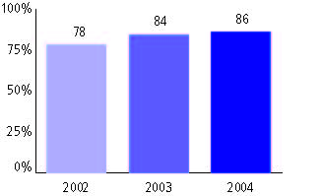

Mississippi Curriculum Test, used for NCLB accountability
Grade 5

Mathematics
Proficient Level or above for:
All students | 68%
Economically disadvantaged students | 58
Migrant students | 60
Students with disabilities | 45
Students with limited English proficiency | 61
Black, non-Hispanic students | 54
Hispanic students | 70
White, non-Hispanic students | 84

Student achievement trend: Mathematics percent proficient level or above

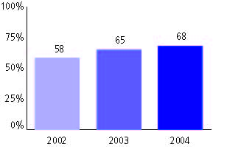

Mississippi Curriculum Test, used for NCLB accountability
Grade 6

Reading
Proficient Level or above for:
All students | 77%
Economically disadvantaged students | 68
Migrant students | 66
Students with disabilities | 47
Students with limited English proficiency | 65
Black, non-Hispanic students | 65
Hispanic students | 82
White, non-Hispanic students | 90

Student achievement trend: Reading percent proficient level or above

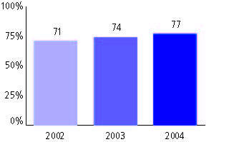

Mississippi Curriculum Test, used for NCLB accountability
Grade 6

Mathematics
Proficient Level or above for:
All students | 71%
Economically disadvantaged students | 61
Migrant students | 66
Students with disabilities | 40
Students with limited English proficiency | 60
Black, non-Hispanic students | 57
Hispanic students | 74
White, non-Hispanic students | 85

Student achievement trend: Mathematics percent proficient level or above

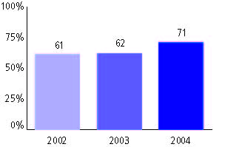

Mississippi Curriculum Test, used for NCLB accountability
Grade 7

Reading
Proficient Level or above for:
All students | 63%
Economically disadvantaged students | 50
Migrant students | 50
Students with disabilities | 26
Students with limited English proficiency | 36
Black, non-Hispanic students | 47
Hispanic students | 61
White, non-Hispanic students | 79

Student achievement trend: Reading percent proficient level or above

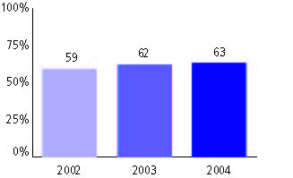

Mississippi Curriculum Test, used for NCLB accountability
Grade 7

Mathematics
Proficient Level or above for:
All students | 54%
Economically disadvantaged students | 41
Migrant students | 48
Students with disabilities | 23
Students with limited English proficiency | 41
Black, non-Hispanic students | 37
Hispanic students | 56
White, non-Hispanic students | 72

Student achievement trend: Mathematics percent proficient level or above

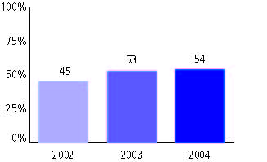

Mississippi Curriculum Test, used for NCLB accountability
Grade 8

Reading
Proficient Level or above for:
All students | 62%
Economically disadvantaged students | 47
Migrant students | 59
Students with disabilities | 24
Students with limited English proficiency | 39
Black, non-Hispanic students | 43
Hispanic students | 63
White, non-Hispanic students | 80

Student achievement trend: Reading percent proficient level or above

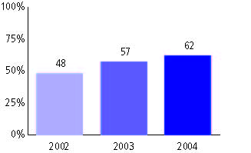

Mississippi Curriculum Test, used for NCLB accountability
Grade 8

Mathematics
Proficient Level or above for:
All students | 60%
Economically disadvantaged students | 46
Migrant students | 58
Students with disabilities | 22
Students with limited English proficiency | 52
Black, non-Hispanic students | 43
Hispanic students | 60
White, non-Hispanic students | 76

Student achievement trend: Mathematics percent proficient level or above

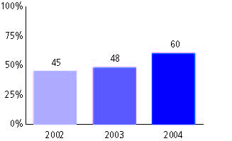

Mississippi Curriculum Test, used for NCLB accountability
High school

Reading
Proficient Level or above for:
All students | 39%
Economically disadvantaged students | 24
Migrant students | 33
Students with disabilities | 8
Students with limited English proficiency | 19
Black, non-Hispanic students | 22
Hispanic students | 37
White, non-Hispanic students | 54

Student achievement trend: Reading percent proficient level or above

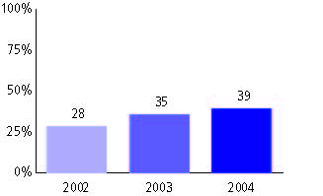

Mississippi Curriculum Test, used for NCLB accountability
High school

Mathematics
Proficient Level or above for:
All students | 55%
Economically disadvantaged students | 41
Migrant students | 61
Students with disabilities | 25
Students with limited English proficiency | 66
Black, non-Hispanic students | 38
Hispanic students | 68
White, non-Hispanic students | 68

Student achievement trend: Mathematics percent proficient level or above

